CareerWise Design Class Diagram

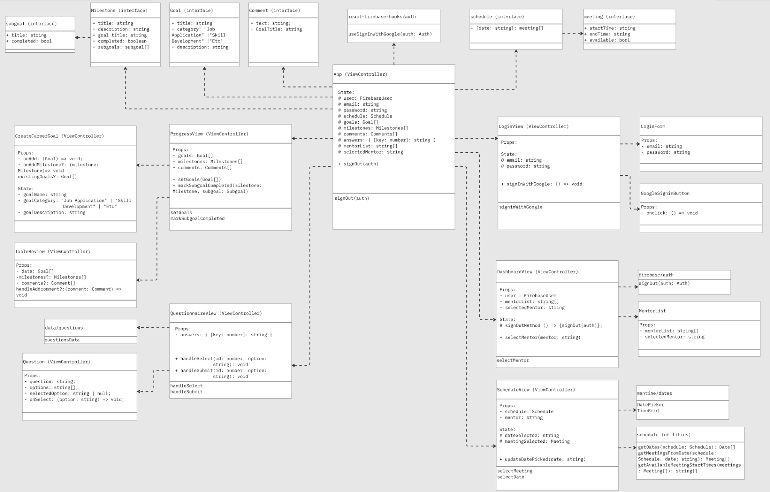

URL (Miro):
https://miro.com/app/board/uXjVJnhmEWM=/?moveToWidget=3458764651541406305&cot=14

Overview
The relationship between the application's main view components, shared interfaces, controller components, is depicted in the diagram. Standard components are implemented as functional React components that are solely responsible for receiving data through props and presenting the user interface. As higher-level orchestrators, ViewController components handle user actions like adding goals, signing in, filling out questionnaires, and setting up meetings. They also manage state and coordinate data flow between subcomponents. ViewController components own and preserve the state required for their portion of the application, in contrast to lower-level UI components. The current authenticated user, goal lists, chosen questionnaire responses, scheduling details, and sign-in status are examples of state. In addition to callback functions for updating or mutating, these components pass state downward into their child components as immutable props.

Goals
The CreateCareerGoal, TableReview, and ProgressView components are located in the goals section of the diagram. CreateCareerGoal gathers user input and uses the onAdd callback to send a newly created goal object upward. While ProgressView receives the same goal list and shows completion or progress data, TableReviews is in charge of displaying an array of current goals. The arrows pointing from these components to the Goal definition illustrate how each component depends on the shared Goal interface. All of the app's components that work with goal objects are designed to be consistent and type-safe. According to a note on the diagram, in order to avoid state duplication and maintain centralized updates, the App component should maintain complete ownership of the goals array.

Login
GoogleSignInButton, LoginView, and LoginForm are all located in the login section. LoginView exposes callback methods, such as signInWithGoogle, that are triggered in response to user interactions and makes use of authentication hooks, such as useSignInWithGoogle. The top-down structure of passing logic into UI components is demonstrated by LoginForm and GoogleSignInButton, which receive handler functions through props. Authentication requests are only made by view controllers; the UI elements are only used for presentation. User data and authentication status are transmitted upward via LoginView, which is subsequently consumed by the primary App controller.

App
The app component serves as the system's central hub, located in the middle of the diagram. The currently authenticated user, login and logout actions, and view transitions are all coordinated by it. Depending on the user flow and authentication status, the app assigns rendering to particular. ViewControllers. The App's function as the top-level orchestrator is highlighted by the arrows pointing outward from it to other ViewControllers.
The app incorporates the logic needed for global state transitions, navigation, and authentication rather than directly manipulating the visual user interface.

Dashboard
The DashboardView is the main landing page. It receives the authenticated user along with callback handlers for signing out or navigating deeper. Its primary role is to serve as the main page for all other functions of the app.

Scheduling
The scheduling section of the website allows users to request meetings with mentors by selecting specific dates and time slots that are best fit for both the user and the mentor. The primary component, ScheduleView, manages internal state for the selected date and meeting, using an interface with start time, end time, and availability. Users interact with the calendar through UI elements, DatePicker, and TimeField, which are provided by the mantime/dates library. Functions like selectMeeting and selectDate are passed down to child components to handle user input. Supporting utilities like getDates and getMeetingsFromDate help populate the calendar with available options. This setup provides an efficient scheduling experience

Questionnaire
The questionnaire component in the application has been designed to help match users with a best fit mentor based on their career development needs. The feature presents a series of multiple choice questions, derived from different categories in career searching, that allow the user to express how they are currently feeling in their field of interest, what type of mentor they need, and the specific career they intend on pursuing. These questions are loaded as a questions.json file and are dynamically rendered in the QuestionnaireView. Additionally, the user responses are stored in state and are displayed in a section called DisplayAnswers. With this setup, the application can collect structured output from users and prepare it for future backend logic.

Design Pattern:
Facade
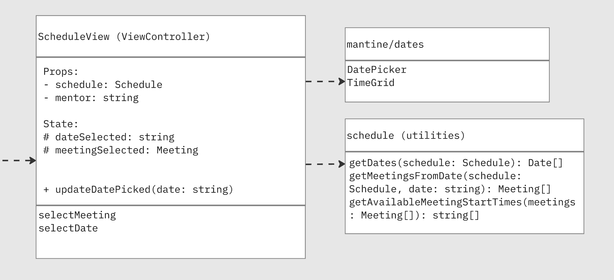

We used the Facade design pattern for both our internal scheduling utilities and third-party date components in our scheduling feature. The ScheduleView view controller serves as the application's facade. It is the only class that is aware of mantine/dates (DatePicker, TimeGrid), the schedule utility module (getDates, getMeetingsFromDate), and the Meeting interface. It also owns the dateSelected and meetingSelected states and only exposes two high-level operations (selectDate and selectMeeting). Without ever relying on Mantine's APIs or the structure of our scheduling data.

This choice is crucial for maintaining the CareerWise app's loose coupling and ease of evolution. We can update or modify the scheduling library, change the shape of the Meeting data, or even transfer scheduling logic to a backend service without affecting the rest of the user interface by concealing the specifics of how available meeting slots are calculated (getDates, getMeetingsFromDate) and visualized (DatePicker, TimeGrid) behind ScheduleView. Additionally, the Facade enhances testability by allowing us to use ScheduleView's public interface to unit-test scheduling behavior rather than mounting Mantine components in each test. All things considered, using Facade here allows us to have a single, coherent entry point to the "scheduling subsystem" while keeping implementation specifics and external dependencies contained within a single, clearly defined component.

