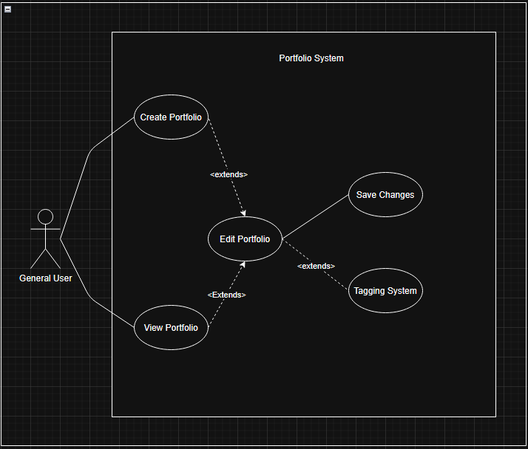
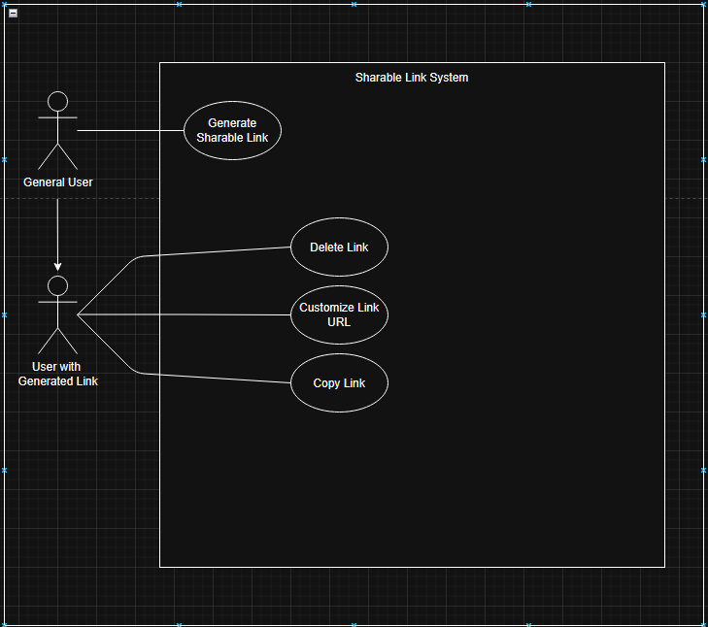

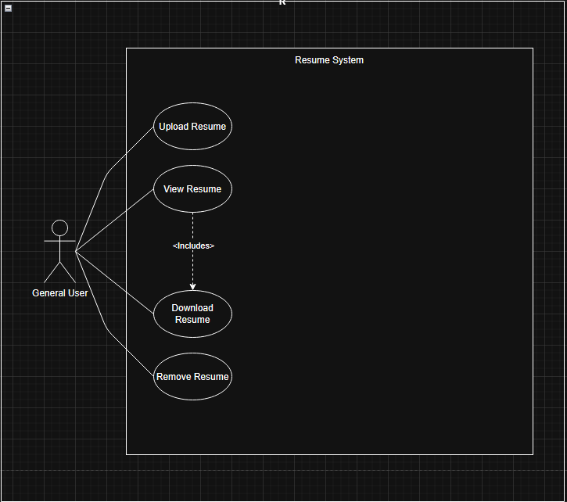
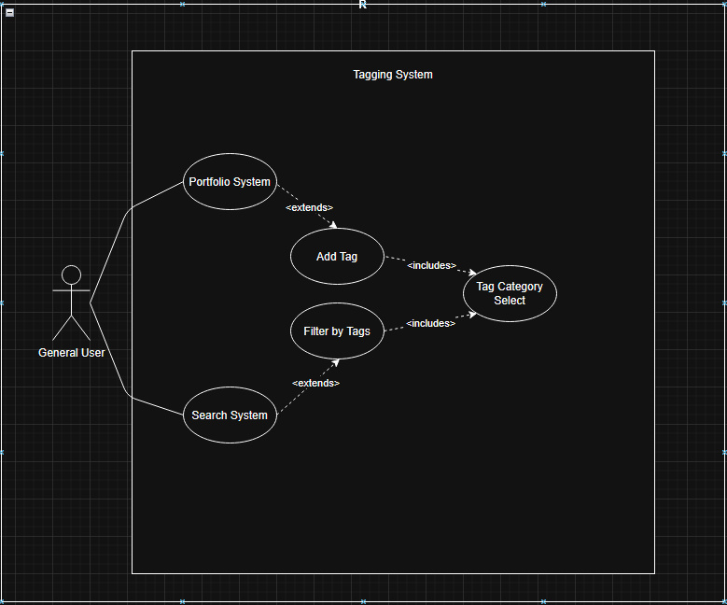

Name/Title: | Log in
ID: | 1
Description: | Sign into SkillShow system using email and password
Related Use Cases: | N/A
Precondition: | User must have an account created
Success Postcondition: | User is sent to their portfolio view page

USER STEPS:  1. User opens application  3. User enters login info | SYSTEM RESPONSE:  2. System displays login page  4.System displays user’s portfolio page

Name/Title: | Create Portfolio
ID: | 2
Description: | As a user, I want to create an appealing portfolio of my work so that it may be seen by potential employers.
Related Use Cases:
Precondition: | Users are logged in
Success Postcondition: | Portfolio creation is successfully saved and displayed on user’s profile

USER STEPS:  1. User navigates to user’s profile page  3. User selects “Create new Portfolio”  5A. User may Edit Portfolio (UC4)  5B. User selects “Save changes” | SYSTEM RESPONSE:  2. System displays profile page  4.System displays portfolio creation page with customization options  6.System saves portfolio and displays message “Portfolio created successfully”

Name/Title: | View Portfolio
ID: | 3
Description: | As a user, I want to be able to view other users' portfolios, so I can see examples and what my peers are working on.
Related Use Cases:
Precondition:
Success Postcondition: | User’s portfolio is displayed

USER STEPS:  1. User searches for portfolios with search bar and/or filter options  3. User selects from list of portfolios | SYSTEM RESPONSE:  2. System displays list of matching public portfolios  4.System displays selected portfolio

Name/Title: | Edit Portfolio
ID: | 4
Description: | As a user, I want to change how my portfolio is displayed, so I can emphasize my strongest work first and create a professional impression.
Related Use Cases:
Precondition: | User is logged in and has a portfolio created
Success Postcondition: | Changes made to portfolio are saved and displayed on user’s portfolio view page

USER STEPS:  1. User selects personal portfolio they want to edit  3. User selects “Edit Portfolio”  5. User inputs changes and selects “Save Changes” | SYSTEM RESPONSE:  2. System displays selected portfolio  4.System displays editing options page (relevant tags, portfolio theme, portfolio layout, portfolio description)  6.System saves changes and displays newly updated portfolio

Name/Title: | Generate Shareable Link
ID: | 5
Description: | As a user, I want to generate a shareable link to my profile, so I can include it in job applications, social media profiles, and email signatures without requiring recipients to create an account.
Related Use Cases:
Precondition: | User has an account with a portfolio created
Success Postcondition: | Link copied to clipboard and system displays message “copied to clipboard”

USER STEPS:  1. User navigates to personal profile  3. User clicks the “Share Profile” button | SYSTEM RESPONSE:  2. System displays personal profile  4.System copies link to clipboard and displays message “Link copied to clipboard”

Name/Title: | Upload Resume
ID: | 6
Description: | Allows a user to upload a resume to their profile when on their own profile page.
Related Use Cases: | Instance of: None  Included by: None  Inclusions: None  Extensions: None
Precondition: | User is logged in and on their profile page.  At least one supported file type is available locally.
Success Postcondition: | Resume is stored, listed under the user’s resumes, and available for view/download/remove.

USER STEPS:  1. User clicks on “Upload Resume” button.  3. User selects a file and confirms. | SYSTEM RESPONSE:  2. System opens file picker and validates type/size.  4. System saves file and shows “Upload successful.”

Name/Title: | Downloading Resume
ID: | 7
Description: | User downloads a stored resume to their device for offline use or external submission.
Related Use Cases: | Instance of: None.  Included by: None.  Inclusions: None.  Extensions: View Portfolio (ID: 3)
Precondition: | User has at least one uploaded resume.
Success Postcondition: | Selected resume file is downloaded to the user’s device.

USER STEPS:  1. User opens Resume section.  3. User selects a resume  5. User selects “Download Resume” Button | SYSTEM RESPONSE:  2. System shows available resumes.  4.System displays selected resume  6. System streams the file and confirms download started/completed.

Name/Title: | Add Tag
ID: | 8
Description: | User adds a tag to a portfolio to improve search and organization.
Related Use Cases: | Instance of: None  Included by: None  Inclusions:Category Select (ID: 9)  Extensions: None
Precondition: | User has Created a portfolio (UCD 2)
Success Postcondition: | Tag is saved and visible in the item’s tag list.

USER STEPS:  1. User opens Portfolio editing page (UCD 4)  3. User selects “Add Tags” option  5. User enters a tag or picks a suggested tag.  5a. User submits changes by selecting the “Save Changes” Button (UCD 4). | SYSTEM RESPONSE:  2. System displays editing Portfolio page  4. System displays text box tag input and lists suggestions under the text box as the user types.  6. System saves tag and shows confirmation.

Name/Title: | Select Tag Category
ID: | 9
Description: | User selects a category or subcategory for a tag.
Related Use Cases: | Instance of: None  Included by: Add Tag (ID: 8)  Inclusions: Subcategory Select (No ID, only when applicable)  Extensions: None
Precondition: | User is in the Tagging flow and category data exists.
Success Postcondition: | Category or subcategory is linked to the tag.

USER STEPS:  1. User clicks “Category Select.”  3. User picks a category.  5. User confirms selection. | SYSTEM RESPONSE:  2. System displays category options.  4. System shows subcategory options.  6. System saves selection and acknowledges.

Name/Title: | Remove Resume
ID: | 10
Description: | User deletes an outdated resume from their account to reduce clutter or have any changes and no longer need outdated resume.
Related Use Cases: | Instance of: None  Included by: None  Inclusions: None  Extensions: Upload Resume (ID: 6)
Precondition: | User has at least one uploaded resume.
Success Postcondition: | Selected resume is removed from storage and list views.

USER STEPS:  1. User opens Resume section.  3. User selects a resume and clicks “Remove.”  5. User confirms deletion. | SYSTEM RESPONSE:  2. System displays the resume list with actions.  4. System shows a confirmation dialog.  6. System deletes file and refreshes the list.

