Team: Team Effigy
Architecture Design:

For designing the architecture of SpecEffect, we designed a Model-View-Controller architecture. Because we intend to use Firestore as a database, we need to isolate the database access from the front end user interface. The MVC architecture will allow for the model to access the database while the view and controller handle the UI and user input respectively.

Architecture Design Diagram:
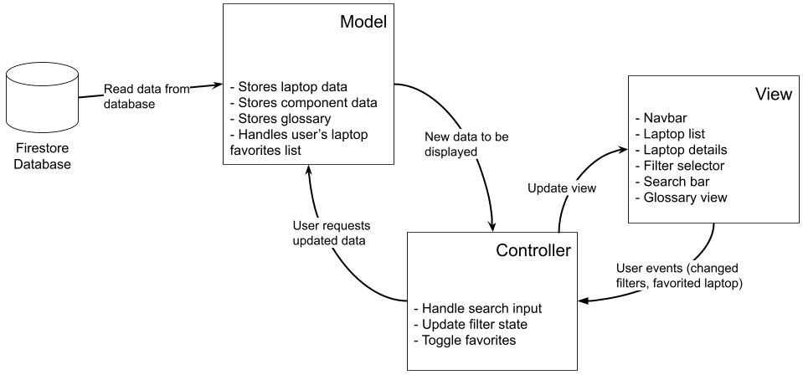
Design Description:

The architectural pattern consists of three components, the view, the controller and the model.

The view for SpecEffect handles the UI of the web application, using React. The application will have many views that can be displayed. The Search/Filter View is the view that will be displayed when a user first opens the application. Interaction with the UI will trigger user events, sending information to the controller to handle the inputs.

The controller handles the various events from the view. These events can be button presses, checkbox changes, text inputs, or number inputs. When an input is detected, the controller notifies the view of any changes, then notifies the model of any state changes.

The model for SpecEffect handles the laptop database, component database, glossary database, and the user data from the app. All laptop, component, and glossary information will be stored in a Firestore database, and the user’s laptop Favorites list will be stored in local browser storage. When the user first opens the application, the model loads all laptop and component data from Firestore. When the controller detects the user changing filters or updating the search field, the model will filter the list of laptops and return the filtered list to the controller to be displayed. The app will use React and Typescript, with the library react-router-dom for multiple pages.

