COS 420 - Team Effigy
Deliverable 3
Domain Model Document

The GlossaryEntry & Laptop classes store data about specific glossary entries and laptops respectively, and are for storing data received from the database. FavoritesManager is a singleton class that keeps track of the IDs of the user’s favorite laptops, which are stored in local browser storage. The DatabaseManager is for querying data from Firestore, with or without filters. The LaptopFilter class represents a single filter selection on the search page. It stores a function that modifies an existing Firestore Query object. A list of these LaptopFilter objects can be passed into the searchWithFilters() in DatabaseManager to additively build a database query.

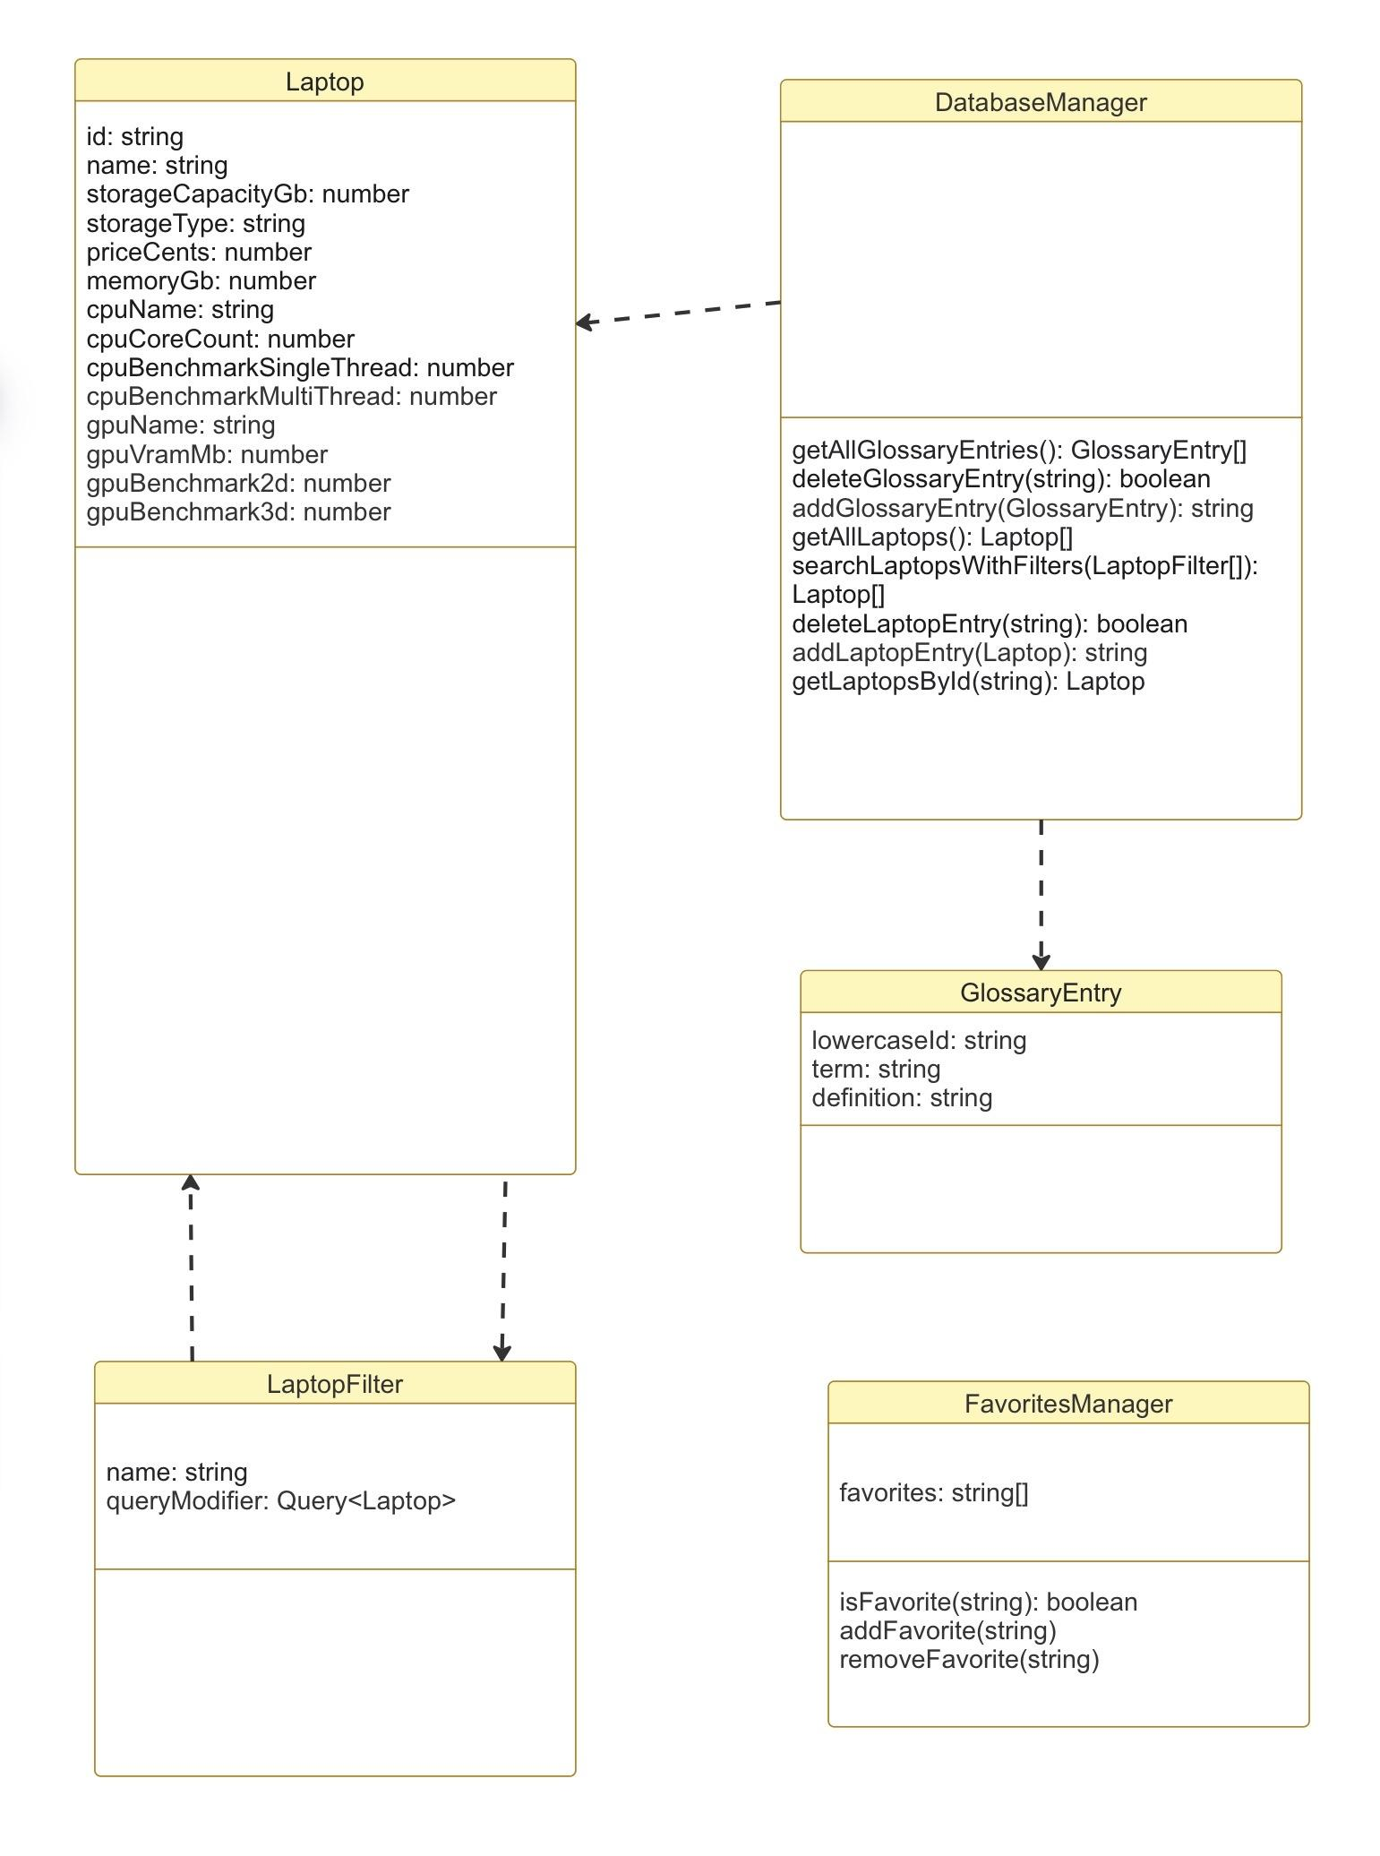
Domain Model

- Laptop
  - id: string
  - name: string
  - storageCapacityGb: number
  - storageType: string
  - priceCents: number
  - memoryGb: number
  - cpuName: string
  - cpuCoreCount: number
  - cpuBenchmarkSingleThread: number
  - cpuBenchmarkMultiThread: number
  - gpuName: string
  - gpuVramMb: number
  - gpuBenchmark2d: number
  - gpuBenchmark3d: number
- LaptopFilter
  - name: string
  - queryModifier: Query<Laptop>
- GlossaryEntry
  - lowercaseId: string
  - term: string
  - definition: string
- DatabaseManager
  - getAllGlossaryEntries(): GlossaryEntry[]
  - deleteGlossaryEntry(string): boolean
  - addGlossaryEntry(GlossaryEntry): string
  - getAllLaptops(): Laptop[]
  - searchLaptopsWithFilters(LaptopFilter[]): Laptop[]
  - deleteLaptopEntry(string): boolean
  - addLaptopEntry(Laptop): string
  - getLaptopsById(string): Laptop
- FavoritesManager
  - favorites: string[]
  - isFavorite(string): boolean
  - addFavorite(string)
  - removeFavorite(string)

