COS 420 - Team Effigy
Design Class Diagram / Detailed Technical Design Document
Link to Our Design Class Diagram:

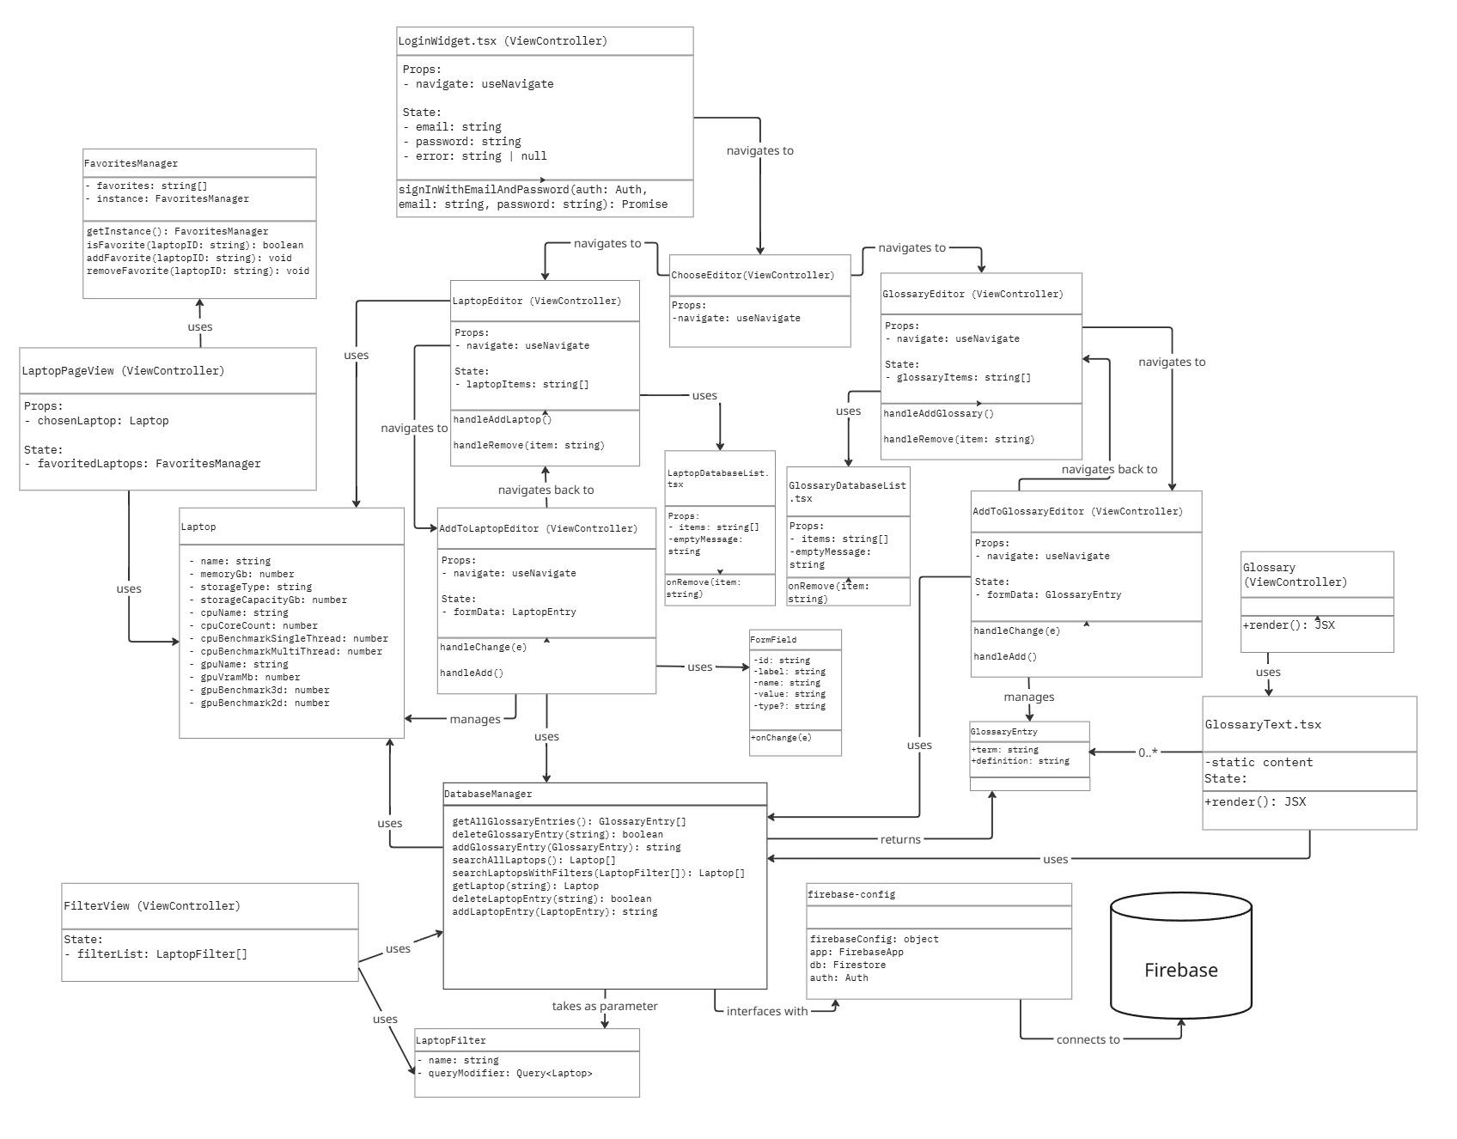

Section 1: Admin Editing

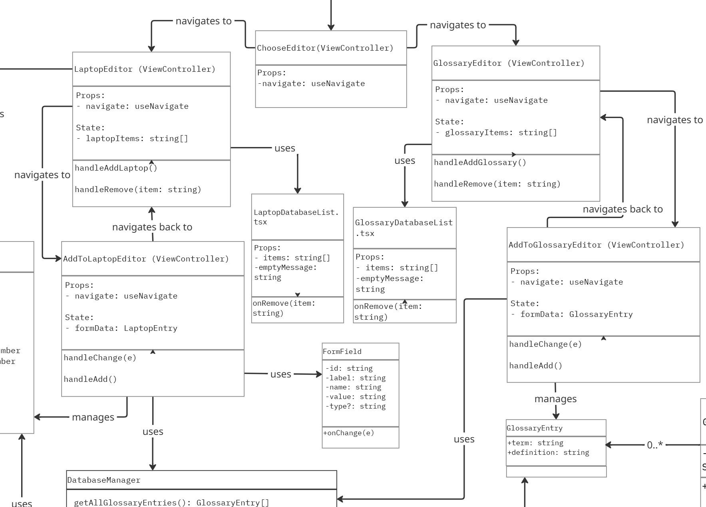

The diagram above demonstrates what the Admin editing system looks like. We have 3 different types of lines. We have a line that says navigate to, which means there is some type of button that switches pages. Then we have a uses line, which says that the thing it points at is used at some point throughout its runthrough. Finally the managed line means that we have a reference to the object, but don’t directly use it. The diagram starts with the ChooseEditor viewcontroller, from here you choose between two buttons to navigate to a separate page.
Say we choose LaptopEditor, our page changes to the LaptopEditor viewcontroller. Then it uses the useState laptopItems and attempts to pull the firebase collection, laptops. From here it makes a list of the name and a remove button using the LaptopDatabaseList component. If you choose to click the remove button, it references the deleteLaptopEntry() function from DatabaseManager, which sends a signal to firebase to remove the laptop. On the other hand, you can choose to add a laptop, this changes pages to the AddToLaptopEditor viewcontroller. From here you type into input fields, which have been created through the FormField class. Once you are finished, you can click the add button. This fills the Laptop class with the inputs temporarily until the process is finished. It then references the addLaptopEntry() function from DatabaseManager, which sends a signal to firebase to add the laptop. It then changes pages back to LaptopEditor and updates the list.
On the other hand we can choose GlossaryEditor, our page changes to the GlossaryEditor viewcontroller. Then it uses the useState glossaryItems and attempts to pull the firebase collection, glossary. From here it makes a list of the terms and a remove button using the GlossaryDatabaseList component. If you choose to click the remove button, it references the deleteGlossaryEntry() function from DatabaseManager, which sends a signal to firebase to remove the term. On the other hand, you can choose to add a term, this changes pages to the AddToGlossaryeditor viewcontroller. From here you type into two input fields, one for the term and the other for the definition. Once you are finished, you can click the add button. This fills the GlossaryEntry class with the inputs temporarily until the process is finished. It then references the addGlossaryEntry() function from DatabaseManager, which sends a signal to firebase to add the term. It then changes pages back to GlossaryEditor and updates the list.

Section 2: Laptop Pages & Filtering

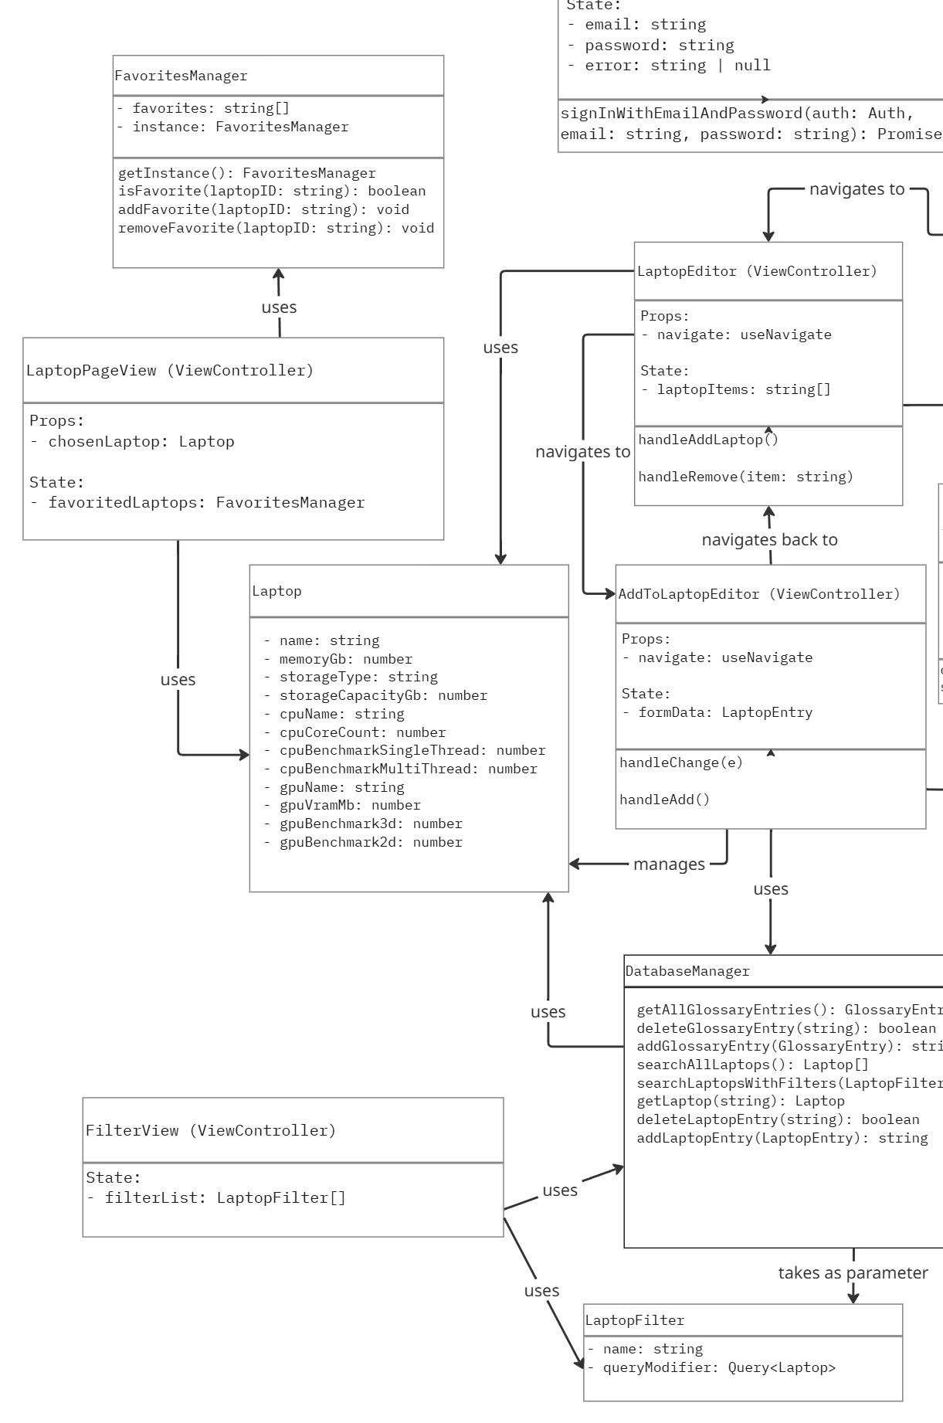
The diagram above depicts using the Laptop pages and filters. Both of these are only accessible through the catalog page. This snapshot utilizes various different associations between classes and components. The filters, shown as a ViewController in FilterView, provides the visual representation of interacting with the backend database. This uses both a LaptopFilter class, stored as a LaptopFilter array in a state, that passes chosen filters to the DatabaseManager, which communicates with the Firebase Database. This allows the DatabaseManager to update the catalog view with the narrowed selection of Laptops, hence the “uses” line connecting to the Laptop Class.
Once the user selects a laptop, they are given the visual provided by the LaptopPageView which gives additional information about a given laptop. This pulls on the Laptop Class, holding the data the LaptopPageView displays. Additionally, users can favorite laptops to a saved list, allowing them to return to them at a later time. This is enabled by the FavoritesManager, which stores the selected laptops for later use, and provides the methods for adding and removing favorite laptops.
Section 3: Glossary Page & Firebase
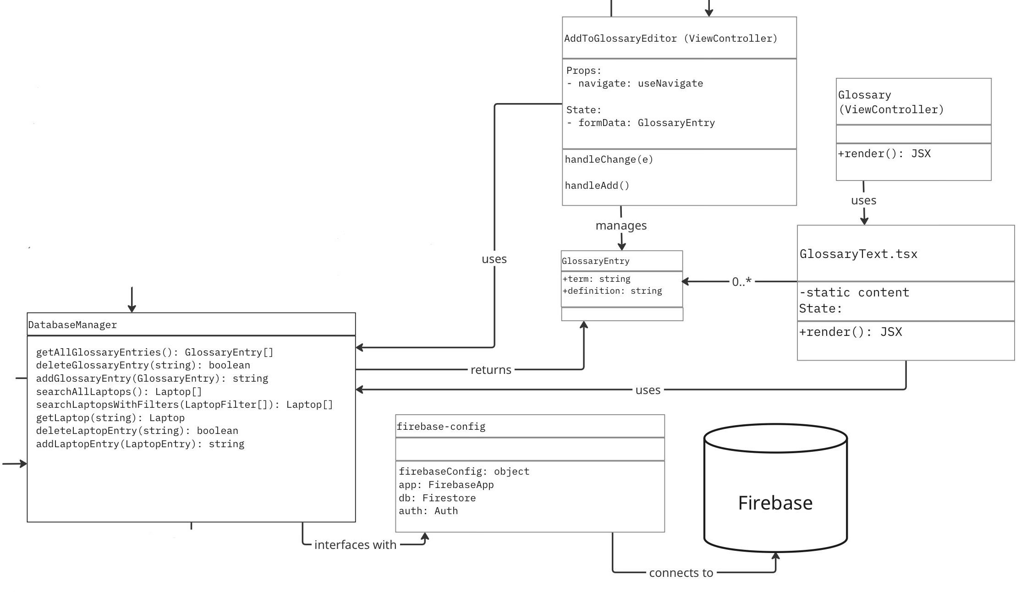
This diagram shows the relationships between the DatabaseManager and Firebase itself, as well as the DatabaseManager and the components of the Glossary page. Starting from the Glossary ViewController, this page uses the formatting of the GlossaryText.tsx file to show its table of contents list and definitions. These terms and definitions are then taken from the DatabaseManager as a list of GlossaryEntries. It’s also important to note that AddToGlossaryEditor also uses the DatabaseManager to manage the GlossaryEntries. The AddToGlossaryEditor’s relationships are further discussed in Section 1. The DatabaseManager gets all of its information from our Firebase database, interfacing and connecting to it through firebase-config. Firebase and its Firestore database tables are also further discussed in section 5.

Section 4: About Page Isolates
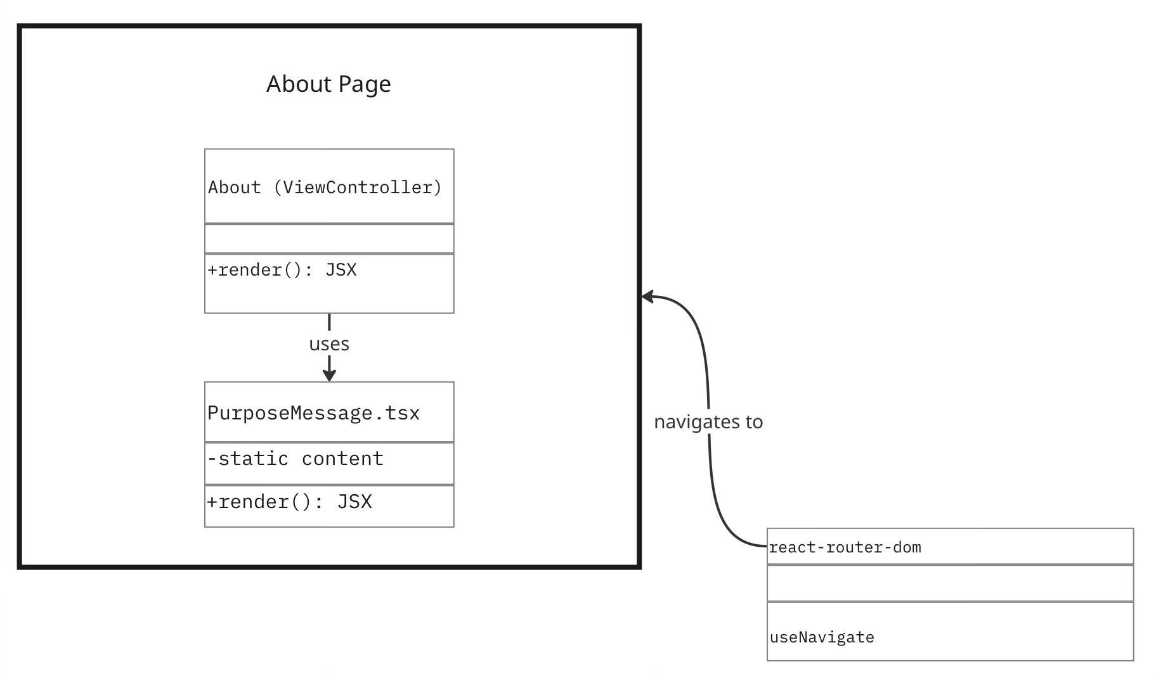
This diagram is a very simple one as it only involves 2 parts. By default, App.tsx starts on the home or catalog page. To get to the about view controller, we have to click the about button. Which uses the useNavigate function from react-router-dom to change pages. On this page the view controller calls on the PurposeMessage component. This component is basic text that has been formatted in sections. It says basic things like what is the purpose of the app and who made it.

Section 5: Firestore Database Tables
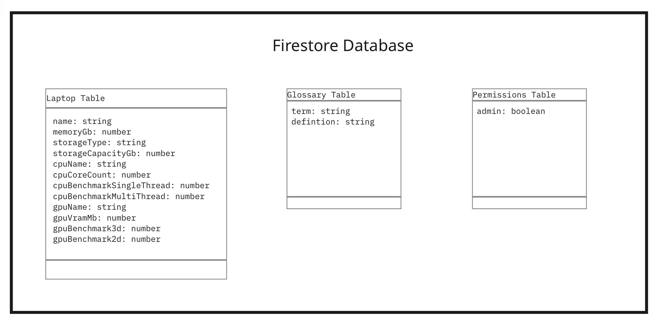 The Firestore database holds three collection tables of data, covering Laptops, the Glossary, and admin Permissions. The Laptop table contains all of the information on a given laptop, including its name, memory, storage, cpu, gpu, and its benchmarks. The Glossary table only contains a term and a definition for each item. Lastly, the Permissions table contains a single boolean to register if an admin is allowed access to the components within section 1.

Design Patterns:

Singleton Pattern

The FavoritesManager class uses the singleton pattern. The favorites are stored as a list of database IDs (strings), stored in local browser storage. To avoid frequent reads of local storage, which can be slow, the FavoritesManager class reads all favorited laptops into a list when the page is loaded. Because it’s a singleton class, it can be accessed by any other class and there can never be two FavoritesManager objects existing at once, making syncing changes with local storage much easier and less error prone.

Diagram from refactoring.guru:
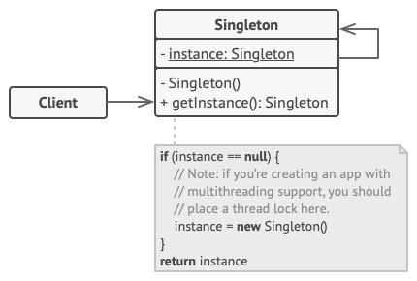

Diagram of the FavoritesManager class:
