COS 420 - Team Effigy
Deliverable 3
Domain Model Document

The GlossaryEntry, Laptop, GPU, and CPU classes store data about a specific glossary entry, laptop, CPU or GPU, and are for storing data received from the database. FavoritesManager is a singleton class that keeps track of the IDs of the user’s favorite laptops, which are stored in local browser storage. DatabaseLaptopReader and DatabaseGlossaryReader are for querying data from Firestore, with or without filters. The LaptopFilter class represents a single filter selection on the search page. It stores a function that modifies an existing Firestore Query object. A list of these LaptopFilter objects can be passed into the searchWithFilters() in DatabaseLaptopReader to additively build a database query. The separation of DatabaseLaptopReader and DatabaseGlossaryReader is because these two parts of the database are completely disconnected and never need to interact.

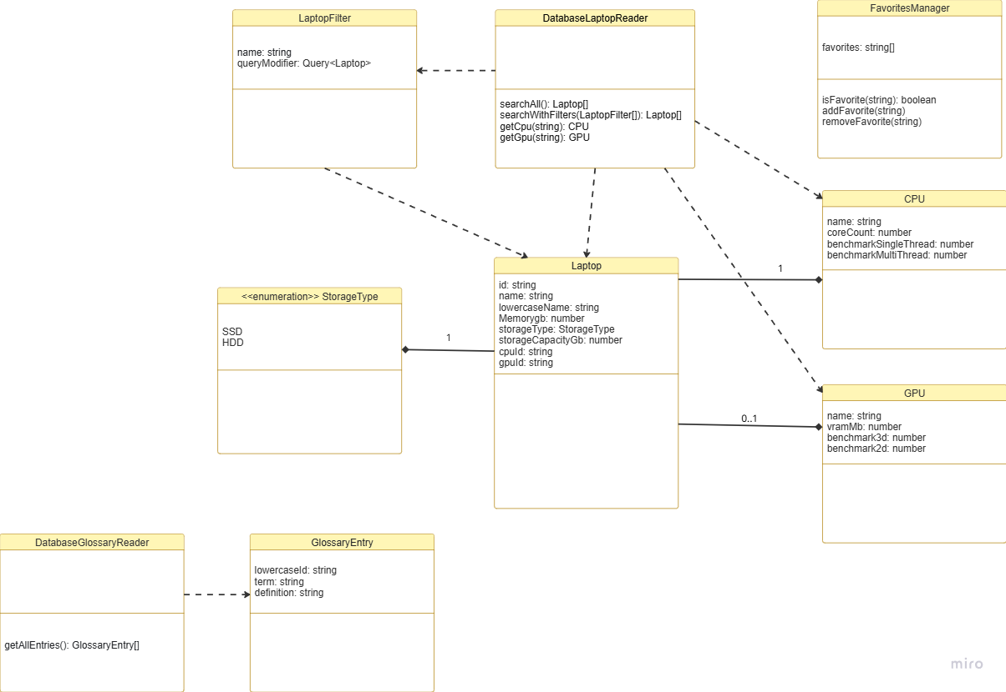
Domain Model

- CPU
  - name: string
  - coreCount: number
  - benchmarkSingleThread: number
  - benchmarkMultiThread: number
- GPU
  - name: string
  - vramMb: number
  - benchmark3d: number
  - benchmark2d: number
- StorageType (enum)
  - SSD
  - HDD
- Laptop
  - id: string
  - name: string
  - lowercaseName: string
  - memoryGb: number
  - storageType: StorageType
  - storageCapacityGb: number
  - cpuId: string
  - gpuId: string
- LaptopFilter
  - name: string
  - queryModifier: Query<Laptop>
- GlossaryEntry
  - lowercaseId: string
  - term: string
  - definition: string
- DatabaseGlossaryReader
  - getAllEntries(): GlossaryEntry[]
- DatabaseLaptopReader
  - searchAll(): Laptop[]
  - searchWithFilters(Filter[]): Laptop[]
  - getCpu(string): CPU
  - getGpu(string): GPU
- FavoritesManager
  - favorites: string[]
  - isFavorite(string): boolean
  - addFavorite(string)
  - removeFavorite(string)

