Software Requirements Specification

for

SpecEffect
Version 3.0 approved
Prepared by Caramon Cotroneo, Grace Cochran, Steven Harrington, & Eliot Cole
Team Effigy - COS 420
4-5-2026
Table of Contents
1. Introduction 1
1.1 Purpose 1
1.2 Document Conventions 1
1.3 Intended Audience and Reading Suggestions 1
1.4 Product Scope 1
1.5 References 1
2. Overall Description 2
2.1 Product Perspective 2
2.2 Product Functions 2
2.3 User Classes and Characteristics 2
2.4 Operating Environment 3
2.5 Design and Implementation Constraints 3
2.6 User Documentation 3
2.7 Assumptions and Dependencies 3
3. External Interface Requirements 3
3.1 User Interfaces 3
3.2 Hardware Interfaces 9
3.3 Software Interfaces 9
3.4 Communications Interfaces 9
4. System Features 9
4.1 Laptop Search 9
4.2 Laptop Filter 10
4.3 Selected Laptop Info 10
4.4 Tech-Vocabulary 11
4.5 Info, when Hovering 11
4.6 Admin Panel 12
5. Other Nonfunctional Requirements 12
5.1 Performance Requirements 13
5.2 Safety Requirements 13
5.3 Security Requirements 13
5.4 Software Quality Attributes 13
5.5 Business Rules 13
6. Other Requirements 14

Revision History
Name | Date | Reason For Changes | Version
 | 2/19/2026 | Initial setup | 1.0
 | 2/26/2026 | Added requirements and UI | 1.1
Deliverable 2 Submit | 3/13/2026 | Version of document prepared for deliverable 2 | 2.0
Deliverable 3 Submit | 4/5/2026 | Version of document prepared for deliverable 3 | 3.0

Introduction

Purpose
SpecEffect is a searchable laptop database that you can filter based on your needs. The main objective of this application is to help people that are less familiar with technical concepts find a laptop that will be useful for them. This document describes the complete working process of the application.

Document Conventions
This document was created based on the IEEE template for System Requirements Specification Documents.

The following conventions were used in the document and they are outlined as followed:

Convention | Description of what it is
Firebase | Backend database provider
SpecEffect | The App Name

Intended Audience and Reading Suggestions
This document is made for developers, project managers, marketing staff, users and testers. The SRS document goes over the product’s scope, an overall description of the application, external interface requirements, system features, non-functional requirements, glossary of terms and any models that are used in the application.

Product Scope
The Software will be an organized catalog that utilizes Firebase to help create its database of laptops and their uses.. Its purpose is to act as a catalog of different laptops to help people find ones for their needs. Its secondary objective is to help explain to users what computer terms such as cpu or ram are in a glossary format.

From a business perspective, this gives the potential for higher purchases of laptops. The reason being because some might have been avoiding it because they were unaware of some terms. As well as getting annoyed by the need to return unsatisfactory laptops constantly.

References
SpecEffect Github Link: COS420-S2025/Team-E: The homebase for Team Effigy's project, code, plans, and files.

Overall Description

Product Perspective
SpecEffect’s main mission is to provide an accessible interface for individuals who are not as confident in their technical skills or technical knowledge as others who’ve been involved in the industry for years. Computers and computer technology have become central to the rapidly developing modern world, especially in the rise of generative AI and the video game industry. This has led to a large number of new consumers entering the computing market who may not have the necessary background knowledge of what the components do or which ones are of good quality.

Some applications, such as Noteb and PCPartPicker, provide tools for consumers to get involved in the technology industry; however, they fail to be accessible to novices or beginners. They use professional jargon and terminology that can be hard to understand, and they do not explore the full background of components or devices, so only partial information is provided, with the rest assumed the consumer already knows.

This can be problematic for several reasons. First, consumers who are not well-versed are essentially choosing items to purchase near blind, as the technical terminology acts as an endless maze of research to be done. Secondly, there is significant potential for misinformation to spread online, leading consumers to mistakenly purchase products that are either counterfeit or not suited to their needs. This constitutes a significant financial loss as these components are almost always expensive.

For such consumers to be able to make smart purchasing decisions, they would need to perform extensive research on individual terms, industry standards, and learn how to properly compare devices and components with one another, and not fall victim to misinformation. How can we make the computer device market accessible and easy to understand for all users of varying experience levels with computer specifications?

Product Functions
- Laptop Catalog: The system allows users to view a full list of laptops
- Laptop Filter: The system allows users to narrow down the list of laptops according to chosen filters.
- Laptop Search: The system allows users to search for a specific laptop by model number.
- Tech. Dictionary: The system allows users to view a dictionary explaining technical terms and standards.

User Classes and Characteristics
The largest class of users anticipated for this product is anyone who is looking to purchase a laptop and is performing research for options. This is a general class, including those who are knowledgeable about computers and not, as this product is not exclusively for beginners to the technology industry. Within this class are two subclasses previously mentioned, with the primary target audience being beginners. Since these users have a greater need, they will be the priority. These could be young adults looking to enter the gaming sphere, older or senior citizens with little experience with technology, or anyone who hasn’t been previously exposed to the computing industry.

Operating Environment
SpecEffect will be made to be functional on web browsers, with a priority for desktop users. It will be functional on Windows and MacOS at a minimum for operating systems. Furthermore, it will be functional on Firefox, Chrome, and Edge at a minimum.

Design and Implementation Constraints
Given the overall description of the product including a catalog list of laptop records, the main concern surrounding the application is the database, which will be served using Firebase for scalability. Additionally, the application will utilize HTTPS for file transfers. Furthermore, all interactions that the user can make with the application must be met with a reaction from the system within 3 seconds at the longest.

User Documentation
The product will be designed in a way to be self-documenting and intuitive, allowing users to understand the tool simply by its design. In addition, pop-up menus with additional information will assist when the user hovers over them with the cursor.

Assumptions and Dependencies
The user must be able to maintain a constant connection to the internet. A server hosting the application must be available to provide service to the user upon connection through IP or domain. Furthermore, continued access to the Firebase database will be necessary for the application to function properly, as without it, the catalog will fail to load.

External Interface Requirements

User Interfaces
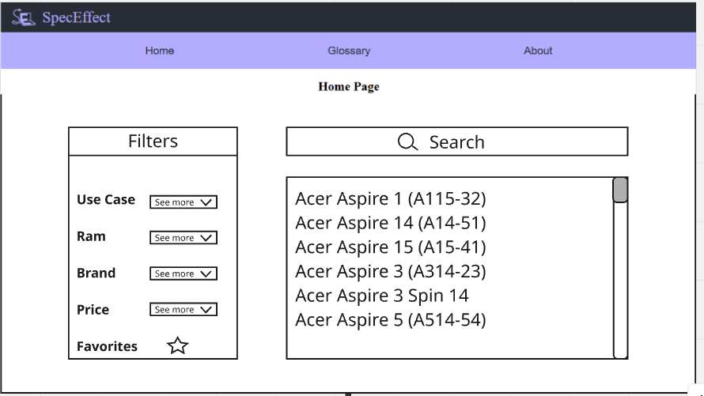
This is the home page, from here you can click the buttons to go to the glossary or about pages. As well as using the search bar to look for a laptop accompanied by a filter of your choice.
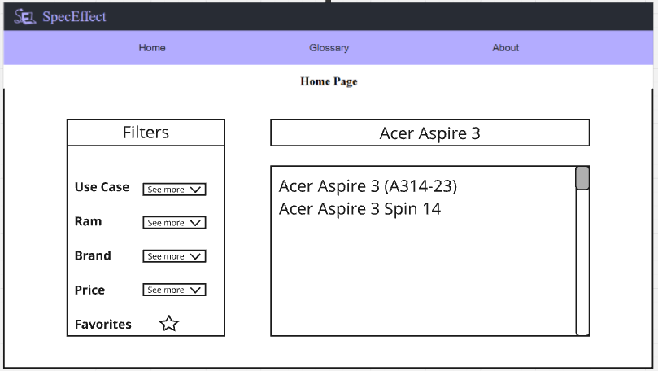
This is an example of what the search function does.
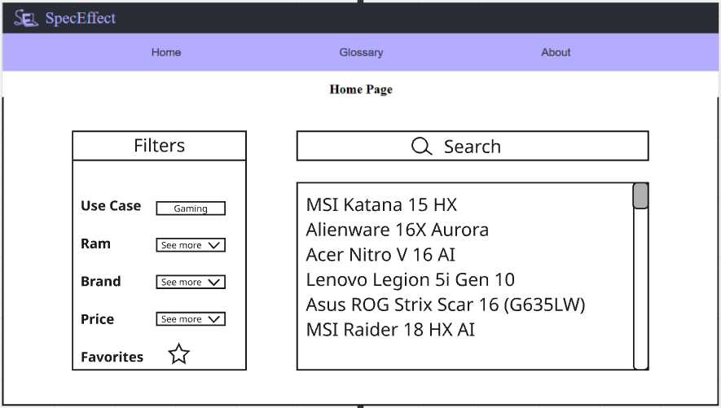
This is an example of choosing a use case, in this situation we chose gaming.
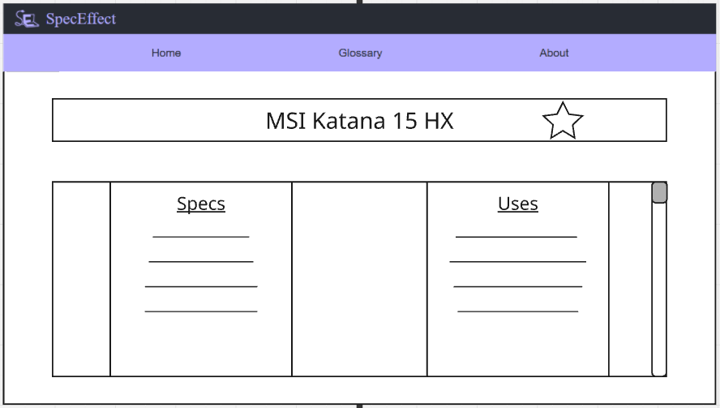
You reach this page by choosing a laptop, here it will give you information about your chosen laptop.
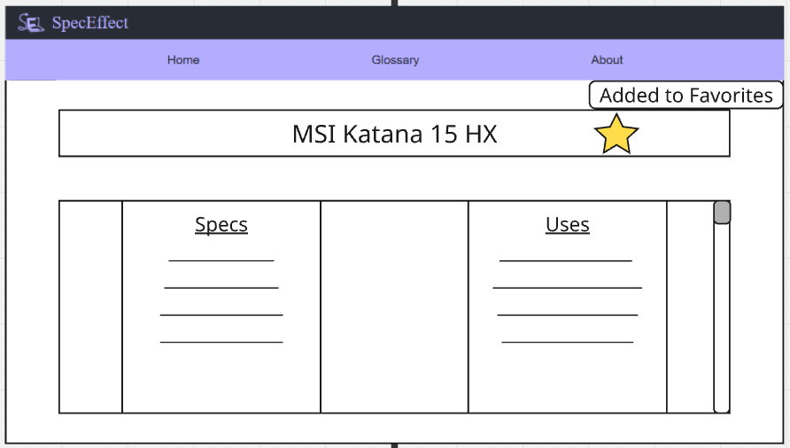
This is what happens if you click on the star on the laptop info page. It compiles a list of your favorite laptops, which can be accessed by filtering.
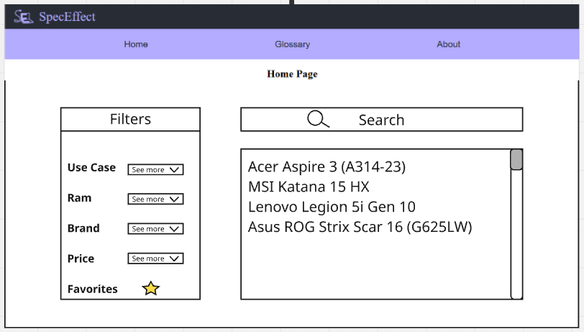
If you click on the favorites filter, it shows what laptops you have previously favorited.
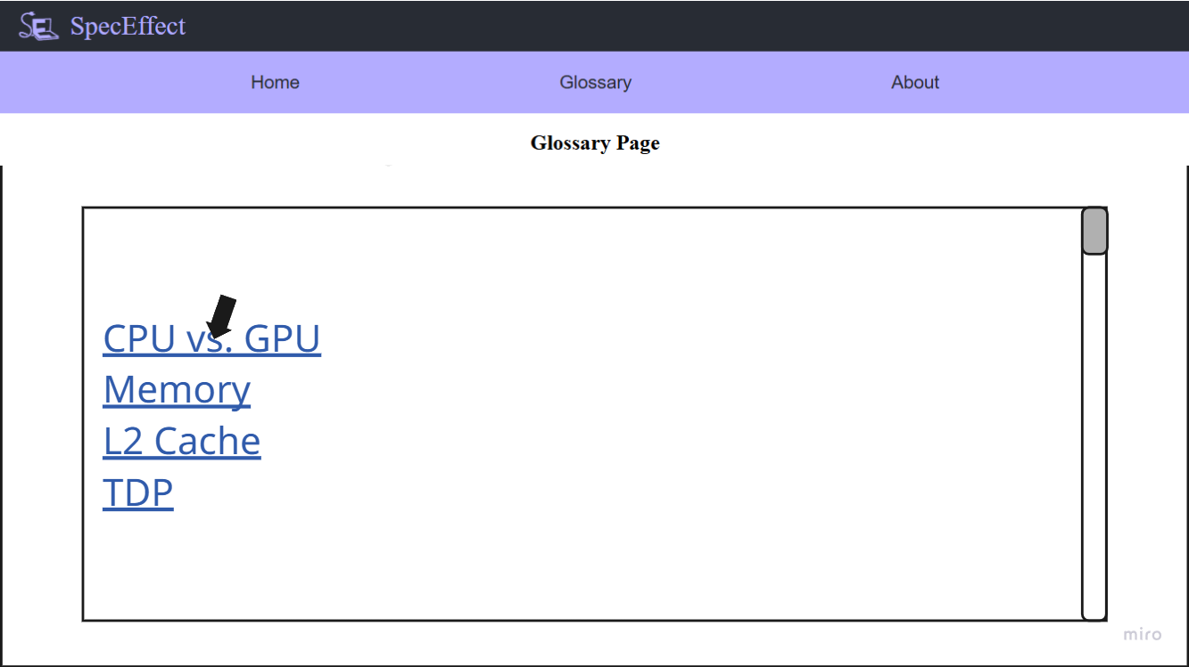
This is what appears if you click the glossary button near the top. This will tell you terms that are used throughout the website and their definitions.
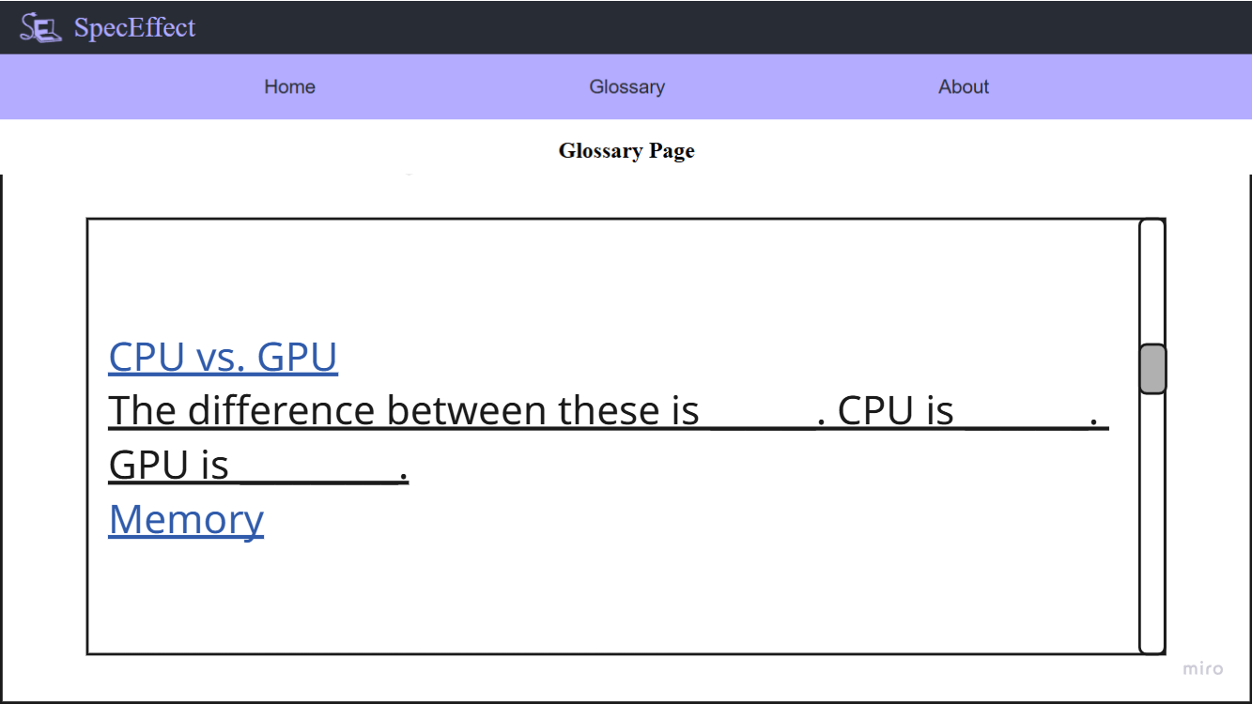
If you click on one of the categories at the top of the glossary page, it scrolls down to this screen.
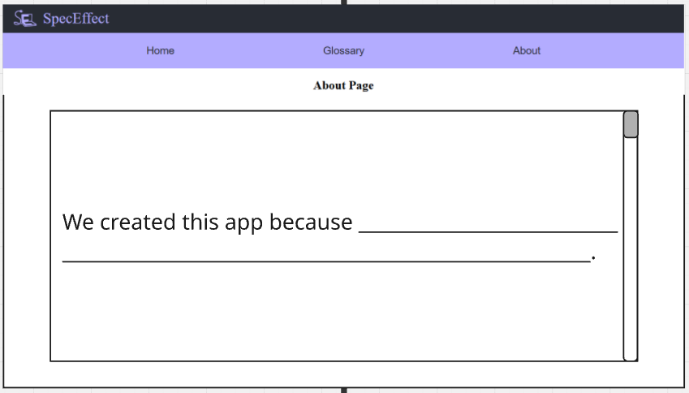
This appears if you click the About button near the top. This page is here to tell you who made it and the reason it was made.

ADMIN PANEL
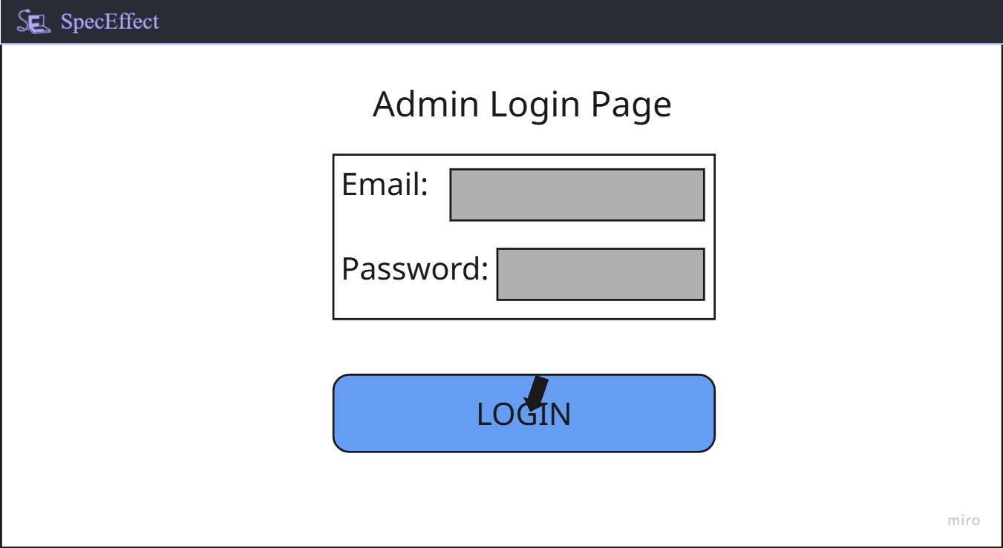
This is the starting screen, as an admin you would enter your email and password. Then you would click the login button and if everything checks out it will proceed.
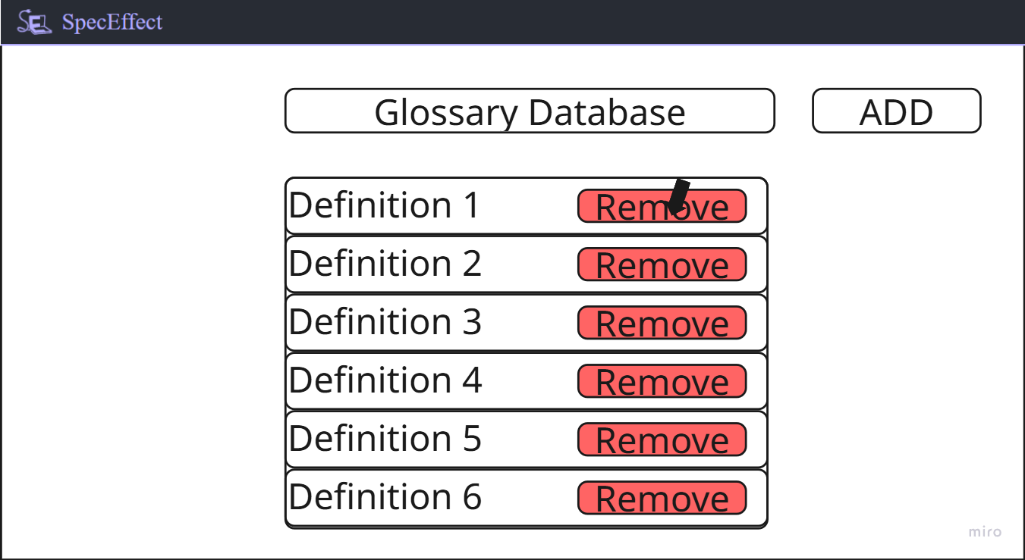
This is the glossary database screen from here you can choose to add or remove a definition. This image shows the removal.
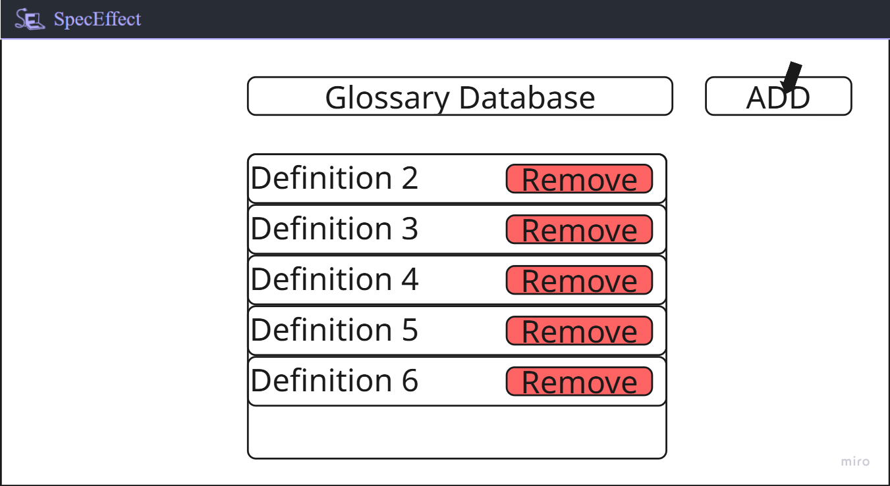
This is what happens after you remove a definition.
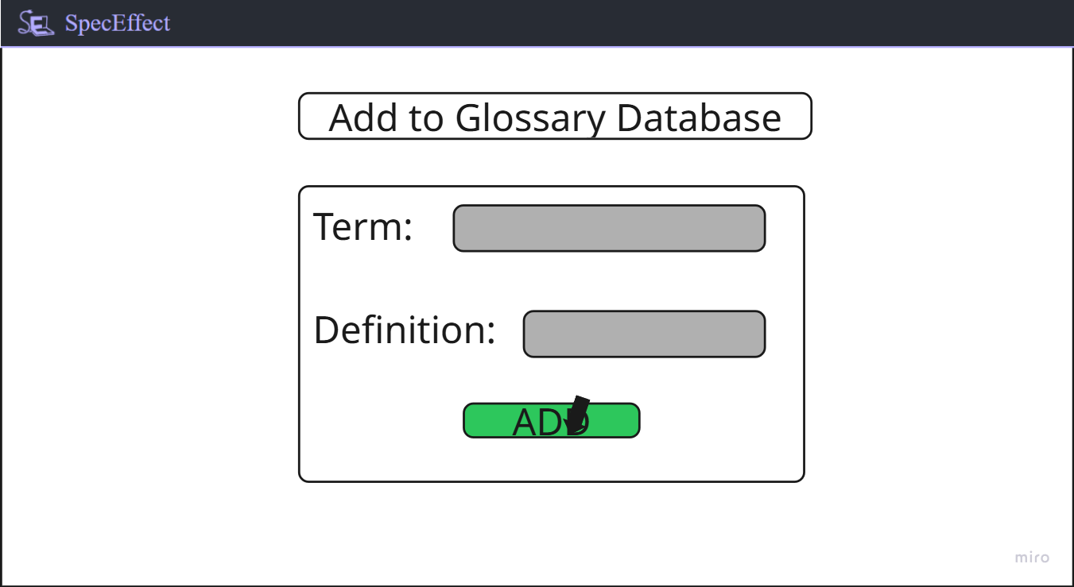
If you clicked add on the previous screen it brings you here. You type in the term you want to add, with its definition. Once you are happy with it, you click the add button.
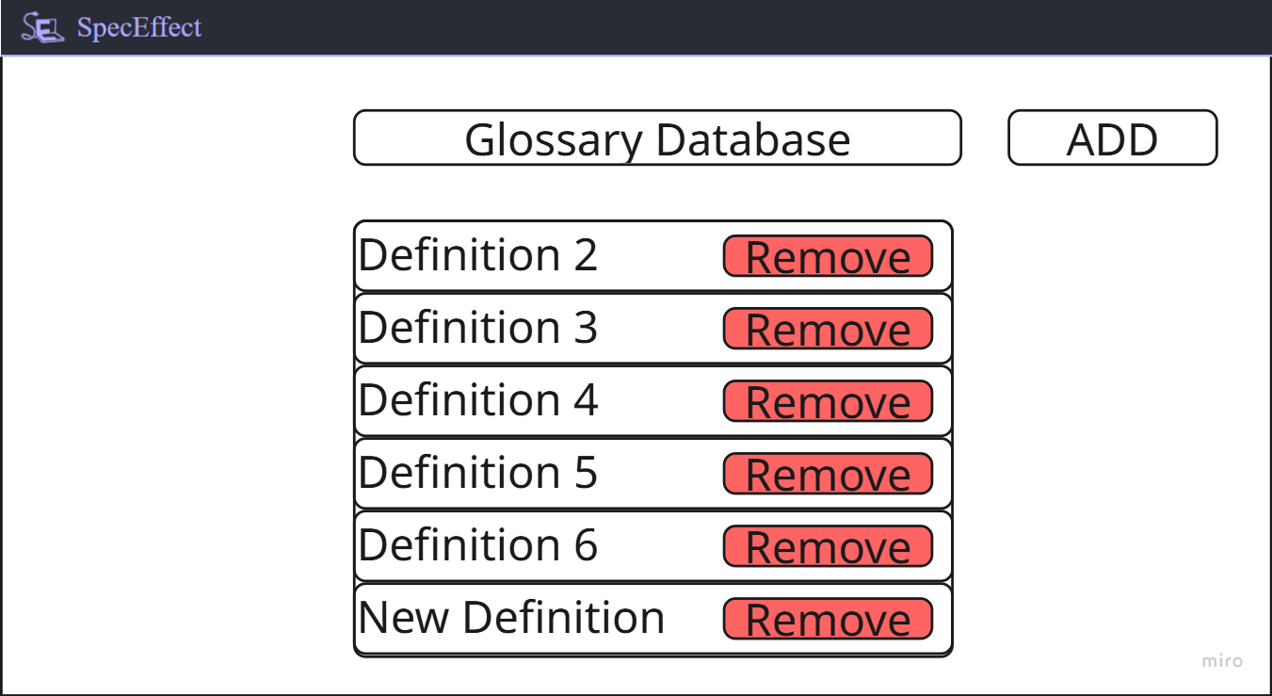
You are returned to this screen where you can add and remove a definition.
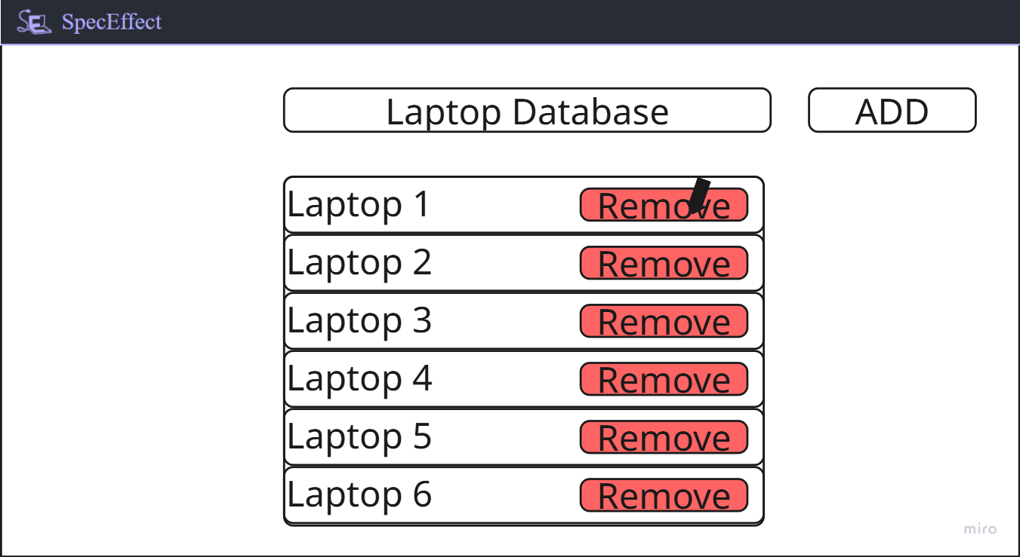
This is the laptop database screen from here you can choose to add or remove a laptop. This image shows the removal.
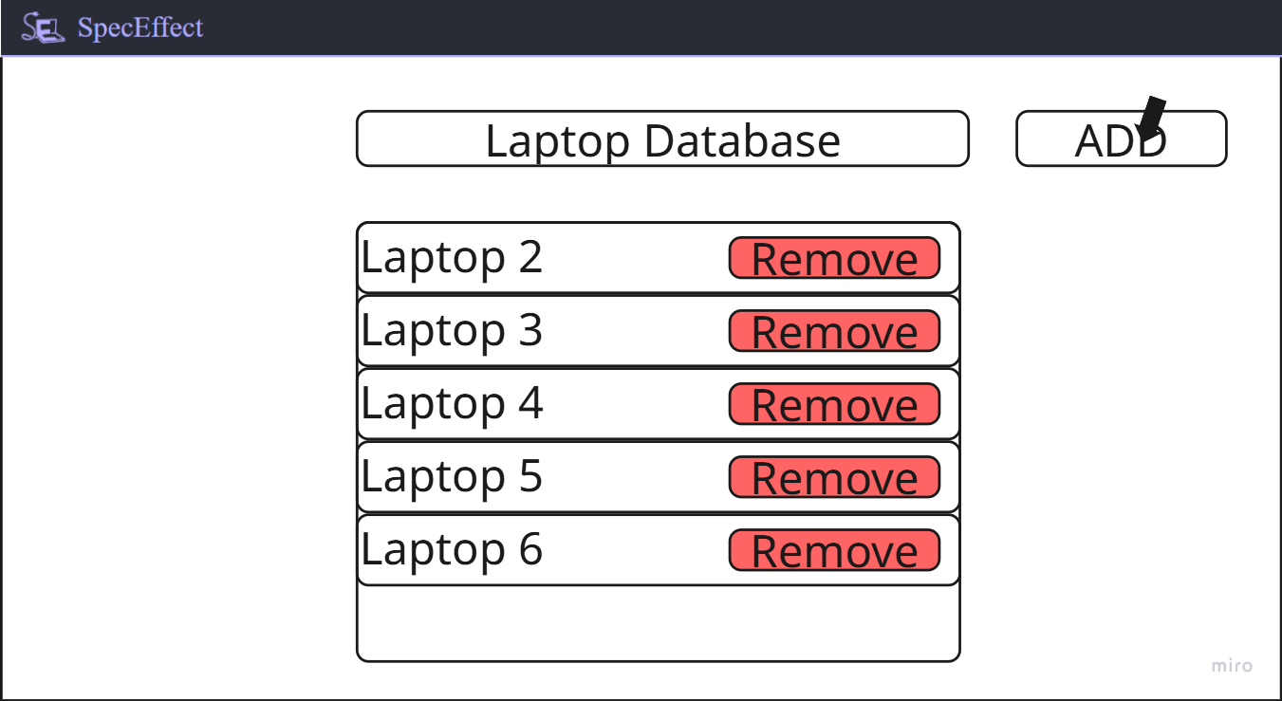
This is what happens after you remove a laptop.
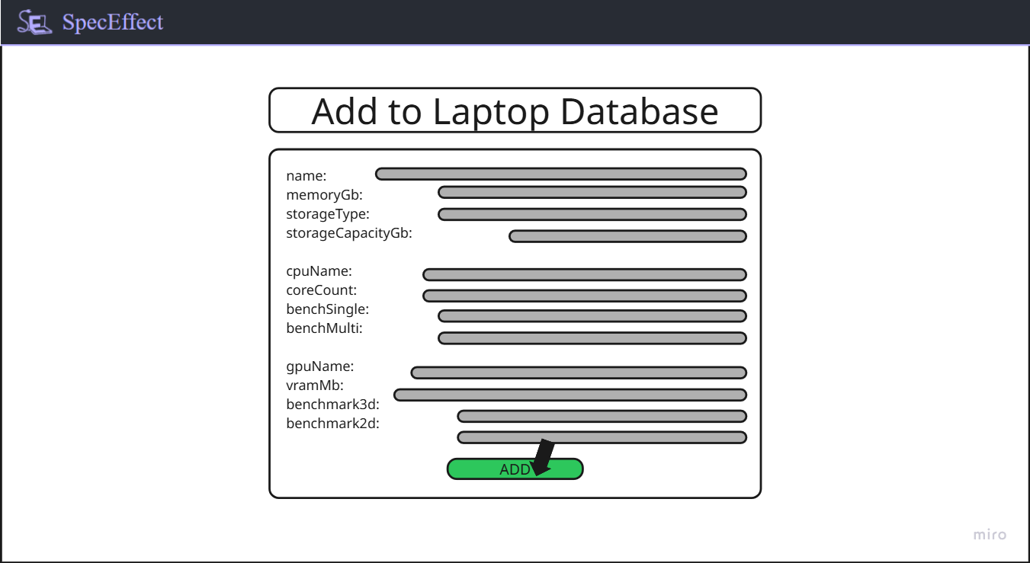
If you clicked add on the previous screen it brings you here. You type in the associated information for the laptop you want to add. Once you are happy with it, you click the add button.
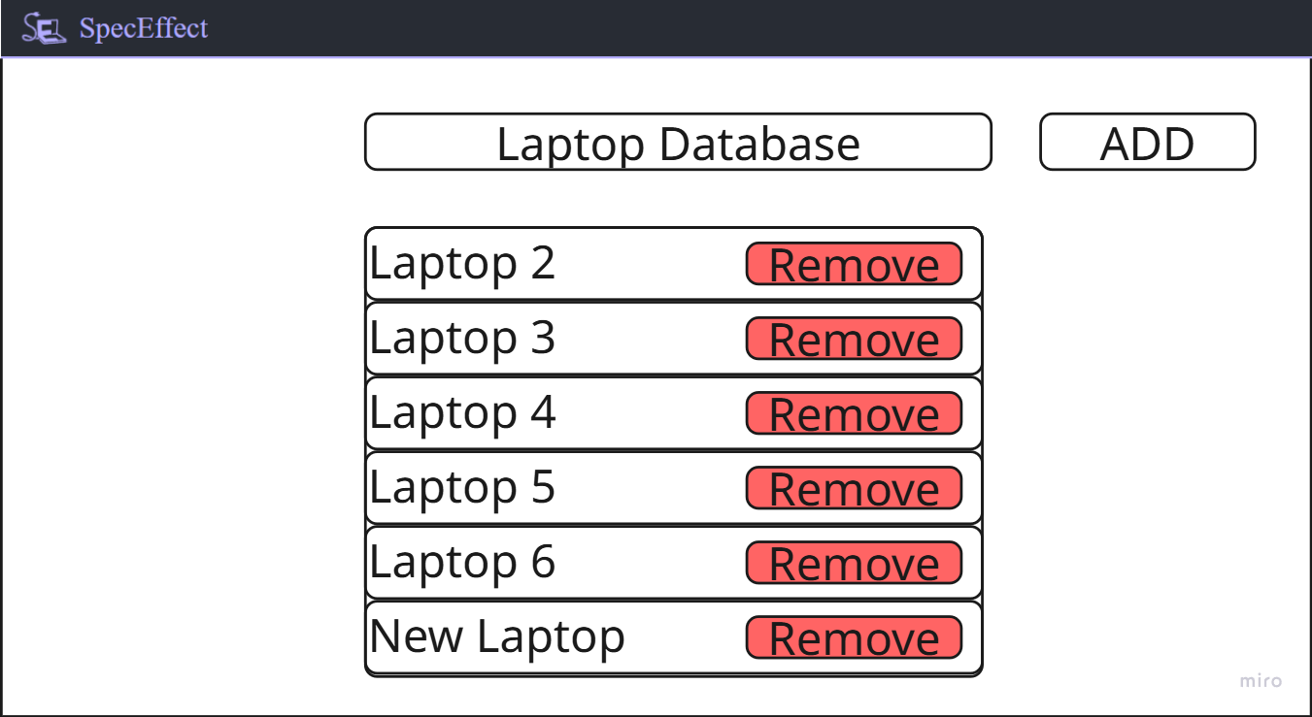
You are returned to this screen where you can add and remove a laptop.

Hardware Interfaces
The application will run on desktop and laptop computers with at least a mouse, keyboard, and display. The device must maintain a connection to the internet while using the web application. This is to request data from the backend when changing filters or the search field.

Software Interfaces
The server will need to run:
- node 24.13.0 (to run the server)
- react 19.2.4
- react-router-dom 7.13.1 (for having multiple pages in the web application)
- typescript 4.9.5
The server can run on any operating system that supports these packages.
The server will intermittently connect to and request data from a Firestore database.

Communications Interfaces
The server will serve the website over HTTPS. It will request data from the Firestore database over HTTPS as well, and the data will be requested in small chunks (paginated) to reduce the amount of data being transferred. There are no security issues, as the database will have rules preventing requesting too much data, and no personal or sensitive information will ever be sent from the client.

System Features

Laptop Search
4.1.1 Description and Priority

This feature allows you to use the search bar to input either the model name or id to look for the laptop you want. This will include a scrolling catalog in case there are multiple search results. This is of high priority to the application.
4.1.2 Stimulus/Response Sequences
User clicks the search bar -> System flashes the search bar, telling you it is selected

User types in the model name or id -> System changes the screen to show laptops that have matching model names

User uses mouse to scroll down screen -> System checks to see if it can scroll
-> System moves the screen downward
-> System changes screen to show new models
4.1.3 Functional Requirements
F-REQ-1.1: The system shall allow the user to type the name of a laptop model into the search bar.
F-REQ-1.2: The system shall display to the screen a list of laptops matching the name entered in the search box.
F-REQ-1.3: The system shall allow the user to click on any of the displayed results of a search.

Laptop Filter
4.2.1 Description and Priority

The feature allows you to limit what laptops you see by selecting different criteria. This criteria includes things like use case, RAM size, price and brand. This is of medium priority to the application.
4.2.2 Stimulus/Response Sequences
System shows a list of different categories of filters on the left side of the screen

User clicks on a category -> System shows a dropdown that shows a list of options to choose from

User clicks on an option -> System updates screen to show laptops with the criteria

4.2.3 Functional Requirements

F-REQ-2.1: The system shall allow filtering by various properties.
F-REQ-2.2: The system shall allow the user to select any number of filters and see a list of all laptops matching those filters displayed on the screen.

Selected Laptop Info
4.3.1 Description and Priority

This feature allows you to click on a laptop and view a page that outlines what the laptop is capable of. This includes things like the name of the laptop, how much RAM it has, what CPU and/or GPU it has. These are accompanied with text explaining what advantage or disadvantage it has for the laptop. This is of high priority to the application.
4.3.2 Stimulus/Response Sequences
User clicks on a model -> System changes to model information screen
-> System fetches information about laptop from the database
-> System updates screen with fetched information
4.3.3 Functional Requirements

F-REQ-3.1: The system shall display on the screen a list of metrics for the selected laptop.
F-REQ-3.2: The system shall allow the user to save the selected laptop to their favorites list.
F-REQ-3.3: The system shall display on the screen a computed “performance score” that combines multiple metrics for the selected laptop.

Tech-Vocabulary
4.4.1 Description and Priority

This feature is a screen with a dictionary of terms that is utilized throughout the website's many pages. It is here to help explain keywords to less knowledgeable users. This is of high priority to the application.
4.4.2 Stimulus/Response Sequences

User clicks the glossary button at the header -> System changes to glossary screen
-> System shows term categories

User clicks on a category the want -> System scrolls through the page to relevant, selected category

4.4.3 Functional Requirements

F-REQ-4.1: The system shall allow the user to click on the dictionary button to change screens.
F-REQ-4.2: The system, SpecEffect, shall change to the respective screen when the navigation buttons are clicked.
F-REQ-4.3: The system shall allow the user to select a tech-vocabulary category to scroll to on the dictionary page.
F-REQ-4.4: SpecEffect shall be able to scroll to the selected section automatically.

Info, when Hovering
4.5.1 Description and Priority

The feature displays a textbox with information about a keyword you are hovering over. This is of lower priority to the application.
4.5.2 Stimulus/Response Sequences
User searches for confusing information
User moves cursor over the keyword -> System displays an empty textbox
-> System fetches the definition from glossary
-> System updates empty textbox with fetched info
4.5.3 Functional Requirements

F-REQ-5.1: The system shall allow the user to move their cursor over information to show a pop-up.
F-REQ-5.2: SpecEffect shall access the definition of the keyword from its dictionary.
F-REQ-5.3: SpecEffect shall pop up a text box with the definition of the hovered keyword.
F-REQ-5.4: SpecEffect shall remove the pop-up when it no longer detects the cursor hovering.

Admin Panel
4.5.1 Description and Priority

This feature allows an administrator to log in to a page of the app that allows manipulation of the laptop, component, and glossary database. This is of medium priority to the application.
4.5.2 Stimulus/Response Sequences
From the homepage, the user clicks the admin login button -> System switches pages to the
login page.
User enters username in the username field
User enters password in the password field
User clicks the submit button -> System evaluates credentials
-> if incorrect, the system denies login and shows an incorrect credentials popup.
-> if correct, the system approves the login and switches to the admin panel
page.
4.5.3 Functional Requirements
F-REQ-6.1: The system shall allow authorized users to log in to an administrator panel.
F-REQ-6.2: The system shall allow authorized users to edit the laptop, component, and glossary database from the admin panel.

Other Nonfunctional Requirements
Additionally, a full list of the non-functional requirements is provided below for the SpecEffect application.

Performance Requirements
NF-REQ-1.1: After clicking a category button from the Glossary page, the system shall scroll the application window to the selected section within 2.5 seconds.
NF-REQ-1.2: The system shall update which entries of the laptop catalog are shown within 3 seconds after a user applies or removes filters.
NF-REQ-1.3: The system shall load individual laptop pages to the screen within 2 seconds.
NF-REQ-1.4: The system shall display laptop catalog search results on the homepage screen within 3 seconds after entering.

Safety Requirements
NF-REQ-2.1: When an invalid search input is entered into the homepage’s search bar, the system shall display an error message below the bar.
NF-REQ-2.2: The system shall maintain at least one restorable backup of the catalogue database on one or more local machines.

Security Requirements
NF-REQ-3.1: The system shall provide an error response to any unauthorized attempts at logging into the admin panel within 1 second.
NF-REQ-3.2: The system shall enforce that all data sent between the client and the server is encrypted with HTTPS.

Software Quality Attributes
NF-REQ-4.1: The system shall function on Chrome version 144 or newer, Firefox 149 or newer, and Edge 146 or newer on at least 98% of machines.
NF-REQ-4.2: The system’s pages shall comply with at least 98% the Web Content Accessibility Guidelines 2 (WCAG 2) international standard.
NF-REQ-4.3: The system shall enable a new user to search for a laptop from the homepage’s search bar without instructions within 2 minutes 99% of the time.

Business Rules
NF-REQ-5.1: The system shall prevent unauthorized users from making changes to laptop entries at least 99.9% of the time.

Other Requirements
Appendix A: Glossary
SpecEffect - App name
Firestore - Firebase cloud database system
Team Effigy - Company name

Appendix B: Analysis Models
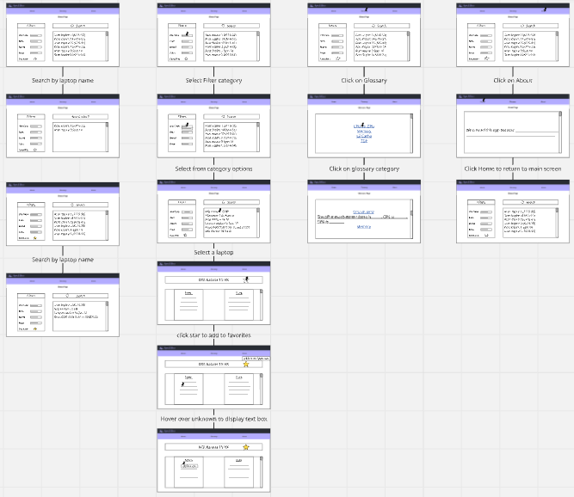
Appendix C: To Be Determined List

