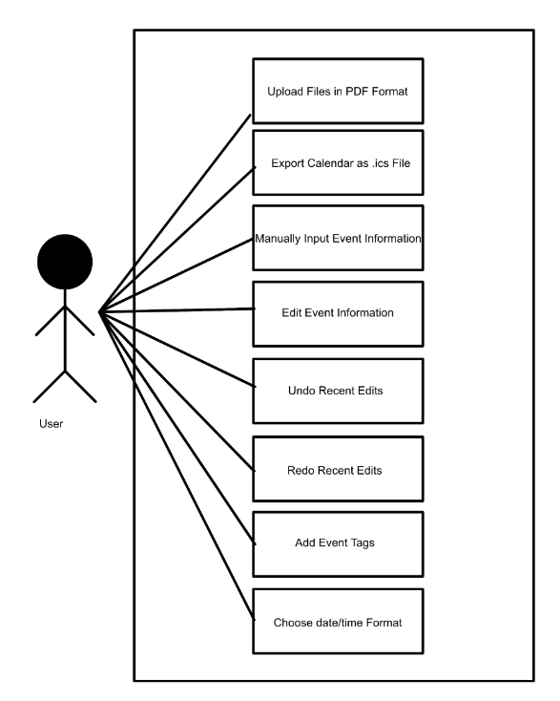

Upload Syllabus to App
Generate Dates from Syllabus PDF
Undo and Redo edits
Edit Descriptions of Dates
Add and Remove Tags from Dates
Download Dates in .ics format
Manually Add Dates
Change Light/Dark Mode

Student
Syllabus to Calendar Converter
<<includes>>
<<extends>>
<<extends>>
<<extends>>
<<extends>>

Name/Title: | Adding a pdf to the ics file and adding one manual addition to the ICS file without description.
ID: | 1
Description: | As a user I want to be able to add both assignments from my syllabus and add ones that are not on the syllabus in one go because that way I can use only one ICS file.
Precondition: | User has the app open
Success Postcondition: | The app provides an ICS file with the syllabus assignment information and the manually input information on it.

USER STEPS:  1. User Logins into the SillyBus app  3. User clicks the Scan Assignment button  5. The user accessed the file that they want to app to scan.  8. User clicks the Manual Add Assignment button.  10. User adds assignment title  12. The user adds assignment date  14. User selects no on creating an assignment description  16. The user chooses to create ICS file | SYSTEM RESPONSE:  2. System brings user to the Homepage 4. The system brings the user to a file explorer  6. App scans the document and extracts the assignment dates and adds them to ICS file. 7. App prompts the user to either return to home to add more or to create final ICS file.  9. The system asks user for assignment name  11. The system prompts the user for the assignment date  13. The system asks the user if they wish to add a description or finish creating assignment  15. System asks user if they would like to add another assignment or create ICS file

17. System provides user with and ICS file with both syllabus added and manually added assignments.

Name/Title: | Export Calendar
ID: | 2
Description: | As a user, I want to be able to export my calendar as a downloadable .ics file so I can put my assignments into my calendar.
Precondition: | User has website open
Success Postcondition: | User receives the ics file

USER STEPS:  1. Upload one or multiple syllabi  3. Confirm extracted information  5. Add or edit extra information  7. Click the export file button | SYSTEM RESPONSE:  2. Extracts event information from the syllabus  4. Adds the information to a schedule  6. Compiles the schedule into an exportable ics file.

Title: | Add descriptions to events
ID: | 3
Description: | As a user, I want to be able to add descriptions to events so that I can better understand the assignment at a glance.
Preconditions | - PDF of syllabus gets uploaded  - PDF of syllabus is parsed by system  - The “edit entries” screen appears
Successful Postcondition: | Exported .ics file contains the inputted description
USER STEPS:  2. User clicks the “Upload File” button and inputs the desired file.  5. User inputs their desired description  6. User clicks the “confirm” button | SYSTEM RESPONSE:  1. System displays the “Input File” page  3. System parses the document and extracts due dates and exam dates  4. For each date extracted, the system prompts the user to edit the title and description of the event  7. System iterates through each event until all events are confirmed

Name/Title: | Upload Syllabus to App and Automatically Extract Due Dates
ID: | 4
Description: | As a user, I want to be able to automatically extract due dates from my syllabus into my calendar, as this saves me time.
Precondition: | User has app open to home page.
Success Postcondition: | App shows list of dates extracted from syllabus.
Failure Postcondition: | App shows error message claiming there were no dates it was able to automatically extract.

USER STEPS:  1. Click “Upload”  3. Select a file from OS’s file upload dialog box. | SYSTEM RESPONSE:  2. System opens OS’s file upload dialog box.  4. System shows progress bar while file is uploading and parsing  5. System displays.

Name/Title: | Manually add assignment/exam
ID: | 5
Description: | As a user, I want the ability to manually input assignments and their dates that the parser might miss or that the syllabus doesn’t include, so that I can make a comprehensive schedule.
Precondition: | User has website open
Success Postcondition: | The ics file for the manually added assignment is created and given to user

USER STEPS:  1. Upload one or multiple syllabi  3. Confirm extracted information  5. Click add event button  7. Enters assignment/event information  8. Hit confirm | SYSTEM RESPONSE:  2. Extracts event information from the syllabus  4. Adds the information to a schedule  6.Displays manual entry form  9. Compiles into an exportable ics file and gives to user

Name/Title: | View and edit extracted information
ID: | 6
Description: | As a user, I want to be able to view and edit the information collected from the syllabus to ensure its accuracy.
Precondition: | Events have been extracted
Success Postcondition: | User receives the ics file with desired edits

USER STEPS:  1. View extracted events  3. Select event to be edited  5. Add or edit extra information  6. Save changes | SYSTEM RESPONSE:  2. Displays extracted events  4. Displays editing interface  7. Updates information

Name/Title: | Select events to be included
ID: | 7
Description: | As a user, I want to select which assignments or events are included in the calendar
Precondition: | Events exist in the schedule
Success Postcondition: | Only selected events are included in the exported file

USER STEPS:  1. View event list  3. Select or deselect events  4. Click export | SYSTEM RESPONSE:  2. Displays calendar  5. Exports only the selected events

Name/Title: | Show the user uninterpretable sections
ID: | 8
Description: | As a user, I want the parser to indicate sections it cannot interpret.
Precondition: | A syllabus gets parsed
Success Postcondition: | Uninterpretable sections are flagged

USER STEPS:  1. Upload one or multiple syllabi  5. Review flagged sections | SYSTEM RESPONSE:  2. Parses syllabus  3. Highlights sections that cannot be interpreted

Name/Title: | Highlight heavily weighted assignments
ID: | 9
Description: | As a user, I want the most heavily weighted assignments highlighted by the parser
Precondition: | The syllabus has grading/weight information
Success Postcondition: | Important assignments are highlighted for the user

USER STEPS:  1. Upload one or multiple syllabi  4. View assignments with important/highly weighted ones highlighted | SYSTEM RESPONSE:  2. Analyses grading weight for assignments  3. Highlights highly weighted assignments

Name/Title: | Tag events
ID: | 10
Description: | As a user, I want to categorize events using tags for customization
Precondition: | Events have been extracted and exist in the schedule
Success Postcondition: | Events have tags attached

USER STEPS:  1. Select an event to edit  3. Add tag to the “Tags” section  4. Save changes | SYSTEM RESPONSE:  2. Displays editing interface  5. Saves/stores the tag information

