COS420 Spring 2026
Team A
Deliverable 4 Domain Model

This setup of domain model was chosen to be simple and easily reflect what is happening on screen for our syllabus-to-calendar app. An EventList holds EventEntries and is responsible for exporting itself as a .ics file once all edits are made by the user. These edits will be able to be made through the many functions of EventEntry to manually edit its details. The EventList and thus EventEntries are not just for the user to manually edit, as the main function of the app is to automate this process through the SyllabusParser, which will return an EventList of detailed EventEntries for the user to verify themselves. Should the user wish to save their work and load it at another time, they can save their data using our DatabaseFacade, which will be able to handle uploading and downloading user generated content from whatever provider we choose.

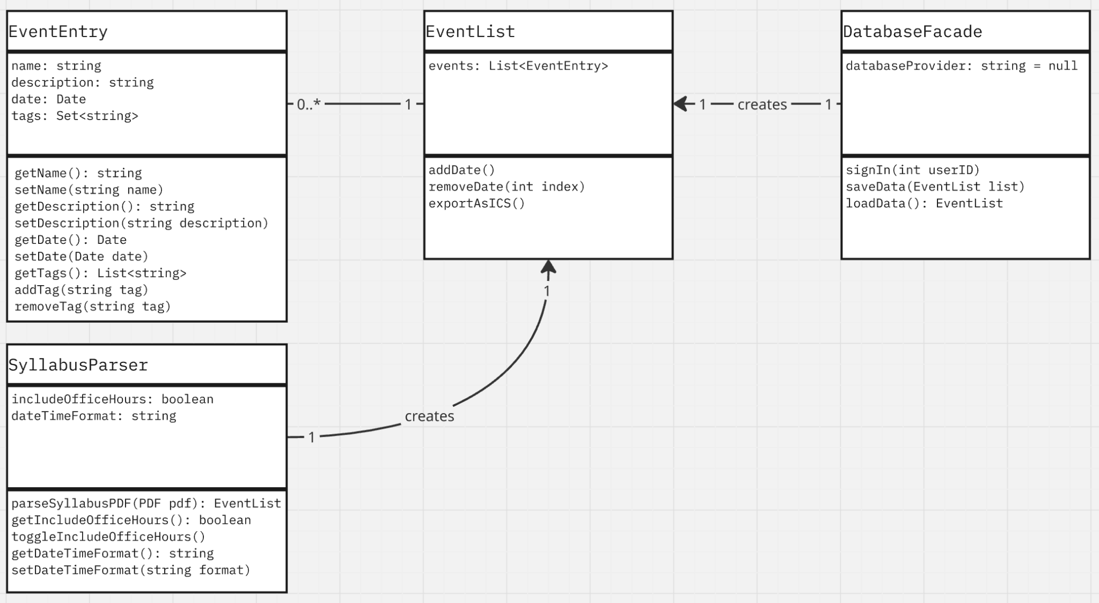
EventEntry:
- name: string
- description: string
- date: Date
- tags: Set<string>
- getName(): string
- setName(string name)
- getDescription(): string
- setDescription(string description)
- getDate(): Date
- setDate(Date date)
- getTags(): List<string>
- addTag(string tag)
- removeTag(string tag)
EventList:
- events: List<EventEntry>
- addDate()
- removeDate(int index)
- exportAsICS()
SyllabusParser:
- includeOfficeHours: boolean
- dateTimeFormat: string
- parseSyllabusPDF(PDF pdf): EventList
- getIncludeOfficeHours(): boolean
- toggleIncludeOfficeHours()
- getDateTimeFormat(): string
- setDateTimeFormat(string format)
DatabaseFacade:
- databaseProvider: string = null
- signIn(int userID)
- saveData(EventList list)
- loadData(): EventList

