Team Alcatote

For designing the architecture of SemesterSort we designed a Model-View-Controller architecture. We chose the architecture due to the interaction based website that we are creating. Every feature of the website can be simplified to the user interacting with the system and the system updating its information. This includes the user manually adding a new event, editing an event, undoing an edit, redoing an edit and more. This is exactly what a Model-View-Controller system does, making it the perfect architectural type for us to use.

Architecture Design Diagram:
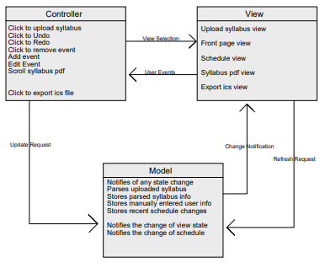
Design Description:
The architectural pattern consists of three components, the view, the controller and the model.
The view for SemesterSort handles the UI of the web application. This is mostly handled by React and Bootstrap. The application will have five main views, when the user uploads a syllabus they may be brought to a file explorer view if they chose not to drag the file. There will be the front page which will have the upload syllabus inside of it as well as the website name and description. After uploading their syllabus the user will be taken to the second page which will have a section to view their uploaded pdf. It will also have a view of the compiled schedule, as well as an option to export the schedule which will bring up another file explorer view.

The controller handles the various events from the view. These events can range from a button press to move to the next page, or to add an event, or undo and redo an edit. The controller will then notify the model to update the view with the new information. The controller will mainly be responsible for sending update requests based on button clicks and user typing. The only library we are currently using that relates to the controller is React.

The model for SemesterSort handles the data from the app. Here the view can access any data for specific elements in the app to update the UI. This is also the location where the schedule will be stored along with the parsed data from the syllabi. Through the users actions this will be updated based on syllabus uploads, manual inputs, edits, or deletions by the user. The controller will send update requests to the model and the model will then automatically update the view. The model will also store the most recent state changes to the schedule so that the user can undo or redo changes.

