Tab 1

Software Requirements Specification
Team Alcatote

Prepared by
Jack Ellingwood
Dawson Ferguson
John Quinn
Drew Turgeon
Nicky Keenan

Table of Contents
1. Introduction 2
1.1 Purpose 2
1.2 Document Conventions 2
1.3 Intended Audience and Reading Suggestions 2
1.4 Product Scope 3
1.5 References 3
2. Overall Description 3
2.1 Product Perspective 3
2.2 Product Functions 3
2.3 User Classes and Characteristics 4
2.4 Operating Environment 4
2.5 Design and Implementation Constraints 4
2.6 Assumptions and Dependencies 4
3. External Interface Requirements 5
3.1 User Interfaces 5
4. System Features 5
5. Other Nonfunctional Requirements 6
5.1 Performance Requirements 6
5.2 Security Requirements 7
5.3 Privacy Requirements 7
5.4 Software Quality Attributes 7
6. Other Requirements 8

Revision History

Name | Date | Reason For Changes | Version
Initial version | 2/26/26 | Initial | 0.0.1
Updated doc. | 3/10/26 | To add requirement headers | 0.0.2
Updated doc. | 3/12/26 | To finish the initial document | 0.0.3
Revised doc. | 4/7/26 | Revisions based on professor feedback | 0.0.4

Introduction

Purpose
This document is a requirements specification for the first release of SemesterSort. The document contains specifications for various systems, including but not limited to, the syllabus upload, pdf parser, and user interface.

Document Conventions
This Document was created based on the IEEE template for System Requirements Specification Documents.

The following conventions in the document were used as follows:

Convention | Description
SS | App Name: SemesterSort
React | Open source JavaScript library for building user interfaces.

Intended Audience and Reading Suggestions
This document is intended for the product manager, developers, designer, product users, and admin. The rest of this document will consist of more detailed descriptions of the product and its functions. This includes software components, major product features, system and non-functional requirements and more.

Users of this product need only read sections 1 and 2 to understand the purpose and functionality of the product. They may read the more detailed specifications if they wish.

The product manager, developers, and designer should read all sections, focusing on sections 3, 4, and 5 to understand the necessary features. This will better give an idea of the features and requirements that will be implemented into the final product.

Product Scope
SS is a schedule building software that aims to provide easy access to important due dates and events from a class syllabus. The goal of this product is to have a seamless user experience between the automatic parsing of the uploaded syllabi and the user input information. Resulting in a customized and functioning course schedule in the form of an ics file to be imported to a Google Calendar.

The hope of this project is to increase student and professor satisfaction by enabling an easier scheduling system. This ensures that students will know when they have due assignments and professors will be less likely to receive complaints from students.

References
SS GitHub:
https://github.com/COS420-S2025/TeamA

Use Cases:
https://docs.google.com/document/d/1ytDNIuA-i633OVWx5vN94FmsyPEFUE28tquCmlvYn2s/edit?tab=t.0

Overall Description

Product Perspective
SS is an independent web application designed to streamline the semester scheduling process for students. By uploading your syllabus our application will automatically parse through and extract the due dates and corresponding assignments to be added to a schedule. The user is also able to manually enter their own information, as well as edit or remove the ones added by the parser. The user is also able to add relevant tags and descriptions to the events. The application will be open-source, and easily accessible through our github repository.

Product Functions
- Upload syllabus: The user can upload one or more syllabi in a pdf format
- Automatic parsing: The system will automatically parse through the syllabus and attempt to extract due date information and the corresponding assignments
- Schedule builder: The system will take the extracted information and use it to build a schedule
- Manual adding: The user can manually add events to the schedule and also add tags or descriptions
- Editing/Deletion: The user can edit or delete the events added by the parser. Additionally they can undo or redo recent edits
- Compilation: The system will compile the finished schedule into an exportable ics file
- Exporting: The user can export the compiled ics file to add to a Google Calendar

User Classes and Characteristics
The largest user class for this product is university students. This product is designed to be usable on a wide variety of syllabi so that as many students as possible can benefit. We expect students to be a majority of the users and therefore they are the highest priority when considering design and requirements.

The other main user class is the system administrators and developers. This class will have a higher security and privilege level and therefore have a very different set of requirements. However this system is designed to work on its own after implementation so this user class is largely meant for the development process.

Finally since this product is an open source web application it is open for anyone else who may wish to use it. However since this product is designed for students not much concern will be placed on this class for development and requirements.

Operating Environment
SS is meant to work on any device that is able to access a web browser that supports Javascript and that can upload files. This means that an operating system that supports these two requirements should theoretically be capable of using the product.

Design and Implementation Constraints
This product will not store user information past the session. This means that once the application is closed all information will be deleted. As such there are no major implementation constraints.

Assumptions and Dependencies
SS is developed using React, which is a Javascript library that incorporates HTML and CSS to render web pages. This means that a web browser capable of using Javascript is necessary to use the product. Additionally for the application to be openly accessible there will need to be a webhost to run the application.

External Interface Requirements

User Interfaces

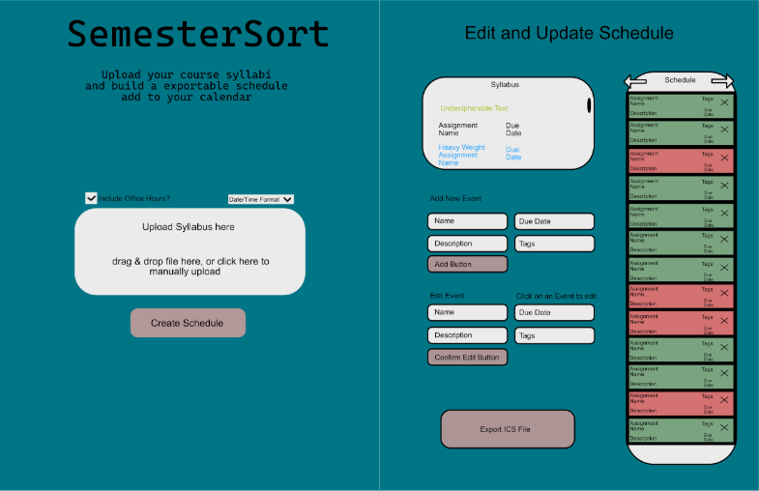

This is an example of what our website will look like. On the left you can see the front page of the website. As you can see it is quite simple, I will have the website name, followed by a short description of the purpose of the website. Below it will have a place to upload syllabi, as well as a couple of additional features. These include the option for the finished schedule to have the professor's office hours, and the specific date/time format that the syllabi use. Finally the user will press the create schedule button to begin the compilation of the ics file.
Next, on the right is an example of the edit and update schedule page. On this page we will display the schedule created by the syllabi parser as well as the original syllabus. Giving the user the option to edit, or add their own events to the schedule. Or the user can also choose to remove certain events added by the parser or the user. There are also a few quality features, the parser will indicate sections of the syllabus it was unable to interpret, as well as indicating any events that hold more course weight. The user is also able to add tags to the events in the schedule and can even undo or redo recent edits using the arrows. Finally the user can click on the Export ICS File button to receive their compiled ics file to be added to a google calendar.

System Features
  - File Upload Requirements

    - The system shall allow the user to upload a pdf file for parsing.
    - The system shall allow the user to upload multiple pdf files at the same time.

4.2 PDF Parsing & Information Extraction Requirements

4.2.1 The system shall parse the contents of the uploaded pdf and extract individual assignments from the pdf.
4.2.2 The system shall extract the corresponding due dates for assignments from the pdf.
4.2.3 The system shall extract the professors office hours and location from the uploaded pdf.
4.2.4 The system shall allow the user to choose to include a professor's office hour in the compiled ics file or not.

4.3 Calendar Compilation, Editing & Management Requirements

4.3.1 The system shall allow the user to make changes to the compiled ics file.
4.3.2 The system shall compile the extracted information into an ics file.
4.3.3 The system shall allow the user to undo their recent edits made to the ics file.
4.3.4 The system shall allow the user to redo their recent edits made to the ics file.
4.3.5 The system shall allow the user to add tags to assignments in the compiled ics file.

4.4 Manual Assignment Entry Requirements

4.4.1 The system shall allow the user to enter assignments to be added to the compiled ics file.
4.4.2 The system shall allow the user to enter corresponding due dates to be added to the compiled ics file.
4.4.3 The system shall allow the user to add corresponding descriptions to assignments in the compiled ics file.

4.5 Viewing and Export Requirements

4.5.1 The system shall visually display the contents of the compiled ics file.
4.5.2 The system shall allow the user to export the compiled ics file.
4.5.3 The system shall visibly indicate sections of the text that it was unable to interpret.
4.5.4 The system shall visibly indicate assignments that carry the most weight.
4.5.5 The system shall allow the user to specify the time/date system that they prefer.

Other Nonfunctional Requirements

Performance Requirements
5.1.1 The system shall recognize the date format used in the uploaded pdf at least 70% of the time.
5.1.2 The system shall produce a compiled ics file within 3 seconds of the user submitting manually entered information.
5.1.3 The system shall support concurrent processing of at least 10 users without performance degradation exceeding 10% of baseline response time.
5.1.4 The system shall successfully process at least 95% of valid uploads without crashing.

Security Requirements

5.2.1 The system shall terminate the user session upon the user closing the page.
5.2.2 The system shall protect user traffic through the use of secure protocols to protect data in transit.
5.2.3 The system shall restrict file uploads to approved formats. (See Appendix C: Approved File Upload Types)

Privacy Requirements
5.3.1 The system shall not save any user data or data collected from the processed syllabi on the server.
5.3.2 The system shall not share user data with third party services.

Software Quality Attributes
5.4.1 The system shall provide error messages when the syllabi parser fails.
5.4.2 The system shall include internal documentation such that each file will include comments describing its purpose and functions for future developers to update system logic.

Other Requirements
Appendix A: Glossary
- Team Alcatote: Development team
- SS: SemesterSort, the app name
- React: Javascript library for web development
Appendix B: Analysis Models

Appendix C: Approved File Upload Types
- PDF
- ICS
Appendix C: To Be Determined List

