Software Requirements Specification

for

FridgeFriend
Version 2.3 approved
Prepared by:
PM: Willa Galipeau-Eldridge
Designer: Paige Doucette

Developers: Jennifer Morin, Drew Hafford, and Isabel Layland
Team Development
02/20/2026
Table of Contents
Table of Contents ii
Revision History ii
1. Introduction 1
1.1 Purpose 1
1.2 Document Conventions 1
1.3 Intended Audience and Reading Suggestions 1
1.4 Product Scope 1
1.5 References 1
2. Overall Description 2
2.1 Product Perspective 2
2.2 Product Functions 2
2.3 User Classes and Characteristics 2
2.4 Operating Environment 2
2.5 Design and Implementation Constraints 2
2.6 User Documentation 2
2.7 Assumptions and Dependencies 3
3. External Interface Requirements 3
3.1 User Interfaces 3
3.2 Hardware Interfaces 3
3.3 Software Interfaces 3
3.4 Communications Interfaces 3
4. System Features 4
4.1 Item Management 4
4.2 Cost Tracking 4
4.3 Expiration Calendar 4
4.4 Account 4
5. Other Nonfunctional Requirements 5
5.1 Performance Requirements 5
5.2 Safety Requirements 5
5.3 Security Requirements 5
5.4 Software Quality Attributes 5
5.5 Business Rules 5
6. Other Requirements 5
Appendix A: Glossary 5
Appendix B: Analysis Models 5
Appendix C: To Be Determined List 6

Revision History
Name | Date | Reason For Changes | Version
Initial Version | 02/20/2026 | Initial | 1.1
Requirements | 02/26/2026 | Added Functional and Non-Functional Requirements to Sections 4 and 5 | 1.2
UI Interface | 02/26/2026 | Added UI Wireframes to Section 3 | 1.3
Introduction | 03/09/2026 | Completed Section 1 (Introduction) | 2.0
Overall Description | 03/10/2026 | Completed Section 2 (Overall Description) | 2.1
External Interface Requirements | 03/11/2026 | Completed Section 3 | 2.2
UI Mockups | 03/13/2026 | Added link to updated UI Mockups | 2.3

Introduction

Purpose
The application FridgeFriend is an inventory management system that is designed to help college students/households track food items, reduce duplicate purchases, and promote better household spending. The main objective of this application is to provide college students a way to reliably track their food inventory in a quick and easy way. This document specifies the software requirements that are needed to create the application.

Document Conventions
This document was created based on the IEEE template for System Requirements Specification documents.

The following conventions in the document were used as follows:

Convention | Description
FridgeFriend | App Name: FridgeFriend
HTTP | Hypertext Transfer Protocol
FREQ | Functional Requirement
NFREQ | Non-Functional Requirement

Intended Audience and Reading Suggestions
This document will be made for developers, project managers, marketing staff, users, testers, and documentation writers. Developers should focus on Section 3 (External Interface Requirements) and Section 4 (System Features). Designers should direct their attention to Section 3.1 (User Interfaces). Testers should use Section 5 (Other Nonfunctional Requirements) to verify the performance of FridgeFriend and ensure security benchmarks are met. The rest of this SRS contains an introduction to the application, external interface requirements, system features, non-functional requirements, and other requirements.

Product Scope
FridgeFriend is a food inventory management software that allows users to see their physical inventory through a digital method of tracking their food supplies.. This software aims to allow users to maintain an accurate inventory of their fridge, freezer, and pantry contents by adding, editing, and deleting items. By providing sight into physical inventory, the application aims to reduce duplicate purchases, minimize household waste, and promote better spending habits.

References

Title | Source
FridgeFriend GitHub Repository | https://github.com/COS420-S2025/TeamD.git
Project Description | FridgeFriend: Project Description
Use Case Diagram/Descriptions | FridgeFriend: Use Case Diagrams/Descriptions

Overall Description

Product Perspective
FridgeFriend is an alternative to prior solutions to track food inventory, focusing on college students by making sure the application isn’t too complex. It serves as an inventory tool for single users or a multiple person household to capture your real-time food inventory. While the application is a standalone-system it utilizes cloud-based synchronization to ensure that inventory data is consistent across many linked devices within a single household.

Product Functions
Login Page  - Welcomes User  - Allows users to login  Homepage  - Links to all other pages  - Shows user notifications  Inventory Page  - Shows list of food inventory  - Shows user quantity of item  - Allows users to add items  - Allows users to scan a barcode  - Allows users to edit items  - Allows users to delete items | Cost Tracking Page  - Shows monthly expenses  - Shows yearly expenses  - Shows wasted money calculation  Expiration Calendar Page  - Shows user monthly calendar  - Allows user to change months  - Allows user to click on item for more information  - Shows user expiration date for item  Household Page  - Shows user household members  - Allows users to add household member  - Allows users to remove a household member

User Classes and Characteristics
The primary user consists of college students and budget-conscious households who need a quick and easy way to monitor their food supplies. These users are expected to utilize the application frequently to keep an accurate inventory, requiring an intuitive interface for fast item entry. Another user class includes household members that share a synchronized account to allow them to coordinate their purchases and collectively reduce waste. Project managers, developers, and testers serve as internal stakeholders to utilize this documentation to ensure the application meets performance and security requirements.

Operating Environment
FridgeFriend is developed to be a mobile application using a React App with HTML, CSS, and TypeScript. FridgeFriend will operate on all major operating systems including IOS and Android.

Design and Implementation Constraints
The development is constrained to the use of React, HTML, CSS, and TypeScript for the application’s front-end. Developers must implement specific security measures, including data encryption and two-factor authentication for every login to protect users personal information from third-parties. Furthermore, FridgeFriend must adhere to the specific regulatory standards of California food labeling laws to facilitate food safety.

User Documentation
Users will be provided with an in-app “Help” section and a digital user manual that details how for users to sync household accounts and use core features.

Assumptions and Dependencies
FridgeFriend is developed using React, with a TypeScript library that incorporates HTML and CSS along with TypeScript to render the web pages. If a user is blocking or disabled TypeScript from their browser the application won’t function properly.

External Interface Requirements

User Interfaces
The user interface is designed for mobile application efficiency, with interfaces for food inventory, expense tracking, expiration calendar, and household management. There will be a homepage with links allowing users to navigate through to the various interfaces.

FridgeFriend: UI Mockups

The login interface gives the user the option to login to an existing account or gives the option to create a new account by entering your username, email, and a password. After logging in, FridgeFriend will bring users to the homepage to interact with the rest of the application interfaces. From all pages, users will be able go back and forth through the interfaces and return to the homepage.
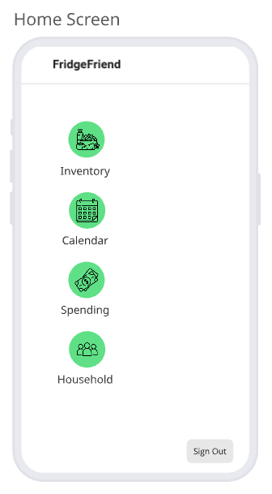
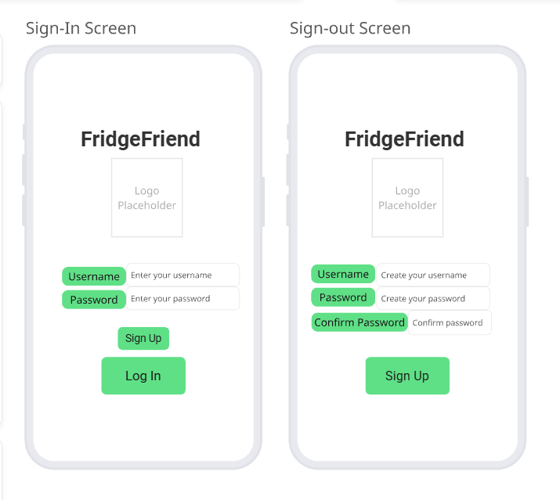
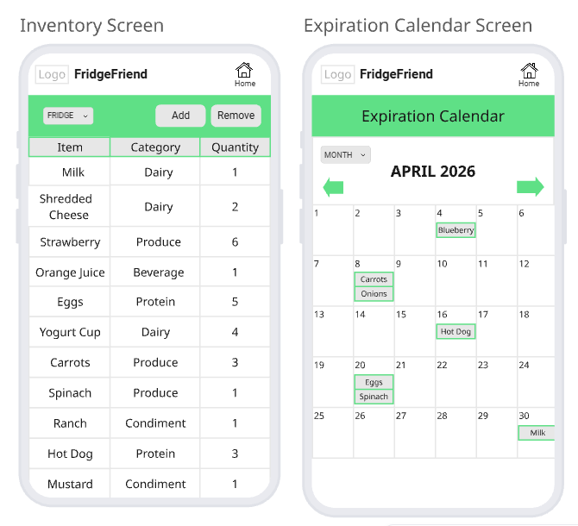
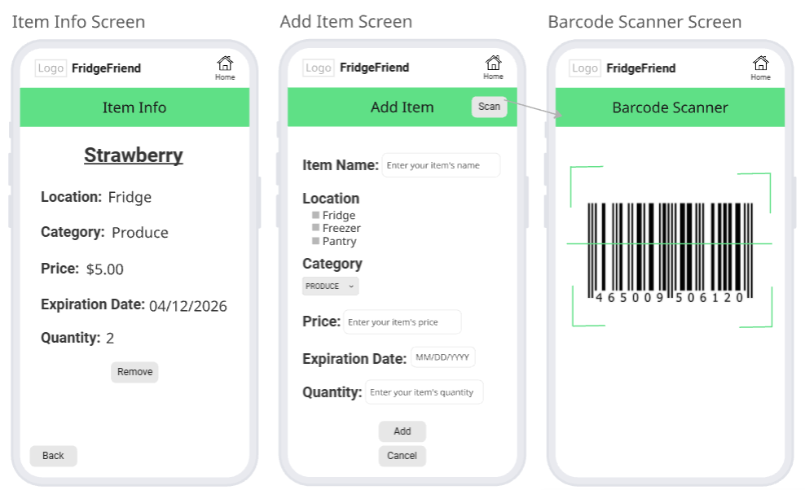
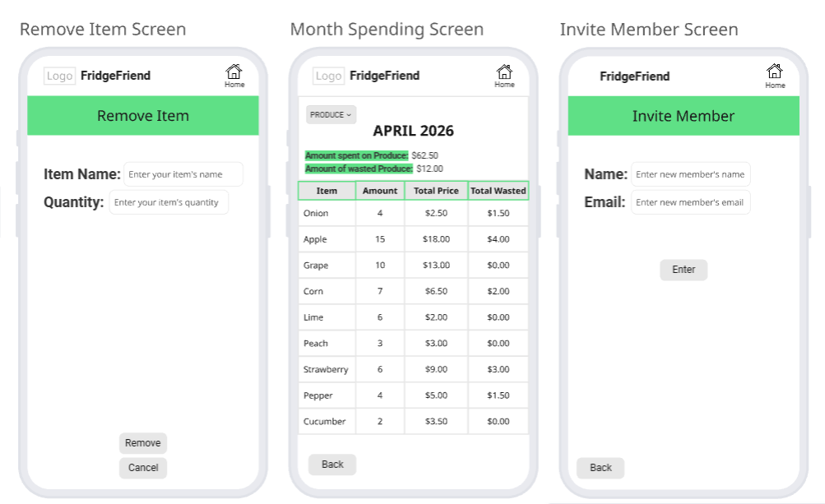

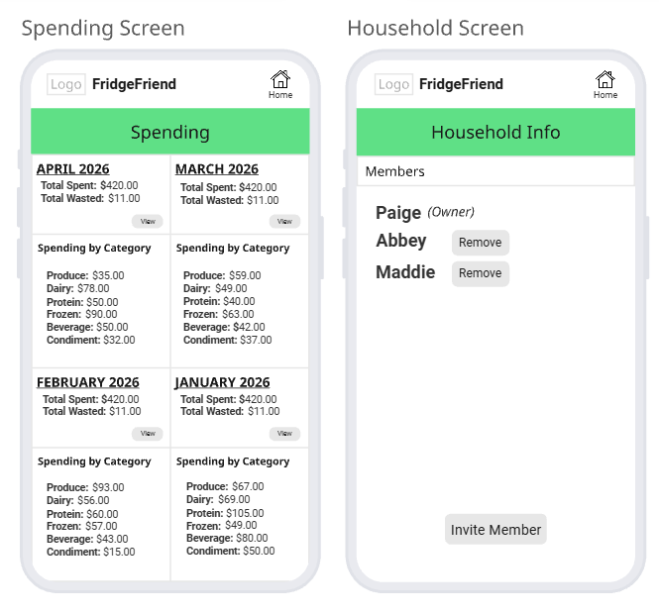

The food inventory interface will allow the user to add items including their location, expiration date, quantity, and have the ability to mark an item as opened. Users will be able click on an item, see the item's specific information and have the ability to edit it. Additionally, users will be able remove an item from the list after it has been consumed.

The expiration calendar interface shows the user a monthly calendar view with the item’s name on the calendar date of when it is due to expire. Users can select the food item within the calendar to view all of its information. The user can switch between months with a dropdown to view all items expiring that month.
The expense tracking interface will show users the amount of money that they spent with a breakdown by month. Additionally, users will be able to see how much money they wasted from food that they had to throw away without consuming.


This section will be updated as more components are added to the application.

Hardware Interfaces
FridgeFriend requires access to the mobile device’s camera to support the barcode scanner functionality for item entry. But due to budget constraints, complete functionality of the barcode scanner won’t be possible since it depends on the access to a paid API service. FridgeFriend must be compatible with touch-screen interfaces and notification hardware of when items will expire by storing the timestamp in a database to deliver expiration warnings and alerts.A reliable internet connection will be required for users to log in and sync their food inventory list.

This section will be updated as more components are added to the application.

Software Interfaces
FridgeFriend is built with HTML, CSS, TypeScript, and React hooks for an intuitive user interface. The backend is also built with TypeScript and supported by third-party libraries.

This section will be updated as more components are added to the application.

Communications Interfaces
The system utilizes HTTP protocols for communication between FridgeFriend and the backend server to confirm data integrity during synchronization. FridgeFriend requires a reliable network connection to update the food inventory list across linked household devices to keep an accurate and current list. To protect user information, FridgeFriend will use encryption for account information and notifications.

This section will be updated as more components are added to the application.

System Features

Item Management
4.1.1 Description and Priority
Item Management allows the user to maintain a digital inventory of their physical products in their fridge, pantry, and freezer. Allowing the user to add, edit, and delete items to ensure accurate inventory management, High Priority
4.1.2 Stimulus/Response Sequences
<List the sequences of user actions and system responses that stimulate the behavior defined for this feature. These will correspond to the dialog elements associated with use cases.> NOT REQUIRED FOR DELIVERABLE 1
4.1.3 Functional Requirements
F_REQ-1.1: The system shall allow users to manually add an item.
F_REQ-1.2: The system shall allow users to edit an item’s quantity.
F_REQ-1.3: The system shall allow users to remove an item.
F_REQ-1.4: The system shall allow users to scan a barcode for an item.
F_REQ-1.5: The system shall allow users to mark an item as “opened” to track freshness.
F_REQ-1.6: The system shall allow users to save “Frequently Bought” items to a list.
F_REQ-1.7: The system shall automatically set the date each item was added.
F_REQ-1.8: The system shall display the expiration date of each item.
F_REQ-1.9: The system shall allow users to filter the item list.
F_REQ-1.10: The system shall allow users to select how many days before an item expires to receive a warning.
F_REQ-1.11: The system shall display a warning when items are "near expiring".

Cost Tracking
4.2.1 Description and Priority
Cost Tracking allows the user to view total amount spent over a designated interval (1month/1year) as well as total amount spent on unused food logged into their fridge, pantry and freezer. This provides the user with helpful insight into spending habits, Medium priority.
4.2.2 Stimulus/Response Sequences
<List the sequences of user actions and system responses that stimulate the behavior defined for this feature. These will correspond to the dialog elements associated with use cases.> NOT REQUIRED FOR DELIVERABLE 1
4.2.3 Functional Requirements
F_REQ-2.1: The system shall allow a user to view the price of an item.
F_REQ-2.2: The system shall allow a user to input the price of an item.
F_REQ-2.3: The system shall calculate the total price of all entered items.
F_REQ-2.4: The system shall display the total price.
F_REQ-2.5: The system shall calculate the total price of unused items.
F_REQ-2.6: The system shall allow the user to select a time interval for viewing total spending.

4.3 Expiration Calendar
4.3.1 Description and Priority
The Expiration Calendar lets the user see the dates all of their items expire on a calendar interface. It will display the date and under it will show which items expire that certain day. The user can click the dates to see more information about the items.
4.3.2 Stimulus/Response Sequences
<List the sequences of user actions and system responses that stimulate the behavior defined for this feature. These will correspond to the dialog elements associated with use cases.> NOT REQUIRED FOR DELIVERABLE 1
4.3.3 Functional Requirements
F_REQ-3.1: The system shall display a calendar showing all dates within the month.
F_REQ-3.2: The system shall display the items on the calendar under their corresponding expiration date.
F_REQ-3.3: The system shall allow the user to switch between months.
F_REQ-3.4: The system shall allow the user to click on certain dates.
F_REQ-3.5: The system shall display a list of expired food on a selected date.
F_REQ-3.6: The system shall display details about the item when the date is clicked (location, category, price).
F_REQ-3.7: The system shall update calendar when a new item is added/removed.

4.4 Account
4.4.1 Description and Priority
This application will require that users create accounts. This will allow for the system to track a users inventory information and share this information with their household members, syncing to keep up to date user data, High Priority
4.3.2 Stimulus/Response Sequences
<List the sequences of user actions and system responses that stimulate the behavior defined for this feature. These will correspond to the dialog elements associated with use cases.> NOT REQUIRED FOR DELIVERABLE 1
4.3.3 Functional Requirements
F_REQ-4.1: The system shall encrypt the user information that is given.
F_REQ-4.2: The system shall have the user use a password in order to log in.
F_REQ-4.3: The system shall allow multiple users to access the same information.
F_REQ-4.4: The system shall use two factor authentication for each login.

Other Nonfunctional Requirements

Performance Requirements
NF_REQ-1.1: The system shall update the item inventory list across linked household devices within 3 seconds of an item being added to the inventory, at least 99% of the time.
NF_REQ-1.2: The system shall parse the data from a barcode scan, displaying the product details within 2 seconds of an image being taken, at least 99% of the time.
NF_REQ-1.3: The system shall display a warning for expiry within one hour, at least 99% of the time.
NF_REQ-1.4: The system shall display search/filter results within 1 second, at least 99% of the time.
NF_REQ-1.5: The system shall calculate the total price within 4 seconds, at least 99% of the time.
NF_REQ-1.6: The system down time shall not exceed 4 hours, at least 99% of the time.

Safety Requirements
NF_REQ-2.1: The system shall include a visible disclaimer stating expiration date alerts are estimates and users should inspect their food before consumption.

Security Requirements
NF_REQ-3.1: The system shall restrict household inventory access to authorized members only.
NF_REQ-3.2: The system shall allow full deletion of user information if they delete their profile.
NF_REQ-3.3:The system shall use encryption for all private information

Software Quality Attributes
NF_REQ-4.1: The system shall function on IOS and Android.
NF_REQ-4.2: The system shall display error messages when the user enters invalid information.
NF_REQ-4.3: The system shall load the main page within 3 seconds.
NF_REQ-4.4: The system shall not crash if a user enters incomplete or invalid information.

Business Rules
NF_REQ-5.1: Each household should have one designated primary account holder.
NF_REQ-5.2: Each item must include a name and a location before being added to inventory.

Other Requirements
NF_REQ-6.3: The system shall Comply with the California food labeling laws.

Appendix A: Glossary
Team Development: Team Name
FridgeFriend: App Name
SRS: Software Requirements Specification

Appendix B: Analysis Models
FridgeFriend Task Flow Diagram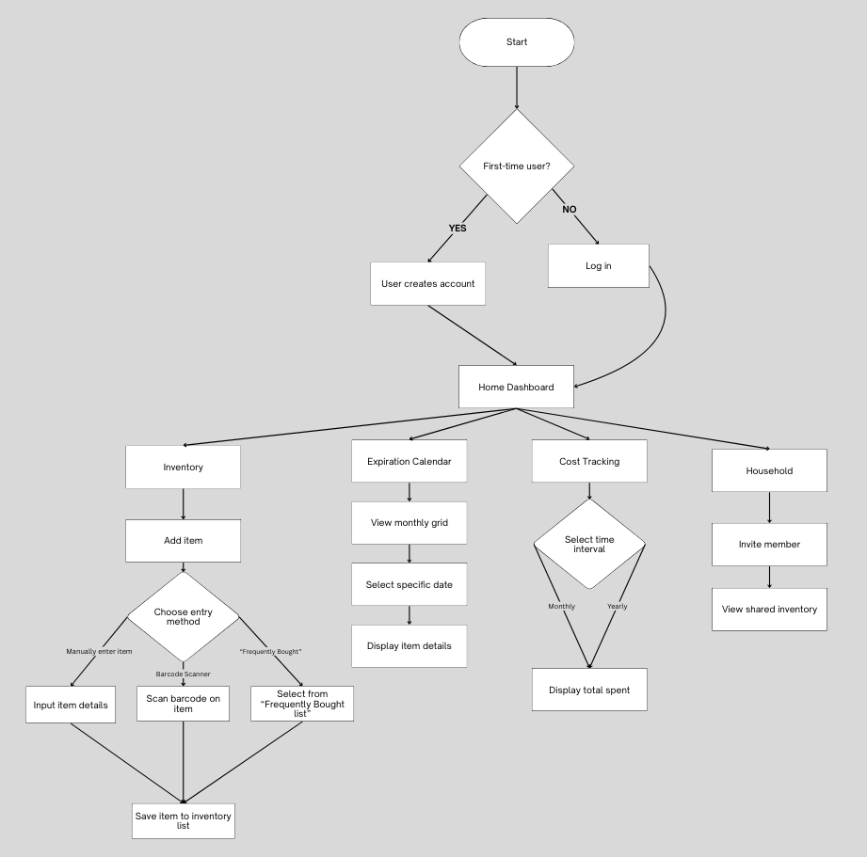
FridgeFriend Application - Task Flow Diagram

Appendix C: To Be Determined List

