Design “Class” Diagram
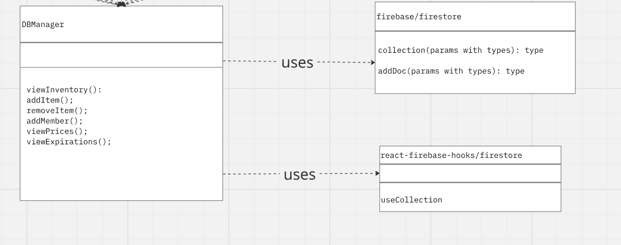

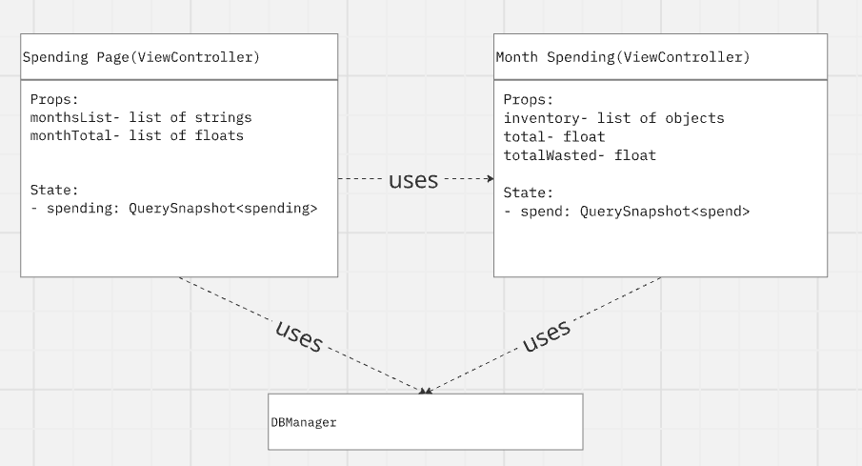
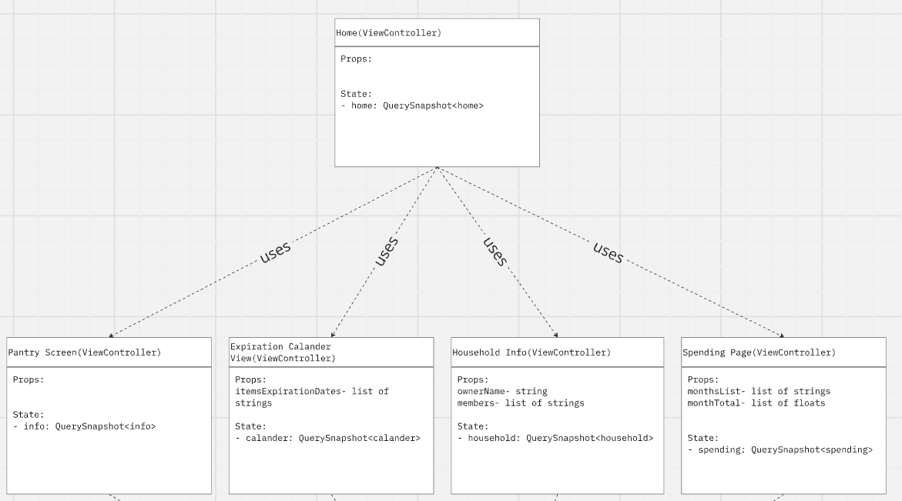
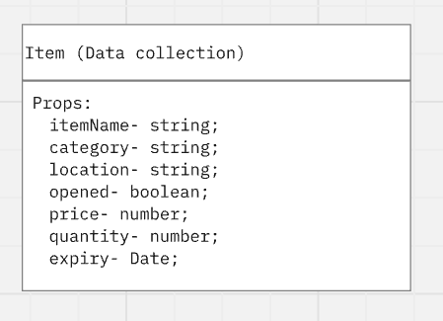
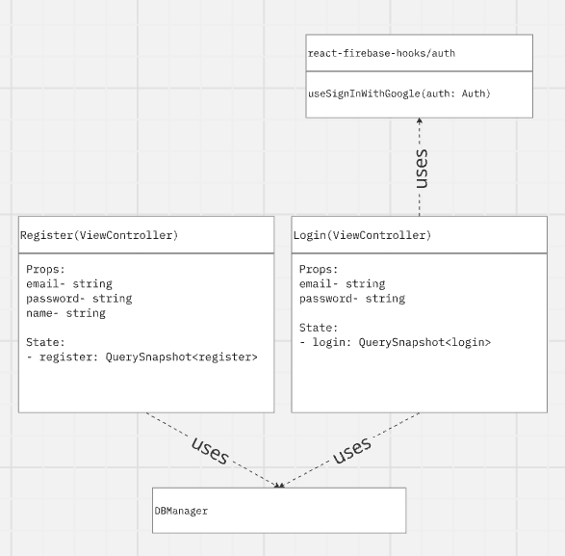
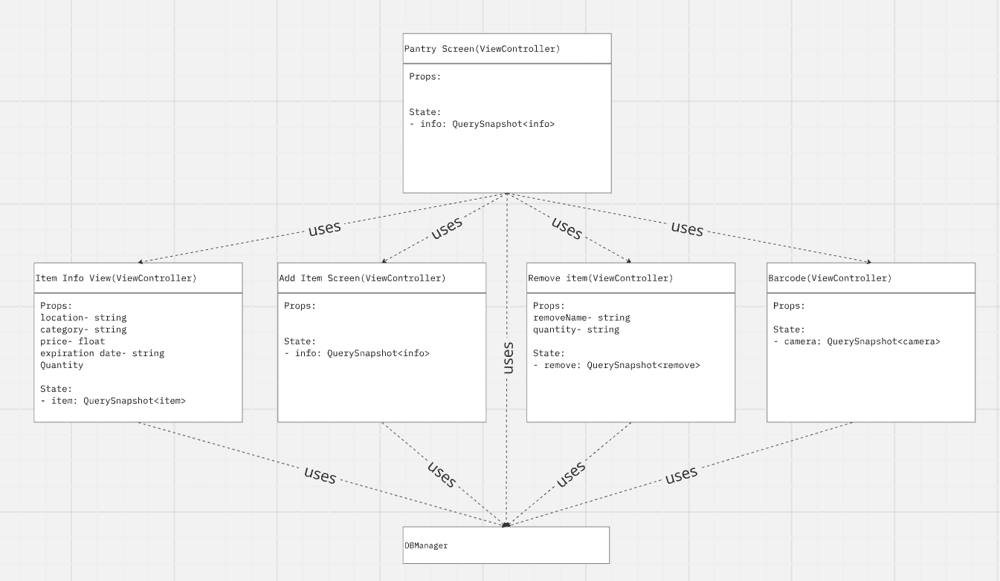

(Link to Board) (Link to join team if not a member)
The diagram above shows detailed class design for the FridgeFriend application and outlines and which classes they use. The user relationship is shown by a dotted line with the arrow pointing from the using class to the used class. Every controller presents itself as a page with its own data being shown, some do not have data of their own but use other classes instead and are just used to get from one place to the next.

As shown in the diagram, the Database is controlled by its manager which has many functions for pulling and pushing to the remote source. This can be seen in the functions used by the Database including addItem and addMember. Where ever returned object has been found inside the Database. The Controller’s most significant uses are the use of the Database and the FireAuth. Without the use of FireAuth none of the functions used by the Controller would be accessible and the same is true for the Database. This is because the authorization in firebase is how you can get to the home page which allows you to move throughout to any other page. Every object used by the Controller is passed in as parameters for certain functions.
The Fridge Friend app makes heavy use of objects like items and in creating lists to be used by certain functions to display data. In order to function all pages must be interconnected and allow the user to follow the chain of classes to get where they are without risking the integrity of the firebase system.

Design Patterns

Mediator
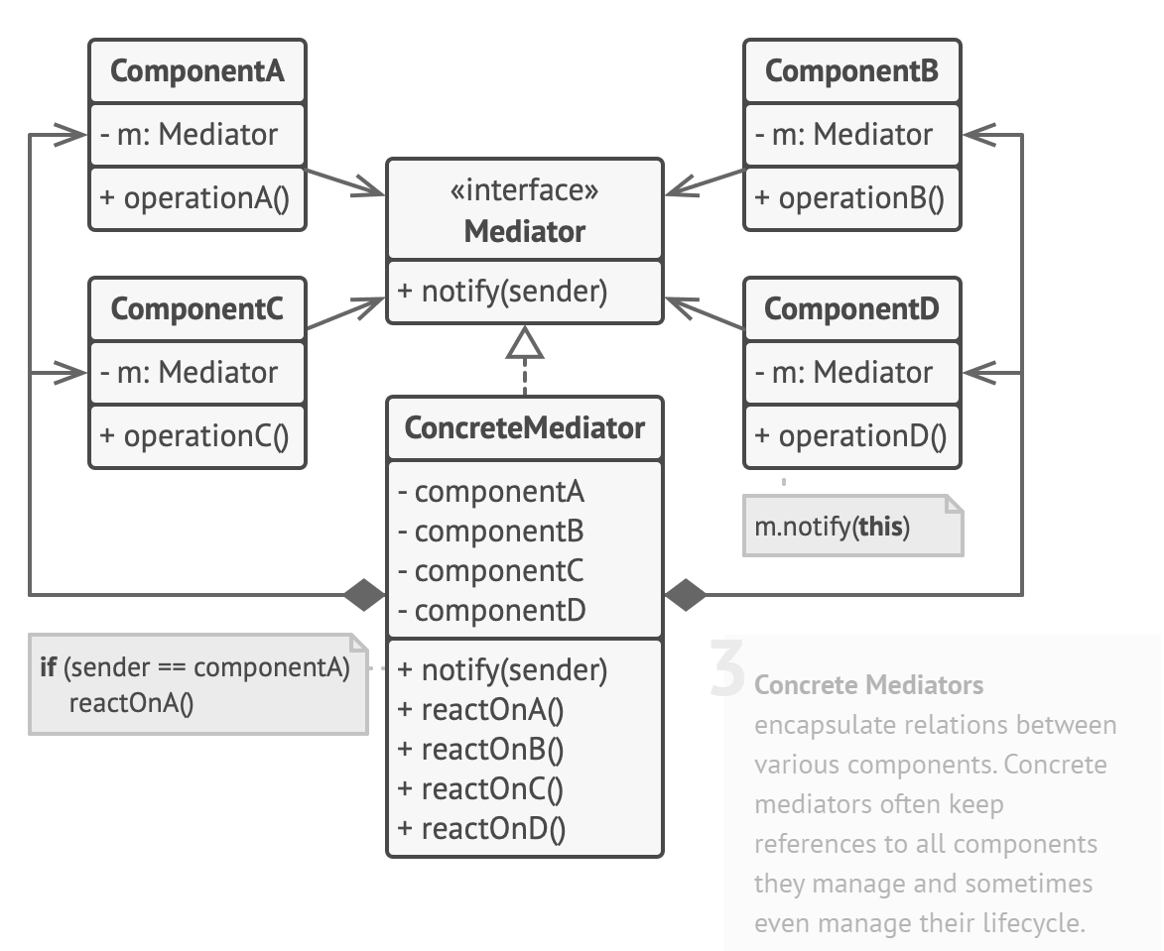
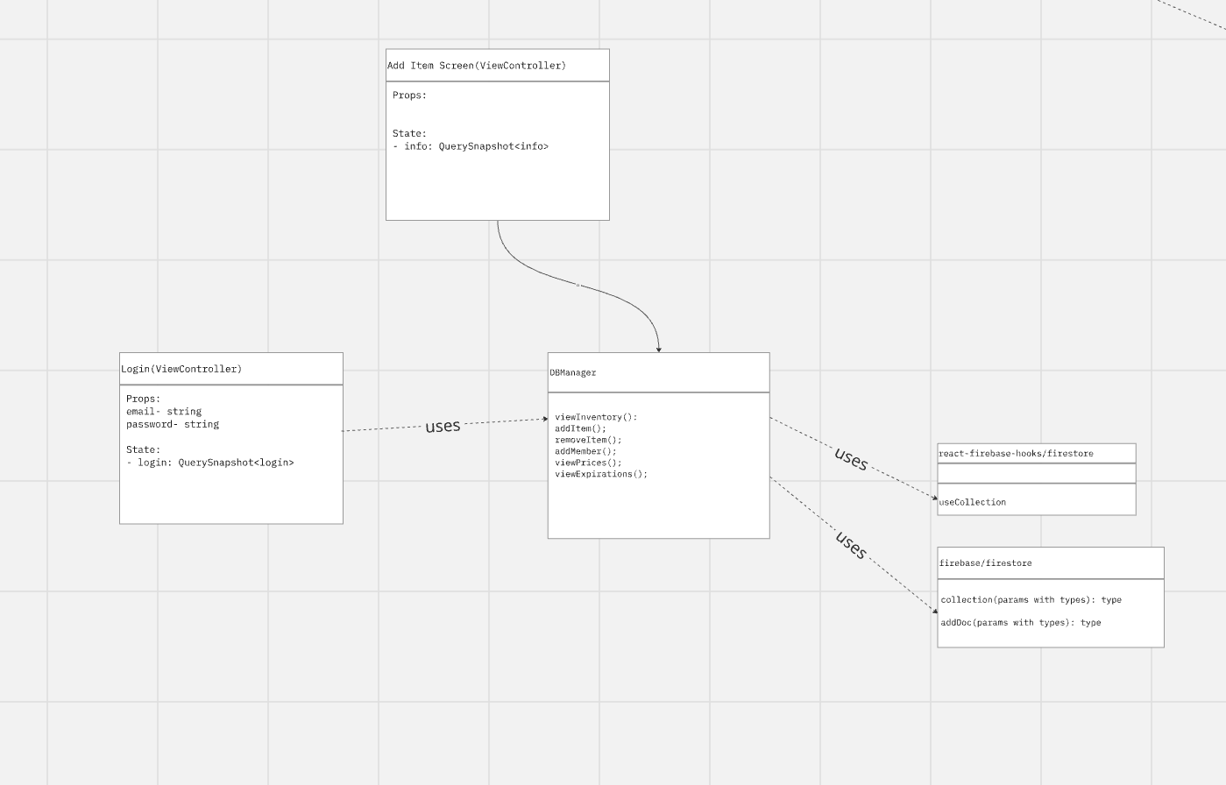
(Bottom of same board) (Link to join team if not a member)
Team Development's FridgeFriend follows the Mediator design pattern, to organize the architecture of the classes in the web application. This process similar to the MVC design allows apps to be designed to cleanly separate functionality and concerns, by distributing responsibilities, between pages but having one main manager that connects to the information in firebase.
The Home Page Model is designed to allow the user to travel throughout the pages giving the logged in user access to all of the different functions. The fire base manager is used to store user credentials such as username, password, and name.This is used to either log in an already registered user or to register a user that is new to the app The Home Page Model allows user data to be isolated to each page which is then only accessed by changing pages and using the predesigned functions, adhering to the principle of encapsulation.
The manager acts as an intermediary, handling all communication between the firebase system, and the user. The manager takes user input from the pages, processes it, and returns the output display to the View. In this design, the manager provides methods for various functionalities in the view itself, further encapsulating user actions triggered by the user interface. This allows the users to be sure their information is not accessible to any other users, it must go through the manager to get to firebase.
The Mediator design pattern works hand in hand with React, as each page can be developed and tested independently, promoting a clean and maintainable codebase. Additionally, the separation of pages, allows teams to work in parallel on different aspects of the application, meaning there's less overhead required when collaborating on certain aspects of the codebase.

