COS 420
Team D
Deliverable 3

Fridge Friend’s purpose is effectively to show and store various kinds of information. This domain model is structured around encapsulation and storage of said information. The overall pattern is that the Household is linked to a collection of more specific information, which is linked to a collection of more specific information, until it reaches a singular unit.
It is structured like this to aid in ease of storage and organization, as well as allowing us to isolate modules for testing and implementation.

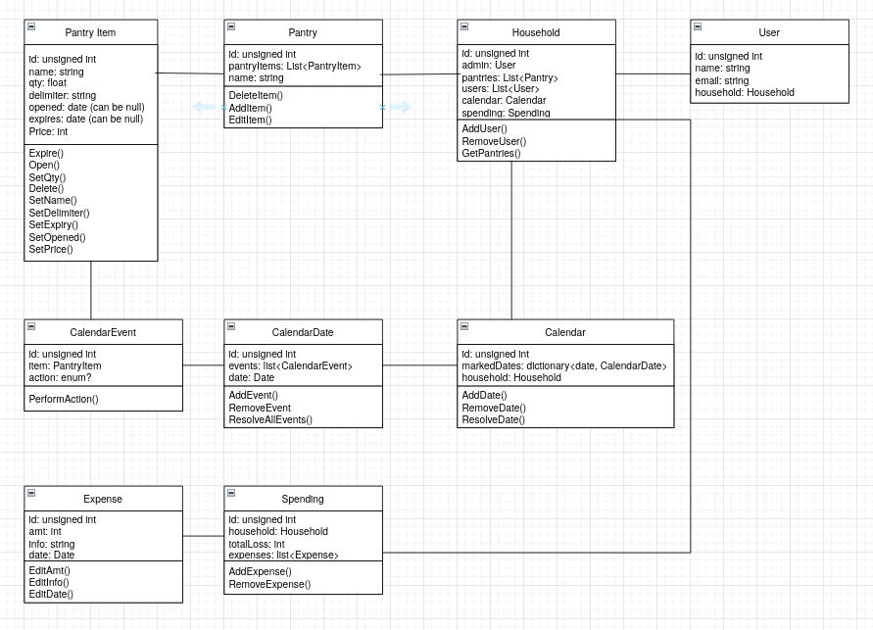

- PantryItem
  - id: unsigned int
  - name: string
  - qty: float
  - delimiter: string
  - opened: date (can be null)
  - expires: date (can be null)
  - Price: int
  - Expire()
  - Open()
  - SetQty()
  - Delete()
  - SetName()
  - SetDelimiter()
  - SetExpiry()
  - SetOpened()
  - SetPrice()
- Pantry
  - pantryItems: list<PantryItem>
id: unsigned int
  - name: string
  - DeleteItem()
  - AddItem()
  - EditItem()
- Household
  - id: unsigned int
  - admin: User
  - pantries: List<Pantry>
  - users: List<User>
  - calendar: Calendar
  - spending: Spending
  - AddUser()
  - RemoveUser()
  - GetPantries()
- User
  - id: unsigned int
  - name: string
  - email: string
  - household: Household
- Calendar
  - id: unsigned int
  - markedDates: dictionary<date, CalendarDate>
  - household: Household
  - AddDate()
  - RemoveDate()
  - ResolveDate()
- CalendarDate
  - id: unsigned int
  - events: list<CalenderEvent>
  - AddEvent()
  - RemoveEvent()
  - ResolveAllEvents()
- CalendarEvent
  - id: unsigned int
  - item: PantryItem
  - action: enum?
  - PerformAction()
- Spending
  - id: unsigned int
  - totalLoss: int
  - expenses: list<Expense>
  - AddExpense()
  - RemoveExpense()
- Expense
  - id: unsigned int
  - amt: int
  - info: string
  - date: Date
  - EditAmt()
  - EditInfo()
  - EditDate()

