Software Requirements Specification

for

FridgeFriend
Version 1.0 approved
Prepared by: Jennifer Morin, Paige Doucette, Drew Hafford, Isabel Layland, and Willa Galipeau-Eldridge
Team Development
02/20/2026
Table of Contents
Table of Contents ii
Revision History ii
1. Introduction 1
1.1 Purpose 1
1.2 Document Conventions 1
1.3 Intended Audience and Reading Suggestions 1
1.4 Product Scope 1
1.5 References 1
2. Overall Description 2
2.1 Product Perspective 2
2.2 Product Functions 2
2.3 User Classes and Characteristics 2
2.4 Operating Environment 2
2.5 Design and Implementation Constraints 2
2.6 User Documentation 2
2.7 Assumptions and Dependencies 3
3. External Interface Requirements 3
3.1 User Interfaces 3
3.2 Hardware Interfaces 3
3.3 Software Interfaces 3
3.4 Communications Interfaces 3
4. System Features 4
4.1 Item Management 4
4.2 Cost Tracking 4
4.3 Expiration Calendar 4
4.4 Account 4
5. Other Nonfunctional Requirements 5
5.1 Performance Requirements 5
5.2 Safety Requirements 5
5.3 Security Requirements 5
5.4 Software Quality Attributes 5
5.5 Business Rules 5
6. Other Requirements 5
Appendix A: Glossary 5
Appendix B: Analysis Models 5
Appendix C: To Be Determined List 6

Revision History
Name | Date | Reason For Changes | Version
Initial Version | 02/20/2026 | Initial | 0.0.1
Requirements | 02/26/2026 | Added Functional and Non-Functional Requirements to Sections 4 and 5 | 0.0.2
UI Interface | 02/26/2026 | Added UI Wireframes to Section 3 | 0.0.3

Introduction

Purpose
<Identify the product whose software requirements are specified in this document, including the revision or release number. Describe the scope of the product that is covered by this SRS, particularly if this SRS describes only part of the system or a single subsystem.>

Document Conventions
<Describe any standards or typographical conventions that were followed when writing this SRS, such as fonts or highlighting that have special significance. For example, state whether priorities for higher-level requirements are assumed to be inherited by detailed requirements, or whether every requirement statement is to have its own priority.>

Intended Audience and Reading Suggestions
<Describe the different types of reader that the document is intended for, such as developers, project managers, marketing staff, users, testers, and documentation writers. Describe what the rest of this SRS contains and how it is organized. Suggest a sequence for reading the document, beginning with the overview sections and proceeding through the sections that are most pertinent to each reader type.>

Product Scope
<Provide a short description of the software being specified and its purpose, including relevant benefits, objectives, and goals. Relate the software to corporate goals or business strategies. If a separate vision and scope document is available, refer to it rather than duplicating its contents here.>

References
<List any other documents or Web addresses to which this SRS refers. These may include user interface style guides, contracts, standards, system requirements specifications, use case documents, or a vision and scope document. Provide enough information so that the reader could access a copy of each reference, including title, author, version number, date, and source or location.>

Overall Description

Product Perspective
<Describe the context and origin of the product being specified in this SRS. For example, state whether this product is a follow-on member of a product family, a replacement for certain existing systems, or a new, self-contained product. If the SRS defines a component of a larger system, relate the requirements of the larger system to the functionality of this software and identify interfaces between the two. A simple diagram that shows the major components of the overall system, subsystem interconnections, and external interfaces can be helpful.>

Product Functions
<Summarize the major functions the product must perform or must let the user perform. Details will be provided in Section 3, so only a high level summary (such as a bullet list) is needed here. Organize the functions to make them understandable to any reader of the SRS. A picture of the major groups of related requirements and how they relate, such as a top level data flow diagram or object class diagram, is often effective.>

User Classes and Characteristics
<Identify the various user classes that you anticipate will use this product. User classes may be differentiated based on frequency of use, subset of product functions used, technical expertise, security or privilege levels, educational level, or experience. Describe the pertinent characteristics of each user class. Certain requirements may pertain only to certain user classes. Distinguish the most important user classes for this product from those who are less important to satisfy.>

Operating Environment
<Describe the environment in which the software will operate, including the hardware platform, operating system and versions, and any other software components or applications with which it must peacefully coexist.>

Design and Implementation Constraints
<Describe any items or issues that will limit the options available to the developers. These might include: corporate or regulatory policies; hardware limitations (timing requirements, memory requirements); interfaces to other applications; specific technologies, tools, and databases to be used; parallel operations; language requirements; communications protocols; security considerations; design conventions or programming standards (for example, if the customer’s organization will be responsible for maintaining the delivered software).>

User Documentation
<List the user documentation components (such as user manuals, on-line help, and tutorials) that will be delivered along with the software. Identify any known user documentation delivery formats or standards.>

Assumptions and Dependencies
<List any assumed factors (as opposed to known facts) that could affect the requirements stated in the SRS. These could include third-party or commercial components that you plan to use, issues around the development or operating environment, or constraints. The project could be affected if these assumptions are incorrect, are not shared, or change. Also identify any dependencies the project has on external factors, such as software components that you intend to reuse from another project, unless they are already documented elsewhere (for example, in the vision and scope document or the project plan).>

External Interface Requirements

User Interfaces
<Describe the logical characteristics of each interface between the software product and the users. This may include sample screen images, any GUI standards or product family style guides that are to be followed, screen layout constraints, standard buttons and functions (e.g., help) that will appear on every screen, keyboard shortcuts, error message display standards, and so on. Define the software components for which a user interface is needed. Details of the user interface design should be documented in a separate user interface specification.>

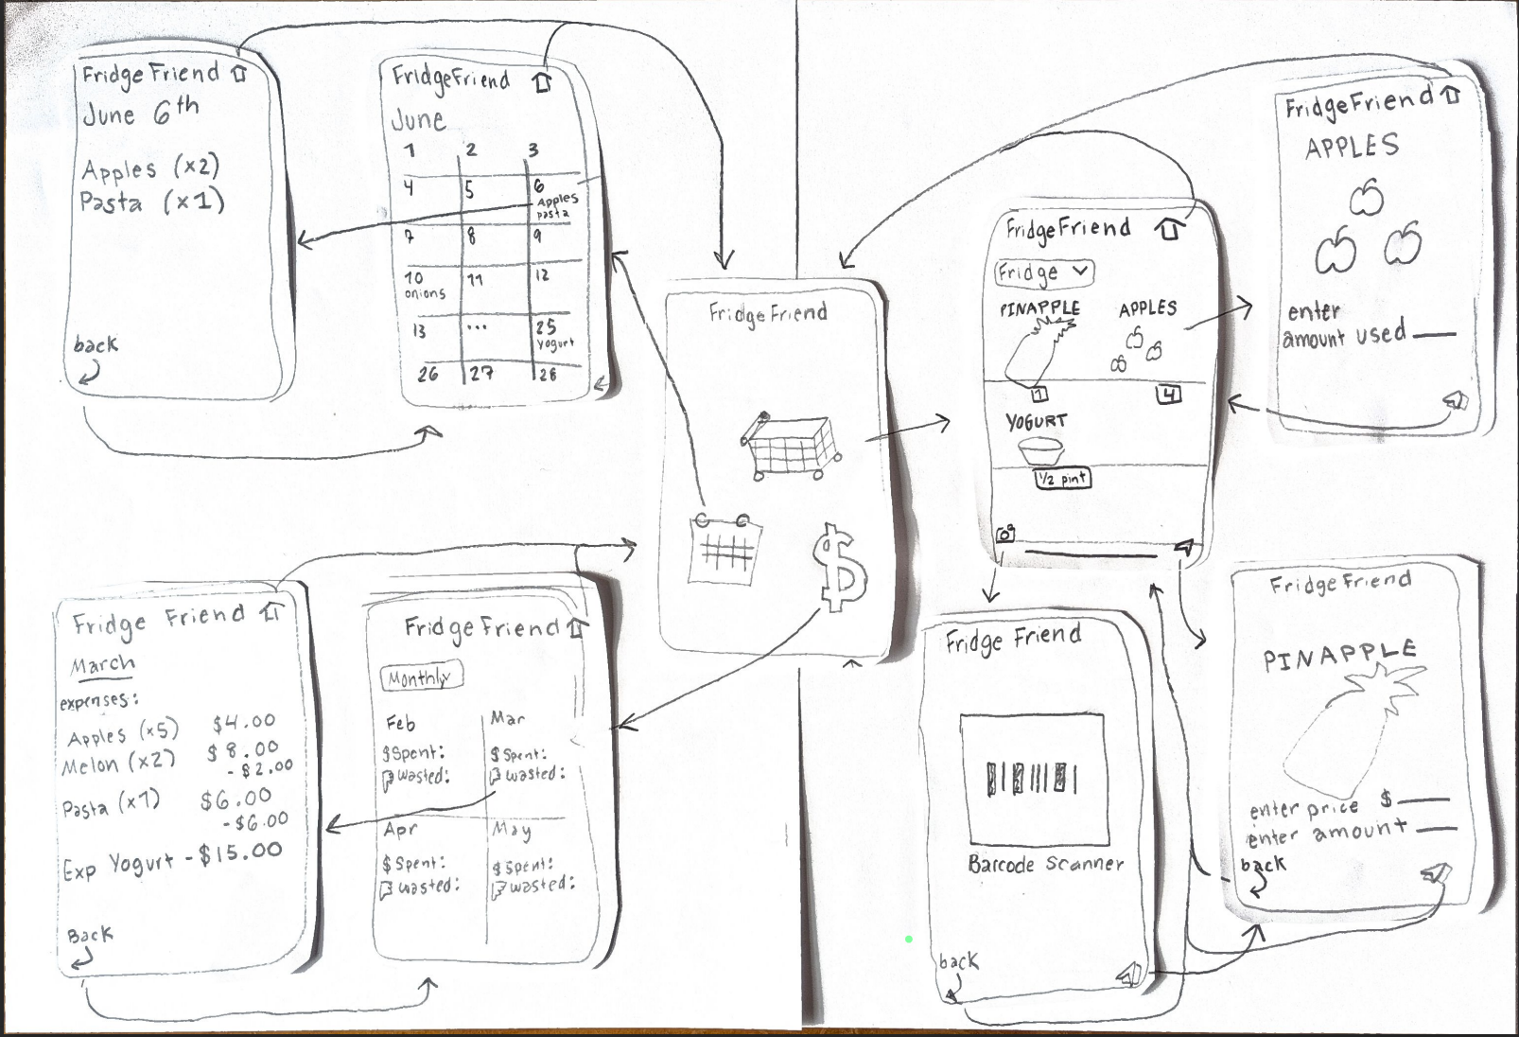

Hardware Interfaces
<Describe the logical and physical characteristics of each interface between the software product and the hardware components of the system. This may include the supported device types, the nature of the data and control interactions between the software and the hardware, and communication protocols to be used.>

Software Interfaces
<Describe the connections between this product and other specific software components (name and version), including databases, operating systems, tools, libraries, and integrated commercial components. Identify the data items or messages coming into the system and going out and describe the purpose of each. Describe the services needed and the nature of communications. Refer to documents that describe detailed application programming interface protocols. Identify data that will be shared across software components. If the data sharing mechanism must be implemented in a specific way (for example, use of a global data area in a multitasking operating system), specify this as an implementation constraint.>

Communications Interfaces
<Describe the requirements associated with any communications functions required by this product, including e-mail, web browser, network server communications protocols, electronic forms, and so on. Define any pertinent message formatting. Identify any communication standards that will be used, such as FTP or HTTP. Specify any communication security or encryption issues, data transfer rates, and synchronization mechanisms.>

System Features

Item Management
4.1.1 Description and Priority
Item Management allows the user to maintain a digital inventory of their physical products in their fridge, pantry, and freezer. Allowing the user to add, edit, and delete items to ensure accurate inventory management, High Priority
4.1.2 Stimulus/Response Sequences
<List the sequences of user actions and system responses that stimulate the behavior defined for this feature. These will correspond to the dialog elements associated with use cases.> NOT REQUIRED FOR DELIVERABLE 1
4.1.3 Functional Requirements
F_REQ-1.1: The system shall allow users to manually add an item.
F_REQ-1.2: The system shall allow users to edit an item’s quantity.
F_REQ-1.3: The system shall allow users to remove an item.
F_REQ-1.4: The system shall allow users to scan a barcode for an item.
F_REQ-1.5: The system shall allow users to mark an item as “opened” to track freshness.
F_REQ-1.6: The system shall allow users to save “Frequently Bought” items to a list.
F_REQ-1.7: The system shall automatically set the date each item was added.
F_REQ-1.8: The system shall display the expiration date of each item.
F_REQ-1.9: The system shall allow users to filter the item list.
F_REQ-1.10: The system shall allow users to select how many days before an item expires to receive a warning.
F_REQ-1.11: The system shall display a warning when items are "near expiring".

Cost Tracking
4.2.1 Description and Priority
Cost Tracking allows the user to view total amount spent over a designated interval (1month/1year) as well as total amount spent on unused food logged into their fridge, pantry and freezer. This provides the user with helpful insight into spending habits, Medium priority.
4.2.2 Stimulus/Response Sequences
<List the sequences of user actions and system responses that stimulate the behavior defined for this feature. These will correspond to the dialog elements associated with use cases.> NOT REQUIRED FOR DELIVERABLE 1
4.2.3 Functional Requirements
F_REQ-2.1: The system shall allow a user to view the price of an item.
F_REQ-2.2: The system shall allow a user to input the price of an item.
F_REQ-2.3: The system shall calculate the total price of all entered items.
F_REQ-2.4: The system shall display the total price.
F_REQ-2.5: The system shall calculate the total price of unused items.
F_REQ-2.6: The system shall allow the user to select a time interval for viewing total spending.

4.3 Expiration Calendar
4.3.1 Description and Priority
The Expiration Calendar lets the user see the dates all of their items expire on a calendar interface. It will display the date and under it will show which items expire that certain day. The user can click the dates to see more information about the items.
4.3.2 Stimulus/Response Sequences
<List the sequences of user actions and system responses that stimulate the behavior defined for this feature. These will correspond to the dialog elements associated with use cases.> NOT REQUIRED FOR DELIVERABLE 1
4.3.3 Functional Requirements
F_REQ-3.1: The system shall display a calendar showing all dates within the month.
F_REQ-3.2: The system shall display the items on the calendar under their corresponding expiration date.
F_REQ-3.3: The system shall allow the user to switch between months.
F_REQ-3.4: The system shall allow the user to click on certain dates.
F_REQ-3.5: The system shall display a list of expired food on a selected date.
F_REQ-3.6: The system shall display details about the item when the date is clicked (location, category, price).
F_REQ-3.7: The system shall update calendar when a new item is added/removed.

4.4 Account
4.4.1 Description and Priority
This application will require that users create accounts. This will allow for the system to track a users inventory information and share this information with their household members, syncing to keep up to date user data, High Priority
4.3.2 Stimulus/Response Sequences
<List the sequences of user actions and system responses that stimulate the behavior defined for this feature. These will correspond to the dialog elements associated with use cases.> NOT REQUIRED FOR DELIVERABLE 1
4.3.3 Functional Requirements
F_REQ-4.1: The system shall encrypt the user information that is given.
F_REQ-4.2: The system shall have the user use a password in order to log in.
F_REQ-4.3: The system shall allow multiple users to access the same information.
F_REQ-4.4: The system shall use two factor authentication for each login.

Other Nonfunctional Requirements

Performance Requirements
<If there are performance requirements for the product under various circumstances, state them here and explain their rationale, to help the developers understand the intent and make suitable design choices. Specify the timing relationships for real time systems. Make such requirements as specific as possible. You may need to state performance requirements for individual functional requirements or features.>

NF_REQ-1.1: The system shall update the item inventory list across linked household devices within 3 seconds of an item being added to the inventory, at least 99% of the time.
NF_REQ-1.2: The system shall parse the data from a barcode scan, displaying the product details within 2 seconds of an image being taken, at least 99% of the time.
NF_REQ-1.3: The system shall display a warning for expiry within one hour, at least 99% of the time.
NF_REQ-1.4: The system shall display search/filter results within 1 second, at least 99% of the time.
NF_REQ-1.5: The system shall calculate the total price within 4 seconds, at least 99% of the time.
NF_REQ-1.6: The system down time shall not exceed 4 hours, at least 99% of the time.

Safety Requirements
<Specify those requirements that are concerned with possible loss, damage, or harm that could result from the use of the product. Define any safeguards or actions that must be taken, as well as actions that must be prevented. Refer to any external policies or regulations that state safety issues that affect the product’s design or use. Define any safety certifications that must be satisfied.>

NF_REQ-2.1: The system shall include a visible disclaimer stating expiration date alerts are estimates and users should inspect their food before consumption.

Security Requirements
<Specify any requirements regarding security or privacy issues surrounding use of the product or protection of the data used or created by the product. Define any user identity authentication requirements. Refer to any external policies or regulations containing security issues that affect the product. Define any security or privacy certifications that must be satisfied.>

NF_REQ-3.1: The system shall restrict household inventory access to authorized members only.
NF_REQ-3.2: The system shall allow full deletion of user information if they delete their profile.
NF_REQ-3.3:The system shall use encryption for all private information

Software Quality Attributes
<Specify any additional quality characteristics for the product that will be important to either the customers or the developers. Some to consider are: adaptability, availability, correctness, flexibility, interoperability, maintainability, portability, reliability, reusability, robustness, testability, and usability. Write these to be specific, quantitative, and verifiable when possible. At the least, clarify the relative preferences for various attributes, such as ease of use over ease of learning.>

NF_REQ-4.1: The system shall function on IOS and Android.
NF_REQ-4.2: The system shall display error messages when the user enters invalid information.
NF_REQ-4.3: The system shall load the main page within 3 seconds.
NF_REQ-4.4: The system shall not crash if a user enters incomplete or invalid information.

Business Rules
<List any operating principles about the product, such as which individuals or roles can perform which functions under specific circumstances. These are not functional requirements in themselves, but they may imply certain functional requirements to enforce the rules.>

NF_REQ-5.1: Each household should have one designated primary account holder.
NF_REQ-5.2: Each item must include a name and a location before being added to inventory.

Other Requirements
<Define any other requirements not covered elsewhere in the SRS. This might include database requirements, internationalization requirements, legal requirements, reuse objectives for the project, and so on. Add any new sections that are pertinent to the project.>
NF_REQ-6.3: The system shall Comply with the California food labeling laws.

Appendix A: Glossary
<Define all the terms necessary to properly interpret the SRS, including acronyms and abbreviations. You may wish to build a separate glossary that spans multiple projects or the entire organization, and just include terms specific to a single project in each SRS.>
Appendix B: Analysis Models
<Optionally, include any pertinent analysis models, such as data flow diagrams, class diagrams, state-transition diagrams, or entity-relationship diagrams.>
Appendix C: To Be Determined List
<Collect a numbered list of the TBD (to be determined) references that remain in the SRS so they can be tracked to closure.>

