Team: Team Development
Architecture Design:
For designing the architecture of FridgeFriend we designed a Model-View-Controller architecture. The main reason we decided to design FridgeFriend using a MVC architecture is a simple and easy to understand model, so we thought it was best for our audience. This model takes a complex process and turns it into a more manageable process. The Model-View-
Controller allows you to view data in multiple different ways, which aligns best with FridgeFriend since items in your inventory will need to be displayed in a calendar view (daily and monthly) and item view (freezer, fridge, and pantry).

Architecture Design Diagram:
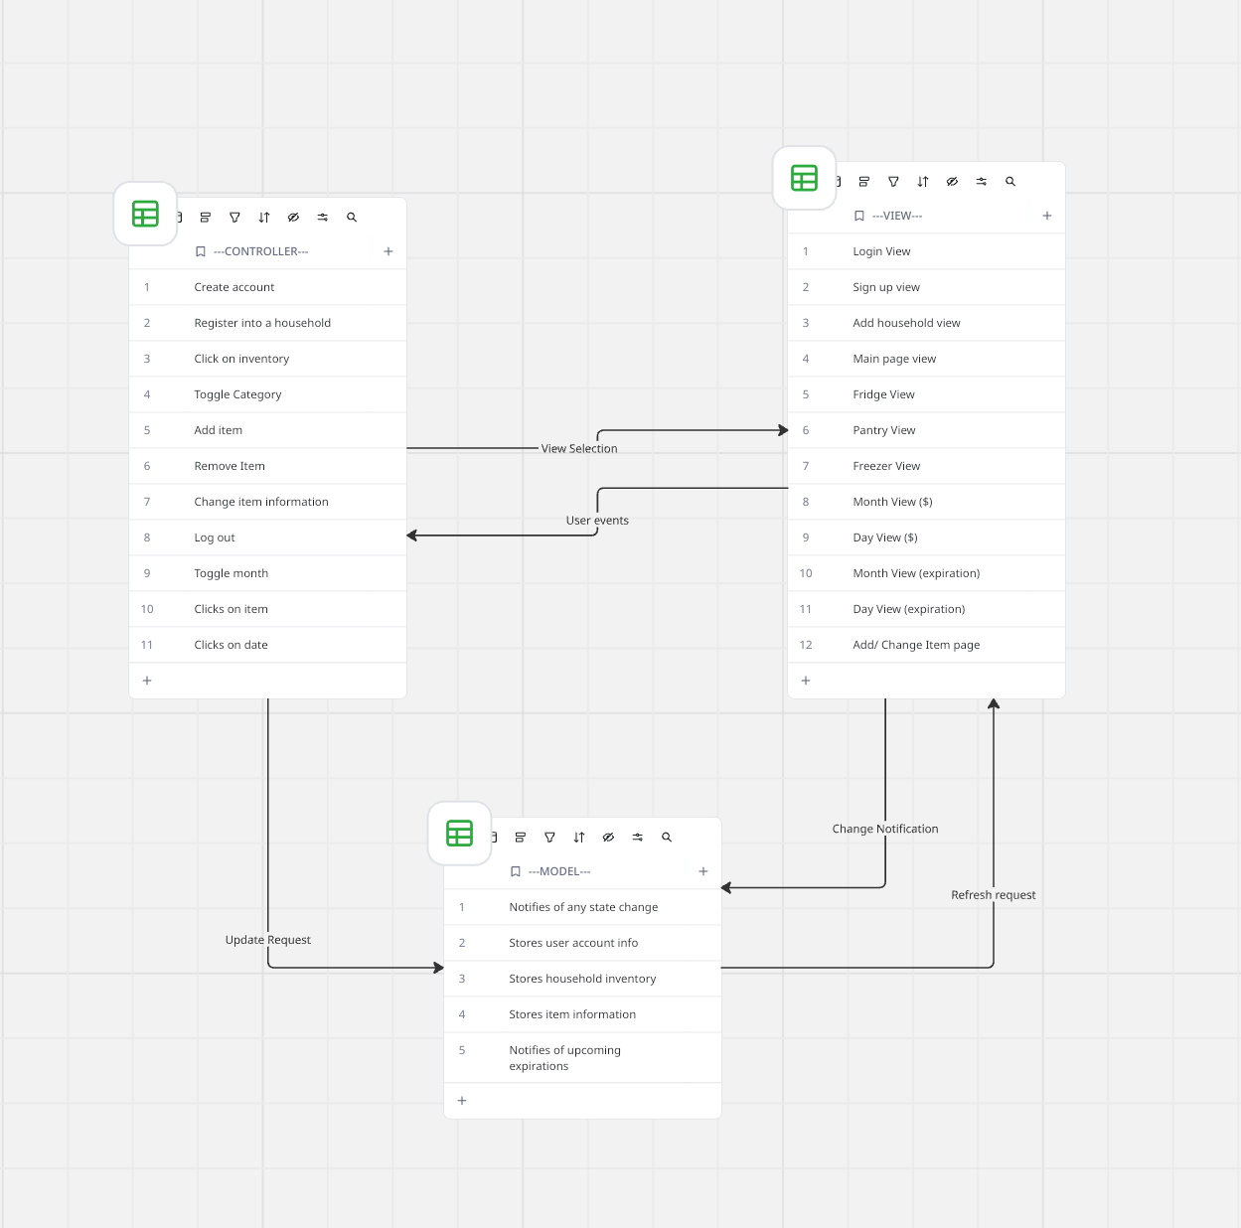

Design Description:
The architectural pattern consists of three components, the view, the controller and the model.
The FridgeFriend app has three layers to its design, those being the View layer, Model layer, and the Controller layer.

In the view layer is where the display/UI of the FridgeFriend application is located. This is achieved using React, CSS, and the data from what the users input.

In the controller section of the FridgeFriend is where most of the functionality of the app will occur. This is where the account management sections would be handled, the entries/editing of food products, and the calendar managements exist.

Then lastly there is the model layer of the FridgeFriend, which handles the more data aligned aspects of the program. In this layer there will be the storage of the user account information, the inventory of the household, and the information of the food items themselves. On this layer is where the notifications will be pushed out regarding expiration dates and information changes.

