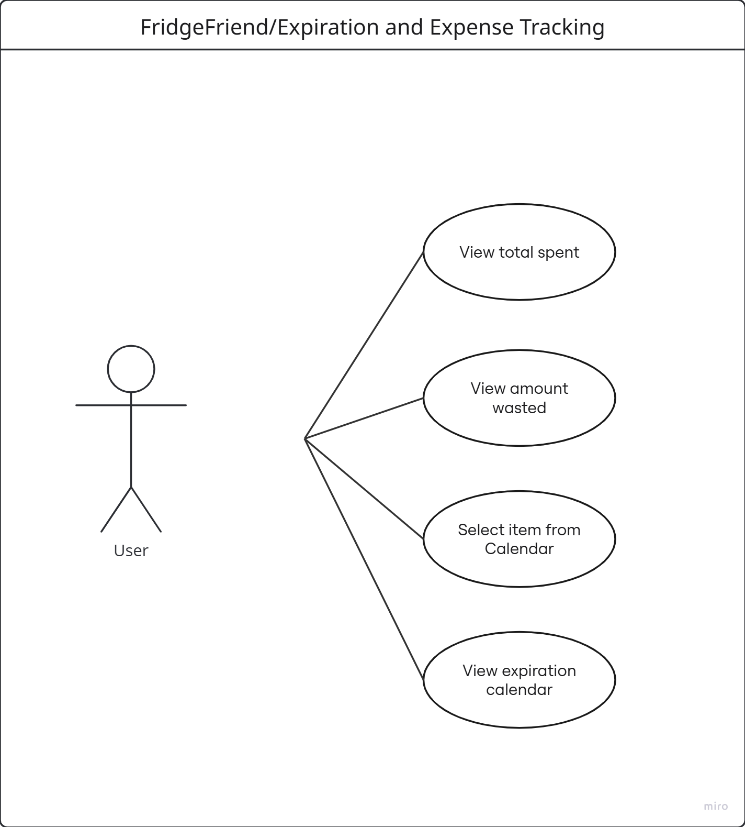

FridgeFriend: Use Case Diagrams

Name/Title: | Add item
ID: | 01
Description: | The user is able to add a new food item into their inventory.
System Under Design: | FridgeFriend
Primary Actor: | Application User
Participants: | None
Related Use Cases: | Extensions: <02, Scan barcode>
Invariant: | The user needs to be connected to the internet and in the FridgeFriend app.
Precondition: | User must be on the inventory page. User must be logged in.
Success Postcondition: | The item is added to the existing inventory and will be visible in their inventory list including name, quantity, category, location, and price. The item is added to the expiration calendar and the price of the item is added into the expense tracking page.

USER STEPS:  1. User presses add item button  3. User inputs item name, quantity, price, item location, and expiration date.  4. User hits add item button | SYSTEM RESPONSE:  2. Opens add item input page  5. System updates inventory list

Name/Title: | Scan barcode
ID: | 02
Description: | The user can use their camera to scan the barcode of their desired item.
System Under Design: | FridgeFriend
Primary Actor: | Application User
Participants: | None
Related Use Cases: | Extensions: <01 Add Item>
Invariant: | The user needs to be connected to the internet and in the FridgeFriend app.
Precondition: | User must be on the inventory page. User must be logged in. User must click the barcode scanner button.
Success Postcondition: | The item is added to the existing inventory and will be visible in their inventory list including name, quantity, category, location, and price. The item is added to the expiration calendar and the price of the item is added into the expense tracking page.

USER STEPS:  1. User positions barcode into the camera view  4. User confirms or edits the auto populated item information for accuracy | SYSTEM RESPONSE:  2. System scans and identifies the item through a product database  3. System auto populates the “Add item” page with item information  5. System updates inventory list

Name/Title: | Edit item
ID: | 03
Description: | The user can modify an item’s information with changes/new information.
System Under Design: | FridgeFriend
Primary Actor: | Application User
Participants: | None
Related Use Cases: | None
Invariant: | The user needs to be connected to the internet and in the FridgeFriend app.
Precondition: | User must be on the inventory page. User must be logged in. User must click on an item.
Success Postcondition: | Item information is updated; marked as opened, quantity changed, expiration date changed, or price changed. The item information is updated on the expiration calendar and expense tracking pages.

USER STEPS:  1. User selects an item  3. User modifies input fields about item  4. User presses “save changes” button | SYSTEM RESPONSE:  2. System opens item input page  5. System updates inventory list

Name/Title: | Delete item
ID: | 04
Description: | The user will be able to remove an item from their inventory, specifically when an item has been consumed, thrown away due to an expiration date, or removed for incorrect entry.
System Under Design: | FridgeFriend
Primary Actor: | Application User
Participants: | None
Related Use Cases: | None
Invariant: | The user needs to be connected to the internet and in the FridgeFriend app.
Precondition: | User must be on the inventory page. User must be logged in.
Success Postcondition: | The item is removed from the inventory, expiration calendar, and expense tracking pages.

USER STEPS:  1. User selects an item to be removed.  3. User clicks on the “Remove” button  5. User confirms the item deletion | SYSTEM RESPONSE:  2. System opens selected item’s details  4. System sends a warning prompting the user to confirm the removal  6. The item is removed from the inventory list and removed from all viewable dashboards (expiration calendar, expense tracking)

Name/Title: | Log in
ID: | 05
Description: | The user will be able to login to their existing account to view all their items and household information.
System Under Design: | FridgeFriend
Primary Actor: | Application User
Participants: | None
Related Use Cases: | None
Invariant: | The user needs to be connected to the internet and in the FridgeFriend app.
Precondition: | User must be on the login page. User must have an account.
Success Postcondition: | User enters their email and password, successful login takes the user to the homepage with their account.

USER STEPS:  1. User selects “Log in” option  3. User enters credentials (email and password)  4. User presses “Log in” button | SYSTEM RESPONSE:  2. System opens login page and prompts user for email and password  5. System validates credentials against the database  6. System grants user access to homepage

Name/Title: | Log out
ID: | 06
Description: | The user will be able to end their authenticated login session.
System Under Design: | FridgeFriend
Primary Actor: | Application User
Participants: | None
Related Use Cases: | None
Invariant: | The user needs to be connected to the internet and in the FridgeFriend app.
Precondition: | User must be logged in.
Success Postcondition: | The session is cleared and the user is directed back to the login screen.

USER STEPS:  1. User clicks on “Log out” button | SYSTEM RESPONSE:  2. System clears session data and returns to the login page

Name/Title: | Create account
ID: | 07
Description: | The user can create an account.
System Under Design: | FridgeFriend
Primary Actor: | Application User
Participants: | None
Related Use Cases: | None
Invariant: | The user needs to be connected to the internet and in the FridgeFriend app.
Precondition: | User must not have an account. User must be on the sign up page.
Success Postcondition: | User successfully creates a new account and initializes all item tracking pages.

USER STEPS:  1. User selects “Sign up” option  4. User inputs their email and new password  5. User presses Submit | SYSTEM RESPONSE:  2. System opens “Sign up” page  3. System prompts user for email, password, and password confirmation  6. System verifies the email address is unique  7. System creates profile and sends verification

Name/Title: | Invite Household Member
ID: | 08
Description: | The user can invite household members to join a household to share inventory data.
System Under Design: | FridgeFriend
Primary Actor: | Application User
Participants: | None
Related Use Cases: | None
Invariant: | The user needs to be connected to the internet and in the FridgeFriend app. Only one user can be Owner/Admin of a household.
Precondition: | User must be logged in. User must have Admin/Owner permissions. User must be on the Household page.
Success Postcondition: | The household member list is updated and inventories are synced between household member accounts.

USER STEPS:  1. User clicks “Household” page button  3. User clicks on add new member  5. User enters new member’s email and name  6. User presses submit | SYSTEM RESPONSE:  2. System opens Household page  4. System opens new member input  7. System sends invitation and updates the household list

Name/Title: | Sync inventory data
ID: | 09
Description: | The system synchronizes the user's local device data with cloud server to reflect inventory changes.
System Under Design: | FridgeFriend
Primary Actor: | Application User
Participants: | None
Related Use Cases: | None
Invariant: | The user needs to be connected to the internet and in the FridgeFriend app.
Precondition: | User must be logged in.
Success Postcondition: | The inventory, expiration calendar, and expense tracking data are updated to keep them current with the cloud database.

USER STEPS:  1. User pulls down to refresh or system triggers auto-sync | SYSTEM RESPONSE:  2. System connects to server and pulls latest information/updates  3. System refreshes user interface

Name/Title: | View expiration calendar
ID: | 10
Description: | The system will display the current month and the user's items with expiration dates of that month will populate into the correct calendar dates.
System Under Design: | FridgeFriend
Primary Actor: | Application User
Participants: | None
Related Use Cases: | None
Invariant: | The user needs to be connected to the internet and in the FridgeFriend app.
Precondition: | User must be logged in. User must be on Home page.
Success Postcondition: | The calendar will be displayed with current month and show items expiration date on the calendar.

USER STEPS:  1. User clicks the calendar button on home screen | SYSTEM RESPONSE:  2. System connects to server and pulls latest information/updates for expiration dates  3. System displays calendar layout for particular month  4. System populates that months expiration dates into the calendar and displays

Name/Title: | Select Item from calendar
ID: | 11
Description: | The system will display the chosen item with most recent expiration date and quantity number
System Under Design: | FridgeFriend
Primary Actor: | Application User
Participants: | None
Related Use Cases: | None
Invariant: | The user needs to be connected to the internet and in the FridgeFriend app.
Precondition: | User must be logged in. User must be on the calendar page
Success Postcondition: | The information pertaining to an item will be displayed

USER STEPS:  1. User chooses drop down menu of months  2. User clicks on the month they want to see  5. User clicks on an item in the month | SYSTEM RESPONSE:  3. System loads the information for the chosen month  4. System displays up to date calendar  6. System finds that item in the inventory and displays a screen including the expiration date, the quantity and the name to the user

Name/Title: | View total spent
ID: | 12
Description: | The system will display total amount spent in a given month
System Under Design: | FridgeFriend
Primary Actor: | Application User
Participants: | None
Related Use Cases: | None
Invariant: | The user needs to be connected to the internet and in the FridgeFriend app.
Precondition: | User must be logged in. User must be on the Home page.
Success Postcondition: | The total amount spent in a chosen month will be displayed

USER STEPS:  1. User clicks the budgeting button on home screen | SYSTEM RESPONSE:  2. System connects to server and pulls latest information/updates for purchases  3. System displays a list of all purchases made in the latest month  4. System adds up all purchases displayed and displays a total sum to the user at the bottom of the screen

Name/Title: | Remove Household member
ID: | 13
Description: | The system will remove a user as a member of the household and not allow them to impact or view any of the households inventory
System Under Design: | FridgeFriend
Primary Actor: | Application User
Participants: | Member being removed
Related Use Cases: | None
Invariant: | The user needs to be connected to the internet and in the FridgeFriend app. User must have Admin/Owner permissions
Precondition: | User must be logged in. User must be on the Home page.
Success Postcondition: | Specified member will be removed

USER STEPS:  1. User clicks the household button on homescreen  4. User clicks trash bin button next to a members name | SYSTEM RESPONSE:  2. System connects to server and pulls latest information/updates about all of the current household members  3. System displays all members in a list format to the screen  5. System removes associated email and account from household, member is removed from list  6.Updated members list is displayed to the screen  7. A message saying the removal was successful is displayed

Name/Title: | Mark item as used
ID: | 14
Description: | The system will update the inventory of a specified item
System Under Design: | FridgeFriend
Primary Actor: | Application User
Participants: | None
Related Use Cases: | None
Invariant: | The user needs to be connected to the internet and in the FridgeFriend app.
Precondition: | User must be logged in. User must be on the Inventory page.
Success Postcondition: | Inventory will be updated

USER STEPS:  1. User clicks on inventory button  4. User selects an item  6. User changes inventory number  7. User saves changes | SYSTEM RESPONSE:  2. System gathers inventory data  3. System displays inventory page with most recently added information  5. System opens item input page  8. System updates inventory list

Name/Title: | View amount wasted
ID: | 15
Description: | The system will display total amount wasted in a given month.
System Under Design: | FridgeFriend
Primary Actor: | Application User
Participants: | None
Related Use Cases: | None
Invariant: | The user needs to be connected to the internet and in the FridgeFriend app.
Precondition: | User must be logged in. User must be on the homepage.
Success Postcondition: | The total amount wasted in a chosen month will be displayed on the expense page.

USER STEPS:  1. User clicks the expense page button on home screen | SYSTEM RESPONSE:  2. System connects to server and pulls latest information/updates.  3. System displays a list of all money wasted in the latest month.  4. System adds up all wasted purchases displayed and displays a total sum to the user at the bottom of the screen.

Name/Title: | View inventory
ID: | 16
Description: | The system will display the current food inventory of the household.
System Under Design: | FridgeFriend
Primary Actor: | Application User
Participants: | None
Related Use Cases: | None
Invariant: | The user needs to be connected to the internet and in the FridgeFriend app.
Precondition: | User must be logged in. User must be on the homepage.
Success Postcondition: | The inventory will be displayed to the user.

USER STEPS:  1. User clicks on inventory button | SYSTEM RESPONSE:  2. System gathers inventory data  3. System displays inventory page with most recently added information

