2009年2月 X X X X Feb. 2009

第32卷第1期 XXXXXXXXXXXXXXXXXXXXXXXXXXXXXXX Vol.32 No.1

文章编号：100XXXXXXXXXXXXXXX-00

一种XXXXXXXXXXXXXXXXXXXXXXXXXX机制

X X, XXX, XXX, XXX, XXX

( XXXXXX XXXXXXX, XX XXXXX)

摘要: 为了实现带内模式下控制链路的快速升级，XXXXXXXXXXXXXXXXXXXXXXXXXXXXXXXXXXXXXXXXXXXXXXXXXXXXXXXXXXXXXXXXXXXXXXXXXXXXXXXXXXXXXXXXXXXXXXXXXXXXXXXXXXXXXXXXXXXXXXXXXXXXXXXXX但是需要占用额外的流表空间．

关 键 词: 软件定义网络；带内模式；网络配置升级；网络管理

中图分类号: XXXXX.53 文献标志码: A

An XXXXXXXXXXXXXXXXXXXXXXXXXXXXXXXXXXX Networking

XXX，XXXXXXXX，XXX，XXXXXXX，XXXXXXX

(XXXXXXXXXXXXXXXXXXXXXXXXXX, XXXXXXXXXXXXXXXXXX, XXXX XXXX, XXXX)

Abstract: In order to solve the problems which may arise when the routing policy of control plane is updated in in-band mode, an update mechanism based on the destination oriented routing is proposed. The mechanism divides the update policy into subclasses based on the different destinations, and also separates the uplink routing from downlink routing based on the destination. And a unified update algorithm is presented for the updating of both uplink and downlink of controlling traffic. The experiment result shows that our mechanism could be more efficient both in the computation time and in updating time, but some extra flow entries may be needed.

**Key words:** software defined networking; in-band control; network policy update; network management

软件定义网络（SDN, software defined networking）是近年来在学术界和工业界都重视研究与应用的一种新的网络架构. X X X X X X X X X X X X X X X X X X X X X X X X X X X X X X X X X X X X X X X X X X X X X X X X X X X X X X X X X X X X X X X X X X X X X X X X X X X X X X X X X X X X X X X X X X X X X X X X X X X X X X 即使初始配置状态与目标配置状态能够保证正确，在向大量交换机下发数据包时也无法保证中间状态的正常.

收稿日期: 2008-01-01

基金项目: XXXXXXXXXXXXXXXXXXXXXXXXXXXXXXXXX

作者简介: XXXXXXXXXXXXXXXXXXXXXXXXXXXXXXXXXXXXXXXXX

作者简介: 作者姓名(1970-), 男, 职称. E-mail: abc@bupt.edu.cn

虽然X X X X X X X X X X X X X X X X X X X X X X X X X X X X X X X X X X X X X X X X X X X X X X X X X X X X X X X X X X X X X X X X X X X X X X X X X X X X X X 问题.

# 带内模式控制路由升级问题

## 问题描述

文献[1]对带内模式控制路由升级问题进行了研究，基于控制路径的定义，X X X X X X X X X X X *X X* X X X X X X X X X X X X X X X X X X X X X X X X X *X X* X X X X X X X X X X X X X X X X X X X X X X X X X X X X X X X X *X X* X *X X* X X X X X X X X X X X *X* X X X X X X X X X X X X X X X X *X* X X X X X X X X X X X X X X X X X X X X X X X X X X X X X X X X X X X X X X X X X X X X X X X X X X X X X X X X X X *X X* X X X X X X X X X X X X X X X X X *X X* X X X X 而此通路则由已升级的交换机集合*X*与未升级的交换机集合*Y*组成，如．

通过对每个交换机建立不等式并建模为整数线性规划求解, X X X X X X X X X X X X X X X X X X X X X X X X X X X X X X X X X X X X X X X X X X X X X X X X X X X X X X X X X X X X X X X X X X X X X X X X X X X X X X 在此时间内的最优结果即被认为是最优解．

## 问题处理

在SDN的带内模式下，X X X X X X X X X *X X* X X X X X X X X X X X X X X X X X X X X X *X X* X X X X X X X X X X X X X X X X X X X X X X X X X X X X X X X X X X X X X X X X X X X X X X X X X X X X X X X X X X X X X X X X X X X X X X X X X X X X X X X X X X 而从控制器到单个交换机的路径升级计算则可以通过基于无环的依存关系算法来求取.

如上所述，X X X X X X X X X *X X* X X X X X X X X X X X X X X X X X X X X X *X X* X X X X X X X X X X X X X X X X X X X X X X X X X X X X X X X X X X X X X X X X X X X X X X X X X X X X X X X X X X X X X X X X X X X X X X X X X X X X X X X X X X X X X X X X X X X X X X X X X X X X X X X X X X X X X X X X X X X X X X X X X X X X X X X X X X X X X X X X X X X X X X X X X X X X X X X X X X X X X X X X X X X X X ，同时保证对应的上下行链路不会造成丢包即可完成升级.

将交换机标记为*Si*，*i*是不同交换机的唯一ID，因为是带内模式，控制器是架设在某个交换机之上的，所以控制器也可由此交换机的标记所代表，在此可标记为*C*. X X X X X X X X X X X X X X X X X X *X* X X X X X X *X X* X X X X X X *X X* X X X X X X X X X X X X X X X X X X X X X X X *X X* X X X X X X X X X X X X X *X X* X X X X X X 下一个节点*Si+*1的一条有向边.

上行链路的升级：X X X X X X X X X X X X X X X X X X X X X X X X X X X X X X X X X X X X X X X X X X X X X X *X* X X X X X X X X X X X X X X X X X X X X X X X X X X X X X X X *X* X X X X X X X X X X X X X X X X X X X X X X X X X X X X X X X X X X X X X X X X X X X X X X X X X X *X* X X X X X X X X X X X X X X X X X X X X *X* X X X X X X X X X X X X X *X X* X X X X X X X *X X* X X X X X X X X X X X X X X *X X* X X X X X X X X X X X X X X X *X X* X X X X *X* X X X X X X X X X X X X 交换机*Si*在任意时刻发送的数据包都有链路到达控制器*C*.

下行链路的升级：由于从控制器*C*到任意交换机*Si*的下行控制链路可以由到不同目的的交换机进行区分，X X X X *X* X X X X X X X X X X X X X X X X X X X *X* X X X X X X *X X* X X X X X X X X X X X X X X X X *X X* X X X X X X X X X X X X X X X X X X X X X X X X X X X X X X X X X X X X X *X X* X X X X X X X X X X X X X X X X X X X *X* X X X X X X X X X X X X X X X X X *X* X X X X X X X X X X X X X X X *X X* X X X X X X X X X X X X X *X* X X X X X X *X X* X X X X X X X X X X X X 控制器*C*在任意时刻发送的数据包都有链路到达交换机*Si*.

可见上述2个问题可以归结为一个问题：X X X X X X X X X X X *X* X X X X X X *X* X X *X* X X *X* X X X X X X X X X X X X X X X X X X X X X X X X *X X* X X X X X X *X X* X 使得在任意时刻，*G*0或*G*1中的任意节点都有链路通向根节点.

# 求解算法

## 算法步骤

按前文所述，笔者提出了一种新的机制：将上行链路与下行链路分开，根据目的节点将转发配置进行区分后分别计算基于目的节点的各节点流表的升级顺序. X X X X X X X X X X X X X X X X X X X X X X X X X X X X X X X X X X X X X X X X X X X X X X X X X X X X X X X X X X X X X X X X X X X X X X X X X X X X X X X X X X X X X X X X X X X X X X X X 再根据优先级顺序下发升级流表，以减少流表空间的使用.

当目的节点确定时，X X X X X X X X X X X X X X X X X X X X X X X X X X X X X X X X X X X X X X X X X X X X X X X X X X X X X X X X X X X X X X X X X X X X X X X X X X X X X X X X X X X X X X X X X X X X X X X X X X X X X X X X X X X X X X X X X X X X X X X X X X X X X X X X X X X X X X X X X X X X X X X X X X X X X X X X X X X X X X X 算法的具体步骤如下．

输入: {初始配置: *original policy*} *,* {目标配置: *target policy*}, 目的节点集合: *Destination*

输出: 流表升级顺序: network update

1. for *d* in *Destination*:
2. generate directed graph *G*0 from original policy*,* and *G*1 From target policy.
3. generate directed graph *Gu* from the union of *G*0 and *G*1.
4. If SCC(strongly connected components) exists in *Gu．*
5. Do: update algorithm for the loops
6. Else Do: update algorithm for no loop
7. End if
8. for each *Si*:
9. Merge the flow-entries with the same *ki*
10. End for
11. End for
13. update algorithm for no loop (*G*0, *G*1 , *Gu* )
14. for *Si* in *Gu*:
15. if *Si* in *G*0.
16. *ki* = 1;
17. Else: *ki* = 0;
19. update algorithm for the loops(*G*0 , *G*1 , *Gu* )
20. reference algorithm

强连接度存在性判定：X X X X X X X X X X X X X X X X X *X* X X X X X X X X X X X *X* X X X X X X X X X *X* X X *X X* X *X X* X X X X X X X X X X X *X X* X *X X* X X X X X X X *X X* X X X X *X X* X X X X X X X X X X X *X X* X X X X X *X X* X X X X X X X X X X X X X X X X X X X X X X X X X X X X X X X X X X X通过Tarjan算法判定*Gu*中是否存在1个节点以上的强连通分量.

若不存在X X X X X X X X X X X X X X X X X *X X* X X X X X X X X X X X X X X X X X X X X X X X X X X X X 升级.

无环升级机制：X X X X X X X *X X* X X X X X X X *X X* X X *X X* X *X X* X X X *X X* X X X X X X X X X X X X X X X X X *X X* X X X X X X X X X X X X X X X X X X X X X X X X X 升级．

1) 对于X X X X X X X X X X X X X X X X X X X X X X *v*.

2) 同时X X X X X X X X X X X X X X X X X X X X X X节点.

可以X X X X X X X X X X X X X X X X X X X X X X X X X X X X X X X X X X X X X X X X X X X X节点.

由于上行链路是存在多个叶节点指向根节点的有向树，X X X X X X X X X X X X X X X X X X X X X X X X X X X X X X X X X X X X X X X X X X X X X X X X X X X X X X X *X* X X X X X X *X X* X X X X X X X X X X X X X X X X X X X X X X X X X X X X X X X X X X X X X X X X X X X X X X X X X X X X X X X X X X X X X X X X X X X X X X X X X X X X X X X X X X X X X X X X X X X X X X X X X X X X X X X X X X X X X X X X X X X X X X X X X X X X X 对下行链路的配置变化进行升级.

若判断存在多节点的强连通分量，X X X X X X X X X X X X X X X X X X X X X X X X X X X X X X X X X X X X X X X X X X X X X X X X *X X* X X X X X X X X X X X X X X X X X X X X X X X X X X X X X X X X X X X X X X X X X X X X X X X X X X X X X X X X X X X X X X X X X X X X X X X X X X X X X X X X X X X X X X X 具体算法如下．

有环的优先级求解：从初始配置*G0*开始，对每个节点在图*G0*中加入该节点的新的配置边，检查是否会引入回环，若不会则此节点为根节点，否则作为不明节点暂存. X X X X X X X X X X X X X X X X X X X X X X X X X X X X X *X* X X X X X *X* X X X X X X X X X X X X X X *X* X X X X X X X X X X X X *X* X X X X X X X X X X X X X X X X *X* X X X X *X* X X X X X X X X X *X* X X X X X X X X X X X X X X X X X X X X X X X X X X X X X X X X X X X X X X X X X X X X X X X X X X X 而升级时则先升级父节点，再升级其子节点，并以此类推.

如前文所述，X X X X X X X X X X X X X X X X X X X X X X X X X X X X X X X X X X X X X X X X X X X X X X X X X X X X X X X X X X X X X X X X X X X X X X X X X X X X X X X X X X X X X X X X X X X X X X X X X X X X X X X X X X X X X X X X X X X X X X X X X X X X X X X X X X X X X只需保证升级过程中上下行链路都是无损通信即可．

## 算法分析

与文献[1]X X X X X X X X X X X X X X X X X X X X X X X X X X X X X X X X X X X X X X X X X X X X X X X X X X X X X X X X X X X X X X X X X X X X X X X X X X X 处理.

对下行流表来说，X X X X X X X X X X X X X X X X X X X X X X X X X X X X X X X X X X X X X X X X X X X X X X X X X X X X X X X X X X X X X X X X X X X X X X X X X X X X X X X X X X X X X X X X X X X X X X X X X X X X X X X X X X X X X X X X X X X X X X X X X X X X X X X X X X X X X X X X X X X X X X X X X X X X X X X X X X X X X X X X X X X X X X X X X X X X X X X X X X X X X X X X X X X X X X X X X X X X X X X X X X X X X X X X X X X X X X X X X X X X X X X X X X X X X X X X X X X X X X X X X X X X X X X X X 如带给交换机和控制器额外的处理压力、传输路径偏移问题等，需要进一步的研究.

对上行流表来说，X X X X X X X X X X X X X X X X X X X X X X X X X X X X X X X X X X X X X X X X X X X X X X X X X X X X X X X X X X X X X X X X X X X X X X X X X X X X X X X X X X X X X X X X X X X X X X X X X X X X X X X 存在环路时的时间复杂度为，*~~V~~*~~和~~*~~E~~*~~的定义与前文相同.~~

# 实验仿真

在仿真中使用了2个拓扑数据库X X X X X X X X X X X X X X X X X X X X X X X X X X X X X X X X X X X X X X X X X X X X X X X X X X X X X X X X X X X X X X X X X X X X X X X X X X X X X X X X X X X X X X X X X X X X X X X X X X X X X X X X X X X X X X X X X X X X X X X X X X X X X X X X X X X X X X X X X X X X X X X X X X X X X X X X X X X X X X X X X X X X X X X X X X X X X X X X X X X X X X X X X X X X X X X X X X X X X X X X X X X X X X X X X X X X X X X X X X X X X X X X X X X X X X X X X X X X X X X X X X X X X X X X X X X X X X X X X X X X X X X X X X X X X X X X X X X X X X X X X X X X X X X X X X X X X X X X X X X X X X X X X X X X X X X X X X X X X X X X X . 下面来分别讨论对于上行链路和下行链路的配置升级的实验情况.

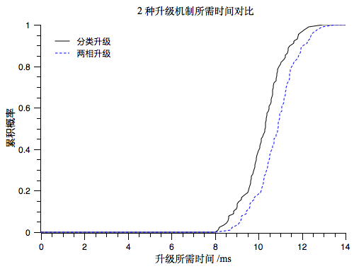实验主要关注的是上行链路的升级计算X X X X X X X X X X X X X X X X X X X X X X X X X X X X X X X X X X X X X X X X X X X X X X X X X X X X X X X X X X X X X X X X X X X X X X X X X X X X X X X X X X X X X X X X X X X X X X X X X X X X X X X X X X X X X X X X X X X X X X X X X X X X X X X X X X X X X X X X X X X X X X X X X X 需要的计算更为复杂，所以以上行链路的计算所需时间来进行参照.

图1所示为在从10个节点增加到50个节点，X X X X X X X X X X X X X X X X X X X X X X X X X X X X X X X X X X X X X X X X X X X X X X X X X X X X X X X X X X X X X X X X X X X X X X X X X X X X X X X X X X X X X X X X X X X X X X X X X X X X X X X X X X X X X X X X X X X X X X X X X X ，节约了求解的时间.

图 2 不同拓扑下的所需升级周期次数

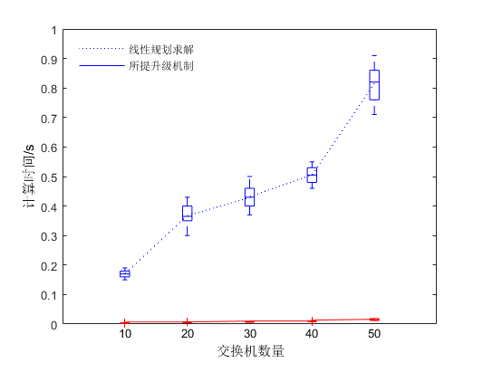在不同拓扑规模下，X X X X X X X X X X X X X X X X X X X X X X X X X X X X X X X X X X X X X X X X X X X X X X X X X X X X X X X X X X X X X X X X X X X X X X X X X X X X X X X X X X X X 配置，X X X X X X X X X X X X X X X X X X X X X X X X X X X X X X X X X X X X X X X X X X X X X X X X X 仍然在一个可接受的时间范围内．

图 1 2种算法的所需时间比较

图2X X X X X X X X X X X X X X X X X X X X X X X X X X X X X X X X X X X X X X X X X X X X X X X X X X X X X X X X X X X X X X X X X X X X X X X X X X X X X X 可完成升级.

图3中，将所提出的分类处理升级机制与目前通用的两相升级机制进行了实验对比.X X X X X X X X X X X X X X X X X X X X X X X X X X X X X X X X X X X X X X X X X X X X X X X X X X X X X X X X X X X X X X X X X X X X X X X X X X X X X X X X X X X X X X X X X X X X X X X X X X X X X X X X X X X X X X X X X X X X X X X X X X X X X X X X X X X X X X X X X X X X X X X X X X X X X X X X X X X X X X X X X X X X X X X X X X X X X X X X X X X X X X X X X X X X X X X X X X X X X X X X X X X X X X X X X X X X X X X X X X X X X X X X X X X X X X X X X X X X X X X X X X X X X X X X X X X X X X X X X X X X X X X X X X X X X X X X X X X X X X X X X X X X X X X X X X X X X X X X X X X X 同时不需要与两相升级机制一样在所有转发节点上使用双倍的流表空间.

# 结束语

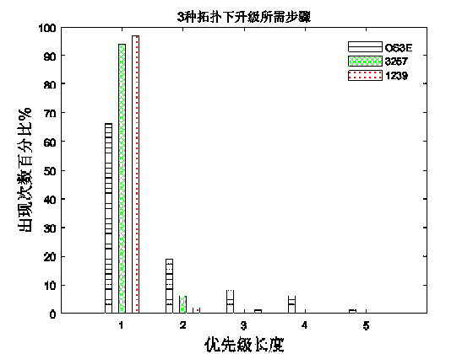对带内模式下控制链路的配置升级问题，X X X X X X X X X X X X X X X X X X X X X X X X X X X X X X X X X X 行分割，X X X X X X X X X X X X X X X X X X X X X X X X X X X X X X X X X X X X X X X X X X X X X X X X X X X X X X X X X X X X X X X X X X X X X X X X X X X X X X X X X X X X X 预期.

图 3 与当前算法的升级所需时间比较

参考文献:

1. Zhang Shuyuan, et al. In-band update for network routing policy migration[C]//2014 IEEE 22nd International Conference on Network Protocols (ICNP 2014). [s.l.]: IEEE, 2014: 356-361
2. Mahajan R, Wattenhofer R. On consistent updates in software defined networks[C]//2013 Proceedings of the Twelfth ACM Workshop on Hot Topics in Networks(HoTNets 2013). [s.l.]: ACM, 2013: 20.
3. Curtis A R, Mogul J C, Tourrilhes J,et al. DevoFlow: scaling flow management for high-performance networks[C]// 2011 ACM SIGCOMM Computer Communication Review(CCR 2011). [s.l.]: ACM, 2011: 254-265
4. Kazemian P, Varghese G, McKeown N. Header space analysis: static checking for networks[C]// USENIX Symposium on Networked Systems Design and Implementation (NSDI 2012). [s.l.]: IEEE, 2012: 113-126.