2014年7月 北 京 邮 电 大 学 学 报 Jul. 2014
第37卷第1期 Journal of Beijing University of Posts and Telecommunications Vol.37 No.1

文章编号：1007-5321（2014）04-0000-00

多波长转换结合网络编码的光组播结构和最小转换度调度
XXX¹，XXX¹，XX²，XXX¹
(1. XXXXXX XXXXXXXX，XX XXXXXX；2. XXXXXX XXXXX，XX XXXXXX)
摘要: 组播的应用使光交换节点的丢包率和分组竞争概率增加．X X X X X X X X X X X X X X X X X X X X X X X X X X X X X X X X X X X X X X X X X X X X X X X X X X X X X X X X X X X X X X X X X X X X X X X X X X X X X X X X X X X X X X X X X X X X X X X X X X X X X X X X X X X X X X X X X X X X X X X X X．仿真结果表明，相比现有的光组播节点及算法，该结构能够在低成本代价和低时延的基础上降低丢包率，提升了光组播节点的性能．
关 键 词: 光组播；节点结构；最小转换度调度；网络编码
中图分类号: TN929.11 文献标志码: A

An Optical Multicast Node Architecture with Multi-Wavelength Conversion and Network Coding and Its Scheduling Respect to Minimal Conversion Degree
X XX¹，X XX ¹， XX²，X XX ¹
(1.XXXXXXXXXXX，XXXXXXX，XX XXXXXX,X；2.XXXXXXX，XXXXXXXXXXXX，XX XXXXXX，XX)
Abstract: Increasing of multicast application makes the packet loss probability and the probability of packet collision increase in optical switching node. To improve it, a novel optical multicast switching node architecture integrating with the advantage of multi-wavelength conversion technology and network coding technology is designed. A group of feedback shared limited range of multi-wavelength converters and a group of output shared network encoders are configured in the optical multicast node architecture. With respect to the minimal wavelength conversion degree in optical multicast scheduling, an improved maximal weighted stable set is designed to optimize the wavelength assignment. Comparing with the existing optical multicast nodes and algorithms, the simulation results show that the proposed node architecture and algorithm largely reduce the packet loss probability with low node cost and low delay to improve the optical node performance.
Key words: optical multicast; node architecture; minimal conversion degree scheduling; network coding

近年来，随着组播应用的不断增加，人们对于多点传输的需求越来越大．X X X X X X X X X X X X X X X X X X X X X X X X X X X X X X X X X X X X X X X X X X X X X X X X X X X X X X X X X X X X X X X X X X X X X X X X X X X X X X X X X X X X X X X X X X X X X X X X X X X X X X X X X X X X X X X X X X X X X X X X X X．刘焕淋等^{[1]}提出一种基于有限范围多波长转换器和全范围波长转换器的双层波长转换（TLWC，two layers wavelength conversion）节点结构．
收稿日期: 2014-07-28
基金项目：XXXXXXXXXXXXXXXXXXXXXXXXXXXXXXXXXXXXXXXXXXXXXXXXXXXXXX XXXXXXXXX
作者简介: XXX(XXXX)，X，XX，XXX，XXXXXXXX.
随着网络编码的不断发展，X X X X X X X X X X X X X X X X X X X X X X X X X X X X X X X X X X X X X X X X X X X X X X X X X X X X X X X X X X X X X X X X X X X X X X X X X X X X X X X X，有效避免基于光/电/光（O/E/O，opto-electro-opto）换降低处理速度问题[5]．

光组播节点结构及其工作原理
笔者设计一种综合波长转换技术和网络编码技术的光组播交换节点结构(OMN-MCNC，optical multicast node with of multi-wavelength conversion and network coding)，如图1所示．X X X X X X X X X X X X X X X X X X X X X X X X X X X X X X X X X X X X X X X X X X X X X X X X X X X X X X X X X X X X X X X X X X X X X X X X X X X X X X X X X X X X X X X X X X X X X X X X X X X X X X X X X X X X X X X X X．有限范围多波长转换器采用反馈共享的配置方式，基于逻辑运算的全光网络编码器采用输出共享方式配置．
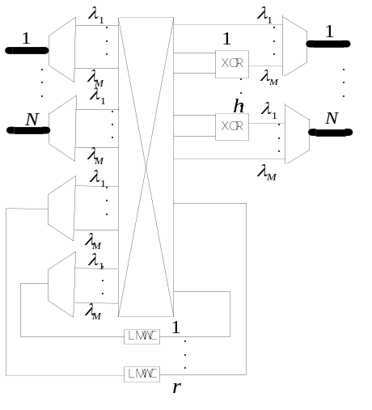
图1 OMN-MCNC节点结构
在一个时隙周期内，当分组到达光交换矩阵时，若没有冲突，则分组无延时地直接送到目的端口．X X X X X X X X X X X X X X X X X X X X X X X X X X X X X X X X X X X X X X X X X X X X X X X X X X X X X X X X X X X X X X X X X X X X X X X X X X X X X X X X X X X X X X X X X X X X X X X X X X X X．若冲突分组是单播分组，则直接送到网络编码器解决．
在网络编码器解决冲突的阶段，X X X X X X X X X X X X X X X X X X X X X X X X X X X X X X X X X X X X X X X X X X X X X X X X X X，进行全光网络编码操作后发送到目标波长上．
在OMN-MCNC中，编码器的编码操作采用一种基于逻辑运算的全光网络编码器件[4]，X X X X X X X X X X X X X X X X X X X X X X X X X X X X X X X X X X X X X X X X X X X X X X X X X X X X X X X X X X X X X X X X X X X X X X X X X X X X X X X X X X X X X X X X X X，定义2个编码向量为
U={p_{n}=(1 2^{n})^{T}|n∈N} (1)
V={q_{m}=(2^{m} 1)^{T}|m∈N,m>0} (2)
其中：p_{n}和q_{m}分别为列向量，N为自然数．X X X X X X X X X X X X X X X X X X X X X X X X X X X X X X X X X X X X X X X X，然后将编码结果发送到目标波长上．

基于最大权重独立集的最小转换度调度算法
设计光组播交换调度算法的主要目的有2个：丢包率最小和转换度最小．X X X X X X X X X X X X X X X X X X X X X X X X X X X X X X，总转换度的大小直接影响到成本的高低．

组播调度算法
全光组X X X X X X X X X X．
步骤1 首先初始化各到达分组，X X X X X X X X X X X X X X X X X X X X X X X X X X X X X X X X X X X X X X X X X X X X X X X X X X X X X X X X X X X X；若是单播，进入步骤3．
步骤2 随机选择1个LMWC处理1个冲突组播分组，X X X X X X X X X X X X X X X X X X X X X X X X X X X X X X X X X X X X X X X X X X X X X X X X X X X X X X X X X X X X X X X X X X X X X X X X X X X X X X X X X X X X X X X X X X X X X X X X X X X X．还没解决冲突的分组则发送到步骤3．
步骤3 目标是解决步骤2未成功调度的组播分组和单播分组的冲突．X X X X X X X X X X X X X X X X X X X X X X X X X X X X X X X X X X X X X X X X，调度算法结束．

最小转换度的实现
分配LMWC的目标是最小化总转换度，进而最小化节点成本代价．X X X X X X X X X X X X X X X X X X X X X X X X X X X X X X X X X X X X X X X X X X X X X X X X X X X X X X X X X X X X X X X X X X X X X X X X X X X X X X X X X X X X X X X X X X X X X X X X X X X X X X X X X X X X X X．类似地，可得3个分组完整的转换图．
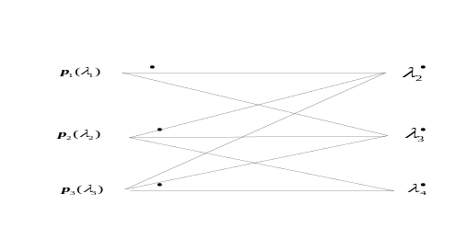
图2 转换度d=2的转换图
根据已建立的转换图，X X X X X X X X X X X X X X X X X X X X X X X X X X X X X X X X X X X X X X X X X X X X X X X X X X X X X X X X X X X X X X X X X X X X X X X X X X X X X X X X．具体包括4个步骤．
步骤1 根据X X X X X X X X X X．
将转换图中的边作为冲突图的顶点，即冲突图的顶点表示所有分组的所有可行转换．X X X X X X X X X X X X X X X X X X X X X X X X X X X X X X X X X X X X X X X X X X X X X X X X X X X X X X X X X X X X X X X X X X X X X X X X X X X X X X X X X X X X X X X X X X X X X X X X X X X X X X X X X X X X X X X X X X X X X X X X．如图3所示为已建的波长转换冲突图．
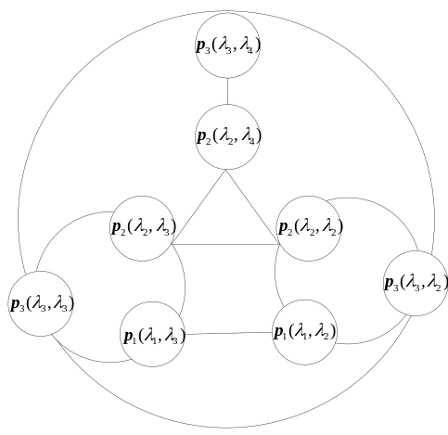
图3 波长转换冲突图
步骤2 为冲突图中的每个顶点赋1个权重值为
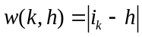 (3)
X X X X X X X X X X X X X X X X X X X X X X X X X X X X X X X X X X X X X X X X X X X X X X X X X X X X X X X X X X X X．如p₃（λ₃，λ₂）的权重值为1．
步骤3 根据X X X X X X X X X X X X X X X X X X X X. X X X X X X X X X X X X X X X X X X X X独立集．
步骤4 求得X X X X X X X X X X X X X X X X X X X X. X X X X X X X X X X X X X X X X X X X X X X X X X X X X X X集合．

仿真结果及分析
为验证OMN-MCNC节点结构的性能，基于VC++6.0开发平台，X X X X X X X X X X X X X X X X X X X X X X X X X X X X X X X X X X X X X X X X X X X X X X X X X X X X X X X X X X X X X X X X X X X X X X X X X X X X X X X X X X X X X X X X X X X X X X X X X X X X X X X X X X X X X X X X X X X X X X X X 4）有效负载ρ_{e}的计算为
ρ_{e}=λ(1-P_{M})+λP_{M}E(X) (4)
首先讨论波长转换范围d对节点性能的影响．X X X X X X X X X X X X X X X X X X X X X X X X X X X X X X X X X X X X X X X X X X X X X X X X X X X X X X X X X X X X X X X X X X X X X X X X X X X X X X X X X X X X X X X X X X X X X X X X X X X X X X X X X X X X X X X X X X X X X X X X X X X X X X X X X X X X X X X X X X X X X X X X X X X X X X X X X X X X X X X X X X X X X X X X X X X X X X X X X X X X X X X X X X X X X X X X X X X X X X X X．折中考虑，在后面的仿真中，d取4．

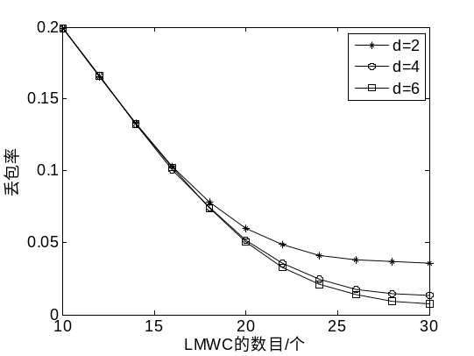
图4 LMWC的数目与丢包率的关系
如图5所示，X X X X X X X X X X X X X X X X X X X X X X X X X X X X X X X X X X X X X X X X X X X X X X X X X X X X X X X X X X X X X X X X X X X X X X，h为网络编码或全范围波长转换器的数目．

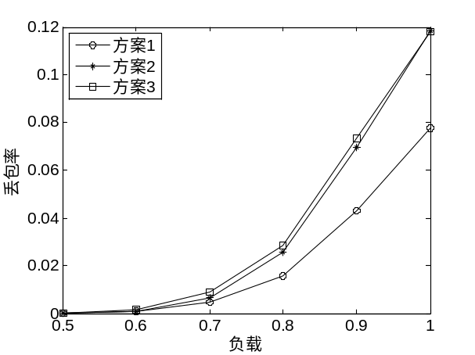
图5 负载与丢包率的关系(d=4)
图5表示在配置不同器件数目的情况下，负载与丢包率的关系．X X X X X X X X X X X X X X X X X X X X X X X X X X X X X X X X X X X X X X X X X X X X X X X X X X X X X X X X X X X X X X X X X X X X X X X X X X X X X X X X X X X X X X X X X X X X X X X X X X X X X X X X X X X X X X X X X X X X X X X X X X X X X X X X X X X X X X X X X X X X X X X X X X X X X X X X X X X X X X X X，节点主要依靠网络编码器解决竞争，而网络编码超大的吞吐量恰恰有效降低了丢包率．
如图6 X X X X X X X X X X X X X X X X X X X X X X X X X X X X X X X X X X X X X X X X X X X X X X X X X X，4．

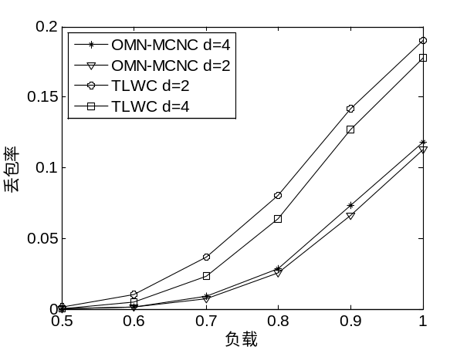
图6 负载与丢包率的关系
图6表示在不同负载下的2种节点结构丢包率性能的对比．X X X X X X X X X X X X X X X X X X X X X X X X X X X X X X X X X X X X X X X X X X X X X X X X X X X X X X X X X X X X X X X X X X X X X X X X X X X X X X X X X X X X X X X X X X X X X X X X X X X X X X X X X X X X X X X X X X X X X X X X X X X X X X X X X X X X X X X X X X X X X X X X X X X X X X X X X X X X X X X X X X X X X X X X X X X X X X X X X X X X X X X X X X X X X X X X X X X X X X X X X X X X X X X X X X．此外，相比于TLWC，OMN-MCNC成本代价大大降低，这是因为1个全波长转换器的代价远远高于1个网络编码器的代价[7]．

结束语
当分组在光组播交换节点处发生冲突时，X X X X X X X X X X X X X X X X X X X X X X X X X X X X X X X X X X X X X X X X X X X X X X X X X X X X X X X X X X X X X X X X X X X X X X X X X X X X X X X X X X X X X X X X X X X X X X X X X X X X X X X X X X X X X X X X X X X X X X X X X X X X X X X X X X X X X X X X X X X X X X X X X X X X X X，OMN-MCNC结构在保证低代价、低时延的同时提升了交换节点的性能．
参考文献:
- 刘焕淋, 陈高翔, 石嵩磊, 等. 共享有限范围多波长和全单波长转换器的光组播冲突解决方案[J]. 光电子·激光, 2012, 23(12): 2304-2309.
Liu Huanlin, Chen Gaoxiang, Shi Songlei, et al. A scheme of shared LMWC and FRWC for optical multicast contention resolution[J]. Journal of Optoelectronics·Laser, 2012, 23(12): 2304-2309.
- Eric D. Manley, Jitender S. Deogun, Lisong Xu, et al. All-optical network coding[J]. Optical Communications and Networking, IEEE/OSA Journal of, 2010, 2(4): 175-191.
- 刘焕淋, 秦亮, 谢芸徽. 多速率分层光组播的波长带宽优化分配[J]. 北京邮电大学学报, 2013, 36(2): 60-63.
Liu Huanlin, Qin Liang, Xie Yunhui. Optimization of wavelength bandwidth allocation in multi-rate layered multicast[J]. Journal of Beijing University of Posts and Telecommunications, 2013, 36(2): 60-63.
- Qu Zhijian, Ji Yuefeng, Bai Lin, et al. Key module for a novel all-optical network coding scheme[J]. Chinese Optics Letters, 2010, 8(8): 753-756.
- 曹张华, 吉晓东, 刘敏. 变信息率线性网络编码的构造[J]. 重庆邮电大学学报, 2014, 26(1): 62-67.
Cao Zhanghua, Ji Xiaodong, Liu Min. Construction of variable rate linear network coding[J]. Journal of Chongqing University of Posts and Telecommunications, 2014, 26(1): 62-67.
- Wei Wang, Yu Li, Guangxi Zhu, et al. Coding-driven scheduling for frame-based multicast switches[C]//, 2011 International Symposium on Network Coding (NetCod), Beijing: 2011: 1-4.
- 曲志坚, 纪越峰. 基于网络编码的波长冲突解决方法[J]. 中国科技论文在线, 2011, 6(1): 15-19.
Qu Zhijian, Ji Yuefeng. Wavelengths conflict resolution based on network coding[J]. Journal of China Science and Technology Papers Online, 2011, 6(1): 15-19.

