植物有效成分间歇浸取动力学研究进展*
X X X ^{,2} X X X ^{1,2}
X X X X X X X X X X X X XXXXXX
X X X X X X X X X X X X X X X X X X X X X X X XXXXXX
摘要：主要介绍了植物有效成分间歇浸取动力学模型的理论基础、数学处理方法、发展沿革和研究进展。X X X X X X X X X X X X X X X X X X X X X X X X X X X X X X X X X X X X X X X X X X X X X X X X X X X X X X X X X X X X X X X X X X X X X X X X X X X X X X X X X X X X X X X X X X X X X X X X X X X X X X X X X X X X X X X X X X X X X X X X X X X X X X X X X X X X X X X X X X X X X X X X X X X X X X X X X X X X X X X X X X X X X X X X X X X X X X X X X X X X X X X X X 。也详细介绍了超声、微波等特殊物理场强化条件下浸取动力学方程建立的理论基础、数学方法和研究进展。
关键词：有效成分，植物，间歇浸取，动力学，模型
植物X X X X X X X X X X X X X X X X X X X X X X X X X X X X X X X X X X X X X X X X X X X X X X X X X X X X X X X X X X X X X X X X X X X X X X X X X X X X X X X X X X X X X X X X X X X X X X X X X X X X X X X X X X X X X X X X X X X X X X X X X X X X X X X X X X X X X X X X X X X X X X X X X X X X X X X X X 。浸取技术一直是研究的热点，但是浸取技术的发展离不开深入的相关技术基础研究，其中植物成分浸取过程动力学研究始终受到高度重视。
通常X X X X X X X X X X X X X X X X X X X X X X X X X X X X X X X X X X X X X X X X X X X X X X X X X X X X X X X X X X X X X X X X X X X X X X X X X X X X X X X X X X X X X X X X X X X X X X X X X X X X X X X X X X X X X X X X X X X X X X X X X X X X X X X X X X X X X X X X X X X X X X X X X X X X X X X X X X X X X X X X X X X X X X X X X X X X X X X X X X X X X X X X X X X X X X X X X X X X X X X X X X X X X X X X X X X X X X X X X X X X X X X X X X X X X X X X X X X X X X X X X X X X X X X X X X X X X X X 模型。
浸取X X X X X X X X X X X X X X X X X X X X X X X X X X X X X X X X X X X X X X X X X X X X X X X X X X X X X X X X X X X X X X X X X X X X X X X X X X X X X X X X X X X X X X X X X X X X X X X X X X X X X X X X X X X X X X X X X X X X X X X X X X X X X X X X X X X X X X X X X X X X X X X X X X X X X X X X X X X X X X X X X X X X X X X X X X X X X X X X X X X X 尝试。
1.4.1 常规间歇浸取动力学
目前，X X X X X X X X X X X X X X X X X X X X X X X X X X X X X X X X X X X X X X X 模型。
Long[]X X X X X X X X X X X X X X X X X X X X X X X X X X X X X X X X X X X X X X X X X X X X X X X X X X X X X X X X X X X X X X X X X X X X X X X X X X X X X X X 基础有：
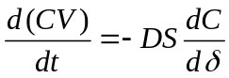 （1）
假设X X X X X X X X X X X X X X X X X X X X X X X X X X ，即有：
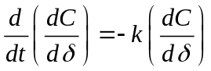 利用X X X X X X X X X X X X X X X X X X X X X X X 模型：
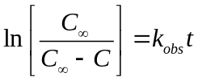 （2）
式中：X X X X X X X X X X X X X X X X X X X X X X X X X X X X X X X X X X X X X X X X X X X X X X X X X X X X X X X X X X时间。
针对X X X X X X X X X X X X X X X X X X X 表达式：
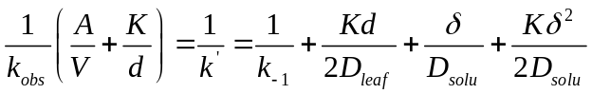 （3）
由于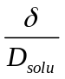﹥﹥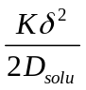成立，则可以忽略。
上式X X X X X X X X X X X X X X X特征。
（1）如果 X X X X X X X X X X X X X X X X X X X X X X X X X X X X X X X X X X X X X X X 叶子中；
（2）如果 X X X X X X X X X X X X X X X X X X X X X X X X X X X X X X X X X X X X X X X 阶段；
（3）如果 X X X X X X X X X X X X X X X X X X X X X X X X X X X X X X X X X X 阶段。
如果X X X X X X X X X X X X X X X X X X X X X X X X X X X X X X X X X X X X X X X X X X X X X X X X X X X X X X X 表达式[]：
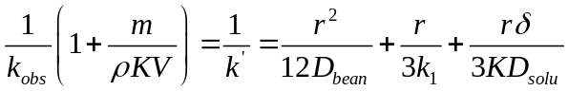 （4）
同样：
（1）如果 X X X X X X X X X X X X X X X X X ，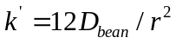；
（2）如果 X X X X X X X X X X X X X X X ，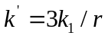；
（3）如果 X X X X X X X X X X X X X X X X X X ，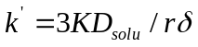。
式（4）X X X X X X X X X X X X X X X X X X X X X X X X X X X X X X X X X X X X X X X X X X X X X X 情况。
该模型X X X X X X X X X X X X X X X X X X X X X X X X X X X X X X X X X X X X X X X X X X 模型。
由于X X X X X X X X X X X X X X X X X X X X X X X X X X X X X X X X X X X X X X X X X X X X X X X X X X X X X X 修正为：
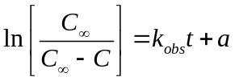 （5）
由于X X X X X X X X X X X X X X X X X XX X X X X X X X X X X X X X X X X X X X X X X X 修正。
植物X X X X X X X X X X X X X X X X X X X X X X X X X X X X X X X X X X X X X X X X X X X X X X X X X X X X X X X X X X X X X X X X X X X X X X X X X X X X X X X X X X X X X X X X X X X X X X X X X X X X X X X X X X X X X X X X X X X X X X X X X X X X X X X X X X X X X X X X X X X X X X X X X X X X X X X X X X X X X X X X X X X X X X X X X X X X X X X X X X X X X X X X X X X X X X X X X X X X X X X X X X X X X X X X X X X X X X X X X X X X X X X X X X X X X X X X X X X X X X X X X X X X X X X X X X X X X X X X X X X X X X X X X X X X X X X X X X X X X X X X X X X X X X X X X X X X X X X模型为：
（6）
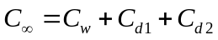 （7）
式中C_{w}：X X X X X X X X X X X X X X X X X X X X X X X X X X X X X X X X X X X X X X X X X X X X X X X X X X X X X X X X X X X X X X X X X X X X X X X X X X X X X X X X X X X X X X X X X X 。
Spiro[]X X X X X X X X X X X X X X X X X X X X X X X X X X X X X X X X X X X X X X X X X X X X X X X X X X X X X X X X X X X X X X X X X X X X X X X X X X X X X X X X X X X X X X X X X X X X X X X X X X X X X X X X X X X X X X X X X X X X X X X X X X X 模型为：
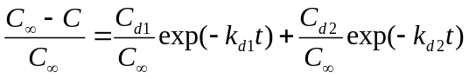 （8）
在浸取X X X X X X X X X X X X X X X X X X X X X X X X X X X X X X X X X X X X X X X X X X X X X X X X X X X X X X X X X改写为：
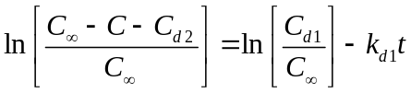 （9）
在浸取X X X X X X X X X X X X X X X X X X X X X X X X X X X X X X X X X X X X X X X X X X X X X X X X X X X X X X X X X X 改写为：
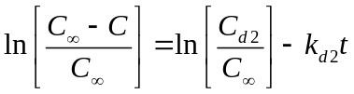 （10）
宋洪波X X X X X X X X X X X X X X X X X X X X X X X X X X X X X X X X X X X X X X X X X X X X X X X X X X X X X X X X X X X X X X X X X X X X X X X X X X X X X X X X X X X X X X X X X X X X X X X X X X X X X X X X X X X X X X X X X X X X X X X X X X X X X X X X X X X X X X X X X X X X X X X X X X 方程。
Zanoni等[]X X X X X X X X X X X X X X X X X X X X X X X X X X X X X X X X X X X X X X X X X X X X X X X X X X X X X X X X X X X X X X X X X X X X X X X X X X X X X X X X X X X X X X X X X X X X X X X X X X X X X X X X X X X X X X X X X X X X X X X X X X X X X X X X X X X X X 模型为：
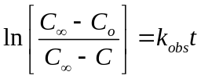 或 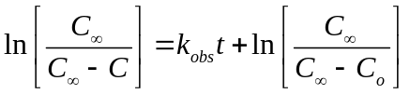 （11）
式中：C_{o}：X X X X X X X X 。
比较式（3）和（8）可以看出：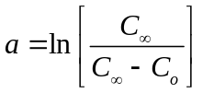
基于X X X X X X X X X X X X X X X X X X X X X X X X X X X X X X X X X X X X X X X X X X X X X X X X X X X X X X X X X X X X X X X X X X X X X X X X X X X X X X X X X X X X X X X X X X X X X X X X X X X X X X X X X X X X X X X X X X X X X X X X X X X X X X X X X X X X X X X X X X X X 一致。
因为，X X X X X X X X X X X X X X X X X X X X X X X X X X X X X X X X X X X X X X X X X X X X X X X X X X X X X X X X X X X X X X X X X X X X X X X X 基础的。
平衡浓度类模型应用时必须测出植物有效成分的浸取平衡浓度。而对于在浸取过程中会发生有效成分降解和参与反应的情况，因为C_{测}=C_{浸}-C_{降}或C_{测}=C_{浸}-C_{反}，以及怎么确定平衡浓度（应该是浸取时间无穷大时的浓度）等问题，使建立的平衡浓度类动力学方程很难真实反映浸取过程各因素对有效成分浸取的影响。X X X X X X X X X X X X X X X X X X X X X X X X X X X X X X X X X X X X X X X X X X X X X X X X X X X X X X X X X X X X X X X X X X X X X X X X X X X X X X X X X X X X X X X X X X X X X X X X X X X X X X X X X X X X X X X X X X X X X X X X X X X X X X X X X X X X X X X X X X X X X X X X X X X X X X X X X X X X X X X X X X X X X X X X X X X X X X X X X X X X X X X X 。这是平衡浓度类模型的不足。
瞬时X X X X X X X X X X X X X X X X X X X X X X X X X X X X X X X X X X X X X X X X X X X X X X X X X X X X X X X X X X X X X X X X X X X X X X X X X X X X X X X X X X X X X X X X X X X X X X X X X X X X X X X X X X X X X X X X X X X X X X X X X X X X X X X X X X X X X X X X X X 方程：
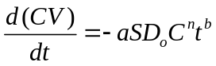 (12)
积分得到：
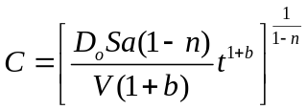 (13)
式中D_{o}：X X X X X X X X X X X X X X X X X X X X X X X X X X X X X X X X X X X X X X X X X X X X X X X X X X X X X X X X X X X X X X X X X X X X X X X X X X X X X X X X X X X X X X X X X X X X X X X X X X X X X X X X X X X X X X X X X X X X X X X X X X X X X X X X X X X X X X X X X X X X X X X X X X X X X X X X X X X X X X X X X X X X X X X X X X X X X X X X X X X X X X X X 体积。
由于X X X X X X X X X X X X X X X X X X X X X X X X X X X X X X X X X X X X X X X X X X X X X X X X X 加大。
储茂泉X X X X X X X X X X X X X X X X X X X X X X X X X X X X X X X X X X X X X X X X X X X X X X X X X X X X X X X X X X X X X X X X X X X X X X X X X X X X X X X X X X X X X X X X X X X X X X X X X X X X X X X X X X X X X X X X X X X X X X X X X X X X X X X X X X X X X X X X X X X X X X X X X X X出现。
杨宏志X X X X X X X X X X X X X X X X X X X X X X X X X X X X X X X X X X X X X X X X X X X X X X X X精度。
由于X X X X X X X X X X X X X X X X X X X X X X X X X X X X X X X X X X X X X X X X X X X X X X X X X X X X X X X X X X X X X X X X X X X X X X X X X X X X X X X X X X X X X X X X X X X X X X X X X X X X X X X X X 问题。
与前面X X X X X X X X X X X X X X X X X X X X X X X X X X X X X X X X X X X X X X X X X X X X X X X X X X X X X X X X X X X X X X X X X X X 关系：
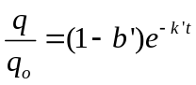 (14)
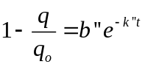 (15)
式中q_{o}：X X X X X X X X X X X X X X X X X X X X X X X X X X X X X X X X X X X X X X X X X X 常数。
这两个X X X X X X X X X X X X X X X X X X X X 应用[,]。
可见，X X X X X X X X X X X X X X X X X X X X X X X X X X X X X X X X X X X X X X X X X X X X X X X X X X X X X X X X X X ，则有：
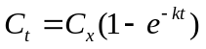 (16)
式中x为∞或o。
1.4.2超声间歇浸取动力学
决定X X X X X X X X X X X X X X X X X X X X X X X X X X X X X X X X X X X X X X X X X X X X X X X X X X X X X X X X X X X X X X X X X X X X X X X X X X X X X X X X X X X X X X X X X X X X X X X X X X X X X X X X X X X X X X X X X X X X X X X X X X X X X X X X X X X X X X X X X X X X X X X X X X X X X X X X X X X X X X X X X X X X X X X X X X X X X X X X X X X X X X X X X X X X X X X X X X X X X X X X X X X X X X X X X X X X X X X X X X X X X X X X X X X X X X X X X X X X X X 、射线等）。
Khan等[]X X X X X X X X X X X X X X X X X X X X X 常数。
黄可龙等[]X X X X X X X X X X X X X X X X X X X X X X X X X X X X X X X X X X X X X X X X X X X X X X X X X X X X X X X X X X X X X X X X X X X X X X X X X X X X X X X X X X X X X X X X X 表示为：
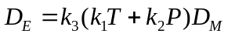 (17)
且 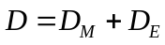 (18)
式中D_{M}：X X X X X X X X X X X X X X X X X X X X X X X X X X X X X X X X X X X X X X X X X X X X X X X X X X X X X系数。
将浸取X X X X X X X X X X X X X X X X X X X X X X X X X X X X X X X X X X X X X X X X X X X方程。
徐化能X X X X X X X X X X X X X X X X X X X X X X X X X X X X X X X X X X X X X X X X X X X X X X X X X X X X X X X X X X X X X X X X X X X X X X X X X X X X X X X X X X X X X X X X X X X X X X X X X X X X X X X X X X X X X X X X X X X X X X X X X X X X X X X X X X X X X X X X X X X X X X X X X X X X X X X X X X X X X X X X X X X X X X X X X X X X X X X X X X X X X X X X X X X X X 正比:
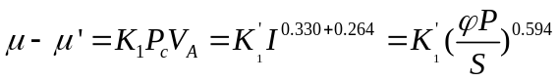 (19)
式中，X X X X X X X X X X X X X X X X X X X X X X X X X X X X X X X X X X X X X X X X X X X X X X X X X X X X X X X X X X X X X X X X X X X X X X X X X X X X X 常数。
又借鉴了X X X X X X X X X X X X X X X X X X X X X X X X X X X X X X X X X X X X X X X X X X X X X X X X X X X X X X X X X X X X X X X X X X X X X X X X X X X X X X X X X X X X X X X X X X X X X X X X X X X X X X X X X X X X X X X X X X X X X X X X X X X X X X X X X X X X X X X X X X X X X X X X X X X X X X 如下:
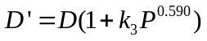 (20)
式中D’： X X X X X X X X X X X X X X X X X X X X X X X X X X X X X X X X X X X X X X X X X X X X X X X X X X X X X X X X X X X X X X X X X X X X X X X X X X X X X X X X X X X X X X X X X X X X X X X X X X X X X X X X X X X X X X X X X X X X X X X X X X X X X X X X X X X X X X X X X X X X X X X X X X X X X X X X X X X X X X X 结果。
曹雁平等[]X X X X X X X X X X X X X X X X X X X X X X X X X X X X X X X X X X X X X X X X X X X X X X X X X X X X X X X X X X X X X X X X X X X X X X X X X X X X X X X X X X X X X X X X X X X X X X X X X X X X X X X X X X X关系式为：
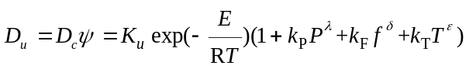 (21)
并建立X X X X X X X X X X X X X X X X X X X X X X X X X X X X X 数据。
Langrniur等X X X X X X X X X X X X X X X X X X X X X X X X X X X X X X X X X X X X X X X X X X X X X X X X X X X X X X X X X X X X X X X X X X X X X X X X X X X X X X X X X X X X关系:
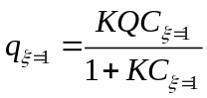 (22)
式中q：X X X X X X X X X X X X X X X X X X X X X X X X X X X X X X X X X X X X X X X X X X X X X X X X X X X X X X X X X X X X X X X X X X X X X X X X X X厚度。
液相传质方程为：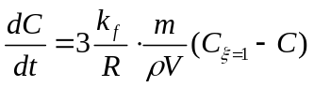 (23)
式中X X X X X X X X X X X X X X X X X X X X X X X X X X X X X X体积。
固相传质方程为：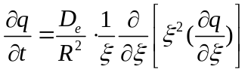 (24)
式中X X X X 系数。
式(23)和(24) X X X X X X X X X X X X X X X X X X X X X X X X X X X X X X X X X X X X X X X X X X X X X X X X X X X X X X X X X X X X X X X X X X X X X X X X X X X X X X X X X X X X X X X X X X X X X X X X X X X X X X X X X X X X X X X X X X X X X X X X X X 因素。
全学军等[]认为受超声波直接作用的主要是粒子表面的植物细胞，细胞破碎利于快速提取目标产物，而颗粒内部目标产物须经过扩散到达颗粒表面后，扩散穿过颗粒表面液膜进入液相主体中。X X X X X X X X X X X X X X X X X X X X X X X X X X X X X X X X X X X X X X X X X X X X X X X X X X X X X X X X X X X X X X X X X X X X X X X X X X X X X X X X X X X X X X X X X X X X X X X X X X X X X X X X X X X X X X X X X X X X X X X X X X X X X X X X X X X X X X X X X X X X X X X X X X X X X X X X X X X X X X X X X X X X X X X X X X X X X X X X X X X X X X X X X X X X X X X X X X X X X X X X X X X X X X X X X X X X X X X X X X X X X X X X X X X X X X X X X X X X X X X X X X X X X X X X X X X X X X X X X X X X X X X X X X X X X X X X X X X X X X X X X X X X X X X X X X X X X X X X X X X X X X X X X X X X X X X X X X X X X X X X X X X X X X X X X X X X X X X X X X X X X X X X X X X X X 。由于随着超声波作用时间的延长，含有有效成分的核半径逐渐缩小，由此该模型称为无扩散阻力的有效成分核收缩模型(简称缩核模型)。
假如X X X X X X X X X X X X X X X X X X X X X X X X X X X X X X X X X X X X X X X X X X X X X X X X X X X X X X X X X X X X X X X X X X X X X X X X X X X X X X X X X X X X X X X X X X X X X X X X X X X X X X X X X X X X X 方程式：
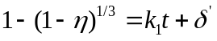 (25)
式中η：X X X X X X X X X X X X X X X X X X X X X X X X X X X X X X X X X X X X X X X X X X X X 常数。
另一方面，X X X X X X X X X X X X X X X X X X X X X X X X X X X X X X X X X X X X X X X X X X X X X X X X X X X X X X X X X X X X X X X X X X X X X X X X X X X X X X X X X X X X X X X X X X X X X X X X X X X X X X X X X X X X X X X X X X X X X X X X X X X X X X X 方程：
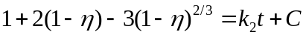 (26)

其中： 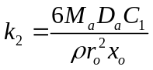 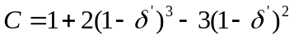
式中X X X X X X X X X X X X X X X X X X X X X X X X X X X X X X X X X X X X X X X X X X X X X X X X X X X X X X X X X X X X X X X X X X X X X X X X X X X X X X X X X X X X X X X X X X X 百分含量。
建立X X X X X X X X X X X X X X X X X X X X X X X X X X X X X X X X X X X X X X X X X X X X X X X X X X X X X X X X X X X X X X X X X X X X X X X X X X X 作用。
1.4.2发展与展望
为了研究浸取机理和便于应用，人们希望浸取动力学模型越简单越好。X X X X X X X X X X X X X X X X X X X X X X X X X X X X X X X X X X X X X X X X 。描述性模型的计算值与实验数据的拟合很好，但是也不能说描述性模型能很好地反映浸取过程，因为该模型不能反映各因素对浸取过程的影响，不能用于探讨浸取机理。
平衡X X X X X X X X X X X X X X X X X X X X X X X X X X X X X X X X X X X X X X X X X X X X X X X X X X X X X X X X X X X X X X X X X X X X X X X X X X X X X X X X X X X X X X X X X X X X X X X X X X X X X X X X X X X X X X X X X X X X X X X X X X X X X X X X X X X X X X X X X X X X X X X X X X X基础。

参考文献

* X X X X X X X X X X X X X X X X X X X X X X X X X X X X X X X X X X X X X X X X X X X X X X X X X X X X X X X X X X X X X X X X X X X X X X X X X X X X X
[?]V. D. LONG .Aqueous extraction of black leaf tea. III. Experiments with a stirred column[J]. International Journal of Food Science and Technology, 1979,14(5): 449-462
[?]Michael Spiro, Robert M. Selwood.The kinetics and mechanism of caffeine infusion from coffee: The effect of particle size [J] Journal of the Science of Food and Agriculture,1984,35(8): 915-924.
[?]Sprio M, Kandiah M.Extraction of ginger rhizome: kinetic studies with acetone[J].International Journal of Food Science and Technology, 1989, 24(6): 589-600.
[?]Zanoni B, Pagliarini E, Peri C. Modelling the aqueous extraction of soluble substances from ground rousted coffeed[J].Journal of the Science of Food and Agriculture, 1992, 58(2): 275-279
[?]D.T. Veličković, D.M. Milenović, M.S. Ristić,et al.Kinetics of ultrasonic extraction of extractive substances from garden (Salvia officinalis L.) and glutinous (Salvia glutinosa L.) sage[J]. Ultrasonic Sonochemistry,2006,13(2):150-156.
[?]Ivana T. Stanisavljević, M.L. Lazić, V.B. Veljković. Ultrasonic extraction of oil from tobacco (Nicotiaha tabacurn L.)seeds [J]. Ultrasonic Sonochemistry,2007,14(5): 646-652.
[?]Muhammad Kamran Khan,Maryvline Abert-Vian,Anne-Sylvie Fabiano-Tixier,etal. Ultrasound- assisted extraction of polyphenols(flavanone glycosides)from orange(Citrus sinensis L.)peel[J].Food Chemistry,2010 ,119 (2) :851-858.
[?]黄可龙,李进飞,刘素琴.超声场强化中药有效成分提取动力学模型[J].化工学报,2004,55(4):646- 648.
[?]曹雁平,矫庆泽.超声功率、频率对姜黄素浸取的影响与动力学模型[J].高校化学工程学报, 2011,25(2): 212-218.
[?]全学军,王万能,陆天健.超声提取植物有效成分的动力学研究[J].化学反应工程与工艺, 2005,21 (4):320-326. Advance in kinetics model of the batch extraction of active components from plants XXX XXXXXXX¹² XXX XXXXXX¹² 1 X X X X X, X X X X X X, X XXXXXX 2 X X X X X X X X X X X, X XXXXXX Abstarct:This paper reviewed the study of the kinetic model in the batch extraction of active components from plants, focusing on its theoretical basis, mathematical methods, and the recent development in world-wide researches. X X X X X X X X X X X X X X X X X X X X X X X X X X X X X X X X X X X X X X X X X X X X X X X X X X X X X X X X X X X X X X X X X X X X X X X X X X X X X X X X X X X X X X X X X X X X X X X X X X X X X X X X X X X X X X X X X X X X X X X X X X X X X X X X X X X X X X X X X X X X X X X X X X X X X X X X X X X X X X X X X X X X X X X X X X X X X X X X X X X X X X X X X X X X X X X X X X X X X X X X X X X X X X X X X X X X X X X X X X X X X X X X X X X X X X X X X X X X X X X X X X X X X X X X X X X X X X X X X X X X X X X X X X X X X X X X X X X X X X . This paper also introduced the theoretical basis, mathematical methods and development of the kinetic equations of extractions under. Key Words: active components, plants, batch extraction, kinetics, model

