TGase酶法交联改善低温花生粕分离蛋白功能特性的研究
X X X ，X X ，X X ，X X X ，X X X
（X X X X X X X X X X X X X ，X X X X XXXXXX）
摘 要：利用转谷氨酰胺酶(TGase)对低温花生粕分离蛋白(PPI)进行交联改性，对比不同交联时间(30min、90min及240min)对PPI功能特性的影响。X X X X X X X X X X X X X X X X X X X X X X X X X X X X X X X X X X X X X X X X X X X X X 。TGases限制性交联（37°C交联90min）可明显提高PPI乳状液的稳定性，但交联时间过长将导致其制备的乳状液乳化活性及稳定性显著降低。DSC分析表明，TGase适度交联使PPI变性温度（Td）增加，变性焓值（ΔH）降低，表明TGase交联可使PPI热稳定性提高。
关键词：低温花生粕分离蛋白；转谷氨酰胺酶；交联；功能特性
The effect of TGase cross-linking on the functional properties of peanut protein isolate
XXX XXXX-XXX, XX XXXX, XXX XXXX, XXXX XXX-XXXX*
(X X X X X X X, X X X X X, X XXXXXX, X)
Abstract: Transglutaminase (TGase) was used to modify peanut protein isolate (PPI) and the effect of different incubation time (30min, 90min and 240min) on the functional properties of PPI was studied. X X X X X X X X X X X X X X X X X X X X X X X X X X X X X X X X X X X X X X X X X X X X X X X X X X X X X X X X X X X X X X X X X X X X X X X X X X X X X X X X X X X X X X X X X X X X X X X X X X X X X X X X X X X X X X X X X X X X X X X X X X X X X X X X X X X X X X X X X X X X X X X X X X X X X X X X X X X X X X X X X X X X X X X X X X X X X X X X X X X X X X X X X X X X X X X X X X X X X X X X X X X X X X X X X X X X X X X X X X X X X X X X X X. The increase of Td and the decrease of ΔH showed by DSC analysis further proved that TGase cross-linking could increase the thermal stability of PPI.
Key words: transglutaminase; peanut protein isolate; cross-linking

我国花生产量居世界第一（年总产量约1500万吨），其主要用途是作为油料作物，在我国用于榨油的花生约占其总产量的50-60%^{[1]}。X X X X X X X X X X X X X X X X X X X X X X X X X X X X X X X X X X X X X X X X X X X X X X X X X X X X X X X X X X X X X X X X X X X X X X X X X X X X X X X X X X X X X X X X X X X X X X X X X X X X X X X X X X X X X X X X X X X X X X X X X X X X X X X X X X X X X X X X X X X X X X X X X X X X X X X X X X X X X X X X X X X X X X X X X X X X X X X X X X X X X X X X X X X X X X X X X X X X X X X X X X X X X X X X X X X X X X X X X X X X X X X X X X X X X X X X X X X X X X X X X X X X X X X X X X 。因此，研究花生粕蛋白的精深加工与高值化利用具有重要意义。
通过酶法改性提高花生粕蛋白的功能特性是充分利用该蛋白资源的重要途径之一。X X X X X X X X X X X X X X X X X X X X X X X X X X X X X X X X X X X X X X X X X X X X X X X X X X X X X X X X X X X X X X X X X X X X X X X X X X X X X X X X X X X X X X X X X X X X X X X X X X X X X X X X X X X X X X X X X X X X X X X X X X X X X X X X X X X X X X X X X X X X X X X X X X X X X X X X X X X X X X X X X X X 。本文从低温压榨花生粕中提取分离蛋白，旨在探讨TGase交联对花生蛋白功能特性的影响，以期为花生粕蛋白资源的精深加工与高值化应用提供方法和理论指导。

1 材料与方法

1.1 材料与设备
主要X X X X X X X X X X X X X X X X X X X X X X X X X X X X X X X X X X X X X X X X X X X X X X X X X X X X X X X X X 。
主要X X X X X X X X X X X X X X X X X X X X X X X X X X X X X X X X X X X X X X X X X X X X X X X X X X X X X X X X X X X X X X X X X X X X X X X X X X X X X X X X X X X X X X X X X X X X X X X X X X X X X X X X X X X X X X X X X X X X X X X X X X X X X X X X X X X X X X X X X X X X X X X X X X X X X X X X X X X X X X X 公司。

1.2 实验方法
1.2.1 花生分离蛋白的制备 取一定量的X X X X X X X X X X X X X X X X X X X X X X X X X X X X X X X X X X X X X X X X X X X X X X X X X X X X X X X X X X X X X X X X X X X X X X X X X X X X X X X X X X X X X X X X X X X X X X X X X X X X X X X X X X X X X X X X X X X X X X X X X X X X X X X X X X X X 花生分离蛋白（PPI）。
1.2.2 TGase交联反应 将PPI X X X X X X X X X X X X X X X X X X X X X X X X X X X X X X X X X X X X X X X X X X X X X X X X X X X X X X X X X X X X X X X X X X X X X X 样品。
1.2.3 乳状液的制备 用去离子水X X X X X X X X X X X X X X X X X X X X X X X X X X X X X X X X X X X X X X X X X X X X X X X X X X X X X X X X X X X 乳状液。
1.2.4 体积排阻色谱（SEC） 采用X X X X X X X X X X X X X X X X X X X X X X X X X X X X X X X X X X X X X X X X X X X X X X X X X X X X X X X X X X X X X X X X X X X X X X X X X X X X X X X X X X X X X X X X X X X X X X X X X X X X X X X X X X X X X X X X X X X X X X X X X X X X X X X X X X X X X X X X X X X X X 280 nm。
1.2.5 OPA测定自由氨基 准确X X X X X X X X X X X X X X X X X X X X X X X X X X X X X X X X X X X X X X X X X X X X X X X X X X X X X X X X X X X X X X X X X X X X X X X X X X X X X X X X X X X X X X X X X X X X X X X X X X X X X X X X X X X X X X X X X X X X X X X X X X X X X X X X X 吸光值A₃₄₀。
1.2.6 溶解性的测定 将1%（w/w）的蛋白质溶液X X X X X X X X X X X X X X X X X X X X X X X X X X X X X X X X X X X X X X X X X X X X X X X X X X X X X X X X X X X X X X X X X X X X X X X X X X X X X X X X X X X X X X X X X X 溶解度。
1.2.7 粒度分布的测定 乳状液X X X X X X X X X X X X X X X X X X X X X X X X X X X X X X X X X X X X X X X X X X X X X X X X X X X X X X X X X X X X X X X X X X X X X X X X X X X X X X X X X X X X X X X X X X X X X X X X X X X X X X X X X X X X X X X X X X X X X X X X X X X X X X X X X X X X X X X X X X X X X X X X X X X X X X X X 数量。
1.2.8 乳析率测定 向制备好的X X X X X X X X X X X X X X X X X X X X X X X X X X X X X X X X X X X X X X X X X X X X X X X X X X X X X X X X X X X X X X X X X X X X X X X X X X X X X X X X X X X X X X X X X X X X X X X X X X X X X X X X X X X X X X X X 比值。
1.2.9 差示扫描测量（DSC）采用 X X X X X X X X X X X X X X X X X X X X X X X X X X X X X X X X X X X X X X X X X X X X X X X X X X X X X X X X X X X X X X X X X X X X X X X X X X X X X X X X X X X X X X X X X X X X X X X X X X X X X X X X X X X X X X X X X X X X X X X X X X X X X X X X X X X X X X X X X X X X X X X X X X X X X X X X X X X X 变性焓值（ΔH）。

2 结果与讨论
2.1 体积排阻色谱(SEC)分析
花生分离蛋白（PPI）X X X X X X X X X X X X X X X X X X X X X X X X X X X X X X X X X X X X X X X X X X X X X X X X X X X X X X X X X X X X X X X X X X X X X X X X X X X X X X X X X X X X X X X X X X X X X X X X X X X X X X X X X X X X X X X X X X X X X X X X X X X X X X X X X X X X X X X X X X X X X X X X X X X X X X X X X X X X X X X X X X X X X X X X X X X 增加。
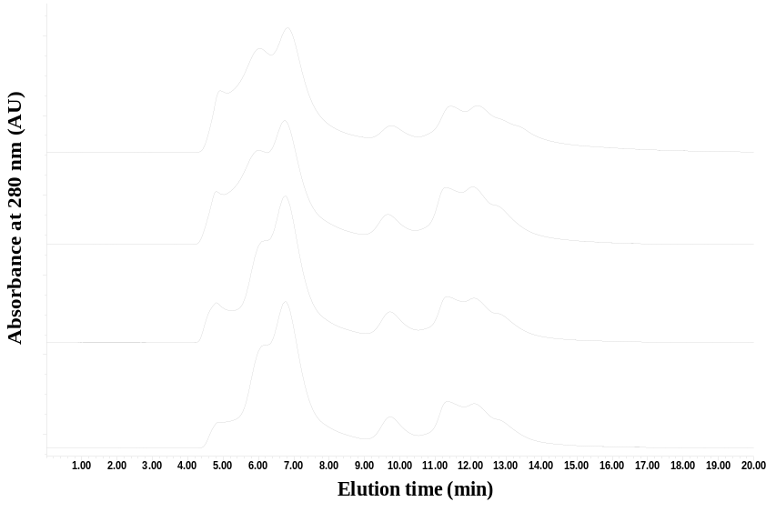
0 min
90 min
30 min
240 min
图1. TGases X X X X X X X XXX X X X X X XXX X X
Fig. 1 XXX X X X-X XXX X X X
2.2 自由氨基含量的变化
OPA法于340 nm测得的吸光值可反映蛋白样品中自由氨基的含量^{[5]}。X X X X X X X X X X X X X X X X X X X X X X X X X X X X X X X X X X X X X X X X X X X X X X X X X X X X X X X X X X X X X X X X X X X X X X X X X X X X X X X X X X X X X X X X X X X X X X X X X X X X X X X X X X X X X X X X X X X X X X X X X X X X X X X X X X X X X X X X X X X X X X X X X X X X X X X X X X X X X X X X X X X X X X X X X X X X X X X X X X X X X X X X X X X X X X X X X X X X X X X X X X X X X X X X X X X X X X X X X X X X X X X 。因此，图2的结果也表明PPI交联程度随着TGase催化时间的延长而提高，这一结果与SEC分析结果相符。
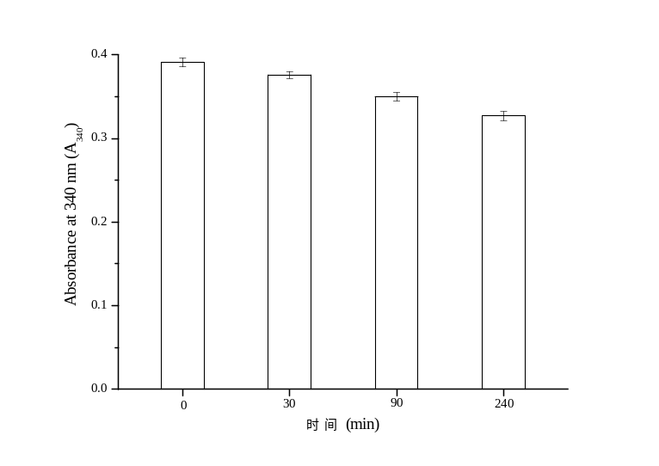
图2 PPIX X X X X X X X
Fig. 2 X X X X X X XXX
2.3 TGase对PPI溶解性的影响
蛋白质的溶解性是蛋白质水化作用的重要体现。X X X X X X X X X X X X X X X X X X X X X X X X X X X X X X X X X X X X X X X X X X X X X X X X X X X X X X X X X X X X X X X X X X X X X X X X X X X X X X X X X X X X X X X X X X X X X X X X X X X X X X X X X X X X X X X X X X X X X X X X X X X X X X X X X X X X X X X X X X X X X X X X X X X X X X X X X X X X X X X X X X X X X X X X X X X X X X X X X X X X X X X X X X X X X X X X X X X X X X X X X X X X X X X X X X X X X X X X X X X X X X X X X 。这种结果上的差异可能是由于不同底物蛋白在其组成与结构上有所不同所导致。
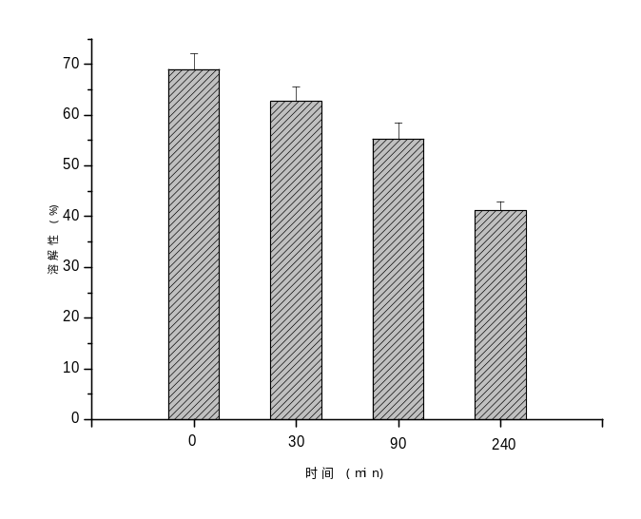
图3 TGaseX X X X X X X X X X X
Fig. 3 X X X X X X X X XXX
2.4 TGase对PPI乳化性的影响
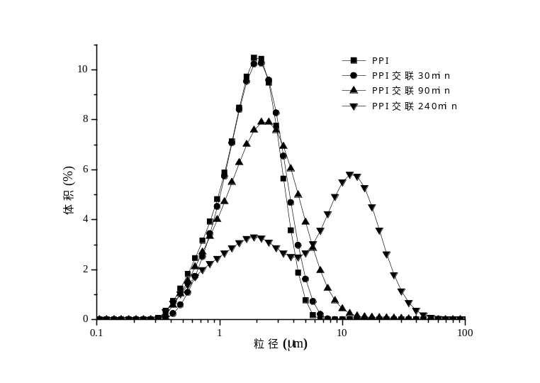
图4 不同X X X X X X X X X X X X X X X X X
Fig. 4 X X X X X X X X X X X X X XXX X
表1 乳状液X X X X X X X
Table 1 X X X X X XX
X X X X | XXX X X X X (XXX)
X X X X | 0 | 30 | 90 | 240
d₃₂ (μm) | 1.714 | 1.746 | 1.812 | 2.607
d₄₃ (μm) | 2.012 | 2.256 | 2.898 | 9.239

蛋白质的乳化特性可以从其制备的乳状液的粒度分布、乳析率来进行综合评价。X X X X X X X X X X X X X X X X X X X X X X X X X X X X X X X X X X X X X X X X X X X X X X X X X X X X X X X X X X X X X X X X X X X X X X X X X X X X X X X X X X X X X X X X X X X X X X X X X X X X X X X X X X X X X X X X X X X X X X X X X X X X X X X X X X X X X X X X X X X X X X X X X X X X X X X X X X X X X X X X X X X X X X X X X X X X X X X X X X X X X X X X X X X X X X X X X X X X X X X X X X X X X X X X X 。从表1中乳状液粒径数据来看，TGases处理时间超过90min后，d₃₂ 及d₄₃极显著增加，因此TGase处理时间不易过长，否则容易导致乳化活性降低。
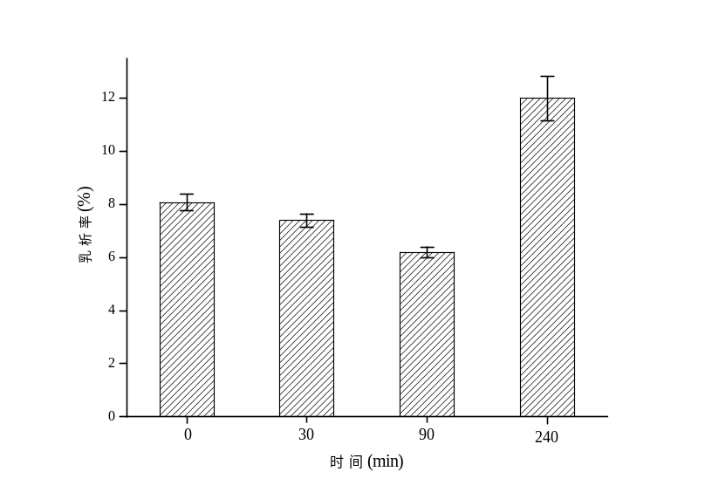
图5 TGaseX X X XXX X X X X X X X X X
Fig. 5 X X X X X X X X X X X XXX X
乳析率是反映乳状液稳定性的重要指标。TGase交联前后PPI乳状液乳析率的变化见图5所示，可以看出当PPI交联时间从0增至90 min时，样品的乳析率逐渐降低，表明其乳状液稳定性逐步提高，其原因可能是蛋白分子交联后形成了支链结构，分子量增加，蛋白交联物吸附在油脂颗粒表面后可增加界面蛋白膜的厚度及抗形变能力，使被其覆盖后的油滴颗粒不易相互碰撞而聚结^{[11,12]}。X X X X X X X X X X X X X X X X X X X X X X X X X X X X X X X X X X X X X X X X X X X X X X X X X X X X X X X X X X X X X X X X X X X X X X X X X X X X 。由此可知，适度交联有利于PPI乳化稳定性的提高。
2.5 热特性分析
PPI X X X X X X X X X X X X X X X X X X X X X X X X X X X X X X X X X X X X X X X X X X X X X X X X X X X X X X X X X X X X X X X X X X X X X X X X X X X X X X X X X X X X X X X X X X X X X X X X X X X X X X X X X X X X X X X X X X X X X X X X X X X X X X X X X X X X X X X X X X X X X X X X X X X X X X X X X X X X X X X X X X 趋势。
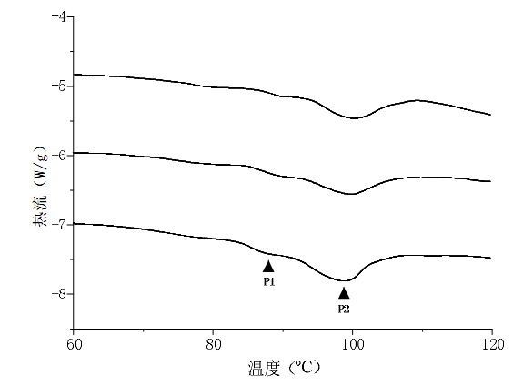
PPI
PPI-240min
PPI-90min
图6 PPIX X X X X X X XXX X X
Fig. 6 XXX X X XXX X X X X X X
从表2可以看出，随着交联时间的延长及PPI交联程度的提高，PPI组分Arachin和Conarachin 的最初变性温度（Tm）与变性温度（Td）均呈增加趋势，表明TGase交联后PPI蛋白组分的热稳定性有所提高^{[13]}，这可能主要归因于TGase催化的交联反应产生了大量的高能异肽共价键从而提高了产物的热稳定性。X X X X X X X X X X X X X X X X X X X X X X X X X X X X X X X X X X X X X X X X X X X X X X X X X X X X X X X X X X X X X X X X X X X X X X X X X X X X X X X X X X X X X X X X X X X X X X X X X X X X X X X X X X X X X X X X X X X X X X X X X。以往研究也发现TGase可提高大豆分离蛋白和芸豆分离蛋白热稳定性 ^{[14,15]}。
表2 PPI X X X X X X X X X X X
Table 2 XXX X X XXX X X X X X X
X X X X (XXX) | X |  |  | X
X X X X (XXX) | Tm  (ºC) | Td  (ºC) | △H (J/g) | Tm  (ºC) | Td  (ºC) | △H (J/g)
0 | 84.41 | 88.16 | 0.49 | 92.97 | 99.22 | 7.69
30 | 85.03 | 88.59 | 0.38 | 93.34 | 99.68 | 7.01
90 | 86.29 | 89.47 | 0.23 | 94.03 | 100.84 | 6.03
240 | 86.82 | 90.05 | 0.31 | 94.51 | 101.97 | 6.62

3 结论

花生分离蛋白X X X X X X X X X X X X X X X X X X X X X X X X X X X X X X X X X X X X X X X X X X X X X X X X X X X X X X X X X X X X X X X X X X X X X X X X X X X X X X X X X X X X X X X X X X X X X X X X X X X X X X X X X X X X X X X X X X X X X X X X X X X X X X X X X X X X X X X X X X X X X X X X X X X X X X X X X X X X X X X X X X X X X X X X X X X X X X X X X X X X X X X X X X X X X X X X X X X X X X X X X X X X X X X X X X X X X X X X X X X X X X X X X X X X X X X X X X X X X X X X X X X X X X X X X X X X X X X X X X X X X X X X X X X X X X X X X X X X X X X X X X X X X X X X X X X X X X X X X X X X X X X X X X X X X X X X X X X X X X X X X X X X X X X X X X X X X X X X X X X X X X X X X X X X X X X X X 提高。

参考文献
[1] Zhu Y, Rinzema A, Tramper J, et al. Microbial transglutaminase-a review of its production and application in food processing [J]. Applied Microbiology and Biotechnology, 1995, 44(3-4):277-282.
[2] Laemmli U K. Cleavage of structural proteins during the assembly of the head of bacteriophage T4 [J]. Nature, 1970, 227(5259):680-685.
[3] Beveridge T, Toma S J, Nakai S. Determination of SH- and SS-groups in some food proteins using Ellman’s reagent [J]. Journal of Food Science, 1974, 39:49-51.
[4] Voutsinas L P, Cheung E, Nakai S. Relationships of hydrophobicity to emulsifying properties of heat denatured proteins [J]. Food Science, 1983, 48:26-32.
[5] Lowry O H, Rosembroug H J, Lewis A, et al. Protein measurement with the folin phenol reagent [J]. Journal of Biological Chemistry, 1951, 19:265-275.
[6] Chen J S, Dickinson E. Protein/surfactant interfacial interactions Part1. Flocculation of emulsions containing mixed protein + surfactant [J]. Colloids and Surfaces A, 1995, 100:255-265.
[7] Schokker E P, Dalgeish D G. The shear-induced destabilization of oil-in-water emulsions using caseinate as emulsifier [J]. Colloids and Surfaces A, 1998, 145:51-69.
[8] Siu N C, Ma C Y, Mock W Y, et al. Functional properties of oat globulin modified by a calcium-independent microbial transglutaminase [J]. Journal of Agricultural and Food Chemistry, 2002, 50:2666-2672.
[9] Tang C H, Sun X, Yin S W, et al. Transglutaminase-induced cross-linking of vicilin-rich kidney protein isolate: Inﬂuence on the functional properties and in vitro digestibility [J]. Food Research International, 2008, 41:941–947.
[10] Babiker E E. Effect of transglutaminase treatment on the functional properties of native and chymotrypsin-digested soy proteins [J]. Food Chemistry, 2000, 70:139-145.
[11] Krause J P, Dudek S, Schwenke K D. Changes in interfacial behaviour, emulsifying and foaming properties of faba bean legumin after modiﬁcation with dimethylsuberimidate [J]. Nahrung, 2000, 44:403–406.
[12] Poon S, Clarke A E, Schultz C J. Effect of denaturants on the emulsifying activity of proteins [J]. Journal of Agricultural and Food Chemistry, 2001, 49:281-286.
[13] Tomas A, Paquet D, Courthaudon J L. Effect of fat and protein contents on droplet size and surface protein coverage in dairy emulsions [J]. Journal of Dairy Science, 1994, 77(2):413-417.
[14] Aluko R E, Yada R Y. Effect of a microbial calcium-independent transglutaminase on functional properties of a partially purified cowpea (Vigna unguiculata) globulin [J]. Journal of the Science of Food and Agriculture, 1999, 79:286-290.
[15] Nonaka M, Toiguchi S, Sakamoto H, et al. Changes caused by microbial transglutaminase on physical properties of thermally induced soy protein gels [J]. Food Hydrocolloids, 1994, 8:1-8.

作者简介：X X X (XXXXX)，X ，X X ，X X ，X X X X ：X X X X X X 。 XXXXXXXXXX 基金项目：X X X X X X X X X X X （XXXXXXXXXXXX）、X X X X X X X X X X X X（X X X X X X X X X X X X X X X X X X X X X X X X X X X X X X X X X X X X X X X X X X 。

