文章编号：100X-XXXX（20XX）0X-0000-00

基于非对称SIR的小型化双频带带通滤波器设计
X X X ，X X X ，X X X
（X X X X X X X X X X X X X X X ，X X XXXXXX）

摘要: 为了实现移动基站的小型化双频带带通滤波，基于非对称阶梯阻抗谐振器(SIR)，提出了两个通带中心频率及带宽均可调节的小型化双频带带通滤波器的设计方法，设计并制作了用于移动基站的0.9 GHz和1.8 GHz的双频段滤波器，测试结果与设计原理符合．X X X X X X X X X X X X X X X X X X X X X X X X X X X X X X X X X X X X X X X X X X X X X X X X X X X X X X X X X X X X X X X X X X X X X X X X X X X X X X X X X X X X X X X X X X X X X X X X X X X X X X X X X X X X X X X X X X X X X X X X X X X X X X X X X X X X X X X X X X X X X X X X X X X X X X X X X X X X X X X X X X X X X X X X X ．实验结果表明，仿真S参数和测量结果符合良好，从而验证了这种设计方法的有效性．
关 键 词: 双频带带通滤波器; 微带滤波器; 非对称阶梯阻抗谐振器
中图分类号: TN713.5 文献标志码: A

Compact Dual Band-Pass Filter Design Using Asymmetrical Stepped-Impedance Resonators
XX XXX-XXX, XXX XXXX-XXXX, XXX XX-XXX
(X X X X, X X X X X, X XXXXXX, X)

Abstract: A compact dual-band bandpass filter was designed and developed based on asymmetrical stepped impedance resonators (SIR) for the realization of miniature dual-band bandpass filtering in mobile base station. X X X X X X X X X X X X X X X X X X X X X X X X X X X X X X X X X X X X X X X X X X X X X X X X X X X X X X X X X X X X X X X X X X X X X X X X X X X X X X X X X X X X X X X X X X X X X X X X X X X X X X X X X X X X X X X X X X X X X X X X X X X X X X X X X X X X X X X X X X X X X X X X X X X X X X X X X X X X X X X X X X X X X X X X X X X X X X X X X X X X X X X X X X X X X X X X X X X X X X X X X X X X X X X X X X X X X X X X X X X X X X X X X X X X X X X X X X X X X X X X X X X X X X X X X X X X X X X X X X X X X X X X X X X X X X X X X X X X X X X X X X X X X X X X X X X X X X X X X X X X X X X X X X X X X X X X X X X X X X X X X X X X X X X X X X X X X X X X X X X X . The effectiveness of the proposed design method was validated.
Key words: dual-band bandpass filter; microstrip filter; asymmetrical stepped impedance resonator

随着无线通信技术的高速发展，各种各样的便携式数字设备，如袖珍计算机、笔记本电脑、可穿戴计算机、智能手机、数码相机、汽车导航仪等都应用了无线通信技术^{[1]}，而且这些移动终端的无线模块大多工作在两个或多个频段，泛在通信系统逐渐应用到数字通信终端上．X X X X X X X X X X X X X X X X X X X X X X X X X X X X X X X X X X X X X X X X X X X X X X X X X X X X X X X X X X X X X X X X X X ^{X X X} ．微带带通滤波器作为一种应用很广泛的微波器件^{[3]}，不仅对其高性能和小型化的要求越来越高，而且要求其中心频率和带宽均可调．
收稿日期：2014XXXX-08XX-27XX
基金项目：国X 家X 留X 学X 基X 金X 委X 公X 派X 留X 学X 基X 金X 资X 助X 项X 目X （X X 2X 0X 1X 2X 0X 8X 1X 1X 0X 3X 9X 6X ）X ；X 中X 央X 高X 校X 基X 本X 科X 研X 业X 务X 费X 资X 助X 项X 目X （X ZX YX 1X 1X 1X 3X 、X YX SX 1X 4X 0X 4X ）X
作者简介：李X 学X 斌X （X 1X 9X 6X 7X —X ）X 男X ，X 副X 教X 授X ；X 韩X 宇X 南X （X 1X 9X 8X 0X —X ）X ，X 男X ，X 博X 士X ，X 硕X 士X 生X 导X 师X ，X EX mX aX iX lX :X cX lX aX rX kX -X hX aX nX @X 1X 2X 6X .X cX oX mX ．
为了达到良好的双频带通特性，带通滤波器最新的设计方法主要有：Wu ^{[4-5]}等用不同拓扑结构的阶梯阻抗谐振器（SIR, stepped impedance resonators），得到了很好的截止频带特性．X X X X X X X ^{X X X} X X X X X X X X X X X X X X X X X X X X X X X X X X X X X X X X X X X X X X X X X X X X X X X X X X X X X X X X X X ^{X X X} X X X X X X X X X X X X X X X X X X X X X X X X X X X X X X X
X X X X X X X X X X X X X X X X X X X X X X X X X X X X X X X X X X X X X X X X X X X X X X X X X X X ^{X X X} X X X X X X X X X X X X X X X X X X X X X X X X X X X X ．这些设计的主要难点在于滤波器的频带、带宽的可调性以及尺寸小型化等方面．
因此，在常规SIR的结构基础之上改进优化设计方法，通过在其内部引入一根准集总短截线，设计了一种小型化双频带微带滤波器．X X X X X X X X X X X X X X X X X X X X X X X X X X X X X X X X X X X X X X X X X X X X X X X X X X X X X X X X X X X X X X X X X X X X X X X X X X X X X X X X X X X X X X X X X X X X X X X X X X X X X X X X X X X X X X X X X X X X X X X X X X X X X X X X X X X X X X X X X X X X X X X X X X X X X X X X X X X X X X X X X X X X X X X X X X X X X X X X X X X X X X X X X X X X X X X X X X X X X X X X X X X X X X X X X X X X X X X X X X X X X X X X X X X X X X X X X X X X X X X X X X X X X X ．通过仿真和测量获得的S参数曲线符合很好，验证了提出的非对称SIR的小型化双频带带通滤波器设计方法．

谐振器设计原理
图1中所示为改进后的SIR的结构图．X X X X X X X X X X X X X X X X X X X X X X X X X X X X X X X X X X X X X X X X X X X X X X X X X X X X X X X X X X X X X X X X X X X X X X X ．AA’为外部谐振器的对称轴，L为各段阶梯阻抗的长度，W为各段阶梯阻抗的宽度．
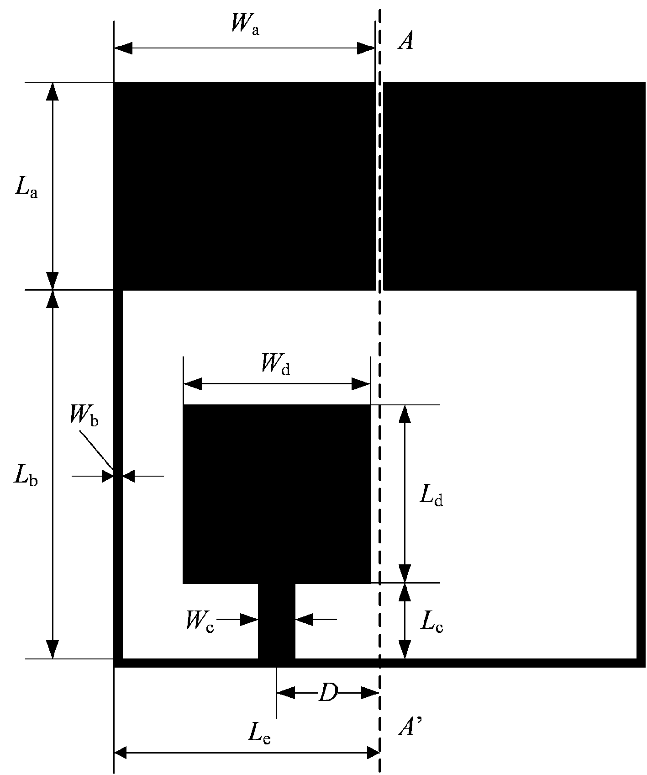
图1 改进X X XXX X X
当D的值为0时，谐振器为对称结构．X X X X X X X X X X X X X X X X X X X X X X X X X X X X X X X X X X X X X X X X X X X X X X X X X X X X X X X X X X X X X X X X X X X X X X X X X X X X X X X X X X X X X X X X X X X X X X X X X X X X X X X X X X X X X X X X X X X X X X X X X X X X ．图中Z_{i}和L_{i}（i = 1,2,3…）分别为各部分微带传输线对应的阻抗和电长度．
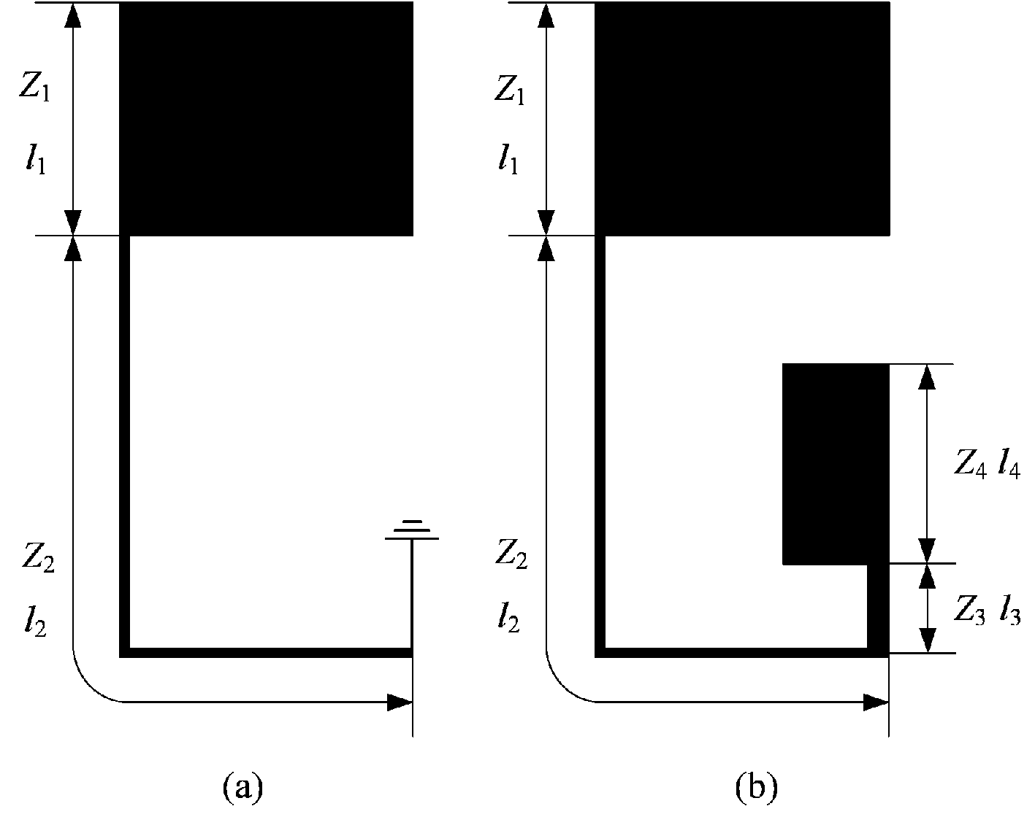
图2 对称XXX X X X X X X
(a) X X X X (b) X X X X
当D的值不为0时，此谐振器结构可以用图3所示的等效传输线模型来分析：两条传输线和一条开放式SIR短截线组成的T型电路与开放式耦合线路的并联．X X X X X _{X X X} X X _{X X X} X X X X X X X X X X X X X X X X X X X X X _{X} X X X X X _{X} X X X X X X X X X X X X X X X _{X} X X _{X} X X X X X X X X X X X X X X X X X _{X} X X _{X} X X X X X _{X} X X X X X X X X X X X X X X _{X X X} X X _{X X X} X X X X X X X X X X X X X X X X X X X X X X ．而根据微带电路的基本原理^{[9]}，可以求得谐振频率．
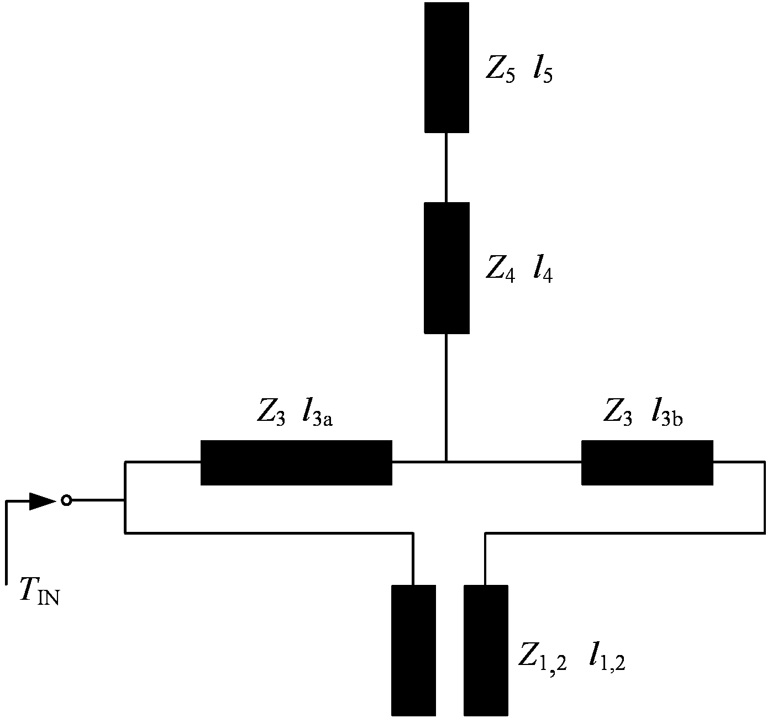
图3 滤波器X X X X X X
谐振器短截线的电长度会随着频率的增大而增大，那么对于阶次越高的谐振频率，D对其影响越大．X X X X X X X X X X X X X X X X X X X X X X X X X X X X X X X X X X X X X X X X X X X X X X X X X X X X X X X X X X X X X X X X X X XX X X X X X X X X X X X X X X X X X X X X X X X X X X X X X X X X X X X X X X X X X X X X X X X X X X X X X X X X X X X．仿真结果也证实了这一点．
仿真X X X X X X X X X X X X X X X X X X X X X X X X X X X X X X X X X X X X X X X X X X X X X X X X X X X X X X X X X X X X X X X X X X X X X X X X X X X X X X X _{X} X X X X X X X X X X X X X X X X X X X X X X X X X X X X X X X X X X X X X X X X X X X X X X X X X 关系：
表 1 不同X X X X X X X X X X X X X X X X
XXXX | XXXXX | XXXXX
0 | 0.938 | 1.765
0.5 | 0.951 | 1.771
1 | 0.949 | 1.772
1.5 | 0.943 | 1.773
2 | 0.947 | 1.809
2.5 | 0.956 | 1.795
从表1中X X X X X X X X X X X X X X X X X X X X X X X X X X X X X X X X X X X X X X X X X X X X X X X X X _{X} X X X X X X X X X X X X X X X X X X X X X X X X X X X X X X X X 如表2所示．
表 2 调整X XX X X X X X X X X X X X X
XXXX | XXXXX | XXXXX | XXXXX
0 | 4.34 | 0.944 | 1.767
0.5 | 4.32 | 0.940 | 1.772
1 | 4.32 | 0.949 | 1.772
1.5 | 4.32 | 0.943 | 1.773
2 | 4.60 | 0.943 | 1.774
2.5 | 4.68 | 0.943 | 1.768

双频带带通滤波器的设计
根据非对称SIR来设计双频段带通滤波器，并采用两个谐振器串联来优化双频带滤波器的性能指标．X X X X X X X X X X X X X X X X X X X X X X X X X X X X X X ．使用有限元仿真软件Ansoft HFSS来完成滤波器的设计与仿真，并通过多参数优化获得最优的参数尺寸．
双频带带通滤波器设计步骤如下：首先，调整外部SIR的参数尺寸，使其第一个谐振频率与滤波器第一个通带的中心频率f_{l}相等．X X X X X X X X X X X X X X X X X X X X X X X X X X X X X X X X X X X X X X X X X X X X X X X X X X X X X X X X X X X X X X X X X X X X X X X _{X} X X X X X X X X X X X X X X X X X X X X X X X X X X X X X X X X X X X X X X X X X X X X X X X X _{X} X X X X X X X X X X X X X X X X X X X X X X X X X X X X X X X X X X X X X X X X X X X X X X X X X X X X X X X X X X X X X X X X X X X X X X X X X X X X X X X X X X X X X X X X X X X X X X X X X X X X X X X X X X _{X} X X X X X X X X X X X X _{X} X X X X X X X _{X} X X X X X X X X X X X X X X X X _{X} X X X X X X X X X X X X X X X X X _{X} X X X X X X X X X X X X X X ．随着D的增大，B₁略变大，而B₂显著减小．
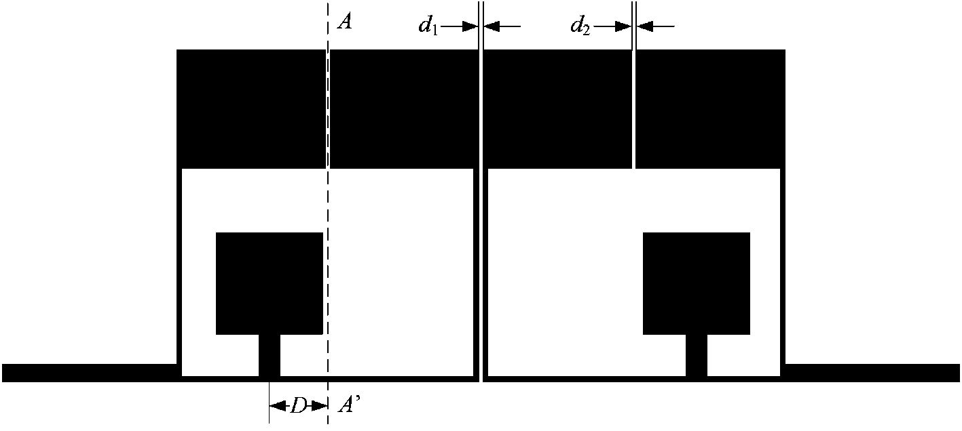
图4 双频带X X X X X X

滤波器设计实例
根据X X X X X X X X X X X X X X X X X X X X X X X X X X X X X X X X X X X X X X X X X X X X 为f₁=0.9 GHz和f₂=1.8 GHz．
为了X X X X X X X X X X X X X X X X X X X X X X X X _{X} X X X X X X X X X X X X X X X X X X X X X X X X X X X X X X X X X X X X X X X X X X X X X X X X X X X X X X X X X X X X X X X X X X X X X X X X X X X X 为24.76 mm×13.5 mm．
所设计的滤波器结构参数定义如图1和图4所示．X X X X X X X X X X X X X X X X _{X} X X _{X} X X X X X X X X X X X X X X X X X X X X X X X X X X X X X X X X X X X X X X X X X X X X X X X X X X X X X X X X X X X X X X X X X X X X X X X X X X X ．对应于谐振频率f₁=0.9 GHz和f₂=1.8 GHz，谐振器的具体参数尺寸如下：L_{a}=4.8 mm，L_{b}=8.52 mm，L_{c}=1.73 mm，L_{d}=4.12 mm，L_{e}=6.14 mm，W_{a}=6.04 mm，W_{b}=0.18 mm，W_{c}=0.83 mm，W_{d}=4.32 mm．
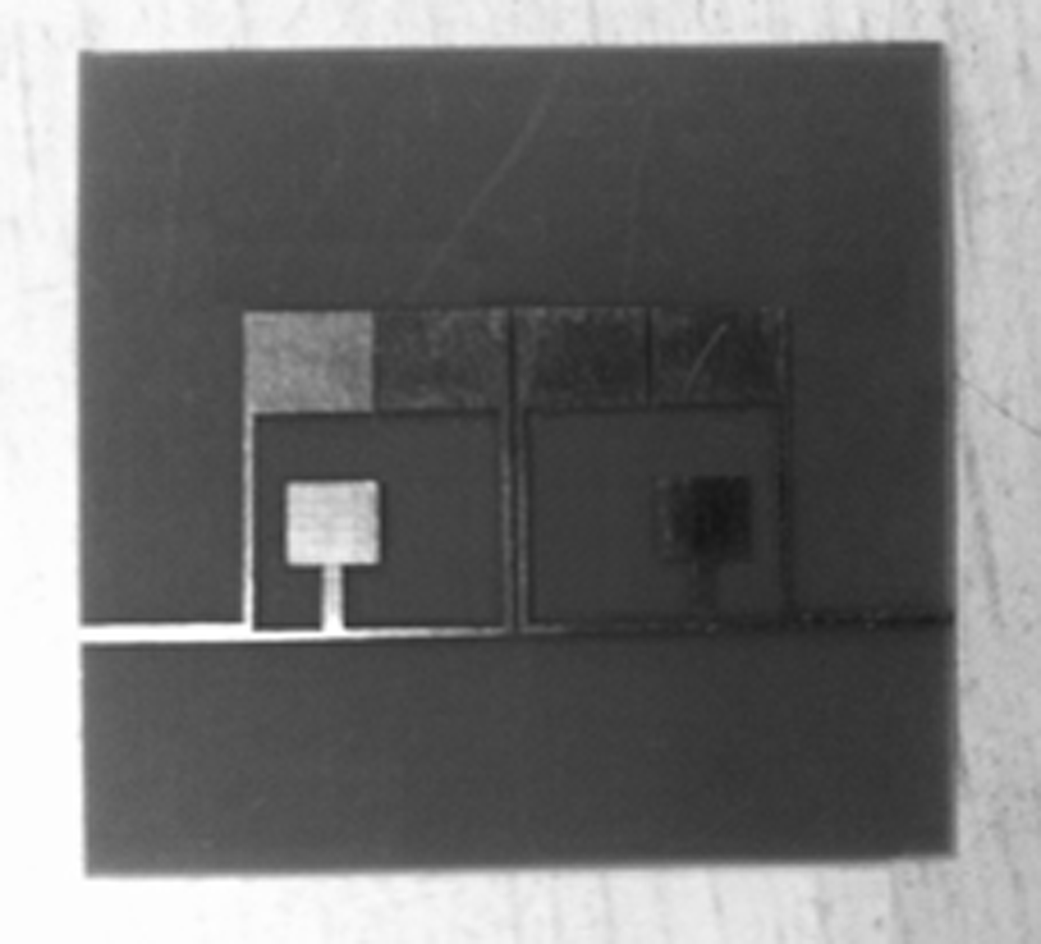
图5 双频带X X X X X X X X
使用安捷伦矢量网络分析仪N5245A（通过校准件N4691-40004校准）对该滤波器进行了测试，仿真和实测的S参数频率响应如图6所示．X X X X X X X X X X X X X X X X X X X X X X X X X X X X X X X X X X X X X X X X X X X X X X X X X X X X X X X X X X X X X X X X X X X X X X X X X X X X X X X X X X X X X X X X X X X X X X X X X X X X X X X ．通过对比，可以看出仿真与实测结果符合得很好．
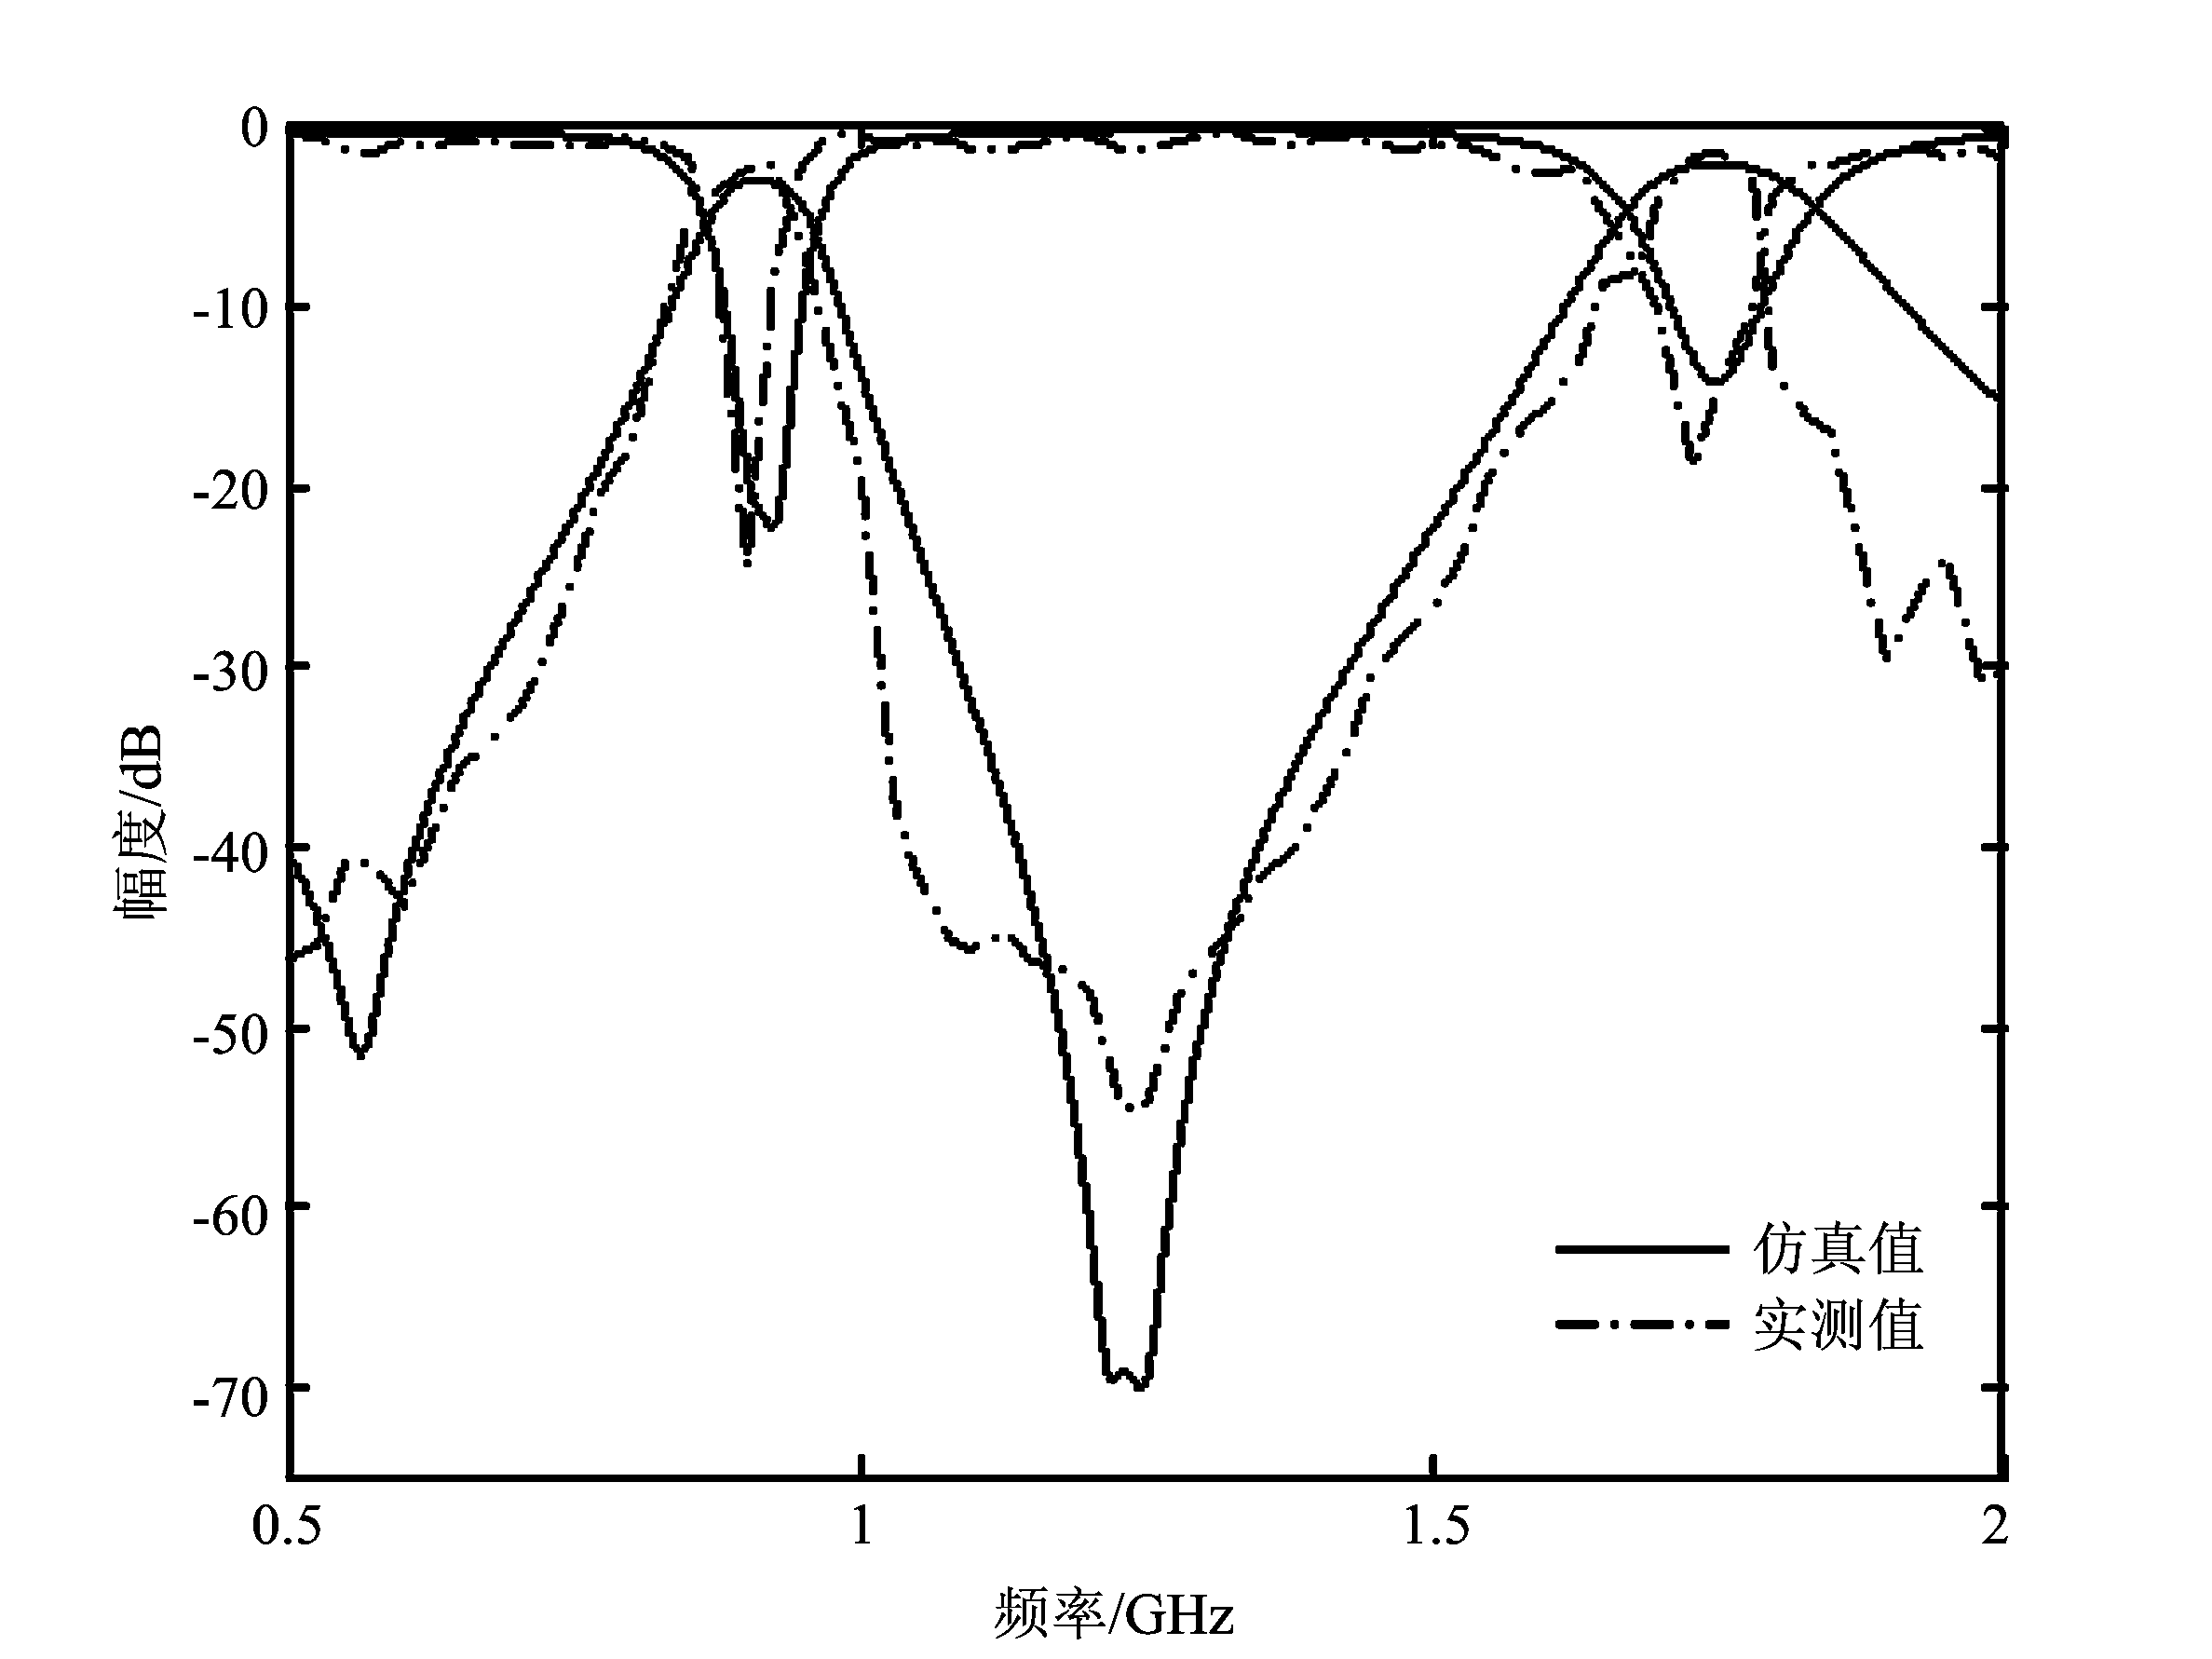
图6 双频带X X X X X X X X X X X X X

结束语
所设计非对称双频带带通微带滤波器，由两个改进后的SIR组合而成，工作在移动基站0.9 GHz和1.8 GHz通信频段，外尺寸小于24.76 mm×13.5 mm．X X X X X X X X X X X X X X X X X X X X X X X X X X X X X X X X X X X X X X X X X X ．最后设计并加工了一个双频带带通滤波器，实测结果和仿真结果基本符合，从而验证了这种设计方法的有效性．
参考文献:
- Han Yunan, Yang Biao, Guo Qing. Design of low-pass filters with ultra-wide stopband using asymmetric DGS[C]// IEEE Electromagnetic Compatibility (EMC) Symposium. Denver Colorado: IEEE Press, 2013: 636-639.
- 朱永忠, 赵志远. 具有多传输零点的微带传输线滤波器设计[J]. 北京邮电大学学报, 2012, 35(5): 77-80.
Zhu Yongzhong, Zhao Zhiyuan. Design of a microstrip transmission line filter with transmission zeros[J]. Journal of Beijing University of Posts and Telecommunications, 2012, 35(5): 77-80.
- 赵晓红, 张玉田, 钱平凯, 等. 高温超导微波带通滤波器的研制[J]. 北京邮电大学学报, 1996, 19(4): 48-52.
Zhao Xiaohong, Zhang Yutian, Qian Pingkai, et al. Investigation on high T_{c} superconductor microwave bandpass filters[J]. Journal of Beijing University of Posts and Telecommunications, 1996, 19(4): 48-52.
- Wu H W, Chen Y F, Chen Y W. Multi-layered dual-band bandpass filter using stub-loaded stepped-impedance and uniform-impedance resonators [J]. IEEE Microw Wireless Compon Lett, 2012, 22(3):114–116.
- Chang W S, Chang C Y. Analytical design of microstrip short circuit terminated stepped-impedance resonator dual-band filter [J]. IEEE Trans Microw Theory Tech, 2011, 59(7): 1730–1739.
- Tseng C H, Shao H Y. A new dual-band microstrip bandpass filter using net-type resonators [J]. IEEE Microw Wireless Compon Lett, 2010, 20(4): 196–198.
- Wang Jianpeng, Ge L, Wang Kai, et al. Compact microstrip dual-mode dual-band bandpass filter with wide stopband [J]. Electron Lett, 2011, 46(4): 263–265.
- Hoang T H, Pham A V Dual band band-pass filter with wide stopband on multilayer organic substrate [J]. IEEE Microw Wireless Compon Lett, 2013, 23(4): 193-195.
- Makimoto M, Yamashita S. Microwave resonators and filters for wireless communications-theory and design [M]. Berlin, Germany: Springer, 2001: 79-83.
- Hong J S, Lancaster M J. Microstrip filters for rf/microwave applications [M]. New York: Wiley Inter-Science, 2001:236-248.

