**Restoration of the Vaginal Microbiome & Its Ecology Following Surgical Obstetrical Fistula Repair in Lilongwe, Malawi**

Michael D. Jochum1, Benjamin Belfort1, Mary Stokes2, Rachel Pope2, Maxim D Seferovic1, Lori Showalter1, Cindy Shope1, Rose Sulentic1, Nicholas Twyman1, Joshua Aagaard1, Jeff Wilkinson1, Kjersti M. Aagaard1

1. Baylor College of Medicine, Obstetrics and Gynecology, Houston, USA.

2. Baylor College of Medicine, OB/GYN- Global Women's Health, Lilongwe, Malawi., Houston, TX, USA

**ABSTRACT**

The vaginal microbiome is a mediator of reproductive health/disease, with well documented fluctuations in ecology and dysbiosis as a result of pregnancy, infection, and/or antibiotics. However, community restoration following disruptive events have not been previously studied. Following obstetric fistula repair, the vaginal community of women (n=15) was restored and differentiated from the vaginal introitus, posterior fornix, and rectal communities. Each woman demonstrated near daily changes in vaginal ecology, being more similar to herself than to others. Community microbial dynamics were shaped by several keystone members belonging to *Lactobacillus* and *Gardnerella*. All women with a successful fistula repair demonstrated microbial restoration within 1-2 weeks, despite months to years of symptomatic vaginal obstetric fistula. We report for the first time the restorative vaginal community ecology in 15 patients undergoing delayed obstetrical fistula repair. While larger cohorts are needed to understand potential microbial predictors of successful obstetrical vaginal fistula repair, these findings illustrate the remarkable resilience of the vaginal microbiome.

**Introduction**

An estimated 20 million women suffer from obstetric fistula (OF) world-wide, the majority in sub-Saharan Africa, with an estimated incidence of 1.6 per 1000 women in Malawi [1, 2]. In areas of the world with limited perinatal obstetrical availability, prolonged, obstructed labor when the fetal head exerts pressure against vaginal tissue, causing pressure necrosis and development of a tract between the vagina and the trigone of the bladder (vesicovaginal fistula or VVF) or between the vagina and rectum (rectovaginal fistula or RVF) (Figure 1), referred to as an obstetric fistula (OF) [3, 4]. Obstetric fistulae result in urinary or fecal incontinence via urine and/or feces constantly leak from the vagina, which has devastation impacts on quality of life on multiple levels: social stigma secondary to the chronic incontinence and the loss of reproductive capacity, and adverse health effects secondary to the destruction of the vaginal mucosa and injury to the bladder and rectum [2, 5, 6]. This condition is treatable through simple surgical repair, yet still afflicts many women in developing countries [7]. In this current study, we aimed to conduct a longitudinal analysis of the microbial dynamics associated with VVF surgical repair by identifying the taxonomic and diversity changes in the vaginal microbiome using marker gene and shotgun sequencing. Characterizing the vaginal microbiome community restoration following surgical repair of chronic obstetrical fistula would be unique and highly informative in understanding microbial community assemblage and resiliency to ecosystem disturbance. The vaginal microbiome is a crucial mediator of reproductive health and disease, and fluctuations in its ecology and dysbiosis as a result of pregnancy and infections/antibiotics are well known. However, community restoration following major disruptive events have not been previously studied.

**Materials and Methods**

***Sample Collection***

Following Malawi Health Ministry IRB approval, n=15 women undergoing delayed repair of their obstetrical VVF or RVF consented for participation in this observational, prospective cohort arising from the Fistula Care Centre (Lilongwe, Malawi). Detailed surgical, medical, dietary & other metadata were collected in parallel with uniformly collected daily vaginal, urine & rectal microbiome specimens (CatchAll swabs) from pre-op (day 0) through discharge (d9-28) and at 6-week post-operative. Nucleic acid was stored in SCF-1 media until transfer.

***16S rRNA gene and Metagenomic shotgun sequencing***

DNA was extracted from all samples in a BSL2 hood with parallel “contaminant” controls & subjected to 16S rRNA V4 & shotgun metagenomic sequencing (Illumina). 16S rRNA raw sequencing reads were trimmed of the adapter sequences and QA/QCed ed via the bioinformatics software packages Trimmomatic [8], FASTQC[9], and MultiQC [10]. Trimmed 16S reads were then imported and demultiplexed in QIIME 2 Core 2019.10 (www.qiime2.org) environment using the q2cli command line interface, followed by denoising, dereplication, processed into amplicon sequencing variants (ASVs), paired end read merging, and chimeric filtering using the Divisive Amplicon Denoising Algorithm (DADA2) plugin [11]. Following DADA2, the sequences were aligned using MAFFT [12], masked for highly variable sequences using qiime2 mask, and converted into a phylogenetic tree using the QIIME2 diversity plugin pipeline for exploring community diversity. The diversity pipeline rarified ASVs for sampling depth, and analyzed sequences for alpha diversity, beta diversity, and constructed principle component of analysis (PCoA) plots using Bray-Curtis and weighted UniFrac dissimilarity indices. Sequences were then taxonomically classified against the silva_132 database. (<https://www.arb-silva.de/download/archive/qiime>), and exported into a table for each taxonomic level.

Raw WGS reads were adapter trimmed, removed of human DNA sequences, and filtered for quality, and screened for taxonomic classification using clade-specific markers using the biobakery tool suite software packages Kneaddata (<https://bitbucket.org/biobakery/kneaddata/wiki/Home>) and MetaPhlAn2 using the ChocoPhlanv203mpa database[13, 14]. The resulting abundance tables and mapping files were merged and imported into Phyloseq in R 3.6.5, subset into bacteria, agglomerated to a species level, prevalence /detection filtered (d = 10, p = 0.01), and subdivided into objects based on sample type [15]. Alpha and beta diversity analyses were calculated based on Shannon and Bray-Curtis, Euclidean, and Manahattan dissimilarity indices and visualized with scatter and PCoA ordination plots using the MicrobiomeR [16] packages. Statistical analysis of beta diversity was conducted using an Adonis permutational multivariate analysis of variance (PERMANOVA) using VEGAN [17]. Samples were binned on the basis of microbial community composition using Dirichlet Multinomial Mixtures (DMM) clustering analysis in order to determine the main periods of microbiome progression [18]. Pre-operation (day 0) timepoints were removed from each object for this specific analysis. Laplace distribution was used for model fitting in order to determine the optimal number of different clusters for each sample type. A linear association between the DMM cluster and time was conducted using Pearson’s correlation coefficient Data visualizations were created using ggplot2 [19], igraph [20], corrplot [21], pheatmap [22], and metacoder [23] packages in R 3.6.5.

**Results**

Following chronic obstetric fistula repair, the vaginal community was restored and able to be fully differentiated from the rectal and urine (sparse) communities within 1 to 2 weeks post-operatively (Figures X [*transition model*] and X [metacoder model]). The majority of women with a successful fistula repair demonstrated microbial restoration within 1-2 weeks, and all by 6 weeks, despite months to years of symptomatic VF (Figure X [*dmm modeling by pt]*). Vaginal communities were characterized through Dirichlet multinomial modeling and defined as either *Gardnerella vaginalis* dominant, Gardnerella *vaginalis* mixed, mixed, or a dominated by the keystone species *Lactobacillus Iners* (Figure X [transition network model] *).* Pearson’s coefficient correlation test resulted in a statistically significant correlation between DMM cluster and day amongst the vaginal introitus samples (p < 0.01) with a 22.7% correlation estimate (Table 2). There was a significant increase in

There was a significant increase in alpha diversity between preoperative to postoperative samples observed in both the amplicon and shotgun sequencing reads (Supplemental Figures X [amplicon longitudinal model] and X [WGS alpha diversity over time]) in both the Vaginal Introitus and Posterior Fornix sample type. There was a significant change in Beta diversity over time in both the vaginal introitus and the posterior fornix sample type, depicted through Bray-Curtis, Euclidean, and Manahattan PCoA plots (Supplemental Figure X [WGS PCoA). Results from an adonis permutational multivariate analysis of variance reported a statistically significant effect of day (p < 0.006) and patient id, with a statistically significant interaction between the individual patient id and day of sample (Table 1).

**Discussion**

Surgical fistula repair restores the vaginal microbiome within 1-2 weeks. Each patient demonstrated restoration of her vaginal ecology, with community structure bearing more similarity to herself than to others. Communities that transitioned to a dominant *L. Iners* state transitioned quickly and remained stable thereafter. In the post-operative samples, there were inverse correlations amongst community members *G. vaginalis*, *P.copri* + *Faecalibacterium prausnitzii*, and *L. iners* in the Vaginal Introitus (Figure Xa [heatmap]), and *G. vaginalis*, *P. bivia, and L. iners* in the posterior fornix samples (Figure Xb [heatmap]), which coincided with the dmm communities based on ward clustering.

**Conclusion**

We report for the first time restorative vaginal community ecology in n=15 subjects undergoing delayed obstetrical fistula repair. The timeline associated with vaginal microbiome restoration is in line with ours and other’s data on the time interval to community restoration following vaginal birth. These findings illustrate the remarkable resilience of the vaginal microbiome community, although larger cohorts inclusive of failed and successful repairs are needed in the future to understand potential microbial predictors of obstetrical vaginal fistula repair success or complication.

**Data Availability**

Raw 16S rRNA and WGS sequencing data have been uploaded to SRA and are available under accessions XXXXX and XXXXX, respectively. Code for the DMM clustering transition model and downstream visualizations presented in figures X, X, and X, has been made publicly available at (https://github.com/MADscientist314/Fistula_dataset/RData). All other bioinformatics software packages profiling the dataset are publicly available and are appropriately referenced.

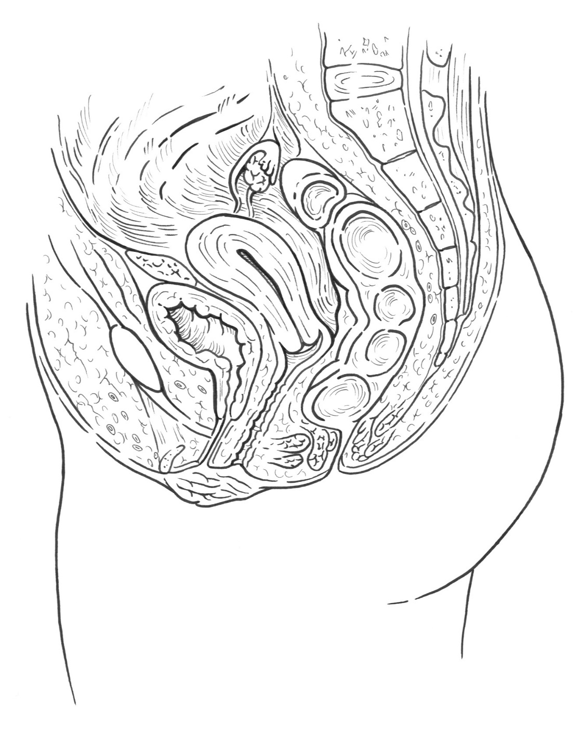

Juxta-cervical

Mid-vaginal

Juxta-urethral

Figure 1. Schematic and description of the most commonly occurring obstetrical vesico-vaginal fistula (VVF) locations. The only cure for VVF is surgical, and our Lilongwe Fistula Center is world-renowned.

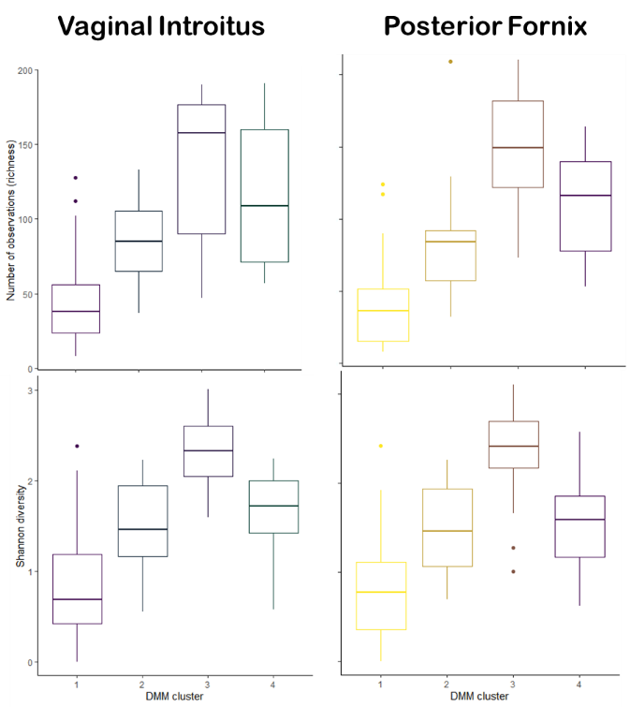

A)

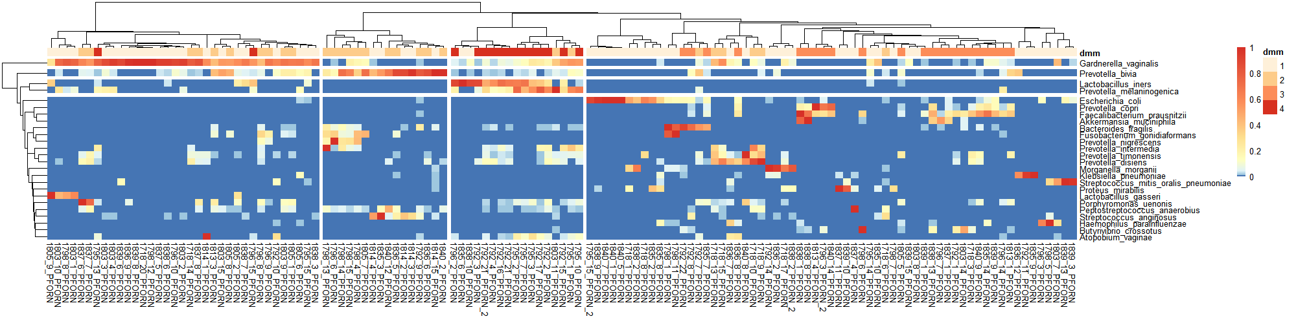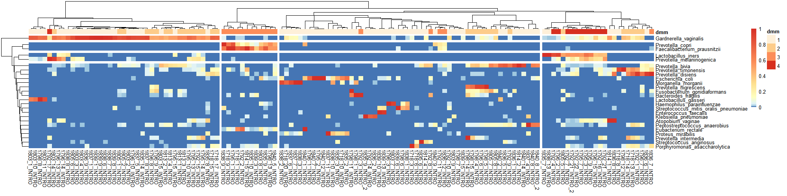

Vaginal Introitus  
(*n* =133)

Posterior Fornix  
(*n* =131)



B)

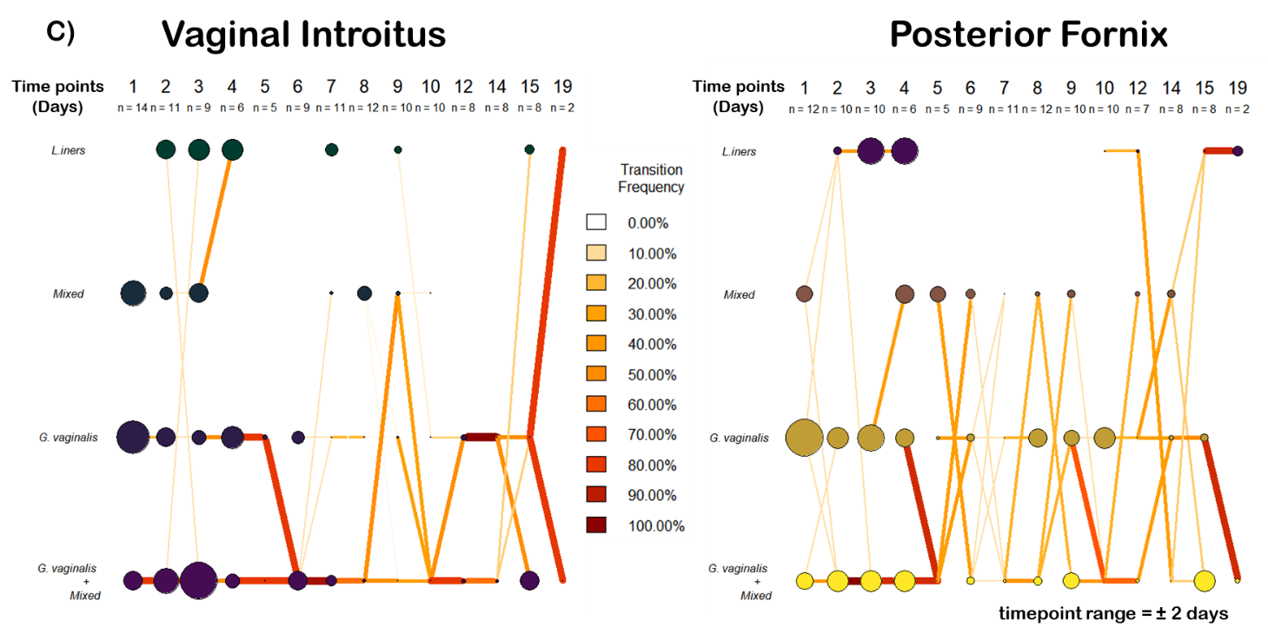

Vaginal Introitus

Posterior Fornix

C)

Figure 2. DMM clustering of vaginal shotgun gene sequencing data (n=264). A. Heat map showing Ward clustering of the relative abundance of the most dominant bacterial species per DMM cluster B. Box plots showing richness and Shannon alpha diversity indices per each DMM cluster (centerline= median, Boxes = 25th and 75th percentiles, whiskers= most distant data point less than 1.5x the box length, with outliers represented byt points outside the whiskers) C. Transition model showing the progression of vaginal samples through each DMM cluster per each time point from Day 1 to 21 post-operative repair.

A)

asadad

Figure 3 WGS transition model based on DMM cluster modeling.

Vaginal Introitus

Posterior Fornix

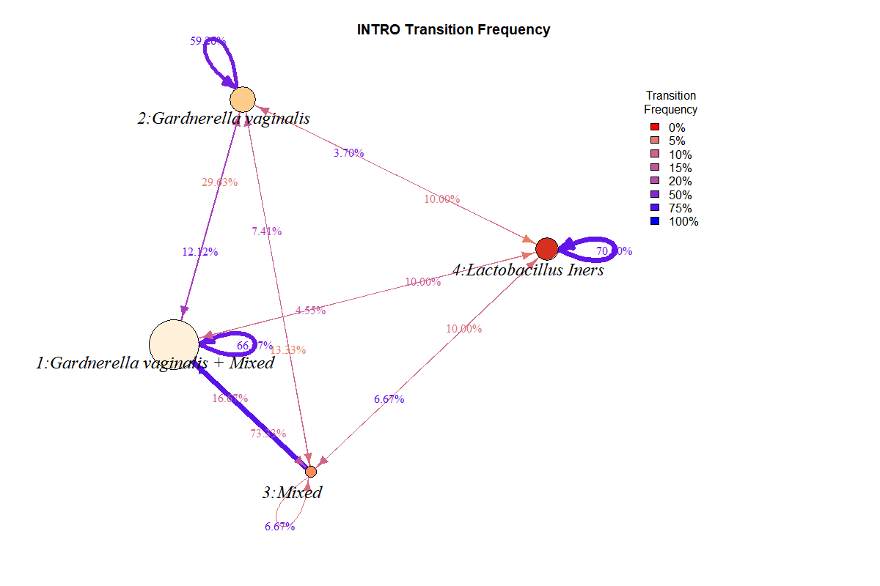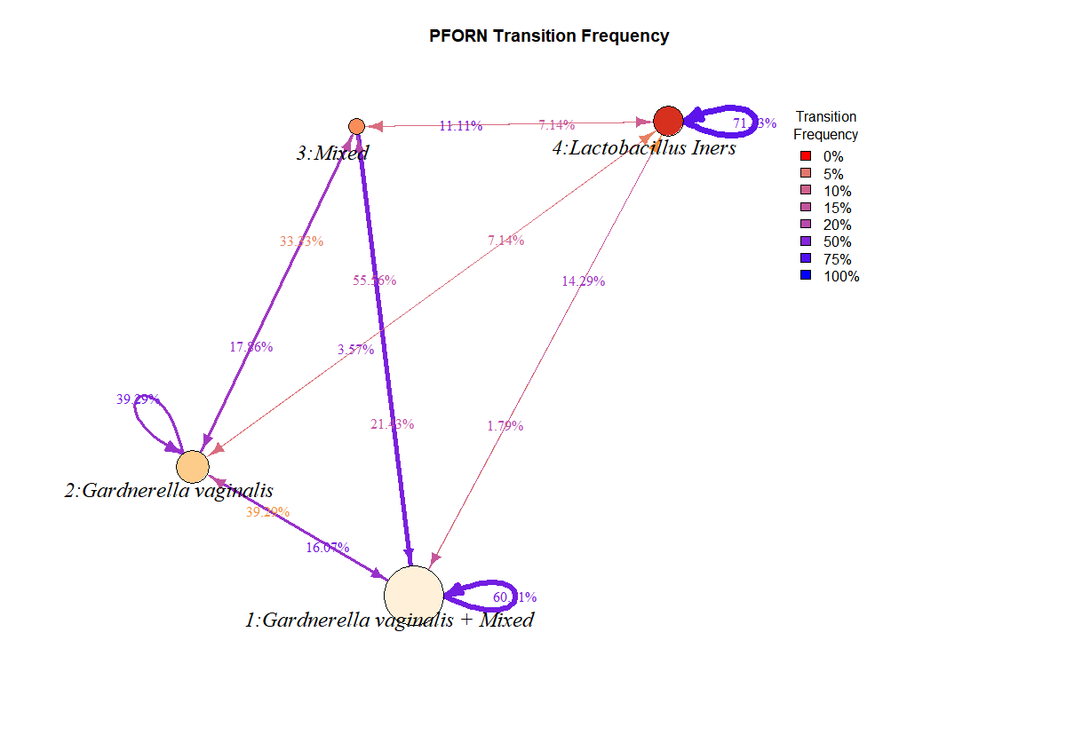

Table Adonis permutational multivariate analysis of variance (PERMANOVA) of shotgun sequencing data.

|  |  |  |  |  |  |  |  |  |
| --- | --- | --- | --- | --- | --- | --- | --- | --- |
|  |  | adonis | | | | | | |
| Variable | Number of permutations | Df | Sum of Squares | Mean Squares | F.Model | R2 | Pr(>F) | sig |
| SampleType | 999 | 2 | 2.447 | 1.22345 | 5.8693 | 0.03138 | 0.001 | *** |
| Patient | 999 | 14 | 10.361 | 0.74008 | 3.5504 | 0.13288 | 0.001 | *** |
| Day | 999 | 1 | 0.438 | 0.43775 | 2.1001 | 0.00561 | 0.045 | * |
| SampleType:Day | 999 | 2 | 0.203 | 0.10134 | 0.4862 | 0.0026 | 0.935 |  |
| Patient:Day | 999 | 14 | 4.494 | 0.32097 | 1.5398 | 0.05763 | 0.006 | ** |
| Residuals | 999 | 288 | 60.033 | 0.20845 | 0.7699 |  |  |  |
| Total | 999 | 321 | 77.975 | 1 |  |  |  |  |

Table Pearson’s product momentum correlation between day and DMM cluster

|  |  |  |  |  |  |  |
| --- | --- | --- | --- | --- | --- | --- |
| Sample type | t | df | p-value | LCI | UCI | correlation |
| Vaginal Introitus | 2.6707 | 131 | 0.00853 | 0.05930087 | 0.38265888 | 0.2272338 |
| Posterior Fornix | 1.3986 | 129 | 0.1643 | - 0.05036525 | 0.28771024 | 0.1222161 |

**Supplementary Figure 1** Alpha diversity across time

**Supplemental Figure 2.** Beta diversity Bray-Curtis, Euclidean, and Manahattan PCoA plots colored by time and faceted by sample type

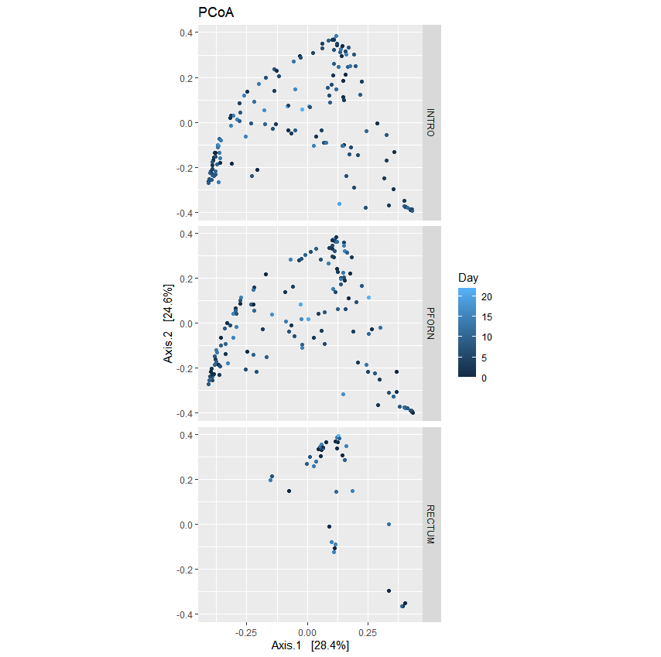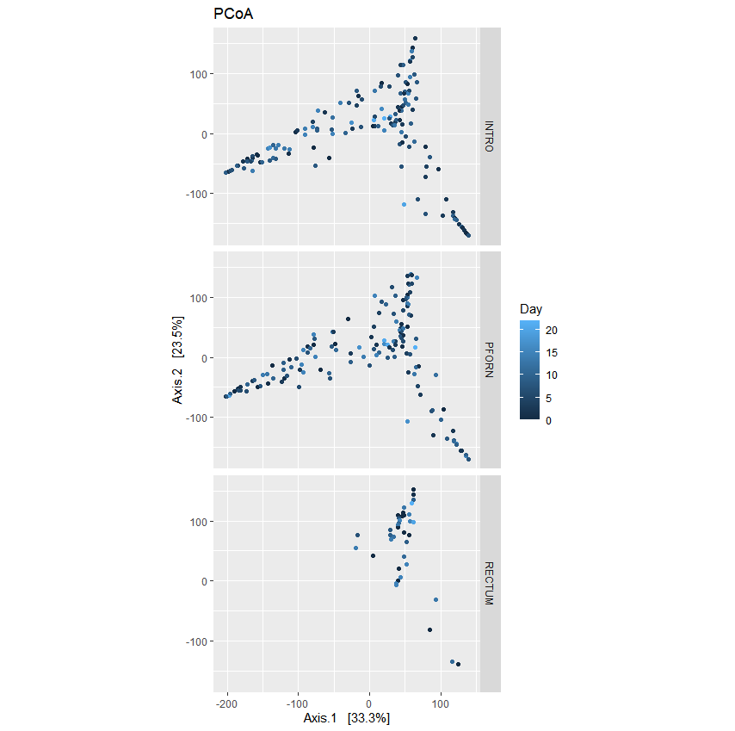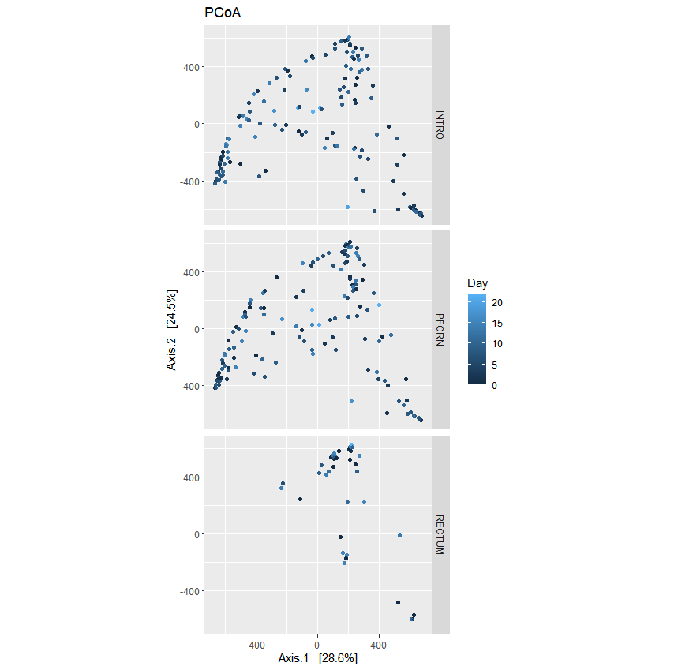

Bray-curtis

Manhattan (vst)

Euclidean (vst)

**References**

1. Kalilani-Phiri LV, Umar E, Lazaro D, Lunguzi J, Chilungo A. Prevalence of obstetric fistula in Malawi. Int J Gynaecol Obstet. 2010;109(3):204-8. Epub 2010/03/12. doi: 10.1016/j.ijgo.2009.12.019. PubMed PMID: 20219194.

2. Wall LL. Obstetric vesicovaginal fistula as an international public-health problem. Lancet (London, England). 2006;368(9542):1201-9. Epub 2006/10/03. doi: 10.1016/S0140-6736(06)69476-2. PubMed PMID: 17011947.

3. Capes T, Ascher-Walsh C, Abdoulaye I, Brodman M. Obstetric fistula in low and middle income countries. Mt Sinai J Med. 2011;78(3):352-61. Epub 2011/05/21. doi: 10.1002/msj.20265. PubMed PMID: 21598262.

4. Rovner ES. Urinary Fistula. In: Hanno PM, Malkowicz SB, Wein AJ, editors. Penn Clinical Manual of Urology. Philadelphia: W.B. Saunders; 2007. p. 325-40.

5. Arrowsmith S, Hamlin EC, Wall LL. Obstructed labor injury complex: obstetric fistula formation and the multifaceted morbidity of maternal birth trauma in the developing world. Obstet Gynecol Surv. 1996;51(9):568-74. Epub 1996/09/01. doi: 10.1097/00006254-199609000-00024. PubMed PMID: 8873157.

6. UNFPA. The second meeting of the working group for the prevention and treatment of obstetric fistula, Addis Ababa, 30 October–1 November, 2002. 2002.

7. Wall LL. Obstetric fistula is a "neglected tropical disease". PLoS Negl Trop Dis. 2012;6(8):e1769. Epub 2012/09/07. doi: 10.1371/journal.pntd.0001769. PubMed PMID: 22953008; PubMed Central PMCID: PMCPMC3429400.

8. Bolger AM, Lohse M, Usadel B. Trimmomatic: a flexible trimmer for Illumina sequence data. Bioinformatics. 2014;30(15):2114-20. Epub 2014/04/04. doi: 10.1093/bioinformatics/btu170. PubMed PMID: 24695404; PubMed Central PMCID: PMCPMC4103590.

9. Andrews S. FastQC: a quality control tool for high throughput sequence data. Babraham Bioinformatics, Babraham Institute, Cambridge, United Kingdom; 2010.

10. Ewels P, Magnusson M, Lundin S, Kaller M. MultiQC: summarize analysis results for multiple tools and samples in a single report. Bioinformatics. 2016;32(19):3047-8. Epub 2016/06/18. doi: 10.1093/bioinformatics/btw354. PubMed PMID: 27312411; PubMed Central PMCID: PMCPMC5039924.

11. Callahan BJ, McMurdie PJ, Rosen MJ, Han AW, Johnson AJ, Holmes SP. DADA2: High-resolution sample inference from Illumina amplicon data. Nat Methods. 2016;13(7):581-3. Epub 2016/05/24. doi: 10.1038/nmeth.3869. PubMed PMID: 27214047; PubMed Central PMCID: PMCPMC4927377.

12. Katoh K, Standley DM. MAFFT multiple sequence alignment software version 7: improvements in performance and usability. Mol Biol Evol. 2013;30(4):772-80. Epub 2013/01/19. doi: 10.1093/molbev/mst010. PubMed PMID: 23329690; PubMed Central PMCID: PMCPMC3603318.

13. Truong DT, Franzosa EA, Tickle TL, Scholz M, Weingart G, Pasolli E, et al. MetaPhlAn2 for enhanced metagenomic taxonomic profiling. Nat Methods. 2015;12(10):902-3. Epub 2015/09/30. doi: 10.1038/nmeth.3589. PubMed PMID: 26418763.

14. McIver LJ, Abu-Ali G, Franzosa EA, Schwager R, Morgan XC, Waldron L, et al. bioBakery: a meta'omic analysis environment. Bioinformatics. 2018;34(7):1235-7. Epub 2017/12/02. doi: 10.1093/bioinformatics/btx754. PubMed PMID: 29194469; PubMed Central PMCID: PMCPMC6030947.

15. McMurdie PJ, Holmes S. phyloseq: an R package for reproducible interactive analysis and graphics of microbiome census data. PLoS One. 2013;8(4):e61217. Epub 2013/05/01. doi: 10.1371/journal.pone.0061217. PubMed PMID: 23630581; PubMed Central PMCID: PMCPMC3632530.

16. Gilmore R, Hutchins S, Zhang X, Vallender E. MicrobiomeR: An R Package for Simplified and Standardized Microbiome Analysis Workflows. Journal of Open Source Software. 2019;4(35):1299.

17. Oksanen J, Blanchet FG, Kindt R, Legendre P, Minchin PR, O’hara R, et al. Package ‘vegan’. Community ecology package, version. 2013;2(9):1-295.

18. Holmes I, Harris K, Quince C. Dirichlet multinomial mixtures: generative models for microbial metagenomics. PLoS One. 2012;7(2):e30126. Epub 2012/02/10. doi: 10.1371/journal.pone.0030126. PubMed PMID: 22319561; PubMed Central PMCID: PMCPMC3272020.

19. Wickham H. ggplot2: elegant graphics for data analysis: Springer; 2016.

20. Csardi G, Nepusz T. The igraph software package for complex network research. InterJournal, complex systems. 2006;1695(5):1-9.

21. Wei T, Simko V, Levy M, Xie Y, Jin Y, Zemla J. Package ‘corrplot’. Statistician. 2017;56:316-24.

22. Kolde R, Kolde MR. Package ‘pheatmap’. R Package. 2015;1(7).

23. Foster ZS, Sharpton TJ, Grunwald NJ. Metacoder: An R package for visualization and manipulation of community taxonomic diversity data. PLoS Comput Biol. 2017;13(2):e1005404. Epub 2017/02/22. doi: 10.1371/journal.pcbi.1005404. PubMed PMID: 28222096; PubMed Central PMCID: PMCPMC5340466.