

GENIVI Document XXXXXXXX

DLT Viewer User Manual

Draft Version 0.2

For release 1.x

25-10-2010

Sponsored by:
GENIVI Alliance
Accepted for release by:
This document has not yet been accepted for release by the GENIVI Alliance Board of Directors.
Abstract:

Keywords: GENIVI

Copyright © GENIVI Alliance, Inc. (2010). All rights Reserved. This information within this document is the property of the GENIVI Alliance and its use and disclosure are restricted.

Elements of GENIVI Alliance specifications may be subject to third party intellectual property rights, including without limitation, patent, copyright or trademark rights (such a third party may or may not be a member of GENIVI). GENIVI is not responsible and shall not be held responsible in any manner for identifying or failing to identify any or all such third party intellectual property rights.

This document and the information contained herein are provided on an “AS IS” basis and GENIVI DISCLAIMS ALL WARRANTIES EXPRESS OR IMPLIED, INCLUDING BUT NOT LIMITED TO (A) ANY WARRANTY THAT THE USE OF THE INFORMATION HEREIN WILL NOT INFRINGE ANY RIGHTS OF THIRD PARTIES (INCLUDING WITHOUT LIMITATION ANY INTELLECTUAL PROPERTY RIGHTS INCLUDING PATENT, COPYRIGHT OR TRADEMARK RIGHTS) OR (B) ANY IMPLIED WARRANTIES OF MERCHANTABILITY, FITNESS FOR A PARTICULAR PURPOSE, TITLE OR NON-INFRINGEMENT. IN NO EVENT WILL GENIVI BE LIABLE FOR ANY LOSS OF PROFITS, LOSS OF BUSINESS, LOSS OF USE OF DATA, INTERRUPTION OF BUSINESS, OR FOR ANY OTHER DIRECT, INDIRECT, SPECIAL OR EXEMPLARY, INCIDENTAL, PUNITIVE OR CONSEQUENTIAL DAMAGES OF ANY KIND, IN CONTRACT OR IN TORT, IN CONNECTION WITH THIS DOCUMENT OR THE INFORMATION CONTAINED HEREIN, EVEN IF ADVISED OF THE POSSIBILITY OF SUCH LOSS OR DAMAGE. All Company, brand and product names may be trademarks that are the sole property of their respective owners.

The above notice and this paragraph must be included on all copies of this document that are made.

GENIVI Alliance, Inc.
2400 Camino Ramon, Suite 375
San Ramon, CA 94583, USA

Participants
This document has been created collaboratively by members of the Automotive Working Group.
Change history
The following table shows the change history for this specification.
Document revision change history
Date | Version | CR# | Description
08/10/10 | 0.1 |  | Initial revision
25/10/10 | 0.2 |  | Screenshots updated

Table of Contents
1 Introduction 1
1.1 Purpose 1
2 References 2
2.1 GENIVI Alliance documents 2
2.2 Other documents 2
3 Definitions 3
4 Acronyms and abbreviations 4
5 Overview 5
5.1 Project 5
5.2 DLT Messages Table 8
5.3 DLT Message View 9
6 Quick Start 10
6.1 Connect to ECU 10
6.2 Available list of contexts 12
6.3 Working with DLT log files 12
6.4 Non Verbose mode description 12
7 Appendix 13
7.1 Implementation specifics 13

List of Figures

List of Tables

Table 1 – Referenced GENIVI Alliance Documents 2
Table 2 – Referenced External Documents 2

Introduction

Purpose

This document describes the DLT Viewer.
The DLT Viewer tool is needed for the GENIVI platform to be able to decode, view and store DLT messages generated by the GENIVI Log and Trace component DLT. The DLT Viewer tool enables the software developer and the tester of the device to view the log and trace information.
It is not the goal of GENIVI to provide full functional analyzing tools for traces, but to provide at least utilities to control and test all features of the GENIVI DLT daemon component in a simple way.
The GENIVI DLT daemon component and the GENIVI DLT Viewer tool is based on the AUTOSAR 4.0 standard DLT.

References

GENIVI Alliance documents
SHN-01 | Stakeholder Needs Document, v0.70
 | GENIVI DLT
Table 1 – Referenced GENIVI Alliance Documents

Other documents
AUTOSAR R4.0 DLT SWS
AUTOSAR R4.0 DLT SRS
Table 2 – Referenced External Documents

Definitions

Name | Description
Application ID | 4 Byte ASCII String
Context ID | 4 Byte ASCII String
DLT Client | This is the application on the tester side connecting to the DLT daemon and receiving all log and trace messages.
DLT Daemon | This is the central component, which gathers all logs and traces from all applications
DLT User | This is an application using the Log and Trace facility of the DLT daemon.

Table 3 – Definitions

Acronyms and abbreviations
Acronym | Description
DLT | Diagnostic Log and Trace
Table 4 – Acronyms and Abbreviations

Overview

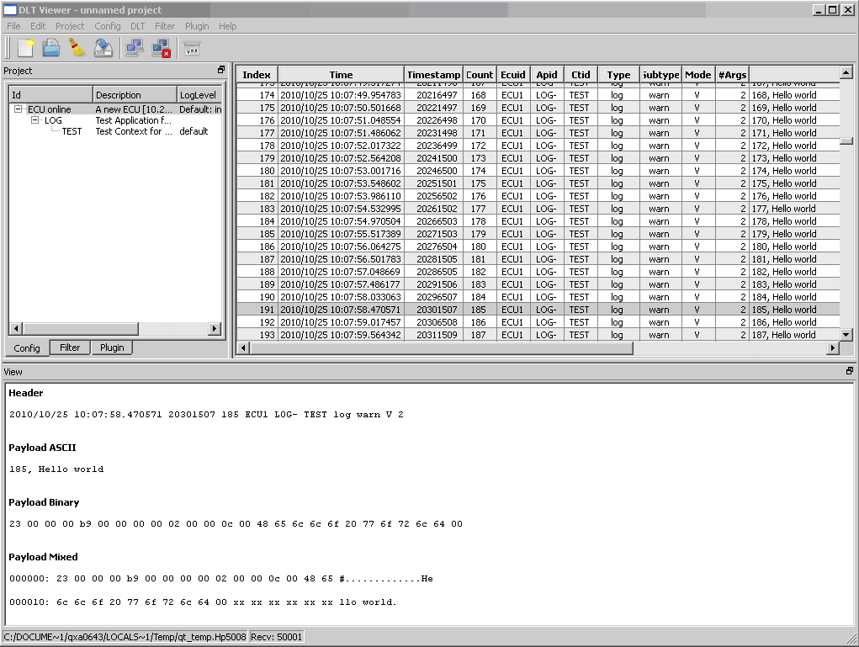

Project
The top left part of the window allows you to configure and control the project. The project is splitted into three configuration parts.
The Config which contains all connected ECUs/Devices. Each Device contains its provided applications. Each application provides its used contexts.
The Filter part configures the Filters, which are used show only specific DLT messages.
The Plugin part shows the loaded Plugins, which are used to decode special DLT log messages.
In the Project menu you can load an existing project or save a changed configuration.
In the Settings you can select a default project, which is loaded during startup.

Config
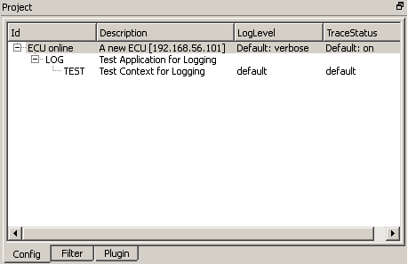
In the config window you see a hierarchical list of all configured devices, applications and contexts.
In the ECU item you see the ID of the ECU, the status of the ECU (offline, connect, online), a description of the ECU including the interface to connect, the default log level and the default trace status.
In the application item you see the ID and the description of the application.
In the context item you see the ID , the description and the log level and trace status of the context.
If you double click an item you can configure the item.
If you select a item and press the right mouse button you get a context menu dependent on the type of selected item:
No ECU is configured yet:

ECU is selected:
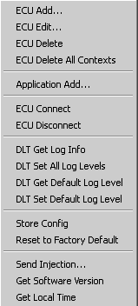
Application is selected:
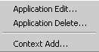
Context is selected:
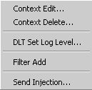

Filter
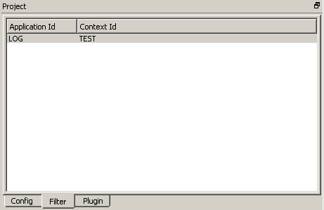
The Filter list gives you an overview of all configured filters. If at least one filter is configured, only DLT messages which match this filter are displayed.
If you double click on a filter item, you can change the filter.
If you right click with your mouse, you get the following context menu.
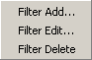

Plugin
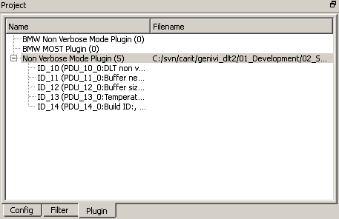
The plugin list shows you all loaded plugins. Plugins are used to decode DLT messages. If you double click on a Plugin you get a window where you can select a file which is loaded for the plugin. The number shows you, how many description items for each plugin is loaded. You get also a summary of all loaded items of a plugin.

DLT Messages Table
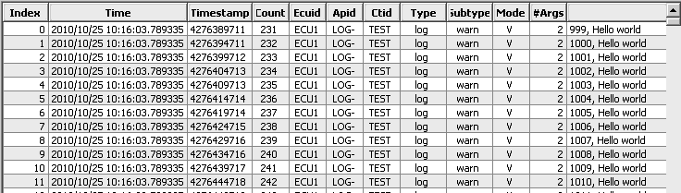
In the DLT Message table you see all DLT messages in the current selected DLT log file. You can scroll through the whole log file. New received DLT messages are written into the DLT log file. If AutoScroll is enabled in the settings the table scroll always to the end, when new DLT messages are received.
Index shows the number of the DLT message in the DLT log file, the header shows all header parameters, the payload shows all parameters of the log message.
If a filter is configured, you will see only these DLT messages, which match the filter. Remove all filters, if you want to see all messages.
If some plugins are configured and a DLT message matches a plugin the decoded information for Header and Payload is displayed.
DLT log files can be loaded or saved in the file menu. A default log file can be configured in the settings.

DLT Message View

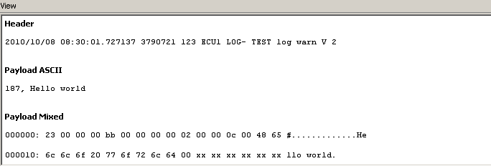
When you select a DLT message in the DLT Message table a detailed information of the DLT Message is displayed. In the settings you can select, which information is displayed.

Quick Start

Connect to ECU
Press the connect button to connect to the target:

If no ECU is configured, the ECU configuration dialog appears. Select the “Interface Type” you want to use TCP or Serial.
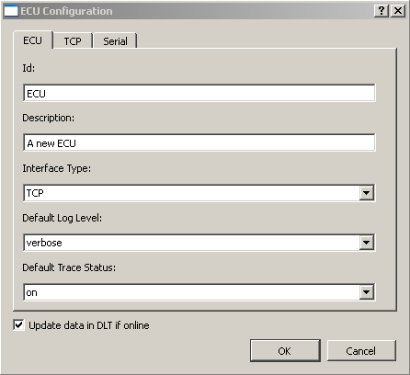

If you use a TCP connection configure the Hostname of the target ECU.
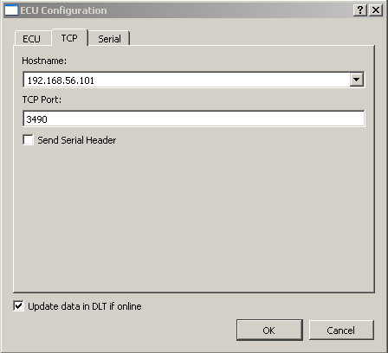
If you use a serial port to connect select the serial port. Check the COM port, where your serial device is connected in your Windows configuration. A drop down list provides you a list of Examples for the Port configuration..
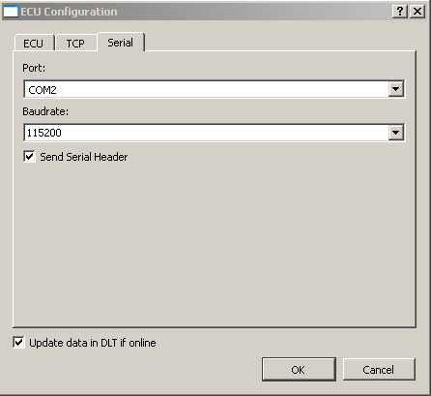
If you select “OK” the DLT Viewer will try to connect to the ECU. The ECU Id shows online, as soon the DLT Viewer is connected to the device.
All received DLT messages should then be displayed in DLT message table.

Available list of contexts
When you are connected to an ECU, you can get a list of available contexts in the ECU. Select an ECU item in the Config window. Right click on the selected ECU and select the context menu item “DLT Get Log Info”. The DLT viewer then send a request to the ECU and gets back a result with all available Contexts. The list of available contexts is added to your Config list

Working with DLT log files
When you start the DLT viewer, a temporary log file is created. All received DLT messages are stored in the temporary log file and shown in the DLT message table.
Cal the menu “File/Save As” to copy your temporary log file to a file you have selected or call “File/New”, if you want to create a new log file.

Non Verbose mode description
If you receive DLT messages in non verbose mode you want to decode the messages and see them in plain text. To do this you have to go to “Plugin”. Double click on the Plugin “Non Verbose Mode Plugin”. In the Dialog select the the non verbose XML description file, which corresponds to your software on the ECU. When you select “OK”, the Plugin shows a list of all available non verbose messages. As soon as you select a DLT message you can view the decoded information.

Appendix

Implementation specifics
None

