System design notes Operations Guide
  - Start check troubleshoot and close
This fork contains study notes, not a running software product.

Open and read
Open Readme.md, then select the relevant chapter in a Markdown viewer or on GitHub. No development server or dependency installation is needed for ordinary reading. Keep attribution and source links when maintaining these notes.

Check and troubleshoot
For a broken link, inspect the actual relative directory and its capitalization. An external reading site being unavailable does not mean this local repository needs restarting. Keep proposed factual corrections tied to the source rather than inventing a runtime or API.

Close and maintain
Save your intended notes, review the diff, and close the viewer. There are no application processes, accounts, or databases to shut down. Use a topic branch and master-targeted PR for deliberate changes to this owned fork; upstream contribution is a separate choice.

Before you begin
The non-runtime or blocked status above governs this repository. Work in this checkout, preserve existing files, and do not invent a service merely because a generic tool offers a Start button. Save findings and deliberate source changes; there is no application process to stop unless a verified recipe explicitly names one.

Keep troubleshooting scoped
Record the first error, source revision, working directory, and selected instance. Check the stated prerequisites before changing anything. Preserve useful work before resets. Stop only the process or dedicated dependency you own; do not kill by a guessed port or broad name. Keep credentials and private records out of reports. Migrations, seeds, volume deletion, deployment, and new model downloads are separate operations, not generic restart fixes.

Normal operating sequence
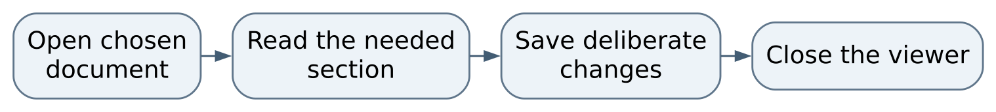
Figure 1 Normal operating sequence

Maintaining this guide
Keep this Markdown, the editable Word edition, PDF, and operating-flow.svg together here. Update them when merged commands, storage, dependencies, or limits change. Edit Word and export PDF independently when convenient, then inspect the affected pages. No running AIOS service is needed to read or maintain these documents.
Source-defined instructions and known gaps are distinguished above. This documentation task did not launch the application or prove a new production workflow. Verify changes locally on NixOS; use a topic PR and human merge for owned source. Deployment is separate, and routine hosted CI remains disabled.

Source and edition
Edition 26 October 2026. Repository COchs-Personal/system-design-notes. Inspected source revision aa7ac69e206bca659020baa5954bb65cfd70ab99.
Source files: Readme.md.
Editable Word edition | PDF edition

