Carter Odem

Dmitriy Bliznyuk

Parker Hayden Olive

Mamadou S Barry

TCSS 371

5/30/2017

CPU Simulator Screen Shots

These screen shots capture the instructions that were not in the previous assignments: STI, LDI, Push and pop are all shown as well as the break point being hit in the program.

**STI**

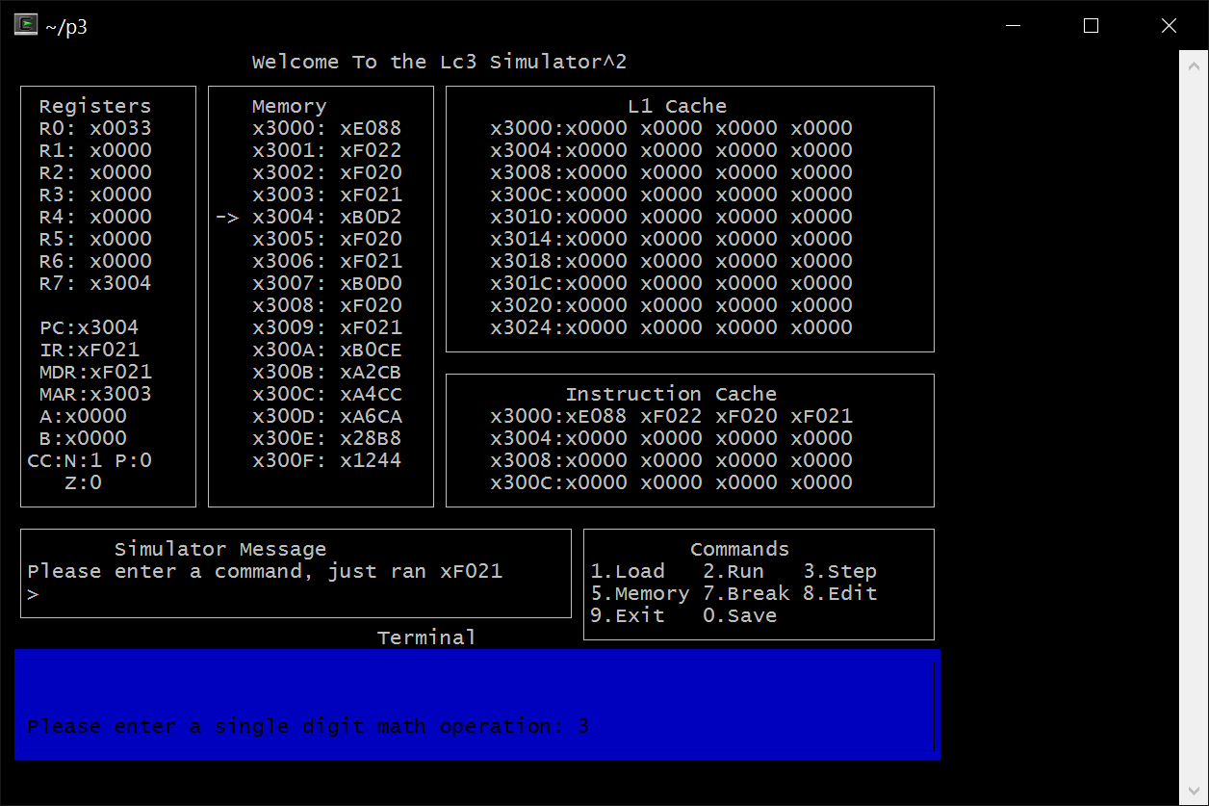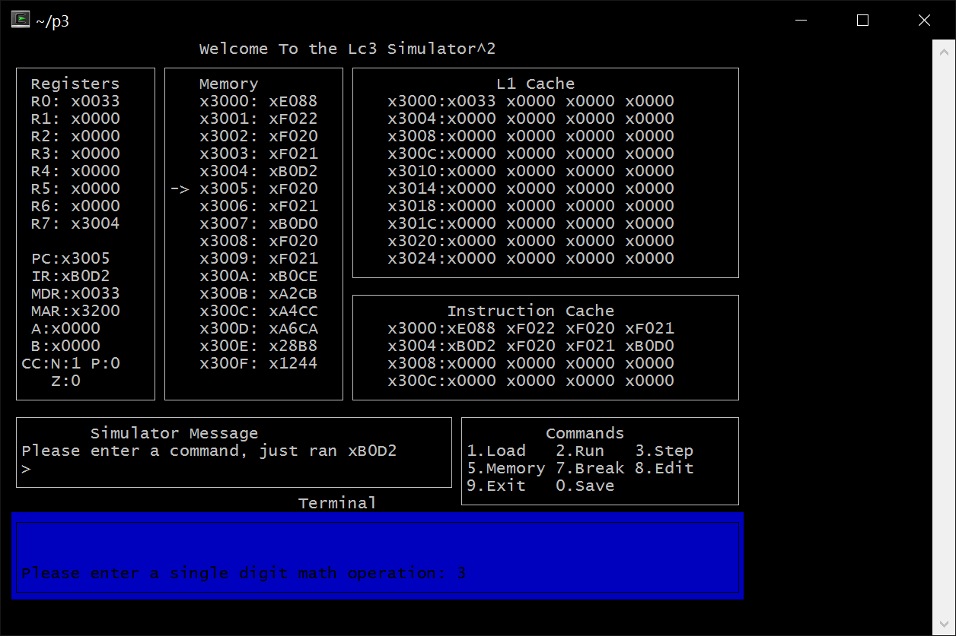

**LDI**

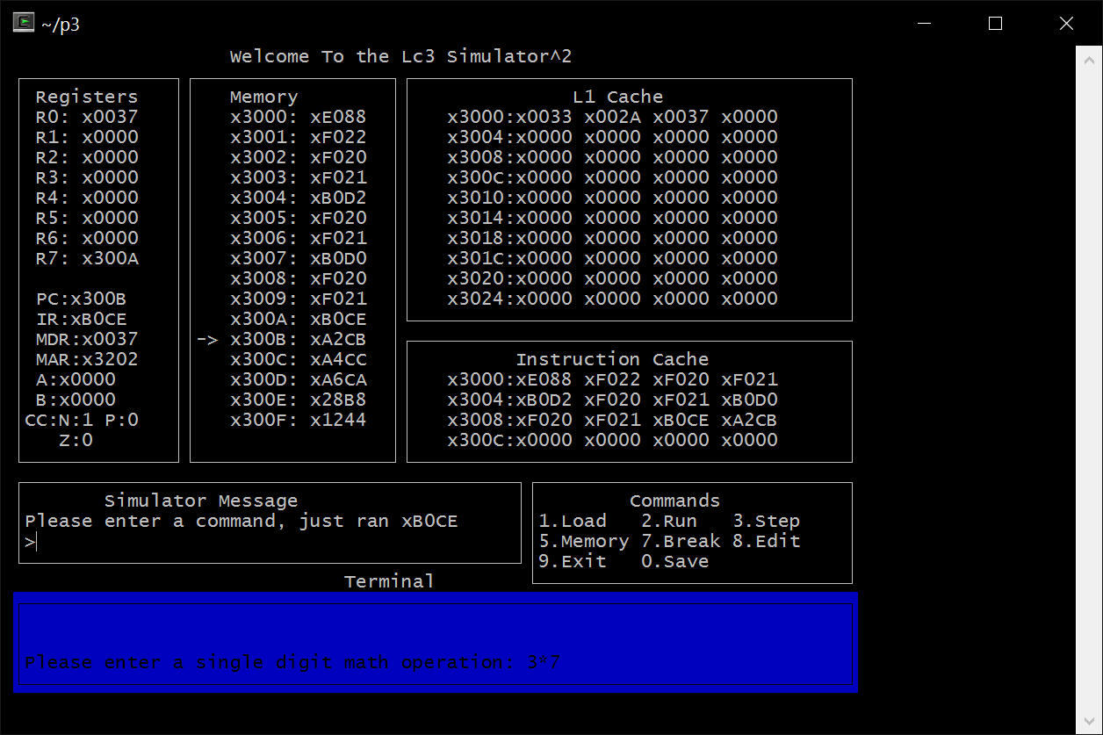

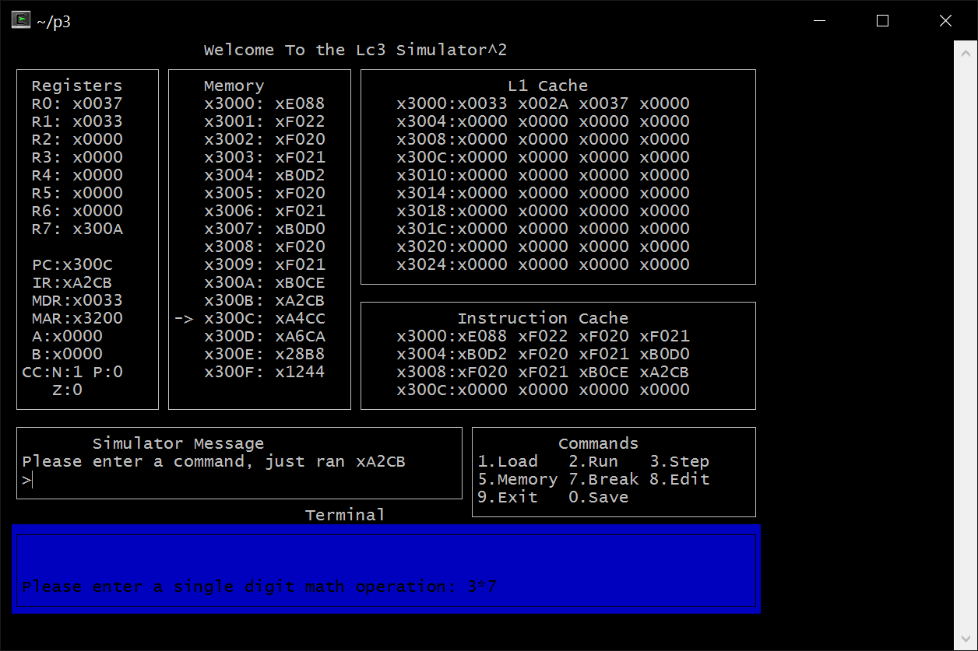

**PUSH**

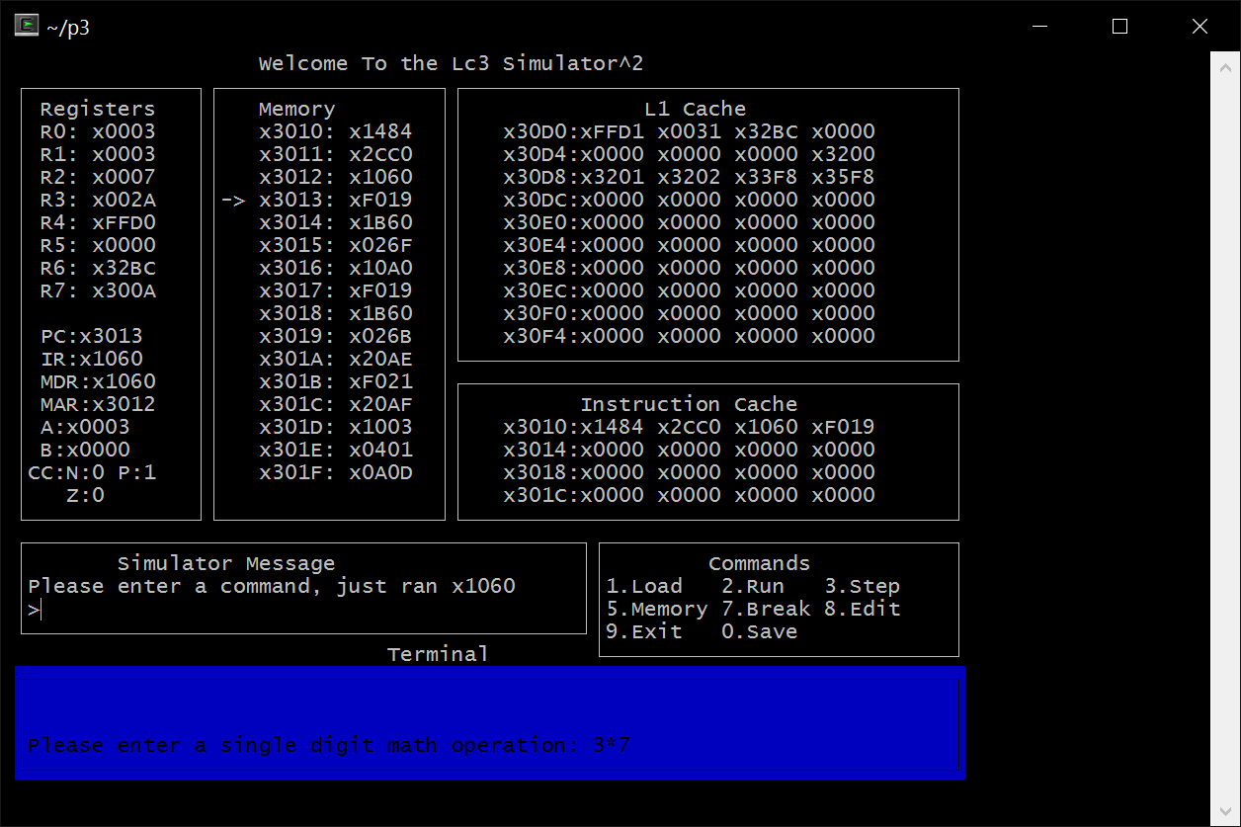

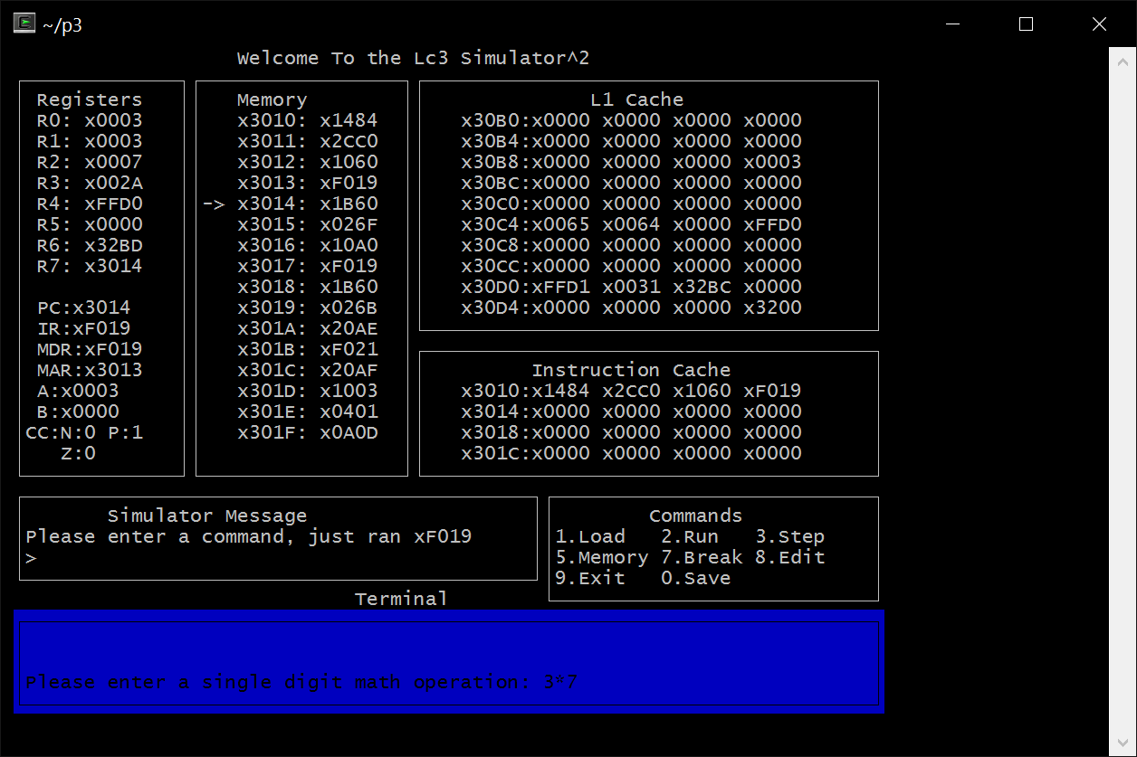

**POP**

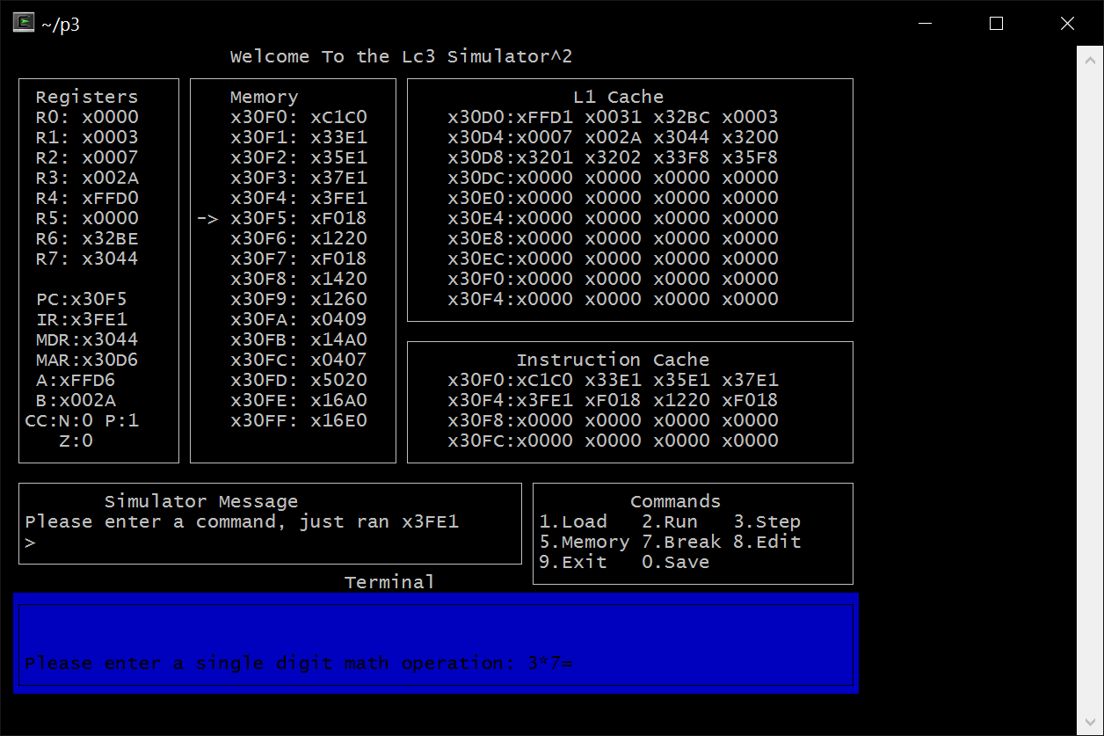

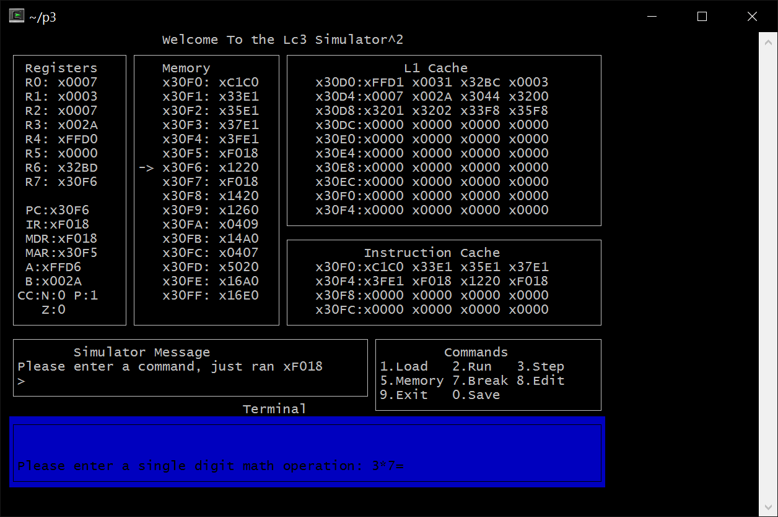

**Break Point** 