GPAT-TRANSFERBENCH
Frozen Research, Reimplementation, Training, Evaluation and Paper-Evidence Specification
Version 1.0 — August 2026
Standalone GPAT study — no PRISM-FAS-B components
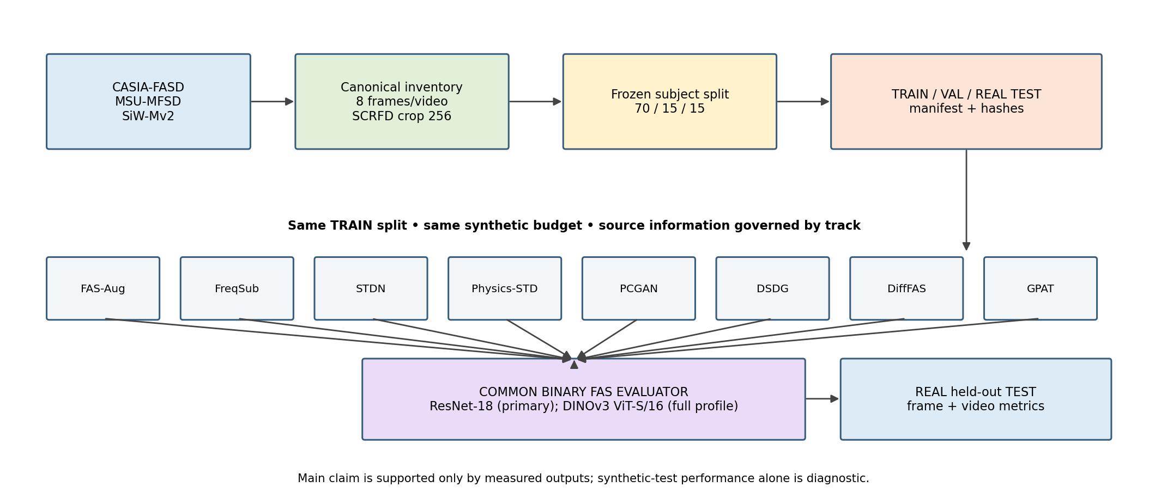
Figure 1. End-to-end experimental contract. All numbers are produced only after real runs; no placeholder may be reported as a result.
EXECUTION CONTRACT: This document is intentionally prescriptive. Claude/Codex must implement the specification as written. It must not substitute models, invent hyperparameters, alter split logic, or silently simplify a baseline. Any unresolved detail must be surfaced as BLOCKED_BY_SOURCE_GAP or recorded in deviation_report.md before continuing.

0. Document status, scope and non-negotiable rules
Scientific status: PROPOSED DESIGN / FROZEN IMPLEMENTATION SPECIFICATION. No experimental number in this document is a measured result. All result cells are intentionally shown as “—”.
- Research scope: image-based Face Anti-Spoofing (FAS) synthetic data generation by transferring or synthesizing spoof evidence onto live faces.
- Primary method under study: GPAT (Geometry-Preserving Artifact Transfer), evaluated as a standalone generator, not as part of PRISM-FAS-B.
- Primary scientific question: under one frozen pooled dataset and one frozen downstream evaluator, which synthetic method best preserves the live target, transfers spoof evidence, and improves real held-out FAS performance?
- Datasets used in this benchmark: the user’s local copies of CASIA-FASD, MSU-MFSD and SiW-Mv2. Local inventory is the source of truth; the code must not assume official sample counts.
- Primary split: 70% train / 15% validation / 15% test, group-disjoint by subject within each dataset. Frame-random splitting is forbidden.
- Final TEST contains only real samples. Synthetic samples are never inserted into the main TEST set.
- Every baseline is retrained/reimplemented on this benchmark. Published paper numbers are literature context only, never mixed with our reimplementation results.
- All self-run results are reported over seeds [42, 1337, 2026] as mean ± standard deviation; test thresholds come from VAL only.
- No target/test-driven tuning, cherry-picking of one seed, or post-hoc changing of metrics is allowed.

0.1 Claude / Codex hard rules
- Read this document completely before coding. Create a frozen_config_snapshot/ directory containing verbatim copies of every YAML/JSON configuration used.
- Implement one milestone at a time. A milestone can be marked COMPLETE only after unit tests, acceptance checks and evidence files pass.
- Never replace a named model with an “equivalent” model because installation is easier. If the named dependency cannot be installed, stop that milestone and write BLOCKED_BY_DEPENDENCY.
- Never invent a missing third-party paper/repository detail. Follow the source-of-truth hierarchy defined in Section 8. If the source is genuinely underspecified and no benchmark override is defined here, write BLOCKED_BY_SOURCE_GAP.
- Never alter split manifests after the first accepted split. Any new split requires a new protocol version and cannot overwrite v1.
- Never train on TEST metadata or use TEST metrics for checkpoint, threshold, quality-gate or hyperparameter selection.
- Never fabricate a result, interpolate a missing method, or copy a reported paper result into an “our reimplementation” table.
- Every run must save code commit, config hash, dataset-manifest hash, model checkpoint hash, seed, environment lock and per-sample predictions.
- Any deviation from this specification must be written to outputs/audit/deviation_report.md with reason, affected experiments and explicit status APPROVED/UNAPPROVED. Unapproved deviations cannot be used as main paper results.

0.2 Fixed project root and directory contract
D:\AI on IOT\Anti_spoofing\GPAT_TransferBench
├── configs\
│ ├── frozen\
│ ├── methods\
│ └── experiments\
├── data\
│ ├── raw\casia_fasd\
│ ├── raw\msu_mfsd\
│ ├── raw\siwmv2\
│ ├── processed\frames\
│ └── processed\faces_256\
├── manifests\
├── cache\geometry\
├── cache\identity\
├── methods\
│ ├── fas_aug\
│ ├── freq_sub\
│ ├── stdn\
│ ├── physics_std\
│ ├── pcgan\
│ ├── dsdg\
│ ├── difffas\
│ └── gpat\
├── probes\
├── downstream\
├── third_party\
├── runs\
├── outputs\tables\
├── outputs\plots\
├── outputs\qualitative\
├── outputs\paper_pack\
├── outputs\audit\
└── tests/

1. Research method and hypotheses
A sample for source-conditioned transfer contains a live target x_t and a real spoof source x_s. A generator G produces a synthetic spoof x_hat whose facial content should remain attributable to x_t while its attack evidence should be attributable to x_s.
x_hat = G(x_t, x_s; supervision, method parameters)
- H1 — Target preservation: GPAT has higher target identity similarity and lower geometric/topological drift than unconstrained full-image conversion methods.
- H2 — Artifact transfer: GPAT does not “win” by producing an almost unchanged live face; source-to-synthetic artifact similarity and attack-family consistency must remain non-collapsed.
- H3 — Downstream utility: replacing a fixed portion of real-spoof training examples with an equal-budget GPAT synthetic bank improves or maintains real held-out FAS performance relative to other generators.
- H4 — Supervision effect: attack-type labels improve artifact controllability; identity supervision primarily reduces source-identity leakage. These effects are tested separately with GPAT B0/B1/B2/B3.
- H5 — Hard wavelet constraint: γ=0 and wavelet residual output produce a better geometry–artifact Pareto trade-off than full RGB generation, RGB residual generation, or γ>0 variants.
- H6 — Improvements are not explained by more synthetic data, a stronger evaluator, a different threshold, generator fingerprint, or data leakage.

1.1 Primary contribution claim allowed after experiments
The paper may claim a “geometry-preserving, source-conditioned, bounded wavelet-residual spoof transfer framework” only if H1, H2 and H5 are supported. The broad statements “first spoof transfer”, “first frequency-domain FAS”, “first spoof map” and “first quality-aware FAS” are prohibited because related prior work exists.

2. Literature position and baseline set
ID | Method | Role in this benchmark | Dataset supervision used by original method | Core overlap with GPAT
R0 | Real-only | Downstream lower bound | Live/Spoof | No synthetic generation
R1 | FAS-Aug | Handcrafted / physics synthetic baseline | Does not require dataset attack-type label for basic operators | Creates spoof artifacts without learning source→target transfer
R2 | Frequency Substitution | Direct frequency transfer baseline | Live/Spoof pair is sufficient | Transfers high-frequency spoof content directly
R3 | STDN (ECCV 2020) | Learned spoof-trace transfer | Binary Live/Spoof in core method | Disentangles spoof trace then geometrically transfers it
R4 | Physics-Guided STD / PAMI | Frequency-aware trace transfer | Weak/binary supervision in core method | Additive + inpainting spoof traces across frequency bands
R5 | PCGAN–PMN (2026) | Full-image learned artifact conversion | Ground-truth Live/Attack labels for conversion | Disentangles content/artifact; generates full RGB mixed image
R6 | DSDG | Generative/disentanglement secondary baseline | Uses spoof-type label; identity/spoof latent factors | Generates paired live/spoof from latent distribution
R7 | DiffFAS (ECCV 2024) | Diffusion generation baseline | Precise spoof style labels + identity-consistent live/spoof pairs | Live→spoof full-image diffusion editing conditioned by spoof style
P | GPAT | Proposed method | B0 binary; B1 +type; B2 +ID; B3 +type+ID | Learned bounded wavelet residual with hard LL preservation

LITERATURE SCOPE: MEGC (ICASSP 2022), Face De-Spoofing/noise modeling, generalized spoof-cue maps and later frequency-domain FAS works are required Related Work references but are not mandatory main generator rows because they do not provide the same source→target synthetic contract.

3. Dataset protocol: pooled held-out evaluation
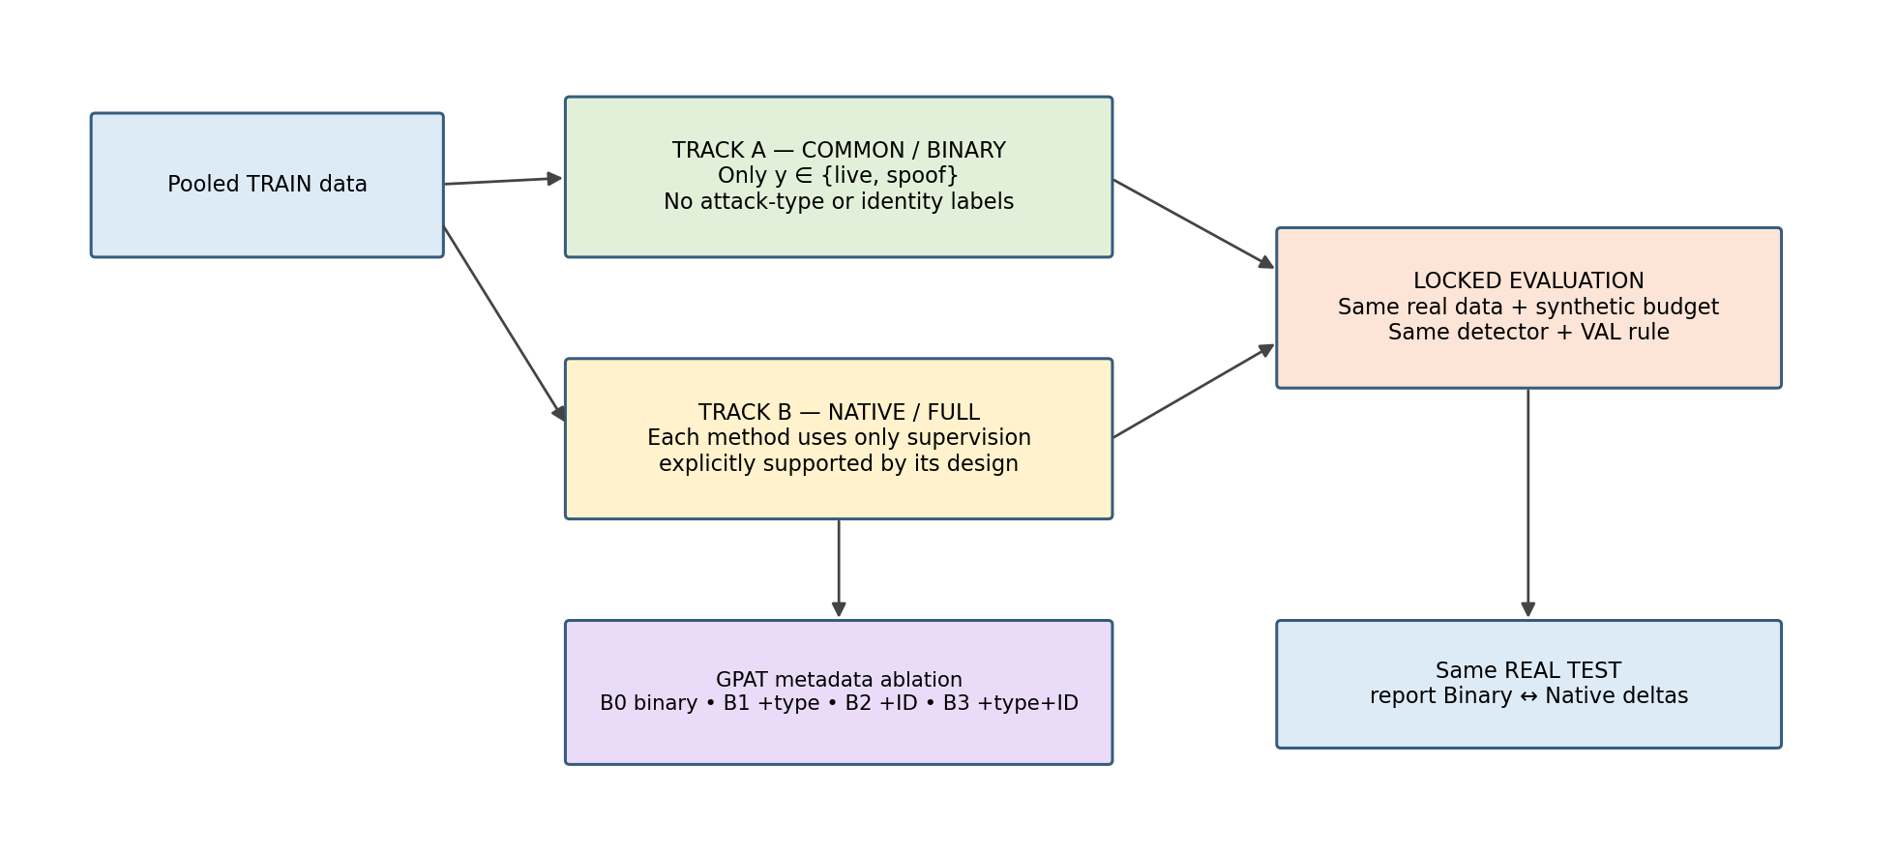
Figure 2. Two supervision tracks. Track A equalizes dataset-label information; Track B runs each method with its native supported supervision.

3.1 Dataset inventory is mandatory before splitting
The implementation MUST inventory the user’s local copies instead of assuming that the local folders contain the full official release. For each dataset the adapter must enumerate canonical videos/sequences, subjects, live/spoof labels and raw attack labels when available.
Dataset | Local role | Known public characteristics used only for validation/context | Hard rule
CASIA-FASD | Pooled dataset | Contains print-style and video/replay attacks; original ICB 2012 dataset | Use local inventory; do not assume sample count
MSU-MFSD | Pooled dataset | Print and replay presentation attacks; associated with Wen et al. TIFS 2015 | Use local inventory; do not assume sample count
SiW-Mv2 | Pooled dataset | 14 spoof types: print/replay, masks, makeup and partial/material attacks | Use local inventory; preserve all available raw attack labels

3.2 Canonical metadata schema
Field | Type | Required | Definition
sample_id | string | Yes | Stable hash from dataset + canonical_video_id + sampled_frame_index
dataset | enum | Yes | casia_fasd | msu_mfsd | siwmv2
subject_id_raw | string | Yes | Dataset-native subject identity token
subject_id_global | string | Yes | dataset::subject_id_raw
video_id | string | Yes | Stable canonical video/sequence ID
frame_index | int | Yes | Original frame index
label_binary | int | Yes | 0=live, 1=spoof
attack_raw | string | Spoof only | Dataset-native attack/style label
attack_macro | enum | Yes | live | print | replay | mask_2d | mask_3d | makeup | partial | other_spoof
style_id | string | Spoof if available | dataset::attack_raw; used only by Native/Full methods that need precise style
source_path | string | Yes | Raw file or image-sequence path
sha256 | string | Yes | Hash of original frame bytes or canonical extracted PNG

3.3 Frozen attack-label harmonization
Dataset raw concept | attack_macro
CASIA warped printed photograph | print
CASIA cut-eye printed photograph | print
CASIA video attack | replay
MSU printed photograph | print
MSU replay/video attack | replay
SiW-Mv2 print | print
SiW-Mv2 replay | replay
SiW-Mv2 paper mask | mask_2d
SiW-Mv2 half mask | mask_3d
SiW-Mv2 transparent mask | mask_3d
SiW-Mv2 silicone mask | mask_3d
SiW-Mv2 mannequin | mask_3d
SiW-Mv2 partial eye | partial
SiW-Mv2 funny eye glasses | partial
SiW-Mv2 partial mouth | partial
SiW-Mv2 paper glasses | partial
SiW-Mv2 cosmetic makeup | makeup
SiW-Mv2 impersonation makeup | makeup
SiW-Mv2 obfuscation makeup | makeup
Any explicitly documented spoof token not listed above | other_spoof (record raw token; do not guess another class)

NO SILENT LABEL GUESSING: If an adapter sees an unknown raw token, it must write outputs/audit/unmapped_attack_tokens.csv. It may map the token to other_spoof for the binary benchmark, but Native/Full experiments that require exact style are BLOCKED until the raw token is explicitly added to attack_map_v1.yaml.

3.4 Frame sampling from videos / image sequences
- Sample exactly 8 unique frames per canonical video/sequence whenever at least 8 valid frames exist.
- Normalized sample positions are fixed at [0.10, 0.2142857, 0.3285714, 0.4428571, 0.5571429, 0.6714286, 0.7857143, 0.90] of the valid frame range; choose the nearest unique valid frame indices.
- For sequences shorter than 8 valid frames, use every unique valid frame once; never duplicate a frame to reach eight.
- Decode with the same backend and record decoder/version. Extract canonical PNGs losslessly before downstream preprocessing.
- No temporal model is used in the core benchmark; the eight frames are independent training samples. Video-level test score is the arithmetic mean of the eight frame probabilities.

3.5 Frozen split algorithm — 70/15/15 subject-disjoint
- Split independently inside each dataset, then pool the dataset-specific TRAIN/VAL/TEST partitions.
- Grouping key = subject_id_global. A subject must appear in exactly one split.
- Target ratios by number of canonical videos are TRAIN 0.70, VAL 0.15, TEST 0.15.
- Deterministic split_seed = 20260814.
- Allocator objective: minimize absolute deviation from target video counts plus penalties for missing binary class and attack_macro coverage. If an attack macro has fewer than 10 unique subjects, coverage across all three splits is not forced; this limitation is reported.
- No video fallback is allowed in the main protocol. If a dataset adapter cannot recover subject ID, the split milestone is BLOCKED_BY_MISSING_SUBJECT_ID. A video-disjoint fallback may be implemented only as a separately named protocol_v1_video_fallback, never as the main result.
split_v1.parquet must contain:
sample_id, dataset, subject_id_global, video_id, frame_index,
label_binary, attack_raw, attack_macro, split, sha256
Acceptance:
- subject intersection TRAIN∩VAL = TRAIN∩TEST = VAL∩TEST = ∅
- video intersection across splits = ∅
- frame/sample intersection across splits = ∅
- each dataset represented in all feasible splits
- split manifest SHA256 recorded in outputs/audit/split_v1.sha256

4. Preprocessing and frozen auxiliary models
Component | Frozen choice | Exact config / purpose
Face detector | SCRFD ONNX | input 320; score threshold 0.50; choose largest detected face; detector weights must be hashed
Crop | Square padded face | center on SCRFD bbox; side = 1.25×max(w,h); clamp to image; no random padding
Master face resolution | 256×256 RGB | INTER_AREA when downscaling; INTER_CUBIC when upscaling; uint8 sRGB canonical crop
Geometry cache | FaceXFormer, frozen | parsing logits/mask, landmarks, yaw-pitch-roll; offline cache only
Identity cache | AdaFace IR-50, frozen | store L2-normalized embedding; follow model’s official BGR/input normalization
Wavelet | ptwt Haar | level 1, boundary_mode=reflect; per RGB channel
High-pass operator | Gaussian residual | HP(x)=x-GaussianBlur(x,kernel=9, sigma=1.5)

FROZEN AUXILIARIES: SCRFD, FaceXFormer and AdaFace are preprocessing/evaluation teachers. They are never fine-tuned on this pooled benchmark. Their model IDs, code commits and weight hashes must be stored in models/registry.yaml.

5. Two supervision tracks and information budget

5.1 Track A — COMMON / BINARY
- Dataset supervision visible to the generator is restricted to image + label_binary. attack_raw, attack_macro, style_id and subject identity labels must not be used in generator optimization.
- Pretrained face/geometry models may still be used if they are intrinsic components of the method; this must be disclosed as external pretrained supervision, not dataset metadata.
- DSDG-BIN: retain DSDG architecture but collapse all spoof-type labels into one spoof class. Mark result as “adapted binary variant”, not faithful DSDG.
- DIFFFAS-BIN: retain DiffFAS architecture but collapse the spoofing style pool to one spoof style label. Same-ID live/spoof pairing may still be used as structural data pairing; the dataset identity token cannot be fed as a class label. Mark as “adapted binary variant”.
- GPAT-B0 is the proposed binary configuration. GPAT-B2 is not part of Track A because it uses identity labels.

5.2 Track B — NATIVE / FULL
Method | Native/full supervision allowed
FAS-Aug | No dataset attack label required by the operator engine; synthetic operator identity is internal provenance only
Frequency Substitution | Live/Spoof pairing only
STDN | Binary Live/Spoof
Physics-Guided STD | Binary/weak Live/Spoof core supervision
PCGAN | Ground-truth Live/Attack labels for conversion
DSDG-NATIVE | Spoof-type label for spoof-pattern classifier; use identity factorization as original design permits
DIFFFAS-NATIVE | Precise style_id labels + same-ID live/spoof reconstruction pairs; guide spoof supplies style
GPAT-B3 | Binary + attack_macro + subject identity adversary

SHORTCUT CONTROL: dataset ID, camera ID and device ID are never fed to GPAT or the common detector. They may be used only for stratification, audit and post-hoc subgroup analysis.

5.3 GPAT supervision ablation
Variant | Binary label | Attack type | Identity label | λ_type | λ_idadv
GPAT-B0 | Yes | No | No | 0.0 | 0.0
GPAT-B1 | Yes | Yes (attack_macro) | No | 0.2 | 0.0
GPAT-B2 | Yes | No | Yes (GRL adversary) | 0.0 | 0.1
GPAT-B3 | Yes | Yes (attack_macro) | Yes (GRL adversary) | 0.2 | 0.1

6. Common source→target pair manifest
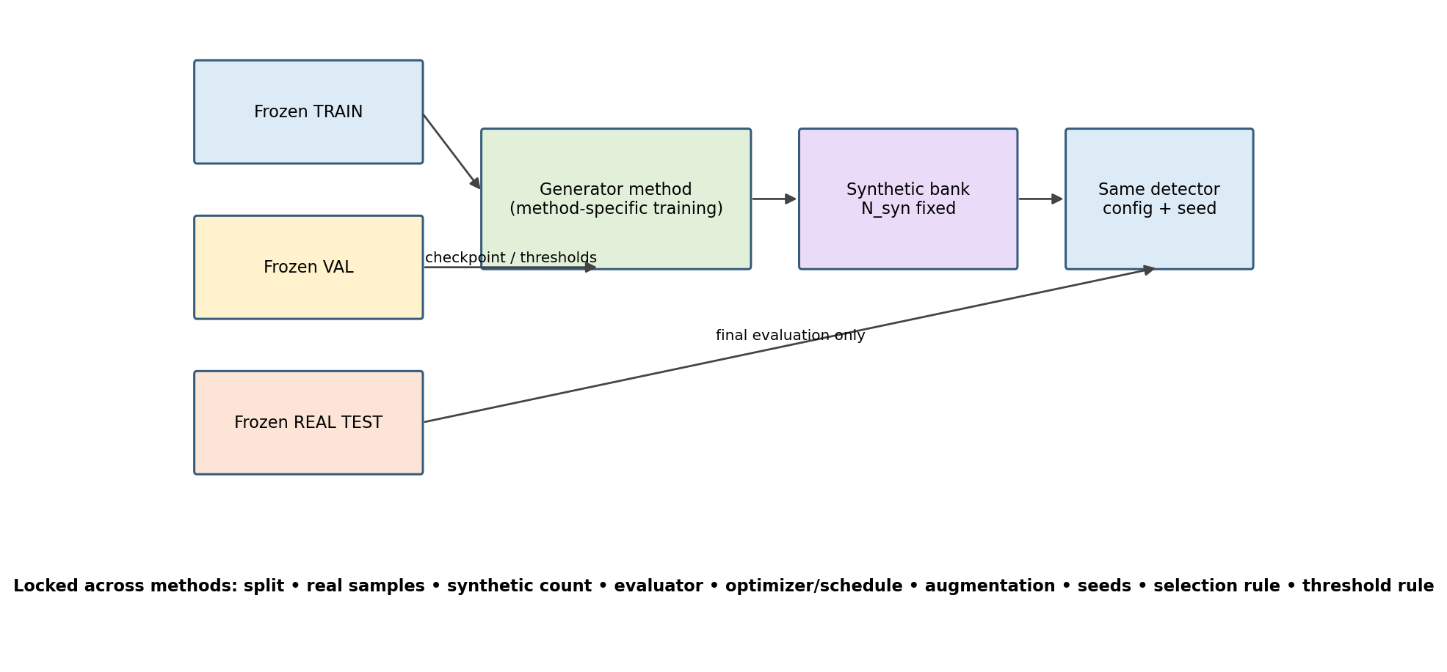
Figure 3. Fairness contract: generators may train differently, but downstream evaluation variables are locked.
- Build pairs only from TRAIN. Each TRAIN spoof frame is one source row and therefore defines one intended synthetic sample. Thus N_syn,intended = number of TRAIN spoof frames.
- Target live candidates must come from the same dataset as the spoof source and from a different subject.
- For every source spoof, deterministically sample up to 64 candidate live frames using a hash of (source_sample_id, split_seed). If fewer than 64 eligible candidates exist, use all candidates.
- Compute pose distance from FaceXFormer yaw/pitch/roll after z-normalization inside TRAIN; scale distance from log face-box area ratio; luminance distance from normalized Y-channel mean.
d_pair = 0.50·d_pose + 0.30·d_scale + 0.20·d_luma
Choose the candidate with minimum d_pair; tie-break by lexical sample_id. The same pair_id is fed to every source-conditioned method that can consume a live target and spoof guide/source.
pair_id | target_live_id | source_spoof_id | dataset | target_subject | source_subject | attack_macro | d_pose | d_scale | d_luma | seed
P000001 | — | — | — | — | — | — | — | — | — | 20260814

METHOD CONTRACT: FAS-Aug uses target_live_id from the pair row and ignores source_spoof_id. DSDG is not a source→target pair method; it generates exactly the same count N_syn but pairwise metrics are reported N/A. DiffFAS uses the pair row at inference; its training also requires a same-ID live/spoof reconstruction-pair manifest described in its method card.

7. Synthetic budget and two fairness views
- Main intended budget: N_syn = N_train_spoof_frames.
- Every synthetic output must be returned as canonical 256×256 RGB uint8, regardless of the method’s internal resolution.
- RAW-MATCHED view: retain every numerically valid generated output; only NaN/Inf, decode failure or missing output is excluded. This view isolates the raw generator.
- QUALITY-MATCHED view: each method may apply its native documented filtering/quality mechanism. Determine N_common = minimum number of valid/accepted outputs among compared methods; deterministically subsample every method to N_common using pair_id/synthetic_id hash. This prevents GPAT quality filtering from receiving a larger or smaller training budget.
- Report both RAW-MATCHED and QUALITY-MATCHED downstream results. The paper must state which one is the primary table before inspecting TEST.

8. Third-party reimplementation policy and method cards
Source-of-truth hierarchy for third-party methods: (1) official repository at pinned commit; (2) official supplementary material; (3) published paper equations/architecture; (4) the controlled benchmark override below. Claude must never skip directly to an ad-hoc implementation when a higher-priority source exists.
Status tag | Meaning
FAITHFUL_OFFICIAL | Official code/config used; only dataset paths/adapters and output wrapper changed
FAITHFUL_PAPER | No usable official code; architecture/equations reconstructed from paper without method-changing assumptions
CONTROLLED_ADAPTATION | Paper idea reimplemented under an explicitly frozen adaptation defined here
BLOCKED_BY_SOURCE_GAP | A required method detail is missing and no override is defined; stop this method rather than guess

8.1 FAS-Aug
- Implementation status target: FAITHFUL_OFFICIAL. Use official FAS-Aug repository; pin the repository commit on first setup and store commit hash. Do not modify published augmentation ranges in the main run.
- Input: pair-manifest target live 256×256. Source spoof image is not used.
- Synthetic operator selection: deterministic round-robin by pair_id across the official FAS-Aug operator set; operator parameters are generated with seed = SHA256(pair_id + global_seed) mod 2^31 and follow the official repository defaults.
- Output: one spoof-labeled canonical 256×256 image per intended pair. Save operator name and all sampled parameters in provenance.
- Track A and Track B are identical for this method because dataset attack labels are not required for basic FAS-Aug synthesis.

8.2 Frequency Substitution — controlled implementation of Huang et al. synthesis idea
- Status: CONTROLLED_ADAPTATION because the paper describes random high-frequency block substitution but does not fully fix every block geometry/implementation detail needed for a deterministic modern implementation.
- Compute per-channel FFT2 of target and source at 256×256. Let A_t, φ_t and A_s be target magnitude, target phase and source magnitude after fftshift.
- Eligible high-frequency region: radial normalized frequency r ∈ [0.20, 0.50] where r=0 at spectrum center and r=0.5 at Nyquist edge.
- Partition the shifted magnitude spectrum into non-overlapping 16×16 blocks. Eligible block if at least 75% of its pixels lie in the eligible high-frequency region.
- Select exactly 25% of eligible blocks using pair-specific RNG seed. Replace target magnitude with source magnitude in selected blocks and the conjugate-symmetric counterparts. Preserve target phase.
- Reconstruct complex spectrum A_mix·exp(jφ_t), inverse shift, inverse FFT, real part, clip to [0,255]. No spatial post-filter.
- Binary and Native tracks are identical. Save block mask as the method’s edit map for diagnostics.

8.3 STDN — On Disentangling Spoof Trace for Generic FAS
- Status: FAITHFUL_OFFICIAL. Official code: yaojieliu/ECCV20-STDN. Preserve its model/loss/training defaults; change only dataset adapter, canonical input/output paths and reproducibility logging.
- Core dataset supervision for this benchmark: binary Live/Spoof only. Do not add attack-type labels to STDN.
- Geometry input required by the method must be produced deterministically from the frozen geometry cache or the official method’s required landmark/3D fitting preprocessing; record this as auxiliary pretrained geometry, not dataset label supervision.
- Generation: use the disentangled spoof trace from source_spoof_id, apply the method’s geometric correction to target_live_id, and output only the synthetic spoof direction for common comparison.
- If the original TensorFlow stack cannot be reproduced in the current environment, create an isolated environment/container. Rewriting the model in PyTorch is not allowed for the main faithful row unless validated numerically against official checkpoints and tagged separately.

8.4 Physics-Guided Spoof Trace Disentanglement / PAMI
- Target status: FAITHFUL_PAPER unless a verified official code release is found. The paper models spoof generation with three additive components at different frequency scales plus one inpainting component.
- Reuse the STDN-compatible geometric alignment/correction machinery. Implement exactly the paper’s additive/inpainting decomposition and its published losses. Store an equation-to-code traceability table in methods/physics_std/source_traceability.md.
- When the paper omits a non-scientific engineering parameter such as dataloader workers, use global benchmark defaults. If a tensor dimension, architecture block, loss coefficient or optimization setting that changes the scientific method is missing, mark BLOCKED_BY_SOURCE_GAP instead of choosing one.
- Core supervision: binary/weak Live/Spoof. Do not add attack-type labels.

8.5 PCGAN artifact pattern conversion
- Status: FAITHFUL_PAPER / CONTROLLED_ADAPTATION depending on official code availability at implementation time. The scientific contract is fixed: separate facial-content and spoof-artifact latent representations, combine them via the paper’s conversion generator, and produce a full RGB synthetic attack image.
- Training uses pooled TRAIN live/attack labels. No attack-type supervision is added.
- For common source→target generation, source_spoof_id supplies spoof-artifact representation and target_live_id supplies facial-content representation. Only Live→Spoof output is evaluated in the main generator table; a symmetric Spoof→Live output may be trained if required by the original losses but is not used as a positive result row.
- The method must output a full 256×256 RGB synthetic image. It may not reuse GPAT identity/landmark losses in the main PCGAN row. A separate PCGAN+geometry-loss diagnostic row is allowed only in the GPAT ablation section.

8.6 DSDG
- Status: FAITHFUL_OFFICIAL for DSDG-NATIVE using FaceX-Zoo addition_module/DSDG.
- Native method: spoof-pattern latent is explicitly supervised by spoof-type cross-entropy. Use attack_macro as the spoof-type target because it is the frozen harmonized label available across all three datasets.
- DSDG-BIN adaptation: collapse every spoof-type target into one spoof class while retaining the rest of the architecture. Mark adapted variant.
- Training live/spoof identity pairing uses only TRAIN identities that possess both live and spoof samples. Log usable identity coverage by dataset.
- Generate exactly N_syn samples for each seed. DSDG does not consume the common pair manifest; target-to-synthetic ID metrics are N/A unless an explicit identity-conditioned pair can be traced by the official generator.

8.7 DiffFAS
- Status: FAITHFUL_OFFICIAL whenever the official murphytju/DiffFAS code path can execute. The repository is the architecture/config source of truth; this spec fixes dataset adaptation and evaluation only.
- Native training: construct same-dataset, same-identity live/spoof reconstruction pairs from TRAIN. style_id = dataset::attack_raw is the precise spoof-style label. Guide spoof image is sampled from the same style_id and a different subject when possible.
- Native inference: target_live_id from common pair manifest is edited using source_spoof_id as the spoof-style guide; output one canonical 256×256 synthetic spoof.
- DIFFFAS-BIN adaptation: collapse all style_id values into one spoof style while preserving the same live/spoof reconstruction-pair structure. Mark adapted binary variant.
- If the local dataset lacks enough same-ID live/spoof pairs for a dataset, report the coverage. Do not synthesize identity labels or pair different identities for the reconstruction target merely to increase count.

9. GPAT exact architecture — frozen proposed method
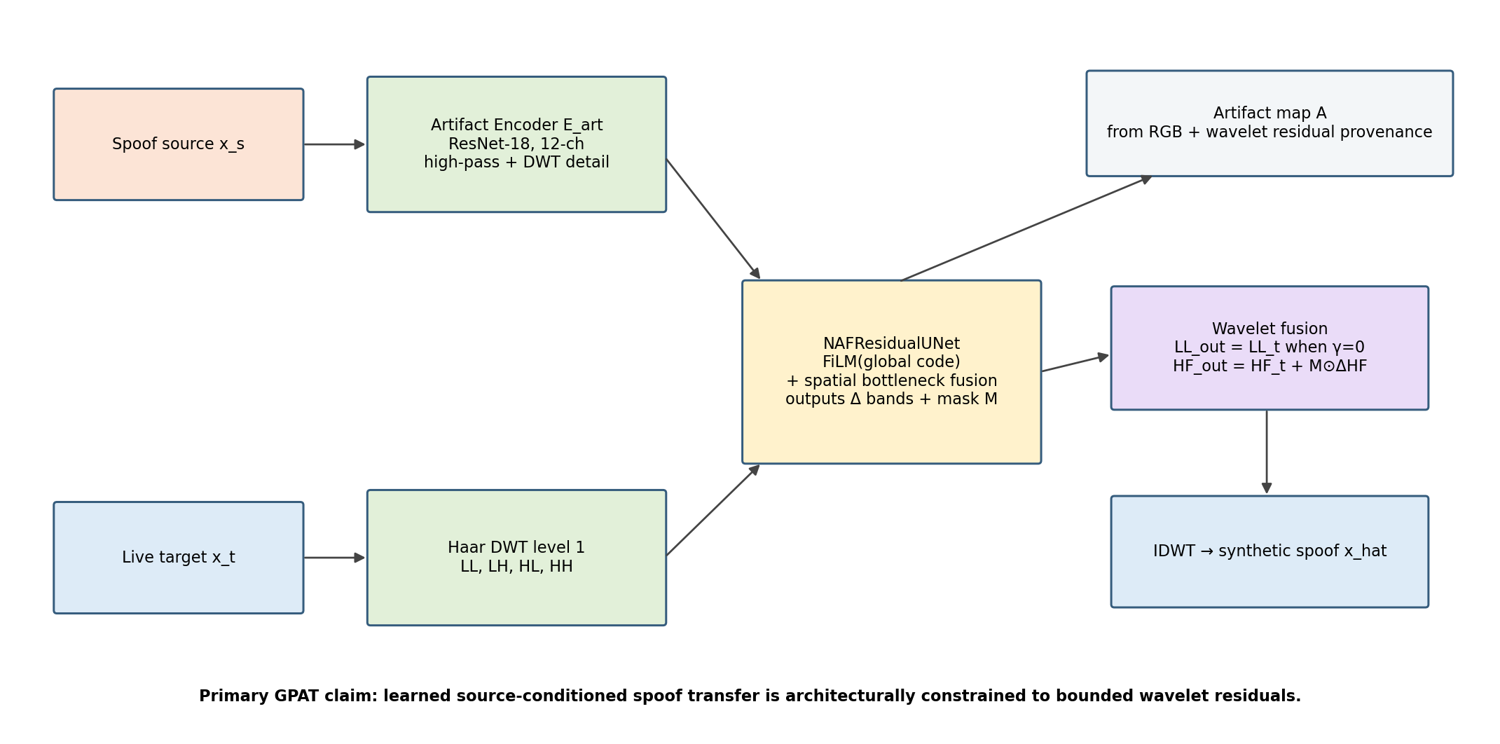
Figure 4. Frozen GPAT generator architecture for this benchmark.

9.1 Input/output contract
z_a = E_art(x_s)
DWT(x_t) = {LL_t, LH_t, HL_t, HH_t}
{ΔLL, ΔLH, ΔHL, ΔHH, M} = G_res(DWT(x_t), z_a)
x_hat = IDWT(LL_t + γΔLL, LH_t + M⊙ΔLH, HL_t + M⊙ΔHL, HH_t + M⊙ΔHH)
Main configuration: γ=0.0. Therefore the generator has no path to alter the target LL band in the primary GPAT result. γ ∈ {0.02, 0.05, 0.10} is an ablation only.

9.2 Artifact Encoder E_art — exact implementation
- Backbone: torchvision ResNet-18 with IMAGENET1K_V1 initialization.
- Input tensor size: 12×256×256. Channels = 3 high-pass RGB channels + upsampled source detail bands [LH_s, HL_s, HH_s] concatenated as 9 channels.
- Modify conv1 from 3 input channels to 12. Initialize channels 0:3 with official pretrained conv1 weights. Initialize each extra channel with mean(pretrained conv1 over RGB)/3 so the total initial response scale remains bounded.
- Spatial artifact code = layer3 output (256 channels, approximately 16×16 at 256 input). Global artifact code = L2-normalized GAP(layer4), 512-D.
- Attack-type auxiliary head: Linear(512, number_of_attack_macro_classes_seen_in_TRAIN), active only in GPAT-B1/B3.
- Identity adversary: GRL coefficient 1.0 followed by Linear(512, number_of_train_subjects), loss weight λ_idadv=0.1, active only in GPAT-B2/B3.

9.3 Residual generator G_res — NAFResidualUNet
Stage | Resolution | Channels | Blocks / operation
Input | 128×128 | 12 | Concatenate target LL/LH/HL/HH (3 channels each); Conv3×3 → 32
Enc1 | 128×128 | 32 | 2 NAFBlocks + FiLM(global z_a); downsample stride-2
Enc2 | 64×64 | 64 | 2 NAFBlocks + FiLM; downsample
Enc3 | 32×32 | 128 | 4 NAFBlocks + FiLM; downsample
Enc4 | 16×16 | 256 | 8 NAFBlocks + FiLM; downsample
Bottleneck | 8×8 | 512 | Project spatial z_a 256→512, adaptive-pool to 8×8, concat with target stream, 1×1 fuse 1024→512, then 12 NAFBlocks
Dec4 | 16×16 | 256 | Upsample ×2 + skip Enc4 + 2 NAFBlocks + FiLM
Dec3 | 32×32 | 128 | Upsample ×2 + skip Enc3 + 2 NAFBlocks + FiLM
Dec2 | 64×64 | 64 | Upsample ×2 + skip Enc2 + 2 NAFBlocks + FiLM
Dec1 | 128×128 | 32 | Upsample ×2 + skip Enc1 + 2 NAFBlocks + FiLM
Output | 128×128 | 13 | Conv3×3: 12 delta channels + 1 mask channel

- HF delta activation = tanh; scale_hf = 0.15 in normalized image range [-1,1].
- LL delta activation = tanh; scale_ll = 0.05 before multiplication by γ. Since γ=0 in main run, ΔLL is ignored at reconstruction.
- Mask M = sigmoid(mask_logit). M is shared across RGB channels and resized only if a future wavelet level changes; no hard threshold during training.
- All upsampling = bilinear ×2 followed by Conv3×3; no transposed convolution.

9.4 Artifact provenance map
A_rgb = mean_channel(|x_hat − x_t|)
A_freq = upsample(|ΔLH| + |ΔHL| + |ΔHH| + γ|ΔLL|)
A = Normalize(M ⊙ [0.5·A_rgb + 0.5·A_freq])
A is stored for every GPAT synthetic sample. It is NOT used by the common downstream detector in the main generator comparison. Artifact-map detector supervision is a separate GPAT-only extension experiment so that the generator comparison remains isolated.

10. GPAT losses and exact training configuration

10.1 Geometry losses
L_id = 1 − cos(F_id(x_t), F_id(x_hat))
L_lm = mean_k ||H_k(x_t) − H_k(x_hat)||_1
L_parse = 1 − Dice(P(x_t), P(x_hat)) + 0.1·KL(P(x_t) || P(x_hat))
L_low = ||LL(x_hat) − LL(x_t)||_1

10.2 Artifact and regularization losses
L_artcon = 1 − cos(F_art(x_hat), F_art(x_s)) + max(0, cos(F_art(x_hat),F_art(x_t)) − cos(F_art(x_hat),F_art(x_s)) + 0.2)
L_spec = ||S_radial(x_hat) − S_radial(x_s)||_1 + 0.5·||S_orient(x_hat) − S_orient(x_s)||_1
L_budget = max(0,0.01−mean(A)) + max(0,mean(A)−0.25)
L_TV = TV(M) + 0.25·[TV(ΔLH)+TV(ΔHL)+TV(ΔHH)]
L_bg = ||(1−M_face_dilated)⊙(x_hat−x_t)||_1
F_art in the generator loss is a frozen ResNet-18 ImageNet feature extractor operating on the same fixed high-pass transform; it is not trained with attack labels and therefore does not leak Track-B metadata into GPAT-B0.

10.3 Loss weights
Weight | Value | Active in
λ_id | 1.0 | All GPAT
λ_lm | 1.0 | All GPAT
λ_parse | 0.5 | All GPAT
λ_low | 2.0 | All GPAT
λ_con | 1.0 | All GPAT
λ_spec | 0.5 | All GPAT
λ_adv | 0.1 | Full curriculum stage
λ_type | 0.0 or 0.2 | B1/B3 only
λ_idadv | 0.0 or 0.1 | B2/B3 only
λ_budget | 0.5 | All GPAT
λ_tv | 0.05 | All GPAT
λ_bg | 1.0 | All GPAT

L_G = λ_id L_id + λ_lm L_lm + λ_parse L_parse + λ_low L_low + λ_con L_artcon + λ_spec L_spec + λ_adv L_Gadv + λ_type L_type + λ_budget L_budget + λ_tv L_TV + λ_bg L_bg − λ_idadv L_identity-adversary

10.4 PatchGAN discriminator
- Input = concatenate RGB image and fixed high-pass RGB → 6 channels, 256×256.
- 70×70 PatchGAN style: Conv4×4 s2 6→64; Conv4×4 s2 64→128 + InstanceNorm + LeakyReLU(0.2); Conv4×4 s2 128→256; Conv4×4 s1 256→512; Conv4×4 s1 512→1.
- Real positive = real TRAIN spoof. Fake negative = current synthetic output. Use non-saturating BCE adversarial objective.
- D optimizer is independent from G optimizer; no discriminator sees VAL/TEST.

10.5 Training schedule — frozen
Item | Frozen value
Resolution | 256×256
DWT | Haar level 1, reflect
Main γ | 0.0
Effective batch | 8 pairs
Physical batch | 4 pairs
Gradient accumulation | 2
Epochs | 60
Optimizer G/E_art | Adam, lr=2e-4, β=(0.5,0.999), weight_decay=0
Optimizer D | Adam, lr=2e-4, β=(0.5,0.999), weight_decay=0
LR schedule | 5-epoch linear warmup to 2e-4, cosine decay to 2e-6 at epoch 60
AMP | fp16 when CUDA; GradScaler enabled
Gradient clip | global norm 1.0
EMA | decay 0.999; start end of epoch 5
Training seeds | 42, 1337, 2026

Epoch stage | Residual scale | Adversarial weight | Artifact weights | Purpose
1–5 | linear 0.02→0.05 | 0 | λ_con=0.5, λ_spec=0.25 | Geometry-first warmup
6–15 | 0.10 | 0.05 | λ_con=1.0, λ_spec=0.5 | Introduce artifact realism
16–60 | 0.15 | 0.10 | full frozen weights | Full training

SUPERVISION-SPECIFIC WARMUP: For B1/B3, run a 10-epoch E_art warmup attack_macro classifier before the 60 generator epochs: AdamW lr=1e-4, batch=64, cosine schedule, no synthetic images. For B0/B2, skip this attack-type warmup. Identity adversary is active during generator training only for B2/B3.

10.6 Generator checkpoint selection
- Evaluate EMA checkpoint at every epoch 10–60 on VAL pairs fixed in val_pairs_v1.parquet.
- For each epoch compute ID cosine, NME, parsing Dice, low-frequency relative error and pairwise artifact similarity.
- Convert each metric to percentile rank across candidate epochs, oriented so higher is better.
- SelectionScore = 0.25·rank(ID) + 0.15·rank(Dice) + 0.25·rank(ArtSim) + 0.20·rank(−NME) + 0.15·rank(−LFErr).
- Choose maximum SelectionScore; tie-break by higher ArtSim, then earlier epoch. The TEST set is never involved.

11. GPAT quality score and fairness isolation
Quality weighting is a secondary experiment, not a prerequisite for the main generator comparison. The RAW-MATCHED table uses GPAT outputs without semantic quality filtering except technical invalidity.
q_i = exp(Σ_k w_k · log(ε + g_tilde_k(i)))
- Technical invalidity hard reject: missing image, NaN/Inf, face detector failure, invalid dimensions, or image outside legal numeric range.
- QUALITY-MATCHED GPAT q uses normalized VAL-calibrated metrics: identity similarity, inverse NME, parsing Dice, inverse low-frequency error, artifact-source similarity and discriminator realism.
- Metric normalization bounds are 5th/95th percentiles measured on VAL generation only; clip normalized values to [0,1]. Equal weights w_k=1/6.
- No threshold is chosen on TEST. For quality filtering, accept top q-ranked samples until the common budget N_common is reached.

12. Independent probes for generator evaluation

12.1 ArtifactProbeNet
- Purpose: independent evaluation of whether synthetic samples preserve source attack-family evidence; it is never the GPAT E_art network.
- Backbone: torchvision ResNet-18 IMAGENET1K_V1.
- Input: 224×224 high-pass RGB using Gaussian residual k=9, σ=1.5.
- Labels: attack_macro over real TRAIN only. Using fine-grained labels in this evaluation probe is permitted even for Binary Track because the labels are not fed back to the generator or downstream detector.
- Loss: class-weighted cross-entropy with inverse-frequency weights clipped to [0.5, 3.0].
- Optimizer: AdamW lr=1e-4, weight_decay=1e-4; batch 64; 30 epochs; cosine decay; AMP; seeds [42] only because this is a frozen measurement tool.
- Checkpoint: maximum VAL macro-F1; freeze thereafter. Penultimate 512-D L2-normalized embedding is the artifact embedding.

12.2 Fingerprint probe
- Extract 512-D high-pass features using the frozen ArtifactProbeNet backbone before its classifier.
- Train logistic regression C=1.0 to classify real spoof vs synthetic spoof. Balance classes 1:1.
- Use 5-fold GroupKFold with group = subject_id_global of the image’s visible face/target. Report mean ROC-AUC. AUC close to 0.5 is better; do not force it to exactly 0.5.
- Run separately per generator and per dataset to identify dataset-specific generator fingerprints.

13. Generator-quality metrics — exact formulas
Metric | Definition | Direction | Applicable methods
Face success | fraction synthetic successfully detected by frozen SCRFD | ↑ | All
Identity cosine | cos(AdaFace(target), AdaFace(synthetic)) | ↑ | Methods with target traceability
Landmark NME | mean landmark L2 / sqrt(face_bbox_w·face_bbox_h) | ↓ | Methods with target traceability
Parsing macro Dice | mean Dice over non-background facial parsing classes | ↑ | Methods with target traceability
LPIPS target drift | LPIPS-Alex(target, synthetic) | ↓ | Methods with target traceability; diagnostic
Low-frequency rel. L1 | ||LL_syn−LL_target||1 / (||LL_target||1+1e-8) | ↓ | Methods with target traceability
Artifact embedding cosine | cos(ArtifactProbe(source), ArtifactProbe(synthetic)) | ↑ | Source-conditioned methods
Attack consistency | synthetic predicted attack_macro equals source attack_macro | ↑ | Source-conditioned methods
Radial spectrum L1 | L1 distance between normalized log radial power spectra of source and synthetic | ↓ | Source-conditioned methods
Wavelet detail distance | mean L1 between normalized |LH/HL/HH| summary histograms | ↓ | Source-conditioned methods
KID | Kernel Inception Distance real-spoof vs synthetic distribution | ↓ | All
Fingerprint probe AUC | 5-fold real-spoof vs synthetic linear-probe AUC | →0.5 | All
Generation time | wall-clock seconds per accepted image | ↓ | All
Peak VRAM | maximum CUDA allocated memory during generation | ↓ | All

14. Downstream evaluator — primary frozen ResNet-18
The common downstream detector is deliberately simple and does NOT consume GPAT artifact maps or q in the main comparison. It receives only RGB images and binary Live/Spoof labels. One detector is trained independently for every synthetic method/track/seed.
Item | Frozen value
Backbone | torchvision ResNet-18 IMAGENET1K_V1
Input | 224×224 RGB; ImageNet normalization
Head | replace FC with Linear(512,1)
Loss | BCEWithLogitsLoss
Real-only batch | 64 = 32 live + 32 real spoof
Mixed batch | 64 = 32 live + 16 real spoof + 16 synthetic spoof
Synthetic share | 25% of total batch; spoof class remains 32/64
Epochs | 40
Optimizer | AdamW
Backbone LR | 1e-4
Head LR | 5e-4
Weight decay | 1e-4
Warmup | 3 epochs linear
Scheduler | cosine to 1e-6
AMP | enabled on CUDA
Gradient clip | 1.0
Seeds | 42, 1337, 2026
Checkpoint rule | minimum VAL video-level ACER; tie-break maximum VAL video-level AUC

14.1 FAS-safe augmentation — frozen
- RandomResizedCrop(224, scale=(0.92,1.00), ratio=(0.95,1.05), interpolation=BICUBIC).
- RandomHorizontalFlip(p=0.5).
- ColorJitter(brightness=0.05, contrast=0.05, saturation=0.05, hue=0.01) with probability 0.5.
- No Gaussian blur, no JPEG compression, no strong downsampling, no MixUp/CutMix, no RandAugment in the main benchmark because those can erase or replace the subtle FAS cues being compared.

14.2 Secondary evaluator — mandatory FULL profile
Item | Frozen value
Backbone | facebook/dinov3-vits16-pretrain-lvd1689m
Input | 224×224
Head | single binary logit from CLS token
Epochs | 40
Epoch 1–3 | freeze backbone; train head only
Epoch 4–40 | unfreeze last 4 transformer blocks
Optimizer | AdamW
Backbone LR | 1e-5
Head LR | 1e-4
Weight decay | 0.05
Batch composition | same as ResNet-18
Augmentation | same as ResNet-18
Seeds | 42,1337,2026
Checkpoint/threshold rules | same as ResNet-18

15. Validation threshold and test aggregation
- Frame probability = sigmoid(binary logit).
- Video probability = arithmetic mean of all sampled frame probabilities belonging to that canonical video.
- Primary reported metrics are video-level; frame-level metrics are secondary diagnostics.
- For each seed/method, compute threshold on VAL video scores by minimizing ACER. Sweep all unique score midpoints plus 0 and 1. Tie-break by threshold closest to 0.5.
- Freeze the selected threshold and apply it once to TEST. AUC and EER are threshold-free/derived and still use the same frozen TEST scores.

16. Downstream metrics
APCER = # spoof videos predicted live / # spoof videos
BPCER = # live videos predicted spoof / # live videos
ACER = (APCER + BPCER) / 2
- Primary: ACER ↓, AUC ↑, EER ↓.
- Secondary: APCER ↓, BPCER ↓, accuracy, balanced accuracy, F1, TPR@FPR=1%, TPR@FPR=5%.
- Subgroups: dataset-wise ACER/AUC; attack_macro-wise APCER; SiW-Mv2 raw 14-type APCER when raw label coverage is valid.
- Report both frame-level and video-level tables, but video-level is the main paper result.

17. Required experiment matrix
Experiment ID | Synthetic source | Track | Evaluator | Purpose
E00 | None / real-only | Binary | ResNet18 + DINOv3 | Lower bound
E01 | FAS-Aug | Binary=native | Both | Handcrafted/physics baseline
E02 | FreqSub controlled | Binary=native | Both | Direct frequency-transfer baseline
E03 | STDN | Binary=native | Both | Learned trace transfer
E04 | Physics-STD | Binary=native | Both | Physics/frequency trace transfer
E05 | PCGAN | Binary=native | Both | Full RGB pattern conversion
E06a | DSDG-BIN | Binary adapted | Both | Equal-label-budget generative baseline
E06b | DSDG-NATIVE | Native | Both | Original type-supervised setting
E07a | DiffFAS-BIN | Binary adapted | Both | Equal-label-budget diffusion baseline
E07b | DiffFAS-NATIVE | Native | Both | Precise style + identity-consistent diffusion
E08 | GPAT-B0 | Binary | Both | Main fair GPAT
E09 | GPAT-B1 | +attack type | Both | Attack-type supervision effect
E10 | GPAT-B2 | +identity | Both | Identity adversary effect
E11 | GPAT-B3 | +type+identity | Both | Full GPAT supervision

17.1 GPAT architectural ablation
Ablation | Change from GPAT-B0 | All else locked
A0 Full RGB | generator outputs full RGB image instead of residual | Yes
A1 RGB residual | x_hat=x_t+bounded RGB residual; no DWT | Yes
A2 Wavelet γ=0.10 | allow small LL transfer | Yes
A3 Wavelet γ=0.05 | allow smaller LL transfer | Yes
A4 Wavelet γ=0.02 | allow minimal LL transfer | Yes
A5 Wavelet γ=0.00 | main hard-lock GPAT | Yes

17.2 GPAT provenance / quality extension ablation
Variant | Common detector input | Special use
G0 | RGB only | GPAT synthetic, equal weight
G1 | RGB only | GPAT synthetic weighted by q in detector loss
G2 | RGB + local supervision branch | Artifact map A used as soft token/patch target; separate extension detector, not main generator comparison
G3 | RGB + local supervision + q | Full optional GPAT extension
Shuffle control | same as G2 but artifact maps randomly permuted across synthetic images | Causal check that map alignment matters

18. Statistical analysis — frozen
- For every self-run downstream condition: seeds [42,1337,2026]; report mean ± sample standard deviation.
- Subject-level bootstrap 95% confidence interval: 10,000 bootstrap resamples of TEST subjects within each dataset, preserving all videos of a sampled subject. Compute CI for ACER and AUC.
- Primary paired comparison: GPAT-B0 vs each Binary-track baseline on identical TEST predictions. Use paired subject-level bootstrap for ΔACER and ΔAUC.
- Multiple-comparison correction: Holm–Bonferroni over the family of GPAT-B0 vs Binary-track baselines.
- Report effect size as absolute ΔACER percentage points and ΔAUC, not only p-values.
- A result is not described as “better” when the mean moves favorably but the CI/pairwise analysis is inconclusive; use “numerically lower/higher” instead.

19. Required result tables — exact outputs
Output file | Required content
T01_dataset_inventory.csv | Counts by dataset, split, binary class, attack_macro, subject, video, frame.
T02_supervision_matrix.csv | For each method: binary/type/identity/style/pair requirements and status faithful/adapted.
T03_reimplementation_fidelity.csv | Paper/repo commit, deviations, source gaps, code status.
T04_generator_pair_metrics.csv | Pair-based generator metrics: ID, NME, Dice, LF error, ArtSim, spectrum, attack consistency.
T05_generator_distribution_metrics.csv | All methods: face success, KID, fingerprint AUC, runtime, VRAM.
T06_downstream_resnet18_video.csv | Primary video-level downstream metrics mean±std + CI.
T07_downstream_dinov3_video.csv | Secondary evaluator results.
T08_downstream_frame.csv | Frame-level diagnostic metrics.
T09_binary_vs_native.csv | Binary vs native/full delta for DSDG, DiffFAS, GPAT.
T10_gpat_supervision_ablation.csv | B0/B1/B2/B3 generator + downstream metrics.
T11_gpat_gamma_outputspace_ablation.csv | Full RGB/RGB residual/γ sweep Pareto + downstream.
T12_quality_raw_vs_matched.csv | RAW-MATCHED vs QUALITY-MATCHED downstream results and coverage.
T13_attackwise_apcer.csv | Attack macro + SiW-Mv2 raw 14-type APCER.
T14_datasetwise_metrics.csv | CASIA/MSU/SiW-Mv2 test subgroup metrics.
T15_compute.csv | Params, training time, gen sec/image, evaluator time, peak VRAM.
T16_statistics.csv | Pairwise deltas, bootstrap CI, corrected p-values.
T17_failures.csv | Generation failures, invalid counts, reject reasons, coverage.

19.1 Paper-ready table templates (all cells remain “—” until measured)
Method | ID cos ↑ | NME ↓ | Dice ↑ | LF err ↓ | ArtSim ↑ | KID ↓ | Fingerprint AUC→0.5
FAS-Aug | — | — | — | — | N/A | — | —
FreqSub | — | — | — | — | — | — | —
STDN | — | — | — | — | — | — | —
Physics-STD | — | — | — | — | — | — | —
PCGAN | — | — | — | — | — | — | —
DSDG | N/A* | N/A* | N/A* | N/A* | N/A | — | —
DiffFAS | — | — | — | — | — | — | —
GPAT-B0 | — | — | — | — | — | — | —

Synthetic method | APCER ↓ | BPCER ↓ | ACER ↓ | AUC ↑ | EER ↓ | 95% CI ACER
Real only | — | — | — | — | — | —
FAS-Aug | — | — | — | — | — | —
FreqSub | — | — | — | — | — | —
STDN | — | — | — | — | — | —
Physics-STD | — | — | — | — | — | —
PCGAN | — | — | — | — | — | —
DSDG-BIN | — | — | — | — | — | —
DiffFAS-BIN | — | — | — | — | — | —
GPAT-B0 | — | — | — | — | — | —

20. Required figures and plot catalog
Every plot is generated automatically from CSV/Parquet outputs. No values are typed manually into plotting scripts. For metrics that are useful in more than one visual form, the spec explicitly requests multiple views.
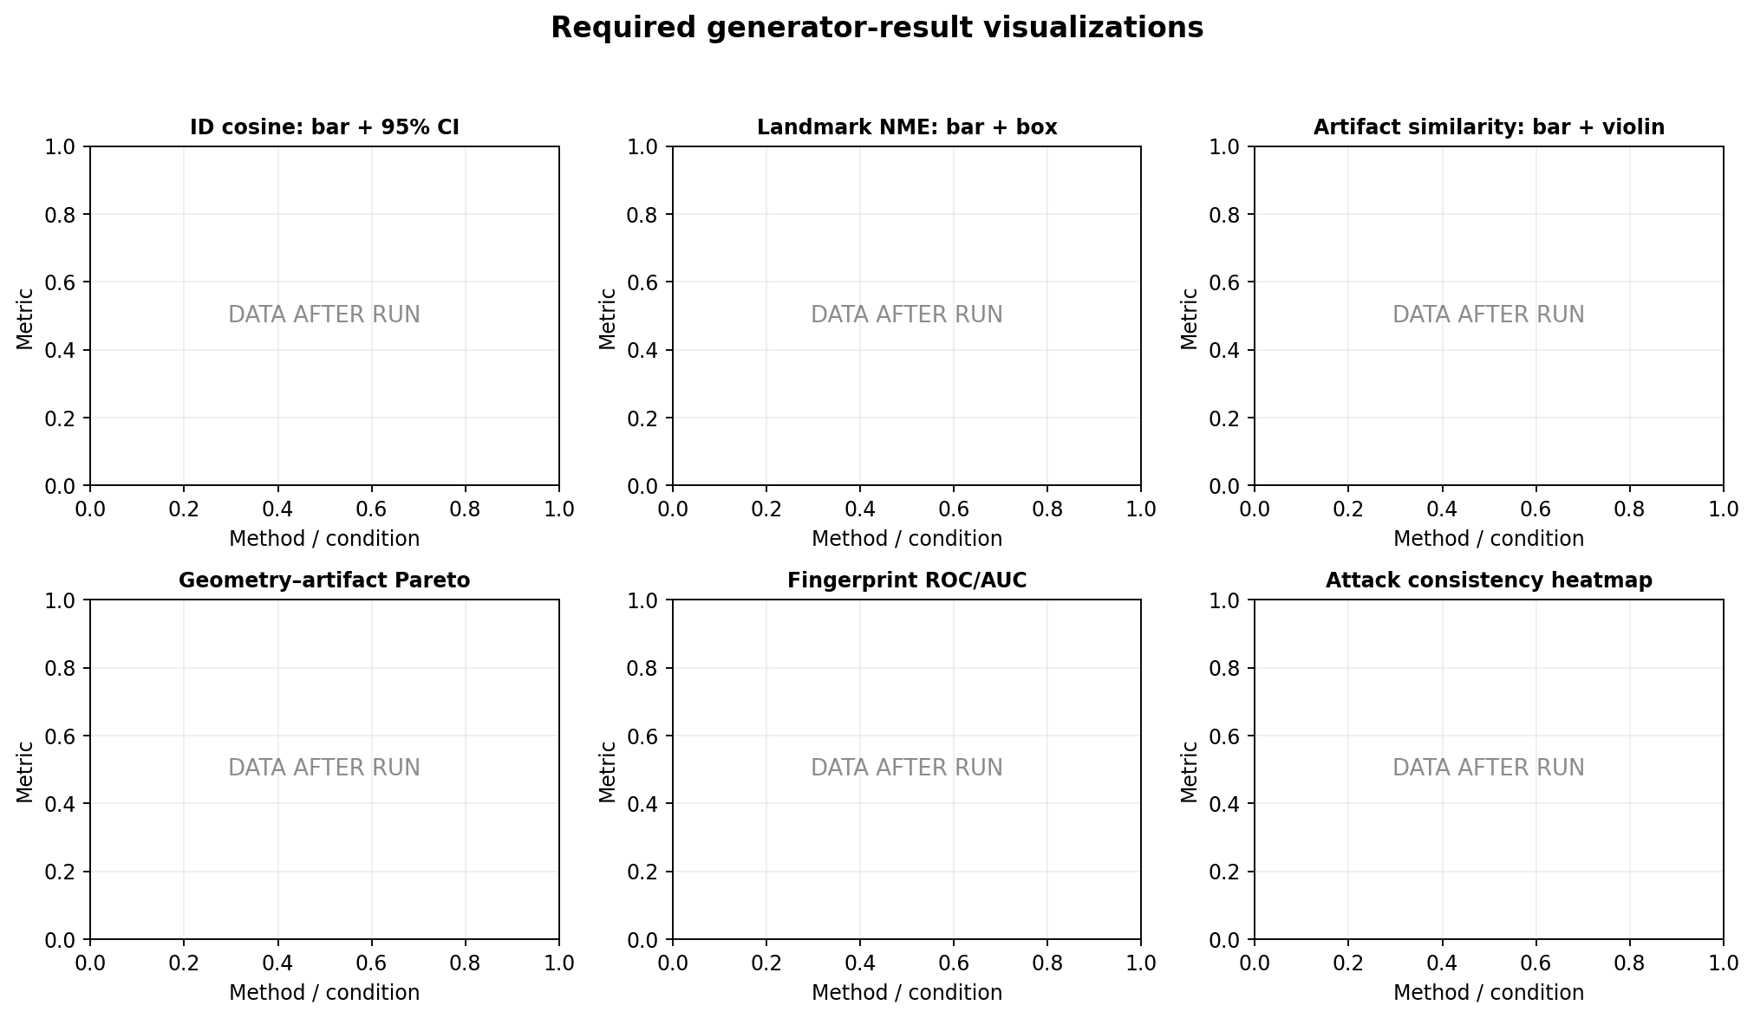
Figure 5. Generator plot templates. These panels contain no results; they define required visualization types.
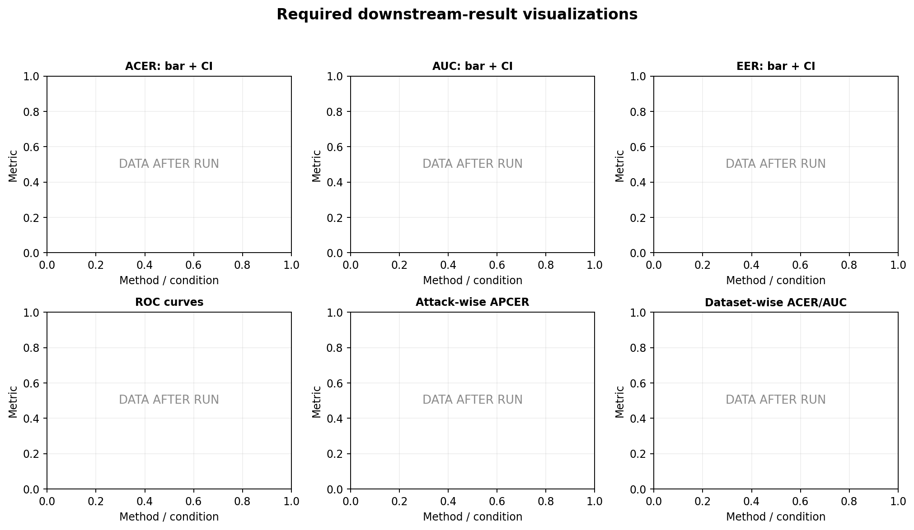
Figure 6. Downstream plot templates.
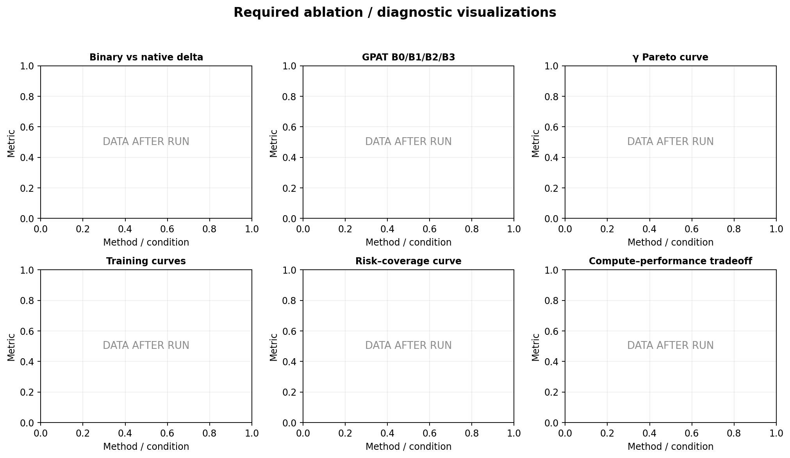
Figure 7. Ablation and diagnostic plot templates.
Filename | Visualization | Data source
fig01_pipeline.png | Protocol schematic | Static spec figure
fig02_split_distribution.png | Stacked bars: dataset × split × class | T01
fig03_supervision_tracks.png | Track schematic | Static
fig04_pair_examples_grid.png | Same live/source → outputs from every pair-based generator | pair manifest + images
fig05_id_cosine_bar.png | Mean ID cosine + 95% CI | T04
fig05b_id_cosine_box.png | Subject-level ID cosine boxplots | per-sample metrics
fig06_nme_bar.png | Mean NME + CI | T04
fig06b_nme_violin.png | NME distribution violin | per-sample
fig07_artifact_similarity_bar.png | Artifact similarity + CI | T04
fig07b_artifact_similarity_violin.png | Artifact similarity distribution | per-sample
fig08_lowfreq_error_bar.png | Low-frequency error | T04
fig09_generator_radar.png | Normalized generator metric radar; diagnostic only | T04/T05
fig10_geometry_artifact_pareto.png | ID/NME vs ArtSim Pareto | T04
fig11_attack_consistency_heatmap.png | Source attack vs synthetic predicted attack | probe predictions
fig12_fingerprint_roc.png | Real-spoof vs synthetic fingerprint ROC per method | probe outputs
fig13_artifact_embedding_umap.png | UMAP of real/synthetic artifact embeddings | probe embeddings
fig14_downstream_acer_bar.png | Video ACER mean±std + CI | T06
fig14b_downstream_acer_box.png | Seed/subject bootstrap ACER view | bootstrap output
fig15_downstream_auc_bar.png | AUC mean±std | T06
fig16_downstream_eer_bar.png | EER mean±std | T06
fig17_downstream_roc.png | ROC curves; one panel primary methods | predictions
fig18_det_curve.png | DET curve | predictions
fig19_attackwise_apcer.png | Grouped APCER by attack macro/raw type | T13
fig20_datasetwise_metrics.png | CASIA/MSU/SiW subgroup ACER+AUC | T14
fig21_binary_vs_native_delta.png | Paired delta plot Binary→Native | T09
fig22_gpat_supervision_ablation.png | B0/B1/B2/B3 bar + generator metrics | T10
fig23_gamma_pareto.png | γ sweep Pareto curve | T11
fig24_training_curves.png | Train/VAL losses and ACER/AUC per epoch | run logs
fig25_compute_tradeoff.png | ACER vs generation cost bubble plot | T15
fig26_quality_risk_coverage.png | q threshold vs retained coverage vs VAL downstream risk | T12
fig27_method_ranking_parallel.png | Parallel coordinates normalized metrics | T04/T06/T15
fig28_failure_counts.png | Failure/reject reasons | T17

21. Qualitative figure protocol
- Preselect qualitative pair IDs from VAL before viewing method outputs: 4 print, 4 replay, 4 mask, 4 makeup/partial if available; balance datasets.
- For each pair show columns: live target | real spoof source | FreqSub | STDN | Physics-STD | PCGAN | DiffFAS | GPAT | GPAT artifact map.
- Do not hand-pick only successful GPAT cases. The list of pair IDs must be saved before generation comparison.
- Generate difference magnitudes and high-pass zoom crops for eye, cheek, mouth and boundary regions when face parsing allows.
- Any visually failed sample shown in failure analysis must keep its pair_id, method, seed and failure reason.

22. Prediction, manifest and run schemas

22.1 Synthetic manifest
synthetic_id, method_id, track_id, seed, pair_id,
target_live_id, source_spoof_id, generated_image_path,
edit_map_path, attack_macro_source, style_id_source,
status, failure_reason, quality_q,
id_cosine, landmark_nme, parsing_dice, lowfreq_rel_l1,
artifact_cosine, attack_consistent, radial_spectrum_l1,
generator_checkpoint_sha256, method_config_sha256,
code_commit, created_at

22.2 Downstream prediction file
sample_id, dataset, subject_id_global, video_id, frame_index,
y_true, attack_raw, attack_macro,
p_frame, threshold, pred_frame,
video_score, pred_video,
method_id, track_id, evaluator_id, seed,
checkpoint_sha256, split_manifest_sha256

22.3 Run metadata JSON
{
"run_id": "...",
"method": "GPAT-B0",
"track": "binary",
"seed": 42,
"git_commit": "...",
"config_sha256": "...",
"split_manifest_sha256": "...",
"pair_manifest_sha256": "...",
"environment_lock_sha256": "...",
"gpu": "...",
"start_time": "...",
"end_time": "...",
"status": "COMPLETED|FAILED|BLOCKED",
"deviations": []
}

23. Frozen configuration files to create
Config | Purpose
configs/frozen/data_v1.yaml | Dataset roots, 8-frame policy, preprocessing, label mapping
configs/frozen/split_v1.yaml | 70/15/15 subject split and seed
configs/frozen/pairs_v1.yaml | candidate count 64 and distance weights
configs/frozen/downstream_resnet18.yaml | Primary evaluator
configs/frozen/downstream_dinov3_vits16.yaml | Secondary evaluator
configs/frozen/artifact_probe.yaml | Independent probe
configs/methods/fas_aug.yaml | FAS-Aug wrapper
configs/methods/freq_sub.yaml | Controlled FFT substitution
configs/methods/stdn.yaml | Official wrapper
configs/methods/physics_std.yaml | Paper reimplementation
configs/methods/pcgan.yaml | Pattern conversion
configs/methods/dsdg_binary.yaml | Adapted binary
configs/methods/dsdg_native.yaml | Native
configs/methods/difffas_binary.yaml | Adapted binary
configs/methods/difffas_native.yaml | Native
configs/methods/gpat_b0.yaml | Binary GPAT
configs/methods/gpat_b1.yaml | + type
configs/methods/gpat_b2.yaml | + ID
configs/methods/gpat_b3.yaml | + type + ID

23.1 Canonical downstream_resnet18.yaml
model:
name: torchvision_resnet18_imagenet1k_v1
input_size: 224
output_logits: 1
training:
epochs: 40
seeds: [42, 1337, 2026]
batch_size: 64
mixed_batch: {real_live: 32, real_spoof: 16, synthetic_spoof: 16}
real_only_batch: {real_live: 32, real_spoof: 32}
optimizer: AdamW
lr_backbone: 1.0e-4
lr_head: 5.0e-4
weight_decay: 1.0e-4
warmup_epochs: 3
scheduler: cosine
min_lr: 1.0e-6
amp: true
grad_clip_norm: 1.0
augmentation:
random_resized_crop: {size: 224, scale: [0.92, 1.00], ratio: [0.95, 1.05]}
horizontal_flip_p: 0.5
color_jitter: {p: 0.5, brightness: 0.05, contrast: 0.05, saturation: 0.05, hue: 0.01}
blur: false
jpeg: false
selection:
checkpoint: min_val_video_acer_then_max_auc
threshold: min_val_video_acer_then_nearest_0.5

23.2 Canonical GPAT-B0 YAML
method: GPAT-B0
supervision: binary_only
input_resolution: 256
wavelet: {library: ptwt, family: haar, level: 1, boundary_mode: reflect}
gamma: 0.0
artifact_encoder:
backbone: torchvision_resnet18_imagenet1k_v1
input_channels: 12
highpass: {kernel: 9, sigma: 1.5}
attack_type_head: false
identity_adversary: false
residual_generator:
name: NAFResidualUNet
width: 32
enc_blocks: [2, 2, 4, 8]
middle_blocks: 12
dec_blocks: [2, 2, 2, 2]
delta_scale_hf: 0.15
delta_scale_ll: 0.05
output_channels: 13
training:
epochs: 60
physical_batch: 4
grad_accum: 2
effective_batch: 8
optimizer: Adam
lr: 2.0e-4
betas: [0.5, 0.999]
weight_decay: 0.0
warmup_epochs: 5
min_lr: 2.0e-6
amp: true
grad_clip_norm: 1.0
ema_decay: 0.999
seeds: [42, 1337, 2026]
loss:
lambda_id: 1.0
lambda_lm: 1.0
lambda_parse: 0.5
lambda_kl: 0.1
lambda_low: 2.0
lambda_con: 1.0
triplet_margin: 0.2
lambda_spec: 0.5
lambda_dir: 0.5
lambda_adv: 0.1
lambda_type: 0.0
lambda_idadv: 0.0
lambda_budget: 0.5
artifact_min: 0.01
artifact_max: 0.25
lambda_tv: 0.05
tv_delta_scale: 0.25
lambda_bg: 1.0

24. CLI contract — commands Claude must implement
python -m gpatbench.cli inventory --config configs/frozen/data_v1.yaml
python -m gpatbench.cli preprocess --config configs/frozen/data_v1.yaml
python -m gpatbench.cli split --config configs/frozen/split_v1.yaml
python -m gpatbench.cli audit-split --manifest manifests/split_v1.parquet
python -m gpatbench.cli build-pairs --config configs/frozen/pairs_v1.yaml
python -m gpatbench.cli train-probe --config configs/frozen/artifact_probe.yaml
python -m gpatbench.cli train-generator --method GPAT-B0 --seed 42
python -m gpatbench.cli generate-bank --method GPAT-B0 --seed 42
# Repeat for every required method/track/seed.
python -m gpatbench.cli evaluate-generator --all-methods
python -m gpatbench.cli train-downstream --evaluator resnet18 --all-methods --all-seeds
python -m gpatbench.cli train-downstream --evaluator dinov3_vits16 --all-methods --all-seeds
python -m gpatbench.cli evaluate-downstream --all
python -m gpatbench.cli statistics --all
python -m gpatbench.cli make-tables --paper-pack
python -m gpatbench.cli make-plots --paper-pack
python -m gpatbench.cli validate-paper-pack

25. Milestones and hard acceptance gates
Milestone | Deliverable | Acceptance / hard stop
M0 Bootstrap | repo skeleton, env locks, third-party registry | all dependencies/version hashes recorded; no method trained
M1 Inventory | inventory.parquet + dataset_report.html | all local files indexed; unknown labels listed; no duplicate sample IDs
M2 Preprocess | faces_256 + geometry/identity caches | SCRFD success report; deterministic rerun hashes for sampled subset
M3 Split | split_v1.parquet | zero subject/video leakage; exact hash frozen
M4 Pair manifests | pairs_train_v1.parquet + native pair manifests | different target/source subject; deterministic rerun
M5 Probe | ArtifactProbeNet checkpoint | VAL macro-F1 saved; checkpoint frozen before synthetic evaluation
M6 Baselines | method adapters + method_status.csv | each row tagged faithful/adapted/blocked; no silent simplification
M7 GPAT | B0/B1/B2/B3 generator checkpoints | zero-residual sanity test; DWT→IDWT reconstruction; generator selection from VAL only
M8 Banks | all synthetic banks | same intended budget; provenance complete; failure counts saved
M9 Generator eval | T04/T05 + plots | all applicable per-sample metrics saved; N/A used correctly
M10 ResNet downstream | T06 primary | 3 seeds/method; same config hash; TEST untouched before checkpoint/threshold freeze
M11 DINOv3 downstream | T07 secondary | same rules; full profile only after M10 passes
M12 Ablations | T09–T12 | B0/B1/B2/B3, γ sweep, raw/quality matched, map/q extension
M13 Statistics | T16 + CIs | 10k subject bootstrap; Holm correction
M14 Paper pack | all tables/figures/predictions/configs | validate-paper-pack PASS; no placeholder numeric cells falsely marked measured

26. Unit tests and scientific sanity tests
- DWT→IDWT reconstruction error < 1e-5 in float32 on 100 random crops.
- GPAT γ=0 and all ΔHF=0 yields x_hat≈x_t (max absolute normalized error < 1e-5).
- GPAT artifact_scale=0 reduces output to target independent of spoof source.
- Pair manifest never pairs same subject; no pair references VAL/TEST for TRAIN synthesis.
- Split audit checks subject/video/sample intersections exactly empty.
- Downstream mixed sampler produces exactly 32 live / 16 real spoof / 16 synthetic per full batch; tail batches may be dropped.
- Threshold code reproduces ACER from confusion counts and is identical across methods.
- Video score aggregation uses only frames of that video and simple arithmetic mean.
- Plot scripts reject input tables that contain non-measured placeholders except in template mode.
- A full deterministic smoke test on a 2-subject-per-class toy subset must finish before full runs.

27. Failure modes and mandatory handling
Failure | Required action
Missing subject IDs | BLOCK main split; do not silently use frame split
Third-party repo incompatible | isolated env/container; if still blocked, record dependency issue
Paper architecture underspecified | use explicit benchmark override only if defined; otherwise BLOCKED_BY_SOURCE_GAP
Generator produces too few valid samples | report failure count; do not duplicate images; QUALITY-MATCHED uses N_common
One attack type absent from TRAIN | do not invent examples; class absent from native classifier and report coverage
VAL class/attack absent | metric shown N/A; no resampling from TEST
GPU OOM | reduce physical batch and increase gradient accumulation while keeping effective batch fixed; log deviation as implementation-only
Method output different resolution | resize exactly once to 256 with canonical interpolation; log original resolution
One seed fails | rerun same seed after technical fix; never replace with a different seed
Unexpectedly high fingerprint AUC | do not hide; report and inspect difference maps/shortcuts

28. Paper-ready evidence package
outputs/paper_pack/
├── tables/ # T01–T17 CSV + formatted DOCX/LaTeX exports
├── figures/ # fig01–fig28 PNG + PDF/SVG when vector-safe
├── predictions/ # per-sample and per-video predictions
├── generator_metrics/ # per-synthetic metrics
├── qualitative/ # precommitted pair grids + failures
├── statistics/ # bootstrap distributions, CI, corrected p-values
├── configs/ # exact frozen YAML snapshot
├── manifests/ # inventory, split, pair manifests + SHA256
├── checkpoints_index.csv # checkpoint hashes and selection evidence
├── environment/ # pip/conda locks, CUDA/GPU info
├── audit/ # leakage, deviations, blocked methods
└── README_EVIDENCE.md # one-page map from paper claim → evidence file
- Every paper claim must reference at least one evidence file.
- Tables derived from published papers, if shown in Related Work, must be visually separated and explicitly labeled “reported by original authors”. They cannot share a numeric column with our reimplementation results without a provenance column.
- Negative results and failed baselines remain in the evidence package; they are not deleted to make the proposed method look cleaner.

29. Recommended paper narrative after experiments
- Problem: existing spoof-transfer approaches can alter facial content, directly copy frequency blocks, or generate the full image without an architectural preservation guarantee.
- Method: GPAT learns source-conditioned spoof evidence but restricts generation to bounded wavelet residuals; γ=0 hard-preserves target LL structure.
- Controlled benchmark: all methods are retrained on one pooled CASIA-FASD + MSU-MFSD + SiW-Mv2 subject-disjoint split and evaluated through the same downstream detector.
- Evidence 1: target preservation vs artifact transfer Pareto.
- Evidence 2: downstream benefit on real held-out test, not synthetic test.
- Evidence 3: Binary vs Native supervision distinguishes architectural benefit from metadata benefit.
- Evidence 4: ablations isolate hard wavelet lock, attack-type label, identity adversary, q and artifact-map extensions.
- Limitations: pooled held-out protocol measures within-pool subject/video generalization, not standard cross-dataset DG; conclusions must stay within this scope.

30. Reference list and quick lookup links
Ref | Citation | Paper / official page | Code
R1 | Y. Liu, J. Stehouwer, X. Liu, “On Disentangling Spoof Trace for Generic Face Anti-Spoofing,” ECCV 2020. arXiv:2007.09273. | https://arxiv.org/abs/2007.09273 | https://github.com/yaojieliu/ECCV20-STDN
R2 | Y. Liu, X. Liu, “Physics-Guided Spoof Trace Disentanglement for Generic Face Anti-Spoofing,” arXiv:2012.05185; later “Spoof Trace Disentanglement for Generic Face Anti-Spoofing,” IEEE TPAMI, 2022, DOI 10.1109/TPAMI.2022.3176387. | https://arxiv.org/abs/2012.05185
R3 | Y. Huang, W. Zhang, J. Wang, “Deep Frequent Spatial Temporal Learning for Face Anti-Spoofing,” 2020. arXiv:2002.03723. | https://arxiv.org/abs/2002.03723
R4 | R. Cai, C. Soh, Z. Yu, H. Li, W. Yang, A. C. Kot, “Towards Data-Centric Face Anti-Spoofing: Improving Cross-domain Generalization via Physics-based Data Synthesis,” IJCV 133, 1689–1710, 2025. arXiv:2409.03501. | https://arxiv.org/abs/2409.03501 | https://github.com/RizhaoCai/FAS_Aug
R5 | H. Wu, D. Zen, Y. Hu, H. Shi, T. Mei, “Dual Spoof Disentanglement Generation for Face Anti-spoofing with Depth Uncertainty Learning,” arXiv:2112.00568 / IEEE TCSVT. | https://arxiv.org/abs/2112.00568 | https://github.com/JDAI-CV/FaceX-Zoo/tree/main/addition_module/DSDG
R6 | X. Ge, X. Liu, Z. Yu, J. Shi, C. Qi, J. Li, H. Kälviäinen, “DiffFAS: Face Anti-Spoofing via Generative Diffusion Models,” ECCV 2024. arXiv:2409.08572. | https://arxiv.org/abs/2409.08572 | https://github.com/murphytju/DiffFAS
R7 | S. Jung et al., “Domain-generalizable Face Anti-Spoofing with Patch-based Multi-tasking and Artifact Pattern Conversion,” Pattern Recognition 179 Part B, 113640, 2026. arXiv:2604.09018. | https://arxiv.org/abs/2604.09018
R8 | Y. Bian et al., “Learning Multiple Explainable and Generalizable Cues for Face Anti-spoofing,” ICASSP 2022. arXiv:2202.10187. | https://arxiv.org/abs/2202.10187
R9 | Z. Zhang, J. Yan, S. Liu, Z. Lei, D. Yi, S. Z. Li, “A face antispoofing database with diverse attacks,” ICB 2012, DOI 10.1109/ICB.2012.6199754.
R10 | D. Wen, H. Han, A. K. Jain, “Face Spoof Detection With Image Distortion Analysis,” IEEE TIFS 10(4), 746–761, 2015, DOI 10.1109/TIFS.2015.2400395.
R11 | X. Guo, Y. Liu, A. Jain, X. Liu, “Multi-domain Learning for Updating Face Anti-spoofing Models,” ECCV 2022. arXiv:2208.11148; introduces/uses SiW-Mv2. | https://arxiv.org/abs/2208.11148 | https://github.com/CHELSEA234/Multi-domain-learning-FAS
R12 | SiW-Mv2 official dataset page — Michigan State University Computer Vision Lab. | https://cvlab.cse.msu.edu/siw-mv2-dataset.html
R13 | M. Kim et al., “AdaFace: Quality Adaptive Margin for Face Recognition,” CVPR 2022. |  | https://github.com/mk-minchul/AdaFace
R14 | K. Narayan et al., “FaceXFormer: A Unified Transformer for Facial Analysis,” ICCV 2025 / arXiv:2403.12960. | https://arxiv.org/abs/2403.12960 | https://github.com/Kartik-3004/facexformer
R15 | O. Siméoni et al., “DINOv3,” arXiv:2508.10104, 2025. | https://arxiv.org/abs/2508.10104 | https://github.com/facebookresearch/dinov3
R16 | C. Chen et al., “Simple Baselines for Image Restoration / NAFNet,” ECCV 2022. |  | https://github.com/megvii-research/NAFNet
R17 | InsightFace / SCRFD model family. |  | https://github.com/deepinsight/insightface
R18 | PyTorch Wavelet Toolbox (ptwt). |  | https://github.com/v0lta/PyTorch-Wavelet-Toolbox

31. Literature-derived supervision facts that must not be altered
- STDN explicitly positions its core spoof-trace learning as using only binary live-vs-spoof labels; spoof-type labels are not part of the main training supervision.
- DSDG explicitly uses a classifier on the spoof-pattern latent with y defined as the spoofing-type label.
- DiffFAS explicitly lists precise spoofing style label, texture preservation and identity consistency as critical properties; its training uses a Spoofing Style Pool and live-spoof pair images.
- PCGAN uses ground-truth live/attack labels to choose artifact conversion pairs; its PMN is a two-class live/attack detector.
- FAS-Aug creates task-specific artifacts from physical capture/recapture simulations rather than requiring a real spoof source for each synthetic sample.
- SiW-Mv2 has 14 named spoof types; the exact local availability must still be verified by inventory before Native/Full training.

32. Final go/no-go checklist before any full training
- ☐ inventory_report.html reviewed; local data completeness known.
- ☐ attack_map_v1.yaml contains every observed raw attack token required by Native/Full track.
- ☐ faces_256 preprocessing complete; detector/crop hashes frozen.
- ☐ split_v1 leakage audit PASS and SHA256 frozen.
- ☐ pair manifests deterministic; different-subject check PASS.
- ☐ ArtifactProbeNet frozen before synthetic evaluation.
- ☐ method_status.csv identifies faithful/adapted/blocked state for all methods.
- ☐ all frozen YAML configs version-controlled and hashed.
- ☐ smoke test passes for generator → bank → evaluator → metrics → plots.
- ☐ no numeric “result” has been entered manually into tables or plots.

Appendix A. Minimal pseudocode for the full benchmark
# DATA
inventory = inventory_all_three_datasets()
frames = sample_8_frames_per_video(inventory)
faces = scrfd_crop_256(frames)
cache_facexformer_and_adaface(faces)
split = subject_group_split(faces, ratios=(0.70,0.15,0.15), seed=20260814)
assert_no_leakage(split)
pairs_train = build_common_pairs(split.TRAIN)
pairs_val = build_common_pairs(split.VAL)
# MEASUREMENT PROBE (real TRAIN only)
artifact_probe = train_artifact_probe(split.TRAIN, validate=split.VAL)
freeze(artifact_probe)
# GENERATORS
for method in REQUIRED_METHODS:
for track in method.required_tracks:
for seed in [42,1337,2026]:
train_method(method, track, split.TRAIN, validate=split.VAL, seed=seed)
bank = generate_fixed_budget(method, pairs_train, N_syn=len(train_spoof_frames))
evaluate_generator(bank, pairs_val, artifact_probe)
# COMMON DOWNSTREAM EVALUATION
for evaluator in [ResNet18Primary, DINOv3ViTS16Secondary]:
for method_bank in ALL_BANKS:
for seed in [42,1337,2026]:
model = train_binary_fas(evaluator, split.TRAIN.real, method_bank, seed)
checkpoint = select_on_VAL(model)
threshold = select_threshold_on_VAL(checkpoint)
predictions = predict_REAL_TEST(checkpoint, threshold, split.TEST)
save_per_sample_and_video_predictions(predictions)
aggregate_metrics()
subject_bootstrap_statistics(n=10000)
make_all_tables_and_plots()
validate_paper_pack()

Appendix B. What Claude is allowed to tune vs. not allowed to tune
Category | Allowed? | Rule
Dataset split ratios/seed | No | Frozen 70/15/15, seed 20260814
Frame count | No | 8/video
Face detector/crop | No | Frozen preprocessing
Main GPAT architecture | No | Frozen in Section 9
Main GPAT loss weights | No for primary | Use frozen values; only named ablations may vary
γ | Only named ablation | Main γ=0; ablation 0.02/0.05/0.10
Downstream evaluator config | No | Frozen in Section 14
Training seeds | No | 42/1337/2026
Threshold rule | No | VAL min-ACER
Third-party native hyperparameters | No arbitrary changes | Official source-of-truth; deviations logged
GPU physical batch due OOM | Yes implementation-only | Keep effective batch by grad accumulation; record
DataLoader workers | Yes | May adapt to OS; no scientific impact
Plot cosmetics | Yes | Cannot change data/statistics; must preserve axes/units

Appendix C. Interpretation rules for common outcomes
Observed outcome | Permitted conclusion
GPAT preserves identity/geometry but ArtSim≈0 | GPAT is over-constrained; H1 alone is insufficient; artifact transfer not supported.
GPAT generator metrics are strong but downstream does not improve | GPAT produces controlled synthetic images but their utility for FAS training is not demonstrated.
Downstream improves but fingerprint AUC is very high | Improvement may rely on generator shortcut; contribution requires additional controls.
GPAT-B3 > B0 but B0 ≈ baselines | Metadata supervision contributes strongly; do not attribute all gain to architecture.
GPAT-B0 > binary baselines on both evaluators | Strong evidence that the transfer architecture itself contributes under equal label budget.
γ=0 has best geometry but γ>0 has clearly better downstream/ArtSim | Hard LL lock may be too restrictive; report Pareto and choose claim accordingly rather than forcing γ=0.
Only one seed is good | No robust improvement claim; report mean±std and investigate variance.

