**Coloring Line-art using Machine Learning**

Rahul Chodvadiya (150110107010) | Chinmay Patel (150110107036)

**Category:** Technological Change

**Abstract:**

Colorization of line-art images is a popular image-to-image translation problem. Manga is the Japanese comic format popular all over the world. Manga is traditionally produced in line-art or monochrome, and colorization takes a lot of manual effort. This makes the process very time consuming and costly. We propose coloring line-art using deep learning.

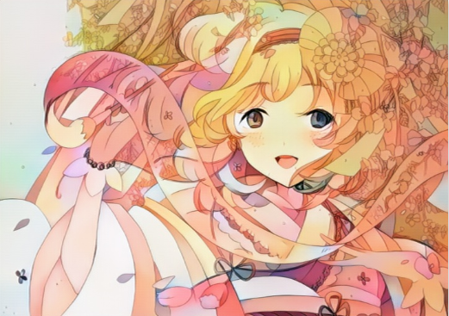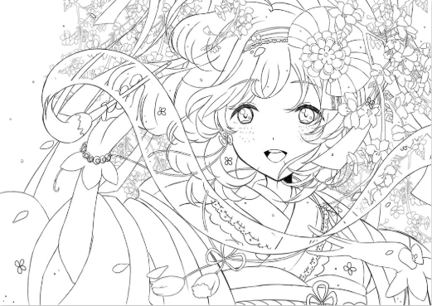

**Innovation:**

Traditionally, manga (Comic book) is produced in black and white. Even though the colored manga is more attractive and entertaining. However, to color the manga, it has to undergo many steps, such as, cleaning the artifacts (noise), adding color and, adding shade. Thus increasing the production cost of colorized manga, due to the time and effort it takes, making it economically inefficient in the competitive market. Hence, more than 99% of manga is still published in black and white. We use state of art deep learning algorithms to automize the colorization process, cutting down on the production cost and time consumed to publish the manga.

**Technology Used:**

Generative adversarial networks (GANs) are deep neural net architectures comprised of two neural networks, pitting against each other (thus the “adversarial”). GANs are successfully used for generating images and videos. We use GAN to fill color in line-arts.

For more details about the project and the technology used, visit:  
<https://drive.google.com/file/d/1aK1WvxWiCrTA6OC6LmYjm9RcX6lASSjz/view?usp=sharing>