Signal processing report

Group member :

Table content

1. Trigger 1

1.1 Block Diagram 1

1.2 Objective 2

1.3 Simulation in MATLAB 2

1.3.1 Read the audio data 2

1.4 MATLAB Output 2

2. Password 3

1. Trigger

1.1 Block Diagram

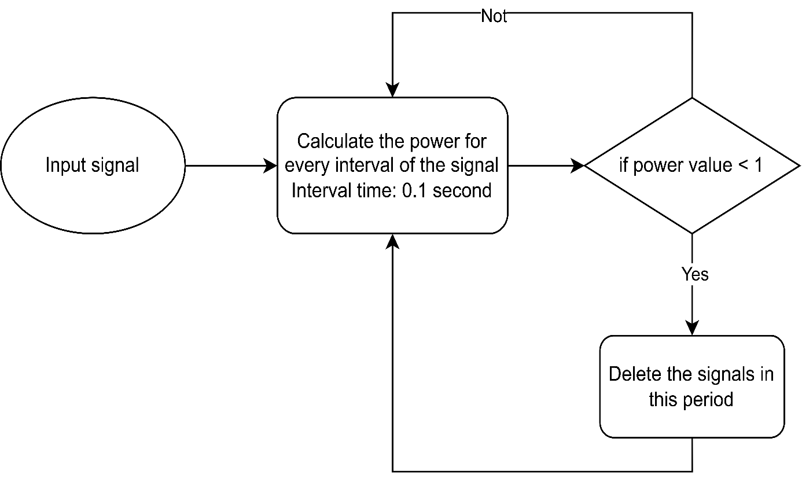

1.2 Objective

To define a threshold value, to erase the meaningless signals at the beginning.

* Defining a threshold helps us to have a reference value to isolate useful information from noise.
* In a real-life scenario, audio collected via Tiva are stored in a buffer of finite size and we can’t wait to detect the signal until the buffer is full.
* So, we measure the data at an interval before the buffer gets full and compare it with silence power in order to detect noise.

1.3 Simulation in MATLAB

1.3.1 Read the audio data

Our audio data is a 4 seconds audio file with frequency equals to 1000hz.

1.3.2 Calculate the power based on the intervals

We set the interval as 0.1s.

Power is calculated based on the energy and time.

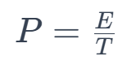

Energy is calculated based on the amplitude values of the audio file.

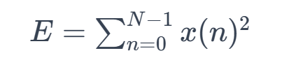

1.3.3 Set power threshold to erase absolute meaningless noise

Assume the power of silent room = 10

If the calculated power < 10, we delete the audio at that interval.

1.4 MATLAB Output

At the end of the process, we get a filtered audio, which contains only the useful signals.

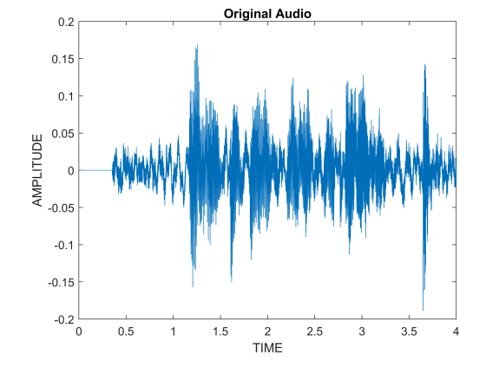

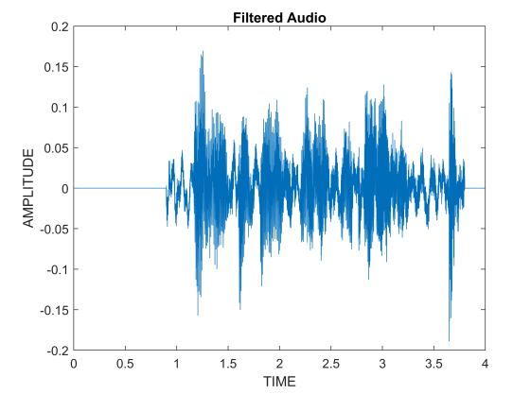

1. Password
   1. Block diagram
   2. Objectives

2.3 Simulation in MATLAB

2.4 MATLAB output

2.5 Results