TVC Calculations Explained:
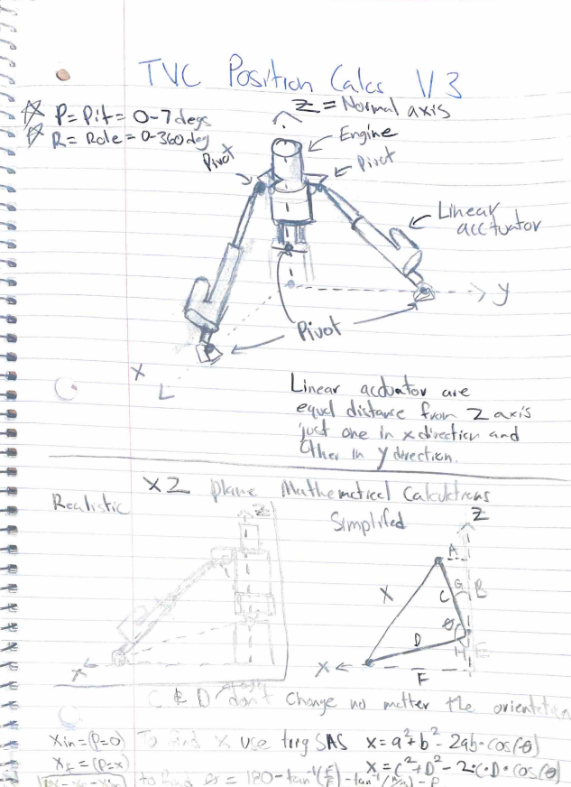
Math Brainstorming to get the length of the actuator at different angles, we just need to calculate one linear actuator and then use cosine and sine to gather the rest of the values. We can use SAS trig to get the length of our linear actuator and use Xi when the engine is normal and Xf when the engine is at a pitch (0-7 degrees). Using these, we can get the delta X needed for the linear actuators.

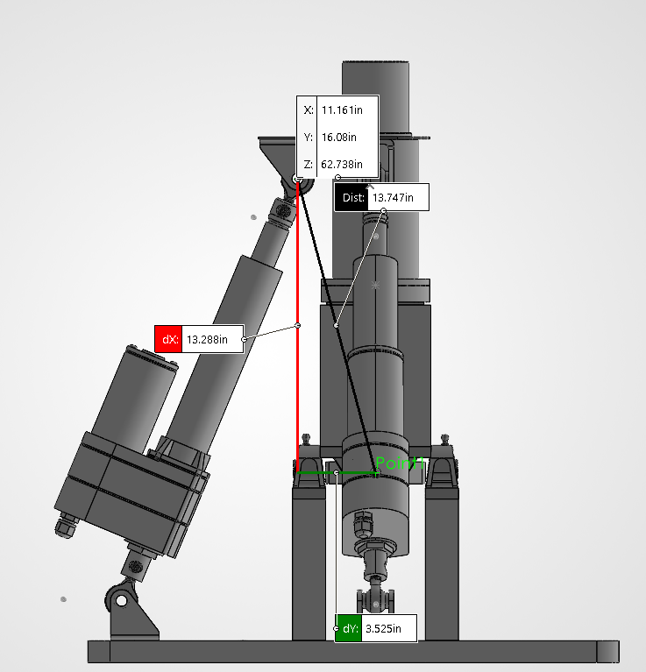
Image contains Length A, B, and C for normal at 0 degrees. A = 3.525in and B = 13.288in and C = 13.747in
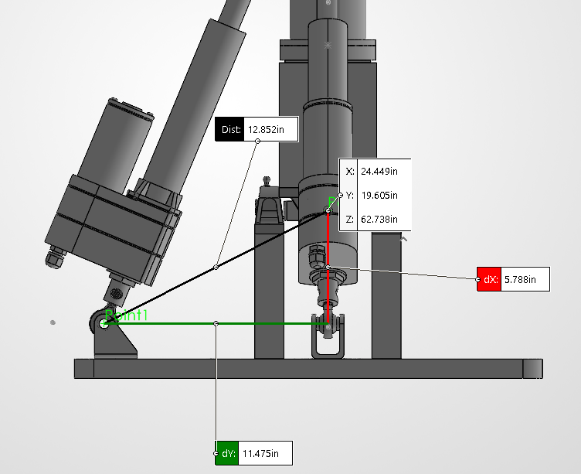
Image contains Length D, E, and F for normal at 0 degrees. D = 12.852in and E = 5.788in and F = 11.475in
MATLAB Script:
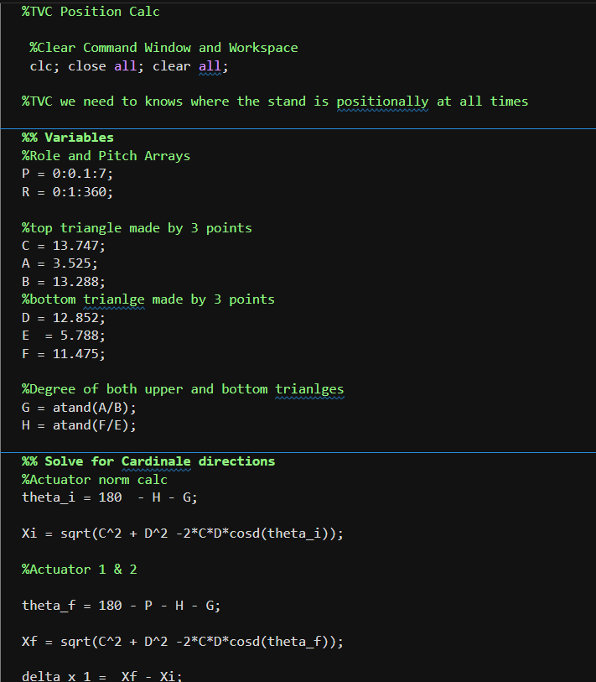
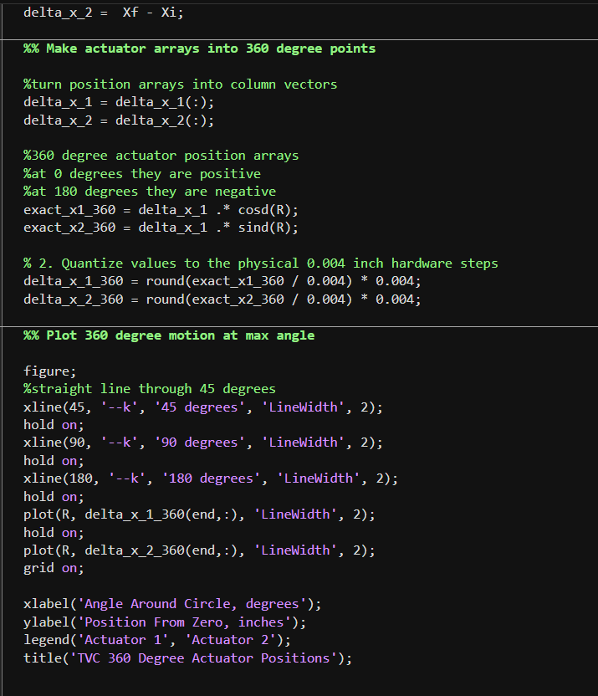
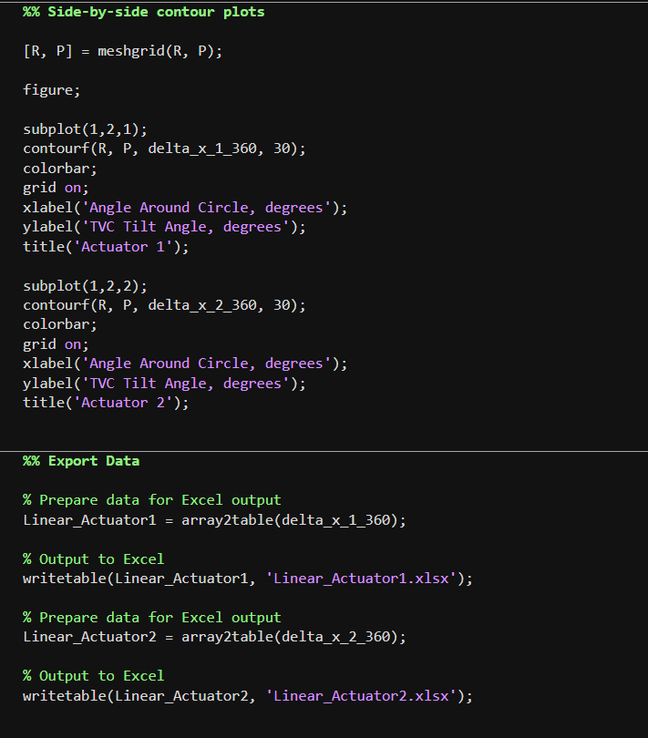
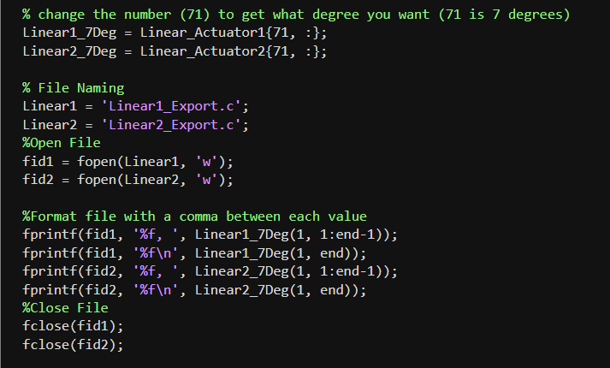
Wiring Diagram:
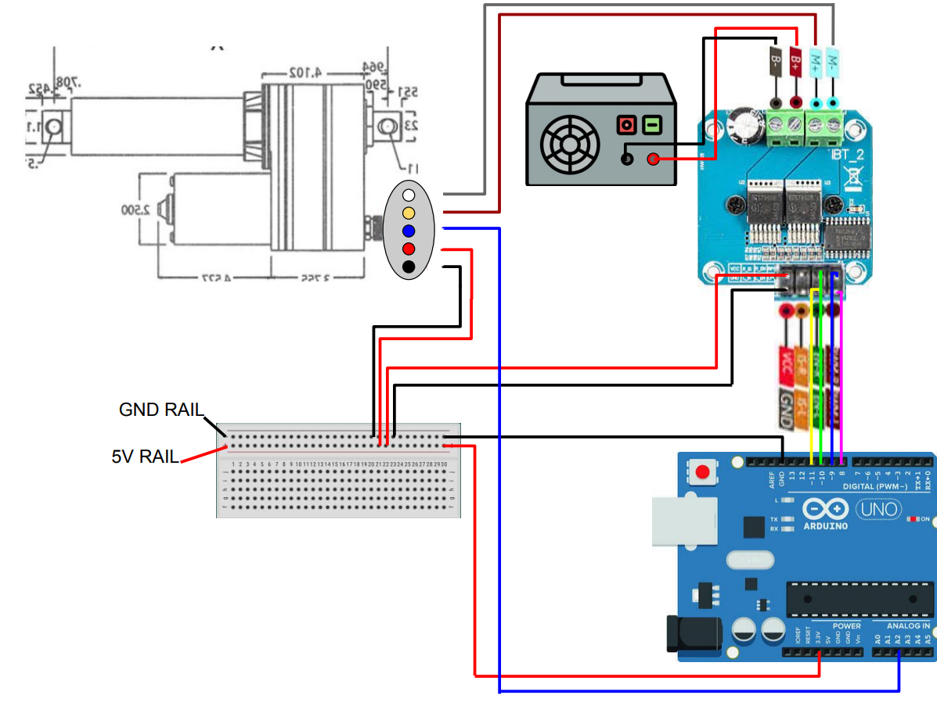
There are 2 wiring diagrams for both linear actuators this is the general layout for each with a shared Arduino and power supply
Arduino IDE Linear Move: Sketch
We will need a way to understand the lowest tolerance move of the linear actuator
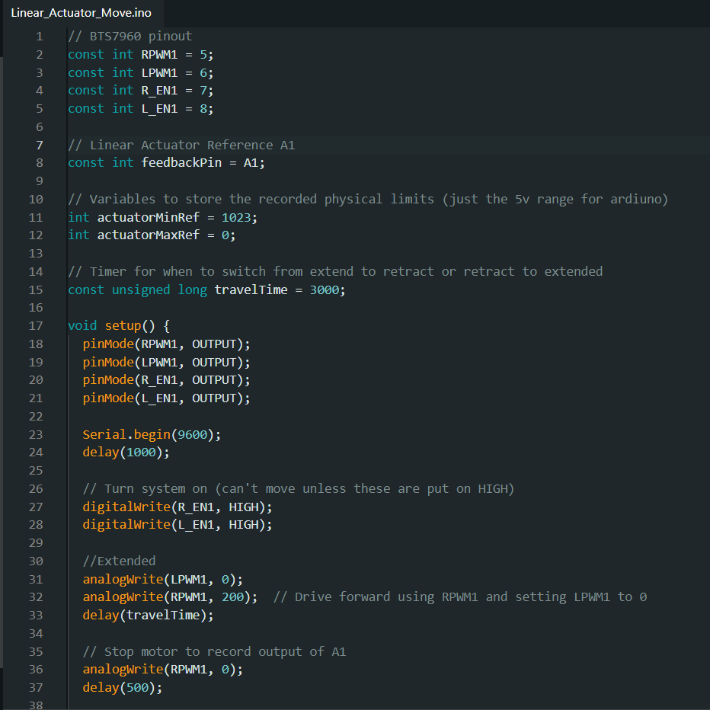
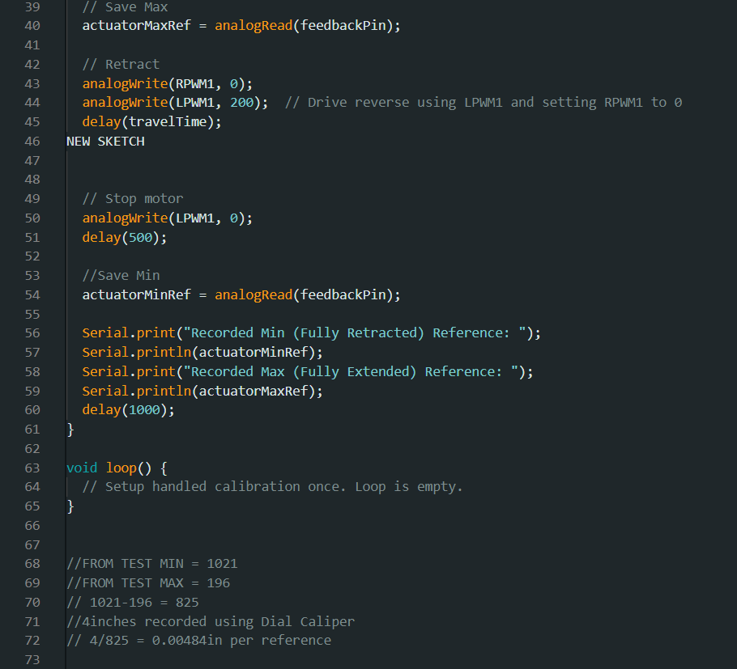
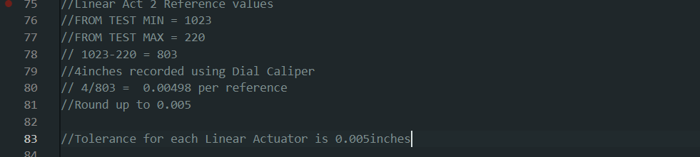
We can see at the bottom that our potential reference from going to min and max records 825 points over 4inches we get a per reference of 0.005 inches.
Arduino Linear Actuator Scaling: Currently we don’t know if this pot reference is a linear function or exponential function so we have to move the motor to certain positions and record values to see where the linear actuator is compared to the pot reference given by the analog output. This will show if it is either linear or exponential.
Code:
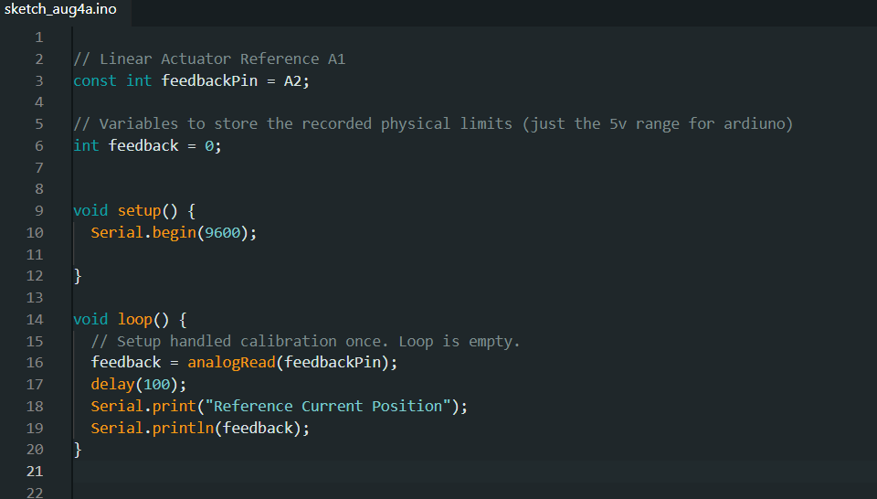
Data:
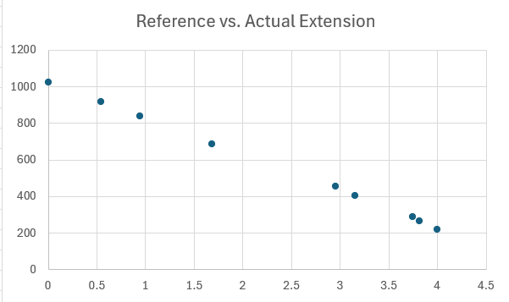
This shows that the linear actuator is linear as it travels through its length to its given reference.

Correctly Demonstrating the Math inside of the Arduino, we can have the pitch angle in the set up as it only needs to be calculated once and the 360 rotation should be calculated on the fly as the linear actuator moves.

Requirements Breakdown Sheet (RBS): | Requirement | Rationale | Traced From | Verification Method
0.0 | Thrust Vector Assembly shall comply with all CPLC and Paso Spaceport rules and regulations | Thrust Vector Assembly is not allowed to fire otherwise. | CPLC Challenge Rules/Paso Spaceport Rules | Documentation/Clear Communication
0.1 | We shall only have 1 primary prolusion device. | This is required to comply with CPLC challenge rules. | CPLC Challenge Rules | Visual Inspection
0.2 | The Primary Propulsion device shall be designed by students | This is required to comply with CPLC challenge rules and demonstrate student engineering. | CPLC Challenge Rules | Documentation
0.3 | All components on the Thrust Vector Assembly are designed, or heavily modified, in 2019 or later | The project work should be recent and updated for current day standards. | CPLC Challenge Rules | Documentation
0.4 | Good Videos of all attempts shall be recorded | To ensure our attempts are verifiable. | CPLC Challenge Rules/CPSS | Hot fire Procedures
0.5 | Hot fire shall not endanger any personnel or bystander | This is necessary to ensure that no one is injured during testing. | Paso Spaceport/CPSS/ CPLC Challenge Rules | Hot fire Procedures
0.6 | TVC shall be structurally stable |  |  | Documentation/ Stress Strain Calcs
0.7 | All components on the Thrust Vector Assembly shall be designed with factor of safety of 2 | To reduce risk and ensure the system operates under expected conditions. | CPSS/Aero Department | Documentation/ Stress Strain Calcs
0.8 | Thrust Vector Assembly shall withstand +300lbf of thrust | To ensure the assembly doesn’t fail under expected thrust. | CPSS | In test loop, recorded data
0.9 | Assembly shall function on the NILE test stand in Paso Robles | The NILE stand is rated for the project and provides a safe testing area. | CPSS | Documentation
1 | TCA shall be designed for nitrous oxide as an oxidizer and ethanol as a fuel | To ensure system performance and safety. | CPSS/Paso Robles Spaceport | Inspection. Documentation
2 | TCA shall be designed to withstand +300psi chamber pressure | This is necessary to ensure the chamber can withhold expected pressure without failure. | CPSS | Test/Analysis. In test loop, recorded data
3 | TCA shall have an e-stop | In case of emergency, the test operators can stop the test safely. | CPSS/Paso Robles Spaceport | Inspection. HITL testing, demonstrate that the TCA stops due to e-stop
4 | The Thrust Chamber Assembly shall fire at or above 300lbf of thrust for at least 15 seconds. | To ensure the assembly can withstand the expected thrust for an extended duration without failure. | CPLC Challenge Rules | Test. In test loop, recorded data
5 | The thrust Vector Gimbal shall actuate 7 degrees in every direction in a full circle twice, in a controlled manner. | To ensure the assembly can actuate in its full range of motion safely and controllably. | CPLC Challenge Rules | Analysis. In test loop, recorded data
6 | Propellants used for testing must fall below 0.5 TNT equivalent. | To keep test risk below max | Paso Robles Spaceport | Documentation TNT equivalent calculation.
---------------------------------------------TVC Stress Stain Calcs----------------------------------------

Base Plate: Compression, Bending, Shear
Compression Plate: Tab Tension, Tab Bending, Tab Shear, Collar Tension

-----------------------------------------TVC Electrical Data Sheets---------------------------------------
Ardiuno Uno:
https://docs.arduino.cc/resources/datasheets/A000066-datasheet.pdf
Motor driver: https://www.handsontec.com/dataspecs/module/BTS7960%20Motor%20Driver.pdf
Buck Convert:
https://rajguruelectronics.com/Product/13060/071123123335.pdf
Linear Actuator:
https://www.servocity.com/content/downloads/super_duty_actuators_specification_sheet_v3_1.pdf
Current Sensor:
https://cdn-shop.adafruit.com/datasheets/ina169.pdf

