Report for part 1-3

XIAO YUE

2020

**Task 1**

Algorithm Non-unique random number

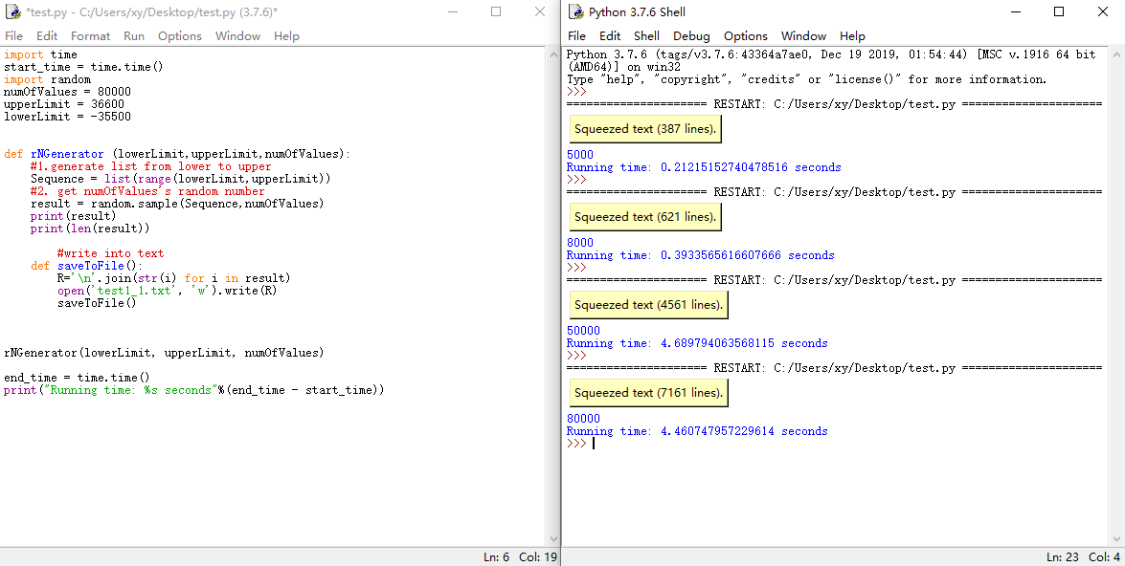

Algorithm Unique random number

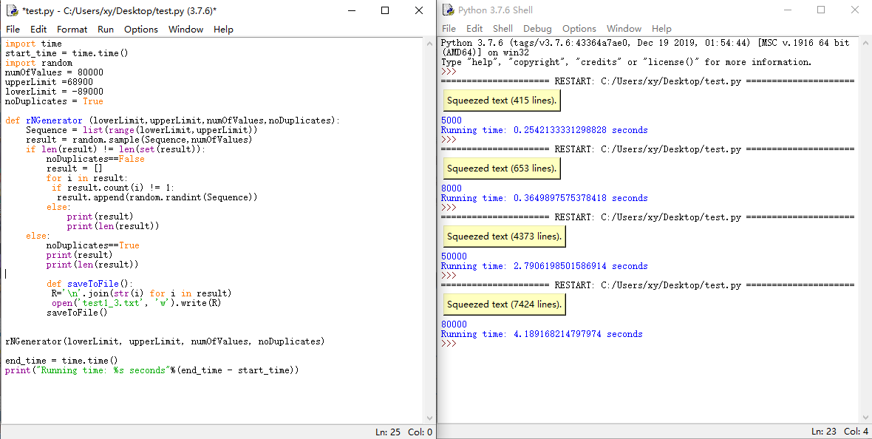

|  |  |  |  |
| --- | --- | --- | --- |
| Algorithm | Timing(s) | | |
|  | Worst | Average | Best |
| Unique random number | [O(N)](https://www.cnblogs.com/lay2017/p/10668311.html#_label1_2) | [O(N)](https://www.cnblogs.com/lay2017/p/10668311.html#_label1_2) | [O(N)](https://www.cnblogs.com/lay2017/p/10668311.html" \l "_label1_2) |
| Non-unique random number | O(N2) | [O(NlogN)](https://www.cnblogs.com/lay2017/p/10668311.html#_label1_4) | [O(N)](https://www.cnblogs.com/lay2017/p/10668311.html#_label1_2) |

**Task 2**

Insertion Sorting

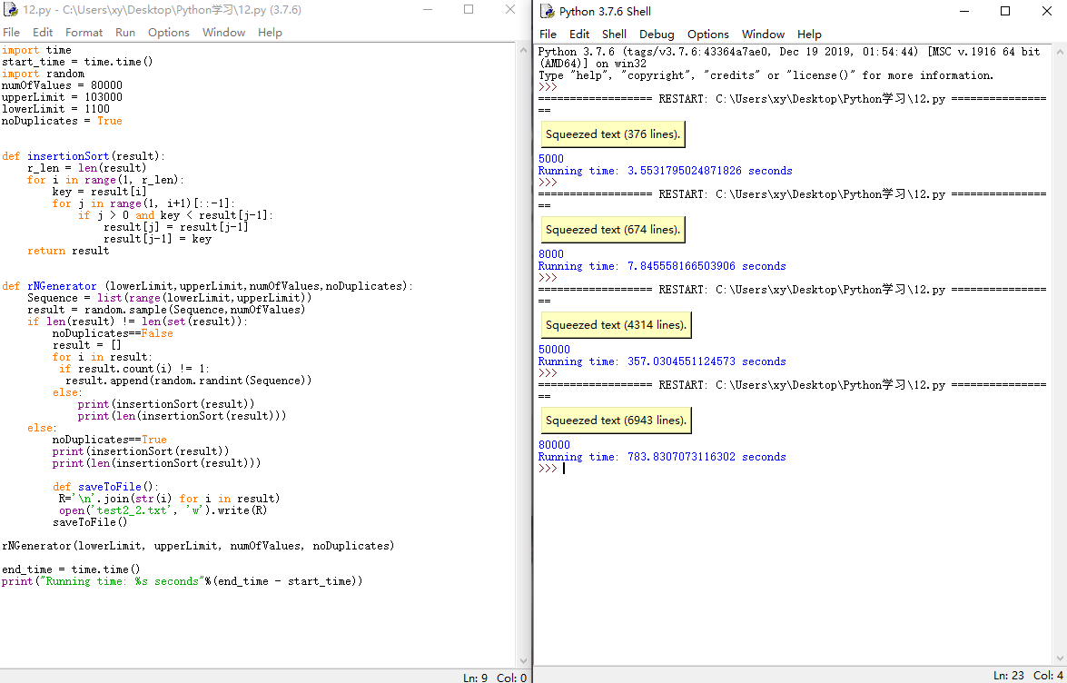

Quick Sorting

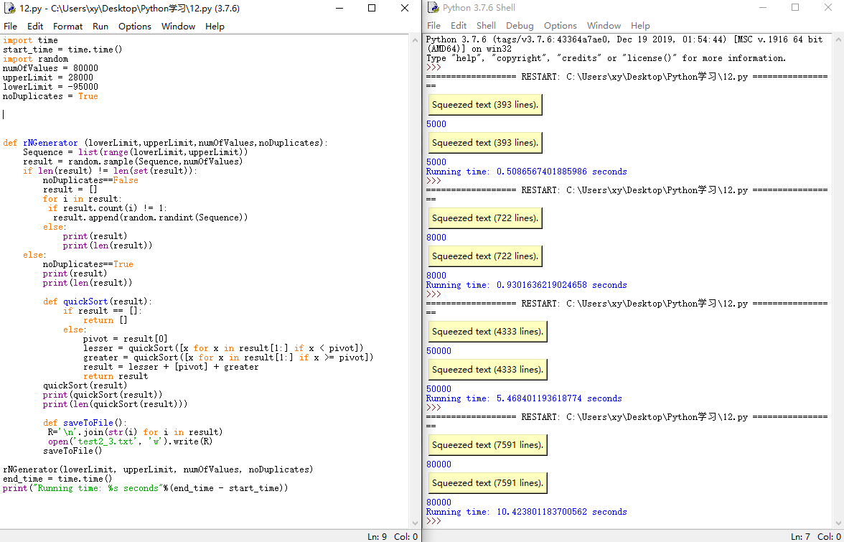

|  |  |  |  |
| --- | --- | --- | --- |
| Algorithm | Timing(s) | | |
| Worst | Average | Best |
| Insertion sorting | [O(NlogN)](https://www.cnblogs.com/lay2017/p/10668311.html#_label1_4) | [O(NlogN)](https://www.cnblogs.com/lay2017/p/10668311.html#_label1_4) | [O(NlogN)](https://www.cnblogs.com/lay2017/p/10668311.html#_label1_4) |
| Quick sorting | [O(NlogN)](https://www.cnblogs.com/lay2017/p/10668311.html#_label1_4) | [O(NlogN)](https://www.cnblogs.com/lay2017/p/10668311.html#_label1_4) | [O(N)](https://www.cnblogs.com/lay2017/p/10668311.html#_label1_2) |

**Task 3**

1. Does the no. of CPUs in a machine significantly affect the performance of the unknown algorithms (in Part 1), sorting algorithms (in Part 2) and data structures (in Part 3)?

Compare running time of two computers:

A. Intel(R) Core(TM) i7-8750H CPU @ 2.20GHz

B. Intel(R) Core(TM) i7-7799 CPU@ 3.60GHz

|  |  |  |
| --- | --- | --- |
| Task | A’s Timing(s) | B’s Timing(s) |
| Taska1 | 0.21 | 0.18 |
| Taskan | 0.39 | 0.13 |
| Taskb1 | 4.69 | 2.70 |
| Taskbn | 4.46 | 3.68 |
| Taskc1 | 3.55 | 2.67 |
| Taskcn | 7.84 | 4.32 |
| Taskd1 | 357.03 | 288.76 |
| Taskdn | 783.83 | 780.12 |

It can be seen that it has difference between computer A and B, B have better CPU processing frequency than A, therefore algorithm running faster in computer B.

b) Does having greater RAM (Random Access Memory) capacity help improve performance for all input sizes?

Compare running time of two computers:

A. Installed RAM 16.0 GB (15.9 GB usable)

B. Installed RAM 4.0 GB

RAM has slightly impact on the performance

c) Does the kind of Operating System running your programs play an important role, in maximizing your performance in Parts 1-3? (To answer this, you must choose at least 1 O.S. from the Windows platform, and at least 1 O.S. from the Unix platform)

Windows & macOS

|  |  |  |
| --- | --- | --- |
| Task | Windows’s Timing(s) | macOS’s Timing(s) |
| Taska1 | 0.21 | 0.21 |
| Taskan | 0.39 | 0.38 |
| Taskb1 | 4.69 | 3.98 |
| Taskbn | 4.46 | 4.22 |
| Taskc1 | 3.55 | 2.87 |
| Taskcn | 7.84 | 5.02 |
| Taskd1 | 357.03 | 343.23 |
| Taskdn | 783.83 | 690.49 |

The running time table shows that algorithm running in macOS system is faster than Windows system