Task 1:

Non-unique:

Test A1:

lowerLimit=-35500

upperLimit=36600

numOfValues=50000

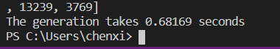

Test A2:

lowerLimit=-42200

upperLimit=43300

numOfValues=60000

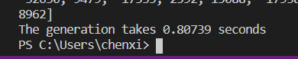

Test A3:

lowerLimit=-42200

upperLimit=54400

numOfValues=70000



Test An:

lowerLimit=13800

upperLimit=96800

numOfValues=80000



Test A4:

lowerLimit=-36600

upperLimit=84400

numOfValues=90000

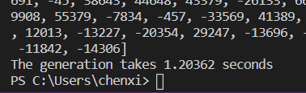

Test A5:

lowerLimit=-46600

upperLimit=84400

numOfValues=100000

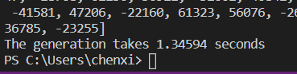

Unique:

Test B1:

lowerLimit=-35500

upperLimit=36600

numOfValues=50000



Test B2:

lowerLimit=-42200

upperLimit=43300

numOfValues=60000

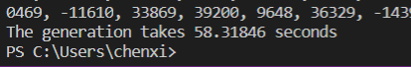

Test B3:

lowerLimit=-42200

upperLimit=53300

numOfValues=70000

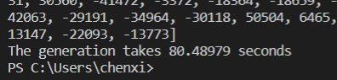

Test Bn:

lowerLimit=-13800

upperLimit=96800

numOfValues=80000



Test B4:

lowerLimit=-36600

upperLimit=84400

numOfValues=90000

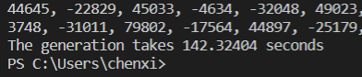

Test B5:

lowerLimit=-46600

upperLimit=84400

numOfValues=100000

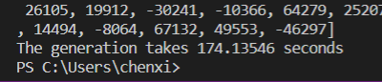

|  |  |  |  |
| --- | --- | --- | --- |
| Algorithm | Timing(s) | | |
| Worst | Average | Best |
| Unique random number | O(n) | O(n) | O(n) |
| Non-unique random number | $$O(n^{2})$$ | $$O(nlog{n})$$ | O(n) |

Task 2:

Insertion sorting:

Test C1:

lowerLimit=-35500

upperLimit=36600

numOfValues=50000

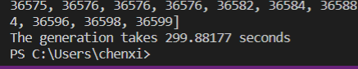

Test C2:

lowerLimit=-42200

upperLimit=43300

numOfValues=60000

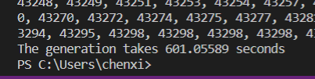

Test C3:

lowerLimit=-42200

upperLimit=54400

numOfValues=70000

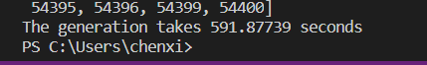

Test Cn:

lowerLimit=-13800

upperLimit=96800

numOfValues=80000

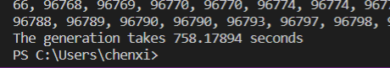

Test C4:

lowerLimit=-36600

upperLimit=84400

numOfValues=90000

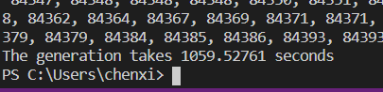

Test C5:

lowerLimit=-46600

upperLimit=84400

numOfValues=100000

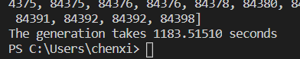

Quick sorting:

Test D1:

lowerLimit=-35500

upperLimit=36600

numOfValues=50000

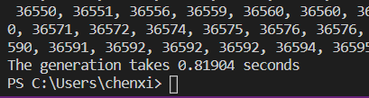

Test D2:

lowerLimit=-42200

upperLimit=43300

numOfValues=60000

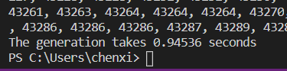

Test D3:

lowerLimit=-42200

upperLimit=54400

numOfValues=70000

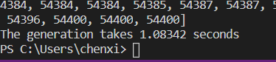

Test Dn:

lowerLimit=-13800

upperLimit=96800

numOfValues=80000

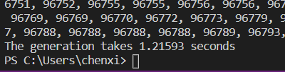

Test D4:

lowerLimit=-36600

upperLimit=84400

numOfValues=90000

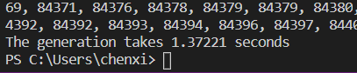

Test D5:

lowerLimit=-46600

upperLimit=84400

numOfValues=100000

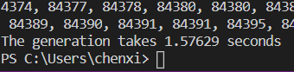

|  |  |  |  |
| --- | --- | --- | --- |
| Algorithm | Timing(s) | | |
| Worst | Average | Best |
| Insertion sorting | $$O(nlog{n})$$ | $$O(nlog{n})$$ | $$O(nlog{n})$$ |
| Quick sorting | $$O(nlog{n})$$ | $$O(nlog{n})$$ | O(n) |

Task 3:

1. Does the no. of CPUs in a machine significantly affect the performance of the unknown algorithms (in Part 1), sorting algorithms (in Part 2) and data structures (in Part 3)?

CPU in my computer is “Intel(R) Core(TM) i7-8750H CPU @ 2.20GHz”, which has 12 cores. But the number of cores can not affect the result. CPU doesn’t affect machine significantly the performance of the unknown algorithm, sorting algorithm and data structures because there are lots of things can affect overall performance.

1. Does having greater RAM (Random Access Memory) capacity help improve performance for all input sizes?

Yes, greater RAM capacity can help improve performance for all input sizes. Your computer's system memory is made up of physical memory, called Random Access Memory (RAM), and virtual memory. System memory is not permanent storage, like a hard disk drive that saves its contents when you turn off your system. When you start a program, your processor gives a command to retrieve the program from the hard drive. Once the files are retrieved, the system needs a workspace to manipulate the data and allow you to interact with it. This digital countertop is your RAM. Your system places your programs in RAM, or the digital countertop, temporarily while you're working with them so that the processor can access that information faster and more easily.

Generally, the more RAM your system has, the larger the digital countertop you have to work on and the faster your programs will run. If your system is running slowly due to lack of RAM, you might be tempted to increase virtual memory because it's less expensive. However, adding RAM is a better solution because your processor can read data from RAM much faster than from a hard drive. RAM has two main attributes that affect your system's performance: memory capacity and memory speed.

1. Does the kind of Operating System running your programs play an important role, in maximizing your performance in Parts 1-3? (To answer this, you must choose at least 1 O.S. from the Windows platform, and at least 1 O.S. from the Unix platform)

An operating system has three main functions: (1) manage the computer's resources, such as the central processing unit, memory, disk drives, and printers, (2) establish a user interface, and (3) execute and provide services for applications software. The kind of OS play an important role while running our programs. Different OS can run program in different performance. Like Windows 10 from Windows platform, Darwin from Unix platform.