**Report**

**Task 1:**

a)  
Test A1 – generate n = 50000 random values from -35500 to 36600

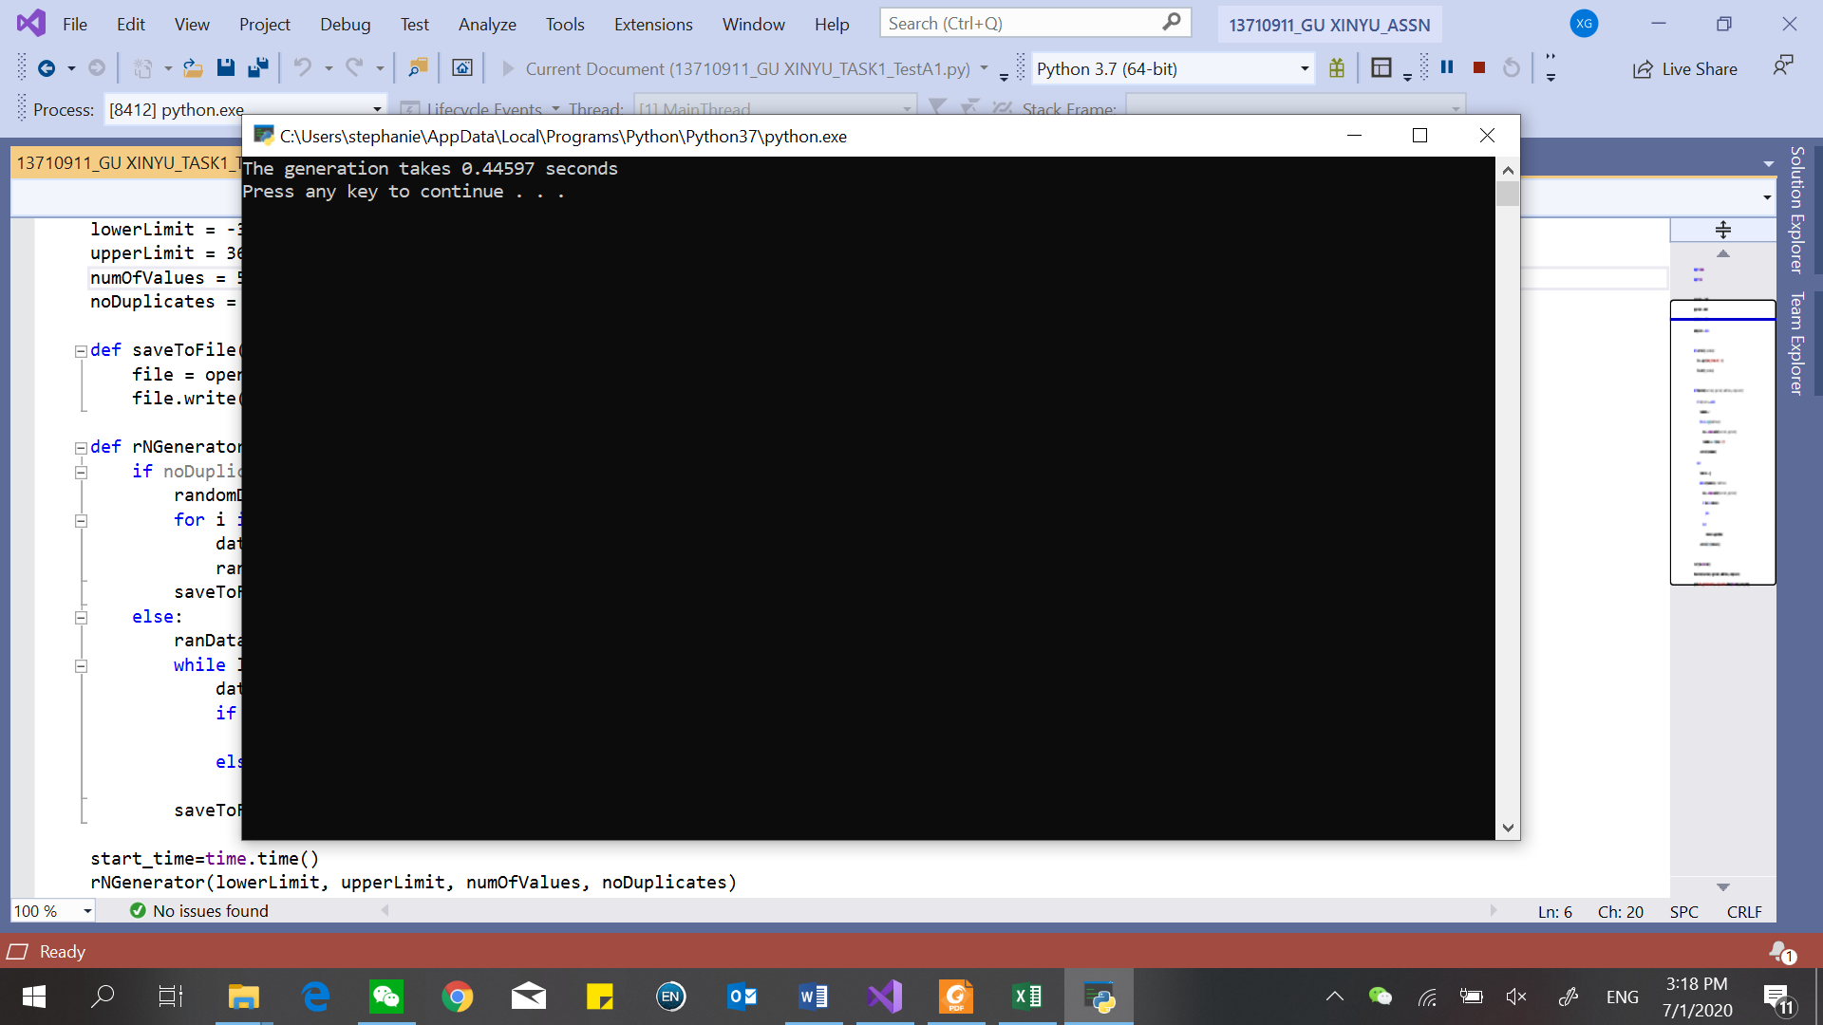

Test A2 – generate n = 60000 random values from -35500 to 36600

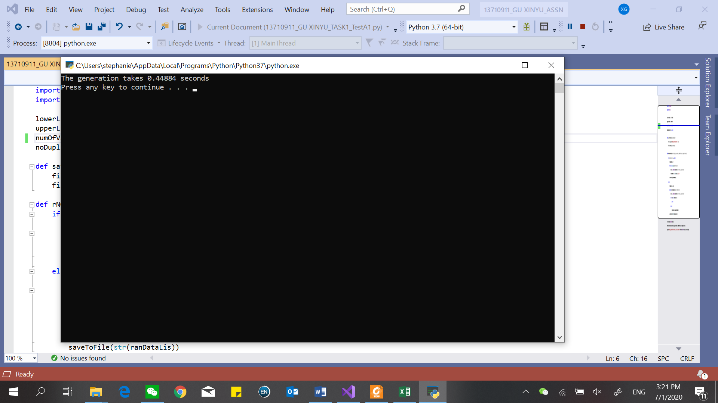

Test A3 – generate n = 70000 random values from -35500 to 36600

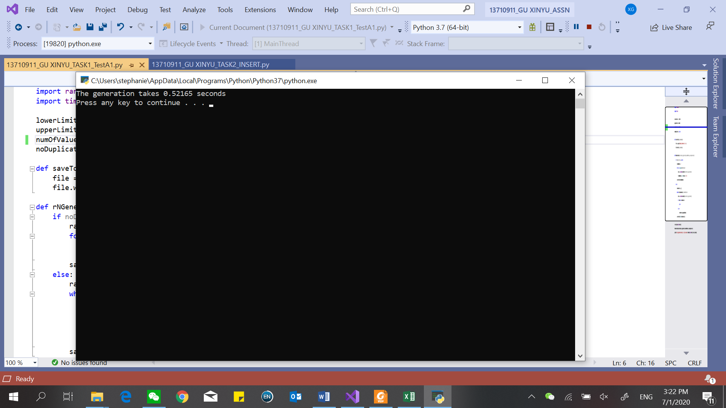

Test A4 – generate n = 80000 random values from -13800 to 96800

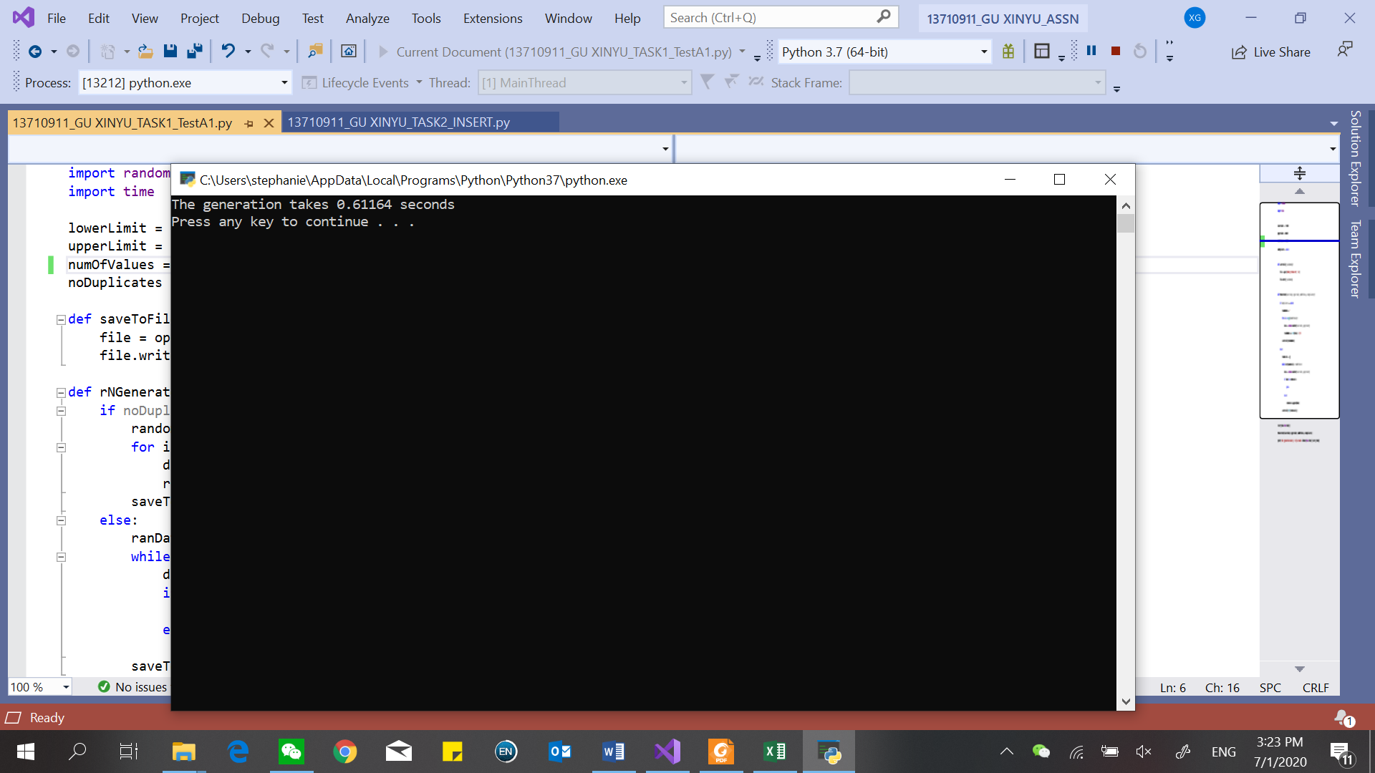

Test B1 - generate n = 50000 unique, random values from -35500 to 36600

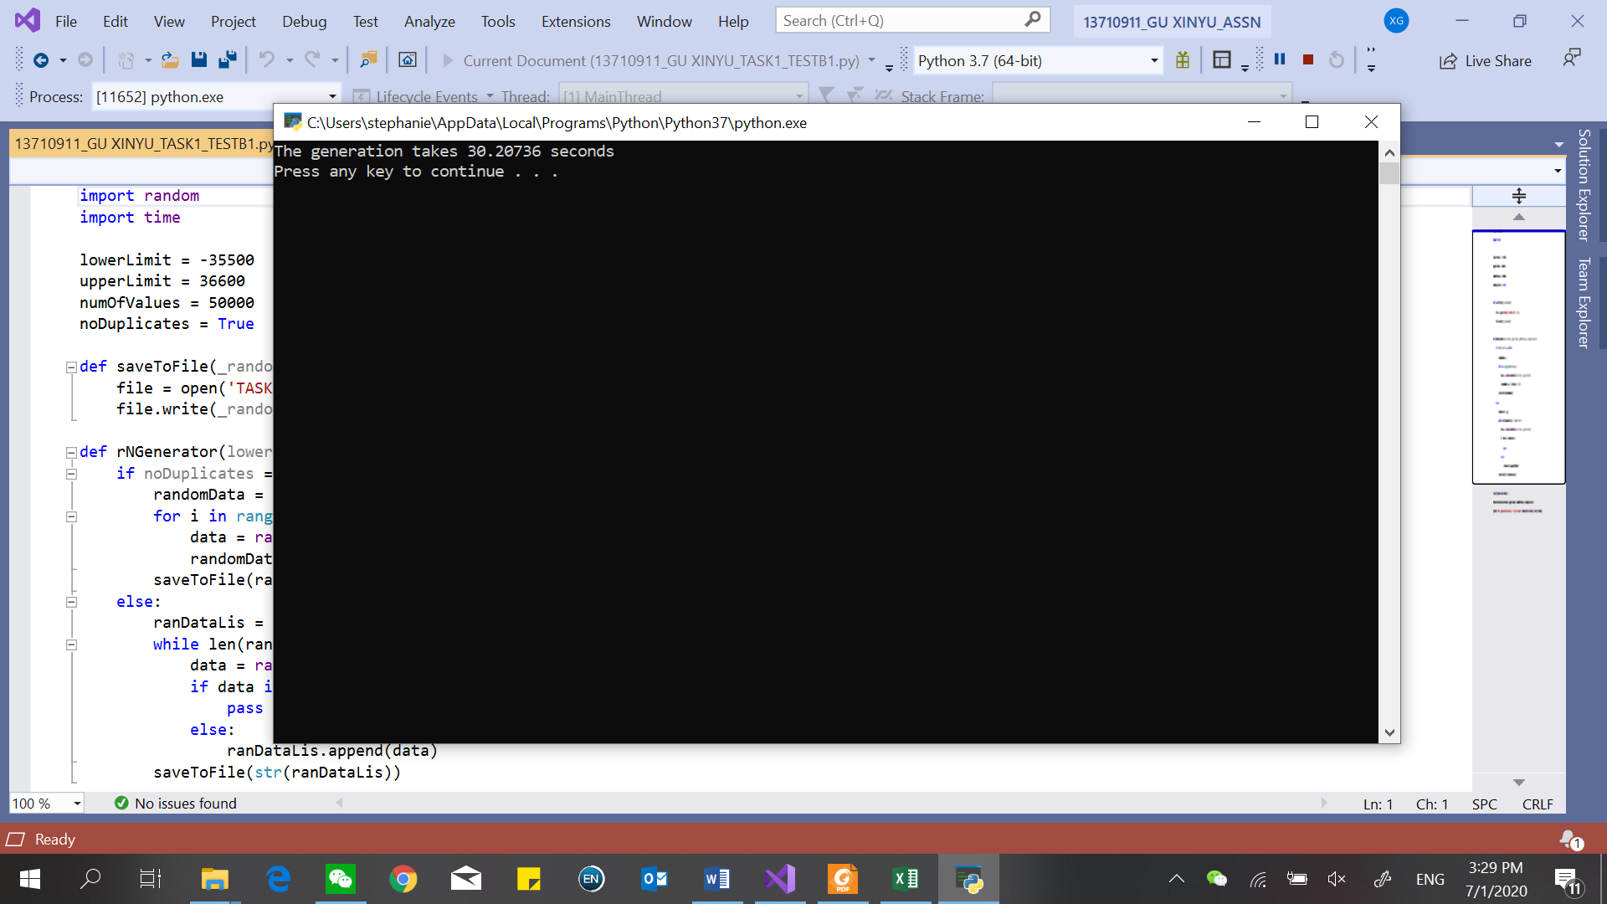

Test B2 - generate n = 60000 unique, random values from -35500 to 36600

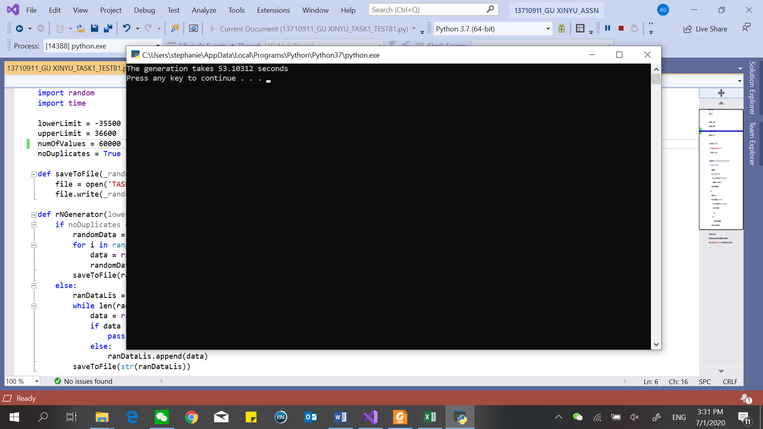

Test B3 - generate n = 70000 unique, random values from -35500 to 36600

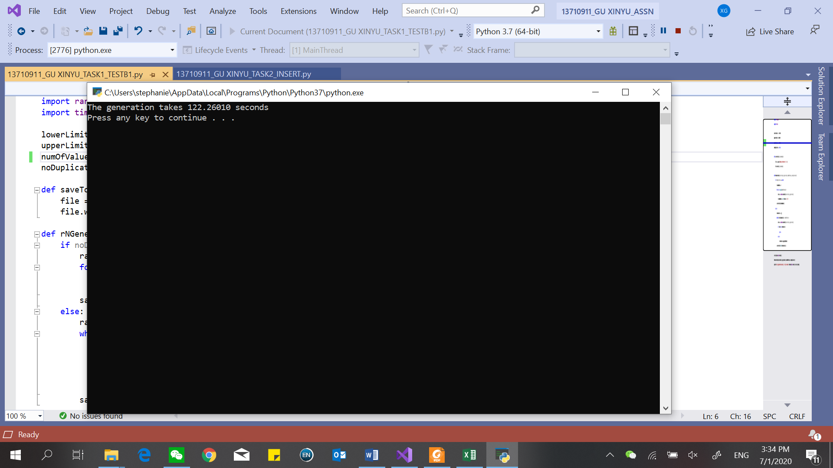

Test Bn - generate n = 80000 unique, random values from -13800 to 96800

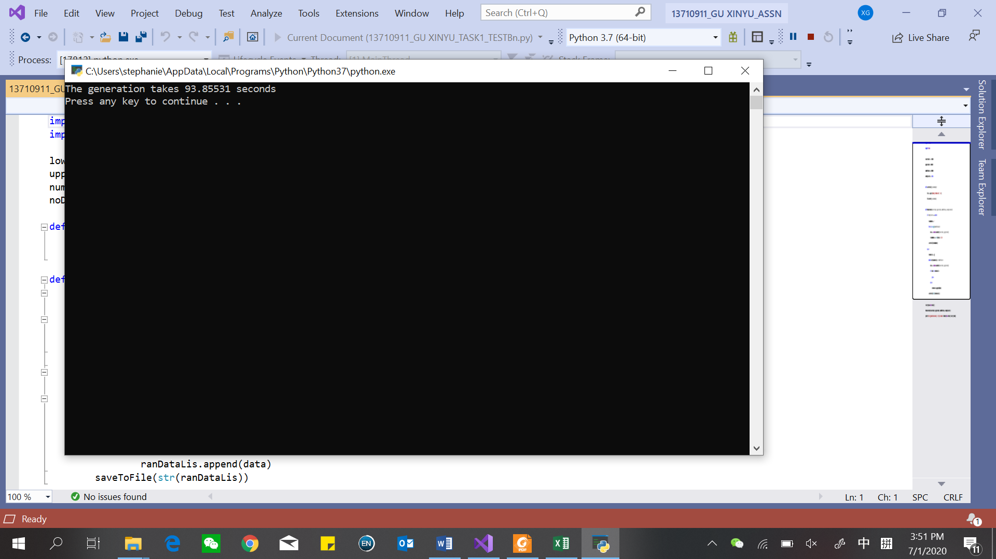

b) see the python files (“13710911_GU XINYU_TASK1_TESTA1”, “13710911_GU XINYU_TASK1_TESTAn”, “13710911_GU XINYU_TASK1_TESTB1”, “13710911_GU XINYU_TASK1_TESTBn”)

c) see the excel file (“13710911_GU XINYU”)

d)

|  |  |  |  |
| --- | --- | --- | --- |
| Algorithm | Timing (s) | | |
| Worst | Average | Best |
| Unique random number | O(n) | O(n) | O(n) |
| Non-unique random number |  |  | O(n) |

**Task 2:**

e)  
Test C1 – generate n = 50000 random values from -35500 to 36600

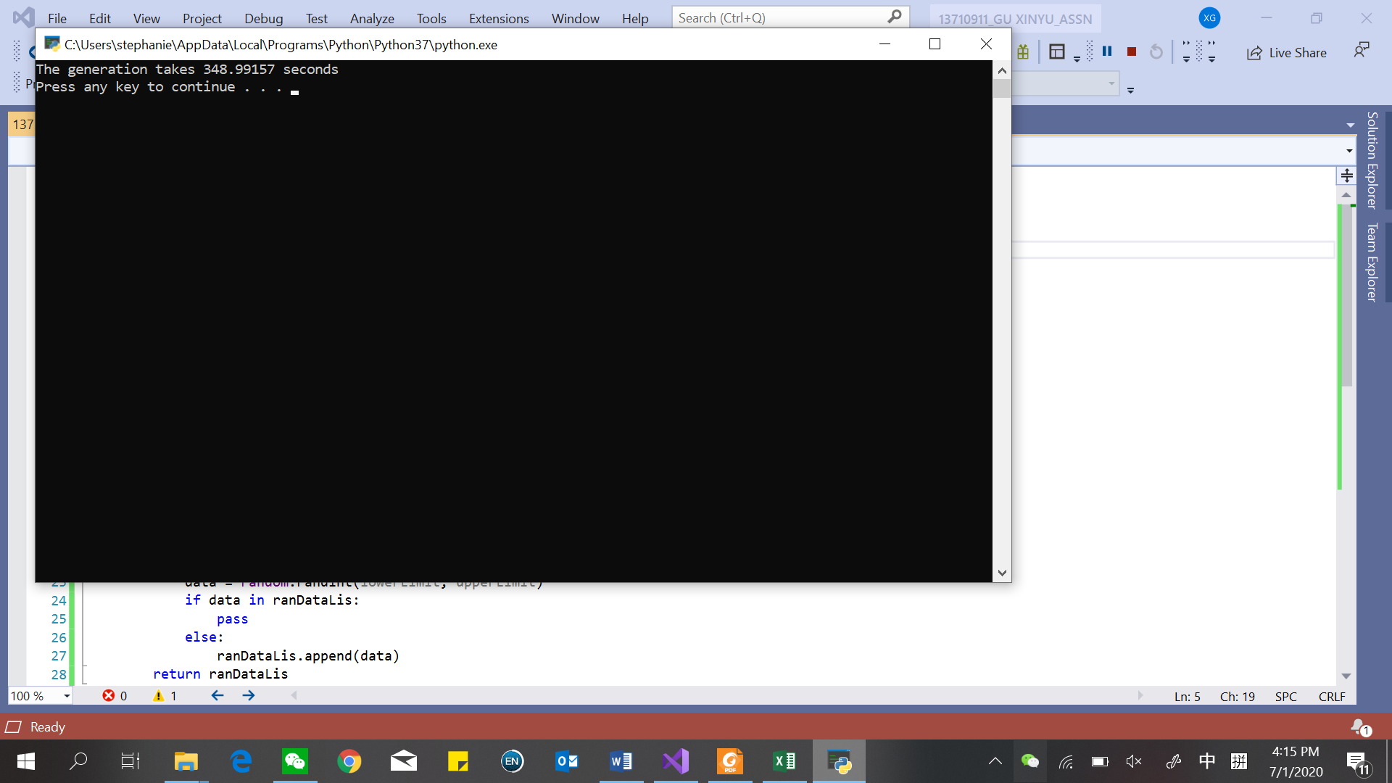

Test C2 – generate n = 60000 random values from -35500 to 36600

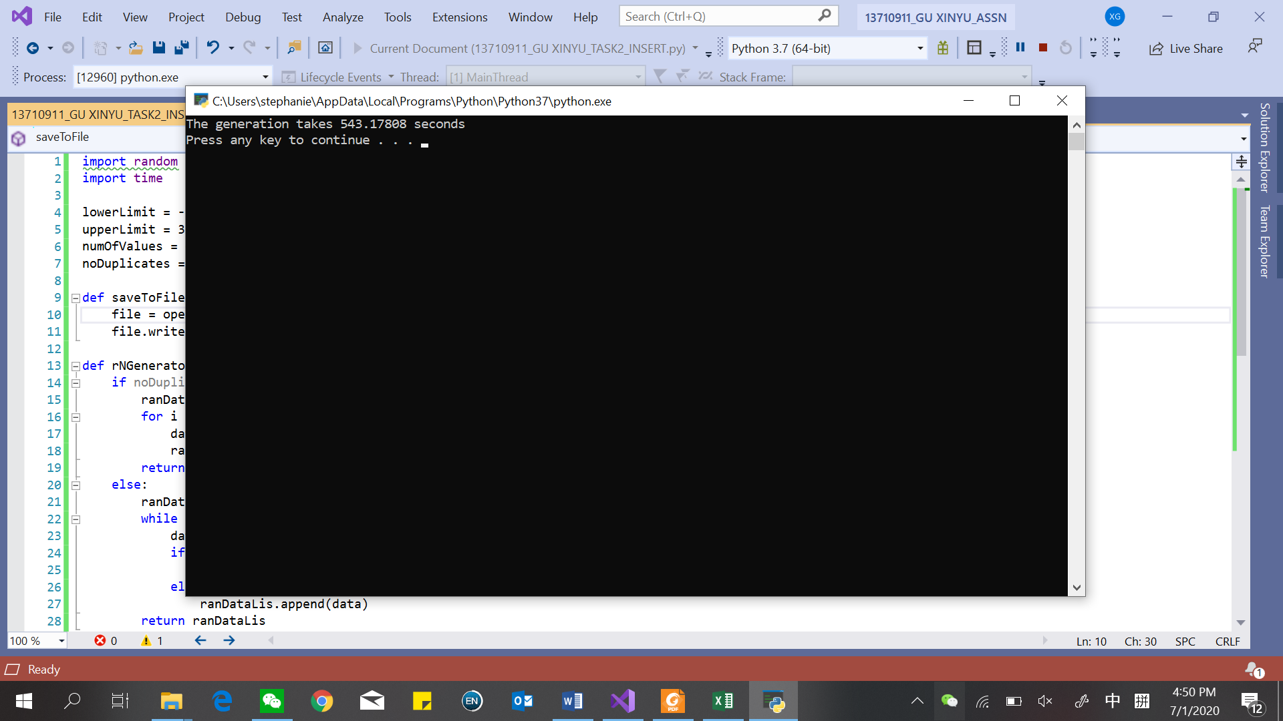

Test C3 – generate n = 70000 random values from -35500 to 36600

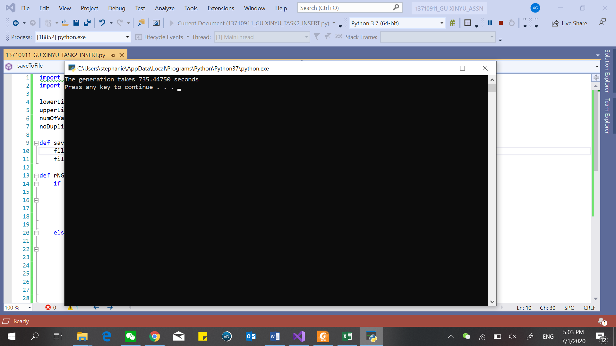

Test Cn – generate n = 80000 random values from -13800 to 96800

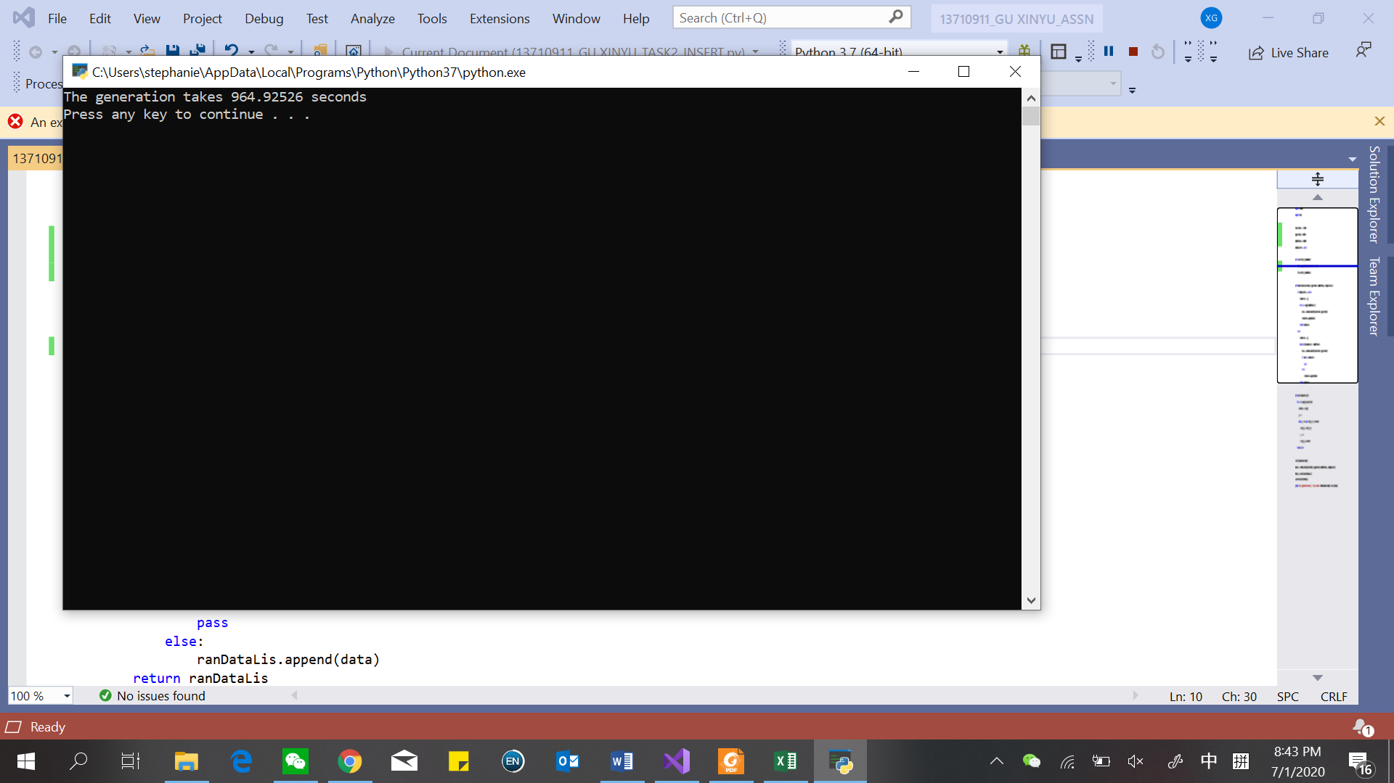

Test D1 - generate n = 50000 random values from -35500 to 36600

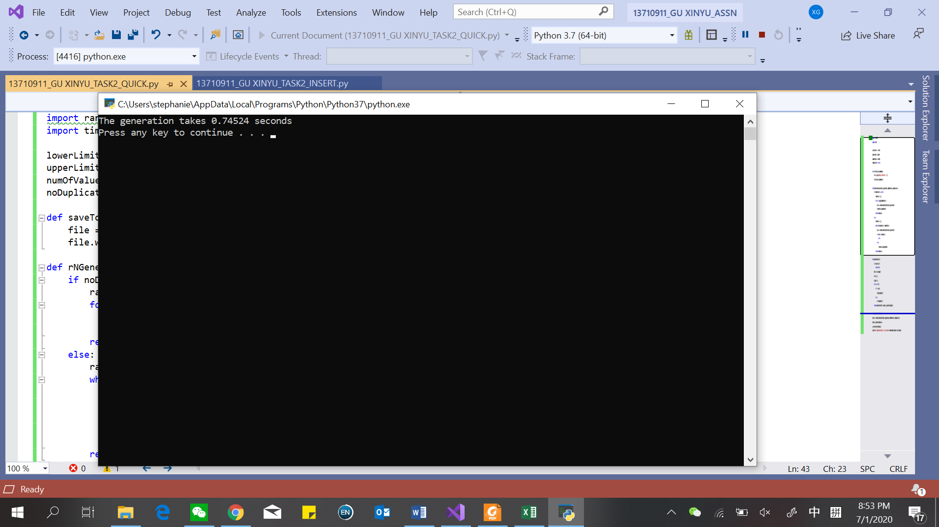

Test D2 - generate n = 60000 random values from -35500 to 36600

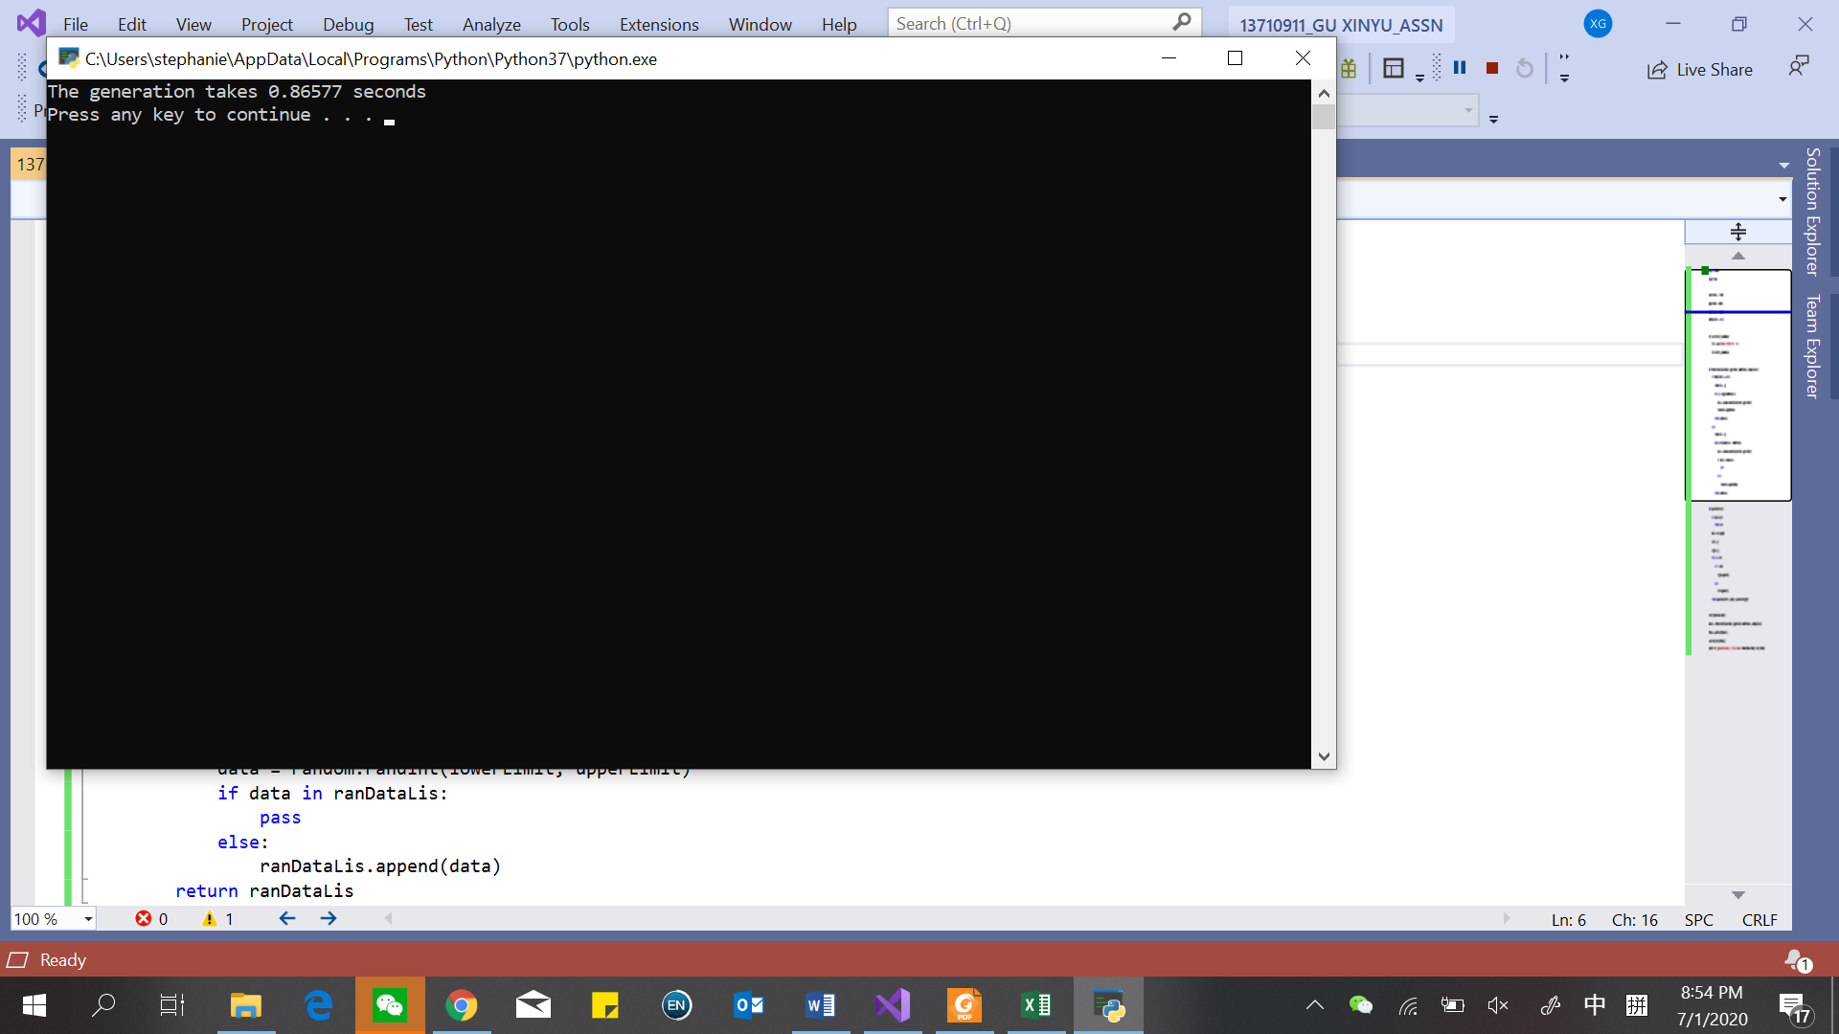

Test D3 - generate n = 70000 random values from -35500 to 36600

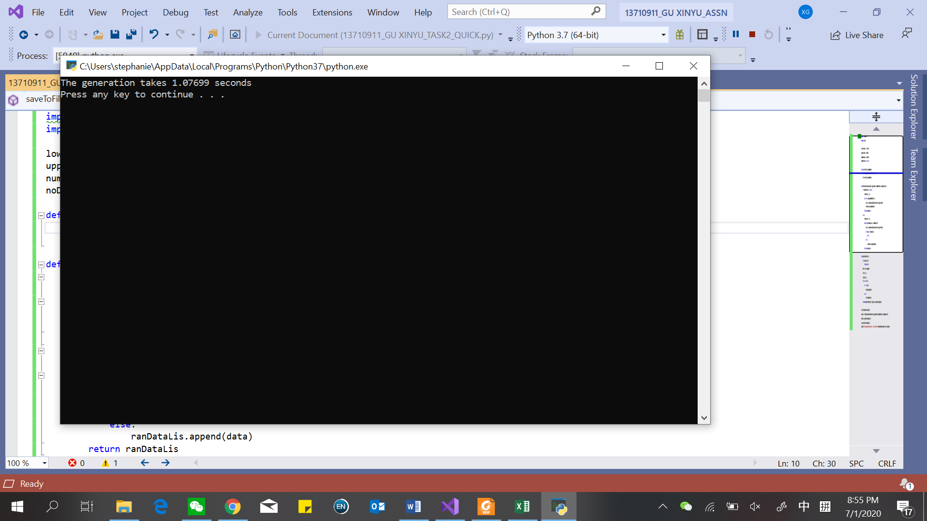

Test Dn - generate n = 80000 random values from -13800 to 96800

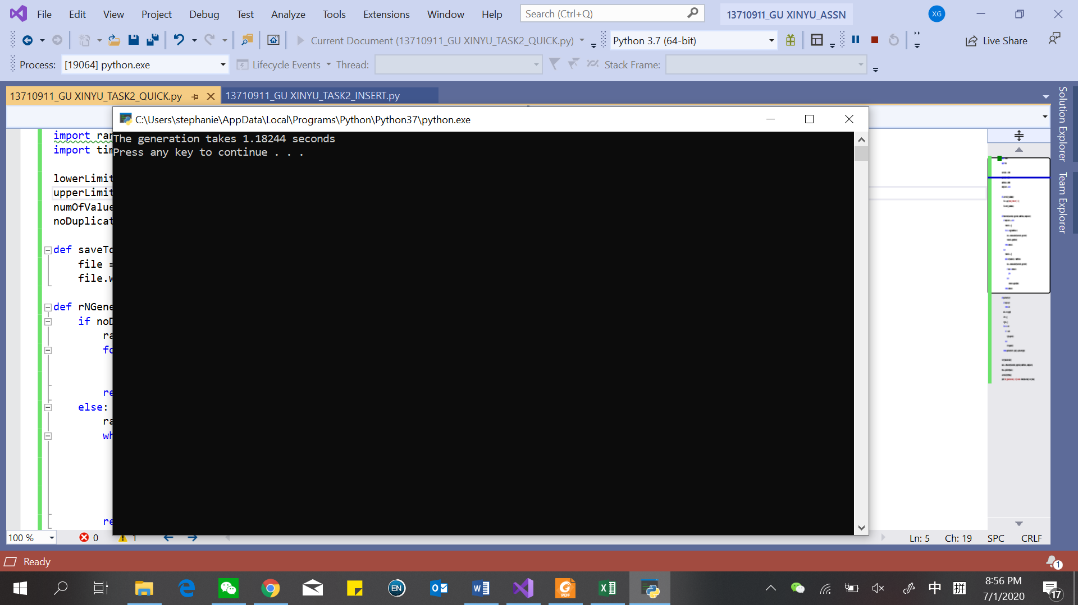

f) see excel file (“13710911_GU XINYU”)

g)

|  |  |  |  |
| --- | --- | --- | --- |
| Algorithm | Timing (s) | | |
| Worst | Average | Best |
| Unique random number |  |  |  |
| Non-unique random number |  |  | O(n) |

**Task 3:**

a) The CPU is quite important in the performance of the unknown algorithms, sorting algorithms and data structures. The same programs running in the computer I use for this assignment which uses Inter(R) Core™ i5-8250U CPU @ 1.60GHz 1.80GHz are lower than them running in the computer which uses Inter(R) Core™ i7-7700HQ CPU @ 2.80GHz 2.81GHz.

b) Generally, the more RAM the system has, the larger the digital countertop to work on and the faster the programs will run. It has two main attributes that affect the system’s performance, memory capacity and memory speed. However, according to task 1 and task 2, there is little effect on improving performance for input sizes. In theory, when input size is really large, the effect of RAM is more obvious and it is more important.

c) The kind of operating system is playing an important role in running the programs. An operating system is a collection of software that manages computer hardware and provides services for programs. There are three key elements of an operating system, which are: (1) Abstractions (process, thread, file, socket, memory), (2) Mechanisms (create, schedule, open, write, allocate), and (3) Policies (LRU, EDF).