Test1.mem

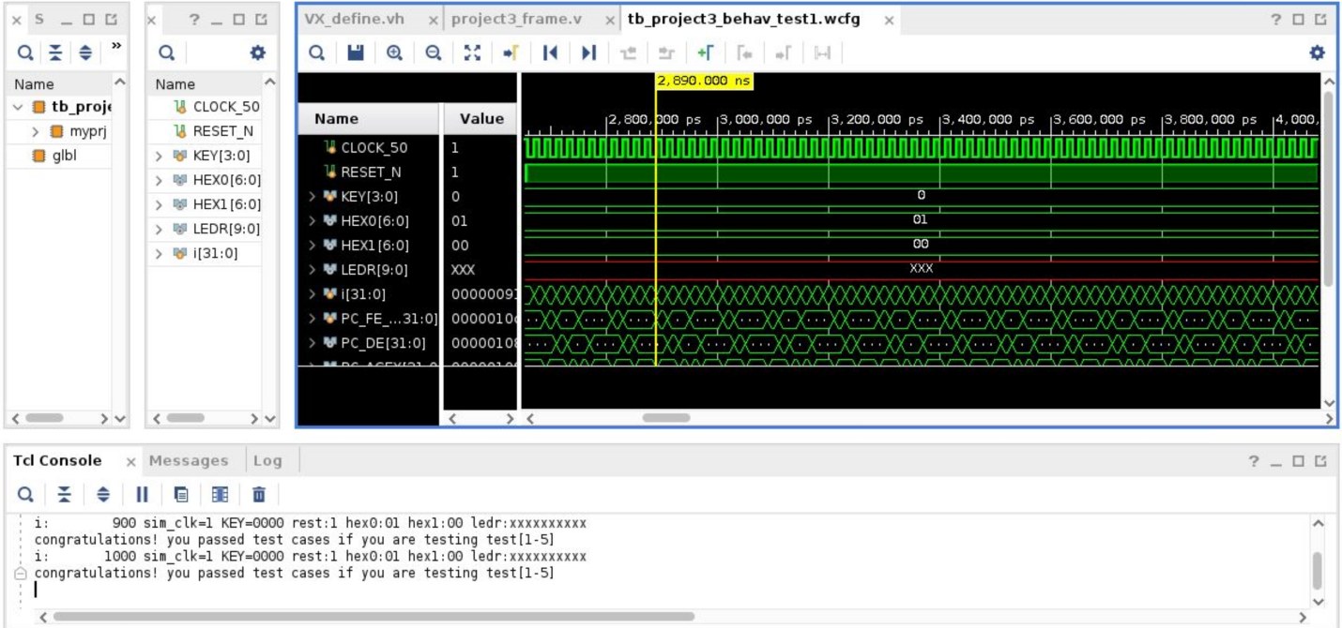

Test2.mem (the header file was changed for test2, but the waveform file is saved as “_test1”)

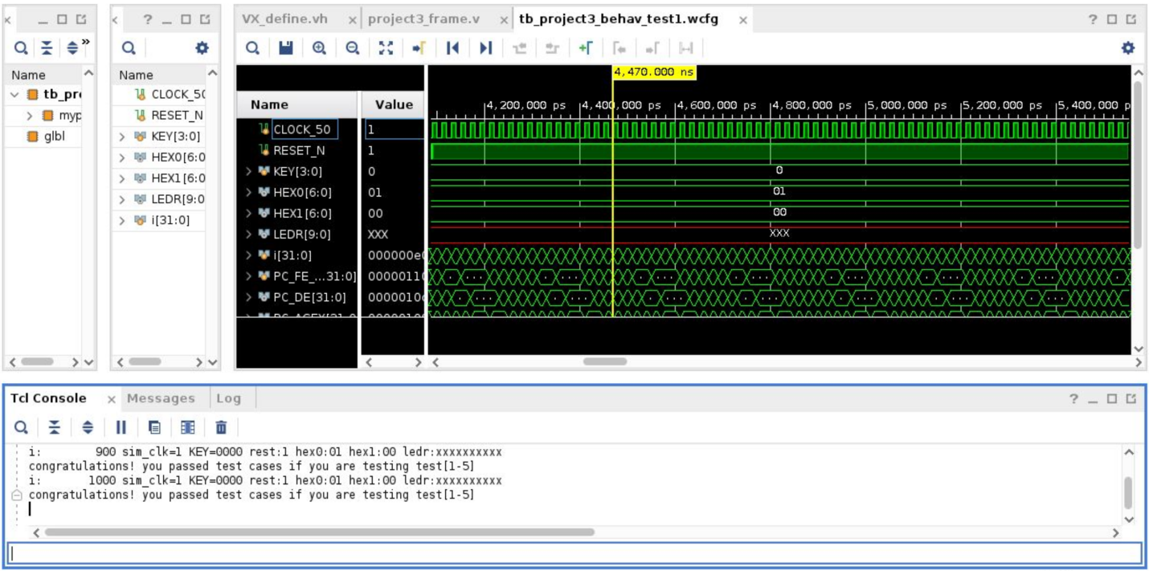

Test3.mem (the header file was changed for test3, but the waveform file is saved as “_test1”)

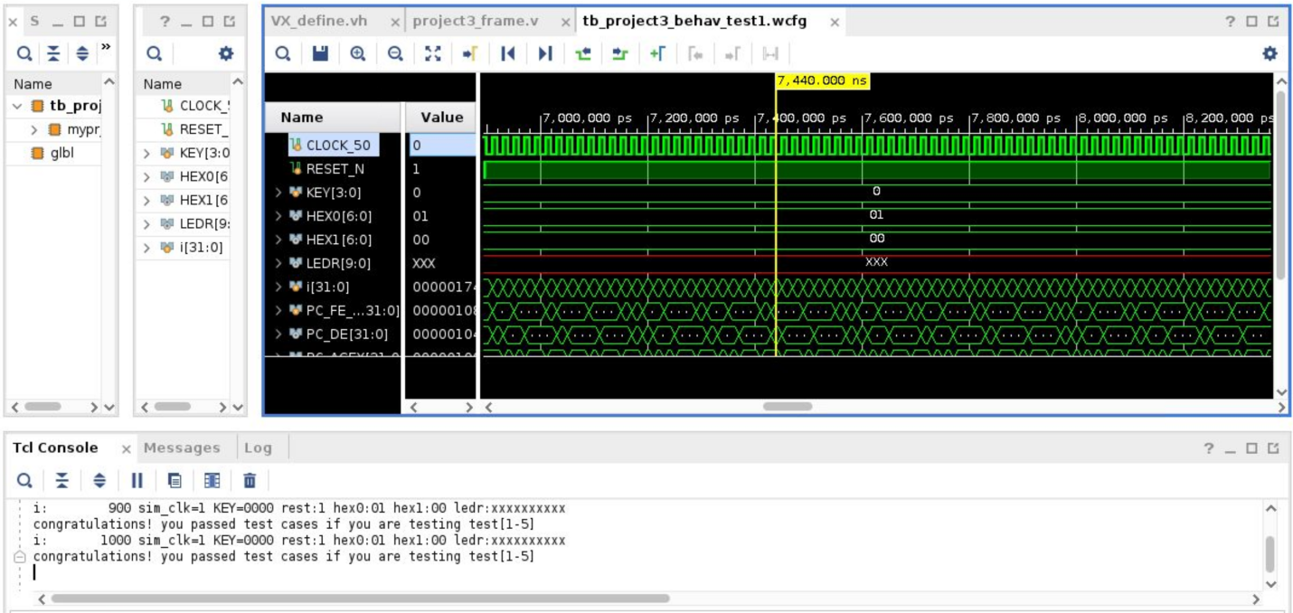

Test4.mem (the header file was changed for test4, but the waveform file is saved as “_test1”)

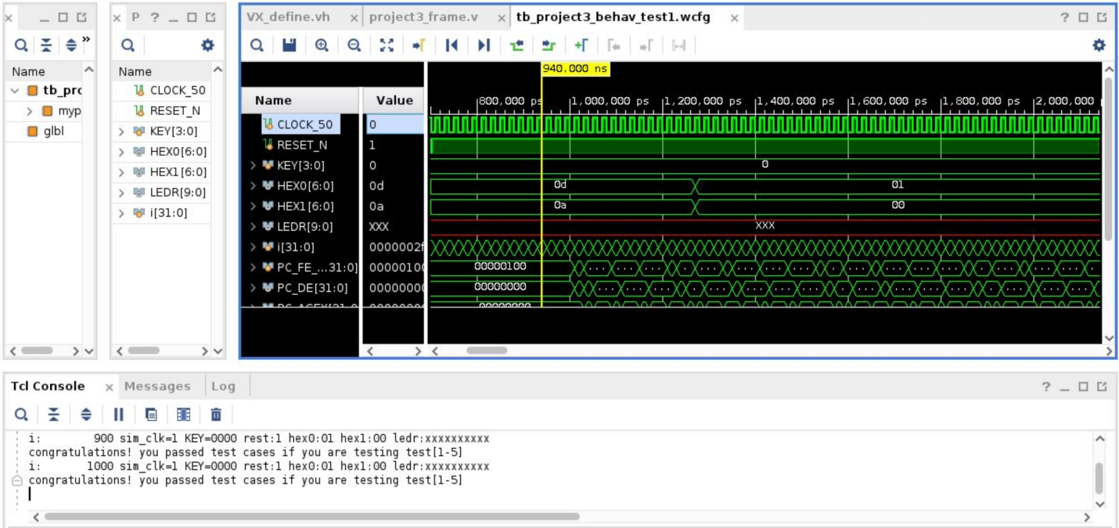

Test5.mem (the header file was changed for test5, but the waveform file is saved as “_test1”)

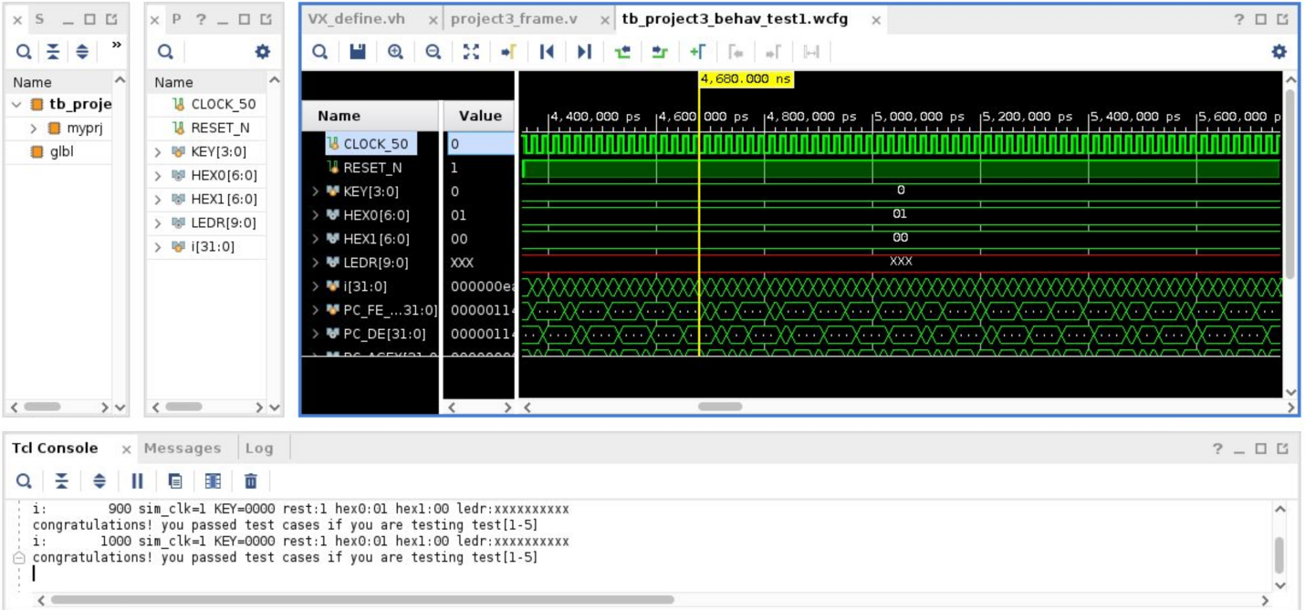

Synthesis and Implementation

