CS {4/6}290 & ECE {4/6}100 - Spring 2021
Homework 3: Pipelined Processors and Branch Prediction
Dr. Thomas Conte
Due: March 12th, 2021 @ 11:59 PM

Rules
- This is an individual assignment. ABSOLUTELY NO COLLABORATION IS PERMITTED. All cases of honor code violations will be reported to the Dean of Students.
- The due date at the top of the assignment is final. Late assignments will not be accepted.
- Please use office hours for getting your questions answered. If you are unable to make it to office hours, please email the TAs.
- Make sure you show your work and give explanations for all questions unless otherwise stated.
- All answers must be handwritten or typed, and an electronic copy (PDF format) uploaded to Canvas before the due date.
- Make sure your answers are written within the boxes we have provided. We will be using Gradescope for grading and answers outside the boxes will be recognized by the system.
- Don’t forget to add your name and email on the second page!

NAME:_________Yue Pan________________

GT-EMAIL:_____ypan331@gatech.edu _____
Question 1
A hazard has potential to reduce the performance of a pipeline processor. For each of the following conditions, specify the hazard type if one exists:
1) A memory read from a unified L1 cache with a single read port
2) Multiple out-of-order writes
3) An adder serving both program counter additions and arithmetic additions
4) A cache read miss
5) A branch misprediction

- Structural hazard.
- Data hazard
3. Structural hazard.
4. Control hazard. Reasoning: a cache miss will make MEM stage longer. Later instructions may have to stall if they depend on this value.
- Control hazard

Question 2
Consider a 5-stage MIPS pipeline (IF ID EX MEM WB), where each stage takes 1 cycle. Assume that there are separate caches for data and instructions, and no misses. The outcome of the branch is figured out at the end of the EX stage. All the branches are statically predicted as not-taken. Data forwarding to the ALU input MUXes in EX is enabled from EX/MEM and MEM/WB pipeline registers. Suppose the branch is taken in the 1st iteration and not taken in the 2nd iteration. How many cycles will it take to complete the write-back of the following instruction stream? Show the pipeline waterfall diagram.
SUB R1 R2 R4
X: ADD R1 R1 1
LW R2 0(R1)
ADD R2 R2 R4
LW R3 0(R2)
BEQ R1 R4 X
SW R3 0(R0)

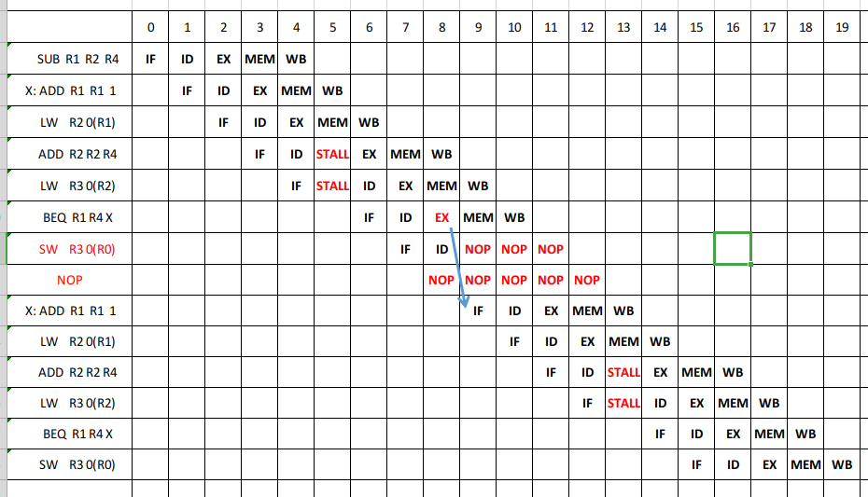
Additional Space for Question 2
Assuming that by “The outcome of the branch is figured out at the end of the EX stage”, the branch address cannot be immediately known in the same stage (branch’s EX stage). Therefore only after 2 cycles can IF get the correct jump address.
The entire instruction stream takes 20 cycles in total.

Question 3
Assume that we have a 10-stage pipeline (IF1 IF2 ID1 ID2 EX1 EX2 MEM1 MEM2 WB1 WB2), where each stage takes 1 cycle. We are given a branch-heavy workload, in which 35% of instructions are branches. The processor does not stall on correct branch predictions, but stalls for 3 cycles on a misprediction. There are no other sources of stalls besides branches for this pipeline. Suppose that 85% of the branches can be correctly predicted.
(a) What is the average number of stall cycles per instruction?
(b) What is the pipeline speedup vs. an unpipelined processor?
(c) Assuming the computation of branch outcome is done in the “ID2” stage. Instead of using branch prediction, the new system is trying to fill the delay slots with instructions. Suppose that the system can fill 3 delay slots for 5% of the branches, 2 slots for 15% of the branches, 1 slot for 35% of the branches, and 0 slot for the remaining branches. All the unfilled slots are treated as no-op. What is the average number of stall cycles per instruction?

- Average stall = 35% * 15% * 3 = 0.1575
- CPI (unpipelined) = 10
CPI (pipelined) = $\frac{10}{1+0.1575}$ = 1.1575
Speedup = $\frac{CPI unpipelined}{CPI pipelined} =10 / 1.1575=$8.64x
- Average stall = 35% * [15% * 1 + 35% * 2 + (1 - 15% - 35% - 5%) * 3] = 0.77

Question 4
Consider the delay of the following pipeline stages:

Fetch: 80 ns
Decode: 10 ns
Execute: 26 ns
Memory access: 70 ns
Write-back: 15 ns

What is the latency of an instruction in this pipeline? What will be the frequency of pipelined structure? Can you think of any way to improve the performance of the above processor?

The cycle time must depend on the time of the critical stage, Fetch in this case. The cycle time here is 80 ns.
Latency = 80 ns * 5 stages = 400 ns

Maximum frequency has to accommodate the slowest stage
Frequency = 1 / 80ns = 12.5 MHz

To improve the performance, we can separate Fetch and Mem into more smaller stages so that the the processor can run under a much faster clock.

Question 5
Simulate a Yeh-Patt predictor with following configuration.
- History table (HT) entries are 2-bit and initialized to 00
- Pattern table (PT) entries are 2-bit and initialized to 01
The following branches occur, where branch X and branch Y alternate:
X: T N N T N N T T N
Y: T N T N N T T N N
- Please show the prediction for each branch and the state of the tables after each branch.
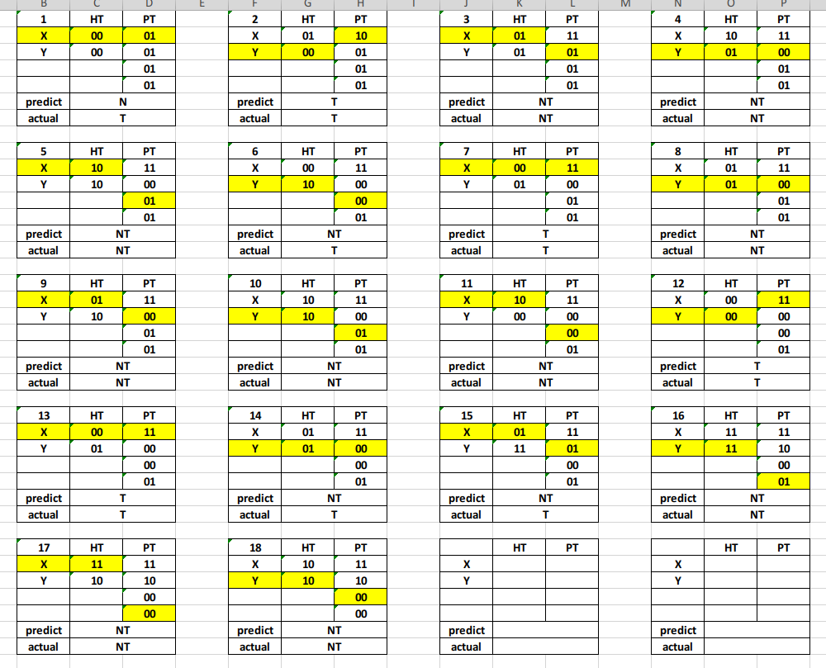
Yellow indicates that these cells will potentially change in the next cycle.

Additional Space for Question 5(a)

- What the accuracy of this predictor for this sequence?
Accuracy = correct predictions / all predictions = 14 / 18 = 77.8%

