Question 1

Assume the following instruction trace. ADD/SUB operations take one cycle, MUL operations take three cycles, and Load/Store operations take two cycles. The pipeline has 2 ADD/SUB units, 1 MUL unit, and 1 Load/Store unit. The functional units are pipelined.

- add R1, R2, R2
- mul R3, R1, R3
- lw R2, 0(R1)
- sub R4, R3, R2
- mul R6, R5, R5
- add R7, R6, R2
- add R7, R4, R7
- sw R7, 0(R8)

- Draw the dependence graph for the 8 instructions shown above. Include all anti, output, and pure dependencies with arcs.

- Show the dependence height of each instruction (multiple answers possible).

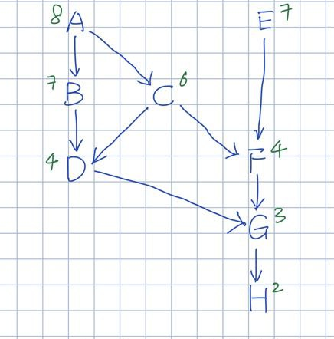
INST | height
A | 8
B | 7
E | 7
C | 6
D | 4
F | 4
G | 3
H | 2

- Show the best VLIW schedule you can find. You may show the schedule using letters only.

ALU 1 |  |  |  | ALU 2 |  |  |  | MUL |  |  |  | LOAD / STORE
INST | DEST | SRC1 | SRC2 | INST | DEST | SRC1 | SRC2 | INST | DEST | SRC1 | SRC2 | INST | D / S | SRC
A | R1 | R2 | R2 |  |  |  |  | E | R6 | R5 | R5
 |  |  |  |  |  |  |  | B | R3 | R1 | R3 | C | R2 | R1
D | R4 | R3 | R2
F | R7 | R6 | R2
G | R7 | R4 | R7
 |  |  |  |  |  |  |  |  |  |  |  | H | R7 | R8

- Based on your result from c), please generate an encoding scheme for the instructions using the tail and pause bits scheme.

INST | OP | DEST | SRC 1 | SRC 2 | TAIL | PAUSE
A | ADD | R1 | R2 | R2 | 0 | 0
E | MUL | R6 | R5 | R5 | 1 | 0
B | MUL | R3 | R1 | R3 | 0 | 0
C | LW | R2 | R1 | - | 1 | 0
D | SUB | R4 | R6 | R2 | 1 | 1
F | ADD | R7 | R6 | R2 | 1 | 0
G | ADD | R7 | R4 | R7 | 1 | 0
H | SW | R7 | R8 | - | 1 | 0

Question 2

Consider the following loop. (Although it's not relevant to the solution, you can assume that R3 begins with a negative value stored in it.)

LABEL:A: ADD R1, R1, #1
B: MUL R1, R1, 4
C: LW R2, 100(R1)
D: SW R2, 200(R1) // Note: R2 is a SOURCE register for SW
E: ADD R3, R3, #1
F: BRNEZ R3, LABEL // branch to LABEL if R3 != 0

Referring to Software Pipelining via Iterative Modulo Scheduling, what is the RecMII and ResMII for this loop? What is the overall minimum II? Assume there is 1 ALU unit, 1 MUL unit, 1 LW unit and 1 SW unit. Both MUL and LW takes 2 cycles and are pipelined. SW, ADD and BREZ all take 1 cycle. ADD and BREZ use the ALU unit. Now show a prologue, kernel and epilog after modulo scheduling. For simplicity, you can write the letter of the operation in a table. You do not need to write the instructions themselves.

