ECE 4100 | Project 4 Cache Coherence | Experiments Report | Yue Pan
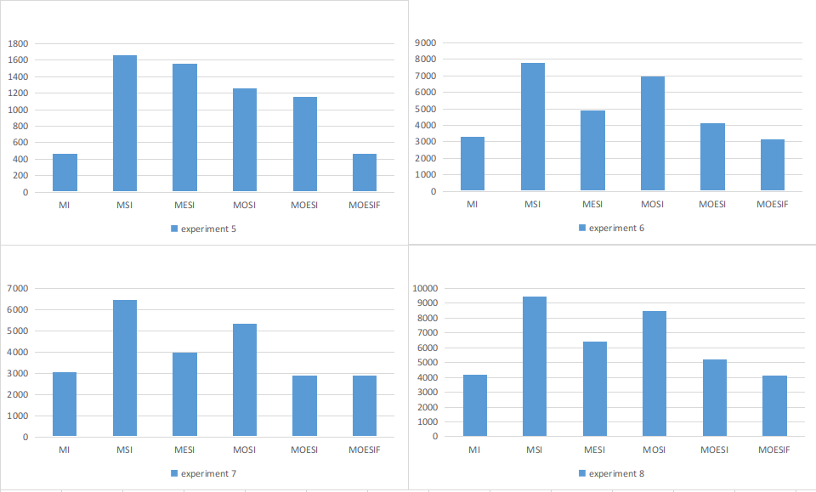
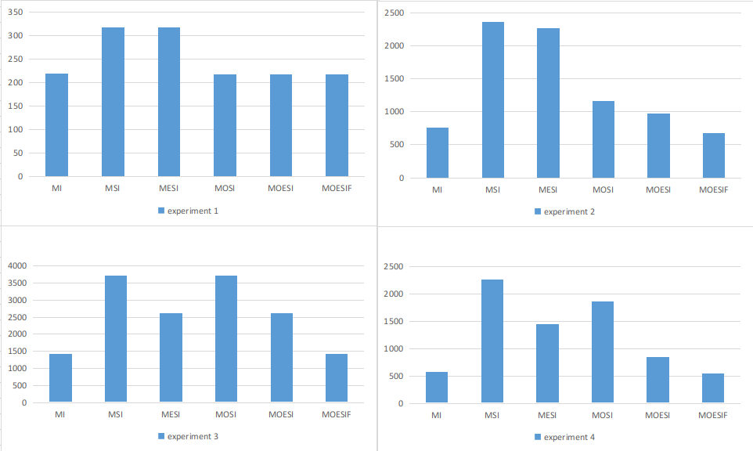
The results (execution time in cycles) of the experiments are summarized into the above charts. In general, we can see the final two protocols, MOESI and MOESIF, perform better than MSI, MESI, and MOSI. The MI protocol, surprisingly, performs very well. Since we didn’t implement it by ourselves, it might be due to a specific implementation scheme that made it abnormally fast. For the purpose of this project, we do not discuss MI’s performance as it is rarely used in a real system.

The simplest trace is experiment 1. There are only three instructions for each core in this trace. For the 5 protocols, we can see a significant performance jump when the state O is introduced into the system: protocols with O state have about 100 cycles less in execution time. This is because that O state is able to perform a cache to cache transfer upon a , thus not requiring memory to respond to a data request, therefore saving 100 cycles in memory transaction. This trend is also generally observed in all experiment traces, especially in experiment 2.

In traces 3, 4, 6, 7, 8 , we can observe that MESI protocol has better performance than MOSI. This is results of the traces’ structure. When a core reads a block and no one else has that block at that specific moment, the block enters E-Exclusive state. E state can perform cache to cache transfer, but only once. On the contrary, when a block is in M-Modified state and it snoops a read request, it enters O-Owner state and from there it can supply as many read requests through cache to cache transfers. It’s possible that due to the access patterns of the traces, some better take advantage of E state and some better take advantage of O state.

In every trace, we can see a performance increase by upgrading MOSI/MESI to MOESI. This increase is relatively straightforward. MOESI protocol combines the benefits of using both E-Exclusive and O-Owner state. More memory transactions can be reduced, thus saving total execution time.

In all traces, MOESIF has better or equal performance than MOESI. This is due to the introduction of the F-forward state. In MOESI, a read in core A followed by another read in core B (suppose both are read misses) will cause the cache block to be fetched from memory twice. With the added F state, core A can become the forwarder and send the block to core B. Therefore, a memory transaction (100 cycles) is saved.

In conclusion, if hardware resource and resource permit, a multi-core system should adopt MOESIF as the cache coherence protocol, as it performs the best in all experimental traces provided.

