Bismillahir Rahmanir Rahim



BANGLADESH UNIVERSITY OF BUSINESS & TECHNOLOGY (BUBT)

Dhaka-1216

#### **Airline Reservation System**

#### **By Group No. 6**

#### UNDERGRADUATE PROJECT

##### Submitted in partial fulfillment of the requirements of software development project 2 for the degree of

B.Sc. Eng. in CSE

By

Team Number: 6

#### UNDER SUPERVISION OF:

##### **Shovon Roy**

Lecturer, Dept. of CSE Bangladesh University of Business and Technology (BUBT)

November 2021

**GROUP MEMBER LIST**

1. Pias Miah (19201103054)
2. Mrityunjoy Biswas (19201103064)
3. Asha Akter (19201103077)

BANGLADESH UNIVERSITY OF BUSINESS & TECHNOLOGY (BUBT) DEPARTMENT OF COMPUTER SCIENCE & ENGINEERING

**Declaration of Authorship**

We, Pias Miah, Mrityunjoy Biswas, Asha Akter declare that this project titled, “Airline Reservation System” and the work presented in it are our own. We confirm that:

* + This work was done wholly or mainly while in candidature for a B.Sc. Engineering in CSE degree at this University.
  + Where any part of this software development project has previously been submitted for a degree or any other qualification at this University or any other institution, this has been clearly stated.
  + Where we have consulted the published work of others, this is always clearly attributed.
  + Where we have quoted from the work of others, the source is always given. With the exception of such quotations, this thesis is entirely our own work.
  + We have acknowledged all main sources of help.
  + Where the thesis is based on work done by our self jointly with others, we have made clear exactly what was done by others and what we have contributed myself.

____________________ ____________________

Pias MiahMrityunjoy Biswas

ID: 19201103054 ID: 19201103064

Date: Date:

____________________

Asha Akter

ID: 19201103077

Date:

## **Certificate**

This is to certify that the project entitled, “Airline Reservation System” and submitted by Pias Miah, Mrityunjoy Biswas, Asha Akter ID No. 19201103054, 19201103064, 19201103077 in partial fulfillment of the requirements of embodies the work done by them under my supervision.

_______________________________________

Shovon Roy

Lecturer,

Department of CSE

Bangladesh University of Business and technology

Date:

**Dedication**

Dedicated to our parents and all honorable teacher for all their love and inspiration.

**Abstract**

The main purpose of our project is to provide airline reservation/air ticketing services. Nowadays everyone is just looking for benefits, so with that in mind we have come up with the idea of creating a software that allows passengers to select all the tickets of their choice. At the same time, we have tried to figure out how to get the most out of the passengers and this will work mainly depending on the online. So, they will get more benefits in less time.

**Acknowledgements**

First of all, we are thankful and expressing our gratefulness to Almighty Allah who offers us His divine blessing, patient, mental and physical strength to complete this project work. We are deeply indebted to our project supervisor Shovon Roy, lecturer, Department of Computer Science and Engineering (CSE), Bangladesh University of Business and Technology (BUBT). His scholarly guidance, important suggestions, work for going through our drafts and correcting them, and generating courage from the beginning to the end of the research work has made the completion of this thesis possible. A very special gratitude goes out to all our friends for their support and help to implement our works. The discussions with them on various topics of our works have been very helpful for us to enrich our knowledge and conception regarding the work. Last but not the least; we are highly grateful to our parents and family members for supporting us spiritually throughout writing this thesis and our life in general.

### **Approval**

This project “Airline Reservation System” Submitted by Pias Miah, Mrityunjoy Biswas, Asha Akter ID No. 19201103054, 19201103064, 19201103077 Department of Computer Science and Engineering (CSE), Bangladesh University of Business and Technology (BUBT) under the supervision of Shovon Roy; Lecturer, Department of Computer Science and Engineering has been accepted as satisfactory for the partial fulfillment of the requirement for the degree of Bachelor of Science (B.Sc. Eng.) in Computer Science and Engineering and approved as to its style and contents.

_____________________________

Supervisor:

Shovon Roy

Lecturer

Department of CSE

Bangladesh University of Business and Technology (BUBT)

_____________________________

Chairman:

Dr. Muhammad Firoz Mridha

Associate Professor and Chairman Department of CSE

Bangladesh University of Business and Technology (BUBT)

Contents

Declaration of Authorship 3

Certificate 4

Abstract 6

Acknowledgements 7

Approval 8

Contents 9

List of Figures 10

1. Introduction………………………………………………………………………….11

1.1 Introduction…………………………………………………………………………11

2 Project Review………………………………………………………………………11

2.1 Problem statement…………………………………………………………………. 11

2.2 Objective of this project…………………………………………………….............11

2.3 feature of this project………………………………………………………………. 12

3 Technologies………………………………………………………………………... 12

3.1 Software…………………………………………………………………….. 12

3.1.1 Visual studio………………………………………………………………. 12

3.1.2 Microsoft SQL Server Management Studio v-18.10……………………… 13

3.2 Programming Language…………………………………………………….. 13

3.2.1 C# Language………………………………………………………………..13

3.3 software framework………………………………………………………….13

3.3.1 The .NET framework……………………………………………………… 13

Contents

4. System Analysis & Architectural Design……………………………………………14

4.1 System user analysis…………………………………………………………………14

4.1.1 Admin Panel……………………………………………………….………. 14

4.1.2 User panel………………………………………………………………….. 14

4.2 Architectural Design…………………………………………………………………14

5. Access system ………………………………………………………………………..14

5.1 description…………………………………………………………………………...14

5.2 manual…………………………………………………………………………………..15

5.2.1 Admin panel………………………………………………………………….. .15

5.2.2 User panel………………………………………………………………………15

5.2.3 Add Flights……………………………………………………………………..15

5.2.4 View Flights……………………………………………………………………15

5.2.5 View Tickets…………………………………………………………………... 15

5.2.6 Home…………………………………………………………………………....15

5.2.7 Search Flights………………………………………………………………….. 15

5.2.8 Seats Booking…………………………………………………………………...15

6. Diagram…………………………………………………………………………………..16

6.1 Schema diagram………….. ……………………………………………………………..16

6.2 ER Diagram……………………………………………………………………………...16

7. Future work………………………………………………………………………………16

8. Conclusion………………………………………………………………………………. 17

9. References….. ……………………………………………………………………..…….17

List of figures

Figure-1: Visual studio…………………………………………………………...……...18

Figure-2: Microsoft SQL Server Management Studio v-18.10………………………….19

Figure 3: C# language……………………………………………………………..…..…20

Figure-4: Schema diagram………………………………………………………..……...21

Figure-5: ER diagram……………………………………………………………………22

Figure-6: Add flight with admin view……………………………………………..…….23

Figure-7: List of flights………………………………………………………………….24

Figure-8: Flights details………………………………………………………..….……..25

Figure-9: View flight with admin view………………………………………...………..26

Figure-10: Search flight…………………………………………………………….……27

Figure-11: Available flight………………………………………………………………27

Figure-12: Seats selection…………………………………………………….…………28

Figure-12.1: Seats selection for flight booking……………………….………………..28

Figure-13: View tickets with admin view…………………………………………….…29

Figure-14: Seats taken………………………………………………………….……..…30

**1.1 Introduction**

Airline reservation systems (ARS) are systems that allow an airline to sell their inventory (seats). It contains information on schedules and fares and contains a database of reservations (or passenger name records) and of tickets issued (if applicable). ARSs are part of [passenger service systems](https://en.wikipedia.org/wiki/Passenger_service_system) (PSS), which are applications supporting the direct contact with the passenger. ARS eventually evolved into the [computer reservations system](https://en.wikipedia.org/wiki/Computer_reservations_system) (CRS). A computer reservation system is used for the reservations of a particular airline and interfaces with a [global distribution system](https://en.wikipedia.org/wiki/Global_distribution_system) (GDS) which supports travel agencies and other distribution channels in making reservations for most major airlines in a single system.

**2.1 Problem statement**

In addition to the many advantage we have some problems in this system. And that's why we went through some problems when we built the software. And we were able to do that through teamwork. Now let's talk about the user system. When a user uses our software, our basic condition is that they must have an internet connection with their device, otherwise they will not be able to use it. Moreover, keeping pace with the times, we have been able to manage our system in such a way that the customer can easily get his fair service in a very short time.

**2.2 Objective**

The project fully technology based. Majority people use technology. So, we create this and give our customer this opportunity. Here some facilities:

In fact, our main objective is how we can serve our customers more efficiently in a very short time. For example, a passenger can select the airport of his choice and buy a ticket in a very short time. And be able to select the flight of his choice. At the same time they will be able to select the seats as they wish. And can select more than one seat. Not only this, with the help of this technology we can do more for the users. We also have different security arrangements for admins.

**2.3 Features**

1.Admin panel  
 1.1- Add Flights  
 1.2-View Flights  
 1.3-View Tickets  
2.User Panel  
 2.1-Home  
 2.2-Search Flights  
 2.3-Seats Booking  
 2.4-View Flights

**3.1.1 Visual Studio**

Microsoft Visual Studio is an [integrated development environment](https://en.wikipedia.org/wiki/Integrated_development_environment) (IDE) from [Microsoft](https://en.wikipedia.org/wiki/Microsoft). It is used to develop [computer programs](https://en.wikipedia.org/wiki/Computer_program), as well as [websites](https://en.wikipedia.org/wiki/Web_site), [web apps](https://en.wikipedia.org/wiki/Web_app), [web services](https://en.wikipedia.org/wiki/Web_service) and [mobile apps](https://en.wikipedia.org/wiki/Mobile_app). Visual Studio uses Microsoft software development platforms such as [Windows API](https://en.wikipedia.org/wiki/Windows_API), [Windows Forms](https://en.wikipedia.org/wiki/Windows_Forms), [Windows Presentation Foundation](https://en.wikipedia.org/wiki/Windows_Presentation_Foundation), [Windows Store](https://en.wikipedia.org/wiki/Windows_Store) and [Microsoft Silverlight](https://en.wikipedia.org/wiki/Microsoft_Silverlight). It can produce both [native code](https://en.wikipedia.org/wiki/Machine_code) and [managed code](https://en.wikipedia.org/wiki/Managed_code). Visual Studio includes a [code editor](https://en.wikipedia.org/wiki/Code_editor) supporting [IntelliSense](https://en.wikipedia.org/wiki/IntelliSense) (the [code completion](https://en.wikipedia.org/wiki/Code_completion) component) as well as [code refactoring](https://en.wikipedia.org/wiki/Code_refactoring). The integrated debugger works both as a source-level debugger and a machine-level debugger. Other built-in tools include a [code profiler](https://en.wikipedia.org/wiki/Profiling_(computer_programming)), designer for building [GUI](https://en.wikipedia.org/wiki/GUI) applications, [web designer](https://en.wikipedia.org/wiki/Web_designer), [class](https://en.wikipedia.org/wiki/Class_(computing)) designer, and [database schema](https://en.wikipedia.org/wiki/Database_schema) designer. It accepts plug-ins that expand the functionality at almost every level—including adding support for [source control](https://en.wikipedia.org/wiki/Source_control) systems (like [Subversion](https://en.wikipedia.org/wiki/Subversion_(software)) and [Git](https://en.wikipedia.org/wiki/Git)) and adding new toolsets like editors and visual designers for [domain-specific languages](https://en.wikipedia.org/wiki/Domain-specific_language) or toolsets for other aspects of the [software development lifecycle](https://en.wikipedia.org/wiki/Software_development_lifecycle) (like the [Azure DevOps](https://en.wikipedia.org/wiki/Azure_DevOps_Server) client: Team Explorer).

**3.1.2 Microsoft SQL server**

SQL Server Management Studio (SSMS) is a software application first launched with [Microsoft](https://en.wikipedia.org/wiki/Microsoft) [SQL Server 2005](https://en.wikipedia.org/wiki/Microsoft_SQL_Server) that is used for configuring, managing, and administering all components within [Microsoft SQL Server](https://en.wikipedia.org/wiki/Microsoft_SQL_Server). It is the successor to the Enterprise Manager in SQL 2000 or before. The tool includes both script editors and graphical tools which work with objects and features of the server. A central feature of SSMS is the Object Explorer, which allows the user to browse, select, and act upon any of the objects within the server.[[3]](https://en.wikipedia.org/wiki/SQL_Server_Management_Studio#cite_note-3) It also shipped a separate Express edition that could be freely downloaded, however recent versions of SSMS are fully capable of connecting to and manage any SQL Server Express instance. Microsoft also incorporated backwards compatibility for older versions of SQL Server thus allowing a newer version of SSMS to connect to older versions of SQL Server instances. It also comes with Microsoft SQL Server Express 2012, or users can download it separately.

**3.2.1 C#**

C# is a general-purpose, [multi-paradigm programming language](https://en.wikipedia.org/wiki/Multi-paradigm_programming_language). C# encompasses static typing, [strong typing](https://en.wikipedia.org/wiki/Strong_typing), [lexically scoped](https://en.wikipedia.org/wiki/Lexically_scoped), [imperative](https://en.wikipedia.org/wiki/Imperative_programming), [declarative](https://en.wikipedia.org/wiki/Declarative_programming), [functional](https://en.wikipedia.org/wiki/Functional_programming), [generic](https://en.wikipedia.org/wiki/Generic_programming), [object-oriented](https://en.wikipedia.org/wiki/Object-oriented_programming) ([class](https://en.wikipedia.org/wiki/Class_(computer_science))-based), and [component-oriented](https://en.wikipedia.org/wiki/Component-based_software_engineering) programming disciplines.

**3.3.1 .Net framework**

The .NET Framework (pronounced as "dot net") is a [software framework](https://en.wikipedia.org/wiki/Software_framework) developed by [Microsoft](https://en.wikipedia.org/wiki/Microsoft) that runs primarily on [Microsoft Windows](https://en.wikipedia.org/wiki/Microsoft_Windows). It includes a large [class library](https://en.wikipedia.org/wiki/Class_library) called [Framework Class Library](https://en.wikipedia.org/wiki/Framework_Class_Library) (FCL) and provides [language interoperability](https://en.wikipedia.org/wiki/Language_interoperability) (each language can use code written in other languages) across several [programming languages](https://en.wikipedia.org/wiki/Programming_language). Programs written for .NET Framework execute in a [software](https://en.wikipedia.org/wiki/Software) environment (in contrast to a [hardware](https://en.wikipedia.org/wiki/Computer_hardware) environment) named the [Common Language Runtime](https://en.wikipedia.org/wiki/Common_Language_Runtime) (CLR). The CLR is an [application virtual machine](https://en.wikipedia.org/wiki/Process_virtual_machine) that provides services such as security, [memory management](https://en.wikipedia.org/wiki/Memory_management), and [exception handling](https://en.wikipedia.org/wiki/Exception_handling). As such, computer code written using .NET Framework is called "[managed code](https://en.wikipedia.org/wiki/Managed_code)". FCL and CLR together constitute the .NET Framework.

**4.1.1 Admin Panel**

In admin panel, admin can do everything what he/she want like that in this system admin can add passengers flight, he/she can see every passengers flight history, tickets history, booking flight and booking tickets history. With this system admin ca cancel passenger data.

**4.1.2 User Panel**

In user panel, user can see booked flight history, with flight details. User also can selected seats plane what they want.

**4.1 Architectural Design**

In this project we used best architectural design for development. We used .net framework and micro soft- sql server local host. We developed this project web-based, software based also application based for helping passengers such that they can easily use these features.

**5.1 Description**

In keeping with the current times we have developed this airline reservation system so that we can give more benefits to our passengers in less time. We can present it to the passengers in different ways and that is the system we have created. If we want to talk about the user interface then we will come across a very different system which we have used a lot before but the users will be able to enjoy it with great pleasure. They start from booking their required flight

You will get all the benefits till you choose the ticket including selecting the seat.

**5.2.1 Admin panel**

If we consider this panel manually then we can see that, admin can do use any of option what he/she want like add, change or update.

**5.2.2 User panel**

In this panel user can see their flight booking details and they can select seats with their pleauser.

**5.2.3 Add flights**

In this table admin add passengers flight for booking with needed information.

**5.2.4 View flight**

In this table admin can see passengers flight.

**5.2.5 View tickets**

Passengers after booked ticket, admin can see passengers tickets.

**5.2.6 Home**

This option is user interface option. Just looking for homepage.

**5.2.7 Search flights**

After booked flight, in this option admin search passengers flight history then ser can see their flight history.

**5.2.8 Seats booking**

In this option, passengers can booking seats with their pleauser.

**6.1 Schema Diagram**

A schema diagram is a diagram which contains entities and the attributes that will define that schema. A schema diagram only shows us the database design. It does not show the actual data of the database. Schema can be a single table or it can have more than one table which is related.

**6.2 E-R Diagram**

An entity relationship diagram (ERD) shows the relationships of entity sets stored

in a database. An entity in this context is an object, a component of data. An entity

set is a collection of similar entities. These entities can have attributes that define its

properties. The ER or (Entity Relational Model) is a high-level conceptual data model diagram. Entity-Relation model is based on the notion of real-world entities and the relationship between them. E-R diagram shows us the entire relationship between all the entities those are used in our project. Here we used total three entities and each entity has several attributes for example, User has user id as primary key in this entity, p_name, phone no, password, email & address.

**7. Future Work**

We have already taken many plans for the future work of our project. If we want to keep our service quality accurate and equal for a long time, we must have a long-term plan, and that is what we have done. As we keep in mind the convenience of our passengers, the features need to be updated regularly. So that they can enjoy our advanced features with pleasure. And to keep up with the times, what they can ask for in the future, what they may need, what they will enjoy our service if they get it, we have to maintain it well. There will be no compromise, especially with the airline services. Because our future plan will not work in any way if we cannot provide the service as per the demand of the customers. Rather we will fail more.

**8. Conclusion**

Airline reservation systems incorporate airline schedules, [fare tariffs](https://en.wikipedia.org/wiki/Fare_basis_code), passenger reservations and ticket records. An airline's direct distribution works within their own reservation system, as well as pushing out information to the GDS. The second type of direct distribution channel are consumers who use the internet or mobile applications to make their own reservations.  Travel agencies and other indirect distribution channels access the same GDS as those accessed by the airline reservation systems, and all messaging is transmitted by a standardized messaging system that functions on two types of messaging that transmit on SITA's high level network (HLN).

**9. References**

Some of the references used for preparing the vision document include:

1. www.orbitz.com

2. IEEE document for Software Requirements Specifications

3. E-Draw software is used to generate the use case diagrams

4. wikipedia

5. MSE Portfolio presentation I lecture by Dr. Deloach, on the CIS website.

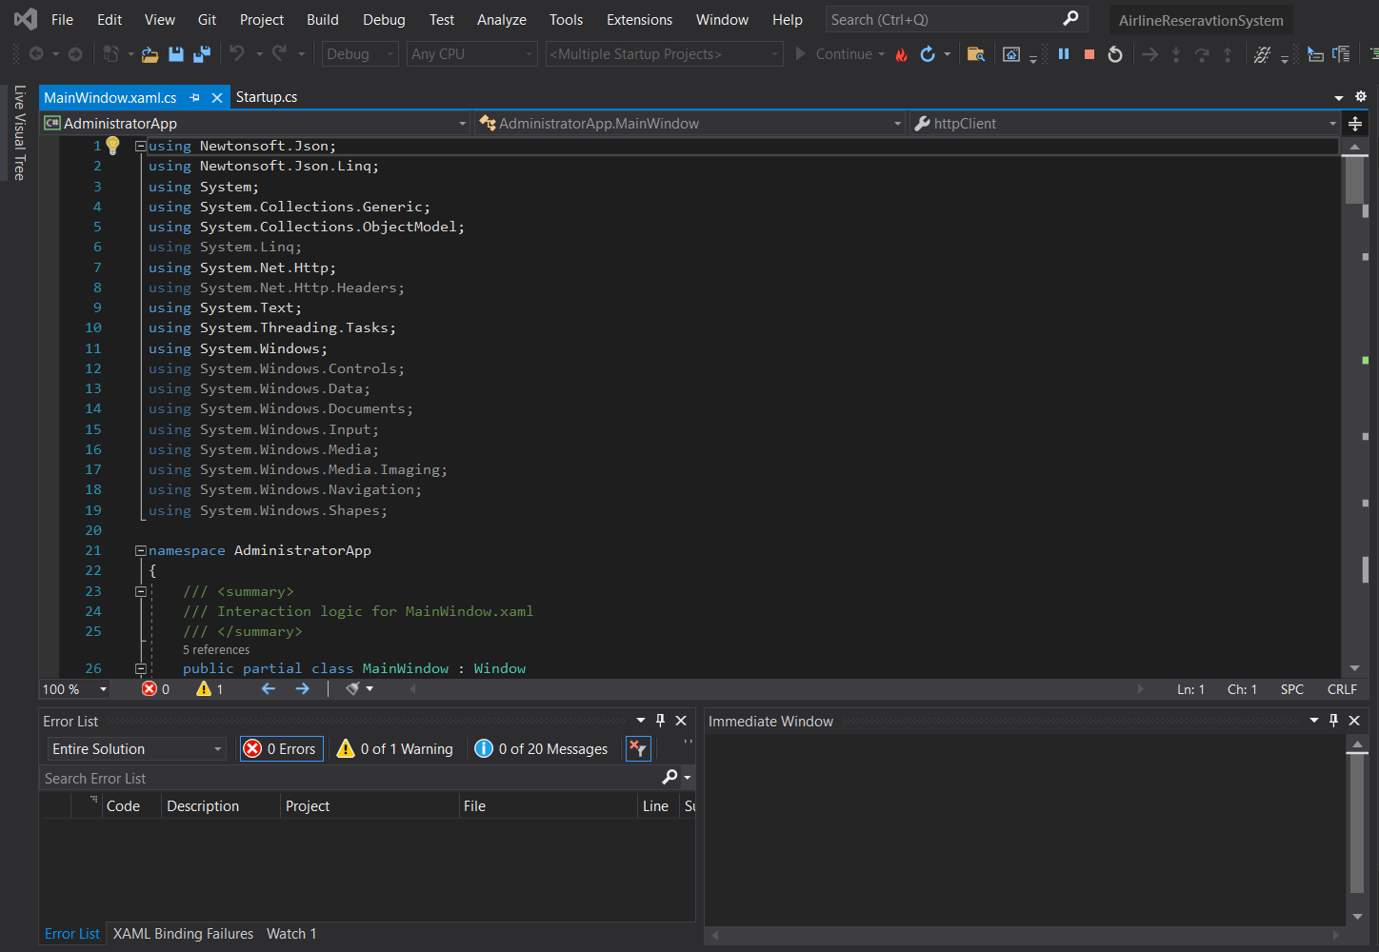

**Figure 1:** Visual Studio

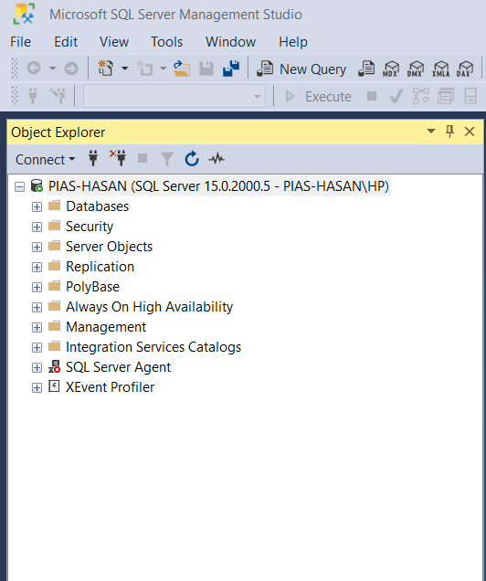

**Figure 2:** Microsoft SQL server

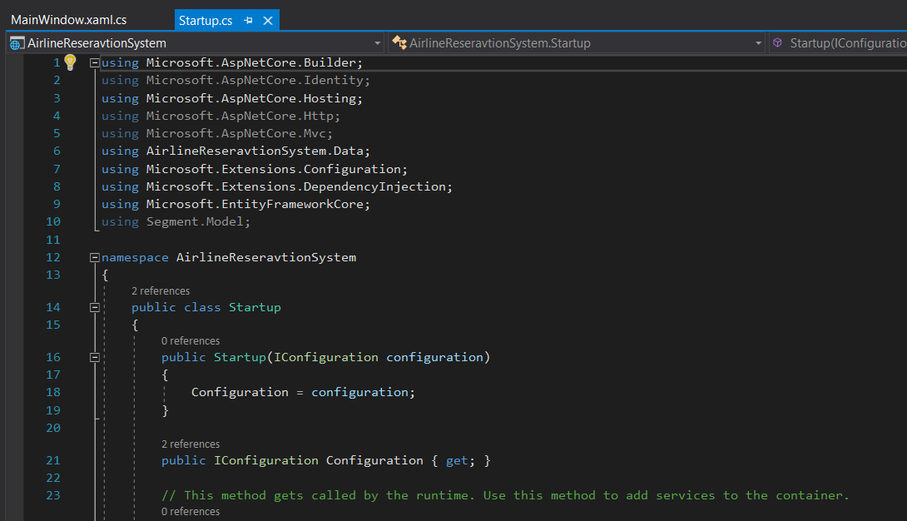

**Figure 3:** C# language

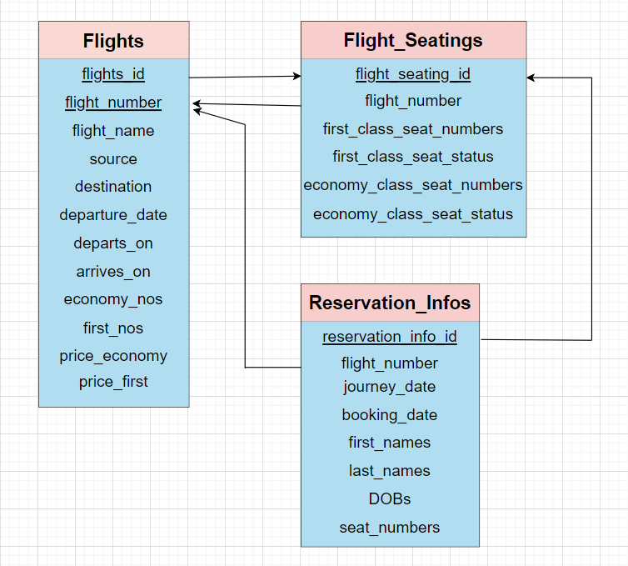

**Figure 4:** Schema diagram

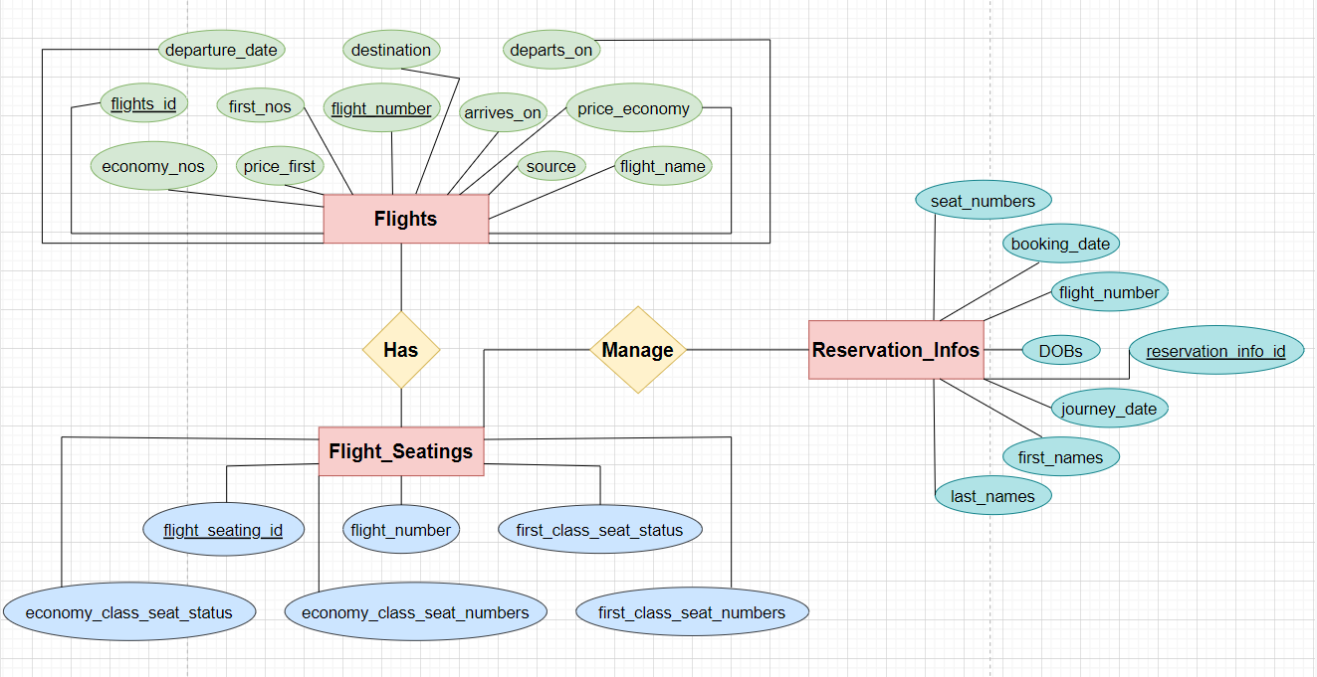

**Figure 5:** E-R diagram

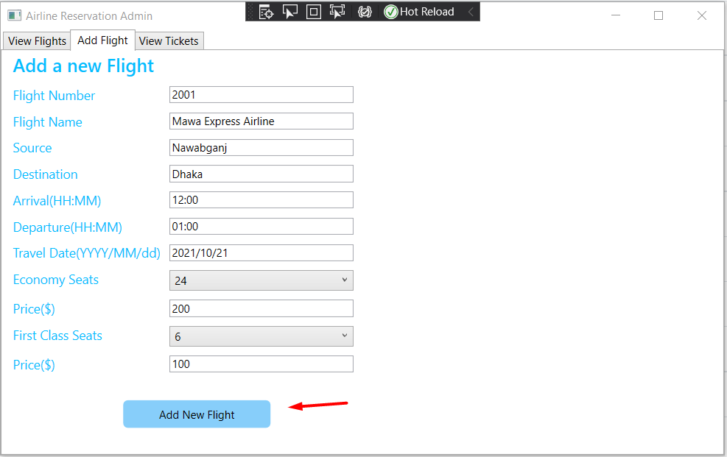

**Figure 6:** Add flights

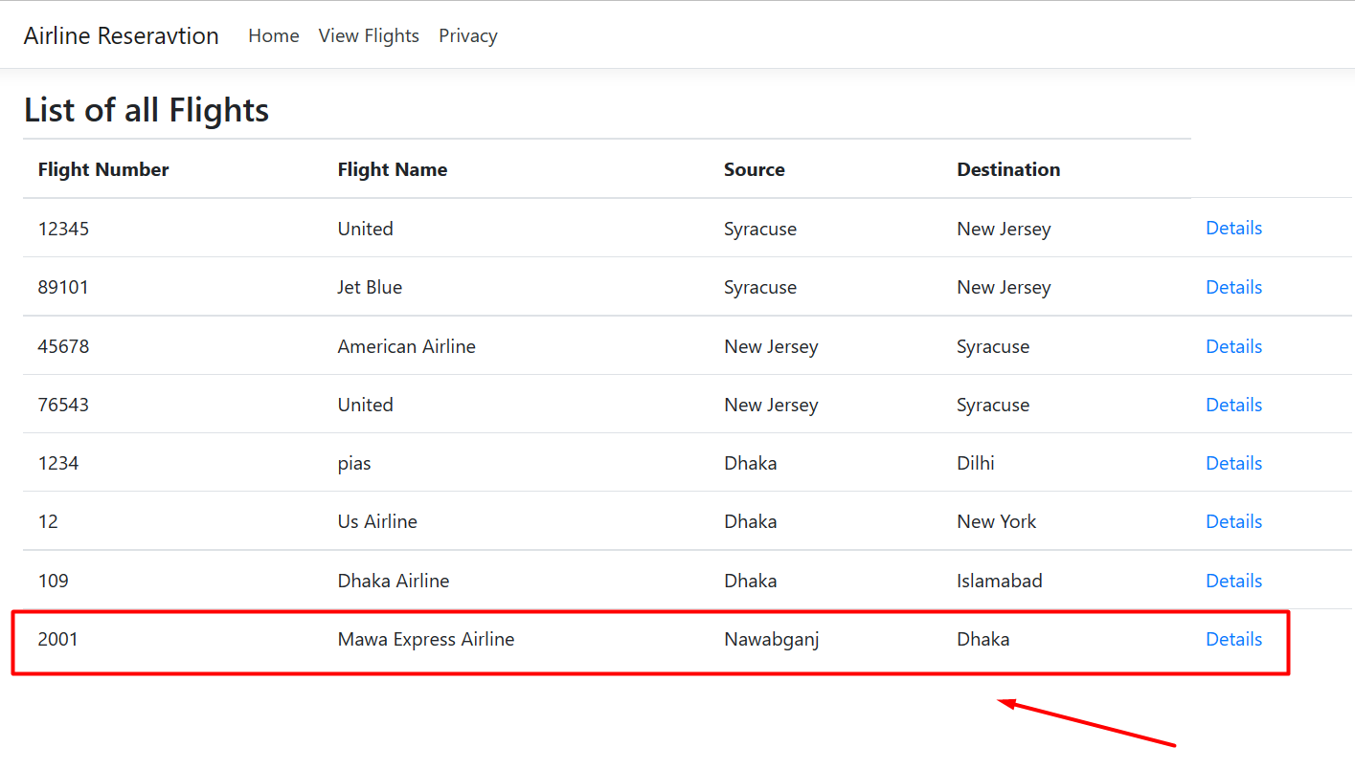

**Figure 7:** List of flights

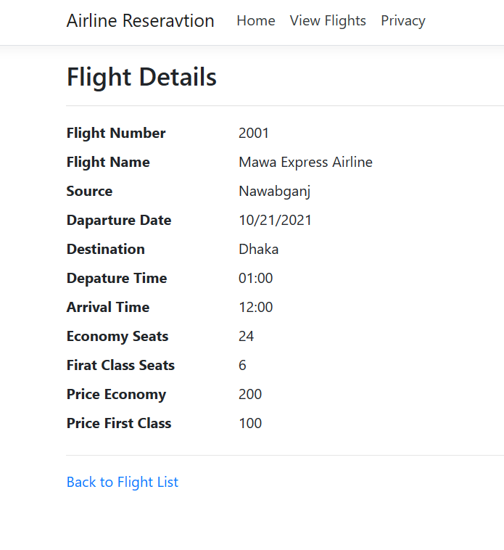

**Figure 8:** Flights details

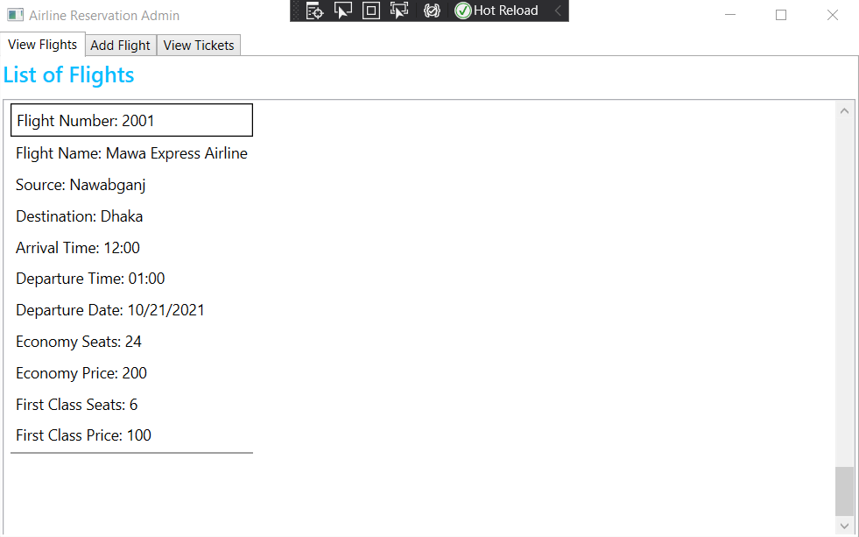

**Figure 9:** View flights with admin view

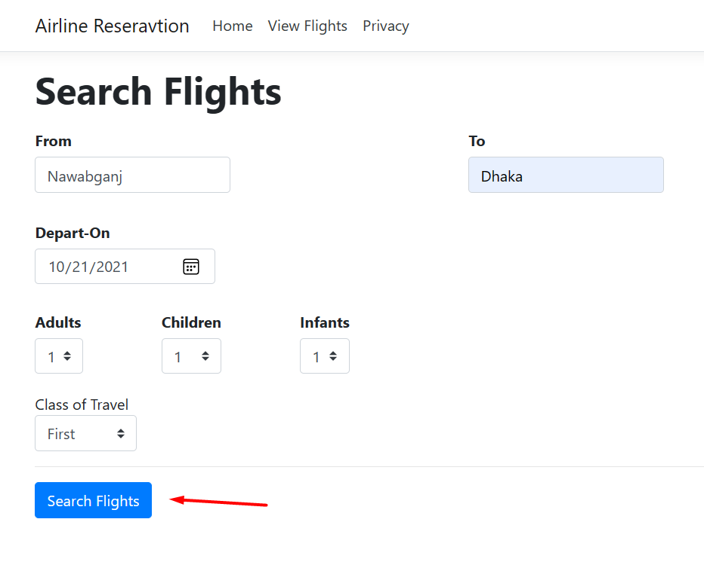

**Figure 10:** Search flights

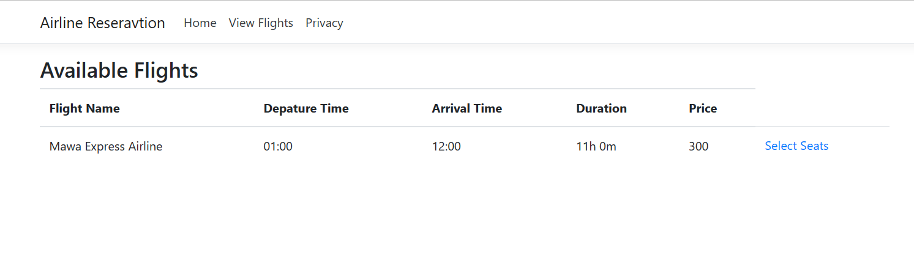

**Figure 11:** Available flights

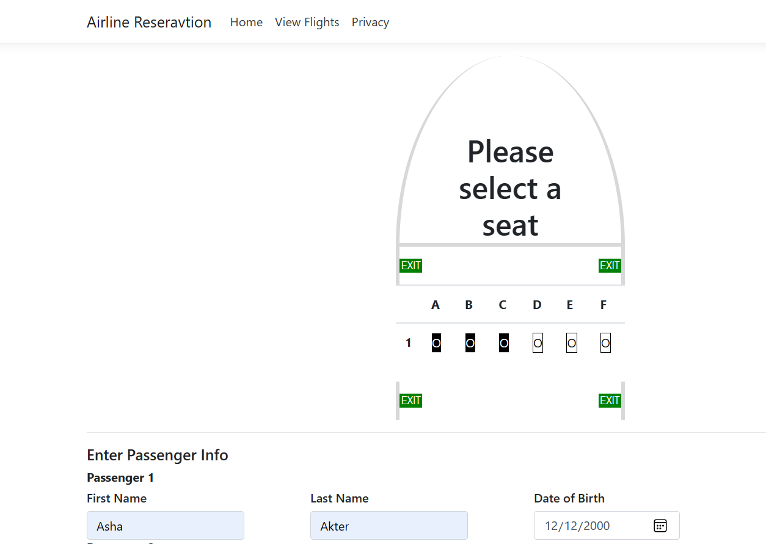

**Figure 12:** Seats selection

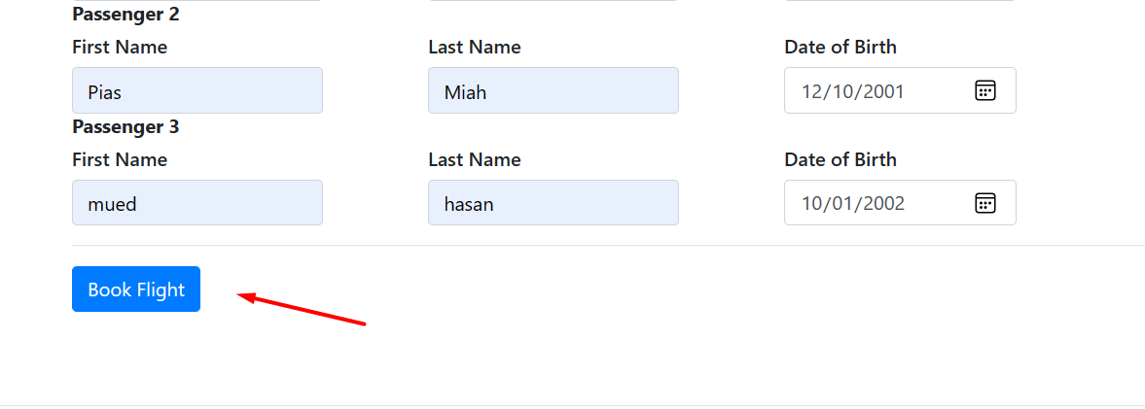

**Figure 12.1:** Seats selection for flight booking

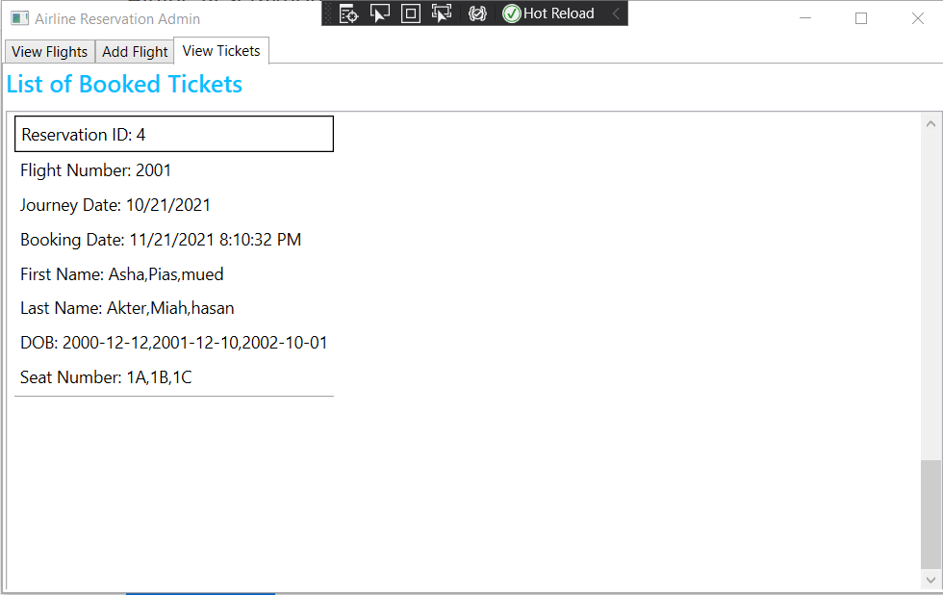

**Figure 13:** View tickets with admin view

After booked flight and tickets which seats are booked then these seats is unavailable to taken. Here 1A, 1B and 1C seats is taken.

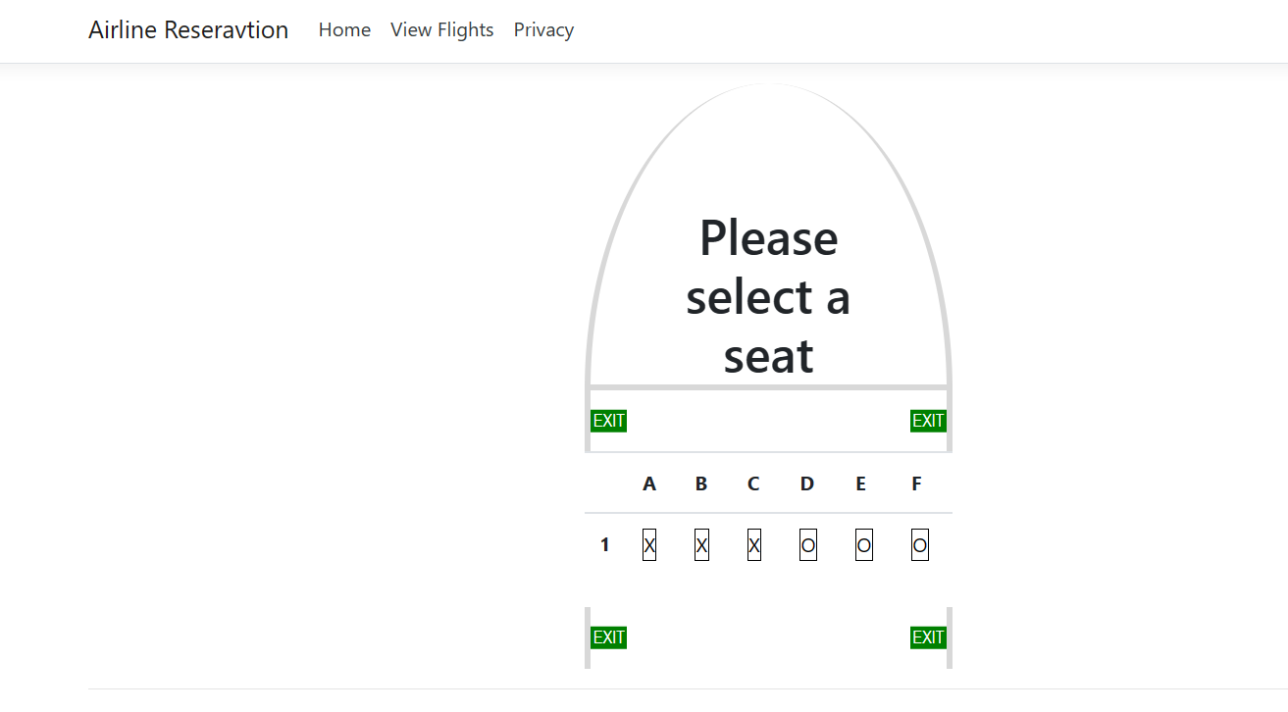

**Figure 14:** Seats taken