Internal Audit Report
Cybersecurity Program Assessment
Alma Security

Report No.: IA-2025-001
Engagement Type: Cybersecurity Program Assessment (NIST CSF 2.0)
Assessment Period: Jan 1, 2026 – Mar 10, 2026
Report Date: March 20, 2026
Classification: Confidential

Prepared For: | Board of Directors and Audit Committee
Prepared By: | Internal Audit Department
Lead Assessor: | John Doe
Quality Reviewer: | Jane Smith
Report Status: | Final

This document is a fictional example created for educational and demonstration purposes only in Simply Cyber Academy, for AKYLADE Cyber Risk Management Practitioner (A/CCRP).
All company names, individuals, findings, scores, and data presented herein are entirely fictitious. This report does not represent an actual audit engagement or reflect the cybersecurity posture of any real organization. It is intended solely to illustrate the format and structure of a NIST CSF 2.0 cybersecurity program assessment report

Table of Contents
Table of Contents 2
1. Independent Assessment Opinion 3
2. Executive Summary 4
Key Results 4
Assessment Rating Summary by Function 4
Top 3 Priority Gaps 4
3. Scope and Methodology 5
Assessment Scope 5
Scoring Framework 5
Methodology 5
4. Overall Maturity Assessment 6
Current Maturity Profile 6
Governance vs Operations Gap Analysis 6
Dashboard Visualizations 6
5. Risk-Rated Findings 8
Finding 1: Change Management Enforcement Gap - 85% Compliance 8
Finding 2: 24/7 SOC Monitoring Coverage Gap 8
Finding 3: Shared Developer SSH Key on Kubernetes Nodes 8
Finding 4: External Attack Surface Monitoring Gap 8
6. Management Response and Action Plans 10
Finding 1: Change Management Enforcement Gap - 85% Compliance (High) 10
Finding 2: 24/7 SOC Monitoring Coverage Gap (High) 10
Finding 3: Shared Developer SSH Key on Kubernetes Nodes (High) 10
Finding 4: External Attack Surface Monitoring Gap (Medium) 10
7. Conclusion 11
Appendix A: CSF Function Scoring Detail 12
Appendix B: Assessment Criteria and Rating Definitions 14
Finding Risk Ratings 14
Function Assessment Ratings 14
Scoring Scale (1-10) 14
Appendix C: Distribution List 15

1. Independent Assessment Opinion
Overall Assessment Rating: UNSATISFACTORY
Based on our assessment of 38 control implementations across all six NIST CSF 2.0 functions, we conclude that Alma Security’s cybersecurity program requires significant improvement to meet target maturity levels. The majority of assessed functions (5 of 6) fall below their target scores, indicating systemic gaps in the cybersecurity program.
Key Statistics:
Controls Assessed: 38
Controls Below Target: 26 of 38
Overall Average Score: 3.2 / 5.0 (target)
Overall Maturity Level: Some Security
Evidence Coverage: 89.5% of controls have linked artifacts

2. Executive Summary

Key Results
Metric | Value
Overall Maturity Score | 3.2 / 10.0 (Some Security)
Controls Meeting Target | 12 of 38 (32%)
Controls Below Target | 26 of 38
Critical Findings | 0
High Findings | 3
Medium Findings | 1
Low Findings | 0
Evidence Coverage | 89.5%

Assessment Rating Summary by Function
Function | Avg Score | Target | Gap | Rating
Govern (GV) | 5.2 | 5.0 | -0.2 | Satisfactory
Identify (ID) | 2.2 | 5.0 | 2.8 | Unsatisfactory
Protect (PR) | 2.8 | 5.0 | 2.3 | Unsatisfactory
Detect (DE) | 2.0 | 5.0 | 3.0 | Unsatisfactory
Respond (RS) | 2.0 | 5.0 | 3.0 | Unsatisfactory
Recover (RC) | 2.0 | 5.0 | 3.0 | Unsatisfactory
Overall | 3.2 | 5.0 | 1.8 | UNSATISFACTORY

Top 3 Priority Gaps
1. ID.RA-07 Ex1 — Gap of 4.0 (Actual: 1.0, Target: 5.0)
2. PR.IR-02 Ex1 — Gap of 4.0 (Actual: 1.0, Target: 5.0)
3. RS.MI-02 Ex2 — Gap of 3.0 (Actual: 2.0, Target: 5.0)

3. Scope and Methodology

Assessment Scope
This assessment evaluated Alma Security’s implementation of the NIST Cybersecurity Framework (CSF) 2.0 across the following functions:
Function | Controls Assessed
Govern (GV) | 12
Identify (ID) | 6
Protect (PR) | 8
Detect (DE) | 8
Respond (RS) | 3
Recover (RC) | 1
Total | 38

Scoring Framework
Controls were evaluated on a 1-10 scale. See Appendix B for full scoring definitions.

Methodology
Assessment procedures included:
Examine: Review of policies, procedures, and technical documentation
Interview: Discussions with control owners and subject matter experts
Test: Technical validation through sampling, inspection, and tool-based verification

4. Overall Maturity Assessment

Current Maturity Profile
The organization’s overall cybersecurity maturity is assessed at Some Security (3.2 / 10.0).
Dimension | Average Score | Maturity Level
Governance (GV) | 5.2 | Minimally Acceptable
Operations (ID, PR, DE, RS, RC) | 2.3 | Some Security
Overall | 3.2 | Some Security

Governance vs Operations Gap Analysis
Governance maturity (5.2) exceeds operational maturity (2.3) by 2.9 points, suggesting that policies and frameworks are more mature than their technical implementation.

Dashboard Visualizations
Function Actual vs Target (Q1)
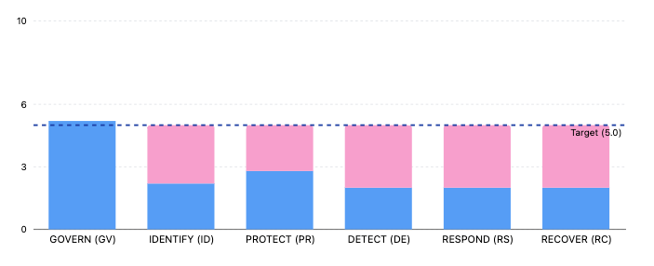
CSF Subcategory Radar (Q1)
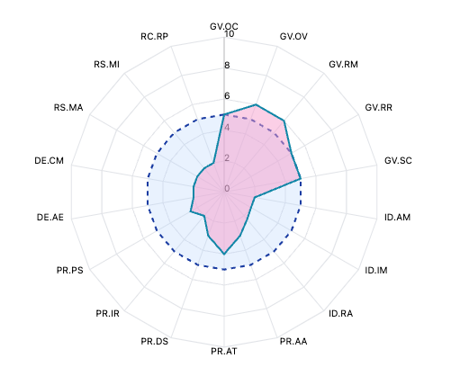
Score Trends by Quarter
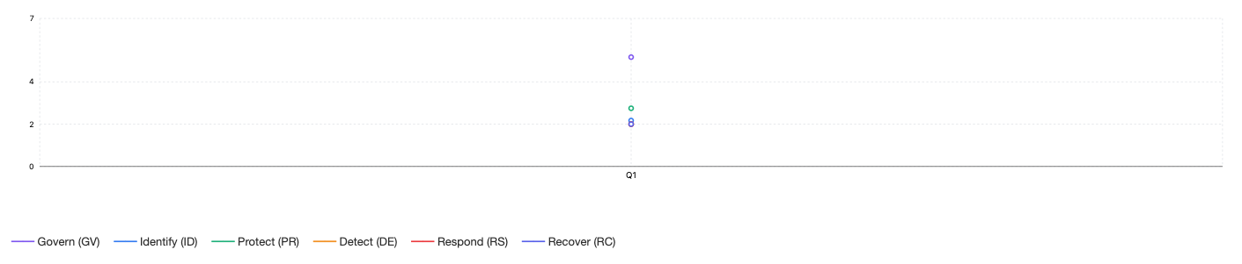

5. Risk-Rated Findings
A total of 4 findings were identified during the assessment.

Finding 1: Change Management Enforcement Gap - 85% Compliance
Risk Rating: High
Affected Controls: DE.CM-01 Ex1
Condition: Change management policy exists but lacks automated enforcement. Teams have varying levels of training and awareness. Exception documentation process established but not consistently followed.
Recommendation: Implement automated change management enforcement in ServiceNow. Extend mandatory risk impact assessments to all systems (not just crown jewels). Conduct training for all teams on change documentation requirements. Target 95% compliance.

Finding 2: 24/7 SOC Monitoring Coverage Gap
Risk Rating: High
Affected Controls: PR.IR-03 Ex2
Condition: Staffing constraints limit coverage to business hours. Current team of 3 security professionals cannot sustain 24/7 operations. STS1 hiring strategy approved but not yet implemented.
Recommendation: Complete Incident Response Enhancement project deliverables for 24/7 monitoring. Add additional SIEM use cases for non-AWS systems. Implement log analysis automation to reduce manual review burden. Hire additional SOC staff per STS1 strategy.

Finding 3: Shared Developer SSH Key on Kubernetes Nodes
Risk Rating: High
Affected Controls: PR.IR-03 Ex2
Condition: Legacy configuration from early infrastructure setup. Individual key deployment was deprioritized during rapid growth phase. SentinelOne application control deployed on workstations but server-side controls still being expanded.
Recommendation: Remediate shared developer SSH key on Kubernetes nodes - issue individual keys per developer. Expand server-side application control deployment. Complete app control policy exception review.

Finding 4: External Attack Surface Monitoring Gap
Risk Rating: Medium
Affected Controls: PR.IR-03 Ex2
Condition: ASM vendor selection was delayed due to budget constraints. Risk register item R2 identifies this as a known gap. DNS/BGP monitoring operational but external asset discovery limited.
Recommendation: Complete ASM solution deployment and integration. Expand DNS/BGP monitoring coverage to all network segments. Deploy network service monitoring dashboards to SOC. Address R2 risk register item.

6. Management Response and Action Plans

Finding 1: Change Management Enforcement Gap - 85% Compliance (High)
Management Response: Implement automated change management enforcement in ServiceNow. Extend mandatory risk impact assessments to all systems (not just crown jewels). Conduct training for all teams on change documentation requirements. Target 95% compliance.
Status: In Progress
Planned Completion: 2026-09-30

Finding 2: 24/7 SOC Monitoring Coverage Gap (High)
Management Response: Complete Incident Response Enhancement project deliverables for 24/7 monitoring. Add additional SIEM use cases for non-AWS systems. Implement log analysis automation to reduce manual review burden. Hire additional SOC staff per STS1 strategy.
Status: In Progress
Planned Completion: 2026-08-31

Finding 3: Shared Developer SSH Key on Kubernetes Nodes (High)
Management Response: Remediate shared developer SSH key on Kubernetes nodes - issue individual keys per developer. Expand server-side application control deployment. Complete app control policy exception review.
Status: Not Started
Planned Completion: 2026-08-15

Finding 4: External Attack Surface Monitoring Gap (Medium)
Management Response: Complete ASM solution deployment and integration. Expand DNS/BGP monitoring coverage to all network segments. Deploy network service monitoring dashboards to SOC. Address R2 risk register item.
Status: In Progress
Planned Completion: 2026-08-31

7. Conclusion
This assessment evaluated 38 control implementations across the six NIST CSF 2.0 functions for Alma Security. Of the 38 controls assessed, 12 (32%) meet or exceed target maturity levels, while 26 controls require improvement to reach their target scores.
4 findings were identified, of which 3 are rated Critical or High priority and require immediate management attention.
Management should prioritize remediation of identified findings in accordance with the action plans outlined in Section 6 and monitor progress through the quarterly assessment cycle.

Appendix A: CSF Function Scoring Detail
Govern (GV) — Rating: Satisfactory
Control ID | Q1 Score | Target | Gap
GV.OC-01 Ex1 | 5.0 | 5.0 | 0.0
GV.OC-02 Ex1 | 5.0 | 5.0 | 0.0
GV.OV-01 Ex2 | 6.0 | 5.0 | -1.0
GV.RM-01 Ex2 | 6.0 | 5.0 | -1.0
GV.RR-01 Ex4 | 5.0 | 5.0 | 0.0
GV.RR-02 Ex1 | 5.0 | 5.0 | 0.0
GV.SC-01 Ex3 | 5.0 | 5.0 | 0.0
GV.SC-02 Ex7 | 5.0 | 5.0 | 0.0
GV.SC-04 Ex1 | 5.0 | 5.0 | 0.0
GV.SC-06 Ex3 | 5.0 | 5.0 | 0.0
GV.SC-09 Ex5 | 5.0 | 5.0 | 0.0
GV.SC-10 Ex3 | 5.0 | 5.0 | 0.0
Average | 5.2 | 5.0 | -0.2
Identify (ID) — Rating: Unsatisfactory
Control ID | Q1 Score | Target | Gap
ID.AM-02 Ex2 | 2.0 | 5.0 | 3.0
ID.AM-07 Ex3 | 2.0 | 5.0 | 3.0
ID.IM-01 Ex1 | 2.0 | 5.0 | 3.0
ID.RA-01 Ex1 | 3.0 | 5.0 | 2.0
ID.RA-07 Ex1 | 1.0 | 5.0 | 4.0
ID.RA-08 Ex1 | 3.0 | 5.0 | 2.0
Average | 2.2 | 5.0 | 2.8
Protect (PR) — Rating: Unsatisfactory
Control ID | Q1 Score | Target | Gap
PR.AA-02 Ex2 | 3.0 | 5.0 | 2.0
PR.AT-01 Ex2 | 4.0 | 5.0 | 1.0
PR.DS-01 Ex4 | 3.0 | 5.0 | 2.0
PR.DS-10 Ex1 | 3.0 | 5.0 | 2.0
PR.IR-02 Ex1 | 1.0 | 5.0 | 4.0
PR.IR-03 Ex3 | 3.0 | 5.0 | 2.0
PR.PS-01 Ex1 | 3.0 | 5.0 | 2.0
PR.PS-05 Ex1 | 2.0 | 5.0 | 3.0
Average | 2.8 | 5.0 | 2.3
Detect (DE) — Rating: Unsatisfactory
Control ID | Q1 Score | Target | Gap
DE.AE-02 Ex1 | 2.0 | 5.0 | 3.0
DE.AE-02 Ex3 | 2.0 | 5.0 | 3.0
DE.AE-03 Ex2 | 2.0 | 5.0 | 3.0
DE.AE-06 Ex1 | 2.0 | 5.0 | 3.0
DE.AE-08 Ex1 | 2.0 | 5.0 | 3.0
DE.CM-01 Ex1 | 2.0 | 5.0 | 3.0
DE.CM-03 Ex2 | 2.0 | 5.0 | 3.0
DE.CM-09 Ex1 | 2.0 | 5.0 | 3.0
Average | 2.0 | 5.0 | 3.0
Respond (RS) — Rating: Unsatisfactory
Control ID | Q1 Score | Target | Gap
RS.MA-03 Ex2 | 2.0 | 5.0 | 3.0
RS.MI-01 Ex1 | 2.0 | 5.0 | 3.0
RS.MI-02 Ex2 | 2.0 | 5.0 | 3.0
Average | 2.0 | 5.0 | 3.0
Recover (RC) — Rating: Unsatisfactory
Control ID | Q1 Score | Target | Gap
RC.RP-03 Ex1 | 2.0 | 5.0 | 3.0
Average | 2.0 | 5.0 | 3.0

Appendix B: Assessment Criteria and Rating Definitions

Finding Risk Ratings
Rating | Definition
Critical | Immediate risk to the organization requiring urgent remediation. Significant control failures or gaps that could lead to material security incidents.
High | Significant risk requiring prompt remediation. Control deficiencies that materially reduce the effectiveness of the cybersecurity program.
Medium | Moderate risk requiring planned remediation. Control gaps that may reduce program effectiveness if not addressed within a reasonable timeframe.
Low | Minor risk for inclusion in ongoing improvement plans. Opportunities to enhance controls beyond current baseline requirements.

Function Assessment Ratings
Rating | Criteria
Satisfactory | Function average score meets or exceeds the target score. Controls are operating effectively.
Needs Improvement | Function average score is at least 70% of the target but below full target. Controls are partially effective with identified gaps.
Unsatisfactory | Function average score is below 70% of the target. Controls have significant deficiencies requiring immediate attention.

Scoring Scale (1-10)
Score | Level | How Secure?
0 - 1.9 | Insecurity | Organization rarely or never does this. Not enough security.
2.0 - 4.9 | Some Security | Organization sometimes does this, but unreliably. Rework is common.
5.0 - 5.9 | Minimally Acceptable | Organization does this consistently, with some minor flaws. Just right.
6.1 - 6.9 | Optimized | Organization does this consistently, with great effectiveness. Just right.
7.0 - 7.9 | Fully Optimized | Organization does this consistently, with fully optimized quality. Just right.
8.1 - 10.0 | Too Much Security | Organization does this at excessive financial cost. People can’t easily get work done.

Appendix C: Distribution List
Role | Name
Prepared For | Board of Directors and Audit Committee
Prepared By | Internal Audit Department
Lead Assessor | John Doe
Quality Reviewer | Jane Smith

This report was generated from the NIST CSF 2.0 Profile Assessment Database.
Confidential — Distribution restricted to authorized recipients.

