Sources

Source code and project log files



CodeNoob Ascend

CAtalogs

Site source file links 3

Project record file links 3

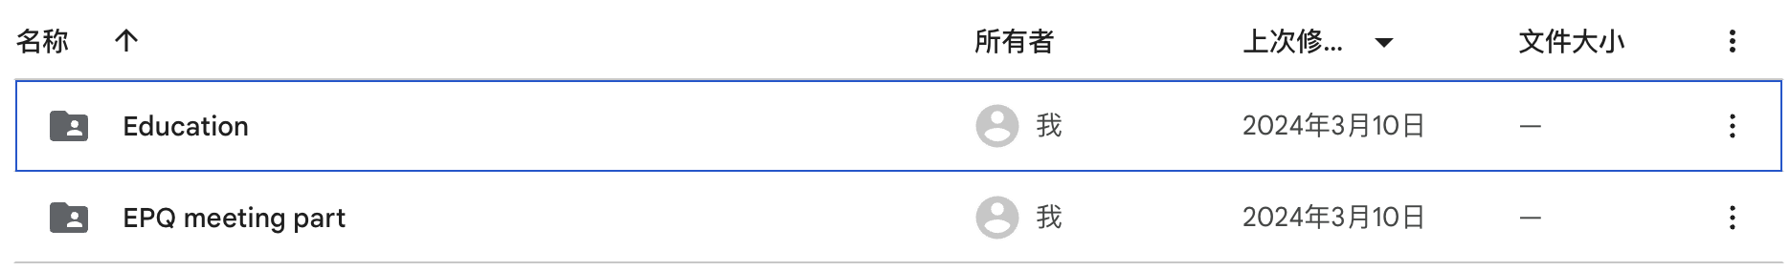

**Website source code:**

<https://drive.google.com/drive/folders/1VyZruUDoeOBpSaqAtGcfzqMKPaV7Wa0S?usp=drive_link>

**Meeting content preparation:**

<https://drive.google.com/drive/folders/1IXr3mQJtImw_tz4YTyAnEYd3s3mAVB0r?usp=drive_link>

*(Note: File names ending in ".key" may be Keynote for Apple systems, other systems may not be able to open properly!)*