**Homework 1 590610644**

require(ggplot2)

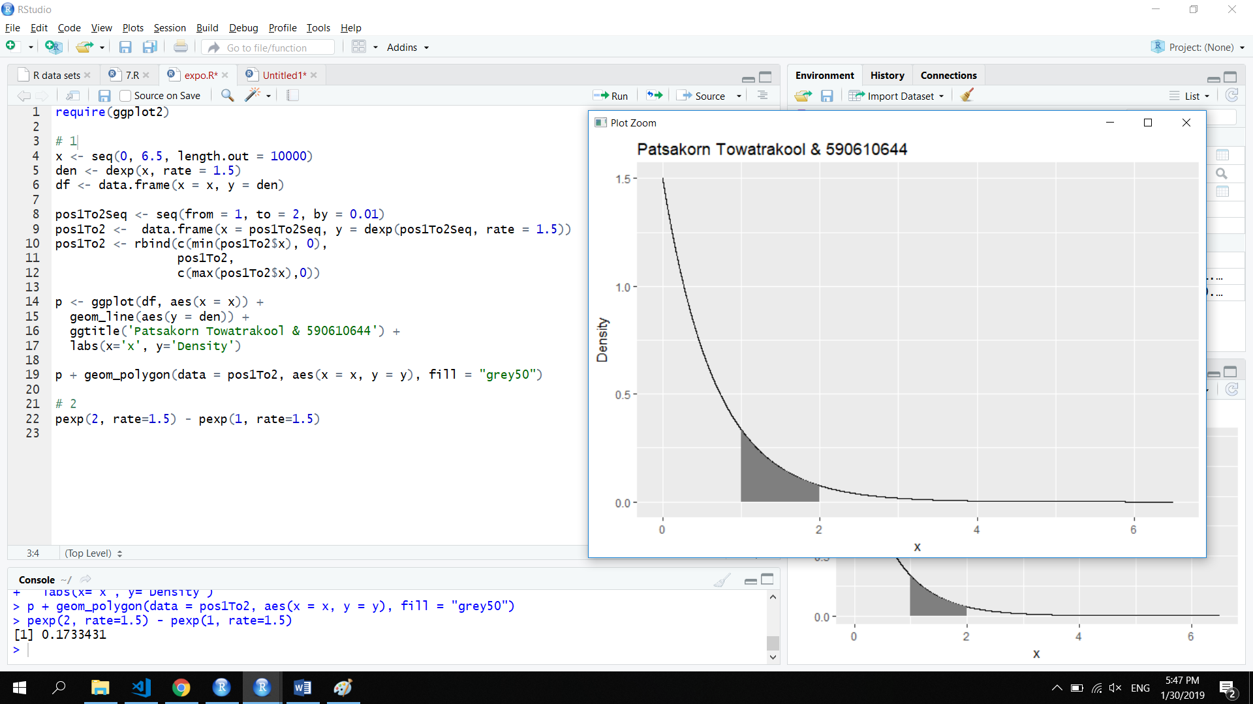# 1

x <- seq(0, 6.5, length.out = 10000)

den <- dexp(x, rate = 1.5)

df <- data.frame(x = x, y = den)

pos1To2Seq <- seq(from = 1, to = 2, by = 0.01)

pos1To2 <- data.frame(x = pos1To2Seq,

y = dexp(pos1To2Seq, rate = 1.5))

pos1To2 <- rbind(c(min(pos1To2$x), 0),

pos1To2,

c(max(pos1To2$x),0))

p <- ggplot(df, aes(x = x)) +

geom_line(aes(y = den)) +

ggtitle('Patsakorn Towatrakool & 590610644') +

labs(x='x', y='Density')

p + geom_polygon(data = pos1To2, aes(x = x, y = y), fill = "grey50")



# 2

pexp(2, rate=1.5) - pexp(1, rate=1.5)

