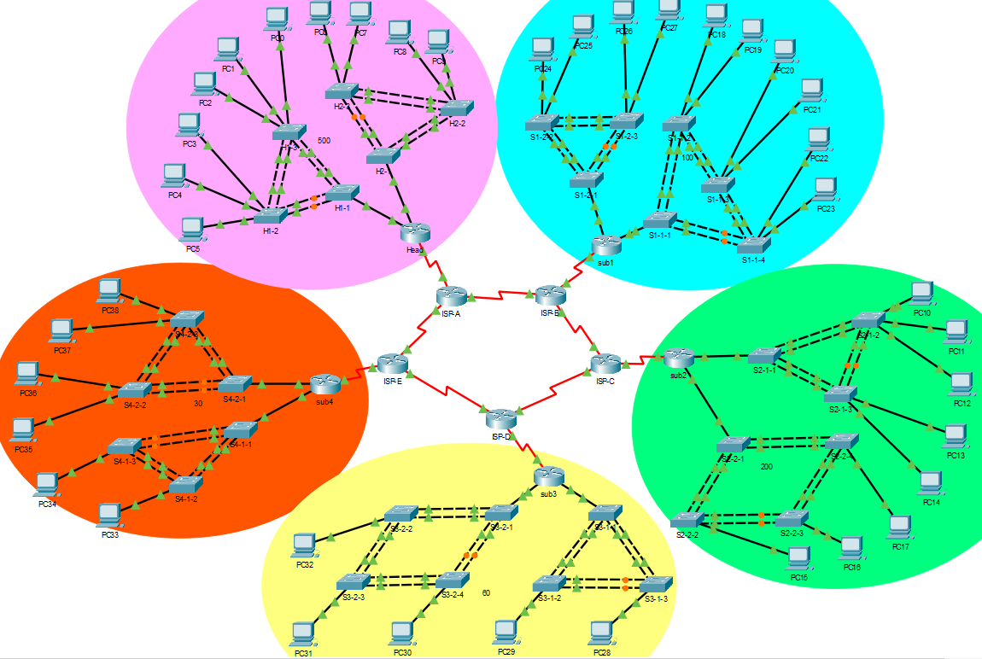

|  |  |  |  |  |
| --- | --- | --- | --- | --- |
| **Device** | **Interface** | **IP Address** | **Subnet Mask** | **Default Gateway** |
| ISP-A | s0/0/0 | 209.165.200.2 | 255.255.255.252 | - |
|  | s0/0/1 (DCE) | 209.165.200.5 | 255.255.255.252 | - |
|  | s0/1/0 | 209.165.200.21 | 255.255.255.252 | - |
| ISP-B | s0/0/0 | 209.165.200.6 | 255.255.255.252 | - |
|  | s0/0/1 (DCE) | 209.165.200.9 | 255.255.255.252 | - |
|  | g0/1/0 | 209.165.200.25 | 255.255.255.252 | - |
| ISP-C | s0/0/0 | 209.165.200.10 | 255.255.255.252 | - |
|  | s0/0/1 (DCE) | 209.165.200.13 | 255.255.255.252 | - |
|  | s0/1/0 | 209.165.200.29 | 255.255.255.252 | - |
| ISP-D | s0/0/0 | 209.165.200.14 | 255.255.255.252 | - |
|  | s0/0/1 (DCE) | 209.165.200.17 | 255.255.255.252 | - |
|  | s0/1/0 | 209.165.200.33 | 255.255.255.252 | - |
| ISP-E | s0/0/0 (DCE) | 209.165.200.1 | 255.255.255.252 | - |
|  | s0/0/1 | 209.165.200.18 | 255.255.255.252 | - |
|  | s0/1/0 | 209.165.200.37 | 255.255.255.252 | - |

|  |  |  |  |  |
| --- | --- | --- | --- | --- |
| **Device** | **Interface** | **IP Address** | **Subnet Mask** | **Default Gateway** |
| Head | s0/1/0 | 209.165.200.22 | 255.255.255.252 | - |
|  | g0/0.10 | 192.168.0.1 | 255.255.252.0 | - |
|  | g0/0.20 | 192.168.4.1 | 255.255.252.0 | - |
|  | g0/1.30 | 192.168.8.1 | 255.255.252.0 | - |
|  | g0/1.40 | 192.168.12.1 | 255.255.252.0 | - |
| PC0 | Fa0 | 192.168.0.3 | 255.255.252.0 | 192.168.0.1 |
| PC1 | Fa0 | 192.168.0.6 | 255.255.252.0 | 192.168.0.1 |
| PC2 | Fa0 | 192.168.0.9 | 255.255.252.0 | 192.168.0.1 |
| PC3 | Fa0 | 192.168.4.3 | 255.255.252.0 | 192.168.4.1 |
| PC4 | Fa0 | 192.168.4.6 | 255.255.252.0 | 192.168.4.1 |
| PC5 | Fa0 | 192.168.4.9 | 255.255.252.0 | 192.168.4.1 |
| PC6 | Fa0 | 192.168.8.5 | 255.255.252.0 | 192.168.8.1 |
| PC7 | Fa0 | 192.168.8.10 | 255.255.252.0 | 192.168.8.1 |
| PC8 | Fa0 | 192.168.12.5 | 255.255.252.0 | 192.168.12.1 |
| PC9 | Fa0 | 192.168.12.10 | 255.255.252.0 | 192.168.12.1 |

|  |  |  |  |  |
| --- | --- | --- | --- | --- |
| **Device** | **Interface** | **IP Address** | **Subnet Mask** | **Default Gateway** |
| sub1 | s0/1/0 | 209.165.200.26 | 255.255.255.252 | - |
|  | g0/0.40 | 192.168.32.1 | 255.255.255.128 | - |
|  | g0/0.50 | 192.168.34.1 | 255.255.255.128 | - |
|  | g0/1.10 | 192.168.26.1 | 255.255.255.128 | - |
|  | g0/1.20 | 192.168.28.1 | 255.255.255.128 | - |
|  | g0/1.30 | 192.168.30.1 | 255.255.255.128 | - |
| PC18 | Fa0 | 192.168.26.5 | 255.255.255.128 | 192.168.26.1 |
| PC19 | Fa0 | 192.168.26.10 | 255.255.255.128 | 192.168.26.1 |
| PC20 | Fa0 | 192.168.28.5 | 255.255.255.128 | 192.168.28.1 |
| PC21 | Fa0 | 192.168.28.10 | 255.255.255.128 | 192.168.28.1 |
| PC22 | Fa0 | 192.168.30.5 | 255.255.255.128 | 192.168.30.1 |
| PC23 | Fa0 | 192.168.30.10 | 255.255.255.128 | 192.168.30.1 |
| PC24 | Fa0 | 192.168.32.5 | 255.255.255.128 | 192.168.32.1 |
| PC25 | Fa0 | 192.168.32.10 | 255.255.255.128 | 192.168.32.1 |
| PC26 | Fa0 | 192.168.34.5 | 255.255.255.128 | 192.168.34.1 |
| PC27 | Fa0 | 192.168.34.10 | 255.255.255.128 | 192.168.34.1 |

|  |  |  |  |  |
| --- | --- | --- | --- | --- |
| **Device** | **Interface** | **IP Address** | **Subnet Mask** | **Default Gateway** |
| Sub2 | s0/1/0 | 209.165.200.30 | 255.255.255.252 | - |
|  | g0/0.10 | 192.168.16.1 | 255.255.255.254 | - |
|  | g0/0.20 | 192.168.18.1 | 255.255.255.254 | - |
|  | g0/1.30 | 192.168.20.1 | 255.255.255.254 | - |
|  | g0/1.40 | 192.168.22.1 | 255.255.255.254 | - |
|  | g0/1.50 | 192.168.24.1 | 255.255.255.254 | - |
| PC10 | Fa0 | 192.168.16.3 | 255.255.255.254 | 192.168.16.1 |
| PC11 | Fa0 | 192.168.16.6 | 255.255.255.254 | 192.168.16.1 |
| PC12 | Fa0 | 192.168.16.9 | 255.255.255.254 | 192.168.16.1 |
| PC13 | Fa0 | 192.168.18.5 | 255.255.255.254 | 192.168.18.1 |
| PC14 | Fa0 | 192.168.18.10 | 255.255.255.254 | 192.168.18.1 |
| PC15 | Fa0 | 192.168.20.10 | 255.255.255.254 | 192.168.20.1 |
| PC16 | Fa0 | 192.168.22.10 | 255.255.255.254 | 192.168.22.1 |
| PC17 | Fa0 | 192.168.24.10 | 255.255.255.254 | 192.168.24.1 |

|  |  |  |  |  |
| --- | --- | --- | --- | --- |
| **Device** | **Interface** | **IP Address** | **Subnet Mask** | **Default Gateway** |
| Sub3 | s0/1/0 | 209.165.200.34 | 255.255.255.252 | - |
|  | g0/0.30 | 192.168.36.1 | 255.255.255.192 | - |
|  | g0/0.40 | 192.168.38.1 | 255.255.255.192 | - |
|  | g0/0.50 | 192.168.40.1 | 255.255.255.192 | - |
|  | g0/1.10 | 192.168.42.1 | 255.255.255.192 | - |
|  | g0/1.20 | 192.168.44.1 | 255.255.255.192 | - |
| PC28 | Fa0 | 192.168.36.10 | 255.255.255.192 | 192.168.36.1 |
| PC29 | Fa0 | 192.168.38.10 | 255.255.255.192 | 192.168.38.1 |
| PC30 | Fa0 | 192.168.40.10 | 255.255.255.192 | 192.168.40.1 |
| PC31 | Fa0 | 192.168.42.10 | 255.255.255.192 | 192.168.42.1 |
| PC32 | Fa0 | 192.168.44.10 | 255.255.255.192 | 192.168.44.1 |

|  |  |  |  |  |
| --- | --- | --- | --- | --- |
| **Device** | **Interface** | **IP Address** | **Subnet Mask** | **Default Gateway** |
| Sub4 | s0/1/0 | 209.165.200.38 | 255.255.255.252 | - |
|  | g0/0.10 | 172.16.1.1 | 255.255.255.192 | - |
|  | g0/0.20 | 172.16.2.1 | 255.255.255.192 | - |
|  | g0/1.30 | 172.16.3.1 | 255.255.255.192 | - |
|  | g0/1.40 | 172.16.4.1 | 255.255.255.192 | - |
| PC33 | Fa0 | 172.16.1.10 | 255.255.255.192 | 172.16.1.1 |
| PC34 | Fa0 | 172.16.2.10 | 255.255.255.192 | 172.16.2.1 |
| PC35 | Fa0 | 172.16.3.5 | 255.255.255.192 | 172.16.3.1 |
| PC36 | Fa0 | 172.16.3.10 | 255.255.255.192 | 172.16.3.1 |
| PC37 | Fa0 | 172.16.4.5 | 255.255.255.192 | 172.16.4.1 |
| PC38 | Fa0 | 172.16.4.10 | 255.255.255.192 | 172.16.4.1 |