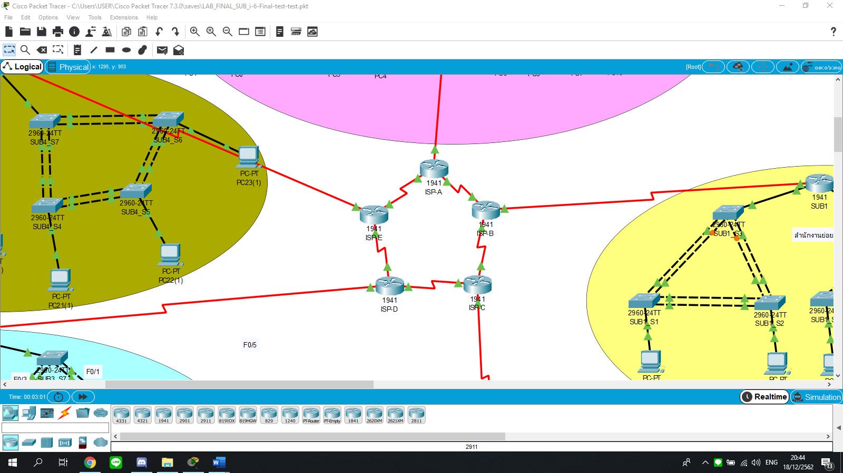

|  |  |  |  |  |
| --- | --- | --- | --- | --- |
| Device | Interface | IP Address | Subnet Mask | Default Gateway |
| ISP-A | S0/0/0 (DCE) | 209.165.200.1 | 255.255.255.252 | N/A |
|  | S0/0/1 | 209.165.200.18 | 255.255.255.252 | N/A |
|  | S0/1/0 (DCE) | 209.165.201.17 | 255.255.255.252 | N/A |
| ISP-B | S0/0/0 (DCE) | 209.165.200.2 | 255.255.255.252 | N/A |
|  | S0/0/1 | 209.165.200.5 | 255.255.255.252 | N/A |
|  | S0/1/0 (DCE) | 209.165.201.21 | 255.255.255.252 | N/A |
| ISP-C | S0/0/0 (DCE) | 209.165.200.1 | 255.255.255.252 | N/A |
|  | S0/0/1 | 209.165.200.18 | 255.255.255.252 | N/A |
|  | S0/1/0 (DCE) | 209.165.201.17 | 255.255.255.252 | N/A |
| ISP-C | S0/0/0 (DCE) | 209.165.200.9 | 255.255.255.252 | N/A |
|  | S0/0/1 | 209.165.200.6 | 255.255.255.252 | N/A |
|  | S0/1/0 (DCE) | 209.165.201.25 | 255.255.255.252 | N/A |
| ISP-D | S0/0/0 (DCE) | 209.165.200.10 | 255.255.255.252 | N/A |
|  | S0/0/1 | 209.165.200.13 | 255.255.255.252 | N/A |
|  | S0/1/0 (DCE) | 209.165.201.29 | 255.255.255.252 | N/A |
| ISP-E | S0/0/0 (DCE) | 209.165.200.17 | 255.255.255.252 | N/A |
|  | S0/0/1 | 209.165.200.14 | 255.255.255.252 | N/A |
|  | S0/1/0 (DCE) | 209.165.201.33 | 255.255.255.252 | N/A |

1. ISP Addressing Table

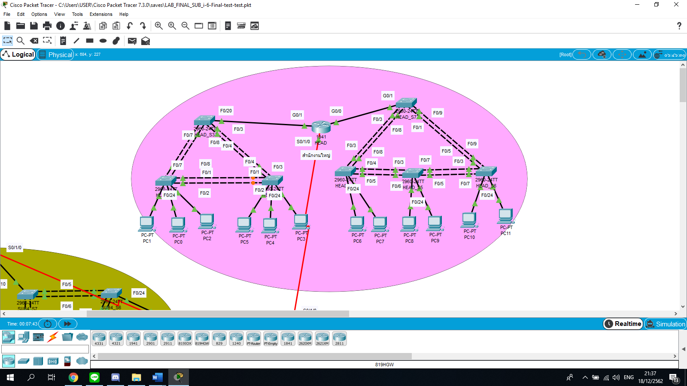

1. HEAD QUATER Addressing Table

|  |  |  |  |  |
| --- | --- | --- | --- | --- |
| Device | Interface | IP Address | Subnet Mask | Default Gateway |
| HEAD | G0/0 | 192.168.100.101 | 255.255.255.252 | N/A |
|  | G0/0.30 | 192.168.8.1 | 255.255.255.0 | N/A |
|  | G0/0.40 | 192.168.12.1 | 255.255.255.0 | N/A |
|  | G0/0.50 | 192.168.16.1 | 255.255.255.0 | N/A |
|  | G0/1 | 192.168.101.101 | 255.255.255.0 | N/A |
|  | G0/1.10 | 192.168.0.1 | 255.255.252.0 | N/A |
|  | G0/1.20 | 192.168.4.1 | 255.255.252.0 | N/A |
|  | Tunnel1 | 12.12.12.1 | 255.255.255.252 | N/A |
|  | Tunnel2 | 13.13.13.1 | 255.255.255.252 | N/A |
|  | S0/1/0 | 209.165.201.18 | 255.255.255.252 | N/A |
| HEAD_S1 | VLAN10 | - | - | N/A |
|  | VLAN20 | - | - | N/A |
| HEAD_S2 | VLAN10 | - | - | N/A |
|  | VLAN20 | - | - | N/A |
| HEAD_S3 | VLAN10 | - | - | N/A |
|  | VLAN20 | - | - | N/A |
| HEAD_S4 | VLAN30 | - | - | N/A |
|  | VLAN40 | - | - | N/A |
|  | VLAN50 | - | - | N/A |
| HEAD_S5 | VLAN30 | - | - | N/A |
|  | VLAN40 | - | - | N/A |
|  | VLAN50 | - | - | N/A |
| HEAD_S6 | VLAN30 | - | - | N/A |
|  | VLAN40 | - | - | N/A |
|  | VLAN50 | - | - | N/A |
| HEAD_S7 | VLAN30 | - | - | N/A |
|  | VLAN40 | - | - | N/A |
|  | VLAN50 | - | - | N/A |
| PC0 | F0 | 192.168.0.6 | 255.255.252.0 | 192.168.0.1 |
| PC1 | F0 | 192.168.0.7 | 255.255.252.0 | 192.168.0.1 |
| PC2 | F0 | 192.168.0.8 | 255.255.252.0 | 192.168.0.1 |
| PC3 | F0 | 192.168.4.6 | 255.255.252.0 | 192.168.4.1 |
| PC4 | F0 | 192.168.4.7 | 255.255.252.0 | 192.168.4.1 |
| PC5 | F0 | 192.168.4.8 | 255.255.252.0 | 192.168.4.1 |
| PC6 | F0 | 192.168.8.6 | 255.255.255.0 | 192.168.8.1 |
| PC7 | F0 | 192.168.8.7 | 255.255.255.0 | 192.168.8.1 |
| PC8 | F0 | 192.168.12.6 | 255.255.255.0 | 192.168.12.1 |
| PC9 | F0 | 192.168.12.7 | 255.255.255.0 | 192.168.12.1 |
| PC10 | F0 | 192.168.16.6 | 255.255.255.0 | 192.168.16.1 |
| PC11 | F0 | 192.168.16.7 | 255.255.255.0 | 192.168.16.1 |

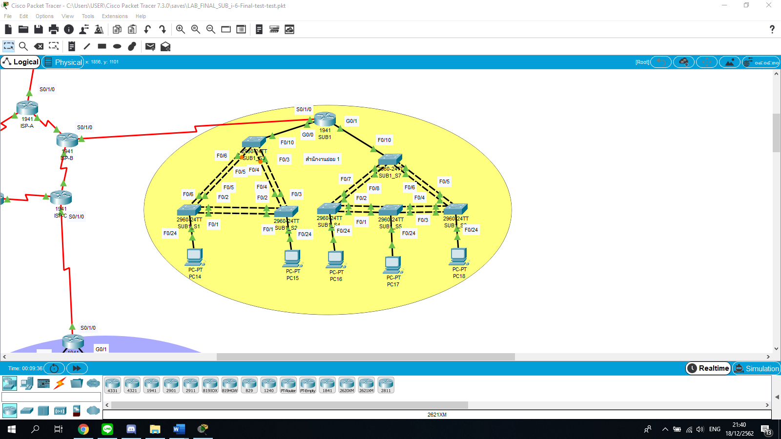

|  |  |  |  |  |
| --- | --- | --- | --- | --- |
| Device | Interface | IP Address | Subnet Mask | Default Gateway |
| SUB1 | G0/0 | 192.168.100.101 | 255.255.255.0 | N/A |
|  | G0/0.10 | 192.168.20.1 | 255.255.255.0 | N/A |
|  | G0/0.20 | 192.168.30.1 | 255.255.255.0 | N/A |
|  | G0/1 | 192.168.101.101 | 255.255.255.0 | N/A |
|  | G0/1.30 | 192.168.40.1 | 255.255.252.128 | N/A |
|  | G0/1.40 | 192.168.50.1 | 255.255.252.128 | N/A |
|  | G0/1.50 | 192.168.60.1 | 255.255.252.128 | N/A |
|  | Tunnel1 | 12.12.12.2 | 255.255.255.252 | N/A |
|  | S0/1/0 | 209.165.201.22 | 255.255.255.252 | N/A |
| SUB1_S1 | VLAN10 | - | - | N/A |
|  | VLAN20 | - | - | N/A |
| SUB1_S2 | VLAN10 | - | - | N/A |
|  | VLAN20 | - | - | N/A |
| SUB1_S3 | VLAN10 | - | - | N/A |
|  | VLAN20 | - | - | N/A |
| SUB1_S4 | VLAN30 | - | - | N/A |
|  | VLAN40 | - | - | N/A |
|  | VLAN50 | - | - | N/A |
| SUB1_S5 | VLAN30 | - | - | N/A |
|  | VLAN40 | - | - | N/A |
|  | VLAN50 | - | - | N/A |
| SUB1_S6 | VLAN30 | - | - | N/A |
|  | VLAN40 | - | - | N/A |
|  | VLAN50 | - | - | N/A |
| SUB1_S7 | VLAN30 | - | - | N/A |
|  | VLAN40 | - | - | N/A |
|  | VLAN50 | - | - | N/A |
| PC14 | F0 | 192.168.20.15 | 255.255.255.0 | 192.168.20.1 |
| PC15 | F0 | 192.168.30.15 | 255.255.255.0 | 192.168.30.1 |
| PC16 | F0 | 192.168.40.15 | 255.255.255.128 | 192.168.40.1 |
| PC17 | F0 | 192.168.50.15 | 255.255.255.128 | 192.168.50.1 |
| PC18 | F0 | 192.168.60.15 | 255.255.255.128 | 192.168.60.1 |

1. SUB branch *1* Addressing Table

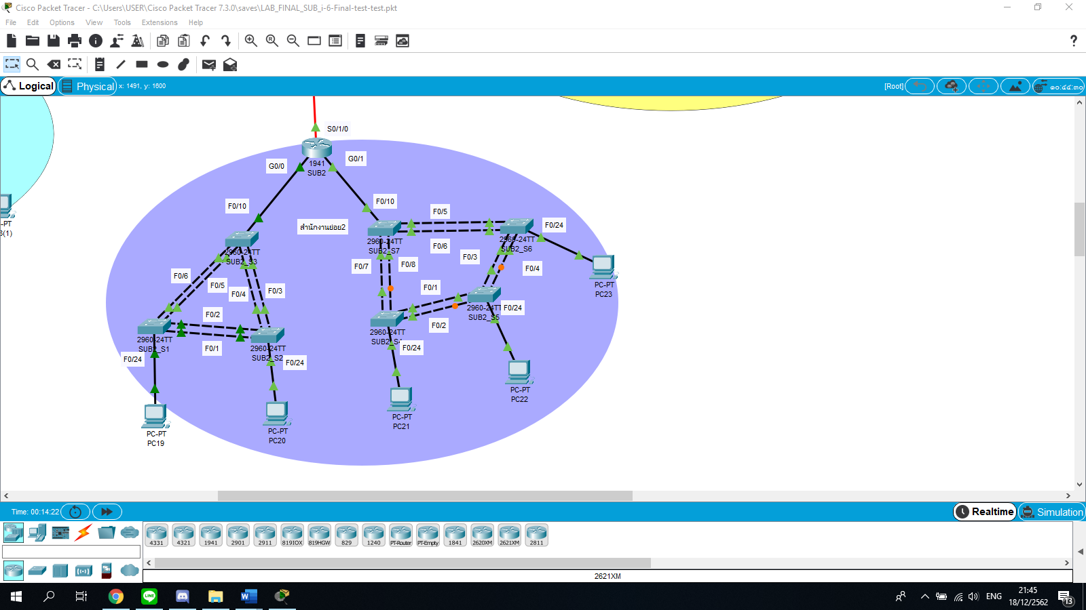

1. SUB branch *2* Addressing Table

|  |  |  |  |  |
| --- | --- | --- | --- | --- |
| Device | Interface | IP Address | Subnet Mask | Default Gateway |
| SUB2 | G0/0 | 192.168.100.101 | 255.255.255.0 | N/A |
|  | G0/0.10 | 192.168.10.1 | 255.255.254.0 | N/A |
|  | G0/0.20 | 192.168.20.1 | 255.255.254.0 | N/A |
|  | G0/1 | 192.168.101.101 | 255.255.255.0 | N/A |
|  | G0/1.30 | 192.168.30.1 | 255.255.255.128 | N/A |
|  | G0/1.40 | 192.168.40.1 | 255.255.255.128 | N/A |
|  | G0/1.50 | 192.168.50.1 | 255.255.255.128 | N/A |
|  | Tunnel2 | 13.13.13.2 | 255.255.255.252 | N/A |
|  | S0/1/0 | 209.165.201.26 | 255.255.255.252 | N/A |
| SUB2_S1 | VLAN10 | - | - | N/A |
|  | VLAN20 | - | - | N/A |
| SUB2_S2 | VLAN10 | - | - | N/A |
|  | VLAN20 | - | - | N/A |
| SUB2_S3 | VLAN10 | - | - | N/A |
|  | VLAN20 | - | - | N/A |
| SUB2_S4 | VLAN30 | - | - | N/A |
|  | VLAN40 | - | - | N/A |
|  | VLAN50 | - | - | N/A |
| SUB2_S5 | VLAN30 | - | - | N/A |
|  | VLAN40 | - | - | N/A |
|  | VLAN50 | - | - | N/A |
| SUB2_S6 | VLAN30 | - | - | N/A |
|  | VLAN40 | - | - | N/A |
|  | VLAN50 | - | - | N/A |
| SUB2_S7 | VLAN30 | - | - | N/A |
|  | VLAN40 | - | - | N/A |
|  | VLAN50 | - | - | N/A |
| PC19 | F0 | 192.168.10.10 | 255.255.254.0 | 192.168.10.1 |
| PC20 | F0 | 192.168.20.10 | 255.255.254.0 | 192.168.20.1 |
| PC21 | F0 | 192.168.30.10 | 255.255.255.128 | 192.168.30.1 |
| PC22 | F0 | 192.168.40.10 | 255.255.255.128 | 192.168.40.1 |
| PC23 | F0 | 192.168.50.10 | 255.255.255.128 | 192.168.50.1 |

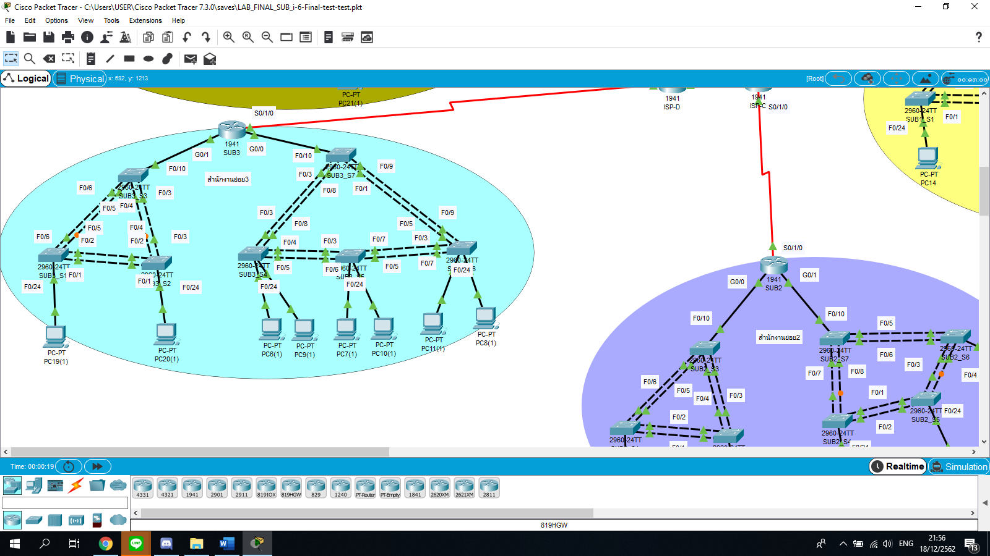

1. SUB branch *3* Addressing Table

|  |  |  |  |  |
| --- | --- | --- | --- | --- |
| Device | Interface | IP Address | Subnet Mask | Default Gateway |
| SUB3 | G0/1 | 192.168.100.101 | 255.255.255.0 | N/A |
|  | G0/1.10 | 192.168.10.1 | 255.255.254.0 | N/A |
|  | G0/1.20 | 192.168.20.1 | 255.255.254.0 | N/A |
|  | G0/0 | 192.168.101.101 | 255.255.255.0 | N/A |
|  | G0/0.30 | 192.168.30.1 | 255.255.255.0 | N/A |
|  | G0/0.40 | 192.168.40.1 | 255.255.255.0 | N/A |
|  | G0/0.50 | 192.168.50.1 | 255.255.255.0 | N/A |
|  | S0/1/0 | 209.165.201.30 | 255.255.255.252 | N/A |
| SUB3_S1 | VLAN10 | - | - | N/A |
|  | VLAN20 | - | - | N/A |
| SUB3_S2 | VLAN10 | - | - | N/A |
|  | VLAN20 | - | - | N/A |
| SUB3_S3 | VLAN10 | - | - | N/A |
|  | VLAN20 | - | - | N/A |
| SUB3_S4 | VLAN30 | - | - | N/A |
|  | VLAN40 | - | - | N/A |
|  | VLAN50 | - | - | N/A |
| SUB3_S5 | VLAN30 | - | - | N/A |
|  | VLAN40 | - | - | N/A |
|  | VLAN50 | - | - | N/A |
| SUB3_S6 | VLAN30 | - | - | N/A |
|  | VLAN40 | - | - | N/A |
|  | VLAN50 | - | - | N/A |
| SUB3_S7 | VLAN30 | - | - | N/A |
|  | VLAN40 | - | - | N/A |
|  | VLAN50 | - | - | N/A |
| PC24 | F0 | 192.168.10.30 | 255.255.254.0 | 192.168.10.1 |
| PC25 | F0 | 192.168.20.30 | 255.255.254.0 | 192.168.20.1 |
| PC26 | F0 | 192.168.30.30 | 255.255.255.128 | 192.168.30.1 |
| PC27 | F0 | 192.168.30.31 | 255.255.255.128 | 192.168.30.1 |
| PC28 | F0 | 192.168.40.30 | 255.255.255.128 | 192.168.40.1 |
| PC29 | F0 | 192.168.40.31 | 255.255.255.128 | 192.168.40.1 |
| PC30 | F0 | 192.168.50.30 | 255.255.255.128 | 192.168.50.1 |
| PC31 | F0 | 192.168.50.31 | 255.255.255.128 | 192.168.50.1 |

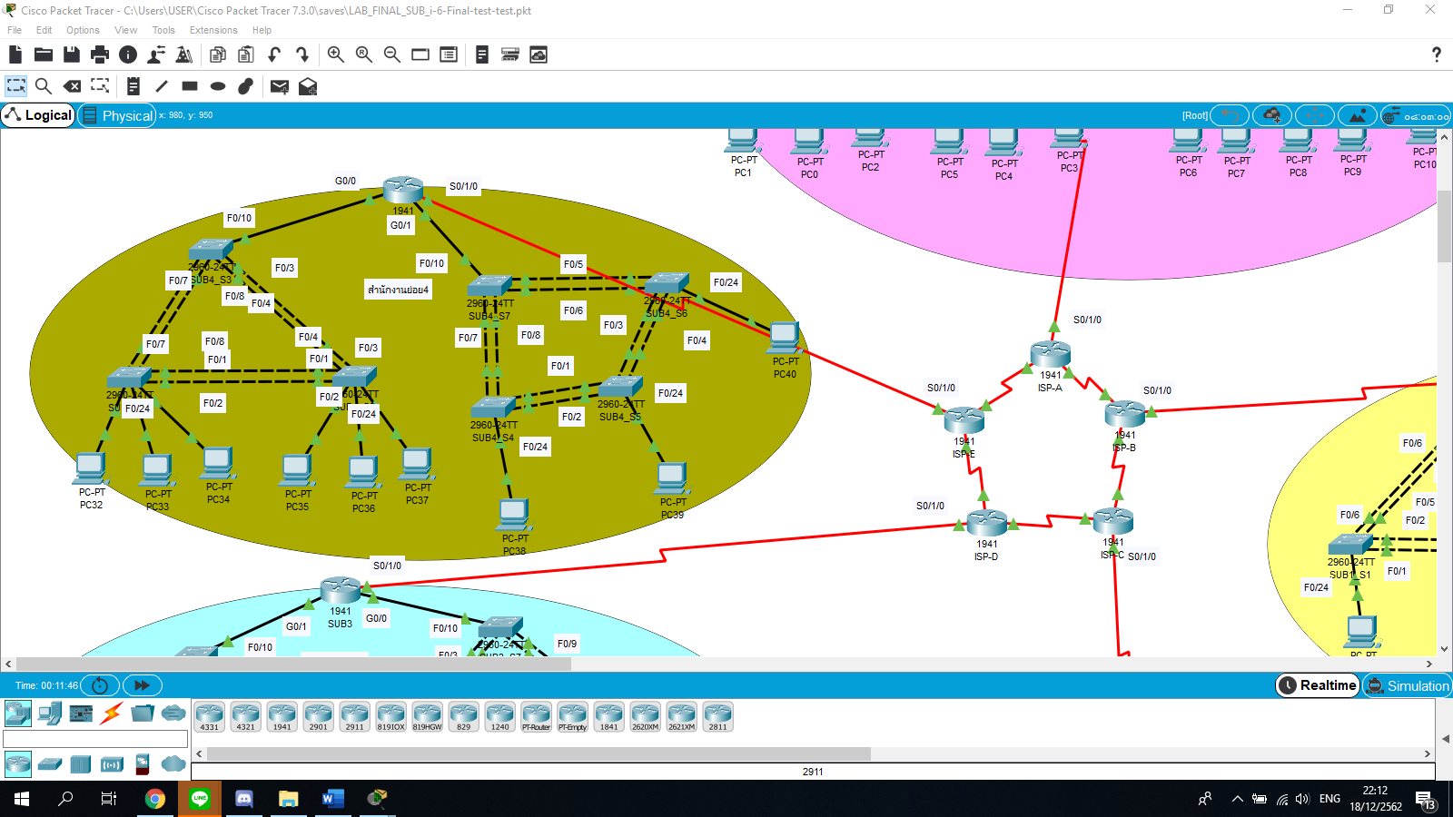

SUB branch 4 Addressing Table

|  |  |  |  |  |
| --- | --- | --- | --- | --- |
| Device | Interface | IP Address | Subnet Mask | Default Gateway |
| SUB4 | G0/0 | 192.168.100.101 | 255.255.255.0 | N/A |
|  | G0/0.10 | 192.168.0.1 | 255.255.252.0 | N/A |
|  | G0/0.20 | 192.168.4.1 | 255.255.252.0 | N/A |
|  | G0/1 | 192.168.101.101 | 255.255.255.0 | N/A |
|  | G0/1.30 | 192.168.30.1 | 255.255.255.128 | N/A |
|  | G0/1.40 | 192.168.40.1 | 255.255.255.128 | N/A |
|  | G0/1.50 | 192.168.50.1 | 255.255.255.128 | N/A |
|  | S0/1/0 | 209.165.201.34 | 255.255.255.252 | N/A |
| SUB4_S1 | VLAN10 | - | - | N/A |
|  | VLAN20 | - | - | N/A |
| SUB4_S2 | VLAN10 | - | - | N/A |
|  | VLAN20 | - | - | N/A |
| SUB4_S3 | VLAN10 | - | - | N/A |
|  | VLAN20 | - | - | N/A |
| SUB4_S4 | VLAN30 | - | - | N/A |
|  | VLAN40 | - | - | N/A |
|  | VLAN50 | - | - | N/A |
| SUB4_S5 | VLAN30 | - | - | N/A |
|  | VLAN40 | - | - | N/A |
|  | VLAN50 | - | - | N/A |
| SUB4_S6 | VLAN30 | - | - | N/A |
|  | VLAN40 | - | - | N/A |
|  | VLAN50 | - | - | N/A |
| SUB4_S7 | VLAN30 | - | - | N/A |
|  | VLAN40 | - | - | N/A |
|  | VLAN50 | - | - | N/A |
| PC32 | F0 | 192.168.0.10 | 255.255.252.0 | 192.168.0.1 |
| PC33 | F0 | 192.168.0.11 | 255.255.252.0 | 192.168.0.1 |
| PC34 | F0 | 192.168.0.12 | 255.255.252.0 | 192.168.0.1 |
| PC35 | F0 | 192.168.4.10 | 255.255.252.0 | 192.168.4.1 |
| PC36 | F0 | 192.168.4.11 | 255.255.252.0 | 192.168.4.1 |
| PC37 | F0 | 192.168.4.12 | 255.255.252.0 | 192.168.4.1 |
| PC38 | F0 | 192.168.30.40 | 255.255.255.128 | 192.168.30.1 |
| PC39 | F0 | 192.168.40.40 | 255.255.255.128 | 192.168.40.1 |
| PC40 | F0 | 192.168.50.40 | 255.255.255.128 | 192.168.50.1 |