**Exercise 3.4** Compute the covariance between the variables

*X*2 = miles per gallon,

*X*8 = weight

from the car data set (Sect. 22.3). What sign do you expect the covariance to have?

Sol.

$$Cov\left(X_{2},X_{8}\right)=-3732.025$$

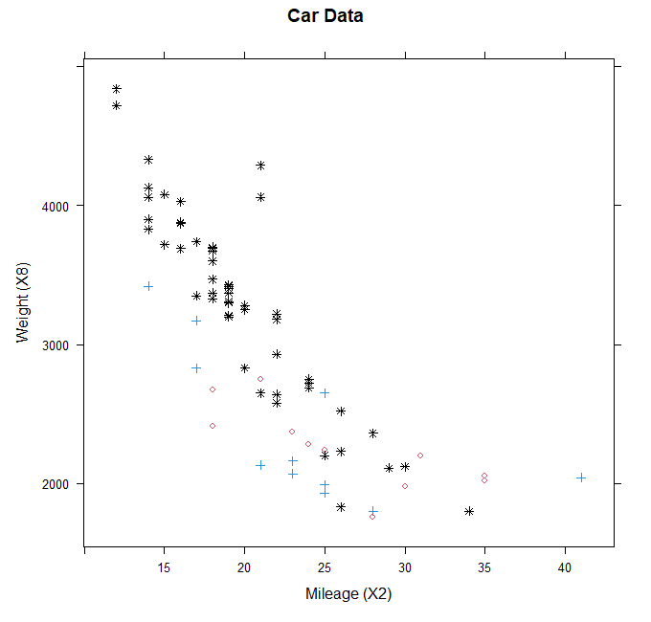After calculate by R, it can be seen that the covariance of $X_{2}$ and $X_{8}$ is less than zero, it means that $X_{2}$ and $X_{8}$ have an inverse relationship. In other words, the higher weight of the car, the less mileage it can run (at the same gallon).

我們也可以藉由散佈圖驗證，當三種車款的 $X_{2}$ 有較大值時，對應 $X_{8}$ 會有較小值，形成負斜率的散佈圖，符合負的共變異數有負斜率的散佈圖這個特徵。

**Exercise 3.25** Compute the covariance matrix *S* = Cov*(X)* where *X* denotes the

matrix of observations on the counterfeit bank notes. Make a Jordan decomposition

of *S*. Why are all of the eigenvalues positive?

Sol.

$$S = Cov(X)=\left[\begin{matrix}0.124 & 0.032 & 0.024 & -0.101 & 0.019 & 0.012 \\ 0.032 & 0.065 & 0.047 & -0.024 & -0.012 & -0.005 \\ 0.024 & 0.047 & 0.089 & -0.019 & 0.0001 & 0.034 \\ -0.101 & -0.024 & -0.019 & 1.281 & -0.490 & 0.238 \\ 0.019 & -0.012 & 0.0001 & -0.490 & 0.404 & -0.022 \\ 0.012 & -0.005 & 0.034 & 0.238 & -0.022 & 0.311\end{matrix}\right]$$

**Eigenvalues:**

$λ_{1}=1.54932311$ $λ_{2}=0.31919416$ $λ_{3}=0.19370655$ $λ_{4}=0.10385594$

$λ_{5}=0.08437643$ $λ_{6}=0.02452663$

**Eigenvectors:**

$$\overset{⃑}{γ}=\left[\begin{matrix}-0.068 & 0.088 & -0.530 & -0.294 & 0.774 & 0.146 \\ -0.014 & -0.010 & -0.363 & -0.418 & -0.258 & -0.791 \\ -0.009 & 0.130 & -0.400 & -0.415 & -0.557 & 0.583 \\ 0.900 & 0.051 & 0.240 & -0.343 & 0.103 & 0.021 \\ -0.390 & 0.493 & 0.563 & -0.527 & 0.097 & -0.011 \\ 0.180 & 0.854 & -0.229 & 0.413 & -0.060 & -0.108\end{matrix}\right]$$

**Jordan decomposition of S:**

$$J=\overset{⃑}{γ}λ{\overset{⃑}{γ}}^{T}=\left[\begin{matrix}-0.068 & 0.088 & -0.530 & -0.294 & 0.774 & 0.146 \\ -0.014 & -0.010 & -0.363 & -0.418 & -0.258 & -0.791 \\ -0.009 & 0.130 & -0.400 & -0.415 & -0.557 & 0.583 \\ 0.900 & 0.051 & 0.240 & -0.343 & 0.103 & 0.021 \\ -0.390 & 0.493 & 0.563 & -0.527 & 0.097 & -0.011 \\ 0.180 & 0.854 & -0.229 & 0.413 & -0.060 & -0.108\end{matrix}\right]*\left[\begin{matrix}1.549 & 0 & 0 & 0 & 0 & 0 \\ 0 & 0.319 & 0 & 0 & 0 & 0 \\ 0 & 0 & 0.194 & 0 & 0 & 0 \\ 0 & 0 & 0 & 0.104 & 0 & 0 \\ 0 & 0 & 0 & 0 & 0.084 & 0 \\ 0 & 0 & 0 & 0 & 0 & 0.025\end{matrix}\right]*\left[\begin{matrix}-0.068 & -0.014 & -0.009 & 0.900 & -0.390 & 0.180 \\ 0.088 & -0.010 & 0.130 & 0.051 & 0.493 & 0.854 \\ -0.530 & -0.363 & -0.400 & 0.240 & 0.563 & -0.229 \\ -0.294 & -0.418 & -0.415 & -0.343 & -0.527 & 0.413 \\ 0.774 & -0.258 & -0.557 & 0.103 & 0.097 & -0.060 \\ 0.146 & -0.791 & 0.583 & 0.021 & -0.011 & -0.108\end{matrix}\right]$$

$$=\left[\begin{matrix}0.124 & 0.032 & 0.024 & -0.101 & 0.019 & 0.012 \\ 0.032 & 0.065 & 0.047 & -0.024 & -0.012 & -0.005 \\ 0.024 & 0.047 & 0.089 & -0.019 & 0.0001 & 0.034 \\ -0.101 & -0.024 & -0.019 & 1.281 & -0.490 & 0.238 \\ 0.019 & -0.012 & 0.0001 & -0.490 & 0.404 & -0.022 \\ 0.012 & -0.005 & 0.034 & 0.238 & -0.022 & 0.311\end{matrix}\right]$$

$$Q\left(\overset{⃑}{γ}\right)={\overset{⃑}{γ}}^{T}S\overset{⃑}{γ}=\left[\begin{matrix}1.549 & 0.319 & 0.194 & 0.104 & 0.084 & 0.025\end{matrix}\right]*\left[\begin{matrix}0.124 & 0.032 & 0.024 & -0.101 & 0.019 & 0.012 \\ 0.032 & 0.065 & 0.047 & -0.024 & -0.012 & -0.005 \\ 0.024 & 0.047 & 0.089 & -0.019 & 0.0001 & 0.034 \\ -0.101 & -0.024 & -0.019 & 1.281 & -0.490 & 0.238 \\ 0.019 & -0.012 & 0.0001 & -0.490 & 0.404 & -0.022 \\ 0.012 & -0.005 & 0.034 & 0.238 & -0.022 & 0.311\end{matrix}\right]\left[\begin{matrix}1.549 \\ 0.319 \\ 0.194 \\ 0.104 \\ 0.084 \\ 0.025\end{matrix}\right]≈0.339>0$$

Because the quadratic form of matrix S is positive, so it is positive definite matrix, it means that the eigenvalues will also be positive.

**Exercise 3.26** Compute the covariance of the counterfeit notes after they are linearly

transformed by the vector $a = {\left(1, 1, 1, 1, 1, 1\right)}^{T}$.

Sol.

$$Var\left(Y\right)=Var\left(a^{T}X\right)=a^{T}Sa=\left[\begin{matrix}1 & 1 & 1 & 1 & 1 & 1\end{matrix}\right]\left[\begin{matrix}0.124 & 0.032 & 0.024 & -0.101 & 0.019 & 0.012 \\ 0.032 & 0.065 & 0.047 & -0.024 & -0.012 & -0.005 \\ 0.024 & 0.047 & 0.089 & -0.019 & 0.0001 & 0.034 \\ -0.101 & -0.024 & -0.019 & 1.281 & -0.490 & 0.238 \\ 0.019 & -0.012 & 0.0001 & -0.490 & 0.404 & -0.022 \\ 0.012 & -0.005 & 0.034 & 0.238 & -0.022 & 0.311\end{matrix}\right]\left[\begin{matrix}1 \\ 1 \\ 1 \\ 1 \\ 1 \\ 1\end{matrix}\right]≈1.742$$

Linear transformation of the matrix X leads to $Var\left(Y\right)=1.742$.

**R code:**

# clear all variables

rm(list = ls(all = TRUE))

graphics.off()

# 3.4

# cov

car <- read.table("C:/Users/user/Desktop/多變量11101/HW3_1019/MVA-ToDo-master/QID-1532-MVAcareffect/carc.dat")

cov(car$V3,car$V9)

# install and load packages

libraries = c("lattice")

lapply(libraries, function(x) if (!(x %in% installed.packages())) {

install.packages(x)

})

lapply(libraries, library, quietly = TRUE, character.only = TRUE)

# scat

# load data

M = car[, 3]

W = car[, 9]

C = car[, 14]

# point definition

D = C

D[car[, 14] == 2] = 1

D[car[, 14] == 1] = 8

# color definition

P = C

P[car[, 14] == 3] = 4

P[car[, 14] == 2] = 2

P[car[, 14] == 1] = 1

leg = c(8, 1, 3)

# plot

xyplot(W ~ M, pch = D, col = P, xlab = "Mileage (X2)", ylab = "Weight (X8)", main = "Car Data")

# 3.25

bank <- read.table("C:/Users/user/Desktop/多變量11101/HW3_1019/MVA-ToDo-master/QID-948-MVApcabankr/bank2.dat")

S <- cov(bank[101:200,])

S

Avalues <- eigen(S)$values

Avectors <- eigen(S)$vectors

Avalues

Avectors

t(Avectors)

J <- Avectors%*%diag(Avalues)%*%t(Avectors)

J

Q <- t(matrix(Avalues))%*%S%*%matrix(Avalues)

Q

# 3.26

a <- matrix(c(1, 1, 1, 1, 1, 1))

a

Sy <- t(a)%*%S%*%a

Sy