**Exercise 4.1** Assume that the random vector *Y* has the following normal distribution: $Y\sim N_{P}(0, I)$. Transform it according to (4.49) to create $X\sim N(μ, Σ)$ with mean $μ={\left(3, 2\right)}^{T}$ and $Σ=\left(\begin{matrix}1 & -1.5 \\ -1.5 & 4\end{matrix}\right)$. How would you implement the resulting formula on a computer?

**Sol.**

$Y\sim N_{P}\left(0, I\right)$ 用 $X=Σ^{\frac{1}{2}}Y+μ$ 做線性轉換得到 $X\sim N(μ, Σ)$，多變量常態母體 $X\sim N(μ, Σ)$ 意味它的變數 ${\left(x-μ\right)}^{'}Σ^{-1}(x-μ)\sim χ^{2}(p)$ 服從卡方分配，自由度為p。

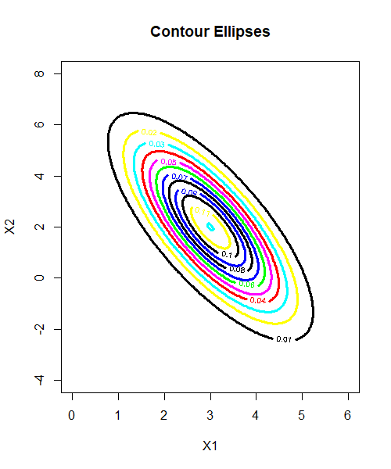

等高線圖中，圖形中心點為平均數 $μ={\left(3, 2\right)}^{T}$，橢圓內的每個值與 $μ$ 的距離都小於 $χ^{2}(p)$，數學式可表示為 ${\left(x-μ\right)}^{'}Σ^{-1}(x-μ)≤χ^{2}(p)$，當 $x$ 越靠近橢圓中心 $μ$，表示它的probability也越高。

另外，搭配3D surface plot可以觀察出X只有一個高峰，而且等高線圖的每條等高線間距沒有特別離很遠或很近的，整體呈現對稱狀態，可以推測為常態分布。

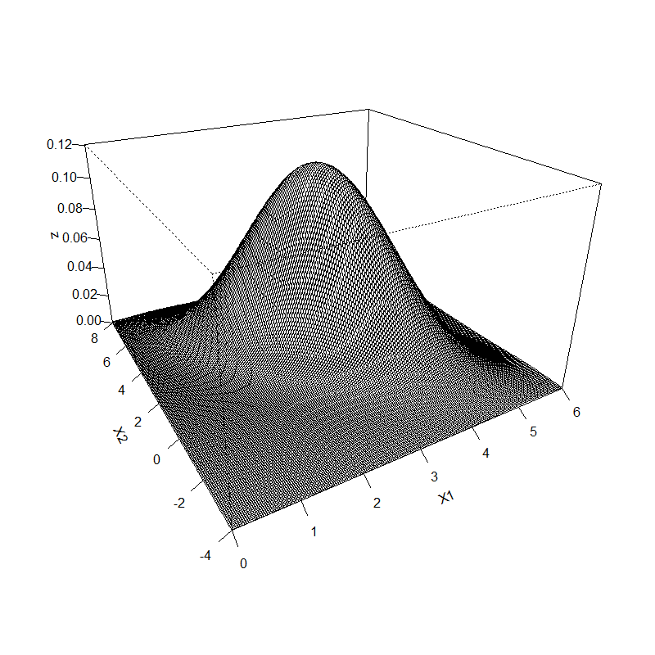

**Exercise 5.1** Consider $X\sim N_{2}(μ, Σ)$ with $μ={\left(2, 2\right)}^{T}$ and $Σ=\left(\begin{matrix}1 & 0 \\ 0 & 1\end{matrix}\right)$ and the matrices $A={\left(\begin{matrix}1 \\ 1\end{matrix}\right)}^{T}$, $B={\left(\begin{matrix}1 \\ -1\end{matrix}\right)}^{T}$. Show that $AX$ and $BX$ are independent.

**Sol.**

根據多變量常態分配定理，若 $X\sim N_{2}(μ, Σ)$，則 $X$ 的任意線性組合皆為常態分配。

$$→假設X_{1}=AX=\sum_{i=1}^{2}{A_{i}X_{i}}, X_{2}=BX=\sum_{i=2}^{2}{B_{i}X_{i}}$$

$$→AX\sim N\left(A^{T}μ, A^{T}ΣA\right), BX\sim N(B^{T}μ, B^{T}ΣB)$$

$$↪ AX和BX皆呈現常態分配$$

$$→Cov\left(X_{1}, X_{2}\right)=AΣB^{T}=\left(\begin{matrix}1 & 1\end{matrix}\right)\left(\begin{matrix}Σ_{11} & Σ_{12} \\ Σ_{21} & Σ_{22}\end{matrix}\right)\left(\begin{matrix}1 \\ -1\end{matrix}\right)$$

$$→AΣ=\left(\begin{matrix}I_{r} & 0\end{matrix}\right)\left(\begin{matrix}Σ_{11} & Σ_{12} \\ Σ_{21} & Σ_{22}\end{matrix}\right)=\left(\begin{matrix}Σ_{11} & Σ_{12}\end{matrix}\right)$$

$$→AΣB^{T}=\left(\begin{matrix}Σ_{11} & Σ_{12}\end{matrix}\right)\left(\begin{matrix}1 \\ -1\end{matrix}\right)=\left(Σ_{11}-Σ_{12}\right)$$

$$→AΣB^{T}≡0$$

$$↪ Cov\left(X_{1}, X_{2}\right)=0$$

$$→\left(\begin{matrix}X_{1} \\ X_{2}\end{matrix}\right)=\left(\begin{matrix}A \\ B\end{matrix}\right)X\sim N_{2}\left(\left(\begin{matrix}μ_{1} \\ μ_{2}\end{matrix}\right), \left(\begin{matrix}Σ_{11} & 0 \\ 0 & Σ_{22}\end{matrix}\right)\right)$$

$$→\left(\begin{matrix}X_{1} \\ X_{2}\end{matrix}\right)=\left(\begin{matrix}A \\ B\end{matrix}\right)X\sim N_{2}\left(\left(\begin{matrix}Aμ \\ Bμ\end{matrix}\right), \left(\begin{matrix}AΣA^{T} & 0 \\ 0 & BΣB^{T}\end{matrix}\right)\right)$$

$$→\left(\begin{matrix}X_{1} \\ X_{2}\end{matrix}\right)=\left(\begin{matrix}A \\ B\end{matrix}\right)X\sim N_{2}\left(\left(\begin{matrix}4 \\ 0\end{matrix}\right), \left(\begin{matrix}2 & 0 \\ 0 & 2\end{matrix}\right)\right)$$

$$⇒{Because Σ_{12},Σ_{21}=0, AX}_{} and BX_{} are independent.$$

R Code:

# clear all variables

rm(list = ls(all = TRUE))

graphics.off()

# 4.1

# install and load packages

libraries = c("MASS", "mnormt")

lapply(libraries, function(x) if (!(x %in% installed.packages())) {

install.packages(x)

})

lapply(libraries, library, quietly = TRUE, character.only = TRUE)

# parameter settings

n1 = 200 # number of draws

mu1 = c(3, 2) # mean vector

sig1 = matrix(c(1, -1.5, -1.5, 4), ncol = 2) # covariance matrix

# bivariate normal sample

set.seed(1024)

x = mvrnorm(n1, mu1, sig1, 2)

# bivariate normal density

xgrid = seq(from = (mu1[1] - 3 * sqrt(sig1[1, 1])), to = (mu1[1] + 3 * sqrt(sig1[1, 1])),

length.out = 200)

ygrid = seq(from = (mu1[2] - 3 * sqrt(sig1[2, 2])), to = (mu1[2] + 3 * sqrt(sig1[2, 2])),

length.out = 200)

z = outer(xgrid, ygrid, FUN = function(xgrid, ygrid) {

dmnorm(cbind(xgrid, ygrid), mean = mu1, varcov = sig1)

})

# contour ellipses

contour(xgrid, ygrid, z, xlim = range(xgrid), ylim = range(ygrid), nlevels = 10, col = c("blue",

"black", "yellow", "cyan", "red", "magenta", "green", "blue", "black"), lwd = 3,

cex.axis = 1, xlab = "X1", ylab = "X2")

title("Contour Ellipses")

# surface plot

persp(xgrid, ygrid, z, theta=-30, phi=25, expand=0.6, ticktype='detailed', xlab="X1", ylab = "X2" )

# 5.1

# parameter settings

n2 = 200 # number of draws

mu2 = c(2, 2) # mean vector

sig2 = matrix(c(1, 0, 0, 1), ncol = 2) # covariance matrix

A <- t(matrix(c(1, 1)))

B <- t(matrix(c(1, -1)))

# bivariate normal sample

set.seed(1024)

x2 = mvrnorm(n2, mu2, sig2, 2)

# 先證AX,BX常態，再做共變異數=0

m1 <- A%*%mu2

m2 <- B%*%mu2

s11 <- A%*%sig2%*%t(A)

s12 <- A%*%sig2%*%t(B)

s21 <- B%*%sig2%*%t(A)

s22 <- B%*%sig2%*%t(B)

S <- matrix(c(s11, s21, s12, s22), ncol = 2)