## Admin shall be able create Custom region

|  |  |  |
| --- | --- | --- |
|  | | |
| **Requirements ID:** REQ0006-CustomRegion | | |
| **Primary Actors:** Admin, CPH-IVT | | |
| **Use Case Name:** Log into system | | **Importance Level:** High |
| **Stakeholders:** | Administrators, Aides, Developers | |
| **Requirement:** | The Admin shall be able to create custom regions | |
| **Story:** | As an Admin, I want to be able to create custom regions of health Identification Data | |
| **Quality Requirements:** | The Admin shall be able to get to create custom region page in sixty seconds or less. | |
| **Pre-Conditions:** | 1. I am an Admin  2. A web browser instance is open | |
| **Post-Conditions:** | Success:   1. I am on CPH-IVT admin page 2. I can see the ‘create custom region’ at <host>/home   Failure:   1. I am not on CPH-IVT admin page 2. I cannot see the ‘create custom region’ at <host> | |
| **Relationships:** | None (This requirement is atomic) | |
| **Trigger:** | **Trigger Type:** External  I request the CPH – IVT create custom region on ‘admin page’ at <host> | |
| **Normal Flow of Events:** | 1. CPH-IVT responds with the ‘create custom region’ page 2. I enter my states that I wish to add to custom region   3. I enter the counties from the states I have selected to add to custom region  4. CPH -IVT creates custom region | |
| **Exception flow** | 1. CPH-IVT is unable to display ‘create custom region’ page | |
| **Storage Requirements** | **Host**  <host>:: notsupplied.etsu.edu  **Login Credentials**  <login credentials>:: <ETSU email>|<username><tab><password>  <ETSU email>:: [a-z]+[0-9]*@etsu.edu  <username>:: [a-z]+[0-9]* <password>:: 8{[A-Z]+[a-z]+[\d]+[@$!%*?&]+)}24 | |
|  |  | |

**Behavioral Flow**

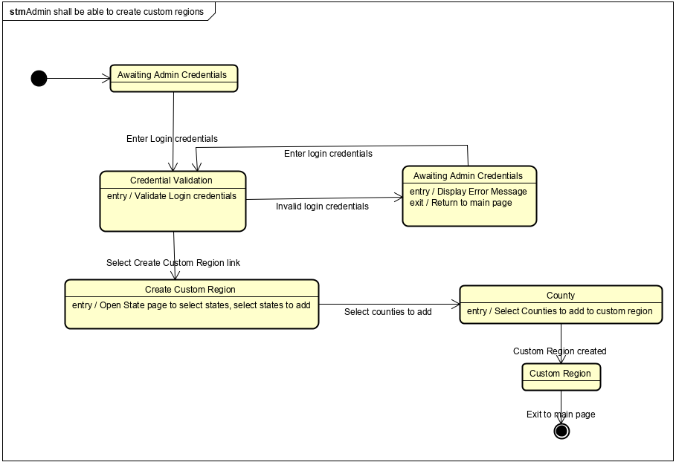

**Data Elements**

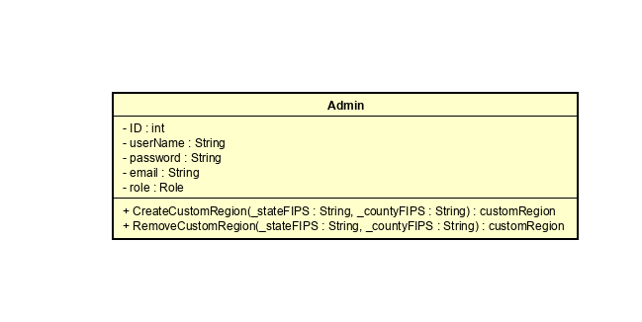

**UI Prototype**

