Source Data Mapping Approach

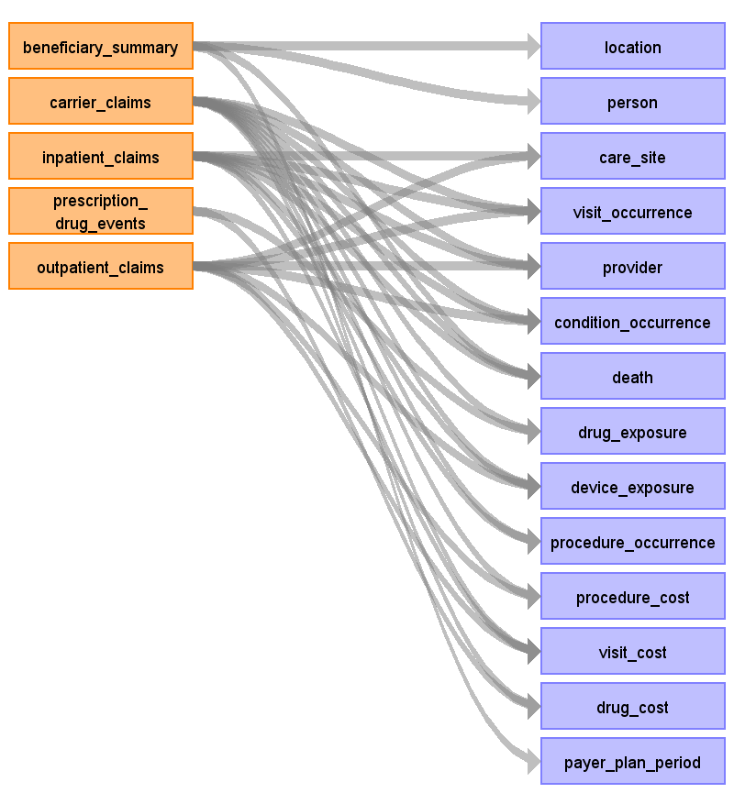

Table name: location

Reading from beneficiary_summary

SOURCE_TO_CONCEPT_MAP Entries:
BENE_RACE_CD
SP_STATE_CD
SSA Codes (http://www.resdac.org/cms-data/variables/County-Code) for COUNTY_CODE IN BENE_COUNTY_CD

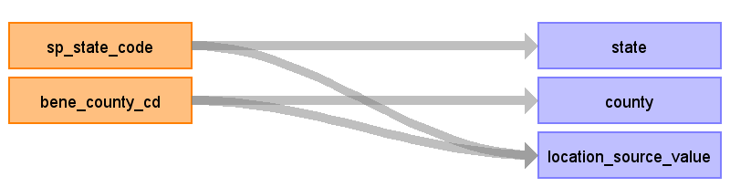

|  |  |  |  |
| --- | --- | --- | --- |
| Destination Field | Source Field | Logic | Comment |
| location_id |  |  |  |
| address_1 |  |  |  |
| address_2 |  |  |  |
| city |  |  |  |
| state | sp_state_code |  | The lookup SP_STATE_CODE lookup should be found in this document and added to the SOURCE_TO_CONCEPT_MAP: http://www.cms.gov/Research-Statistics-Data-and-Systems/Downloadable-Public-Use-Files/SynPUFs/Downloads/SynPUF_Codebook.pdf |
| zip |  |  |  |
| county | bene_county_cd |  | http://www.cms.gov/Research-Statistics-Data-and-Systems/Downloadable-Public-Use-Files/SynPUFs/Downloads/SynPUF_Codebook.pdf THIS CODE SPECIFIES THE SSA CODE FOR THE COUNTY OF RESIDENCE OF THE BENEFICIARY. EACH STATE HAS A SERIES OF CODES BEGINNING WITH '000' FOR EACH COUNTY WITHIN THAT STATE. CERTAIN CITIES WITHIN THAT STATE HAVE THEIR OWN CODE. COUNTY CODES MUST BE COMBINED WITH STATE CODES IN ORDER TO LOCATE THE SPECIFIC COUNTY. THE CODING SYSTEM IS THE SSA SYSTEM, NOT THE FEDERAL INFORMATION PROCESSING STANDARD (FIPS). http://www.resdac.org/cms-data/variables/County-Code These will need to be added to the SOURCE_TO_CONCEPT_MAP. |
| location_source_value | sp_state_code bene_county_cd |  |  |

Table name: person

Reading from beneficiary_summary

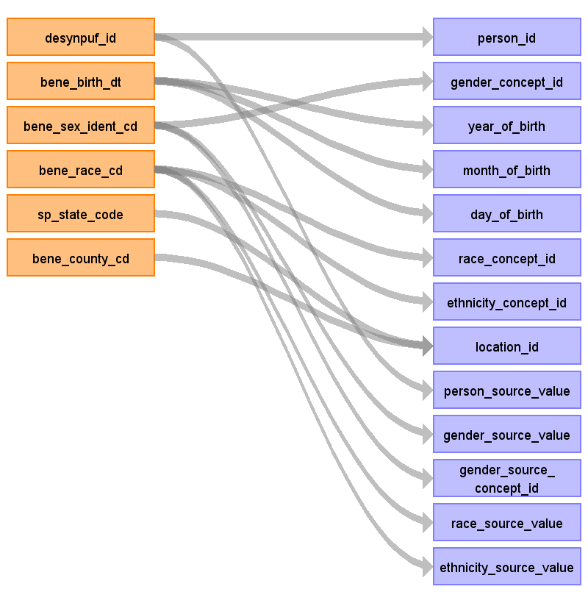

|  |  |  |  |
| --- | --- | --- | --- |
| Destination Field | Source Field | Logic | Comment |
| person_id | desynpuf_id |  |  |
| gender_concept_id | bene_sex_ident_cd | 1 = 8507 2 = 8532 | <<ACTION ITEM>> Mark&Team will double check |
| year_of_birth | bene_birth_dt | Source is YYYYMMDD |  |
| month_of_birth | bene_birth_dt | Source is YYYYMMDD |  |
| day_of_birth | bene_birth_dt | Source is YYYYMMDD | We assume that the day of birth is set to '01' |
| time_of_birth |  |  |  |
| race_concept_id | bene_race_cd | The manual lists the following: 0 = Unknown = 0 1 = White = 8527 2 = Black = 8516 3 = Other = 0 5 = Hispanic = 0 Do not believe these will exist so we may not put them in: 4 = Asian = 8515 6 = North American Native = 38003572 | <<ACTION ITEM>> |
| ethnicity_concept_id | bene_race_cd | Manual Says These Exists: 0 = Unknown = 0 1 = White = 38003564 2 = Black = 38003564 3 = Other = 0 5 = Hispanic = 38003563 Possible Other Codes, Do Not Believe Exist in Data: 4 = Asian = 38003564 6 = North American Native = 38003564 |  |
| location_id | sp_state_code bene_county_cd |  | Lookup based on the source values. |
| provider_id |  |  | There is not designated provider. |
| care_site_id |  |  | There is no designated care site. |
| person_source_value | desynpuf_id |  |  |
| gender_source_value | bene_sex_ident_cd |  | Translate into human readable text. |
| gender_source_concept_id | bene_sex_ident_cd |  | <<ACTION ITEM>> We need to know if the source is using a standard, is that in the vocabulary already? |
| race_source_value | bene_race_cd |  | Put a readable label. |
| race_source_concept_id |  |  |  |
| ethnicity_source_value | bene_race_cd |  | Put a readable label. |
| ethnicity_source_concept_id |  |  |  |

Table name: observation_period

Table name: care_site

Reading from outpatient_claims

Generated

|  |  |  |  |
| --- | --- | --- | --- |
| Destination Field | Source Field | Logic | Comment |
| care_site_id |  |  |  |
| care_site_name |  |  |  |
| place_of_service_concept_id |  |  |  |
| location_id |  |  |  |
| care_site_source_value |  |  |  |
| place_of_service_source_value |  |  |  |

Reading from inpatient_claims

Generated

|  |  |  |  |
| --- | --- | --- | --- |
| Destination Field | Source Field | Logic | Comment |
| care_site_id |  |  |  |
| care_site_name |  |  |  |
| place_of_service_concept_id |  |  |  |
| location_id |  |  |  |
| care_site_source_value |  |  |  |
| place_of_service_source_value |  |  |  |

Table name: visit_occurrence

Reading from carrier_claims

Generated

|  |  |  |  |
| --- | --- | --- | --- |
| Destination Field | Source Field | Logic | Comment |
| visit_occurrence_id |  |  |  |
| person_id |  |  |  |
| visit_concept_id |  |  |  |
| visit_start_date |  |  |  |
| visit_start_time |  |  |  |
| visit_end_date |  |  |  |
| visit_end_time |  |  |  |
| visit_type_concept_id |  |  |  |
| provider_id |  |  |  |
| care_site_id |  |  |  |
| visit_source_value |  |  |  |
| visit_source_concept_id |  |  |  |

Reading from outpatient_claims

Generated

|  |  |  |  |
| --- | --- | --- | --- |
| Destination Field | Source Field | Logic | Comment |
| visit_occurrence_id |  |  |  |
| person_id |  |  |  |
| visit_concept_id |  |  |  |
| visit_start_date |  |  |  |
| visit_start_time |  |  |  |
| visit_end_date |  |  |  |
| visit_end_time |  |  |  |
| visit_type_concept_id |  |  |  |
| provider_id |  |  |  |
| care_site_id |  |  |  |
| visit_source_value |  |  |  |
| visit_source_concept_id |  |  |  |

Reading from inpatient_claims

Generated

|  |  |  |  |
| --- | --- | --- | --- |
| Destination Field | Source Field | Logic | Comment |
| visit_occurrence_id |  |  |  |
| person_id |  |  |  |
| visit_concept_id |  |  |  |
| visit_start_date |  |  |  |
| visit_start_time |  |  |  |
| visit_end_date |  |  |  |
| visit_end_time |  |  |  |
| visit_type_concept_id |  |  |  |
| provider_id |  |  |  |
| care_site_id |  |  |  |
| visit_source_value |  |  |  |
| visit_source_concept_id |  |  |  |

Table name: provider

Reading from carrier_claims

We are not going to pull in TAX_IDs right now.

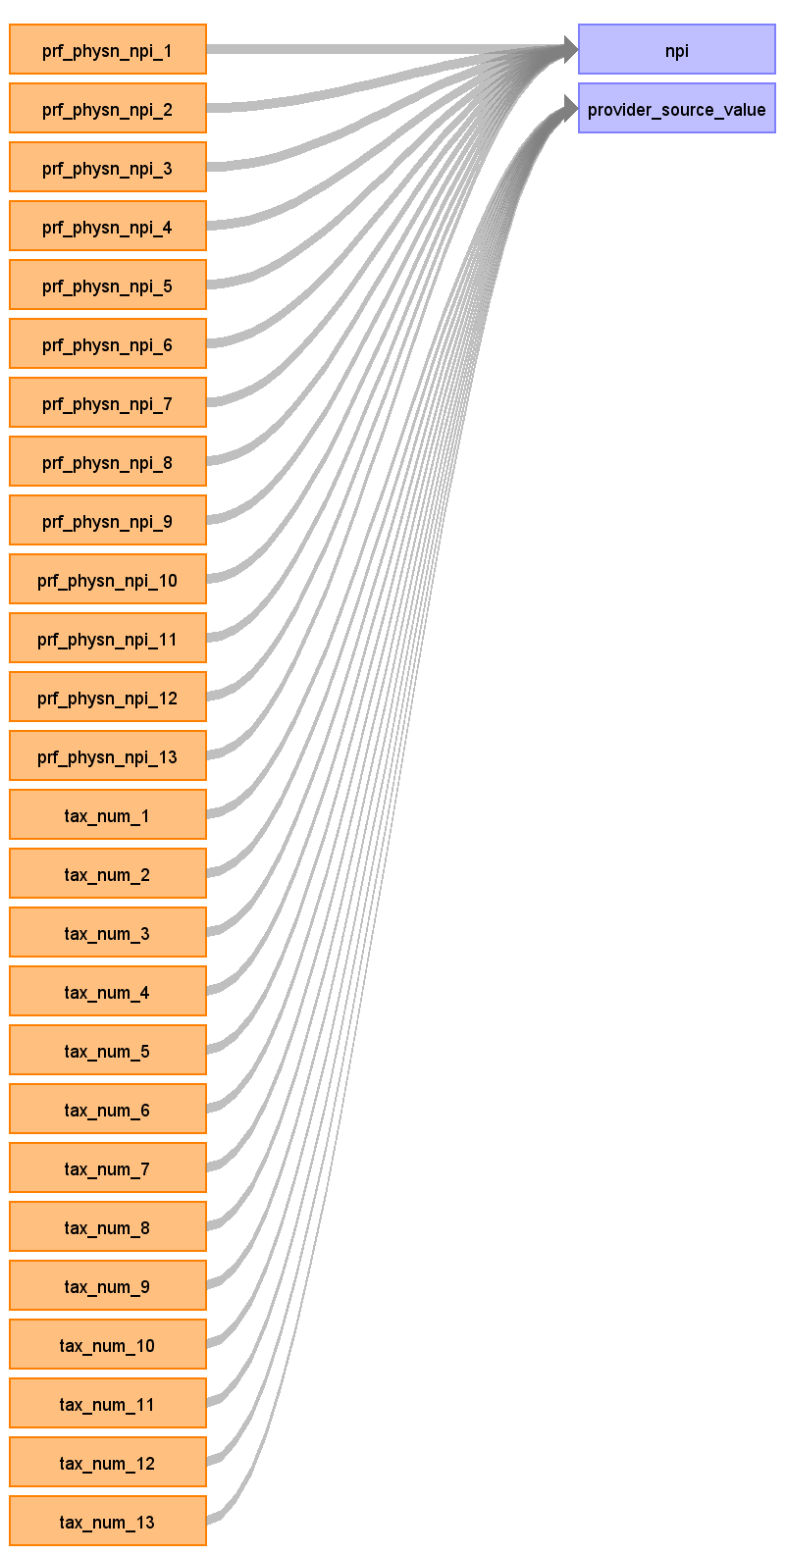

|  |  |  |  |
| --- | --- | --- | --- |
| Destination Field | Source Field | Logic | Comment |
| provider_id |  |  | Autogenerated |
| provider_name |  |  |  |
| npi | prf_physn_npi_1 prf_physn_npi_2 prf_physn_npi_3 prf_physn_npi_4 prf_physn_npi_5 prf_physn_npi_6 prf_physn_npi_7 prf_physn_npi_8 prf_physn_npi_9 prf_physn_npi_10 prf_physn_npi_11 prf_physn_npi_12 prf_physn_npi_13 |  |  |
| dea |  |  |  |
| specialty_concept_id |  |  |  |
| care_site_id |  |  |  |
| year_of_birth |  |  |  |
| gender_concept_id |  |  |  |
| provider_source_value | tax_num_1 tax_num_2 tax_num_3 tax_num_4 tax_num_5 tax_num_6 tax_num_7 tax_num_8 tax_num_9 tax_num_10 tax_num_11 tax_num_12 tax_num_13 |  |  |
| specialty_source_value |  |  |  |
| specialty_source_concept_id |  |  |  |
| gender_source_value |  |  |  |
| gender_source_concept_id |  |  |  |

Reading from outpatient_claims

Generated

|  |  |  |  |
| --- | --- | --- | --- |
| Destination Field | Source Field | Logic | Comment |
| provider_id |  |  | Autogenerated |
| provider_name |  |  |  |
| npi |  |  |  |
| dea |  |  |  |
| specialty_concept_id |  |  |  |
| care_site_id |  |  |  |
| year_of_birth |  |  |  |
| gender_concept_id |  |  |  |
| provider_source_value |  |  |  |
| specialty_source_value |  |  |  |
| specialty_source_concept_id |  |  |  |
| gender_source_value |  |  |  |
| gender_source_concept_id |  |  |  |

Reading from inpatient_claims

Generated

|  |  |  |  |
| --- | --- | --- | --- |
| Destination Field | Source Field | Logic | Comment |
| provider_id |  |  | Autogenerated |
| provider_name |  |  |  |
| npi |  |  |  |
| dea |  |  |  |
| specialty_concept_id |  |  |  |
| care_site_id |  |  |  |
| year_of_birth |  |  |  |
| gender_concept_id |  |  |  |
| provider_source_value |  |  |  |
| specialty_source_value |  |  |  |
| specialty_source_concept_id |  |  |  |
| gender_source_value |  |  |  |
| gender_source_concept_id |  |  |  |

Table name: condition_occurrence

Reading from carrier_claims

Generated

|  |  |  |  |
| --- | --- | --- | --- |
| Destination Field | Source Field | Logic | Comment |
| condition_occurrence_id |  |  |  |
| person_id |  |  |  |
| condition_concept_id |  |  |  |
| condition_start_date |  |  |  |
| condition_end_date |  |  |  |
| condition_type_concept_id |  |  |  |
| stop_reason |  |  |  |
| provider_id |  |  |  |
| visit_occurrence_id |  |  |  |
| condition_source_value |  |  |  |
| condition_source_concept_id |  |  |  |

Reading from outpatient_claims

Generated

|  |  |  |  |
| --- | --- | --- | --- |
| Destination Field | Source Field | Logic | Comment |
| condition_occurrence_id |  |  |  |
| person_id |  |  |  |
| condition_concept_id |  |  |  |
| condition_start_date |  |  |  |
| condition_end_date |  |  |  |
| condition_type_concept_id |  |  |  |
| stop_reason |  |  |  |
| provider_id |  |  |  |
| visit_occurrence_id |  |  |  |
| condition_source_value |  |  |  |
| condition_source_concept_id |  |  |  |

Reading from inpatient_claims

Generated

|  |  |  |  |
| --- | --- | --- | --- |
| Destination Field | Source Field | Logic | Comment |
| condition_occurrence_id |  |  |  |
| person_id |  |  |  |
| condition_concept_id |  |  |  |
| condition_start_date |  |  |  |
| condition_end_date |  |  |  |
| condition_type_concept_id |  |  |  |
| stop_reason |  |  |  |
| provider_id |  |  |  |
| visit_occurrence_id |  |  |  |
| condition_source_value |  |  |  |
| condition_source_concept_id |  |  |  |

Table name: death

Reading from beneficiary_summary

Generated

|  |  |  |  |
| --- | --- | --- | --- |
| Destination Field | Source Field | Logic | Comment |
| person_id |  |  |  |
| death_date |  |  |  |
| death_type_concept_id |  |  |  |
| cause_concept_id |  |  |  |
| cause_source_value |  |  |  |
| cause_source_concept_id |  |  |  |

Reading from carrier_claims

Generated

|  |  |  |  |
| --- | --- | --- | --- |
| Destination Field | Source Field | Logic | Comment |
| person_id |  |  |  |
| death_date |  |  |  |
| death_type_concept_id |  |  |  |
| cause_concept_id |  |  |  |
| cause_source_value |  |  |  |
| cause_source_concept_id |  |  |  |

Reading from inpatient_claims

Generated

|  |  |  |  |
| --- | --- | --- | --- |
| Destination Field | Source Field | Logic | Comment |
| person_id |  |  |  |
| death_date |  |  |  |
| death_type_concept_id |  |  |  |
| cause_concept_id |  |  |  |
| cause_source_value |  |  |  |
| cause_source_concept_id |  |  |  |

Table name: drug_exposure

Reading from prescription_drug_events

Generated

|  |  |  |  |
| --- | --- | --- | --- |
| Destination Field | Source Field | Logic | Comment |
| drug_exposure_id |  |  |  |
| person_id |  |  |  |
| drug_concept_id |  |  |  |
| drug_exposure_start_date |  |  |  |
| drug_exposure_end_date |  |  |  |
| drug_type_concept_id |  |  |  |
| stop_reason |  |  |  |
| refills |  |  |  |
| quantity |  |  |  |
| days_supply |  |  |  |
| sig |  |  |  |
| route_concept_id |  |  |  |
| effective_drug_dose |  |  |  |
| dose_unit_concept_id |  |  |  |
| lot_number |  |  |  |
| provider_id |  |  |  |
| visit_occurrence_id |  |  |  |
| drug_source_value |  |  |  |
| drug_source_concept_id |  |  |  |
| route_source_value |  |  |  |
| dose_unit_source_value |  |  |  |

Reading from carrier_claims

Generated

|  |  |  |  |
| --- | --- | --- | --- |
| Destination Field | Source Field | Logic | Comment |
| drug_exposure_id |  |  |  |
| person_id |  |  |  |
| drug_concept_id |  |  |  |
| drug_exposure_start_date |  |  |  |
| drug_exposure_end_date |  |  |  |
| drug_type_concept_id |  |  |  |
| stop_reason |  |  |  |
| refills |  |  |  |
| quantity |  |  |  |
| days_supply |  |  |  |
| sig |  |  |  |
| route_concept_id |  |  |  |
| effective_drug_dose |  |  |  |
| dose_unit_concept_id |  |  |  |
| lot_number |  |  |  |
| provider_id |  |  |  |
| visit_occurrence_id |  |  |  |
| drug_source_value |  |  |  |
| drug_source_concept_id |  |  |  |
| route_source_value |  |  |  |
| dose_unit_source_value |  |  |  |

Table name: device_exposure

Reading from outpatient_claims

Generated

|  |  |  |  |
| --- | --- | --- | --- |
| Destination Field | Source Field | Logic | Comment |
| device_exposure_id |  |  |  |
| person_id |  |  |  |
| device_concept_id |  |  |  |
| device_exposure_start_date |  |  |  |
| device_exposure_end_date |  |  |  |
| device_type_concept_id |  |  |  |
| unique_device_id |  |  |  |
| quantity |  |  |  |
| provider_id |  |  |  |
| visit_occurrence_id |  |  |  |
| device_source_value |  |  |  |
| device_source_concept_id |  |  |  |

Reading from inpatient_claims

Generated

|  |  |  |  |
| --- | --- | --- | --- |
| Destination Field | Source Field | Logic | Comment |
| device_exposure_id |  |  |  |
| person_id |  |  |  |
| device_concept_id |  |  |  |
| device_exposure_start_date |  |  |  |
| device_exposure_end_date |  |  |  |
| device_type_concept_id |  |  |  |
| unique_device_id |  |  |  |
| quantity |  |  |  |
| provider_id |  |  |  |
| visit_occurrence_id |  |  |  |
| device_source_value |  |  |  |
| device_source_concept_id |  |  |  |

Reading from carrier_claims

Generated

|  |  |  |  |
| --- | --- | --- | --- |
| Destination Field | Source Field | Logic | Comment |
| device_exposure_id |  |  |  |
| person_id |  |  |  |
| device_concept_id |  |  |  |
| device_exposure_start_date |  |  |  |
| device_exposure_end_date |  |  |  |
| device_type_concept_id |  |  |  |
| unique_device_id |  |  |  |
| quantity |  |  |  |
| provider_id |  |  |  |
| visit_occurrence_id |  |  |  |
| device_source_value |  |  |  |
| device_source_concept_id |  |  |  |

Table name: procedure_occurrence

Reading from carrier_claims

Generated

|  |  |  |  |
| --- | --- | --- | --- |
| Destination Field | Source Field | Logic | Comment |
| procedure_occurrence_id |  |  |  |
| person_id |  |  |  |
| procedure_concept_id |  |  |  |
| procedure_date |  |  |  |
| procedure_type_concept_id |  |  |  |
| modifier_concept_id |  |  |  |
| quantity |  |  |  |
| provider_id |  |  |  |
| visit_occurrence_id |  |  |  |
| procedure_source_value |  |  |  |
| procedure_source_concept_id |  |  |  |
| qualifier_source_value |  |  |  |

Reading from inpatient_claims

Generated

|  |  |  |  |
| --- | --- | --- | --- |
| Destination Field | Source Field | Logic | Comment |
| procedure_occurrence_id |  |  |  |
| person_id |  |  |  |
| procedure_concept_id |  |  |  |
| procedure_date |  |  |  |
| procedure_type_concept_id |  |  |  |
| modifier_concept_id |  |  |  |
| quantity |  |  |  |
| provider_id |  |  |  |
| visit_occurrence_id |  |  |  |
| procedure_source_value |  |  |  |
| procedure_source_concept_id |  |  |  |
| qualifier_source_value |  |  |  |

Table name: measurement

Table name: observation

Table name: note

Table name: specimen

Table name: fact_relationship

Table name: procedure_cost

Reading from carrier_claims

Generated

|  |  |  |  |
| --- | --- | --- | --- |
| Destination Field | Source Field | Logic | Comment |
| procedure_cost_id |  |  |  |
| procedure_occurrence_id |  |  |  |
| currency_concept_id |  |  |  |
| paid_copay |  |  |  |
| paid_coinsurance |  |  |  |
| paid_toward_deductible |  |  |  |
| paid_by_payer |  |  |  |
| paid_by_coordination_benefits |  |  |  |
| total_out_of_pocket |  |  |  |
| total_paid |  |  |  |
| revenue_code_concept_id |  |  |  |
| payer_plan_period_id |  |  |  |
| revenue_code_source_value |  |  |  |

Reading from outpatient_claims

Generated

|  |  |  |  |
| --- | --- | --- | --- |
| Destination Field | Source Field | Logic | Comment |
| procedure_cost_id |  |  |  |
| procedure_occurrence_id |  |  |  |
| currency_concept_id |  |  |  |
| paid_copay |  |  |  |
| paid_coinsurance |  |  |  |
| paid_toward_deductible |  |  |  |
| paid_by_payer |  |  |  |
| paid_by_coordination_benefits |  |  |  |
| total_out_of_pocket |  |  |  |
| total_paid |  |  |  |
| revenue_code_concept_id |  |  |  |
| payer_plan_period_id |  |  |  |
| revenue_code_source_value |  |  |  |

Table name: visit_cost

Reading from carrier_claims

Generated

|  |  |  |  |
| --- | --- | --- | --- |
| Destination Field | Source Field | Logic | Comment |
| visit_cost_id |  |  |  |
| visit_occurrence_id |  |  |  |
| currency_concept_id |  |  |  |
| paid_copay |  |  |  |
| paid_coinsurance |  |  |  |
| paid_toward_deductible |  |  |  |
| paid_by_payer |  |  |  |
| paid_by_coordination_benefits |  |  |  |
| total_out_of_pocket |  |  |  |
| total_paid |  |  |  |
| payer_plan_period_id |  |  |  |

Reading from outpatient_claims

Generated

|  |  |  |  |
| --- | --- | --- | --- |
| Destination Field | Source Field | Logic | Comment |
| visit_cost_id |  |  |  |
| visit_occurrence_id |  |  |  |
| currency_concept_id |  |  |  |
| paid_copay |  |  |  |
| paid_coinsurance |  |  |  |
| paid_toward_deductible |  |  |  |
| paid_by_payer |  |  |  |
| paid_by_coordination_benefits |  |  |  |
| total_out_of_pocket |  |  |  |
| total_paid |  |  |  |
| payer_plan_period_id |  |  |  |

Reading from inpatient_claims

Generated

|  |  |  |  |
| --- | --- | --- | --- |
| Destination Field | Source Field | Logic | Comment |
| visit_cost_id |  |  |  |
| visit_occurrence_id |  |  |  |
| currency_concept_id |  |  |  |
| paid_copay |  |  |  |
| paid_coinsurance |  |  |  |
| paid_toward_deductible |  |  |  |
| paid_by_payer |  |  |  |
| paid_by_coordination_benefits |  |  |  |
| total_out_of_pocket |  |  |  |
| total_paid |  |  |  |
| payer_plan_period_id |  |  |  |

Table name: drug_cost

Reading from prescription_drug_events

Generated

|  |  |  |  |
| --- | --- | --- | --- |
| Destination Field | Source Field | Logic | Comment |
| drug_cost_id |  |  |  |
| drug_exposure_id |  |  |  |
| currency_concept_id |  |  |  |
| paid_copay |  |  |  |
| paid_coinsurance |  |  |  |
| paid_toward_deductible |  |  |  |
| paid_by_payer |  |  |  |
| paid_by_coordination_benefits |  |  |  |
| total_out_of_pocket |  |  |  |
| total_paid |  |  |  |
| ingredient_cost |  |  |  |
| dispensing_fee |  |  |  |
| average_wholesale_price |  |  |  |
| payer_plan_period_id |  |  |  |

Reading from carrier_claims

Generated

|  |  |  |  |
| --- | --- | --- | --- |
| Destination Field | Source Field | Logic | Comment |
| drug_cost_id |  |  |  |
| drug_exposure_id |  |  |  |
| currency_concept_id |  |  |  |
| paid_copay |  |  |  |
| paid_coinsurance |  |  |  |
| paid_toward_deductible |  |  |  |
| paid_by_payer |  |  |  |
| paid_by_coordination_benefits |  |  |  |
| total_out_of_pocket |  |  |  |
| total_paid |  |  |  |
| ingredient_cost |  |  |  |
| dispensing_fee |  |  |  |
| average_wholesale_price |  |  |  |
| payer_plan_period_id |  |  |  |

Table name: payer_plan_period

Reading from beneficiary_summary

We are going to look at birth and death date.
We know which months they had claims.
We know how many months they had coverages.
If MONTH = 0 they were not enrolled for that year.
IF MONTH > 0 then they were enrolled.
We will use the birth and death to correct the tails.
We need to knit the records together the years.

We will have overlapping payer plan periods.

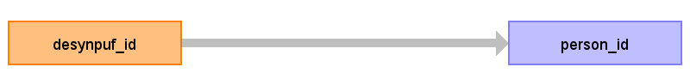

|  |  |  |  |
| --- | --- | --- | --- |
| Destination Field | Source Field | Logic | Comment |
| payer_plan_period_id |  |  |  |
| person_id | desynpuf_id |  |  |
| payer_plan_period_start_date |  |  |  |
| payer_plan_period_end_date |  |  |  |
| payer_source_value |  |  |  |
| plan_source_value |  |  |  |
| family_source_value |  |  |  |

Table name: device_cost

Table name: drug_era

Table name: dose_era

Table name: condition_era

Table name: cdm_source

Table name: cohort

Table name: cohort_definition

Table name: cohort_attribute

Table name: attribute_definition

Appendix: source tables

Table: beneficiary_summary

|  |  |  |  |
| --- | --- | --- | --- |
| Field | Type | Most freq. value | Comment |
| desynpuf_id | varchar | List truncated... |  |
| bene_birth_dt | int | 19421001 |  |
| bene_death_dt | int | 0 |  |
| bene_sex_ident_cd | smallint | 2 |  |
| bene_race_cd | smallint | 1 |  |
| bene_esrd_ind | varchar | 0 |  |
| sp_state_code | smallint | 5 |  |
| bene_county_cd | smallint | 200 | THIS CODE SPECIFIES THE SSA CODE FOR THE COUNTY OF RESIDENCE OF THE BENEFICIARY. EACH STATE HAS A SERIES OF CODES BEGINNING WITH '000' FOR EACH COUNTY WITHIN THAT STATE. CERTAIN CITIES WITHIN THAT STATE HAVE THEIR OWN CODE. COUNTY CODES MUST BE COMBINED WITH STATE CODES IN ORDER TO LOCATE THE SPECIFIC COUNTY. THE CODING SYSTEM IS THE SSA SYSTEM, NOT THE FEDERAL INFORMATION PROCESSING STANDARD (FIPS). |
| bene_hi_cvrage_tot_mons | smallint | 12 |  |
| bene_smi_cvrage_tot_mons | smallint | 12 |  |
| bene_hmo_cvrage_tot_mons | smallint | 0 |  |
| plan_cvrg_mos_num | smallint | 12 |  |
| sp_alzhdmta | smallint | 2 |  |
| sp_chf | smallint | 2 |  |
| sp_chrnkidn | smallint | 2 |  |
| sp_cncr | smallint | 2 |  |
| sp_copd | smallint | 2 |  |
| sp_depressn | smallint | 2 |  |
| sp_diabetes | smallint | 2 |  |
| sp_ischmcht | smallint | 2 |  |
| sp_osteoprs | smallint | 2 |  |
| sp_ra_oa | smallint | 2 |  |
| sp_strketia | smallint | 2 |  |
| medreimb_ip | real | 0.0 |  |
| benres_ip | real | 0.0 |  |
| pppymt_ip | real | 0.0 |  |
| medreimb_op | real | 0.0 |  |
| benres_op | real | 0.0 |  |
| pppymt_op | real | 0.0 |  |
| medreimb_car | real | 0.0 |  |
| benres_car | real | 0.0 |  |
| pppymt_car | real | 0.0 |  |

Table: carrier_claims

|  |  |  |  |
| --- | --- | --- | --- |
| Field | Type | Most freq. value | Comment |
| desynpuf_id | varchar | AEF310232161AC91 |  |
| clm_id | bigint | List truncated... |  |
| clm_from_dt | int | 20090216 |  |
| clm_thru_dt | int | 20081106 |  |
| icd9_dgns_cd_1 | varchar | 4011 |  |
| icd9_dgns_cd_2 | varchar |  |  |
| icd9_dgns_cd_3 | varchar |  |  |
| icd9_dgns_cd_4 | varchar |  |  |
| icd9_dgns_cd_5 | varchar |  |  |
| icd9_dgns_cd_6 | varchar |  |  |
| icd9_dgns_cd_7 | varchar |  |  |
| icd9_dgns_cd_8 | varchar |  |  |
| prf_physn_npi_1 | bigint | 888901330 |  |
| prf_physn_npi_2 | bigint | 0 |  |
| prf_physn_npi_3 | bigint | 0 |  |
| prf_physn_npi_4 | bigint | 0 |  |
| prf_physn_npi_5 | bigint | 0 |  |
| prf_physn_npi_6 | bigint | 0 |  |
| prf_physn_npi_7 | bigint | 0 |  |
| prf_physn_npi_8 | bigint | 0 |  |
| prf_physn_npi_9 | bigint | 0 |  |
| prf_physn_npi_10 | bigint | 0 |  |
| prf_physn_npi_11 | bigint | 0 |  |
| prf_physn_npi_12 | bigint | 0 |  |
| prf_physn_npi_13 | bigint | 0 |  |
| tax_num_1 | int | 532092265 |  |
| tax_num_2 | int | 0 |  |
| tax_num_3 | int | 0 |  |
| tax_num_4 | int | 0 |  |
| tax_num_5 | int | 0 |  |
| tax_num_6 | int | 0 |  |
| tax_num_7 | int | 0 |  |
| tax_num_8 | int | 0 |  |
| tax_num_9 | int | 0 |  |
| tax_num_10 | int | 0 |  |
| tax_num_11 | int | 0 |  |
| tax_num_12 | int | 0 |  |
| tax_num_13 | int | 0 |  |
| hcpcs_cd_1 | varchar | 99213 |  |
| hcpcs_cd_2 | varchar |  |  |
| hcpcs_cd_3 | varchar |  |  |
| hcpcs_cd_4 | varchar |  |  |
| hcpcs_cd_5 | varchar |  |  |
| hcpcs_cd_6 | varchar |  |  |
| hcpcs_cd_7 | varchar |  |  |
| hcpcs_cd_8 | varchar |  |  |
| hcpcs_cd_9 | varchar |  |  |
| hcpcs_cd_10 | varchar |  |  |
| hcpcs_cd_11 | varchar |  |  |
| hcpcs_cd_12 | varchar |  |  |
| hcpcs_cd_13 | varchar |  |  |
| line_nch_pmt_amt_1 | real | 0.0 |  |
| line_nch_pmt_amt_2 | real | 0.0 |  |
| line_nch_pmt_amt_3 | real | 0.0 |  |
| line_nch_pmt_amt_4 | real | 0.0 |  |
| line_nch_pmt_amt_5 | real | 0.0 |  |
| line_nch_pmt_amt_6 | real | 0.0 |  |
| line_nch_pmt_amt_7 | real | 0.0 |  |
| line_nch_pmt_amt_8 | real | 0.0 |  |
| line_nch_pmt_amt_9 | real | 0.0 |  |
| line_nch_pmt_amt_10 | real | 0.0 |  |
| line_nch_pmt_amt_11 | real | 0.0 |  |
| line_nch_pmt_amt_12 | real | 0.0 |  |
| line_nch_pmt_amt_13 | real | 0.0 |  |
| line_bene_ptb_ddctbl_amt_1 | real | 0.0 |  |
| line_bene_ptb_ddctbl_amt_2 | real | 0.0 |  |
| line_bene_ptb_ddctbl_amt_3 | real | 0.0 |  |
| line_bene_ptb_ddctbl_amt_4 | real | 0.0 |  |
| line_bene_ptb_ddctbl_amt_5 | real | 0.0 |  |
| line_bene_ptb_ddctbl_amt_6 | real | 0.0 |  |
| line_bene_ptb_ddctbl_amt_7 | real | 0.0 |  |
| line_bene_ptb_ddctbl_amt_8 | real | 0.0 |  |
| line_bene_ptb_ddctbl_amt_9 | real | 0.0 |  |
| line_bene_ptb_ddctbl_amt_10 | real | 0.0 |  |
| line_bene_ptb_ddctbl_amt_11 | real | 0.0 |  |
| line_bene_ptb_ddctbl_amt_12 | real | 0.0 |  |
| line_bene_ptb_ddctbl_amt_13 | real | 0.0 |  |
| line_bene_prmry_pyr_pd_amt_1 | real | 0.0 |  |
| line_bene_prmry_pyr_pd_amt_2 | real | 0.0 |  |
| line_bene_prmry_pyr_pd_amt_3 | real | 0.0 |  |
| line_bene_prmry_pyr_pd_amt_4 | real | 0.0 |  |
| line_bene_prmry_pyr_pd_amt_5 | real | 0.0 |  |
| line_bene_prmry_pyr_pd_amt_6 | real | 0.0 |  |
| line_bene_prmry_pyr_pd_amt_7 | real | 0.0 |  |
| line_bene_prmry_pyr_pd_amt_8 | real | 0.0 |  |
| line_bene_prmry_pyr_pd_amt_9 | real | 0.0 |  |
| line_bene_prmry_pyr_pd_amt_10 | real | 0.0 |  |
| line_bene_prmry_pyr_pd_amt_11 | real | 0.0 |  |
| line_bene_prmry_pyr_pd_amt_12 | real | 0.0 |  |
| line_bene_prmry_pyr_pd_amt_13 | real | 0.0 |  |
| line_coinsrnc_amt_1 | real | 0.0 |  |
| line_coinsrnc_amt_2 | real | 0.0 |  |
| line_coinsrnc_amt_3 | real | 0.0 |  |
| line_coinsrnc_amt_4 | real | 0.0 |  |
| line_coinsrnc_amt_5 | real | 0.0 |  |
| line_coinsrnc_amt_6 | real | 0.0 |  |
| line_coinsrnc_amt_7 | real | 0.0 |  |
| line_coinsrnc_amt_8 | real | 0.0 |  |
| line_coinsrnc_amt_9 | real | 0.0 |  |
| line_coinsrnc_amt_10 | real | 0.0 |  |
| line_coinsrnc_amt_11 | real | 0.0 |  |
| line_coinsrnc_amt_12 | real | 0.0 |  |
| line_coinsrnc_amt_13 | real | 0.0 |  |
| line_alowd_chrg_amt_1 | real | 10.0 |  |
| line_alowd_chrg_amt_2 | real | 0.0 |  |
| line_alowd_chrg_amt_3 | real | 0.0 |  |
| line_alowd_chrg_amt_4 | real | 0.0 |  |
| line_alowd_chrg_amt_5 | real | 0.0 |  |
| line_alowd_chrg_amt_6 | real | 0.0 |  |
| line_alowd_chrg_amt_7 | real | 0.0 |  |
| line_alowd_chrg_amt_8 | real | 0.0 |  |
| line_alowd_chrg_amt_9 | real | 0.0 |  |
| line_alowd_chrg_amt_10 | real | 0.0 |  |
| line_alowd_chrg_amt_11 | real | 0.0 |  |
| line_alowd_chrg_amt_12 | real | 0.0 |  |
| line_alowd_chrg_amt_13 | real | 0.0 |  |
| line_prcsg_ind_cd_1 | varchar | A |  |
| line_prcsg_ind_cd_2 | varchar |  |  |
| line_prcsg_ind_cd_3 | varchar |  |  |
| line_prcsg_ind_cd_4 | varchar |  |  |
| line_prcsg_ind_cd_5 | varchar |  |  |
| line_prcsg_ind_cd_6 | varchar |  |  |
| line_prcsg_ind_cd_7 | varchar |  |  |
| line_prcsg_ind_cd_8 | varchar |  |  |
| line_prcsg_ind_cd_9 | varchar |  |  |
| line_prcsg_ind_cd_10 | varchar |  |  |
| line_prcsg_ind_cd_11 | varchar |  |  |
| line_prcsg_ind_cd_12 | varchar |  |  |
| line_prcsg_ind_cd_13 | varchar |  |  |
| line_icd9_dgns_cd_1 | varchar | 4019 |  |
| line_icd9_dgns_cd_2 | varchar |  |  |
| line_icd9_dgns_cd_3 | varchar |  |  |
| line_icd9_dgns_cd_4 | varchar |  |  |
| line_icd9_dgns_cd_5 | varchar |  |  |
| line_icd9_dgns_cd_6 | varchar |  |  |
| line_icd9_dgns_cd_7 | varchar |  |  |
| line_icd9_dgns_cd_8 | varchar |  |  |
| line_icd9_dgns_cd_9 | varchar |  |  |
| line_icd9_dgns_cd_10 | varchar |  |  |
| line_icd9_dgns_cd_11 | varchar |  |  |
| line_icd9_dgns_cd_12 | varchar |  |  |
| line_icd9_dgns_cd_13 | varchar |  |  |

Table: inpatient_claims

|  |  |  |  |
| --- | --- | --- | --- |
| Field | Type | Most freq. value | Comment |
| desynpuf_id | varchar | List truncated... |  |
| clm_id | bigint | List truncated... |  |
| segment | smallint | 1 |  |
| clm_from_dt | int | 20080522 |  |
| clm_thru_dt | int | 20080529 |  |
| prvdr_num | varchar | 23006G |  |
| clm_pmt_amt | real | 4000.0 |  |
| nch_prmry_pyr_clm_pd_amt | real | 0.0 |  |
| at_physn_npi | bigint | 0 |  |
| op_physn_npi | bigint | 0 |  |
| ot_physn_npi | bigint | 0 |  |
| clm_admsn_dt | int | 20080522 |  |
| admtng_icd9_dgns_cd | varchar | 78605 |  |
| clm_pass_thru_per_diem_amt | real | 0.0 |  |
| nch_bene_ip_ddctbl_amt | real | 1024.0 |  |
| nch_bene_pta_coinsrnc_lblty_am | real | 0.0 |  |
| nch_bene_blood_ddctbl_lblty_am | real | 0.0 |  |
| clm_utlztn_day_cnt | int | 3 |  |
| nch_bene_dschrg_dt | int | 20080529 |  |
| clm_drg_cd | varchar | 882 |  |
| icd9_dgns_cd_1 | varchar | 486 |  |
| icd9_dgns_cd_2 | varchar | 4019 |  |
| icd9_dgns_cd_3 | varchar | 4019 |  |
| icd9_dgns_cd_4 | varchar | 4019 |  |
| icd9_dgns_cd_5 | varchar |  |  |
| icd9_dgns_cd_6 | varchar |  |  |
| icd9_dgns_cd_7 | varchar |  |  |
| icd9_dgns_cd_8 | varchar |  |  |
| icd9_dgns_cd_9 | varchar |  |  |
| icd9_dgns_cd_10 | varchar |  |  |
| icd9_prcdr_cd_1 | varchar |  |  |
| icd9_prcdr_cd_2 | varchar |  |  |
| icd9_prcdr_cd_3 | varchar |  |  |
| icd9_prcdr_cd_4 | varchar |  |  |
| icd9_prcdr_cd_5 | varchar |  |  |
| icd9_prcdr_cd_6 | varchar |  |  |
| hcpcs_cd_1 | varchar |  |  |
| hcpcs_cd_2 | varchar |  |  |
| hcpcs_cd_3 | varchar |  |  |
| hcpcs_cd_4 | varchar |  |  |
| hcpcs_cd_5 | varchar |  |  |
| hcpcs_cd_6 | varchar |  |  |
| hcpcs_cd_7 | varchar |  |  |
| hcpcs_cd_8 | varchar |  |  |
| hcpcs_cd_9 | varchar |  |  |
| hcpcs_cd_10 | varchar |  |  |
| hcpcs_cd_11 | varchar |  |  |
| hcpcs_cd_12 | varchar |  |  |
| hcpcs_cd_13 | varchar |  |  |
| hcpcs_cd_14 | varchar |  |  |
| hcpcs_cd_15 | varchar |  |  |
| hcpcs_cd_16 | varchar |  |  |
| hcpcs_cd_17 | varchar |  |  |
| hcpcs_cd_18 | varchar |  |  |
| hcpcs_cd_19 | varchar |  |  |
| hcpcs_cd_20 | varchar |  |  |
| hcpcs_cd_21 | varchar |  |  |
| hcpcs_cd_22 | varchar |  |  |
| hcpcs_cd_23 | varchar |  |  |
| hcpcs_cd_24 | varchar |  |  |
| hcpcs_cd_25 | varchar |  |  |
| hcpcs_cd_26 | varchar |  |  |
| hcpcs_cd_27 | varchar |  |  |
| hcpcs_cd_28 | varchar |  |  |
| hcpcs_cd_29 | varchar |  |  |
| hcpcs_cd_30 | varchar |  |  |
| hcpcs_cd_31 | varchar |  |  |
| hcpcs_cd_32 | varchar |  |  |
| hcpcs_cd_33 | varchar |  |  |
| hcpcs_cd_34 | varchar |  |  |
| hcpcs_cd_35 | varchar |  |  |
| hcpcs_cd_36 | varchar |  |  |
| hcpcs_cd_37 | varchar |  |  |
| hcpcs_cd_38 | varchar |  |  |
| hcpcs_cd_39 | varchar |  |  |
| hcpcs_cd_40 | varchar |  |  |
| hcpcs_cd_41 | varchar |  |  |
| hcpcs_cd_42 | varchar |  |  |
| hcpcs_cd_43 | varchar |  |  |
| hcpcs_cd_44 | varchar |  |  |
| hcpcs_cd_45 | varchar |  |  |

Table: prescription_drug_events

|  |  |  |  |
| --- | --- | --- | --- |
| Field | Type | Most freq. value | Comment |
| desynpuf_id | varchar | 91D777A10F0E8C60 |  |
| pde_id | bigint | List truncated... |  |
| srvc_dt | int | 20090323 |  |
| prod_srvc_id | varchar | 00002840099 |  |
| qty_dspnsd_num | real | 30.0 |  |
| days_suply_num | smallint | 30 |  |
| ptnt_pay_amt | real | 0.0 |  |
| tot_rx_cst_amt | real | 10.0 |  |

Table: outpatient_claims

|  |  |  |  |
| --- | --- | --- | --- |
| Field | Type | Most freq. value | Comment |
| desynpuf_id | varchar | AD5D4E087BF57C05 |  |
| clm_id | bigint | List truncated... |  |
| segment | smallint | 1 |  |
| clm_from_dt | int | 0 |  |
| clm_thru_dt | int | 0 |  |
| prvdr_num | varchar | 0502NA |  |
| clm_pmt_amt | real | 100.0 |  |
| nch_prmry_pyr_clm_pd_amt | real | 0.0 |  |
| at_physn_npi | bigint | 0 |  |
| op_physn_npi | bigint | 0 |  |
| ot_physn_npi | bigint | 0 |  |
| nch_bene_blood_ddctbl_lblty_am | real | 0.0 |  |
| icd9_dgns_cd_1 | varchar | 4019 |  |
| icd9_dgns_cd_2 | varchar |  |  |
| icd9_dgns_cd_3 | varchar |  |  |
| icd9_dgns_cd_4 | varchar |  |  |
| icd9_dgns_cd_5 | varchar |  |  |
| icd9_dgns_cd_6 | varchar |  |  |
| icd9_dgns_cd_7 | varchar |  |  |
| icd9_dgns_cd_8 | varchar |  |  |
| icd9_dgns_cd_9 | varchar |  |  |
| icd9_dgns_cd_10 | varchar |  |  |
| icd9_prcdr_cd_1 | varchar |  |  |
| icd9_prcdr_cd_2 | varchar |  |  |
| icd9_prcdr_cd_3 | varchar |  |  |
| icd9_prcdr_cd_4 | varchar |  |  |
| icd9_prcdr_cd_5 | varchar |  |  |
| icd9_prcdr_cd_6 | varchar |  |  |
| nch_bene_ptb_ddctbl_amt | real | 0.0 |  |
| nch_bene_ptb_coinsrnc_amt | real | 0.0 |  |
| admtng_icd9_dgns_cd | varchar |  |  |
| hcpcs_cd_1 | varchar | 36415 |  |
| hcpcs_cd_2 | varchar |  |  |
| hcpcs_cd_3 | varchar |  |  |
| hcpcs_cd_4 | varchar |  |  |
| hcpcs_cd_5 | varchar |  |  |
| hcpcs_cd_6 | varchar |  |  |
| hcpcs_cd_7 | varchar |  |  |
| hcpcs_cd_8 | varchar |  |  |
| hcpcs_cd_9 | varchar |  |  |
| hcpcs_cd_10 | varchar |  |  |
| hcpcs_cd_11 | varchar |  |  |
| hcpcs_cd_12 | varchar |  |  |
| hcpcs_cd_13 | varchar |  |  |
| hcpcs_cd_14 | varchar |  |  |
| hcpcs_cd_15 | varchar |  |  |
| hcpcs_cd_16 | varchar |  |  |
| hcpcs_cd_17 | varchar |  |  |
| hcpcs_cd_18 | varchar |  |  |
| hcpcs_cd_19 | varchar |  |  |
| hcpcs_cd_20 | varchar |  |  |
| hcpcs_cd_21 | varchar |  |  |
| hcpcs_cd_22 | varchar |  |  |
| hcpcs_cd_23 | varchar |  |  |
| hcpcs_cd_24 | varchar |  |  |
| hcpcs_cd_25 | varchar |  |  |
| hcpcs_cd_26 | varchar |  |  |
| hcpcs_cd_27 | varchar |  |  |
| hcpcs_cd_28 | varchar |  |  |
| hcpcs_cd_29 | varchar |  |  |
| hcpcs_cd_30 | varchar |  |  |
| hcpcs_cd_31 | varchar |  |  |
| hcpcs_cd_32 | varchar |  |  |
| hcpcs_cd_33 | varchar |  |  |
| hcpcs_cd_34 | varchar |  |  |
| hcpcs_cd_35 | varchar |  |  |
| hcpcs_cd_36 | varchar |  |  |
| hcpcs_cd_37 | varchar |  |  |
| hcpcs_cd_38 | varchar |  |  |
| hcpcs_cd_39 | varchar |  |  |
| hcpcs_cd_40 | varchar |  |  |
| hcpcs_cd_41 | varchar |  |  |
| hcpcs_cd_42 | varchar |  |  |
| hcpcs_cd_43 | varchar |  |  |
| hcpcs_cd_44 | varchar |  |  |
| hcpcs_cd_45 | varchar |  |  |