Source Data Mapping Approach

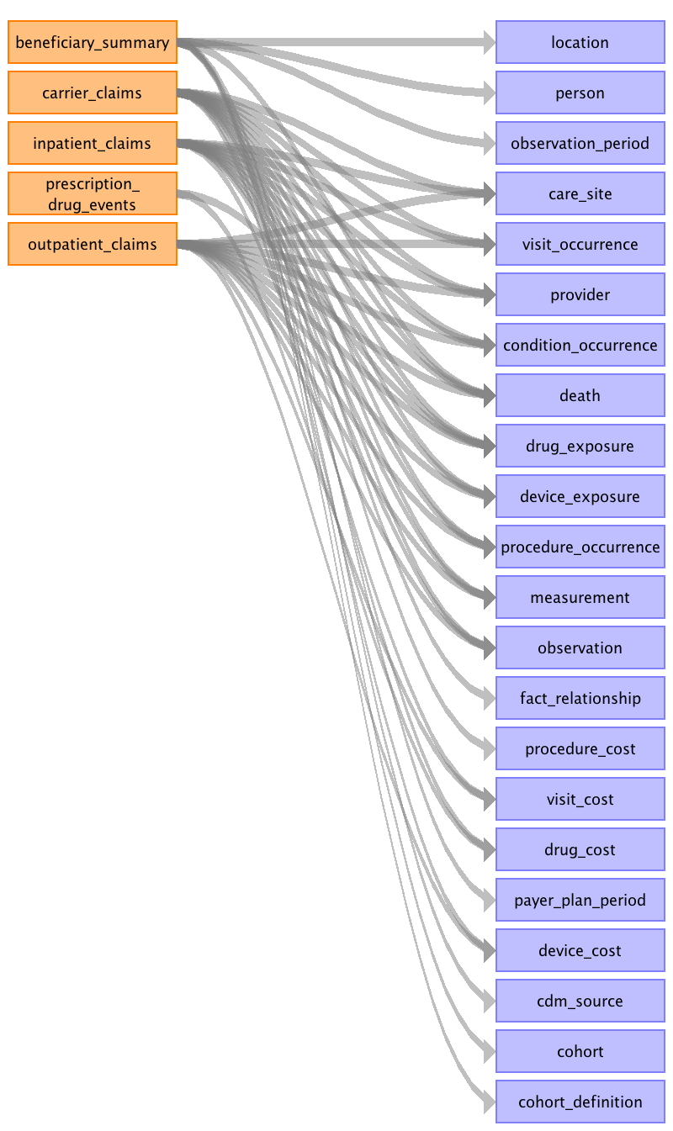

Table name: location

Reading from beneficiary_summary

SOURCE_TO_CONCEPT_MAP Entries:
BENE_RACE_CD
SP_STATE_CD
SSA Codes (http://www.resdac.org/cms-data/variables/County-Code) for COUNTY_CODE IN BENE_COUNTY_CD

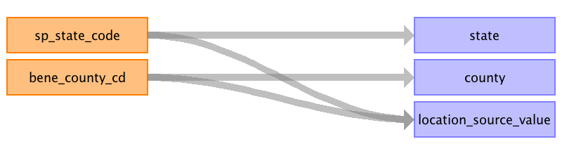

|  |  |  |  |
| --- | --- | --- | --- |
| Destination Field | Source Field | Logic | Comment |
| location_id |  |  |  |
| address_1 |  |  |  |
| address_2 |  |  |  |
| city |  |  |  |
| state | sp_state_code |  | The lookup SP_STATE_CODE lookup should be found in this document and added to the SOURCE_TO_CONCEPT_MAP: http://www.cms.gov/Research-Statistics-Data-and-Systems/Downloadable-Public-Use-Files/SynPUFs/Downloads/SynPUF_Codebook.pdf |
| zip |  |  |  |
| county | bene_county_cd |  | http://www.cms.gov/Research-Statistics-Data-and-Systems/Downloadable-Public-Use-Files/SynPUFs/Downloads/SynPUF_Codebook.pdf THIS CODE SPECIFIES THE SSA CODE FOR THE COUNTY OF RESIDENCE OF THE BENEFICIARY. EACH STATE HAS A SERIES OF CODES BEGINNING WITH '000' FOR EACH COUNTY WITHIN THAT STATE. CERTAIN CITIES WITHIN THAT STATE HAVE THEIR OWN CODE. COUNTY CODES MUST BE COMBINED WITH STATE CODES IN ORDER TO LOCATE THE SPECIFIC COUNTY. THE CODING SYSTEM IS THE SSA SYSTEM, NOT THE FEDERAL INFORMATION PROCESSING STANDARD (FIPS). http://www.resdac.org/cms-data/variables/County-Code These will need to be added to the SOURCE_TO_CONCEPT_MAP. |
| location_source_value | sp_state_code bene_county_cd |  |  |

Table name: person

Reading from beneficiary_summary

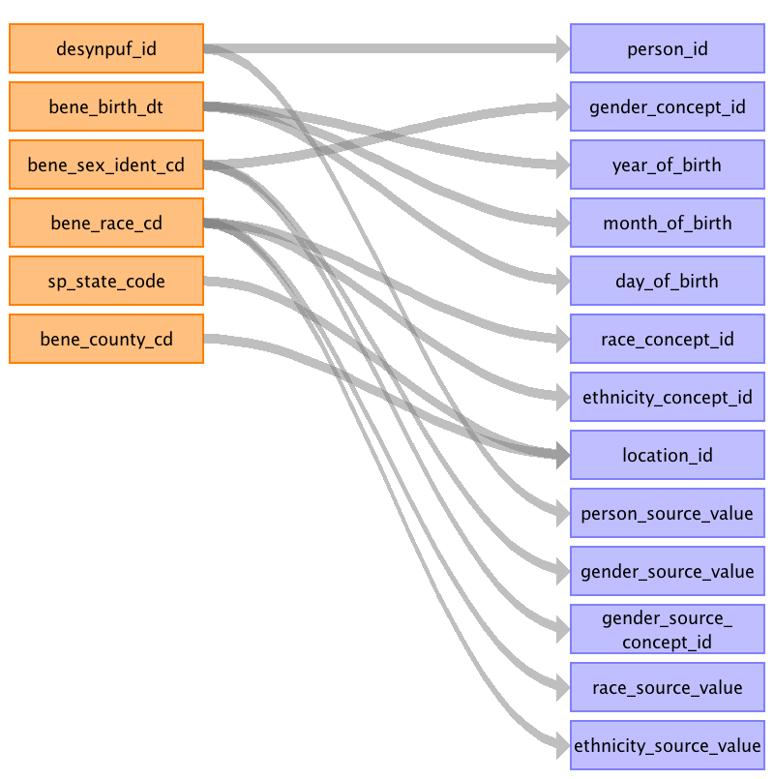

|  |  |  |  |
| --- | --- | --- | --- |
| Destination Field | Source Field | Logic | Comment |
| person_id | desynpuf_id |  |  |
| gender_concept_id | bene_sex_ident_cd | male: 1 = 8507 female: 2 = 8532 |  |
| year_of_birth | bene_birth_dt | Source is YYYYMMDD |  |
| month_of_birth | bene_birth_dt | Source is YYYYMMDD |  |
| day_of_birth | bene_birth_dt | Source is YYYYMMDD | We assume that the day of birth is set to '01' |
| time_of_birth |  |  | Null |
| race_concept_id | bene_race_cd | The manual lists the following: 0 = Unknown = 0 1 = White = 8527 2 = Black = 8516 3 = Other = 0 5 = Hispanic = 0 Do not believe these will exist so we may not put them in: 4 = Asian = 8515 6 = North American Native = 38003572 |  |
| ethnicity_concept_id | bene_race_cd | Manual Says These Exists: 0 = Unknown = 0 1 = White = 38003564 2 = Black = 38003564 3 = Other = 0 5 = Hispanic = 38003563 Possible Other Codes, Do Not Believe Exist in Data: 4 = Asian = 38003564 6 = North American Native = 38003564 |  |
| location_id | sp_state_code bene_county_cd |  | Lookup based on the source values. |
| provider_id |  |  | Null |
| care_site_id |  |  | Null |
| person_source_value | desynpuf_id |  |  |
| gender_source_value | bene_sex_ident_cd |  | Translate into human readable text. |
| gender_source_concept_id | bene_sex_ident_cd |  | <<ACTION ITEM>> We need to know if the source is using a standard, is that in the vocabulary already? 0 |
| race_source_value | bene_race_cd |  | Put a readable label. |
| race_source_concept_id |  |  |  |
| ethnicity_source_value | bene_race_cd |  | Put a readable label. |
| ethnicity_source_concept_id |  |  |  |

Table name: observation_period

Reading from beneficiary_summary

We are going to look at birth and death date.
We know which months they had claims.
We know how many months they had coverages.
If MONTH = 0 they were not enrolled for that year.
IF MONTH > 0 then they were enrolled.
MONTH = any of these variables: BENE_HI_CVRAGE_TOT_MONS, BENE_SMI_CVRAGE_TOT_MONS, BENE_HMO_CVRAGE_TOT_MONS, PLAN_CVRG_MONS_NUM
We will use the birth and death to correct the tails.
birth = BENE_BIRTH_DT
death = BENE_DEATH_DT
We need to knit the records together the years.

no overlapping observation periods

Generated

|  |  |  |  |
| --- | --- | --- | --- |
| Destination Field | Source Field | Logic | Comment |
| observation_period_id |  |  |  |
| person_id |  |  |  |
| observation_period_start_date |  |  |  |
| observation_period_end_date |  |  |  |
| period_type_concept_id |  |  |  |

Table name: care_site

Reading from outpatient_claims

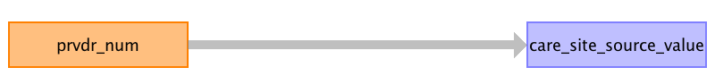

|  |  |  |  |
| --- | --- | --- | --- |
| Destination Field | Source Field | Logic | Comment |
| care_site_id |  |  | Autogenerated, you pull all columns and put distinct values here. |
| care_site_name |  |  |  |
| place_of_service_concept_id |  |  | INPATIENT_CLAIMS: 8717-Inpatient Hospital OUTPATIENT_CLAIMS: 8756-Outpatient Hospital CARRIER_CLAIMS: 8940-Office |
| location_id |  |  |  |
| care_site_source_value | prvdr_num |  |  |
| place_of_service_source_value |  |  | INPATIENT_CLAIMS = "Inpatient Facility" OUTPATIENT_CLAIMS = "Outpatient Facility" |

Reading from inpatient_claims



|  |  |  |  |
| --- | --- | --- | --- |
| Destination Field | Source Field | Logic | Comment |
| care_site_id |  |  | Autogenerated, you pull all columns and put distinct values here. |
| care_site_name |  |  |  |
| place_of_service_concept_id |  |  | INPATIENT_CLAIMS: 8717-Inpatient Hospital OUTPATIENT_CLAIMS: 8756-Outpatient Hospital CARRIER_CLAIMS: 8940-Office |
| location_id |  |  |  |
| care_site_source_value | prvdr_num |  |  |
| place_of_service_source_value |  |  | INPATIENT_CLAIMS = "Inpatient Facility" OUTPATIENT_CLAIMS = "Outpatient Facility" |

Reading from carrier_claims

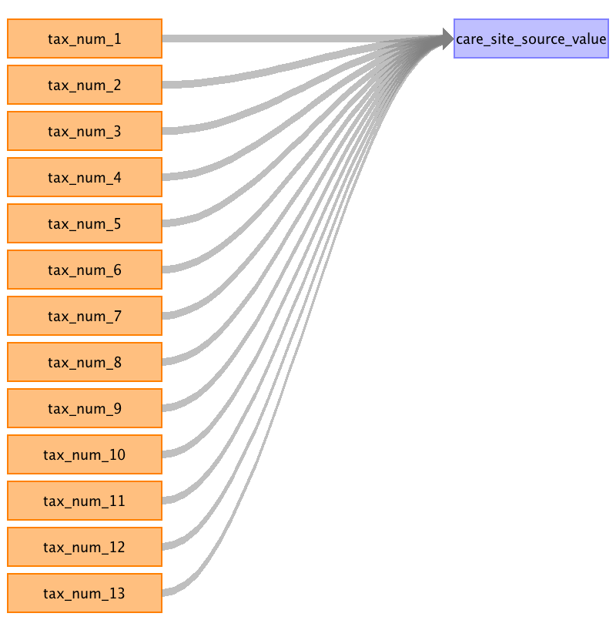

|  |  |  |  |
| --- | --- | --- | --- |
| Destination Field | Source Field | Logic | Comment |
| care_site_id |  |  | Autogenerated, you pull all columns and put distinct values here. |
| care_site_name |  |  |  |
| place_of_service_concept_id |  |  | INPATIENT_CLAIMS: 8717-Inpatient Hospital OUTPATIENT_CLAIMS: 8756-Outpatient Hospital CARRIER_CLAIMS: 8940-Office |
| location_id |  |  |  |
| care_site_source_value | tax_num_1 tax_num_2 tax_num_3 tax_num_4 tax_num_5 tax_num_6 tax_num_7 tax_num_8 tax_num_9 tax_num_10 tax_num_11 tax_num_12 tax_num_13 |  |  |
| place_of_service_source_value |  |  | INPATIENT_CLAIMS = "Inpatient Facility" OUTPATIENT_CLAIMS = "Outpatient Facility" |

Table name: visit_occurrence

Reading from carrier_claims

A unique visit is defined by a CLAIM_ID
Visit Roll-Up Logic:
(1--)INPATIENT logic:
(1A)CARRIER_CLAIM is within an INPATIENT_CLAIM, it becomes part of that VISIT_OCCURRENCE
(1B)OP within IP logic
(1B1)OP that ends the day an IP start or starts before IP, OP gets its own visit
(1B2)OP in the middle of an IP, it adopts the IP visit
(1B3)OP starts on the end of an IP visit, OP gets its own visit
(2--)OUTPATIENT logic:
(2A)On one day, there is one OP and one CC, they share NPI, we link them
(2B)On one day, there is one OP and one CC, they do not share an NPI, we end up with 2 visits
(2C)One OP, and two CC visits, CC1 shares an NPI, CC2 does not, CC1 and OP share a visit, and CC2 is its own visit.
(2D)One OP, and two CC that all share NPIs, they all become one visit.
(2E)Two OP visits, and one CC, if they share NPI connect ELSE end up with 3 visits.
(2F)If you have two OP visits, they do not combined.
(3--)CARRIER CLAIMS logic:
(3A)orphan CCs get categorized 0
In this data we cannot categorize an ER visit, there will only be IP and OP.

CARRIER_CLAIMS = 0 - ELSE
INPATIENT_CLAIMS = 9201 - Inpatient Visit
OUTPATIENT_CLAIMS = 9202 - Outpatient Visit

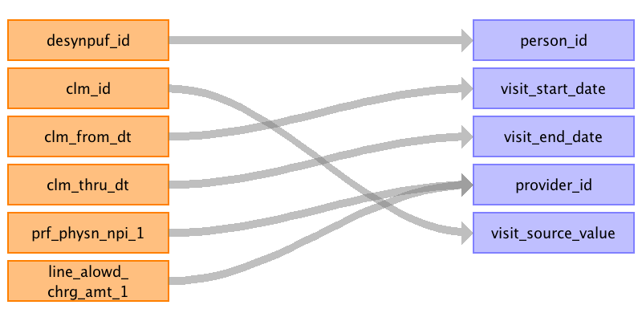

|  |  |  |  |
| --- | --- | --- | --- |
| Destination Field | Source Field | Logic | Comment |
| visit_occurrence_id |  |  | Autogenerated (possibly a hash lookup) |
| person_id | desynpuf_id |  |  |
| visit_concept_id |  |  | CARRIER_CLAIMS = 0 INPATIENT_CLAIMS = 9201 - Inpatient Visit OUTPATIENT_CLAIMS = 9202 - Outpatient Visit |
| visit_start_date | clm_from_dt |  |  |
| visit_start_time |  |  | Null |
| visit_end_date | clm_thru_dt |  |  |
| visit_end_time |  |  | Null |
| visit_type_concept_id |  |  | 44818517 - Visit derived from encounter on claim |
| provider_id | line_alowd_chrg_amt_1 prf_physn_npi_1 | Use the LIN_ALOWD_CHRG_AMT_# to find the column that has the MAX() amount. That column identifies the PRF_PHYSN_NPI_# that you need to choose. Alternate proposal (Optimal) - sum up by PRF_PHYSN_NPI the LIN_ALOWD_CHRG_AMT, the NPI with the larges charge amount wins the PROVIDER_ID. |  |
| care_site_id |  |  | CARRIER_CLAIMS: NULL |
| visit_source_value | clm_id |  |  |
| visit_source_concept_id |  |  | 0 |

Reading from outpatient_claims

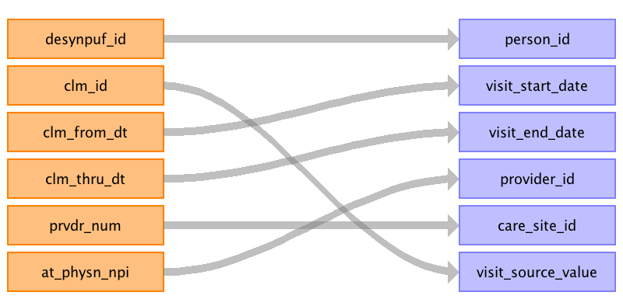

|  |  |  |  |
| --- | --- | --- | --- |
| Destination Field | Source Field | Logic | Comment |
| visit_occurrence_id |  |  | Autogenerated (possibly a hash lookup) |
| person_id | desynpuf_id |  |  |
| visit_concept_id |  |  | CARRIER_CLAIMS = 0 INPATIENT_CLAIMS = 9201 - Inpatient Visit OUTPATIENT_CLAIMS = 9202 - Outpatient Visit |
| visit_start_date | clm_from_dt |  |  |
| visit_start_time |  |  | Null |
| visit_end_date | clm_thru_dt |  |  |
| visit_end_time |  |  | Null |
| visit_type_concept_id |  |  | 44818517 - Visit derived from encounter on claim |
| provider_id | at_physn_npi | Lookup |  |
| care_site_id | prvdr_num | Lookup | CARRIER_CLAIMS: NULL |
| visit_source_value | clm_id |  |  |
| visit_source_concept_id |  |  | 0 |

Reading from inpatient_claims

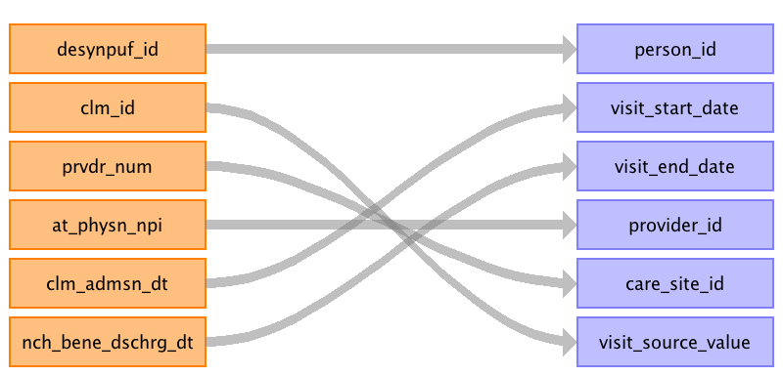

|  |  |  |  |
| --- | --- | --- | --- |
| Destination Field | Source Field | Logic | Comment |
| visit_occurrence_id |  |  | Autogenerated (possibly a hash lookup) |
| person_id | desynpuf_id |  |  |
| visit_concept_id |  |  | CARRIER_CLAIMS = 0 INPATIENT_CLAIMS = 9201 - Inpatient Visit OUTPATIENT_CLAIMS = 9202 - Outpatient Visit |
| visit_start_date | clm_admsn_dt |  |  |
| visit_start_time |  |  | Null |
| visit_end_date | nch_bene_dschrg_dt |  |  |
| visit_end_time |  |  | Null |
| visit_type_concept_id |  |  | 44818517 - Visit derived from encounter on claim |
| provider_id | at_physn_npi | Lookup in PROVIDER table. |  |
| care_site_id | prvdr_num | INPATIENT_CLAIMS: Lookup with the PRVDR_NUM | CARRIER_CLAIMS: NULL |
| visit_source_value | clm_id |  |  |
| visit_source_concept_id |  |  | 0 |

Table name: provider

Reading from carrier_claims

Tax_IDs will be used in the Care_Site table as locations for the physician offices.

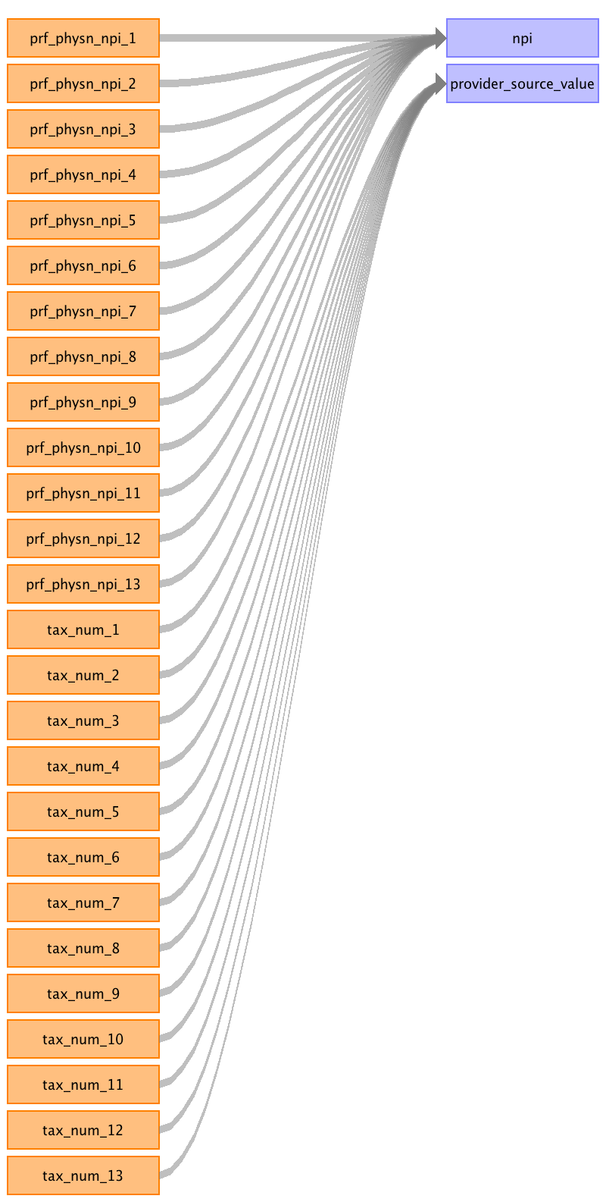

|  |  |  |  |
| --- | --- | --- | --- |
| Destination Field | Source Field | Logic | Comment |
| provider_id |  |  | Autogenerated |
| provider_name |  |  | Null |
| npi | prf_physn_npi_1 prf_physn_npi_2 prf_physn_npi_3 prf_physn_npi_4 prf_physn_npi_5 prf_physn_npi_6 prf_physn_npi_7 prf_physn_npi_8 prf_physn_npi_9 prf_physn_npi_10 prf_physn_npi_11 prf_physn_npi_12 prf_physn_npi_13 |  |  |
| dea |  |  | Null |
| specialty_concept_id |  |  | 0 |
| care_site_id |  |  | Null |
| year_of_birth |  |  | Null |
| gender_concept_id |  |  | 0 |
| provider_source_value | tax_num_1 tax_num_2 tax_num_3 tax_num_4 tax_num_5 tax_num_6 tax_num_7 tax_num_8 tax_num_9 tax_num_10 tax_num_11 tax_num_12 tax_num_13 |  |  |
| specialty_source_value |  |  | Null |
| specialty_source_concept_id |  |  | 0 |
| gender_source_value |  |  | Null |
| gender_source_concept_id |  |  | 0 |

Reading from outpatient_claims

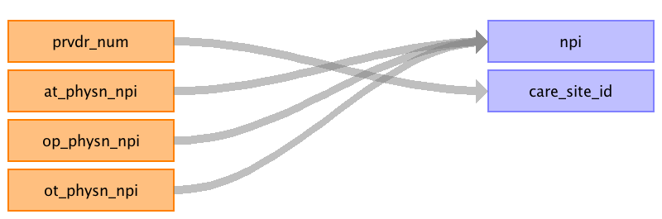

|  |  |  |  |
| --- | --- | --- | --- |
| Destination Field | Source Field | Logic | Comment |
| provider_id |  |  | Autogenerated |
| provider_name |  |  | Null |
| npi | at_physn_npi op_physn_npi ot_physn_npi |  |  |
| dea |  |  | Null |
| specialty_concept_id |  |  | 0 |
| care_site_id | prvdr_num |  | Lookup in the CARE_SITE table. Null |
| year_of_birth |  |  | Null |
| gender_concept_id |  |  | 0 |
| provider_source_value |  |  |  |
| specialty_source_value |  |  | Null |
| specialty_source_concept_id |  |  | 0 |
| gender_source_value |  |  | Null |
| gender_source_concept_id |  |  | 0 |

Reading from inpatient_claims



|  |  |  |  |
| --- | --- | --- | --- |
| Destination Field | Source Field | Logic | Comment |
| provider_id |  |  | Autogenerated |
| provider_name |  |  | Null |
| npi | at_physn_npi op_physn_npi ot_physn_npi |  |  |
| dea |  |  | Null |
| specialty_concept_id |  |  | 0 |
| care_site_id | prvdr_num | You need to look up the CARE_SITE_ID | Null |
| year_of_birth |  |  | Null |
| gender_concept_id |  |  | 0 |
| provider_source_value |  |  |  |
| specialty_source_value |  |  | Null |
| specialty_source_concept_id |  |  | 0 |
| gender_source_value |  |  | Null |
| gender_source_concept_id |  |  | 0 |

Table name: condition_occurrence

Reading from carrier_claims

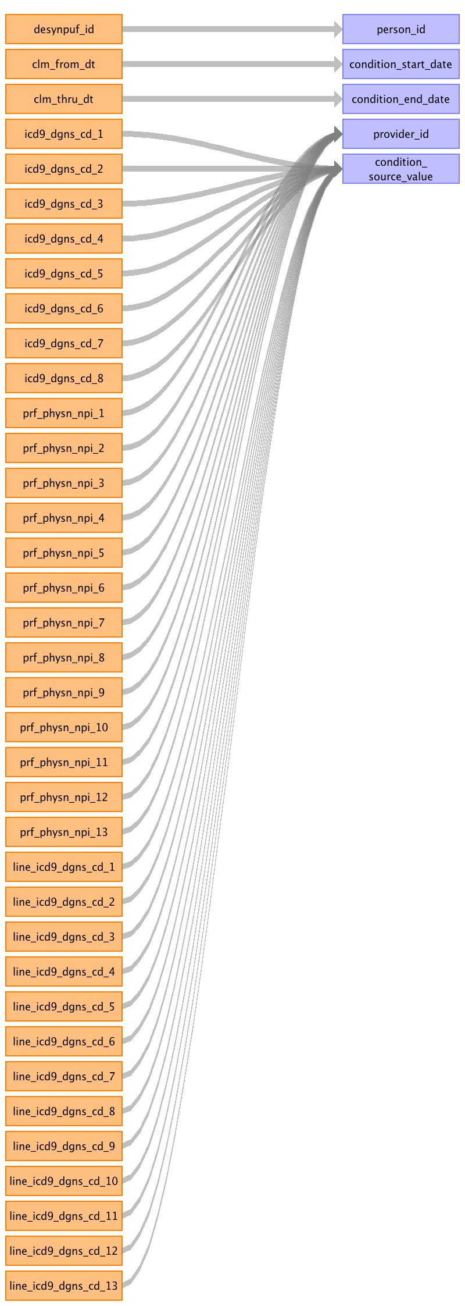

|  |  |  |  |
| --- | --- | --- | --- |
| Destination Field | Source Field | Logic | Comment |
| condition_occurrence_id |  |  | Autogenerated |
| person_id | desynpuf_id |  |  |
| condition_concept_id |  |  | Mapping from CONDITION_SOURCE_VALUE into SNOMED (INVALID_REASON IS NULL). |
| condition_start_date | clm_from_dt | YYYYMMDD converted to date. | YYYYMMDD converted to date. |
| condition_end_date | clm_thru_dt | YYYYMMDD converted to date. | YYYYMMDD converted to date. |
| condition_type_concept_id |  |  | Line diagnosis are details and the claim diagnosis are headers. Admitting diagnosis (ADMTNG_ICD9_DGNS_CD) is the last number (e.g. 11) CARRIER_CLAIMS: --ICD9_DGNS_CD_1 = 45756835 Carrier claim header - 1st position --ICD9_DGNS_CD_2 = 45756836 Carrier claim header - 2nd position --ICD9_DGNS_CD_3 = 45756837 Carrier claim header - 3rd position --ICD9_DGNS_CD_4 = 45756838 Carrier claim header - 4th position --ICD9_DGNS_CD_5 = 45756839 Carrier claim header - 5th position --ICD9_DGNS_CD_6 = 45756840 Carrier claim header - 6th position --ICD9_DGNS_CD_7 = 45756841 Carrier claim header - 7th position --ICD9_DGNS_CD_8 = 45756842 Carrier claim header - 8th position --LINE_ICD9_DGNS_CD_1 = 45756843 Carrier claim detail - 1st position --LINE_ICD9_DGNS_CD_2 = 45756844 Carrier claim detail - 2nd position --LINE_ICD9_DGNS_CD_3 = 45756845 Carrier claim detail - 3rd position --LINE_ICD9_DGNS_CD_4 = 45756846 Carrier claim detail - 4th position --LINE_ICD9_DGNS_CD_5 = 45756847 Carrier claim detail - 5th position --LINE_ICD9_DGNS_CD_6 = 45756848 Carrier claim detail - 6th position --LINE_ICD9_DGNS_CD_7 = 45756849 Carrier claim detail - 7th position --LINE_ICD9_DGNS_CD_8 = 45756850 Carrier claim detail - 8th position --LINE_ICD9_DGNS_CD_9 = 45756851 Carrier claim detail - 9th position --LINE_ICD9_DGNS_CD_10 = 45756852 Carrier claim detail - 10th position --LINE_ICD9_DGNS_CD_11 = 45756853 Carrier claim detail - 11th position --LINE_ICD9_DGNS_CD_12 = 45756855 Carrier claim detail - 13th position --LINE_ICD9_DGNS_CD_13 = 45756855 Carrier claim detail - 13th position INPATIENT_CLAIMS: --ICD9_DGNS_CD_1 = 38000200-Inpatient header - 1st position --ICD9_DGNS_CD_2 = 38000201-Inpatient header - 2nd position --ICD9_DGNS_CD_3 = 38000202-Inpatient header - 3rd position --ICD9_DGNS_CD_4 = 38000203-Inpatient header - 4th position --ICD9_DGNS_CD_5 = 38000204-Inpatient header - 5th position --ICD9_DGNS_CD_6 = 38000205-Inpatient header - 6th position --ICD9_DGNS_CD_7 = 38000206-Inpatient header - 7th position --ICD9_DGNS_CD_8 = 38000207-Inpatient header - 8th position --ICD9_DGNS_CD_9 = 38000208-Inpatient header - 9th position --ICD9_DGNS_CD_10 = 38000209-Inpatient header - 10th position --ADMTNG_ICD9_DGNS_CD = 38000210-Inpatient header - 11th position OUTPATEINT_CLAIMS: --ICD9_DGNS_CD_1 = 38000230-Outpatient header - 1st position --ICD9_DGNS_CD_2 = 38000231-Outpatient header - 2nd position --ICD9_DGNS_CD_3 = 38000232-Outpatient header - 3rd position --ICD9_DGNS_CD_4 = 38000233-Outpatient header - 4th position --ICD9_DGNS_CD_5 = 38000234-Outpatient header - 5th position --ICD9_DGNS_CD_6 = 38000235-Outpatient header - 6th position --ICD9_DGNS_CD_7 = 38000236-Outpatient header - 7th position --ICD9_DGNS_CD_8 = 38000237-Outpatient header - 8th position --ICD9_DGNS_CD_9 = 38000238-Outpatient header - 9th position --ICD9_DGNS_CD_10 = 38000239-Outpatient header - 10th position |
| stop_reason |  |  | NULL |
| provider_id | prf_physn_npi_1 prf_physn_npi_2 prf_physn_npi_3 prf_physn_npi_4 prf_physn_npi_5 prf_physn_npi_6 prf_physn_npi_7 prf_physn_npi_8 prf_physn_npi_9 prf_physn_npi_10 prf_physn_npi_11 prf_physn_npi_12 prf_physn_npi_13 |  | CARRIER_CLAIMS: Lookup the PROVIDER_ID in the PROVIDER table. Associate a PROVIDER_ID with the ICD9 line item it goes with. The claim ICD9s will not get a PROVIDER_ID. INPATIENT & OUTPATIENT_CLAIMS: All get mapped to the AT_PHYSN_NPI |
| visit_occurrence_id |  |  | Associated to right VISIT_OCCURENCE. |
| condition_source_value | icd9_dgns_cd_1 icd9_dgns_cd_2 icd9_dgns_cd_3 icd9_dgns_cd_4 icd9_dgns_cd_5 icd9_dgns_cd_6 icd9_dgns_cd_7 line_icd9_dgns_cd_1 icd9_dgns_cd_8 line_icd9_dgns_cd_2 line_icd9_dgns_cd_3 line_icd9_dgns_cd_4 line_icd9_dgns_cd_5 line_icd9_dgns_cd_6 line_icd9_dgns_cd_7 line_icd9_dgns_cd_8 line_icd9_dgns_cd_9 line_icd9_dgns_cd_10 line_icd9_dgns_cd_11 line_icd9_dgns_cd_12 line_icd9_dgns_cd_13 |  |  |
| condition_source_concept_id |  |  | Map the CONDITION_SOURCE_VALUE to ICD9 CONCEPT_IDs. |

Reading from outpatient_claims

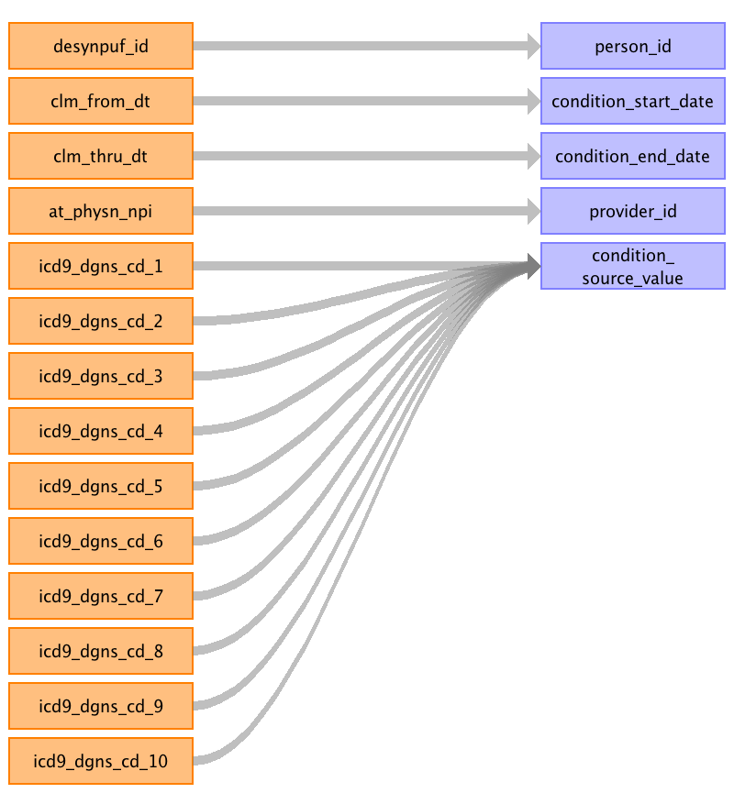

|  |  |  |  |
| --- | --- | --- | --- |
| Destination Field | Source Field | Logic | Comment |
| condition_occurrence_id |  |  | Autogenerated |
| person_id | desynpuf_id |  |  |
| condition_concept_id |  |  | Mapping from CONDITION_SOURCE_VALUE into SNOMED (INVALID_REASON IS NULL). |
| condition_start_date | clm_from_dt |  | YYYYMMDD converted to date. |
| condition_end_date | clm_thru_dt |  | YYYYMMDD converted to date. |
| condition_type_concept_id |  |  | Line diagnosis are details and the claim diagnosis are headers. Admitting diagnosis (ADMTNG_ICD9_DGNS_CD) is the last number (e.g. 11) CARRIER_CLAIMS: --ICD9_DGNS_CD_1 = 45756835 Carrier claim header - 1st position --ICD9_DGNS_CD_2 = 45756836 Carrier claim header - 2nd position --ICD9_DGNS_CD_3 = 45756837 Carrier claim header - 3rd position --ICD9_DGNS_CD_4 = 45756838 Carrier claim header - 4th position --ICD9_DGNS_CD_5 = 45756839 Carrier claim header - 5th position --ICD9_DGNS_CD_6 = 45756840 Carrier claim header - 6th position --ICD9_DGNS_CD_7 = 45756841 Carrier claim header - 7th position --ICD9_DGNS_CD_8 = 45756842 Carrier claim header - 8th position --LINE_ICD9_DGNS_CD_1 = 45756843 Carrier claim detail - 1st position --LINE_ICD9_DGNS_CD_2 = 45756844 Carrier claim detail - 2nd position --LINE_ICD9_DGNS_CD_3 = 45756845 Carrier claim detail - 3rd position --LINE_ICD9_DGNS_CD_4 = 45756846 Carrier claim detail - 4th position --LINE_ICD9_DGNS_CD_5 = 45756847 Carrier claim detail - 5th position --LINE_ICD9_DGNS_CD_6 = 45756848 Carrier claim detail - 6th position --LINE_ICD9_DGNS_CD_7 = 45756849 Carrier claim detail - 7th position --LINE_ICD9_DGNS_CD_8 = 45756850 Carrier claim detail - 8th position --LINE_ICD9_DGNS_CD_9 = 45756851 Carrier claim detail - 9th position --LINE_ICD9_DGNS_CD_10 = 45756852 Carrier claim detail - 10th position --LINE_ICD9_DGNS_CD_11 = 45756853 Carrier claim detail - 11th position --LINE_ICD9_DGNS_CD_12 = 45756855 Carrier claim detail - 13th position --LINE_ICD9_DGNS_CD_13 = 45756855 Carrier claim detail - 13th position INPATIENT_CLAIMS: --ICD9_DGNS_CD_1 = 38000200-Inpatient header - 1st position --ICD9_DGNS_CD_2 = 38000201-Inpatient header - 2nd position --ICD9_DGNS_CD_3 = 38000202-Inpatient header - 3rd position --ICD9_DGNS_CD_4 = 38000203-Inpatient header - 4th position --ICD9_DGNS_CD_5 = 38000204-Inpatient header - 5th position --ICD9_DGNS_CD_6 = 38000205-Inpatient header - 6th position --ICD9_DGNS_CD_7 = 38000206-Inpatient header - 7th position --ICD9_DGNS_CD_8 = 38000207-Inpatient header - 8th position --ICD9_DGNS_CD_9 = 38000208-Inpatient header - 9th position --ICD9_DGNS_CD_10 = 38000209-Inpatient header - 10th position --ADMTNG_ICD9_DGNS_CD = 38000210-Inpatient header - 11th position OUTPATEINT_CLAIMS: --ICD9_DGNS_CD_1 = 38000230-Outpatient header - 1st position --ICD9_DGNS_CD_2 = 38000231-Outpatient header - 2nd position --ICD9_DGNS_CD_3 = 38000232-Outpatient header - 3rd position --ICD9_DGNS_CD_4 = 38000233-Outpatient header - 4th position --ICD9_DGNS_CD_5 = 38000234-Outpatient header - 5th position --ICD9_DGNS_CD_6 = 38000235-Outpatient header - 6th position --ICD9_DGNS_CD_7 = 38000236-Outpatient header - 7th position --ICD9_DGNS_CD_8 = 38000237-Outpatient header - 8th position --ICD9_DGNS_CD_9 = 38000238-Outpatient header - 9th position --ICD9_DGNS_CD_10 = 38000239-Outpatient header - 10th position |
| stop_reason |  |  | NULL |
| provider_id | at_physn_npi |  | CARRIER_CLAIMS: Lookup the PROVIDER_ID in the PROVIDER table. Associate a PROVIDER_ID with the ICD9 line item it goes with. The claim ICD9s will not get a PROVIDER_ID. INPATIENT & OUTPATIENT_CLAIMS: All get mapped to the AT_PHYSN_NPI |
| visit_occurrence_id |  |  | Associated to right VISIT_OCCURENCE. |
| condition_source_value | icd9_dgns_cd_1 icd9_dgns_cd_2 icd9_dgns_cd_3 icd9_dgns_cd_4 icd9_dgns_cd_5 icd9_dgns_cd_6 icd9_dgns_cd_7 icd9_dgns_cd_8 icd9_dgns_cd_9 icd9_dgns_cd_10 |  |  |
| condition_source_concept_id |  |  | Map the CONDITION_SOURCE_VALUE to ICD9 CONCEPT_IDs. |

Reading from inpatient_claims

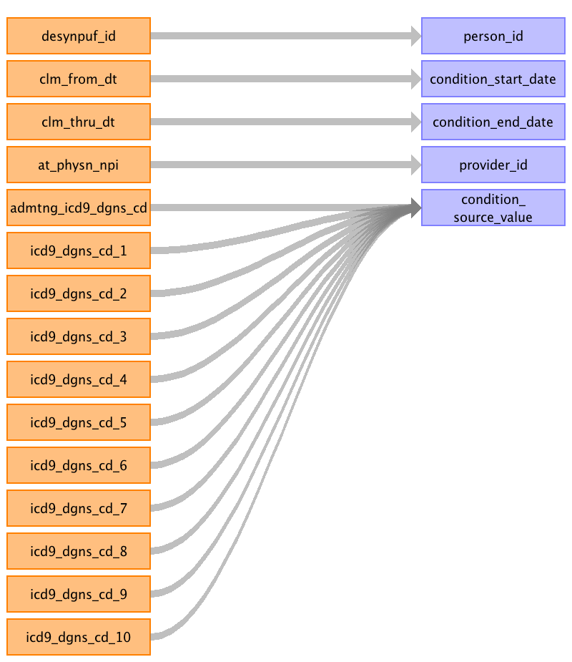

|  |  |  |  |
| --- | --- | --- | --- |
| Destination Field | Source Field | Logic | Comment |
| condition_occurrence_id |  |  | Autogenerated |
| person_id | desynpuf_id |  |  |
| condition_concept_id |  |  | Mapping from CONDITION_SOURCE_VALUE into SNOMED (INVALID_REASON IS NULL). |
| condition_start_date | clm_from_dt | YYYYMMDD convert to date. | YYYYMMDD converted to date. |
| condition_end_date | clm_thru_dt | YYYYMMDD convert to date. | YYYYMMDD converted to date. |
| condition_type_concept_id |  |  | Line diagnosis are details and the claim diagnosis are headers. Admitting diagnosis (ADMTNG_ICD9_DGNS_CD) is the last number (e.g. 11) CARRIER_CLAIMS: --ICD9_DGNS_CD_1 = 45756835 Carrier claim header - 1st position --ICD9_DGNS_CD_2 = 45756836 Carrier claim header - 2nd position --ICD9_DGNS_CD_3 = 45756837 Carrier claim header - 3rd position --ICD9_DGNS_CD_4 = 45756838 Carrier claim header - 4th position --ICD9_DGNS_CD_5 = 45756839 Carrier claim header - 5th position --ICD9_DGNS_CD_6 = 45756840 Carrier claim header - 6th position --ICD9_DGNS_CD_7 = 45756841 Carrier claim header - 7th position --ICD9_DGNS_CD_8 = 45756842 Carrier claim header - 8th position --LINE_ICD9_DGNS_CD_1 = 45756843 Carrier claim detail - 1st position --LINE_ICD9_DGNS_CD_2 = 45756844 Carrier claim detail - 2nd position --LINE_ICD9_DGNS_CD_3 = 45756845 Carrier claim detail - 3rd position --LINE_ICD9_DGNS_CD_4 = 45756846 Carrier claim detail - 4th position --LINE_ICD9_DGNS_CD_5 = 45756847 Carrier claim detail - 5th position --LINE_ICD9_DGNS_CD_6 = 45756848 Carrier claim detail - 6th position --LINE_ICD9_DGNS_CD_7 = 45756849 Carrier claim detail - 7th position --LINE_ICD9_DGNS_CD_8 = 45756850 Carrier claim detail - 8th position --LINE_ICD9_DGNS_CD_9 = 45756851 Carrier claim detail - 9th position --LINE_ICD9_DGNS_CD_10 = 45756852 Carrier claim detail - 10th position --LINE_ICD9_DGNS_CD_11 = 45756853 Carrier claim detail - 11th position --LINE_ICD9_DGNS_CD_12 = 45756855 Carrier claim detail - 13th position --LINE_ICD9_DGNS_CD_13 = 45756855 Carrier claim detail - 13th position INPATIENT_CLAIMS: --ICD9_DGNS_CD_1 = 38000200-Inpatient header - 1st position --ICD9_DGNS_CD_2 = 38000201-Inpatient header - 2nd position --ICD9_DGNS_CD_3 = 38000202-Inpatient header - 3rd position --ICD9_DGNS_CD_4 = 38000203-Inpatient header - 4th position --ICD9_DGNS_CD_5 = 38000204-Inpatient header - 5th position --ICD9_DGNS_CD_6 = 38000205-Inpatient header - 6th position --ICD9_DGNS_CD_7 = 38000206-Inpatient header - 7th position --ICD9_DGNS_CD_8 = 38000207-Inpatient header - 8th position --ICD9_DGNS_CD_9 = 38000208-Inpatient header - 9th position --ICD9_DGNS_CD_10 = 38000209-Inpatient header - 10th position --ADMTNG_ICD9_DGNS_CD = 38000210-Inpatient header - 11th position OUTPATEINT_CLAIMS: --ICD9_DGNS_CD_1 = 38000230-Outpatient header - 1st position --ICD9_DGNS_CD_2 = 38000231-Outpatient header - 2nd position --ICD9_DGNS_CD_3 = 38000232-Outpatient header - 3rd position --ICD9_DGNS_CD_4 = 38000233-Outpatient header - 4th position --ICD9_DGNS_CD_5 = 38000234-Outpatient header - 5th position --ICD9_DGNS_CD_6 = 38000235-Outpatient header - 6th position --ICD9_DGNS_CD_7 = 38000236-Outpatient header - 7th position --ICD9_DGNS_CD_8 = 38000237-Outpatient header - 8th position --ICD9_DGNS_CD_9 = 38000238-Outpatient header - 9th position --ICD9_DGNS_CD_10 = 38000239-Outpatient header - 10th position |
| stop_reason |  |  | NULL |
| provider_id | at_physn_npi |  | CARRIER_CLAIMS: Lookup the PROVIDER_ID in the PROVIDER table. Associate a PROVIDER_ID with the ICD9 line item it goes with. The claim ICD9s will not get a PROVIDER_ID. INPATIENT & OUTPATIENT_CLAIMS: All get mapped to the AT_PHYSN_NPI |
| visit_occurrence_id |  |  | Associated to right VISIT_OCCURENCE. |
| condition_source_value | admtng_icd9_dgns_cd icd9_dgns_cd_1 icd9_dgns_cd_2 icd9_dgns_cd_3 icd9_dgns_cd_4 icd9_dgns_cd_5 icd9_dgns_cd_6 icd9_dgns_cd_7 icd9_dgns_cd_8 icd9_dgns_cd_9 icd9_dgns_cd_10 |  |  |
| condition_source_concept_id |  |  | Map the CONDITION_SOURCE_VALUE to ICD9 CONCEPT_IDs. |

Table name: death

Reading from beneficiary_summary

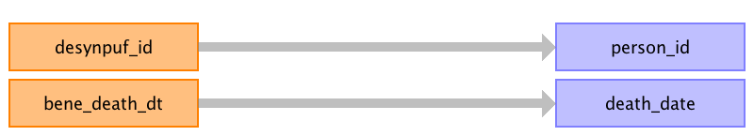

|  |  |  |  |
| --- | --- | --- | --- |
| Destination Field | Source Field | Logic | Comment |
| person_id | desynpuf_id |  |  |
| death_date | bene_death_dt |  |  |
| death_type_concept_id |  |  | Inpatient_claims, Outpatient_claims, Carrier_claims: 38003567 - death captured by condition Beneficiary_summary: 38003565 - Payer enrollment status "Deceased" |
| cause_concept_id |  |  | 0 |
| cause_source_value |  |  | Null |
| cause_source_concept_id |  |  | Inpatient_claims, Outpatient_claims, and Carrier_claims files: write record if ICD9 codes are one of the following: '7616','798','7980','7981','7982','7989','E9131','E978' Beneficiary_summary: 0 |

Reading from carrier_claims

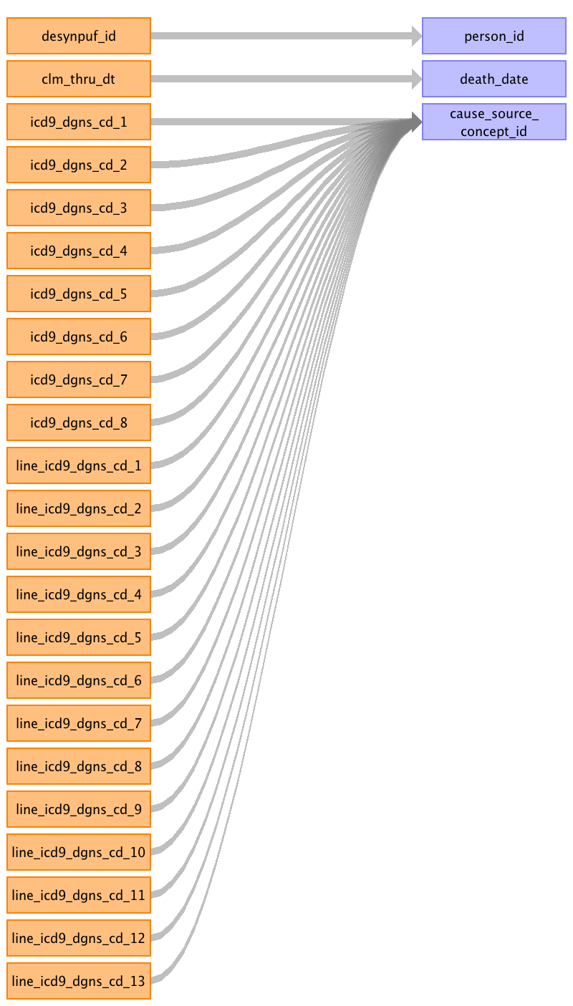

|  |  |  |  |
| --- | --- | --- | --- |
| Destination Field | Source Field | Logic | Comment |
| person_id | desynpuf_id |  |  |
| death_date | clm_thru_dt |  |  |
| death_type_concept_id |  |  | Inpatient_claims, Outpatient_claims, Carrier_claims: 38003567 - death captured by condition Beneficiary_summary: 38003565 - Payer enrollment status "Deceased" |
| cause_concept_id |  |  | 0 |
| cause_source_value |  |  | Null |
| cause_source_concept_id | icd9_dgns_cd_1 icd9_dgns_cd_2 icd9_dgns_cd_3 icd9_dgns_cd_4 icd9_dgns_cd_5 icd9_dgns_cd_6 icd9_dgns_cd_7 icd9_dgns_cd_8 line_icd9_dgns_cd_1 line_icd9_dgns_cd_2 line_icd9_dgns_cd_3 line_icd9_dgns_cd_4 line_icd9_dgns_cd_5 line_icd9_dgns_cd_6 line_icd9_dgns_cd_7 line_icd9_dgns_cd_8 line_icd9_dgns_cd_9 line_icd9_dgns_cd_10 line_icd9_dgns_cd_11 line_icd9_dgns_cd_12 line_icd9_dgns_cd_13 |  | Inpatient_claims, Outpatient_claims, and Carrier_claims files: write record if ICD9 codes are one of the following: '7616','798','7980','7981','7982','7989','E9131','E978' Beneficiary_summary: 0 |

Reading from inpatient_claims

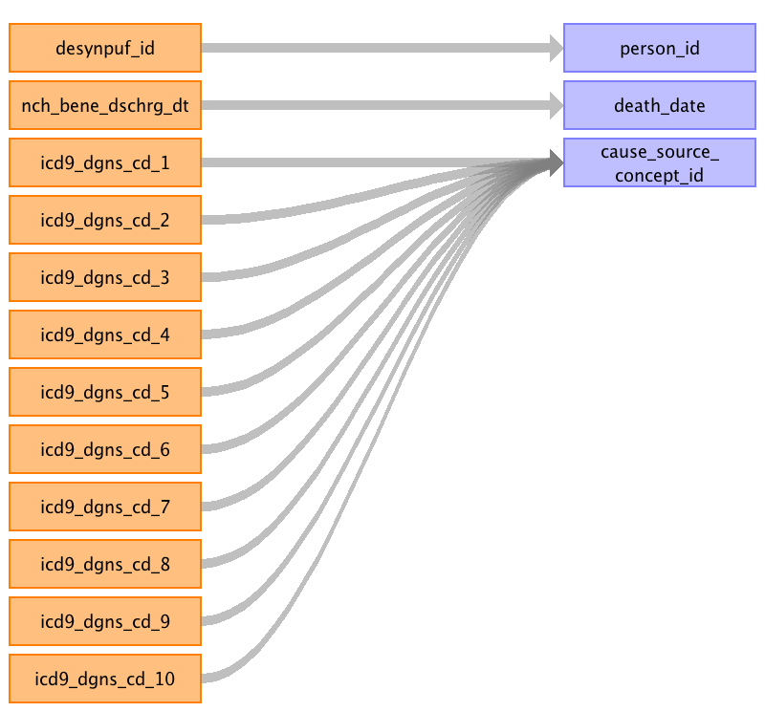

|  |  |  |  |
| --- | --- | --- | --- |
| Destination Field | Source Field | Logic | Comment |
| person_id | desynpuf_id |  |  |
| death_date | nch_bene_dschrg_dt |  |  |
| death_type_concept_id |  |  | Inpatient_claims, Outpatient_claims, Carrier_claims: 38003567 - death captured by condition Beneficiary_summary: 38003565 - Payer enrollment status "Deceased" |
| cause_concept_id |  |  | 0 |
| cause_source_value |  |  | Null |
| cause_source_concept_id | icd9_dgns_cd_1 icd9_dgns_cd_2 icd9_dgns_cd_3 icd9_dgns_cd_4 icd9_dgns_cd_5 icd9_dgns_cd_6 icd9_dgns_cd_7 icd9_dgns_cd_8 icd9_dgns_cd_9 icd9_dgns_cd_10 |  | Inpatient_claims, Outpatient_claims, and Carrier_claims files: write record if ICD9 codes are one of the following: '7616','798','7980','7981','7982','7989','E9131','E978' Beneficiary_summary: 0 |

Reading from outpatient_claims

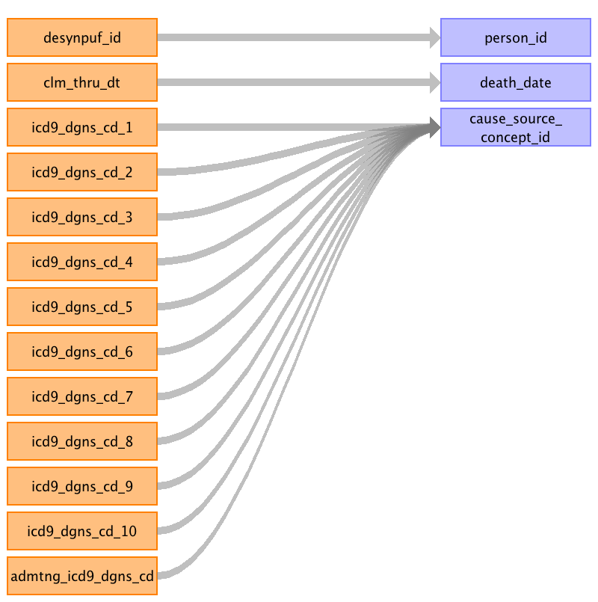

|  |  |  |  |
| --- | --- | --- | --- |
| Destination Field | Source Field | Logic | Comment |
| person_id | desynpuf_id |  |  |
| death_date | clm_thru_dt |  |  |
| death_type_concept_id |  |  | Inpatient_claims, Outpatient_claims, Carrier_claims: 38003567 - death captured by condition Beneficiary_summary: 38003565 - Payer enrollment status "Deceased" |
| cause_concept_id |  |  | 0 |
| cause_source_value |  |  | Null |
| cause_source_concept_id | icd9_dgns_cd_1 icd9_dgns_cd_2 icd9_dgns_cd_3 icd9_dgns_cd_4 icd9_dgns_cd_5 icd9_dgns_cd_6 icd9_dgns_cd_7 icd9_dgns_cd_8 icd9_dgns_cd_9 icd9_dgns_cd_10 admtng_icd9_dgns_cd |  | Inpatient_claims, Outpatient_claims, and Carrier_claims files: write record if ICD9 codes are one of the following: '7616','798','7980','7981','7982','7989','E9131','E978' Beneficiary_summary: 0 |

Table name: drug_exposure

Reading from prescription_drug_events

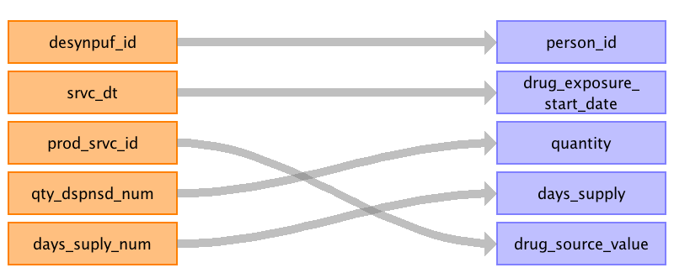

|  |  |  |  |
| --- | --- | --- | --- |
| Destination Field | Source Field | Logic | Comment |
| drug_exposure_id |  |  | Autogenerated |
| person_id | desynpuf_id |  |  |
| drug_concept_id |  |  | RX: Use the VOCABULARY to translate the NDC into a RxNorm CONCEPT_ID. CARRIER_CLAIMS & OUTPATIENT_CLAIMS: Use the VOCABULARY to figure out which HCPCs have the DOMAIN = "Drug", if so the entry is written into the DRUG_EXPOSURE table and not the PROCEDURE_OCCURRENCE. The cost data also ends up in the DRUG_COST table not the PROCEDURE_COST. |
| drug_exposure_start_date | srvc_dt |  | YYYYMMDD converted to date. |
| drug_exposure_end_date |  |  | Outpatient_claims, carrier_claims: YYYYMMDD converted to date. Perscription_drugs_events: Null |
| drug_type_concept_id |  |  | RX: 38000175-Prescription dispensed in pharmacy CARRIER_CLAIMS & OUTPATIENT_CLAIMS & INPATIENT_CLAIMS: 38000179-Physician administered drug (identified as procedure) |
| stop_reason |  |  | NULL |
| refills |  |  | NULL |
| quantity | qty_dspnsd_num |  | CARRIER_CLAIMS & OUTPATIENT_CLAIMS & INPATIENT_CLAIMS: NULL |
| days_supply | days_suply_num |  | CARRIER_CLAIMS & OUTPATIENT_CLAIMS & INPATIENT_CLAIMS: NULL |
| sig |  |  | NULL |
| route_concept_id |  |  | NULL |
| effective_drug_dose |  |  | NULL |
| dose_unit_concept_id |  |  | NULL |
| lot_number |  |  | NULL |
| provider_id |  |  | RX: null |
| visit_occurrence_id |  |  | RX: Null for PRESCRIPTION_DRUG_EVENTS CARRIER_CLAIMS & OUTPATIENT_CLAIMS & INPATIENT_CLAIMS: Track the VISIT_OCCURENCE_ID associated with record. |
| drug_source_concept_id |  |  | RX: Translate NDC to NDC CONCEPT_ID CARRIER_CLAIMS & OUTPATIENT_CLAIMS & INPATIENT_CLAIMS: Use SOURCE_CONCEPT_ID for each HCPCS, ICD9 diagnosis or ICD9 procedure mapped. |
| drug_source_value | prod_srvc_id |  |  |
| route_source_value |  |  | NULL |
| dose_unit_source_value |  |  | NULL |

Reading from carrier_claims

For HCPCS, ICD9 diagnosis and ICD9 procedure columns, use VOCABULARY to determine if the code belongs to the DRUG_EXPOSURE domain, else it will go to a MEASUREMENT, PROCEDURE_OCCURRENCE, OBSERVATION, or DEVICE_EXPOSURE.
CAUTION: The MEASUREMENT and OBSERVATION CDM tables do not have cost tables associated with them in CDM v5. If HCPCS are mapped to these tables, the associated costs will be lost. Since SynPUF is fake data, we will go ahead with using the VOCABULARY assignments and not include the costs associated with HCPCS in the MEASUREMENT and OBSERVATION tables. However, when creating a specification document for real data, we DO NOT recommend using the VOCABULARY for HCPCS domain assignment for CDM v5, as certain cost data will not be included in the final CDM. This is not an issue with ICD9 procedure codes as these associated costs are stored at the VISIT_COST table.

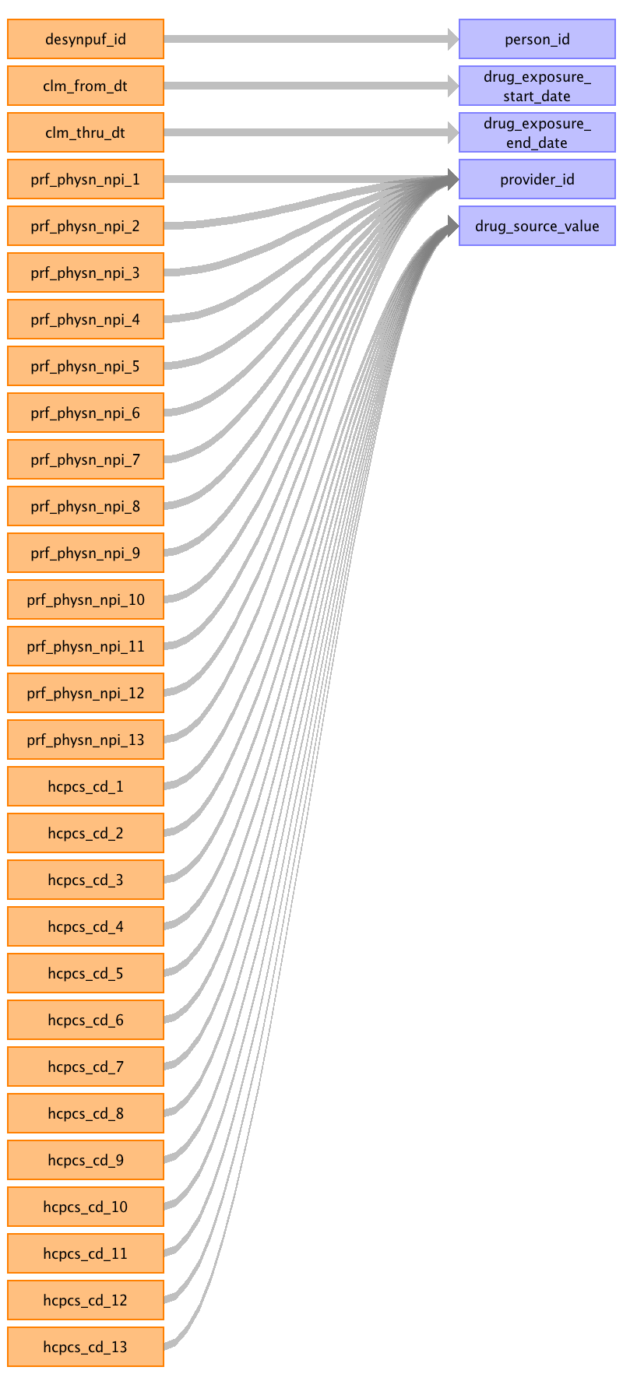

|  |  |  |  |
| --- | --- | --- | --- |
| Destination Field | Source Field | Logic | Comment |
| drug_exposure_id |  |  | Autogenerated |
| person_id | desynpuf_id |  |  |
| drug_concept_id |  |  | RX: Use the VOCABULARY to translate the NDC into a RxNorm CONCEPT_ID. CARRIER_CLAIMS & OUTPATIENT_CLAIMS: Use the VOCABULARY to figure out which HCPCs have the DOMAIN = "Drug", if so the entry is written into the DRUG_EXPOSURE table and not the PROCEDURE_OCCURRENCE. The cost data also ends up in the DRUG_COST table not the PROCEDURE_COST. |
| drug_exposure_start_date | clm_from_dt |  | YYYYMMDD converted to date. |
| drug_exposure_end_date | clm_thru_dt |  | Outpatient_claims, carrier_claims: YYYYMMDD converted to date. Perscription_drugs_events: Null |
| drug_type_concept_id |  |  | RX: 38000175-Prescription dispensed in pharmacy CARRIER_CLAIMS & OUTPATIENT_CLAIMS & INPATIENT_CLAIMS: 38000179-Physician administered drug (identified as procedure) |
| stop_reason |  |  | NULL |
| refills |  |  | NULL |
| quantity |  |  | CARRIER_CLAIMS & OUTPATIENT_CLAIMS & INPATIENT_CLAIMS: NULL |
| days_supply |  |  | CARRIER_CLAIMS & OUTPATIENT_CLAIMS & INPATIENT_CLAIMS: NULL |
| sig |  |  | NULL |
| route_concept_id |  |  | NULL |
| effective_drug_dose |  |  | NULL |
| dose_unit_concept_id |  |  | NULL |
| lot_number |  |  | NULL |
| provider_id | prf_physn_npi_1 prf_physn_npi_2 prf_physn_npi_3 prf_physn_npi_4 prf_physn_npi_5 prf_physn_npi_6 prf_physn_npi_7 prf_physn_npi_8 prf_physn_npi_9 prf_physn_npi_10 prf_physn_npi_11 prf_physn_npi_12 prf_physn_npi_13 |  | RX: null |
| visit_occurrence_id |  |  | RX: Null for PRESCRIPTION_DRUG_EVENTS CARRIER_CLAIMS & OUTPATIENT_CLAIMS & INPATIENT_CLAIMS: Track the VISIT_OCCURENCE_ID associated with record. |
| drug_source_concept_id |  |  | RX: Translate NDC to NDC CONCEPT_ID CARRIER_CLAIMS & OUTPATIENT_CLAIMS & INPATIENT_CLAIMS: Use SOURCE_CONCEPT_ID for each HCPCS, ICD9 diagnosis or ICD9 procedure mapped. |
| drug_source_value | hcpcs_cd_1 hcpcs_cd_2 hcpcs_cd_3 hcpcs_cd_4 hcpcs_cd_5 hcpcs_cd_6 hcpcs_cd_7 hcpcs_cd_8 hcpcs_cd_9 hcpcs_cd_10 hcpcs_cd_11 hcpcs_cd_12 hcpcs_cd_13 |  |  |
| route_source_value |  |  | NULL |
| dose_unit_source_value |  |  | NULL |

Reading from outpatient_claims

For HCPCS, ICD9 diagnosis and ICD9 procedure columns, use VOCABULARY to determine if the code belongs to the DRUG_EXPOSURE domain, else it will go to a MEASUREMENT, PROCEDURE_OCCURRENCE, OBSERVATION, or DEVICE_EXPOSURE.
CAUTION: The MEASUREMENT and OBSERVATION CDM tables do not have cost tables associated with them in CDM v5. If HCPCS are mapped to these tables, the associated costs will be lost. Since SynPUF is fake data, we will go ahead with using the VOCABULARY assignments and not include the costs associated with HCPCS in the MEASUREMENT and OBSERVATION tables. However, when creating a specification document for real data, we DO NOT recommend using the VOCABULARY for HCPCS domain assignment for CDM v5, as certain cost data will not be included in the final CDM. This is not an issue with ICD9 procedure codes as these associated costs are stored at the VISIT_COST table.

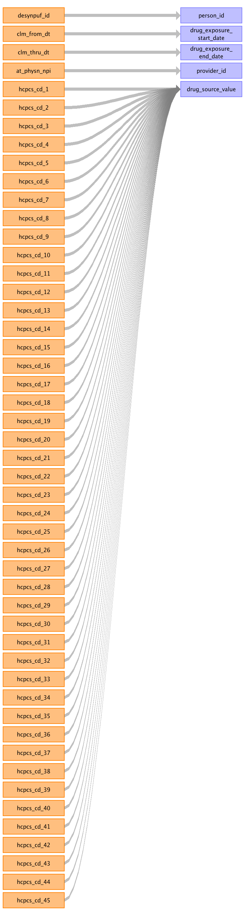

|  |  |  |  |
| --- | --- | --- | --- |
| Destination Field | Source Field | Logic | Comment |
| drug_exposure_id |  |  | Autogenerated |
| person_id | desynpuf_id |  |  |
| drug_concept_id |  |  | RX: Use the VOCABULARY to translate the NDC into a RxNorm CONCEPT_ID. CARRIER_CLAIMS & OUTPATIENT_CLAIMS: Use the VOCABULARY to figure out which HCPCs have the DOMAIN = "Drug", if so the entry is written into the DRUG_EXPOSURE table and not the PROCEDURE_OCCURRENCE. The cost data also ends up in the DRUG_COST table not the PROCEDURE_COST. |
| drug_exposure_start_date | clm_from_dt |  | YYYYMMDD converted to date. |
| drug_exposure_end_date | clm_thru_dt |  | Outpatient_claims, carrier_claims: YYYYMMDD converted to date. Perscription_drugs_events: Null |
| drug_type_concept_id |  |  | RX: 38000175-Prescription dispensed in pharmacy CARRIER_CLAIMS & OUTPATIENT_CLAIMS & INPATIENT_CLAIMS: 38000179-Physician administered drug (identified as procedure) |
| stop_reason |  |  | NULL |
| refills |  |  | NULL |
| quantity |  |  | CARRIER_CLAIMS & OUTPATIENT_CLAIMS & INPATIENT_CLAIMS: NULL |
| days_supply |  |  | CARRIER_CLAIMS & OUTPATIENT_CLAIMS & INPATIENT_CLAIMS: NULL |
| sig |  |  | NULL |
| route_concept_id |  |  | NULL |
| effective_drug_dose |  |  | NULL |
| dose_unit_concept_id |  |  | NULL |
| lot_number |  |  | NULL |
| provider_id | at_physn_npi |  | RX: null |
| visit_occurrence_id |  |  | RX: Null for PRESCRIPTION_DRUG_EVENTS CARRIER_CLAIMS & OUTPATIENT_CLAIMS & INPATIENT_CLAIMS: Track the VISIT_OCCURENCE_ID associated with record. |
| drug_source_concept_id |  |  | RX: Translate NDC to NDC CONCEPT_ID CARRIER_CLAIMS & OUTPATIENT_CLAIMS & INPATIENT_CLAIMS: Use SOURCE_CONCEPT_ID for each HCPCS, ICD9 diagnosis or ICD9 procedure mapped. |
| drug_source_value | hcpcs_cd_1 hcpcs_cd_2 hcpcs_cd_3 hcpcs_cd_4 hcpcs_cd_5 hcpcs_cd_6 hcpcs_cd_7 hcpcs_cd_8 hcpcs_cd_9 hcpcs_cd_10 hcpcs_cd_11 hcpcs_cd_12 hcpcs_cd_13 hcpcs_cd_14 hcpcs_cd_15 hcpcs_cd_16 hcpcs_cd_17 hcpcs_cd_18 hcpcs_cd_19 hcpcs_cd_20 hcpcs_cd_21 hcpcs_cd_22 hcpcs_cd_23 hcpcs_cd_24 hcpcs_cd_25 hcpcs_cd_26 hcpcs_cd_45 hcpcs_cd_44 hcpcs_cd_27 hcpcs_cd_43 hcpcs_cd_42 hcpcs_cd_41 hcpcs_cd_40 hcpcs_cd_39 hcpcs_cd_38 hcpcs_cd_37 hcpcs_cd_36 hcpcs_cd_35 hcpcs_cd_28 hcpcs_cd_29 hcpcs_cd_30 hcpcs_cd_31 hcpcs_cd_32 hcpcs_cd_33 hcpcs_cd_34 |  |  |
| route_source_value |  |  | NULL |
| dose_unit_source_value |  |  | NULL |

Reading from inpatient_claims

For HCPCS, ICD9 diagnosis and ICD9 procedure columns, use VOCABULARY to determine if the code belongs to the DRUG_EXPOSURE domain, else it will go to a MEASUREMENT, PROCEDURE_OCCURRENCE, OBSERVATION, or DEVICE_EXPOSURE.
CAUTION: The MEASUREMENT and OBSERVATION CDM tables do not have cost tables associated with them in CDM v5. If HCPCS are mapped to these tables, the associated costs will be lost. Since SynPUF is fake data, we will go ahead with using the VOCABULARY assignments and not include the costs associated with HCPCS in the MEASUREMENT and OBSERVATION tables. However, when creating a specification document for real data, we DO NOT recommend using the VOCABULARY for HCPCS domain assignment for CDM v5, as certain cost data will not be included in the final CDM. This is not an issue with ICD9 procedure codes as these associated costs are stored at the VISIT_COST table.

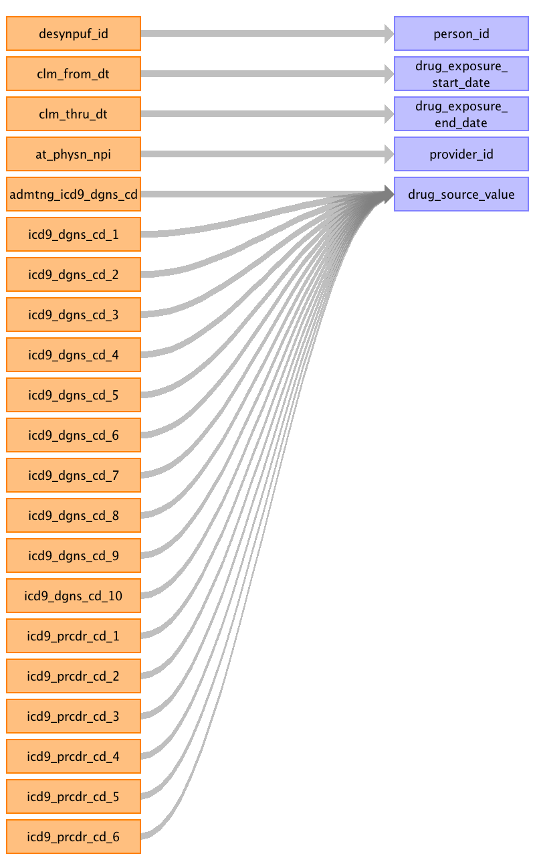

|  |  |  |  |
| --- | --- | --- | --- |
| Destination Field | Source Field | Logic | Comment |
| drug_exposure_id |  |  | Autogenerated |
| person_id | desynpuf_id |  |  |
| drug_concept_id |  |  | RX: Use the VOCABULARY to translate the NDC into a RxNorm CONCEPT_ID. CARRIER_CLAIMS & OUTPATIENT_CLAIMS: Use the VOCABULARY to figure out which HCPCs have the DOMAIN = "Drug", if so the entry is written into the DRUG_EXPOSURE table and not the PROCEDURE_OCCURRENCE. The cost data also ends up in the DRUG_COST table not the PROCEDURE_COST. |
| drug_exposure_start_date | clm_from_dt |  | YYYYMMDD converted to date. |
| drug_exposure_end_date | clm_thru_dt |  | Outpatient_claims, carrier_claims: YYYYMMDD converted to date. Perscription_drugs_events: Null |
| drug_type_concept_id |  |  | RX: 38000175-Prescription dispensed in pharmacy CARRIER_CLAIMS & OUTPATIENT_CLAIMS & INPATIENT_CLAIMS: 38000179-Physician administered drug (identified as procedure) |
| stop_reason |  |  | NULL |
| refills |  |  | NULL |
| quantity |  |  | CARRIER_CLAIMS & OUTPATIENT_CLAIMS & INPATIENT_CLAIMS: NULL |
| days_supply |  |  | CARRIER_CLAIMS & OUTPATIENT_CLAIMS & INPATIENT_CLAIMS: NULL |
| sig |  |  | NULL |
| route_concept_id |  |  | NULL |
| effective_drug_dose |  |  | NULL |
| dose_unit_concept_id |  |  | NULL |
| lot_number |  |  | NULL |
| provider_id | at_physn_npi |  | RX: null |
| visit_occurrence_id |  |  | RX: Null for PRESCRIPTION_DRUG_EVENTS CARRIER_CLAIMS & OUTPATIENT_CLAIMS & INPATIENT_CLAIMS: Track the VISIT_OCCURENCE_ID associated with record. |
| drug_source_concept_id |  |  | RX: Translate NDC to NDC CONCEPT_ID CARRIER_CLAIMS & OUTPATIENT_CLAIMS & INPATIENT_CLAIMS: Use SOURCE_CONCEPT_ID for each HCPCS, ICD9 diagnosis or ICD9 procedure mapped. |
| drug_source_value | admtng_icd9_dgns_cd icd9_dgns_cd_1 icd9_dgns_cd_2 icd9_dgns_cd_3 icd9_dgns_cd_4 icd9_dgns_cd_5 icd9_dgns_cd_6 icd9_dgns_cd_7 icd9_dgns_cd_8 icd9_dgns_cd_9 icd9_dgns_cd_10 icd9_prcdr_cd_1 icd9_prcdr_cd_2 icd9_prcdr_cd_3 icd9_prcdr_cd_4 icd9_prcdr_cd_5 icd9_prcdr_cd_6 |  |  |
| route_source_value |  |  | NULL |
| dose_unit_source_value |  |  | NULL |

Table name: device_exposure

Reading from outpatient_claims

For HCPCS, ICD9 diagnosis and ICD9 procedure columns, use VOCABULARY to determine if the code belongs to the DEVICE_EXPOSURE domain, else it will go to a MEASUREMENT, PROCEDURE_OCCURRENCE, OBSERVATION, or DRUG_EXPOSURE.
CAUTION: The MEASUREMENT and OBSERVATION CDM tables do not have cost tables associated with them in CDM v5. If HCPCS are mapped to these tables, the associated costs will be lost. Since SynPUF is fake data, we will go ahead with using the VOCABULARY assignments and not include the costs associated with HCPCS in the MEASUREMENT and OBSERVATION tables. However, when creating a specification document for real data, we DO NOT recommend using the VOCABULARY for HCPCS domain assignment for CDM v5, as certain cost data will not be included in the final CDM. This is not an issue with ICD9 procedure codes as these associated costs are stored at the VISIT_COST table.

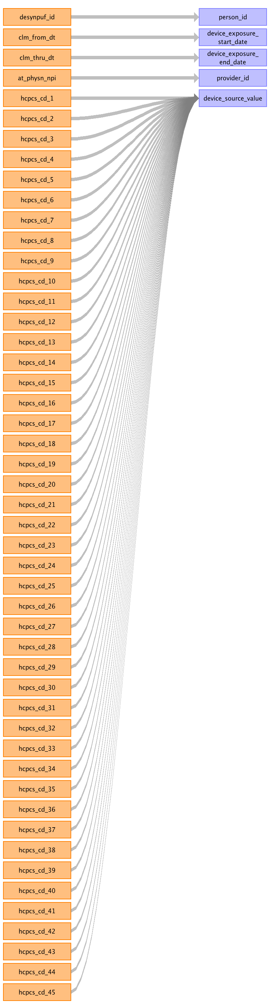

|  |  |  |  |
| --- | --- | --- | --- |
| Destination Field | Source Field | Logic | Comment |
| device_exposure_id |  |  | Autogenerated |
| person_id | desynpuf_id |  |  |
| device_concept_id |  |  | ALL SOURCE FILES: Use Concept_Relationship table to match standard concepts from the following fields mapped: HCPCS, ICD9 diagnoses and procedures. |
| device_exposure_start_date | clm_from_dt |  | YYYYMMDD converted to date |
| device_exposure_end_date | clm_thru_dt |  | NULL |
| device_type_concept_id |  |  | Use concept_id = 44818705 for "Inferred from procedure claim" for all mappings of HCPCS, ICD9 diagnosis or ICD9 procedure codes. |
| unique_device_id |  |  | Null |
| quantity |  |  | Null |
| provider_id | at_physn_npi |  | OUTPATIENT_CLAIMS: Lookup Provider in PROVIDER table. |
| visit_occurrence_id |  |  | At the row level you are assigning a VISIT, this occurs prior to writing to this table. Track that ID and write here. |
| device_source_value | hcpcs_cd_1 hcpcs_cd_2 hcpcs_cd_3 hcpcs_cd_4 hcpcs_cd_5 hcpcs_cd_6 hcpcs_cd_7 hcpcs_cd_8 hcpcs_cd_9 hcpcs_cd_10 hcpcs_cd_11 hcpcs_cd_12 hcpcs_cd_13 hcpcs_cd_14 hcpcs_cd_15 hcpcs_cd_16 hcpcs_cd_17 hcpcs_cd_18 hcpcs_cd_19 hcpcs_cd_20 hcpcs_cd_21 hcpcs_cd_45 hcpcs_cd_44 hcpcs_cd_43 hcpcs_cd_42 hcpcs_cd_41 hcpcs_cd_40 hcpcs_cd_39 hcpcs_cd_38 hcpcs_cd_37 hcpcs_cd_36 hcpcs_cd_35 hcpcs_cd_34 hcpcs_cd_33 hcpcs_cd_32 hcpcs_cd_31 hcpcs_cd_30 hcpcs_cd_29 hcpcs_cd_28 hcpcs_cd_27 hcpcs_cd_26 hcpcs_cd_25 hcpcs_cd_22 hcpcs_cd_23 hcpcs_cd_24 |  |  |
| device_source_concept_id |  |  | ALL SOURCE FILES: Use SOURCE_CONCEPT_ID for each HCPCS, ICD9 diagnosis or ICD9 procedure mapped. |

Reading from carrier_claims

For HCPCS, ICD9 diagnosis and ICD9 procedure columns, use VOCABULARY to determine if the code belongs to the DEVICE_EXPOSURE domain, else it will go to a MEASUREMENT, PROCEDURE_OCCURRENCE, OBSERVATION, or DRUG_EXPOSURE.
CAUTION: The MEASUREMENT and OBSERVATION CDM tables do not have cost tables associated with them in CDM v5. If HCPCS are mapped to these tables, the associated costs will be lost. Since SynPUF is fake data, we will go ahead with using the VOCABULARY assignments and not include the costs associated with HCPCS in the MEASUREMENT and OBSERVATION tables. However, when creating a specification document for real data, we DO NOT recommend using the VOCABULARY for HCPCS domain assignment for CDM v5, as certain cost data will not be included in the final CDM. This is not an issue with ICD9 procedure codes as these associated costs are stored at the VISIT_COST table.

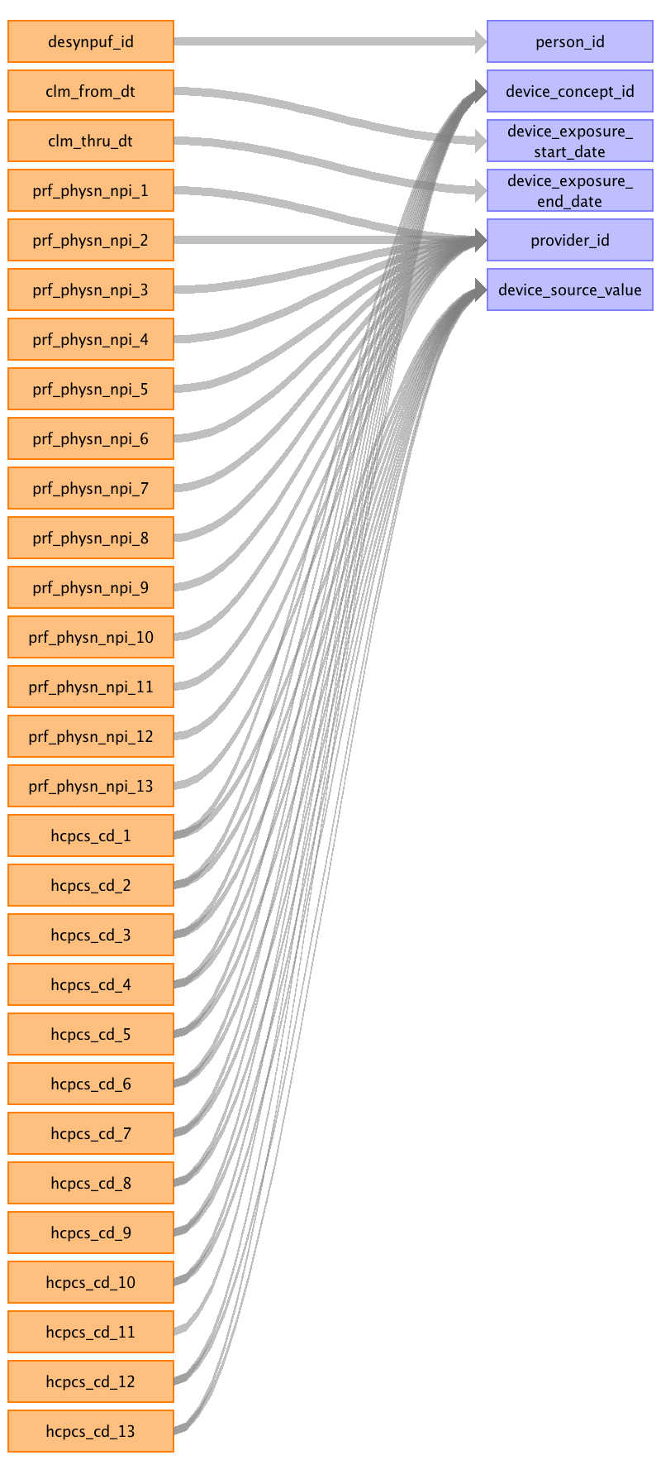

|  |  |  |  |
| --- | --- | --- | --- |
| Destination Field | Source Field | Logic | Comment |
| device_exposure_id |  |  | Autogenerated |
| person_id | desynpuf_id |  |  |
| device_concept_id | hcpcs_cd_1 hcpcs_cd_2 hcpcs_cd_3 hcpcs_cd_4 hcpcs_cd_5 hcpcs_cd_6 hcpcs_cd_7 hcpcs_cd_8 hcpcs_cd_9 hcpcs_cd_10 hcpcs_cd_11 hcpcs_cd_12 hcpcs_cd_13 |  | ALL SOURCE FILES: Use Concept_Relationship table to match standard concepts from the following fields mapped: HCPCS, ICD9 diagnoses and procedures. |
| device_exposure_start_date | clm_from_dt |  | YYYYMMDD converted to date |
| device_exposure_end_date | clm_thru_dt |  | NULL |
| device_type_concept_id |  |  | Use concept_id = 44818705 for "Inferred from procedure claim" for all mappings of HCPCS, ICD9 diagnosis or ICD9 procedure codes. |
| unique_device_id |  |  | Null |
| quantity |  |  | Null |
| provider_id | prf_physn_npi_1 prf_physn_npi_2 prf_physn_npi_3 prf_physn_npi_4 prf_physn_npi_5 prf_physn_npi_6 prf_physn_npi_7 prf_physn_npi_8 prf_physn_npi_9 prf_physn_npi_10 prf_physn_npi_11 prf_physn_npi_12 prf_physn_npi_13 |  | OUTPATIENT_CLAIMS: Lookup Provider in PROVIDER table. |
| visit_occurrence_id |  |  | At the row level you are assigning a VISIT, this occurs prior to writing to this table. Track that ID and write here. |
| device_source_value | hcpcs_cd_1 hcpcs_cd_2 hcpcs_cd_3 hcpcs_cd_4 hcpcs_cd_5 hcpcs_cd_6 hcpcs_cd_7 hcpcs_cd_8 hcpcs_cd_9 hcpcs_cd_10 hcpcs_cd_12 hcpcs_cd_13 |  |  |
| device_source_concept_id |  |  | ALL SOURCE FILES: Use SOURCE_CONCEPT_ID for each HCPCS, ICD9 diagnosis or ICD9 procedure mapped. |

Reading from inpatient_claims

For HCPCS, ICD9 diagnosis and ICD9 procedure columns, use VOCABULARY to determine if the code belongs to the DEVICE_EXPOSURE domain, else it will go to a MEASUREMENT, PROCEDURE_OCCURRENCE, OBSERVATION, or DRUG_EXPOSURE.
CAUTION: The MEASUREMENT and OBSERVATION CDM tables do not have cost tables associated with them in CDM v5. If HCPCS are mapped to these tables, the associated costs will be lost. Since SynPUF is fake data, we will go ahead with using the VOCABULARY assignments and not include the costs associated with HCPCS in the MEASUREMENT and OBSERVATION tables. However, when creating a specification document for real data, we DO NOT recommend using the VOCABULARY for HCPCS domain assignment for CDM v5, as certain cost data will not be included in the final CDM. This is not an issue with ICD9 procedure codes as these associated costs are stored at the VISIT_COST table.

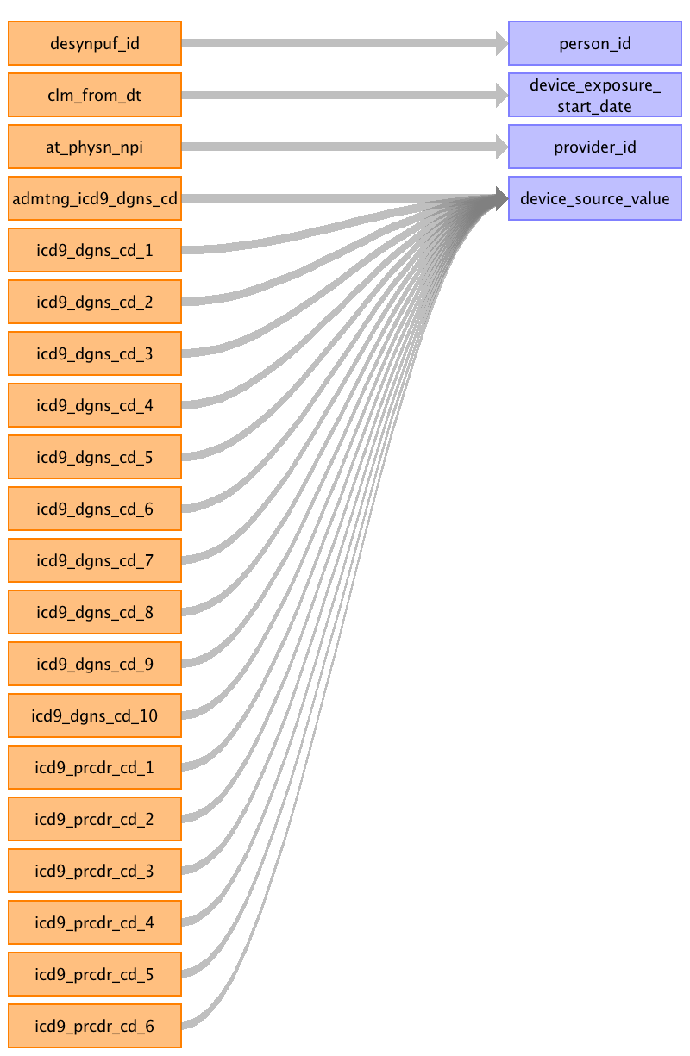

|  |  |  |  |
| --- | --- | --- | --- |
| Destination Field | Source Field | Logic | Comment |
| device_exposure_id |  |  | Autogenerated |
| person_id | desynpuf_id |  |  |
| device_concept_id |  |  | ALL SOURCE FILES: Use Concept_Relationship table to match standard concepts from the following fields mapped: HCPCS, ICD9 diagnoses and procedures. |
| device_exposure_start_date | clm_from_dt |  | YYYYMMDD converted to date |
| device_exposure_end_date |  |  | NULL |
| device_type_concept_id |  |  | Use concept_id = 44818705 for "Inferred from procedure claim" for all mappings of HCPCS, ICD9 diagnosis or ICD9 procedure codes. |
| unique_device_id |  |  | Null |
| quantity |  |  | Null |
| provider_id | at_physn_npi |  | OUTPATIENT_CLAIMS: Lookup Provider in PROVIDER table. |
| visit_occurrence_id |  |  | At the row level you are assigning a VISIT, this occurs prior to writing to this table. Track that ID and write here. |
| device_source_value | admtng_icd9_dgns_cd icd9_dgns_cd_1 icd9_dgns_cd_2 icd9_dgns_cd_3 icd9_dgns_cd_4 icd9_dgns_cd_5 icd9_dgns_cd_6 icd9_dgns_cd_7 icd9_dgns_cd_8 icd9_dgns_cd_9 icd9_dgns_cd_10 icd9_prcdr_cd_1 icd9_prcdr_cd_2 icd9_prcdr_cd_3 icd9_prcdr_cd_4 icd9_prcdr_cd_5 icd9_prcdr_cd_6 |  |  |
| device_source_concept_id |  |  | ALL SOURCE FILES: Use SOURCE_CONCEPT_ID for each HCPCS, ICD9 diagnosis or ICD9 procedure mapped. |

Table name: procedure_occurrence

Reading from carrier_claims

For HCPCS, ICD9 diagnosis and ICD9 procedure columns, use VOCABULARY to determine if the code belongs to the PROCEDURE_OCCURRENCE domain, else it will go to a DEVICE_EXPOSURE, OBSERVATION, MEASUREMENT, or DRUG_EXPOSURE.
CAUTION: The MEASUREMENT and OBSERVATION CDM tables do not have cost tables associated with them in CDM v5. If HCPCS are mapped to these tables, the associated costs will be lost. Since SynPUF is fake data, we will go ahead with using the VOCABULARY assignments and not include the costs associated with HCPCS in the MEASUREMENT and OBSERVATION tables. However, when creating a specification document for real data, we DO NOT recommend using the VOCABULARY for HCPCS domain assignment for CDM v5, as certain cost data will not be included in the final CDM. This is not an issue with ICD9 procedure codes as these associated costs are stored at the VISIT_COST table.

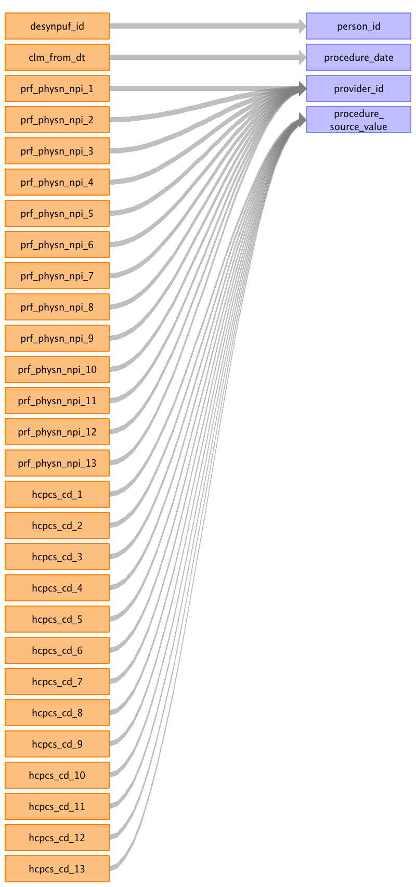

|  |  |  |  |
| --- | --- | --- | --- |
| Destination Field | Source Field | Logic | Comment |
| procedure_occurrence_id |  |  | Autogenerated |
| person_id | desynpuf_id |  |  |
| procedure_concept_id |  |  | In CARRIER_CLAIMS & OUTPATIENT_CLAIMS map to HCPC CONCEPT_IDs. Only write rows for HCPCs that have a drug associated domain. IN INPATIENT_CLAIMS map to ICD9 Procedures CONCEPT_IDs. |
| procedure_date | clm_from_dt | YYYYMMDD converted to date. | When CLM_FROM_DT != CLM_THRU_DT we do not know which date the procedure occured, we will default to the CLM_FROM_DT. |
| procedure_type_concept_id |  |  | CARRIER_CLAIMS (details) --HCPCS_CD_1 - 45756900-Carrier claim detail - 1st position --HCPCS_CD_2 - 45756901 Carrier claim detail - 2nd position --HCPCS_CD_3 - 45756902 Carrier claim detail - 3rd position --HCPCS_CD_4 - TBD45756903        Carrier claim detail - 4th position --HCPCS_CD_5 - TBD45756904        Carrier claim detail - 5th position --HCPCS_CD_6 - TBD45756905        Carrier claim detail - 6th position --HCPCS_CD_7 - TBD45756906        Carrier claim detail - 7th position --HCPCS_CD_8 - TBD45756907        Carrier claim detail - 8th position --HCPCS_CD_9 - TBD45756908        Carrier claim detail - 9th position --HCPCS_CD_10 - TBD45756909        Carrier claim detail - 10th position --HCPCS_CD_11 - TBD45756910        Carrier claim detail - 11th position --HCPCS_CD_12 - TBD45756911        Carrier claim detail - 12th position --HCPCS_CD_13 - TBD45756912        Carrier claim detail - 13th position INPATIENT_CLAIMS: --ICD9_PRCDR_CD_1 - 38000251-Inpatient header - 1st position --ICD9_PRCDR_CD_2 - 38000252-Inpatient header - 2nd position --ICD9_PRCDR_CD_3 - 38000253-Inpatient header - 3rd position --ICD9_PRCDR_CD_4 - 38000254-Inpatient header - 4th position --ICD9_PRCDR_CD_5 - 38000255-Inpatient header - 5th position --ICD9_PRCDR_CD_6 - 38000256-Inpatient header - 6th position OUTPATIENT_CLAIMS (DETAILS) --HCPCS_CD_1 - 38000267-Outpatient detail - 1st position --HCPCS_CD_2 - 45756856 Outpatient detail – 2nd position --HCPCS_CD_3 - 45756857 Outpatient detail – 3rd position --HCPCS_CD_4 - 45756858 Outpatient detail - 4th position --HCPCS_CD_5 - 45756859 Outpatient detail - 5th position --HCPCS_CD_6 - 45756860 Outpatient detail - 6th position --HCPCS_CD_7 - 45756861 Outpatient detail - 7th position --HCPCS_CD_8 - 45756862 Outpatient detail - 8th position --HCPCS_CD_9 - 45756863 Outpatient detail - 9th position --HCPCS_CD_10 - 45756864 Outpatient detail - 10th position --HCPCS_CD_11 - 45756865 Outpatient detail - 11th position --HCPCS_CD_12 - 45756866 Outpatient detail - 12th position --HCPCS_CD_13 - 45756867 Outpatient detail - 13th position --HCPCS_CD_14 - 45756868 Outpatient detail - 14th position --HCPCS_CD_15 - TBD45756869        Outpatient detail - 15th position --HCPCS_CD_16 - TBD45756870        Outpatient detail - 16th position --HCPCS_CD_17 - TBD45756871        Outpatient detail - 17th position --HCPCS_CD_18 - TBD45756872        Outpatient detail - 18th position --HCPCS_CD_19 - TBD45756873        Outpatient detail - 19th position --HCPCS_CD_20 - TBD45756874        Outpatient detail - 20th position --HCPCS_CD_21 - TBD45756875        Outpatient detail - 21th position --HCPCS_CD_22 - TBD45756876        Outpatient detail - 22th position --HCPCS_CD_23 - TBD45756877        Outpatient detail - 23th position --HCPCS_CD_24 - TBD45756878        Outpatient detail - 24th position --HCPCS_CD_25 - TBD45756879        Outpatient detail - 25th position --HCPCS_CD_26 - TBD45756880        Outpatient detail - 26th position --HCPCS_CD_27 - TBD45756881        Outpatient detail - 27th position --HCPCS_CD_28 - TBD45756882        Outpatient detail - 28th position --HCPCS_CD_29 - TBD45756883        Outpatient detail - 29th position --HCPCS_CD_30 - TBD45756884        Outpatient detail - 30th position --HCPCS_CD_31 - TBD45756885        Outpatient detail - 31th position --HCPCS_CD_32 - TBD45756886        Outpatient detail - 32th position --HCPCS_CD_33 - TBD45756887        Outpatient detail - 33th position --HCPCS_CD_34 - TBD45756888        Outpatient detail - 34th position --HCPCS_CD_35 - TBD45756889        Outpatient detail - 35th position --HCPCS_CD_36 - TBD45756890        Outpatient detail - 36th position --HCPCS_CD_37 - TBD45756891        Outpatient detail - 37th position --HCPCS_CD_38 - TBD45756892        Outpatient detail - 38th position --HCPCS_CD_39 - TBD45756893        Outpatient detail - 39th position --HCPCS_CD_40 - TBD45756894        Outpatient detail - 40th position --HCPCS_CD_41 - TBD45756895        Outpatient detail - 41th position --HCPCS_CD_42 - TBD45756896        Outpatient detail - 42th position --HCPCS_CD_43 - TBD45756897        Outpatient detail - 43th position --HCPCS_CD_44 - TBD45756898        Outpatient detail - 44th position --HCPCS_CD_45 - TBD45756899        Outpatient detail - 45th position |
| modifier_concept_id |  |  | 0 |
| quantity |  |  | NULL |
| provider_id | prf_physn_npi_1 prf_physn_npi_2 prf_physn_npi_3 prf_physn_npi_4 prf_physn_npi_5 prf_physn_npi_6 prf_physn_npi_7 prf_physn_npi_8 prf_physn_npi_9 prf_physn_npi_10 prf_physn_npi_11 prf_physn_npi_12 prf_physn_npi_13 | Lookup the NPI in the PROVIDER table and associate with the HCPC_CD_XX of the same number (e.g. pick PRF_PHYSN_NPI_13 for the row written for HCPCS_CD_13) |  |
| visit_occurrence_id |  |  | Associate to proper VISIT_OCCURRENCE_ID. |
| procedure_source_value | hcpcs_cd_1 hcpcs_cd_2 hcpcs_cd_3 hcpcs_cd_4 hcpcs_cd_5 hcpcs_cd_6 hcpcs_cd_7 hcpcs_cd_8 hcpcs_cd_9 hcpcs_cd_10 hcpcs_cd_11 hcpcs_cd_12 hcpcs_cd_13 |  |  |
| procedure_source_concept_id |  |  | In CARRIER_CLAIMS & OUTPATIENT_CLAIMS map to HCPC CONCEPT_IDs. Only write rows for HCPCs that have a drug associated domain. IN INPATIENT_CLAIMS map to ICD9 Procedures CONCEPT_IDs. |
| qualifier_source_value |  |  | NULL |

Reading from inpatient_claims

For HCPCS, ICD9 diagnosis and ICD9 procedure columns, use VOCABULARY to determine if the code belongs to the PROCEDURE_OCCURRENCE domain, else it will go to a DEVICE_EXPOSURE, OBSERVATION, MEASUREMENT, or DRUG_EXPOSURE.
CAUTION: The MEASUREMENT and OBSERVATION CDM tables do not have cost tables associated with them in CDM v5. If HCPCS are mapped to these tables, the associated costs will be lost. Since SynPUF is fake data, we will go ahead with using the VOCABULARY assignments and not include the costs associated with HCPCS in the MEASUREMENT and OBSERVATION tables. However, when creating a specification document for real data, we DO NOT recommend using the VOCABULARY for HCPCS domain assignment for CDM v5, as certain cost data will not be included in the final CDM. This is not an issue with ICD9 procedure codes as these associated costs are stored at the VISIT_COST table.

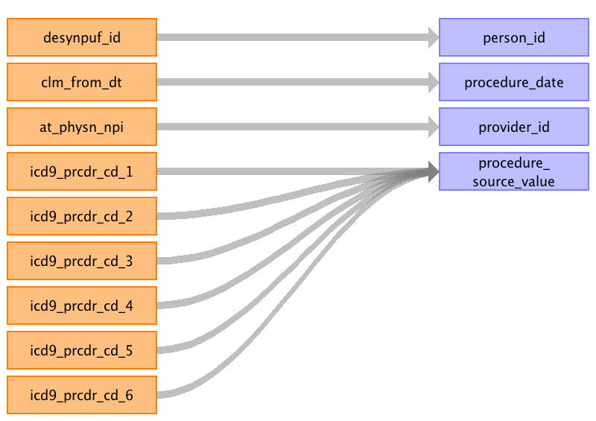

|  |  |  |  |
| --- | --- | --- | --- |
| Destination Field | Source Field | Logic | Comment |
| procedure_occurrence_id |  |  | Autogenerated |
| person_id | desynpuf_id |  |  |
| procedure_concept_id |  |  | In CARRIER_CLAIMS & OUTPATIENT_CLAIMS map to HCPC CONCEPT_IDs. Only write rows for HCPCs that have a drug associated domain. IN INPATIENT_CLAIMS map to ICD9 Procedures CONCEPT_IDs. |
| procedure_date | clm_from_dt | YYYYMMDD converted to date. | When CLM_FROM_DT != CLM_THRU_DT we do not know which date the procedure occured, we will default to the CLM_FROM_DT. |
| procedure_type_concept_id |  |  | CARRIER_CLAIMS (details) --HCPCS_CD_1 - 45756900-Carrier claim detail - 1st position --HCPCS_CD_2 - 45756901 Carrier claim detail - 2nd position --HCPCS_CD_3 - 45756902 Carrier claim detail - 3rd position --HCPCS_CD_4 - TBD45756903        Carrier claim detail - 4th position --HCPCS_CD_5 - TBD45756904        Carrier claim detail - 5th position --HCPCS_CD_6 - TBD45756905        Carrier claim detail - 6th position --HCPCS_CD_7 - TBD45756906        Carrier claim detail - 7th position --HCPCS_CD_8 - TBD45756907        Carrier claim detail - 8th position --HCPCS_CD_9 - TBD45756908        Carrier claim detail - 9th position --HCPCS_CD_10 - TBD45756909        Carrier claim detail - 10th position --HCPCS_CD_11 - TBD45756910        Carrier claim detail - 11th position --HCPCS_CD_12 - TBD45756911        Carrier claim detail - 12th position --HCPCS_CD_13 - TBD45756912        Carrier claim detail - 13th position INPATIENT_CLAIMS: --ICD9_PRCDR_CD_1 - 38000251-Inpatient header - 1st position --ICD9_PRCDR_CD_2 - 38000252-Inpatient header - 2nd position --ICD9_PRCDR_CD_3 - 38000253-Inpatient header - 3rd position --ICD9_PRCDR_CD_4 - 38000254-Inpatient header - 4th position --ICD9_PRCDR_CD_5 - 38000255-Inpatient header - 5th position --ICD9_PRCDR_CD_6 - 38000256-Inpatient header - 6th position OUTPATIENT_CLAIMS (DETAILS) --HCPCS_CD_1 - 38000267-Outpatient detail - 1st position --HCPCS_CD_2 - 45756856 Outpatient detail – 2nd position --HCPCS_CD_3 - 45756857 Outpatient detail – 3rd position --HCPCS_CD_4 - 45756858 Outpatient detail - 4th position --HCPCS_CD_5 - 45756859 Outpatient detail - 5th position --HCPCS_CD_6 - 45756860 Outpatient detail - 6th position --HCPCS_CD_7 - 45756861 Outpatient detail - 7th position --HCPCS_CD_8 - 45756862 Outpatient detail - 8th position --HCPCS_CD_9 - 45756863 Outpatient detail - 9th position --HCPCS_CD_10 - 45756864 Outpatient detail - 10th position --HCPCS_CD_11 - 45756865 Outpatient detail - 11th position --HCPCS_CD_12 - 45756866 Outpatient detail - 12th position --HCPCS_CD_13 - 45756867 Outpatient detail - 13th position --HCPCS_CD_14 - 45756868 Outpatient detail - 14th position --HCPCS_CD_15 - TBD45756869        Outpatient detail - 15th position --HCPCS_CD_16 - TBD45756870        Outpatient detail - 16th position --HCPCS_CD_17 - TBD45756871        Outpatient detail - 17th position --HCPCS_CD_18 - TBD45756872        Outpatient detail - 18th position --HCPCS_CD_19 - TBD45756873        Outpatient detail - 19th position --HCPCS_CD_20 - TBD45756874        Outpatient detail - 20th position --HCPCS_CD_21 - TBD45756875        Outpatient detail - 21th position --HCPCS_CD_22 - TBD45756876        Outpatient detail - 22th position --HCPCS_CD_23 - TBD45756877        Outpatient detail - 23th position --HCPCS_CD_24 - TBD45756878        Outpatient detail - 24th position --HCPCS_CD_25 - TBD45756879        Outpatient detail - 25th position --HCPCS_CD_26 - TBD45756880        Outpatient detail - 26th position --HCPCS_CD_27 - TBD45756881        Outpatient detail - 27th position --HCPCS_CD_28 - TBD45756882        Outpatient detail - 28th position --HCPCS_CD_29 - TBD45756883        Outpatient detail - 29th position --HCPCS_CD_30 - TBD45756884        Outpatient detail - 30th position --HCPCS_CD_31 - TBD45756885        Outpatient detail - 31th position --HCPCS_CD_32 - TBD45756886        Outpatient detail - 32th position --HCPCS_CD_33 - TBD45756887        Outpatient detail - 33th position --HCPCS_CD_34 - TBD45756888        Outpatient detail - 34th position --HCPCS_CD_35 - TBD45756889        Outpatient detail - 35th position --HCPCS_CD_36 - TBD45756890        Outpatient detail - 36th position --HCPCS_CD_37 - TBD45756891        Outpatient detail - 37th position --HCPCS_CD_38 - TBD45756892        Outpatient detail - 38th position --HCPCS_CD_39 - TBD45756893        Outpatient detail - 39th position --HCPCS_CD_40 - TBD45756894        Outpatient detail - 40th position --HCPCS_CD_41 - TBD45756895        Outpatient detail - 41th position --HCPCS_CD_42 - TBD45756896        Outpatient detail - 42th position --HCPCS_CD_43 - TBD45756897        Outpatient detail - 43th position --HCPCS_CD_44 - TBD45756898        Outpatient detail - 44th position --HCPCS_CD_45 - TBD45756899        Outpatient detail - 45th position |
| modifier_concept_id |  |  | 0 |
| quantity |  |  | NULL |
| provider_id | at_physn_npi |  |  |
| visit_occurrence_id |  |  | Associate to proper VISIT_OCCURRENCE_ID. |
| procedure_source_value | icd9_prcdr_cd_1 icd9_prcdr_cd_2 icd9_prcdr_cd_3 icd9_prcdr_cd_4 icd9_prcdr_cd_5 icd9_prcdr_cd_6 |  |  |
| procedure_source_concept_id |  |  | In CARRIER_CLAIMS & OUTPATIENT_CLAIMS map to HCPC CONCEPT_IDs. Only write rows for HCPCs that have a drug associated domain. IN INPATIENT_CLAIMS map to ICD9 Procedures CONCEPT_IDs. |
| qualifier_source_value |  |  | NULL |

Reading from outpatient_claims

For HCPCS, ICD9 diagnosis and ICD9 procedure columns, use VOCABULARY to determine if the code belongs to the PROCEDURE_OCCURRENCE domain, else it will go to a DEVICE_EXPOSURE, OBSERVATION, MEASUREMENT, or DRUG_EXPOSURE.
CAUTION: The MEASUREMENT and OBSERVATION CDM tables do not have cost tables associated with them in CDM v5. If HCPCS are mapped to these tables, the associated costs will be lost. Since SynPUF is fake data, we will go ahead with using the VOCABULARY assignments and not include the costs associated with HCPCS in the MEASUREMENT and OBSERVATION tables. However, when creating a specification document for real data, we DO NOT recommend using the VOCABULARY for HCPCS domain assignment for CDM v5, as certain cost data will not be included in the final CDM. This is not an issue with ICD9 procedure codes as these associated costs are stored at the VISIT_COST table.

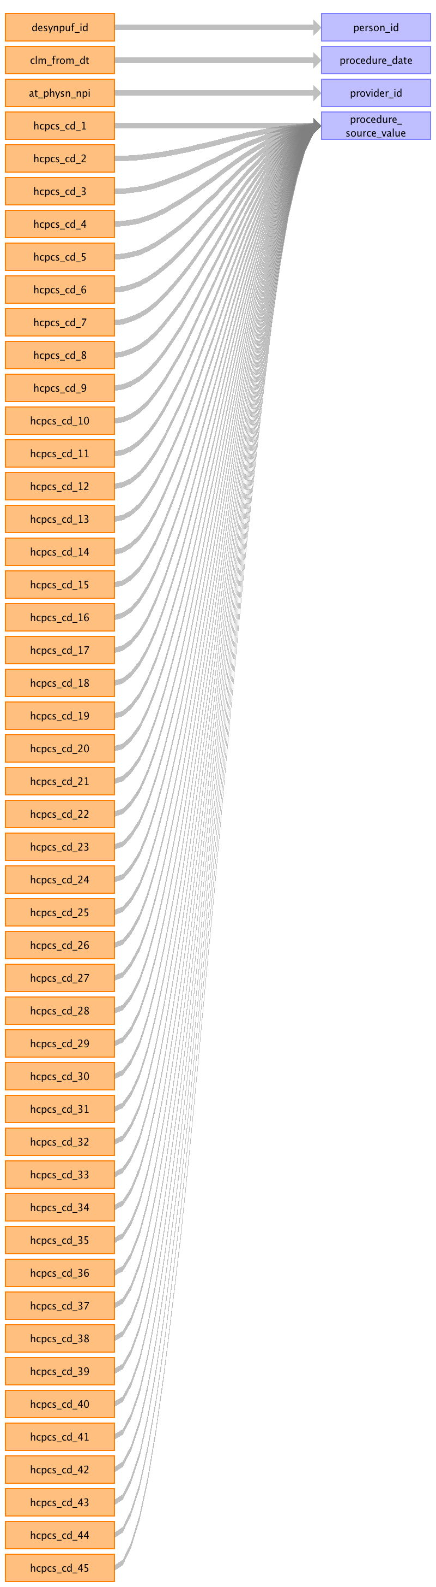

|  |  |  |  |
| --- | --- | --- | --- |
| Destination Field | Source Field | Logic | Comment |
| procedure_occurrence_id |  |  | Autogenerated |
| person_id | desynpuf_id |  |  |
| procedure_concept_id |  |  | In CARRIER_CLAIMS & OUTPATIENT_CLAIMS map to HCPC CONCEPT_IDs. Only write rows for HCPCs that have a drug associated domain. IN INPATIENT_CLAIMS map to ICD9 Procedures CONCEPT_IDs. |
| procedure_date | clm_from_dt | YYYYMMDD converted to date. | When CLM_FROM_DT != CLM_THRU_DT we do not know which date the procedure occured, we will default to the CLM_FROM_DT. |
| procedure_type_concept_id |  |  | CARRIER_CLAIMS (details) --HCPCS_CD_1 - 45756900-Carrier claim detail - 1st position --HCPCS_CD_2 - 45756901 Carrier claim detail - 2nd position --HCPCS_CD_3 - 45756902 Carrier claim detail - 3rd position --HCPCS_CD_4 - TBD45756903        Carrier claim detail - 4th position --HCPCS_CD_5 - TBD45756904        Carrier claim detail - 5th position --HCPCS_CD_6 - TBD45756905        Carrier claim detail - 6th position --HCPCS_CD_7 - TBD45756906        Carrier claim detail - 7th position --HCPCS_CD_8 - TBD45756907        Carrier claim detail - 8th position --HCPCS_CD_9 - TBD45756908        Carrier claim detail - 9th position --HCPCS_CD_10 - TBD45756909        Carrier claim detail - 10th position --HCPCS_CD_11 - TBD45756910        Carrier claim detail - 11th position --HCPCS_CD_12 - TBD45756911        Carrier claim detail - 12th position --HCPCS_CD_13 - TBD45756912        Carrier claim detail - 13th position INPATIENT_CLAIMS: --ICD9_PRCDR_CD_1 - 38000251-Inpatient header - 1st position --ICD9_PRCDR_CD_2 - 38000252-Inpatient header - 2nd position --ICD9_PRCDR_CD_3 - 38000253-Inpatient header - 3rd position --ICD9_PRCDR_CD_4 - 38000254-Inpatient header - 4th position --ICD9_PRCDR_CD_5 - 38000255-Inpatient header - 5th position --ICD9_PRCDR_CD_6 - 38000256-Inpatient header - 6th position OUTPATIENT_CLAIMS (DETAILS) --HCPCS_CD_1 - 38000267-Outpatient detail - 1st position --HCPCS_CD_2 - 45756856 Outpatient detail – 2nd position --HCPCS_CD_3 - 45756857 Outpatient detail – 3rd position --HCPCS_CD_4 - 45756858 Outpatient detail - 4th position --HCPCS_CD_5 - 45756859 Outpatient detail - 5th position --HCPCS_CD_6 - 45756860 Outpatient detail - 6th position --HCPCS_CD_7 - 45756861 Outpatient detail - 7th position --HCPCS_CD_8 - 45756862 Outpatient detail - 8th position --HCPCS_CD_9 - 45756863 Outpatient detail - 9th position --HCPCS_CD_10 - 45756864 Outpatient detail - 10th position --HCPCS_CD_11 - 45756865 Outpatient detail - 11th position --HCPCS_CD_12 - 45756866 Outpatient detail - 12th position --HCPCS_CD_13 - 45756867 Outpatient detail - 13th position --HCPCS_CD_14 - 45756868 Outpatient detail - 14th position --HCPCS_CD_15 - TBD45756869        Outpatient detail - 15th position --HCPCS_CD_16 - TBD45756870        Outpatient detail - 16th position --HCPCS_CD_17 - TBD45756871        Outpatient detail - 17th position --HCPCS_CD_18 - TBD45756872        Outpatient detail - 18th position --HCPCS_CD_19 - TBD45756873        Outpatient detail - 19th position --HCPCS_CD_20 - TBD45756874        Outpatient detail - 20th position --HCPCS_CD_21 - TBD45756875        Outpatient detail - 21th position --HCPCS_CD_22 - TBD45756876        Outpatient detail - 22th position --HCPCS_CD_23 - TBD45756877        Outpatient detail - 23th position --HCPCS_CD_24 - TBD45756878        Outpatient detail - 24th position --HCPCS_CD_25 - TBD45756879        Outpatient detail - 25th position --HCPCS_CD_26 - TBD45756880        Outpatient detail - 26th position --HCPCS_CD_27 - TBD45756881        Outpatient detail - 27th position --HCPCS_CD_28 - TBD45756882        Outpatient detail - 28th position --HCPCS_CD_29 - TBD45756883        Outpatient detail - 29th position --HCPCS_CD_30 - TBD45756884        Outpatient detail - 30th position --HCPCS_CD_31 - TBD45756885        Outpatient detail - 31th position --HCPCS_CD_32 - TBD45756886        Outpatient detail - 32th position --HCPCS_CD_33 - TBD45756887        Outpatient detail - 33th position --HCPCS_CD_34 - TBD45756888        Outpatient detail - 34th position --HCPCS_CD_35 - TBD45756889        Outpatient detail - 35th position --HCPCS_CD_36 - TBD45756890        Outpatient detail - 36th position --HCPCS_CD_37 - TBD45756891        Outpatient detail - 37th position --HCPCS_CD_38 - TBD45756892        Outpatient detail - 38th position --HCPCS_CD_39 - TBD45756893        Outpatient detail - 39th position --HCPCS_CD_40 - TBD45756894        Outpatient detail - 40th position --HCPCS_CD_41 - TBD45756895        Outpatient detail - 41th position --HCPCS_CD_42 - TBD45756896        Outpatient detail - 42th position --HCPCS_CD_43 - TBD45756897        Outpatient detail - 43th position --HCPCS_CD_44 - TBD45756898        Outpatient detail - 44th position --HCPCS_CD_45 - TBD45756899        Outpatient detail - 45th position |
| modifier_concept_id |  |  | 0 |
| quantity |  |  | NULL |
| provider_id | at_physn_npi |  |  |
| visit_occurrence_id |  |  | Associate to proper VISIT_OCCURRENCE_ID. |
| procedure_source_value | hcpcs_cd_1 hcpcs_cd_45 hcpcs_cd_2 hcpcs_cd_3 hcpcs_cd_4 hcpcs_cd_5 hcpcs_cd_6 hcpcs_cd_7 hcpcs_cd_8 hcpcs_cd_9 hcpcs_cd_10 hcpcs_cd_11 hcpcs_cd_12 hcpcs_cd_13 hcpcs_cd_14 hcpcs_cd_15 hcpcs_cd_16 hcpcs_cd_17 hcpcs_cd_18 hcpcs_cd_19 hcpcs_cd_20 hcpcs_cd_21 hcpcs_cd_22 hcpcs_cd_44 hcpcs_cd_43 hcpcs_cd_42 hcpcs_cd_41 hcpcs_cd_40 hcpcs_cd_39 hcpcs_cd_38 hcpcs_cd_37 hcpcs_cd_36 hcpcs_cd_35 hcpcs_cd_34 hcpcs_cd_33 hcpcs_cd_32 hcpcs_cd_23 hcpcs_cd_24 hcpcs_cd_25 hcpcs_cd_26 hcpcs_cd_27 hcpcs_cd_28 hcpcs_cd_29 hcpcs_cd_30 hcpcs_cd_31 |  |  |
| procedure_source_concept_id |  |  | In CARRIER_CLAIMS & OUTPATIENT_CLAIMS map to HCPC CONCEPT_IDs. Only write rows for HCPCs that have a drug associated domain. IN INPATIENT_CLAIMS map to ICD9 Procedures CONCEPT_IDs. |
| qualifier_source_value |  |  | NULL |

Table name: measurement

Reading from outpatient_claims

For HCPCS, ICD9 diagnosis and ICD9 procedure columns, use VOCABULARY to determine if the code belongs to the MEASUREMENT domain, else it will go to a DEVICE_EXPOSURE, PROCEDURE_OCCURRENCE, OBSERVATION, or DRUG_EXPOSURE.
CAUTION: The MEASUREMENT and OBSERVATION CDM tables do not have cost tables associated with them in CDM v5. If HCPCS are mapped to these tables, the associated costs will be lost. Since SynPUF is fake data, we will go ahead with using the VOCABULARY assignments and not include the costs associated with HCPCS in the MEASUREMENT and OBSERVATION tables. However, when creating a specification document for real data, we DO NOT recommend using the VOCABULARY for HCPCS domain assignment for CDM v5, as certain cost data will not be included in the final CDM. This is not an issue with ICD9 procedure codes as these associated costs are stored at the VISIT_COST table.

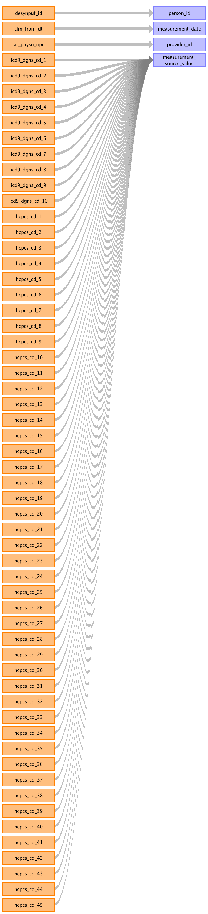

|  |  |  |  |
| --- | --- | --- | --- |
| Destination Field | Source Field | Logic | Comment |
| measurement_id |  |  | autogenerated |
| person_id | desynpuf_id |  |  |
| measurement_concept_id |  |  | ALL SOURCE FILES: Use Concept_Relationship table to match standard concepts from the following fields mapped: HCPCS, ICD9 diagnoses and procedures. |
| measurement_date | clm_from_dt |  |  |
| measurement_time |  |  | null |
| measurement_type_concept_id |  |  | Use concept id = 45754907 for "Derived value" for all HCPCS, ICD9 diagnoses and ICD9 procedure codes mapped. |
| operator_concept_id |  |  | null |
| value_as_number |  |  | null |
| value_as_concept_id |  |  | null |
| unit_concept_id |  |  | null |
| range_low |  |  | 0 |
| range_high |  |  | 0 |
| provider_id | at_physn_npi |  |  |
| visit_occurrence_id |  |  | Associate to proper VISIT_OCCURRENCE_ID. |
| measurement_source_value | icd9_dgns_cd_1 icd9_dgns_cd_2 icd9_dgns_cd_3 icd9_dgns_cd_4 icd9_dgns_cd_5 icd9_dgns_cd_6 icd9_dgns_cd_7 icd9_dgns_cd_8 icd9_dgns_cd_9 icd9_dgns_cd_10 hcpcs_cd_1 hcpcs_cd_2 hcpcs_cd_3 hcpcs_cd_4 hcpcs_cd_5 hcpcs_cd_6 hcpcs_cd_7 hcpcs_cd_8 hcpcs_cd_9 hcpcs_cd_10 hcpcs_cd_11 hcpcs_cd_12 hcpcs_cd_13 hcpcs_cd_14 hcpcs_cd_15 hcpcs_cd_16 hcpcs_cd_17 hcpcs_cd_18 hcpcs_cd_19 hcpcs_cd_20 hcpcs_cd_21 hcpcs_cd_22 hcpcs_cd_23 hcpcs_cd_24 hcpcs_cd_25 hcpcs_cd_26 hcpcs_cd_27 hcpcs_cd_28 hcpcs_cd_29 hcpcs_cd_30 hcpcs_cd_31 hcpcs_cd_32 hcpcs_cd_33 hcpcs_cd_34 hcpcs_cd_35 hcpcs_cd_36 hcpcs_cd_37 hcpcs_cd_38 hcpcs_cd_39 hcpcs_cd_40 hcpcs_cd_41 hcpcs_cd_42 hcpcs_cd_43 hcpcs_cd_44 hcpcs_cd_45 |  |  |
| measurement_source_concept_id |  |  | ALL SOURCE FILES: Use SOURCE_CONCEPT_ID for each HCPCS, ICD9 diagnosis or ICD9 procedure mapped. |
| unit_source_value |  |  | null |
| value_source_value |  |  | null |

Reading from carrier_claims

For HCPCS, ICD9 diagnosis and ICD9 procedure columns, use VOCABULARY to determine if the code belongs to the MEASUREMENT domain, else it will go to a DEVICE_EXPOSURE, PROCEDURE_OCCURRENCE, OBSERVATION, or DRUG_EXPOSURE.
CAUTION: The MEASUREMENT and OBSERVATION CDM tables do not have cost tables associated with them in CDM v5. If HCPCS are mapped to these tables, the associated costs will be lost. Since SynPUF is fake data, we will go ahead with using the VOCABULARY assignments and not include the costs associated with HCPCS in the MEASUREMENT and OBSERVATION tables. However, when creating a specification document for real data, we DO NOT recommend using the VOCABULARY for HCPCS domain assignment for CDM v5, as certain cost data will not be included in the final CDM. This is not an issue with ICD9 procedure codes as these associated costs are stored at the VISIT_COST table.

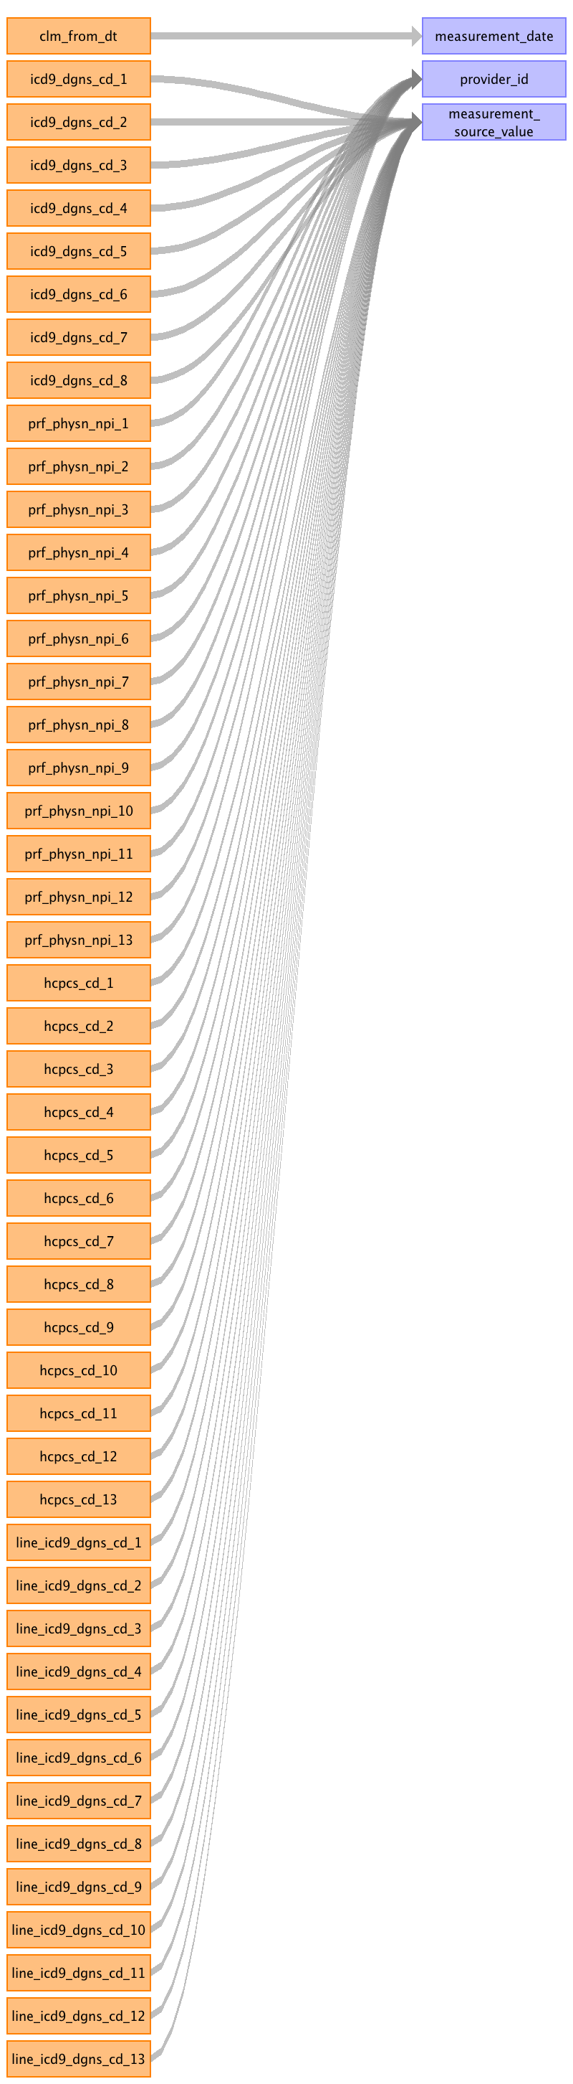

|  |  |  |  |
| --- | --- | --- | --- |
| Destination Field | Source Field | Logic | Comment |
| measurement_id |  |  | autogenerated |
| person_id |  |  |  |
| measurement_concept_id |  |  | ALL SOURCE FILES: Use Concept_Relationship table to match standard concepts from the following fields mapped: HCPCS, ICD9 diagnoses and procedures. |
| measurement_date | clm_from_dt |  |  |
| measurement_time |  |  | null |
| measurement_type_concept_id |  |  | Use concept id = 45754907 for "Derived value" for all HCPCS, ICD9 diagnoses and ICD9 procedure codes mapped. |
| operator_concept_id |  |  | null |
| value_as_number |  |  | null |
| value_as_concept_id |  |  | null |
| unit_concept_id |  |  | null |
| range_low |  |  | 0 |
| range_high |  |  | 0 |
| provider_id | prf_physn_npi_1 prf_physn_npi_2 prf_physn_npi_3 prf_physn_npi_4 prf_physn_npi_5 prf_physn_npi_6 prf_physn_npi_7 prf_physn_npi_8 prf_physn_npi_9 prf_physn_npi_10 prf_physn_npi_11 prf_physn_npi_12 prf_physn_npi_13 |  |  |
| visit_occurrence_id |  |  | Associate to proper VISIT_OCCURRENCE_ID. |
| measurement_source_value | icd9_dgns_cd_1 icd9_dgns_cd_2 icd9_dgns_cd_3 icd9_dgns_cd_4 icd9_dgns_cd_5 icd9_dgns_cd_6 icd9_dgns_cd_7 icd9_dgns_cd_8 hcpcs_cd_1 hcpcs_cd_2 hcpcs_cd_3 hcpcs_cd_4 hcpcs_cd_5 hcpcs_cd_6 hcpcs_cd_7 hcpcs_cd_8 hcpcs_cd_9 hcpcs_cd_10 hcpcs_cd_11 hcpcs_cd_12 hcpcs_cd_13 line_icd9_dgns_cd_1 line_icd9_dgns_cd_2 line_icd9_dgns_cd_3 line_icd9_dgns_cd_4 line_icd9_dgns_cd_5 line_icd9_dgns_cd_6 line_icd9_dgns_cd_7 line_icd9_dgns_cd_8 line_icd9_dgns_cd_9 line_icd9_dgns_cd_10 line_icd9_dgns_cd_11 line_icd9_dgns_cd_12 line_icd9_dgns_cd_13 |  |  |
| measurement_source_concept_id |  |  | ALL SOURCE FILES: Use SOURCE_CONCEPT_ID for each HCPCS, ICD9 diagnosis or ICD9 procedure mapped. |
| unit_source_value |  |  | null |
| value_source_value |  |  | null |

Reading from inpatient_claims

For HCPCS, ICD9 diagnosis and ICD9 procedure columns, use VOCABULARY to determine if the code belongs to the MEASUREMENT domain, else it will go to a DEVICE_EXPOSURE, PROCEDURE_OCCURRENCE, OBSERVATION, or DRUG_EXPOSURE.
CAUTION: The MEASUREMENT and OBSERVATION CDM tables do not have cost tables associated with them in CDM v5. If HCPCS are mapped to these tables, the associated costs will be lost. Since SynPUF is fake data, we will go ahead with using the VOCABULARY assignments and not include the costs associated with HCPCS in the MEASUREMENT and OBSERVATION tables. However, when creating a specification document for real data, we DO NOT recommend using the VOCABULARY for HCPCS domain assignment for CDM v5, as certain cost data will not be included in the final CDM. This is not an issue with ICD9 procedure codes as these associated costs are stored at the VISIT_COST table.

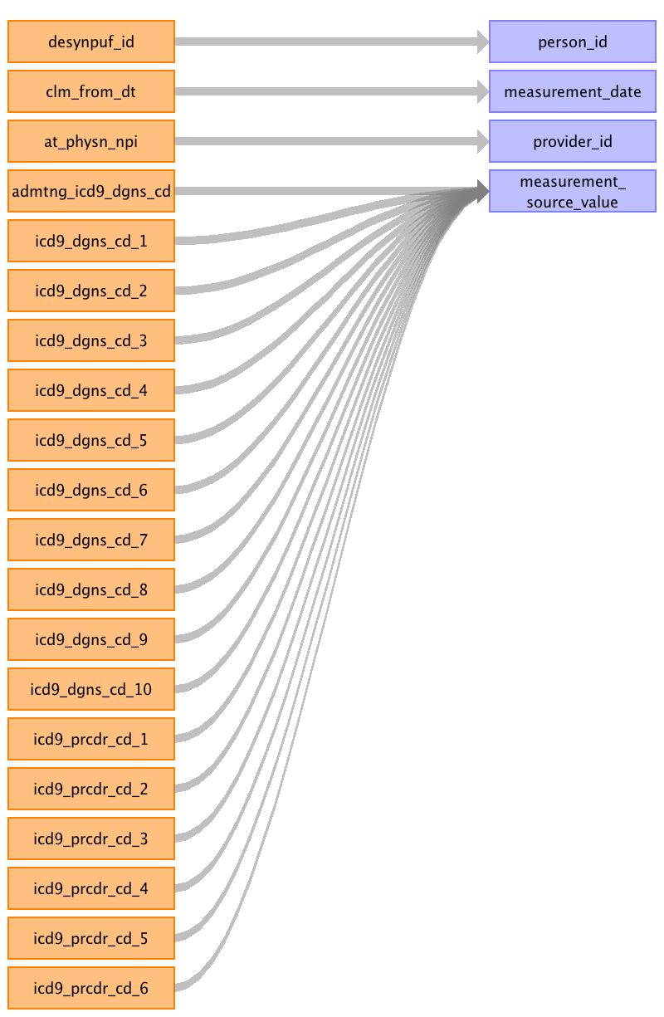

|  |  |  |  |
| --- | --- | --- | --- |
| Destination Field | Source Field | Logic | Comment |
| measurement_id |  |  | autogenerated |
| person_id | desynpuf_id |  |  |
| measurement_concept_id |  |  | ALL SOURCE FILES: Use Concept_Relationship table to match standard concepts from the following fields mapped: HCPCS, ICD9 diagnoses and procedures. |
| measurement_date | clm_from_dt |  |  |
| measurement_time |  |  | null |
| measurement_type_concept_id |  |  | Use concept id = 45754907 for "Derived value" for all HCPCS, ICD9 diagnoses and ICD9 procedure codes mapped. |
| operator_concept_id |  |  | null |
| value_as_number |  |  | null |
| value_as_concept_id |  |  | null |
| unit_concept_id |  |  | null |
| range_low |  |  | 0 |
| range_high |  |  | 0 |
| provider_id | at_physn_npi |  |  |
| visit_occurrence_id |  |  | Associate to proper VISIT_OCCURRENCE_ID. |
| measurement_source_value | admtng_icd9_dgns_cd icd9_dgns_cd_1 icd9_dgns_cd_2 icd9_dgns_cd_3 icd9_dgns_cd_4 icd9_dgns_cd_5 icd9_dgns_cd_6 icd9_dgns_cd_7 icd9_dgns_cd_8 icd9_dgns_cd_9 icd9_dgns_cd_10 icd9_prcdr_cd_1 icd9_prcdr_cd_2 icd9_prcdr_cd_3 icd9_prcdr_cd_4 icd9_prcdr_cd_5 icd9_prcdr_cd_6 |  |  |
| measurement_source_concept_id |  |  | ALL SOURCE FILES: Use SOURCE_CONCEPT_ID for each HCPCS, ICD9 diagnosis or ICD9 procedure mapped. |
| unit_source_value |  |  | null |
| value_source_value |  |  | null |

Table name: observation

Reading from inpatient_claims

For HCPCS, ICD9 diagnosis and ICD9 procedure columns, use VOCABULARY to determine if the code belongs to the OBSERVATION domain, else it will go to a DEVICE_EXPOSURE, PROCEDURE_OCCURRENCE, MEASUREMENT, or DRUG_EXPOSURE.
CAUTION: The MEASUREMENT and OBSERVATION CDM tables do not have cost tables associated with them in CDM v5. If HCPCS are mapped to these tables, the associated costs will be lost. Since SynPUF is fake data, we will go ahead with using the VOCABULARY assignments and not include the costs associated with HCPCS in the MEASUREMENT and OBSERVATION tables. However, when creating a specification document for real data, we DO NOT recommend using the VOCABULARY for HCPCS domain assignment for CDM v5, as certain cost data will not be included in the final CDM. This is not an issue with ICD9 procedure codes as these associated costs are stored at the VISIT_COST table.

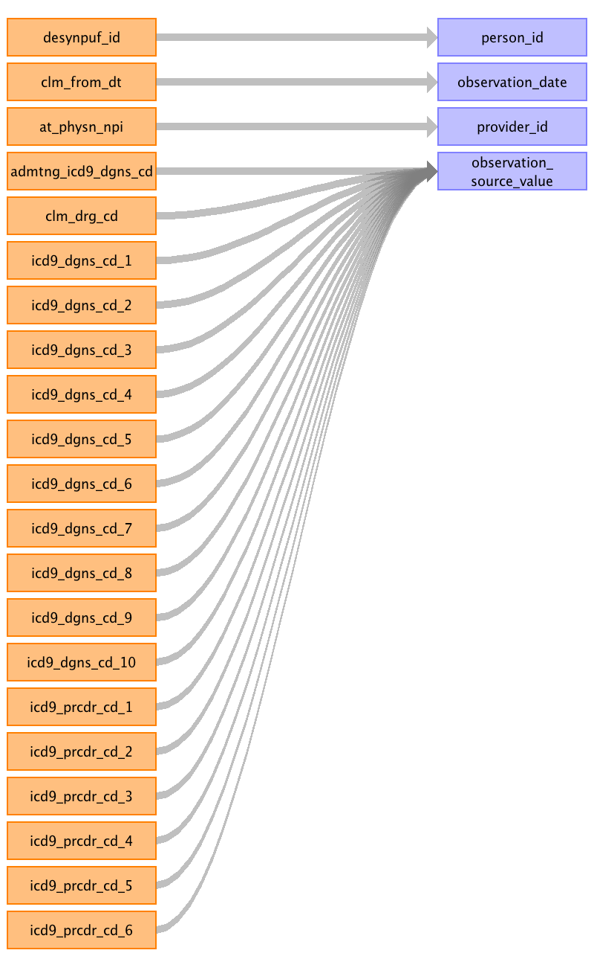

|  |  |  |  |
| --- | --- | --- | --- |
| Destination Field | Source Field | Logic | Comment |
| observation_id |  |  | autogenerated |
| person_id | desynpuf_id |  |  |
| observation_concept_id |  |  | INPATIENT_CLAIMS: Use DRG concept IDs ALL SOURCE FILES: Use Concept_Relationship table to match standard concepts from the following fields mapped: HCPCS, ICD9 diagnoses and procedures. |
| observation_date | clm_from_dt | YYYYMMDD converted to date. |  |
| observation_time |  |  | NULL |
| observation_type_concept_id |  |  | Use 38000282-Chief complaint for all DRG, HCPCS, ICD9 diagnosis and ICD9 procedure fields mapped. |
| value_as_number |  |  | NULL |
| value_as_string |  |  | NULL |
| value_as_concept_id |  |  | 0 |
| qualifier_concept_id |  |  | 0 |
| unit_concept_id |  |  | 0 |
| provider_id | at_physn_npi |  |  |
| visit_occurrence_id |  |  | Track this as writing records. |
| observation_source_value | clm_drg_cd icd9_dgns_cd_1 icd9_dgns_cd_2 icd9_dgns_cd_3 icd9_dgns_cd_4 icd9_dgns_cd_5 icd9_dgns_cd_6 icd9_dgns_cd_7 icd9_dgns_cd_8 icd9_dgns_cd_9 admtng_icd9_dgns_cd icd9_dgns_cd_10 icd9_prcdr_cd_1 icd9_prcdr_cd_2 icd9_prcdr_cd_3 icd9_prcdr_cd_4 icd9_prcdr_cd_5 icd9_prcdr_cd_6 |  |  |
| observation_source_concept_id |  |  | INPATIENT_CLAIMS: Convert DRG from CLM_DRG_CD to CONCEPT_ID, look for the source DRG in the CONCEPT.CONCEPT_CODE and use the CLM_FROM_DT to determine the appropriate DRG to select. ALL SOURCE FILES: Use SOURCE_CONCEPT_ID for each HCPCS, ICD9 diagnosis or ICD9 procedure mapped. |
| unit_source_value |  |  | NULL |
| qualifier_source_value |  |  | NULL |

Reading from carrier_claims

For HCPCS, ICD9 diagnosis and ICD9 procedure columns, use VOCABULARY to determine if the code belongs to the OBSERVATION domain, else it will go to a DEVICE_EXPOSURE, PROCEDURE_OCCURRENCE, MEASUREMENT, or DRUG_EXPOSURE.
CAUTION: The MEASUREMENT and OBSERVATION CDM tables do not have cost tables associated with them in CDM v5. If HCPCS are mapped to these tables, the associated costs will be lost. Since SynPUF is fake data, we will go ahead with using the VOCABULARY assignments and not include the costs associated with HCPCS in the MEASUREMENT and OBSERVATION tables. However, when creating a specification document for real data, we DO NOT recommend using the VOCABULARY for HCPCS domain assignment for CDM v5, as certain cost data will not be included in the final CDM. This is not an issue with ICD9 procedure codes as these associated costs are stored at the VISIT_COST table.

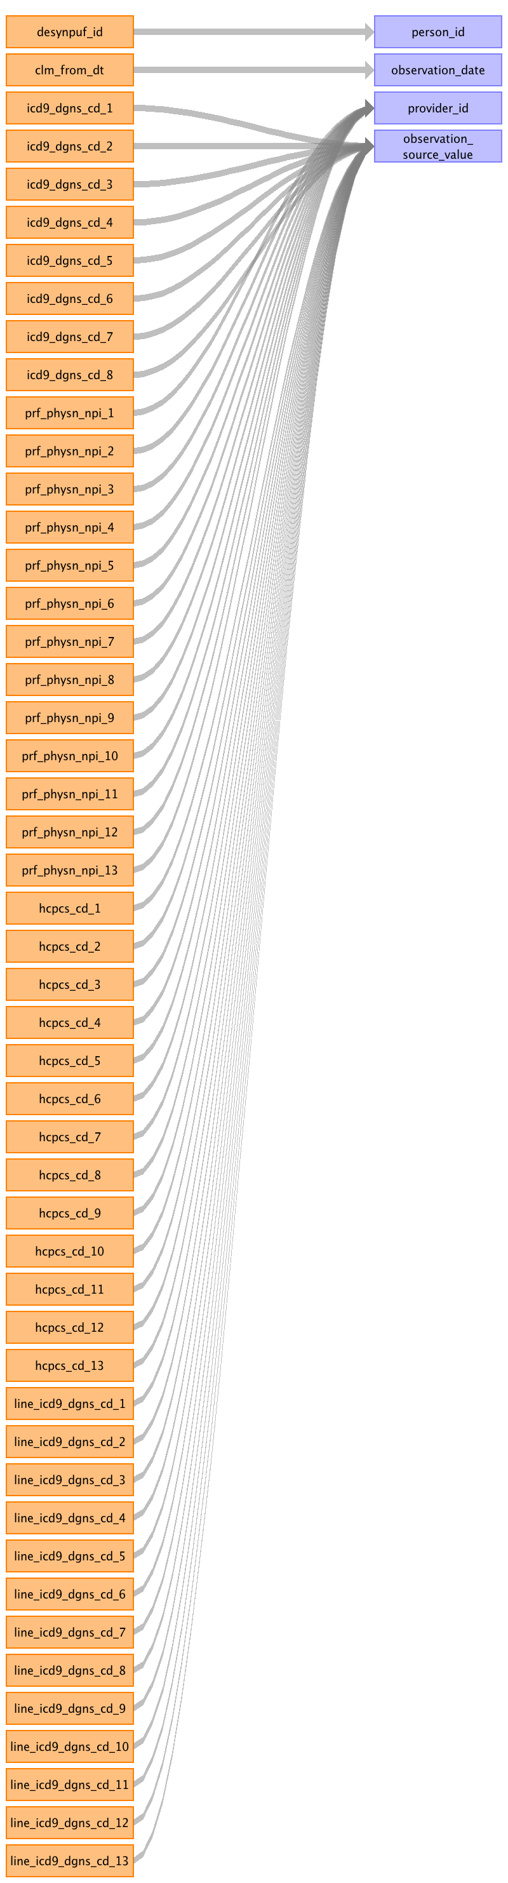

|  |  |  |  |
| --- | --- | --- | --- |
| Destination Field | Source Field | Logic | Comment |
| observation_id |  |  | autogenerated |
| person_id | desynpuf_id |  |  |
| observation_concept_id |  |  | INPATIENT_CLAIMS: Use DRG concept IDs ALL SOURCE FILES: Use Concept_Relationship table to match standard concepts from the following fields mapped: HCPCS, ICD9 diagnoses and procedures. |
| observation_date | clm_from_dt |  |  |
| observation_time |  |  | NULL |
| observation_type_concept_id |  |  | Use 38000282-Chief complaint for all DRG, HCPCS, ICD9 diagnosis and ICD9 procedure fields mapped. |
| value_as_number |  |  | NULL |
| value_as_string |  |  | NULL |
| value_as_concept_id |  |  | 0 |
| qualifier_concept_id |  |  | 0 |
| unit_concept_id |  |  | 0 |
| provider_id | prf_physn_npi_1 prf_physn_npi_2 prf_physn_npi_3 prf_physn_npi_4 prf_physn_npi_5 prf_physn_npi_6 prf_physn_npi_7 prf_physn_npi_8 prf_physn_npi_9 prf_physn_npi_10 prf_physn_npi_11 prf_physn_npi_12 prf_physn_npi_13 |  |  |
| visit_occurrence_id |  |  | Track this as writing records. |
| observation_source_value | icd9_dgns_cd_1 icd9_dgns_cd_2 icd9_dgns_cd_3 icd9_dgns_cd_4 icd9_dgns_cd_5 icd9_dgns_cd_6 icd9_dgns_cd_7 icd9_dgns_cd_8 hcpcs_cd_1 hcpcs_cd_2 hcpcs_cd_3 hcpcs_cd_4 hcpcs_cd_5 hcpcs_cd_6 hcpcs_cd_7 hcpcs_cd_8 hcpcs_cd_9 hcpcs_cd_10 hcpcs_cd_11 hcpcs_cd_12 hcpcs_cd_13 line_icd9_dgns_cd_1 line_icd9_dgns_cd_2 line_icd9_dgns_cd_3 line_icd9_dgns_cd_4 line_icd9_dgns_cd_5 line_icd9_dgns_cd_6 line_icd9_dgns_cd_7 line_icd9_dgns_cd_8 line_icd9_dgns_cd_9 line_icd9_dgns_cd_10 line_icd9_dgns_cd_11 line_icd9_dgns_cd_12 line_icd9_dgns_cd_13 |  |  |
| observation_source_concept_id |  |  | INPATIENT_CLAIMS: Convert DRG from CLM_DRG_CD to CONCEPT_ID, look for the source DRG in the CONCEPT.CONCEPT_CODE and use the CLM_FROM_DT to determine the appropriate DRG to select. ALL SOURCE FILES: Use SOURCE_CONCEPT_ID for each HCPCS, ICD9 diagnosis or ICD9 procedure mapped. |
| unit_source_value |  |  | NULL |
| qualifier_source_value |  |  | NULL |

Reading from outpatient_claims

For HCPCS, ICD9 diagnosis and ICD9 procedure columns, use VOCABULARY to determine if the code belongs to the OBSERVATION domain, else it will go to a DEVICE_EXPOSURE, PROCEDURE_OCCURRENCE, MEASUREMENT, or DRUG_EXPOSURE.
CAUTION: The MEASUREMENT and OBSERVATION CDM tables do not have cost tables associated with them in CDM v5. If HCPCS are mapped to these tables, the associated costs will be lost. Since SynPUF is fake data, we will go ahead with using the VOCABULARY assignments and not include the costs associated with HCPCS in the MEASUREMENT and OBSERVATION tables. However, when creating a specification document for real data, we DO NOT recommend using the VOCABULARY for HCPCS domain assignment for CDM v5, as certain cost data will not be included in the final CDM. This is not an issue with ICD9 procedure codes as these associated costs are stored at the VISIT_COST table.

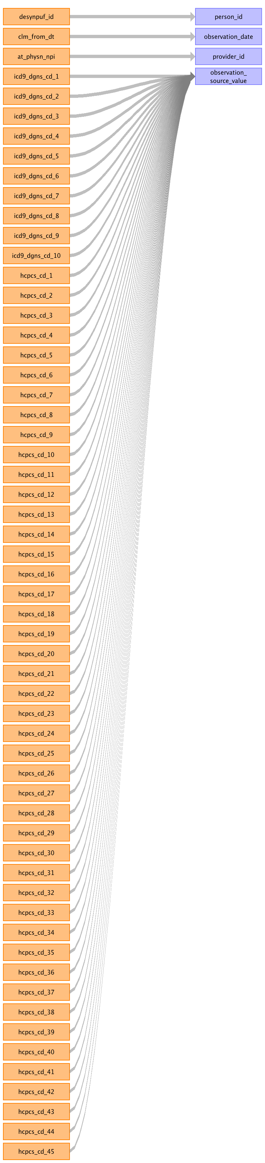

|  |  |  |  |
| --- | --- | --- | --- |
| Destination Field | Source Field | Logic | Comment |
| observation_id |  |  | autogenerated |
| person_id | desynpuf_id |  |  |
| observation_concept_id |  |  | INPATIENT_CLAIMS: Use DRG concept IDs ALL SOURCE FILES: Use Concept_Relationship table to match standard concepts from the following fields mapped: HCPCS, ICD9 diagnoses and procedures. |
| observation_date | clm_from_dt |  |  |
| observation_time |  |  | NULL |
| observation_type_concept_id |  |  | Use 38000282-Chief complaint for all DRG, HCPCS, ICD9 diagnosis and ICD9 procedure fields mapped. |
| value_as_number |  |  | NULL |
| value_as_string |  |  | NULL |
| value_as_concept_id |  |  | 0 |
| qualifier_concept_id |  |  | 0 |
| unit_concept_id |  |  | 0 |
| provider_id | at_physn_npi |  |  |
| visit_occurrence_id |  |  | Track this as writing records. |
| observation_source_value | icd9_dgns_cd_1 icd9_dgns_cd_2 icd9_dgns_cd_3 icd9_dgns_cd_4 icd9_dgns_cd_7 icd9_dgns_cd_5 icd9_dgns_cd_6 icd9_dgns_cd_8 icd9_dgns_cd_9 icd9_dgns_cd_10 hcpcs_cd_1 hcpcs_cd_2 hcpcs_cd_3 hcpcs_cd_4 hcpcs_cd_5 hcpcs_cd_6 hcpcs_cd_7 hcpcs_cd_8 hcpcs_cd_9 hcpcs_cd_10 hcpcs_cd_11 hcpcs_cd_12 hcpcs_cd_13 hcpcs_cd_14 hcpcs_cd_15 hcpcs_cd_16 hcpcs_cd_17 hcpcs_cd_18 hcpcs_cd_19 hcpcs_cd_45 hcpcs_cd_20 hcpcs_cd_21 hcpcs_cd_22 hcpcs_cd_23 hcpcs_cd_24 hcpcs_cd_25 hcpcs_cd_26 hcpcs_cd_44 hcpcs_cd_43 hcpcs_cd_42 hcpcs_cd_41 hcpcs_cd_40 hcpcs_cd_39 hcpcs_cd_38 hcpcs_cd_37 hcpcs_cd_36 hcpcs_cd_35 hcpcs_cd_34 hcpcs_cd_33 hcpcs_cd_32 hcpcs_cd_27 hcpcs_cd_28 hcpcs_cd_29 hcpcs_cd_31 hcpcs_cd_30 |  |  |
| observation_source_concept_id |  |  | INPATIENT_CLAIMS: Convert DRG from CLM_DRG_CD to CONCEPT_ID, look for the source DRG in the CONCEPT.CONCEPT_CODE and use the CLM_FROM_DT to determine the appropriate DRG to select. ALL SOURCE FILES: Use SOURCE_CONCEPT_ID for each HCPCS, ICD9 diagnosis or ICD9 procedure mapped. |
| unit_source_value |  |  | NULL |
| qualifier_source_value |  |  | NULL |

Table name: note

Table name: specimen

Table name: fact_relationship

Reading from carrier_claims

(1) CARE_SITE --> PROCEDURE_OCCURRENCE
--DOMAIN_CONCEPT_ID_1 = 57-Care site
--FACT_ID_1= (TAX_NUM_1 to TAX_NUM_13)
--DOMAIN_CONCEPT_ID_2 = 10-Procedure
--FACT_ID_2 = (HCPC_CODE_1 to HCPC_CODE_13)
--RELATIONSHIP_CONCEPT_ID = 44818841-Procedure site of (SNOMED)
(2) CONDITION_OCCURRENCE --> PROCEDURE_OCCURRENCE
--DOMAIN_CONCEPT_ID_1 = 19-Condition
--FACT_ID_1= (LINE_DGNS_CD_1 to LINE_DGNS_CD_13)
--DOMAIN_CONCEPT_ID_2 = 10-Procedure
--FACT_ID_2 = (HCPC_CODE_1 to HCPC_CODE_13)
--RELATIONSHIP_CONCEPT_ID = 44818784-Has associated procedure (SNOMED)

for the FACT_ID, this is for the related CONDITON_OCCURRENCE_ID, PROCEDURE_OCCURRENCE_ID or CARE_SITE_ID.

Generated

|  |  |  |  |
| --- | --- | --- | --- |
| Destination Field | Source Field | Logic | Comment |
| domain_concept_id_1 |  |  |  |
| fact_id_1 |  |  |  |
| domain_concept_id_2 |  |  |  |
| fact_id_2 |  |  |  |
| relationship_concept_id |  |  |  |

Table name: procedure_cost

Reading from carrier_claims

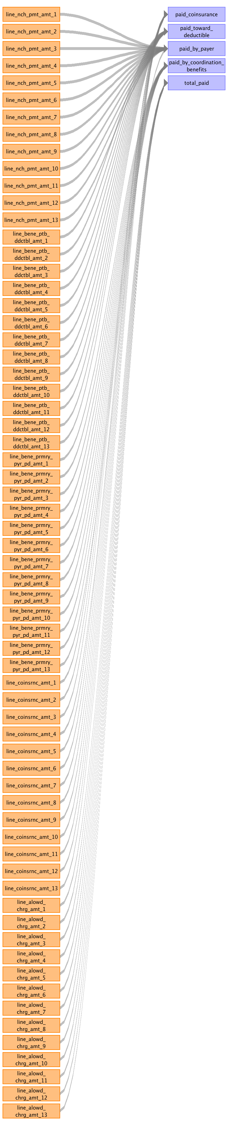

|  |  |  |  |
| --- | --- | --- | --- |
| Destination Field | Source Field | Logic | Comment |
| procedure_cost_id |  |  | autogenerated |
| procedure_occurrence_id |  |  | Once the records for the procedures are written to the PROCEDURE_OCCURRENCE table, then you'll be able to use that autogenerated ID for this column. |
| currency_concept_id |  |  | 44818668-United States dollar |
| paid_copay |  |  | Null |
| paid_coinsurance | line_coinsrnc_amt_1 line_coinsrnc_amt_2 line_coinsrnc_amt_3 line_coinsrnc_amt_13 line_coinsrnc_amt_5 line_coinsrnc_amt_6 line_coinsrnc_amt_7 line_coinsrnc_amt_8 line_coinsrnc_amt_9 line_coinsrnc_amt_10 line_coinsrnc_amt_11 line_coinsrnc_amt_12 |  |  |
| paid_toward_deductible | line_bene_ptb_ddctbl_amt_1 line_bene_ptb_ddctbl_amt_2 line_bene_ptb_ddctbl_amt_3 line_bene_ptb_ddctbl_amt_4 line_bene_ptb_ddctbl_amt_5 line_bene_ptb_ddctbl_amt_6 line_bene_ptb_ddctbl_amt_7 line_bene_ptb_ddctbl_amt_8 line_bene_ptb_ddctbl_amt_9 line_bene_ptb_ddctbl_amt_10 line_bene_ptb_ddctbl_amt_11 line_bene_ptb_ddctbl_amt_12 line_bene_ptb_ddctbl_amt_13 |  |  |
| paid_by_payer | line_nch_pmt_amt_1 line_nch_pmt_amt_2 line_nch_pmt_amt_3 line_nch_pmt_amt_4 line_nch_pmt_amt_5 line_nch_pmt_amt_6 line_nch_pmt_amt_7 line_nch_pmt_amt_8 line_nch_pmt_amt_9 line_nch_pmt_amt_10 line_nch_pmt_amt_11 line_nch_pmt_amt_12 line_nch_pmt_amt_13 line_coinsrnc_amt_4 |  |  |
| paid_by_coordination_benefits | line_bene_prmry_pyr_pd_amt_1 line_bene_prmry_pyr_pd_amt_2 line_bene_prmry_pyr_pd_amt_3 line_bene_prmry_pyr_pd_amt_4 line_bene_prmry_pyr_pd_amt_5 line_bene_prmry_pyr_pd_amt_6 line_bene_prmry_pyr_pd_amt_7 line_bene_prmry_pyr_pd_amt_8 line_bene_prmry_pyr_pd_amt_9 line_bene_prmry_pyr_pd_amt_10 line_bene_prmry_pyr_pd_amt_11 line_bene_prmry_pyr_pd_amt_12 line_bene_prmry_pyr_pd_amt_13 |  |  |
| total_out_of_pocket |  |  | PAID_TOWARD_DEDUCTIBLE + PAID_COINSURANCE |
| total_paid | line_alowd_chrg_amt_1 line_alowd_chrg_amt_2 line_alowd_chrg_amt_3 line_alowd_chrg_amt_4 line_alowd_chrg_amt_5 line_alowd_chrg_amt_6 line_alowd_chrg_amt_7 line_alowd_chrg_amt_8 line_alowd_chrg_amt_9 line_alowd_chrg_amt_10 line_alowd_chrg_amt_11 line_alowd_chrg_amt_12 line_alowd_chrg_amt_13 |  |  |
| revenue_code_concept_id |  |  | 0 |
| payer_plan_period_id |  |  | CARRIER_CLAIMS: Lookup to the PAYER_PLAN_PERIOD table, the default it to select PART B. |
| revenue_code_source_value |  |  | NULL |

Table name: visit_cost

Reading from outpatient_claims

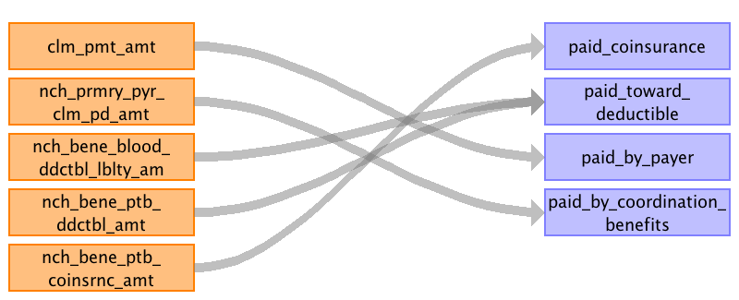

|  |  |  |  |
| --- | --- | --- | --- |
| Destination Field | Source Field | Logic | Comment |
| visit_cost_id |  |  | Autogenerated |
| visit_occurrence_id |  |  | Maintain the VISIT_OCCURRENCE_ID as you are pulling the information from this table and write it here. |
| currency_concept_id |  |  | 44818668-United States dollar |
| paid_copay |  |  | Null |
| paid_coinsurance | nch_bene_ptb_coinsrnc_amt |  |  |
| paid_toward_deductible | nch_bene_ptb_ddctbl_amt nch_bene_blood_ddctbl_lblty_am |  | Inpatient Claims: PAID_TOWARD_DEDUCTIBLE + NCH_BENE_BLOOD_DDCTBLE_LBLTY_AM Outpatient Claims: (NCH_BENE_BLOOD_DDCTBL_LBLTY_AM + NCH_BENE_PTB_DDCTBL_AMT) |
| paid_by_payer | clm_pmt_amt |  | Inpatient Claims: CLM_PMT_AMT + (CLM_UTLZTN_DAY_CNT * CLM_PASS_THRU_PER_DIEM_AMT) |
| paid_by_coordination_benefits | nch_prmry_pyr_clm_pd_amt |  |  |
| total_out_of_pocket |  |  | sum of CDM tables (PAID_COINSURANCE + PAID_TOWARD_DEDUCTIBLE) |
| total_paid |  |  | sum of CDM tables (PAID_BY_PAYER + PAID_BY_COORDINATION_BENEFITS + TOTAL_OUT_OF_POCKET) |
| payer_plan_period_id |  |  | Lookup the PAYER_PLAN_PERIOD, but for INPATIENT_CLAIMS we will default to PARTA for OUTPATIENT_CLAIMS we will default to PARTB ELSE NULL. |

Reading from inpatient_claims

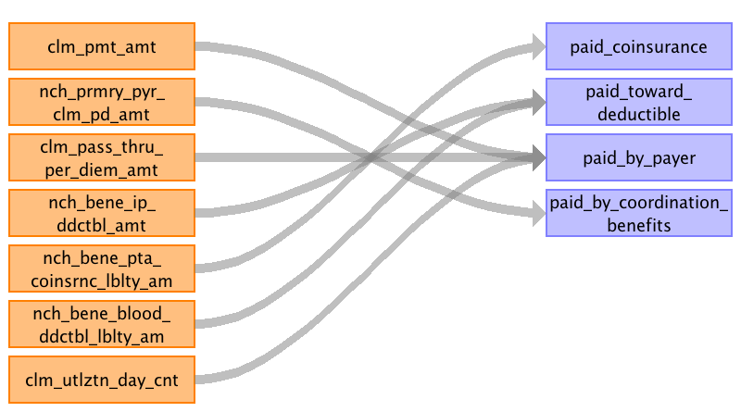

|  |  |  |  |
| --- | --- | --- | --- |
| Destination Field | Source Field | Logic | Comment |
| visit_cost_id |  |  | Autogenerated |
| visit_occurrence_id |  |  | Maintain the VISIT_OCCURRENCE_ID as you are pulling the information from this table and write it here. |
| currency_concept_id |  |  | 44818668-United States dollar |
| paid_copay |  |  | Null |
| paid_coinsurance | nch_bene_pta_coinsrnc_lblty_am |  |  |
| paid_toward_deductible | nch_bene_ip_ddctbl_amt nch_bene_blood_ddctbl_lblty_am |  | Inpatient Claims: PAID_TOWARD_DEDUCTIBLE + NCH_BENE_BLOOD_DDCTBLE_LBLTY_AM Outpatient Claims: (NCH_BENE_BLOOD_DDCTBL_LBLTY_AM + NCH_BENE_PTB_DDCTBL_AMT) |
| paid_by_payer | clm_utlztn_day_cnt clm_pass_thru_per_diem_amt clm_pmt_amt |  | Inpatient Claims: CLM_PMT_AMT + (CLM_UTLZTN_DAY_CNT * CLM_PASS_THRU_PER_DIEM_AMT) |
| paid_by_coordination_benefits | nch_prmry_pyr_clm_pd_amt |  |  |
| total_out_of_pocket |  |  | sum of CDM tables (PAID_COINSURANCE + PAID_TOWARD_DEDUCTIBLE) |
| total_paid |  |  | sum of CDM tables (PAID_BY_PAYER + PAID_BY_COORDINATION_BENEFITS + TOTAL_OUT_OF_POCKET) |
| payer_plan_period_id |  |  | Lookup the PAYER_PLAN_PERIOD, but for INPATIENT_CLAIMS we will default to PARTA for OUTPATIENT_CLAIMS we will default to PARTB ELSE NULL. |

Table name: drug_cost

Reading from prescription_drug_events

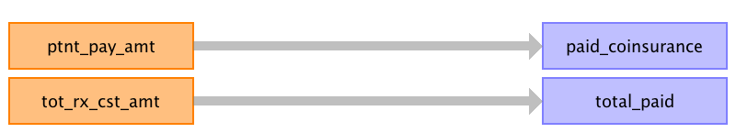

|  |  |  |  |
| --- | --- | --- | --- |
| Destination Field | Source Field | Logic | Comment |
| drug_cost_id |  |  | Autogenerated |
| drug_exposure_id |  |  | When pulling record into DRUG_EXPOSURE keep track of that ID generated before writing to DRUG_COST table. |
| currency_concept_id |  |  | 44818668-United States dollar |
| paid_copay |  |  | NULL |
| paid_coinsurance | ptnt_pay_amt |  |  |
| paid_toward_deductible |  |  | PRESCRIPTION_DRUG_EVENTS: Null |
| paid_by_payer |  |  | PRESCRIPTION_DRUG_EVENTS: Null |
| paid_by_coordination_benefits |  |  | PRESCRIPTION_DRUG_EVENTS: Null |
| total_out_of_pocket |  |  | SUM of CDM tables (PAID_COINSURANCE + PAID_TOWARD_DEDUCTIBLE) |
| total_paid | tot_rx_cst_amt |  | CARRIER_CLAIMS: We are using the allowed amounts here and not the sum of PAID_BY_COORDINATION_BENEFITS, PAID_BY_PAYER, and TOTAL_OUT_OF_POCKET. |
| ingredient_cost |  |  | Null |
| dispensing_fee |  |  | Null |
| average_wholesale_price |  |  | Null |
| payer_plan_period_id |  |  | CARRIER_CLAIMS: Lookup in the PAYER_PLAN_PERIOD table for a PARTB plan, ELSE NULL PRESCRIPTION_DRUG_EVENTS: Lookup in the PAYER_PLAN_PERIOD table for a PARTD plan, ELSE NULL. |

Reading from carrier_claims

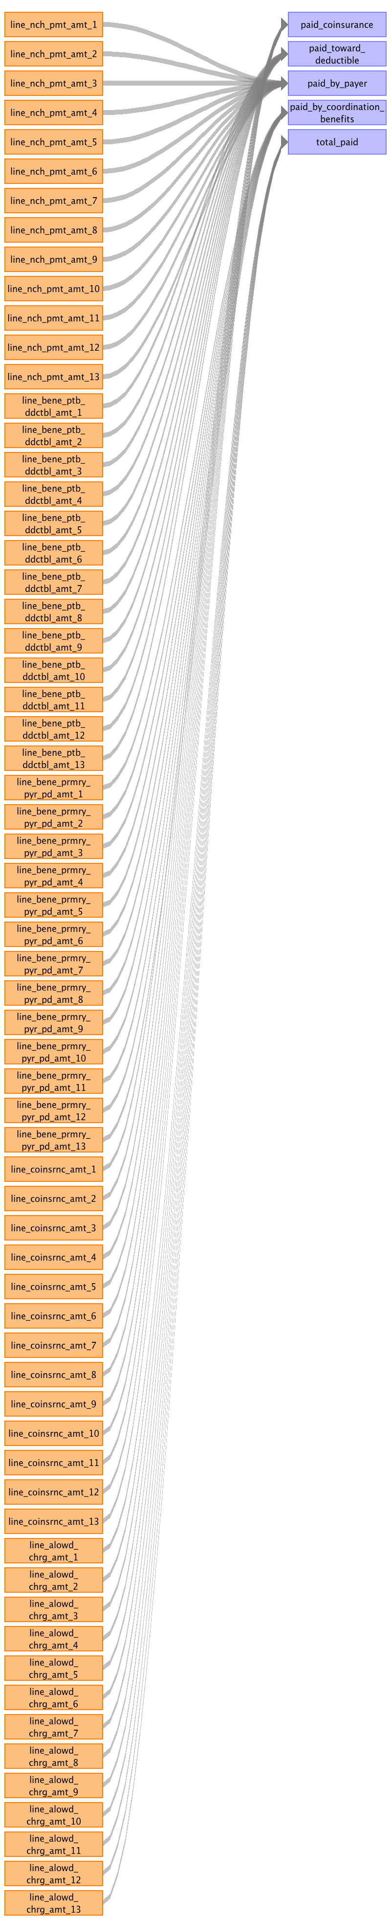

|  |  |  |  |
| --- | --- | --- | --- |
| Destination Field | Source Field | Logic | Comment |
| drug_cost_id |  |  | Autogenerated |
| drug_exposure_id |  |  | When pulling record into DRUG_EXPOSURE keep track of that ID generated before writing to DRUG_COST table. |
| currency_concept_id |  |  | 44818668-United States dollar |
| paid_copay |  |  | NULL |
| paid_coinsurance | line_coinsrnc_amt_1 line_coinsrnc_amt_2 line_coinsrnc_amt_3 line_coinsrnc_amt_4 line_coinsrnc_amt_5 line_coinsrnc_amt_6 line_coinsrnc_amt_7 line_coinsrnc_amt_8 line_coinsrnc_amt_9 line_coinsrnc_amt_10 line_coinsrnc_amt_11 line_coinsrnc_amt_12 line_coinsrnc_amt_13 |  |  |
| paid_toward_deductible | line_bene_ptb_ddctbl_amt_1 line_bene_ptb_ddctbl_amt_2 line_bene_ptb_ddctbl_amt_3 line_bene_ptb_ddctbl_amt_4 line_bene_ptb_ddctbl_amt_5 line_bene_ptb_ddctbl_amt_6 line_bene_ptb_ddctbl_amt_7 line_bene_ptb_ddctbl_amt_8 line_bene_ptb_ddctbl_amt_9 line_bene_ptb_ddctbl_amt_10 line_bene_ptb_ddctbl_amt_11 line_bene_ptb_ddctbl_amt_12 line_bene_ptb_ddctbl_amt_13 |  | PRESCRIPTION_DRUG_EVENTS: Null |
| paid_by_payer | line_nch_pmt_amt_1 line_nch_pmt_amt_2 line_nch_pmt_amt_3 line_nch_pmt_amt_4 line_nch_pmt_amt_5 line_nch_pmt_amt_6 line_nch_pmt_amt_7 line_nch_pmt_amt_8 line_nch_pmt_amt_9 line_nch_pmt_amt_10 line_nch_pmt_amt_11 line_nch_pmt_amt_12 line_nch_pmt_amt_13 |  | PRESCRIPTION_DRUG_EVENTS: Null |
| paid_by_coordination_benefits | line_bene_prmry_pyr_pd_amt_1 line_bene_prmry_pyr_pd_amt_2 line_bene_prmry_pyr_pd_amt_3 line_bene_prmry_pyr_pd_amt_4 line_bene_prmry_pyr_pd_amt_5 line_bene_prmry_pyr_pd_amt_6 line_bene_prmry_pyr_pd_amt_7 line_bene_prmry_pyr_pd_amt_8 line_bene_prmry_pyr_pd_amt_9 line_bene_prmry_pyr_pd_amt_10 line_bene_prmry_pyr_pd_amt_11 line_bene_prmry_pyr_pd_amt_12 line_bene_prmry_pyr_pd_amt_13 |  | PRESCRIPTION_DRUG_EVENTS: Null |
| total_out_of_pocket |  |  | SUM of CDM tables (PAID_COINSURANCE + PAID_TOWARD_DEDUCTIBLE) |
| total_paid | line_alowd_chrg_amt_1 line_alowd_chrg_amt_2 line_alowd_chrg_amt_3 line_alowd_chrg_amt_13 line_alowd_chrg_amt_12 line_alowd_chrg_amt_4 line_alowd_chrg_amt_5 line_alowd_chrg_amt_6 line_alowd_chrg_amt_7 line_alowd_chrg_amt_8 line_alowd_chrg_amt_11 line_alowd_chrg_amt_9 line_alowd_chrg_amt_10 |  | CARRIER_CLAIMS: We are using the allowed amounts here and not the sum of PAID_BY_COORDINATION_BENEFITS, PAID_BY_PAYER, and TOTAL_OUT_OF_POCKET. |
| ingredient_cost |  |  | Null |
| dispensing_fee |  |  | Null |
| average_wholesale_price |  |  | Null |
| payer_plan_period_id |  |  | CARRIER_CLAIMS: Lookup in the PAYER_PLAN_PERIOD table for a PARTB plan, ELSE NULL PRESCRIPTION_DRUG_EVENTS: Lookup in the PAYER_PLAN_PERIOD table for a PARTD plan, ELSE NULL. |

Table name: payer_plan_period

Reading from beneficiary_summary

We are going to look at birth and death date.
We know which months they had claims.
We know how many months they had coverages.
If MONTH = 0 they were not enrolled for that year.
IF MONTH > 0 then they were enrolled.
MONTH = any of these variables: BENE_HI_CVRAGE_TOT_MONS, BENE_SMI_CVRAGE_TOT_MONS, BENE_HMO_CVRAGE_TOT_MONS, PLAN_CVRG_MONS_NUM
We will use the birth and death to correct the tails.
birth = BENE_BIRTH_DT
death = BENE_DEATH_DT
We need to knit the records together the years.

We will have overlapping payer plan periods.

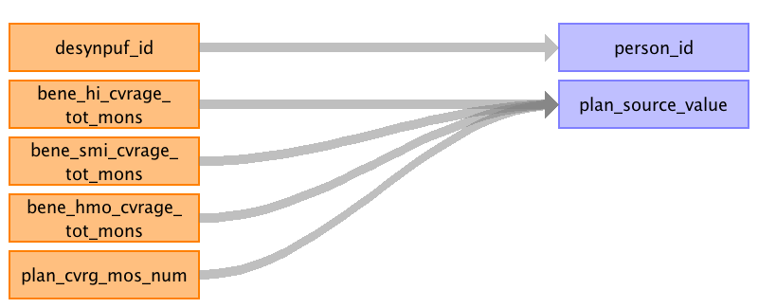

|  |  |  |  |
| --- | --- | --- | --- |
| Destination Field | Source Field | Logic | Comment |
| payer_plan_period_id |  |  |  |
| person_id | desynpuf_id |  |  |
| payer_plan_period_start_date |  |  | If MONTH = 0 they were not enrolled for that year. IF MONTH > 0 then they were enrolled (for 2008 file date = January 1, 2008) MONTH = any of these variables: BENE_HI_CVRAGE_TOT_MONS, BENE_SMI_CVRAGE_TOT_MONS, BENE_HMO_CVRAGE_TOT_MONS, PLAN_CVRG_MONS_NUM We will use the birth and death to correct the tails. Use birthdate to correct start date: birth = BENE_BIRTH_DT Use death date to correct end date: death = BENE_DEATH_DT |
| payer_plan_period_end_date |  |  | If MONTH = 0 they were not enrolled for that year. IF MONTH > 0 then they were enrolled (for 2008 file date = December 31, 2008) MONTH = any of these variables: BENE_HI_CVRAGE_TOT_MONS, BENE_SMI_CVRAGE_TOT_MONS, BENE_HMO_CVRAGE_TOT_MONS, PLAN_CVRG_MONS_NUM We will use the birth and death to correct the tails. Use birthdate to correct start date: birth = BENE_BIRTH_DT Use death date to correct end date: death = BENE_DEATH_DT |
| payer_source_value |  |  | Medicare |
| plan_source_value | bene_hi_cvrage_tot_mons bene_smi_cvrage_tot_mons bene_hmo_cvrage_tot_mons plan_cvrg_mos_num |  | if value from bene_hi_covrage_tot_mons = Part A if value from bene_smi_cvrage_tot_mons = Part B if value from bene_hmo_cvrage_tot_mons = HMO if value from plan_cvrg_mos_num = Part D |
| family_source_value |  |  | Null |

Table name: device_cost

Reading from outpatient_claims



|  |  |  |  |
| --- | --- | --- | --- |
| Destination Field | Source Field | Logic | Comment |
| device_cost_id |  |  | autogenerated |
| device_exposure_id |  |  | As writing the DEVICE_EXPOSURE table keep track of ID and write here. |
| currency_concept_id |  |  | 44818668-United States dollar |
| paid_copay |  |  | Null |
| paid_coinsurance | nch_bene_ptb_coinsrnc_amt |  |  |
| paid_toward_deductible | nch_bene_blood_ddctbl_lblty_am nch_bene_ptb_ddctbl_amt |  | Sum of NCH_BENE_BLOOD_DDCTBL_LBLTY_AM + NCH_BENE_PTB_DDCTBL_AMT |
| paid_by_payer | clm_pmt_amt |  |  |
| paid_by_coordination_benefits | nch_prmry_pyr_clm_pd_amt |  |  |
| total_out_of_pocket |  |  | Sum of CDM Tables (PAID_COINSURANCE + PAID_TOWARD_DEDUCTIBLE) |
| total_paid |  |  | OUTPATIENT_CLAIMS: Sum of CDM tables (PAID_BY_PAYER + PAID_BY_COORDINATION_BENEFITS + TOTAL_OUT_OF_POCKET) |
| payer_plan_period_id |  |  | Look up to PAYER_PLAN_PERIOD and select PARTB plans, else NULL. |

Reading from carrier_claims



|  |  |  |  |
| --- | --- | --- | --- |
| Destination Field | Source Field | Logic | Comment |
| device_cost_id |  |  | autogenerated |
| device_exposure_id |  |  | As writing the DEVICE_EXPOSURE table keep track of ID and write here. |
| currency_concept_id |  |  | 44818668-United States dollar |
| paid_copay |  |  | Null |
| paid_coinsurance | line_coinsrnc_amt_1 line_coinsrnc_amt_2 line_coinsrnc_amt_3 line_coinsrnc_amt_4 line_coinsrnc_amt_5 line_coinsrnc_amt_6 line_coinsrnc_amt_7 line_coinsrnc_amt_8 line_coinsrnc_amt_9 line_coinsrnc_amt_10 line_coinsrnc_amt_11 line_coinsrnc_amt_12 line_coinsrnc_amt_13 |  |  |
| paid_toward_deductible | line_bene_ptb_ddctbl_amt_1 line_bene_ptb_ddctbl_amt_2 line_bene_ptb_ddctbl_amt_3 line_bene_ptb_ddctbl_amt_4 line_bene_ptb_ddctbl_amt_5 line_bene_ptb_ddctbl_amt_6 line_bene_ptb_ddctbl_amt_7 line_bene_ptb_ddctbl_amt_8 line_bene_ptb_ddctbl_amt_9 line_bene_ptb_ddctbl_amt_10 line_bene_ptb_ddctbl_amt_11 line_bene_ptb_ddctbl_amt_12 line_bene_ptb_ddctbl_amt_13 |  | Sum of NCH_BENE_BLOOD_DDCTBL_LBLTY_AM + NCH_BENE_PTB_DDCTBL_AMT |
| paid_by_payer | line_nch_pmt_amt_1 line_nch_pmt_amt_2 line_nch_pmt_amt_3 line_nch_pmt_amt_4 line_nch_pmt_amt_5 line_nch_pmt_amt_6 line_nch_pmt_amt_7 line_nch_pmt_amt_8 line_nch_pmt_amt_9 line_nch_pmt_amt_10 line_nch_pmt_amt_11 line_nch_pmt_amt_12 line_nch_pmt_amt_13 |  |  |
| paid_by_coordination_benefits | line_bene_prmry_pyr_pd_amt_1 line_bene_prmry_pyr_pd_amt_2 line_bene_prmry_pyr_pd_amt_3 line_bene_prmry_pyr_pd_amt_4 line_bene_prmry_pyr_pd_amt_5 line_bene_prmry_pyr_pd_amt_6 line_bene_prmry_pyr_pd_amt_7 line_bene_prmry_pyr_pd_amt_8 line_bene_prmry_pyr_pd_amt_9 line_bene_prmry_pyr_pd_amt_10 line_bene_prmry_pyr_pd_amt_11 line_bene_prmry_pyr_pd_amt_12 line_bene_prmry_pyr_pd_amt_13 |  |  |
| total_out_of_pocket |  |  | Sum of CDM Tables (PAID_COINSURANCE + PAID_TOWARD_DEDUCTIBLE) |
| total_paid | line_alowd_chrg_amt_1 line_alowd_chrg_amt_2 line_alowd_chrg_amt_3 line_alowd_chrg_amt_4 line_alowd_chrg_amt_5 line_alowd_chrg_amt_6 line_alowd_chrg_amt_7 line_alowd_chrg_amt_8 line_alowd_chrg_amt_9 line_alowd_chrg_amt_10 line_alowd_chrg_amt_11 line_alowd_chrg_amt_12 line_alowd_chrg_amt_13 |  | OUTPATIENT_CLAIMS: Sum of CDM tables (PAID_BY_PAYER + PAID_BY_COORDINATION_BENEFITS + TOTAL_OUT_OF_POCKET) |
| payer_plan_period_id |  |  | Look up to PAYER_PLAN_PERIOD and select PARTB plans, else NULL. |

Table name: drug_era

Table name: dose_era

Table name: condition_era

Table name: cdm_source

Reading from beneficiary_summary

Generated

|  |  |  |  |
| --- | --- | --- | --- |
| Destination Field | Source Field | Logic | Comment |
| cdm_source_name |  |  | Medicare Claims Synthetic Public Use Files (SynPUFs) |
| cdm_source_abbreviation |  |  | CDM_MDCR_SynPUF |
| cdm_holder |  |  | OHDSI |
| source_description |  |  | Medicare Claims Synthetic Public Use Files (SynPUFs) were created to allow interested parties to gain familiarity using Medicare claims data while protecting beneficiary privacy. The data structure of the Medicare SynPUFs is very similar to the CMS Limited Data Sets, but with a smaller number of variables. They provide data analysts and software developers the opportunity to develop programs and products utilizing the identical formats and variable names as those which appear in the actual CMS data files. The files have been designed so that programs and procedures created on the SynPUFs will function on CMS Limited Data Sets. The SynPUFs also provide a robust set of metadata on the CMS claims data that have not been available in the public domain. Although these files have very limited inferential research value to draw conclusions about Medicare beneficiaries due to the synthetic processes used to create the files, they increase access to realistic Medicare claims data files in a timely and less expensive manner to spur the innovation necessary to achieve the goals of better care for beneficiaries and improve the health of the population. |
| source_documentation_reference |  |  | http://www.cms.gov/Research-Statistics-Data-and-Systems/Downloadable-Public-Use-Files/SynPUFs/ |
| cdm_etl_reference |  |  |  |
| source_release_date |  |  |  |
| cdm_release_date |  |  | get current date |
| cdm_version |  |  |  |
| vocabulary_version |  |  | Populate this field with the vocabulary you use: SELECT VOCABULARY_VERSION FROM [vocabulary] WHERE VOCABULARY_ID = 'None' |

Table name: cohort

Reading from beneficiary_summary

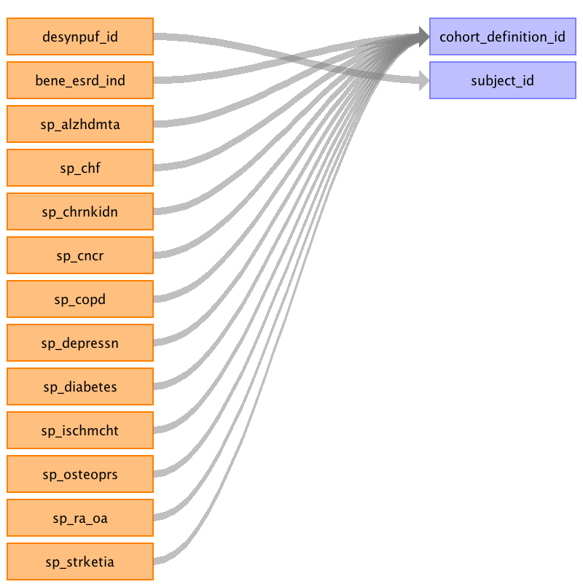

|  |  |  |  |
| --- | --- | --- | --- |
| Destination Field | Source Field | Logic | Comment |
| cohort_definition_id | sp_alzhdmta sp_chf sp_chrnkidn sp_cncr sp_copd sp_depressn sp_diabetes sp_ischmcht sp_osteoprs sp_ra_oa sp_strketia bene_esrd_ind |  | Depending on the column, will depend on the COHORT_DEFINITION_ID used. |
| subject_id | desynpuf_id |  |  |
| cohort_start_date |  |  | The BENEFICIARY_SUMMARY files come as yearly files. We concatinate them together and append the year. That YEAR column will be what determines the START_DATE and END_DATE. START_DATE = '01/01' + YEAR |
| cohort_end_date |  |  | The BENEFICIARY_SUMMARY files come as yearly files. We concatinate them together and append the year. That YEAR column will be what determines the START_DATE and END_DATE. END_DATE = '12/31' + YEAR |

Table name: cohort_definition

Reading from beneficiary_summary

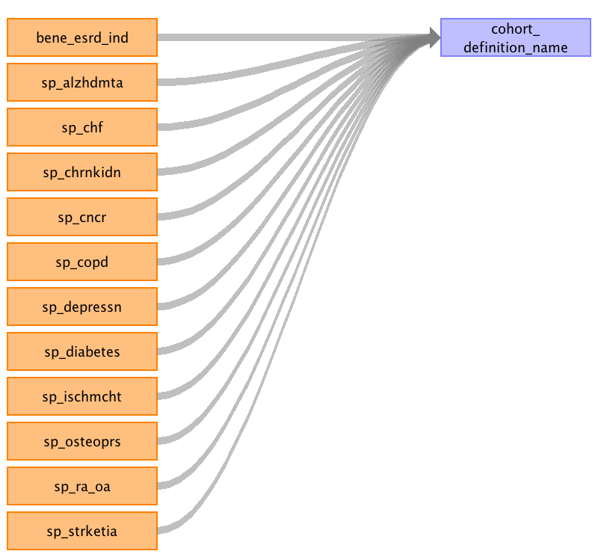

|  |  |  |  |
| --- | --- | --- | --- |
| Destination Field | Source Field | Logic | Comment |
| cohort_definition_id |  |  | Autogenerated |
| cohort_definition_name | sp_alzhdmta sp_chf sp_chrnkidn sp_cncr sp_copd sp_depressn sp_diabetes sp_ischmcht sp_osteoprs sp_ra_oa sp_strketia bene_esrd_ind |  | Depending on the column will depend on the values listed in COHORT_DEFINITION_NAME, COHORT_DEFINITION_DESCRIPTION. It will be listed in the following format: [COLUMN_NAME][COHORT_DEFINITION_NAME][COHORT_DEFINITION_DESCRIPTION], [SP_ALZHDMTA][Alzheimer's Disease and Related Disorders or Senile Dementia][Algorithm: At least 1 inpatient, HOP or Carrier claim with DX codes during the yearly period Codes: DX 331.0, 331.1, 331.11, 331.19, 331.2, 331.7, 290.0, 290.1, 290.10, 290.11, 290.12, 290.13, 290.20, 290.21, 290.3, 290.40, 290.41, 290.42, 290.43, 294.0, 294.1, 294.10, 294.11, 294.8, 797 (any DX on the claim)], [SP_CHF][Heart Failure][Algorithm: At least 1 inpatient, HOP or Carrier claim with DX codes during the yearly period Codes: DX 398.91, 402.01, 402.11, 402.91, 404.01, 404.11, 404.91, 404.03, 404.13, 404.93, 428.0, 428.1, 428.20, 428.21, 428.22, 428.23, 428.30, 428.31, 428.32, 428.33, 428.40, 428.41, 428.42, 428.43, 428.9 (any DX on the claim)], [SP_CHRNKIDN][Chronic Kidney Disease][Algorithm: At least 1 inpatient or 2 HOP or Carrier claims with DX codes during the yearly period Codes: DX 016.00, 016.01, 016.02, 016.03, 016.04, 016.05, 016.06, 095.4, 189.0, 189.9, 223.0, 236.91, 249.40, 249.41, 250.40, 250.41, 250.42, 250.43, 271.4, 274.1, 274.10, 283.11, 403.01, 403.11, 403.91, 404.02, 404.03, 404.12, 404.13, 404.92, 404.93, 440.1, 442.1, 572.4, 580.0, 580.4, 580.81, 580.89, 580.9, 581.0, 581.1, 581.2, 581.3, 581.81, 581.89, 581.9, 582.0, 582.1, 582.2, 582.4, 582.81, 582.89, 582.9, 583.0, 583.1, 583.2, 583.4, 583.6, 583.7, 583.81, 583.89, 583.9, 584.5, 584.6, 584.7, 584.8, 584.9, 585, 585.1, 585.2, 585.3, 585.4, 585.5, 585.6, 585.9, 586, 587, 588.0, 588.1, 588.81, 588.89, 588.9, 591, 753.12, 753.13, 753.14, 753.15, 753.16, 753.17, 753.19, 753.20, 753.21, 753.22, 753.23, 753.29, 794.4 (any DX on the claim)], [SP_CNCR][Female Breast, Colorectal, Prostate, or Lung Cancer][Algorithm: At least 1 inpatient or 2 HOP or Carrier claims with DX codes during yearly time period Codes: DX 174.0, 174.1, 174.2, 174.3, 174.4, 174.5, 174.6, 174.8, 174.9, 233.0, 154.0, 154.1, 153.0, 153.1, 153.2, 153.3, 153.4, 153.5, 153.6, 153.7, 153.8, 153.9, 230.3, 230.4, 185, 233.4, 162.0, 162.2, 162.3, 162.4, 162.5, 162.8, 162.9, 231.2 (any DX on the claim)], [SP_COPD][Chronic Obstructive Pulmonary Disease][Algorithm: At least 1 inpatient, or 2 HOP or Carrier claims with DX codes during yearly period Codes: DX 491.0, 491.1, 491.20, 491.21, 491.22, 491.8, 491.9, 492.0, 492.8, 494.0, 494.1, 496 (any DX on the claim)], [SP_DEPRESSN][Depression][Algorithm: At least 1 inpatient, HOP or Carrier claim with DX codes during the yearly period Codes: DX 296.20, 296.21, 296.22, 296.23, 296.24, 296.25, 296.26, 296.30, 296.31, 296.32, 296.33, 296.34, 296.35, 296.36, 296.50, 296.51, 296.52, 296.53, 296.54, 296.55, 296.56, 296.60, 296.61, 296.62, 296.63, 296.64, 296.65, 296.66, 296.89, 298.0, 300.4, 309.1, 311 (any DX on the claim)], [SP_DIABETES][Diabetes][Algorithm: At least 1 inpatient or 2 HOP or Carrier claim with DX codes during the yearly period Codes: DX 249.00, 249.01, 249.10, 249.11, 249.20, 249.21, 249.30, 249.31, 249.40, 249.41, 249.50, 249.51, 249.60, 249.61, 249.70, 249.71, 249.80, 249.81, 249.90, 249.91, 250.00, 250.01, 250.02, 250.03, 250.10, 250.11, 250.12, 250.13, 250.20, 250.21, 250.22, 250.23, 250.30, 250.31, 250.32, 250.33, 250.40, 250.41, 250.42, 250.43, 250.50, 250.51, 250.52, 250.53, 250.60, 250.61, 250.62, 250.63, 250.70, 250.71, 250.72, 250.73, 250.80, 250.81, 250.82, 250.83, 250.90, 250.91, 250.92, 250.93, 357.2, 362.01, 362.02, 366.41 (any DX on the claim)], [SP_ISCHMCHT][Ischemic Heart Disease][Algorithm: At least 1 inpatient, HOP or Carrier claim with DX, Procedure or HCPC codes during the yearly period Codes: DX 410.00, 410.01, 410.02, 410.10, 410.11, 410.12, 410.20, 410.21, 410.22, 410.30, 410.31, 410.32, 410.40, 410.41, 410.42, 410.50, 410.51, 410.52, 410.60, 410.61, 410.62, 410.70, 410.71, 410.72, 410.80, 410.81, 410.82, 410.90, 410.91, 410.92, 411.0, 411.1, 411.81, 411.89, 412, 413.0, 413.1, 413.9, 414.00, 414.01, 414.02, 414.03, 414.04, 414.05, 414.06, 414.07, 414.10, 414.11, 414.12, 414.19, 414.2, 414.3, 414.8, 414.9 Proc 00.66, 36.01, 36.02, 36.03, 36.04, 36.05, 36.06, 36.07, 36.09, 36.10, 36.11, 36.12, 36.13, 36.14, 36.15, 36.16, 36.17, 36.19, 36.2, 36.31, 36.32 HCPCS 33510, 33511, 33512, 33513, 33514, 33515, 33516, 33517, 33518, 33519, 33521, 33522, 33523, 33533, 33534, 33535, 33536, 33542, 33545, 33548, 92975, 92977, 92980, 92982, 92995, 33140, 33141 (any DX, PROC or HCPCS on the claim)], [SP_OSTEOPRS][Osteoporosis][Algorithm: At least 1 inpatient, HOP or Carrier claim with DX code during the yearly period Codes: DX 733.00, 733.01, 733.02, 733.03, 733.09 (any DX on the claim)], [SP_RA_OA][rheumatoid arthritis and osteoarthritis (RA/OA)][Algorithm: At least 2 inpatient, HOP or Carrier claims with DX codes during yearly period Codes: DX 714.0, 714.1, 714.2, 714.30, 714.31, 714.32, 714.33, 715.00, 715.04, 715.09, 715.10, 715.11, 715.12, 715.13, 715.14, 715.15, 715.16, 715.17, 715.18, 715.20, 715.21, 715.22, 715.23, 715.24, 715.25, 715.26, 715.27, 715.28, 715.30, 715.31, 715.32, 715.33, 715.34, 715.35, 715.36, 715.37, 715.38, 715.80, 715.89, 715.90, 715.98 (any DX on the claim)], [SP_STRKETIA][Stroke / Transient Ischemic Attack][Algorithm: At least 1 inpatient claim or 2 HOP or Carrier claims with DX codes during the yearly period Codes: DX 430, 431, 434.00, 434.01, 434.10, 434.11, 434.90, 434.91, 435.0, 435.1, 435.3, 435.8, 435.9, 436, 997.02 (any DX on the claim)], [BENE_ESRD_IND][End Stage Renal Disease Indicator][Algorithm: Indicator in the beneficiary summary files showing the patient does have end stage renal disease Codes: ] |
| cohort_definition_description |  |  | Information is under cohort_definition_name field. |
| definition_type_concept_id |  |  | 0 |
| cohort_definition_syntax |  |  | NULL |
| subject_concept_id |  |  | 56-Person |
| cohort_initiation_date |  |  | GETDATE() |

Table name: cohort_attribute

Table name: attribute_definition

Appendix: source tables

Table: beneficiary_summary

|  |  |  |  |
| --- | --- | --- | --- |
| Field | Type | Most freq. value | Comment |
| desynpuf_id | varchar | List truncated... |  |
| bene_birth_dt | int | 19421001 |  |
| bene_death_dt | int | 0 |  |
| bene_sex_ident_cd | smallint | 2 |  |
| bene_race_cd | smallint | 1 |  |
| bene_esrd_ind | varchar | 0 |  |
| sp_state_code | smallint | 5 |  |
| bene_county_cd | smallint | 200 | THIS CODE SPECIFIES THE SSA CODE FOR THE COUNTY OF RESIDENCE OF THE BENEFICIARY. EACH STATE HAS A SERIES OF CODES BEGINNING WITH '000' FOR EACH COUNTY WITHIN THAT STATE. CERTAIN CITIES WITHIN THAT STATE HAVE THEIR OWN CODE. COUNTY CODES MUST BE COMBINED WITH STATE CODES IN ORDER TO LOCATE THE SPECIFIC COUNTY. THE CODING SYSTEM IS THE SSA SYSTEM, NOT THE FEDERAL INFORMATION PROCESSING STANDARD (FIPS). |
| bene_hi_cvrage_tot_mons | smallint | 12 |  |
| bene_smi_cvrage_tot_mons | smallint | 12 |  |
| bene_hmo_cvrage_tot_mons | smallint | 0 |  |
| plan_cvrg_mos_num | smallint | 12 |  |
| sp_alzhdmta | smallint | 2 |  |
| sp_chf | smallint | 2 |  |
| sp_chrnkidn | smallint | 2 |  |
| sp_cncr | smallint | 2 |  |
| sp_copd | smallint | 2 |  |
| sp_depressn | smallint | 2 |  |
| sp_diabetes | smallint | 2 |  |
| sp_ischmcht | smallint | 2 |  |
| sp_osteoprs | smallint | 2 |  |
| sp_ra_oa | smallint | 2 |  |
| sp_strketia | smallint | 2 |  |
| medreimb_ip | real | 0.0 |  |
| benres_ip | real | 0.0 |  |
| pppymt_ip | real | 0.0 |  |
| medreimb_op | real | 0.0 |  |
| benres_op | real | 0.0 |  |
| pppymt_op | real | 0.0 |  |
| medreimb_car | real | 0.0 |  |
| benres_car | real | 0.0 |  |
| pppymt_car | real | 0.0 |  |

Table: carrier_claims

|  |  |  |  |
| --- | --- | --- | --- |
| Field | Type | Most freq. value | Comment |
| desynpuf_id | varchar | AEF310232161AC91 |  |
| clm_id | bigint | List truncated... |  |
| clm_from_dt | int | 20090216 |  |
| clm_thru_dt | int | 20081106 |  |
| icd9_dgns_cd_1 | varchar | 4011 |  |
| icd9_dgns_cd_2 | varchar |  |  |
| icd9_dgns_cd_3 | varchar |  |  |
| icd9_dgns_cd_4 | varchar |  |  |
| icd9_dgns_cd_5 | varchar |  |  |
| icd9_dgns_cd_6 | varchar |  |  |
| icd9_dgns_cd_7 | varchar |  |  |
| icd9_dgns_cd_8 | varchar |  |  |
| prf_physn_npi_1 | bigint | 888901330 |  |
| prf_physn_npi_2 | bigint | 0 |  |
| prf_physn_npi_3 | bigint | 0 |  |
| prf_physn_npi_4 | bigint | 0 |  |
| prf_physn_npi_5 | bigint | 0 |  |
| prf_physn_npi_6 | bigint | 0 |  |
| prf_physn_npi_7 | bigint | 0 |  |
| prf_physn_npi_8 | bigint | 0 |  |
| prf_physn_npi_9 | bigint | 0 |  |
| prf_physn_npi_10 | bigint | 0 |  |
| prf_physn_npi_11 | bigint | 0 |  |
| prf_physn_npi_12 | bigint | 0 |  |
| prf_physn_npi_13 | bigint | 0 |  |
| tax_num_1 | int | 532092265 |  |
| tax_num_2 | int | 0 |  |
| tax_num_3 | int | 0 |  |
| tax_num_4 | int | 0 |  |
| tax_num_5 | int | 0 |  |
| tax_num_6 | int | 0 |  |
| tax_num_7 | int | 0 |  |
| tax_num_8 | int | 0 |  |
| tax_num_9 | int | 0 |  |
| tax_num_10 | int | 0 |  |
| tax_num_11 | int | 0 |  |
| tax_num_12 | int | 0 |  |
| tax_num_13 | int | 0 |  |
| hcpcs_cd_1 | varchar | 99213 |  |
| hcpcs_cd_2 | varchar |  |  |
| hcpcs_cd_3 | varchar |  |  |
| hcpcs_cd_4 | varchar |  |  |
| hcpcs_cd_5 | varchar |  |  |
| hcpcs_cd_6 | varchar |  |  |
| hcpcs_cd_7 | varchar |  |  |
| hcpcs_cd_8 | varchar |  |  |
| hcpcs_cd_9 | varchar |  |  |
| hcpcs_cd_10 | varchar |  |  |
| hcpcs_cd_11 | varchar |  |  |
| hcpcs_cd_12 | varchar |  |  |
| hcpcs_cd_13 | varchar |  |  |
| line_nch_pmt_amt_1 | real | 0.0 |  |
| line_nch_pmt_amt_2 | real | 0.0 |  |
| line_nch_pmt_amt_3 | real | 0.0 |  |
| line_nch_pmt_amt_4 | real | 0.0 |  |
| line_nch_pmt_amt_5 | real | 0.0 |  |
| line_nch_pmt_amt_6 | real | 0.0 |  |
| line_nch_pmt_amt_7 | real | 0.0 |  |
| line_nch_pmt_amt_8 | real | 0.0 |  |
| line_nch_pmt_amt_9 | real | 0.0 |  |
| line_nch_pmt_amt_10 | real | 0.0 |  |
| line_nch_pmt_amt_11 | real | 0.0 |  |
| line_nch_pmt_amt_12 | real | 0.0 |  |
| line_nch_pmt_amt_13 | real | 0.0 |  |
| line_bene_ptb_ddctbl_amt_1 | real | 0.0 |  |
| line_bene_ptb_ddctbl_amt_2 | real | 0.0 |  |
| line_bene_ptb_ddctbl_amt_3 | real | 0.0 |  |
| line_bene_ptb_ddctbl_amt_4 | real | 0.0 |  |
| line_bene_ptb_ddctbl_amt_5 | real | 0.0 |  |
| line_bene_ptb_ddctbl_amt_6 | real | 0.0 |  |
| line_bene_ptb_ddctbl_amt_7 | real | 0.0 |  |
| line_bene_ptb_ddctbl_amt_8 | real | 0.0 |  |
| line_bene_ptb_ddctbl_amt_9 | real | 0.0 |  |
| line_bene_ptb_ddctbl_amt_10 | real | 0.0 |  |
| line_bene_ptb_ddctbl_amt_11 | real | 0.0 |  |
| line_bene_ptb_ddctbl_amt_12 | real | 0.0 |  |
| line_bene_ptb_ddctbl_amt_13 | real | 0.0 |  |
| line_bene_prmry_pyr_pd_amt_1 | real | 0.0 |  |
| line_bene_prmry_pyr_pd_amt_2 | real | 0.0 |  |
| line_bene_prmry_pyr_pd_amt_3 | real | 0.0 |  |
| line_bene_prmry_pyr_pd_amt_4 | real | 0.0 |  |
| line_bene_prmry_pyr_pd_amt_5 | real | 0.0 |  |
| line_bene_prmry_pyr_pd_amt_6 | real | 0.0 |  |
| line_bene_prmry_pyr_pd_amt_7 | real | 0.0 |  |
| line_bene_prmry_pyr_pd_amt_8 | real | 0.0 |  |
| line_bene_prmry_pyr_pd_amt_9 | real | 0.0 |  |
| line_bene_prmry_pyr_pd_amt_10 | real | 0.0 |  |
| line_bene_prmry_pyr_pd_amt_11 | real | 0.0 |  |
| line_bene_prmry_pyr_pd_amt_12 | real | 0.0 |  |
| line_bene_prmry_pyr_pd_amt_13 | real | 0.0 |  |
| line_coinsrnc_amt_1 | real | 0.0 |  |
| line_coinsrnc_amt_2 | real | 0.0 |  |
| line_coinsrnc_amt_3 | real | 0.0 |  |
| line_coinsrnc_amt_4 | real | 0.0 |  |
| line_coinsrnc_amt_5 | real | 0.0 |  |
| line_coinsrnc_amt_6 | real | 0.0 |  |
| line_coinsrnc_amt_7 | real | 0.0 |  |
| line_coinsrnc_amt_8 | real | 0.0 |  |
| line_coinsrnc_amt_9 | real | 0.0 |  |
| line_coinsrnc_amt_10 | real | 0.0 |  |
| line_coinsrnc_amt_11 | real | 0.0 |  |
| line_coinsrnc_amt_12 | real | 0.0 |  |
| line_coinsrnc_amt_13 | real | 0.0 |  |
| line_alowd_chrg_amt_1 | real | 10.0 |  |
| line_alowd_chrg_amt_2 | real | 0.0 |  |
| line_alowd_chrg_amt_3 | real | 0.0 |  |
| line_alowd_chrg_amt_4 | real | 0.0 |  |
| line_alowd_chrg_amt_5 | real | 0.0 |  |
| line_alowd_chrg_amt_6 | real | 0.0 |  |
| line_alowd_chrg_amt_7 | real | 0.0 |  |
| line_alowd_chrg_amt_8 | real | 0.0 |  |
| line_alowd_chrg_amt_9 | real | 0.0 |  |
| line_alowd_chrg_amt_10 | real | 0.0 |  |
| line_alowd_chrg_amt_11 | real | 0.0 |  |
| line_alowd_chrg_amt_12 | real | 0.0 |  |
| line_alowd_chrg_amt_13 | real | 0.0 |  |
| line_prcsg_ind_cd_1 | varchar | A | Develop logic to eliminate columns associated to bad claims. Remove Conditions and Procedures associated to values I (for 'Invalid data') and M (for multiple submittal - duplicate line item) |
| line_prcsg_ind_cd_2 | varchar |  | Develop logic to eliminate columns associated to bad claims. Remove Conditions and Procedures associated to values I (for 'Invalid data') and M (for multiple submittal - duplicate line item) |
| line_prcsg_ind_cd_3 | varchar |  | Develop logic to eliminate columns associated to bad claims. Remove Conditions and Procedures associated to values I (for 'Invalid data') and M (for multiple submittal - duplicate line item) |
| line_prcsg_ind_cd_4 | varchar |  | Develop logic to eliminate columns associated to bad claims. Remove Conditions and Procedures associated to values I (for 'Invalid data') and M (for multiple submittal - duplicate line item) |
| line_prcsg_ind_cd_5 | varchar |  | Develop logic to eliminate columns associated to bad claims. Remove Conditions and Procedures associated to values I (for 'Invalid data') and M (for multiple submittal - duplicate line item) |
| line_prcsg_ind_cd_6 | varchar |  | Develop logic to eliminate columns associated to bad claims. Remove Conditions and Procedures associated to values I (for 'Invalid data') and M (for multiple submittal - duplicate line item) |
| line_prcsg_ind_cd_7 | varchar |  | Develop logic to eliminate columns associated to bad claims. Remove Conditions and Procedures associated to values I (for 'Invalid data') and M (for multiple submittal - duplicate line item) |
| line_prcsg_ind_cd_8 | varchar |  | Develop logic to eliminate columns associated to bad claims. Remove Conditions and Procedures associated to values I (for 'Invalid data') and M (for multiple submittal - duplicate line item) |
| line_prcsg_ind_cd_9 | varchar |  | Develop logic to eliminate columns associated to bad claims. Remove Conditions and Procedures associated to values I (for 'Invalid data') and M (for multiple submittal - duplicate line item) |
| line_prcsg_ind_cd_10 | varchar |  | Develop logic to eliminate columns associated to bad claims. Remove Conditions and Procedures associated to values I (for 'Invalid data') and M (for multiple submittal - duplicate line item) |
| line_prcsg_ind_cd_11 | varchar |  | Develop logic to eliminate columns associated to bad claims. Remove Conditions and Procedures associated to values I (for 'Invalid data') and M (for multiple submittal - duplicate line item) |
| line_prcsg_ind_cd_12 | varchar |  | Develop logic to eliminate columns associated to bad claims. Remove Conditions and Procedures associated to values I (for 'Invalid data') and M (for multiple submittal - duplicate line item) |
| line_prcsg_ind_cd_13 | varchar |  | Develop logic to eliminate columns associated to bad claims. Remove Conditions and Procedures associated to values I (for 'Invalid data') and M (for multiple submittal - duplicate line item) |
| line_icd9_dgns_cd_1 | varchar | 4019 |  |
| line_icd9_dgns_cd_2 | varchar |  |  |
| line_icd9_dgns_cd_3 | varchar |  |  |
| line_icd9_dgns_cd_4 | varchar |  |  |
| line_icd9_dgns_cd_5 | varchar |  |  |
| line_icd9_dgns_cd_6 | varchar |  |  |
| line_icd9_dgns_cd_7 | varchar |  |  |
| line_icd9_dgns_cd_8 | varchar |  |  |
| line_icd9_dgns_cd_9 | varchar |  |  |
| line_icd9_dgns_cd_10 | varchar |  |  |
| line_icd9_dgns_cd_11 | varchar |  |  |
| line_icd9_dgns_cd_12 | varchar |  |  |
| line_icd9_dgns_cd_13 | varchar |  |  |

Table: inpatient_claims

|  |  |  |  |
| --- | --- | --- | --- |
| Field | Type | Most freq. value | Comment |
| desynpuf_id | varchar | List truncated... |  |
| clm_id | bigint | List truncated... |  |
| segment | smallint | 1 |  |
| clm_from_dt | int | 20080522 |  |
| clm_thru_dt | int | 20080529 |  |
| prvdr_num | varchar | 23006G |  |
| clm_pmt_amt | real | 4000.0 |  |
| nch_prmry_pyr_clm_pd_amt | real | 0.0 |  |
| at_physn_npi | bigint | 0 |  |
| op_physn_npi | bigint | 0 |  |
| ot_physn_npi | bigint | 0 |  |
| clm_admsn_dt | int | 20080522 |  |
| admtng_icd9_dgns_cd | varchar | 78605 |  |
| clm_pass_thru_per_diem_amt | real | 0.0 |  |
| nch_bene_ip_ddctbl_amt | real | 1024.0 |  |
| nch_bene_pta_coinsrnc_lblty_am | real | 0.0 |  |
| nch_bene_blood_ddctbl_lblty_am | real | 0.0 |  |
| clm_utlztn_day_cnt | int | 3 |  |
| nch_bene_dschrg_dt | int | 20080529 |  |
| clm_drg_cd | varchar | 882 |  |
| icd9_dgns_cd_1 | varchar | 486 |  |
| icd9_dgns_cd_2 | varchar | 4019 |  |
| icd9_dgns_cd_3 | varchar | 4019 |  |
| icd9_dgns_cd_4 | varchar | 4019 |  |
| icd9_dgns_cd_5 | varchar |  |  |
| icd9_dgns_cd_6 | varchar |  |  |
| icd9_dgns_cd_7 | varchar |  |  |
| icd9_dgns_cd_8 | varchar |  |  |
| icd9_dgns_cd_9 | varchar |  |  |
| icd9_dgns_cd_10 | varchar |  |  |
| icd9_prcdr_cd_1 | varchar |  |  |
| icd9_prcdr_cd_2 | varchar |  |  |
| icd9_prcdr_cd_3 | varchar |  |  |
| icd9_prcdr_cd_4 | varchar |  |  |
| icd9_prcdr_cd_5 | varchar |  |  |
| icd9_prcdr_cd_6 | varchar |  |  |
| hcpcs_cd_1 | varchar |  |  |
| hcpcs_cd_2 | varchar |  |  |
| hcpcs_cd_3 | varchar |  |  |
| hcpcs_cd_4 | varchar |  |  |
| hcpcs_cd_5 | varchar |  |  |
| hcpcs_cd_6 | varchar |  |  |
| hcpcs_cd_7 | varchar |  |  |
| hcpcs_cd_8 | varchar |  |  |
| hcpcs_cd_9 | varchar |  |  |
| hcpcs_cd_10 | varchar |  |  |
| hcpcs_cd_11 | varchar |  |  |
| hcpcs_cd_12 | varchar |  |  |
| hcpcs_cd_13 | varchar |  |  |
| hcpcs_cd_14 | varchar |  |  |
| hcpcs_cd_15 | varchar |  |  |
| hcpcs_cd_16 | varchar |  |  |
| hcpcs_cd_17 | varchar |  |  |
| hcpcs_cd_18 | varchar |  |  |
| hcpcs_cd_19 | varchar |  |  |
| hcpcs_cd_20 | varchar |  |  |
| hcpcs_cd_21 | varchar |  |  |
| hcpcs_cd_22 | varchar |  |  |
| hcpcs_cd_23 | varchar |  |  |
| hcpcs_cd_24 | varchar |  |  |
| hcpcs_cd_25 | varchar |  |  |
| hcpcs_cd_26 | varchar |  |  |
| hcpcs_cd_27 | varchar |  |  |
| hcpcs_cd_28 | varchar |  |  |
| hcpcs_cd_29 | varchar |  |  |
| hcpcs_cd_30 | varchar |  |  |
| hcpcs_cd_31 | varchar |  |  |
| hcpcs_cd_32 | varchar |  |  |
| hcpcs_cd_33 | varchar |  |  |
| hcpcs_cd_34 | varchar |  |  |
| hcpcs_cd_35 | varchar |  |  |
| hcpcs_cd_36 | varchar |  |  |
| hcpcs_cd_37 | varchar |  |  |
| hcpcs_cd_38 | varchar |  |  |
| hcpcs_cd_39 | varchar |  |  |
| hcpcs_cd_40 | varchar |  |  |
| hcpcs_cd_41 | varchar |  |  |
| hcpcs_cd_42 | varchar |  |  |
| hcpcs_cd_43 | varchar |  |  |
| hcpcs_cd_44 | varchar |  |  |
| hcpcs_cd_45 | varchar |  |  |

Table: prescription_drug_events

|  |  |  |  |
| --- | --- | --- | --- |
| Field | Type | Most freq. value | Comment |
| desynpuf_id | varchar | 91D777A10F0E8C60 |  |
| pde_id | bigint | List truncated... |  |
| srvc_dt | int | 20090323 |  |
| prod_srvc_id | varchar | 00002840099 |  |
| qty_dspnsd_num | real | 30.0 |  |
| days_suply_num | smallint | 30 |  |
| ptnt_pay_amt | real | 0.0 |  |
| tot_rx_cst_amt | real | 10.0 |  |

Table: outpatient_claims

|  |  |  |  |
| --- | --- | --- | --- |
| Field | Type | Most freq. value | Comment |
| desynpuf_id | varchar | AD5D4E087BF57C05 |  |
| clm_id | bigint | List truncated... |  |
| segment | smallint | 1 |  |
| clm_from_dt | int | 0 |  |
| clm_thru_dt | int | 0 |  |
| prvdr_num | varchar | 0502NA |  |
| clm_pmt_amt | real | 100.0 |  |
| nch_prmry_pyr_clm_pd_amt | real | 0.0 |  |
| at_physn_npi | bigint | 0 |  |
| op_physn_npi | bigint | 0 |  |
| ot_physn_npi | bigint | 0 |  |
| nch_bene_blood_ddctbl_lblty_am | real | 0.0 |  |
| icd9_dgns_cd_1 | varchar | 4019 |  |
| icd9_dgns_cd_2 | varchar |  |  |
| icd9_dgns_cd_3 | varchar |  |  |
| icd9_dgns_cd_4 | varchar |  |  |
| icd9_dgns_cd_5 | varchar |  |  |
| icd9_dgns_cd_6 | varchar |  |  |
| icd9_dgns_cd_7 | varchar |  |  |
| icd9_dgns_cd_8 | varchar |  |  |
| icd9_dgns_cd_9 | varchar |  |  |
| icd9_dgns_cd_10 | varchar |  |  |
| icd9_prcdr_cd_1 | varchar |  |  |
| icd9_prcdr_cd_2 | varchar |  |  |
| icd9_prcdr_cd_3 | varchar |  |  |
| icd9_prcdr_cd_4 | varchar |  |  |
| icd9_prcdr_cd_5 | varchar |  |  |
| icd9_prcdr_cd_6 | varchar |  |  |
| nch_bene_ptb_ddctbl_amt | real | 0.0 |  |
| nch_bene_ptb_coinsrnc_amt | real | 0.0 |  |
| admtng_icd9_dgns_cd | varchar |  |  |
| hcpcs_cd_1 | varchar | 36415 |  |
| hcpcs_cd_2 | varchar |  |  |
| hcpcs_cd_3 | varchar |  |  |
| hcpcs_cd_4 | varchar |  |  |
| hcpcs_cd_5 | varchar |  |  |
| hcpcs_cd_6 | varchar |  |  |
| hcpcs_cd_7 | varchar |  |  |
| hcpcs_cd_8 | varchar |  |  |
| hcpcs_cd_9 | varchar |  |  |
| hcpcs_cd_10 | varchar |  |  |
| hcpcs_cd_11 | varchar |  |  |
| hcpcs_cd_12 | varchar |  |  |
| hcpcs_cd_13 | varchar |  |  |
| hcpcs_cd_14 | varchar |  |  |
| hcpcs_cd_15 | varchar |  |  |
| hcpcs_cd_16 | varchar |  |  |
| hcpcs_cd_17 | varchar |  |  |
| hcpcs_cd_18 | varchar |  |  |
| hcpcs_cd_19 | varchar |  |  |
| hcpcs_cd_20 | varchar |  |  |
| hcpcs_cd_21 | varchar |  |  |
| hcpcs_cd_22 | varchar |  |  |
| hcpcs_cd_23 | varchar |  |  |
| hcpcs_cd_24 | varchar |  |  |
| hcpcs_cd_25 | varchar |  |  |
| hcpcs_cd_26 | varchar |  |  |
| hcpcs_cd_27 | varchar |  |  |
| hcpcs_cd_28 | varchar |  |  |
| hcpcs_cd_29 | varchar |  |  |
| hcpcs_cd_30 | varchar |  |  |
| hcpcs_cd_31 | varchar |  |  |
| hcpcs_cd_32 | varchar |  |  |
| hcpcs_cd_33 | varchar |  |  |
| hcpcs_cd_34 | varchar |  |  |
| hcpcs_cd_35 | varchar |  |  |
| hcpcs_cd_36 | varchar |  |  |
| hcpcs_cd_37 | varchar |  |  |
| hcpcs_cd_38 | varchar |  |  |
| hcpcs_cd_39 | varchar |  |  |
| hcpcs_cd_40 | varchar |  |  |
| hcpcs_cd_41 | varchar |  |  |
| hcpcs_cd_42 | varchar |  |  |
| hcpcs_cd_43 | varchar |  |  |
| hcpcs_cd_44 | varchar |  |  |
| hcpcs_cd_45 | varchar |  |  |