Re-evaluating TOD Opportunities in Greater Philadelphia

Lechuan Huang

Final Report

1. **Question**

To develop a method to comprehensively analyze the potential of TOD opportunities in Philadelphia MSA (Delaware River Valley) that’s actually feasible and benefits local communities using Multi-Criteria Decision Analysis.

1. **Background**

Philadelphia has its own subway and regional rail systems built over a century ago. However, according to the [analysis](https://urbanspatial.github.io/PublicPolicyAnalytics/TOD.html) conducted by Ken and Michael, only certain parts of the city served by rail transit had a positive impact brought by TOD. Other parts of the city served by subways, like West and North Philly remains unchanged compared to non-TOD communities.

DVRPC did produce a [dashboard](https://www.dvrpc.org/webmaps/TOD/) showing the TOD indexes for all major rail transit stations in the Philadelphia MSA. However, there are a few problems with its rating methods: firstly, all of the factors are not weighted, so that decision treat all factors as equivalent despite that is not the case in reality; second, there is not social factors like existing demography that will affect the feasibility of transition and may cause gentrification.

1. **Methodology**

All the data are processed through R codes via the integrated development environment (IDE) of RStudio. The entire process could be split into two parts: the exploratory analysis and model building.

* 1. Exploratory Analysis

In this step, I import the data from various sources, clean them, and briefly look at the exploratory results in order to decide whether to include it in the final model. The following paragraphs lists what kinds of data I use and how did I clean them (please refer to the Metadata file for detailed documentation):

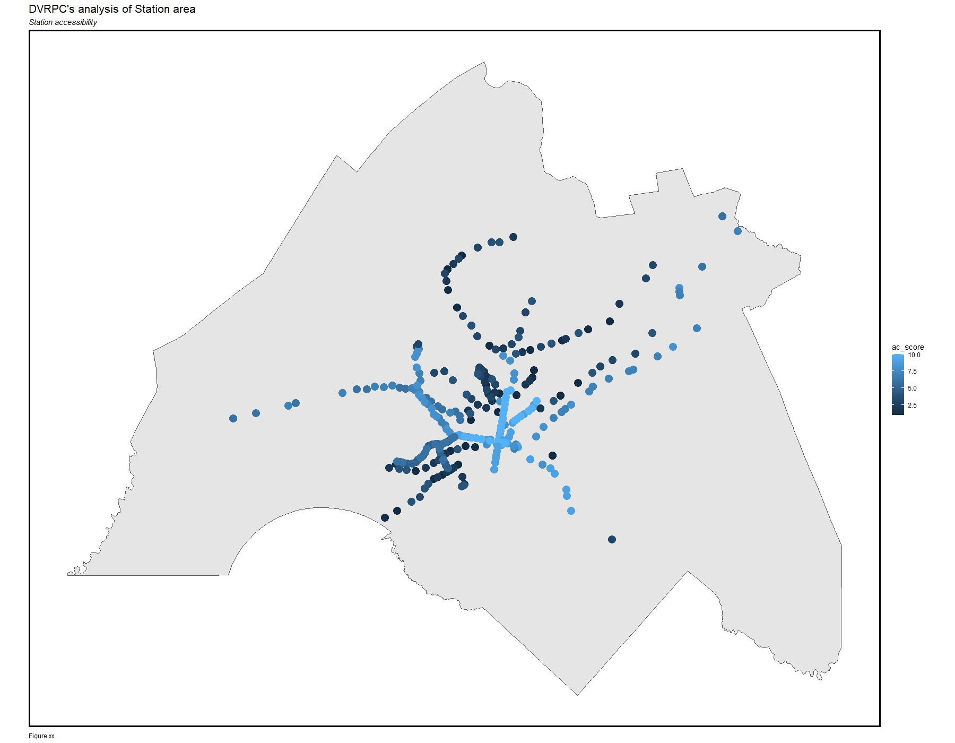

*Maps for the station accessibility score: we can see station served by rapid-transit - that has the highest frequency and highest capacity – have the highest accessibility score.*

* Station data: this is the data of all rail-transit stations in Greater Philadelphia Region from the official website of DVRPC. ID numbers are assigned to avoid stations with the same name; meanwhile, several stations that are physically connected and interchangeable are merged manually.
  + The type of modes are regrouped into four types: Regional Rail, Rail Transit (Rapid Rail), Light Rail, and Trolley for symbological use.
  + I use the station information to calculate the accessibility score (ac_score). The score is based on the quantiled result of the accessibility index, which calculated the ideal maximum ridership of the station based on the frequency of train services and the capacity of the train.
* Job Data: this is the data of employment data and prediction in Greater Philadelphia Region at neighborhood level from the official website of DVRPC. I join the neighborhood into the station in order to calculate job-related identifiers.
  + Job Score: Score for the job density for the district where the station is located.
  + Employment Gap Score: Scores for station in the neighborhoods where there are huge gaps between population and number of jobs available.
* Census Data: I use the American Community Survey data of 2019 at the census-tract level to conduct social analysis using Tidycensus package in R. Some of the variables used include Total Population, Number of people living in Poverty, Median Income, Number of people living in own houses. I join the tract into the stations.
  + Poverty Rate Score: Scores for the inverse Poverty Rate of the Census tract the station is located – the higher the score is, the less poverty rate they have.
  + Median Income Score: Scores for the median income of the census tract the station is located. It is worth mentioning that both poverty rate and median income are not the same: people with low income are not necessarily living under poverty.
  + Not be gentrified Score: Likelihood of not being gentrified after the TOD project. This is calculated based on the gaps between quantiled medium income and quantiled poverty rate, then by quantiled house ownership rate. This identifier is based on the assumption that how vulnerable the affordability (how likely you will survive in this neighborhood given the current income) of the neighborhood is.

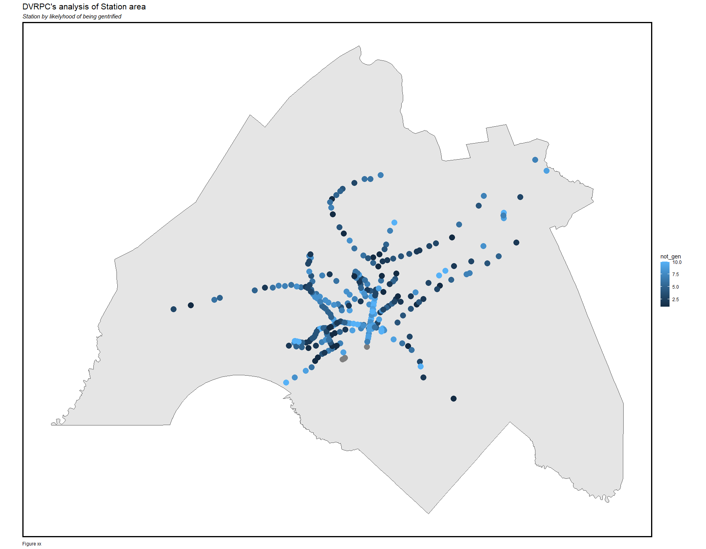

*Maps for the possible gentrification: they are clustered in North Philly, Northeast Philadelphia and Southwest part of the region.*

* Municipality Data: this is the boundary data of all the municipality (cities, boroughs and townships) queried from the DVRPC Open Data and are joined to the station data. Generally, stations located in type of municipalities of cities, boroughs, or small townships are assigned higher score as those places are more densely developed.
* Slope Data: This is calculated based on the raster Digital Elevation Model (DEM) data from the USGS Earth Explorer.
* Parcel Data: this is the most challenging part of the analysis due to the size of the data and complexity on how to analyze them. The data are from the DVRPC. Firstly, I converted them into point data just for the convenience in processing. Second, I filtered parcels around 800-meter TOD buffer zone for all the stations, and lastly, I join the parcels to the station for by the type of land use and total size. Given that, I have created three factors related to land use:
  + Underused Land: there are still quite a lot of underused parcels around the 800 meters buffer zone. I aggregate the size of all the parcels zoned as agriculture, underdeveloped (General and Transitional), parking (Undetermined and transportation), and cut them into 10.

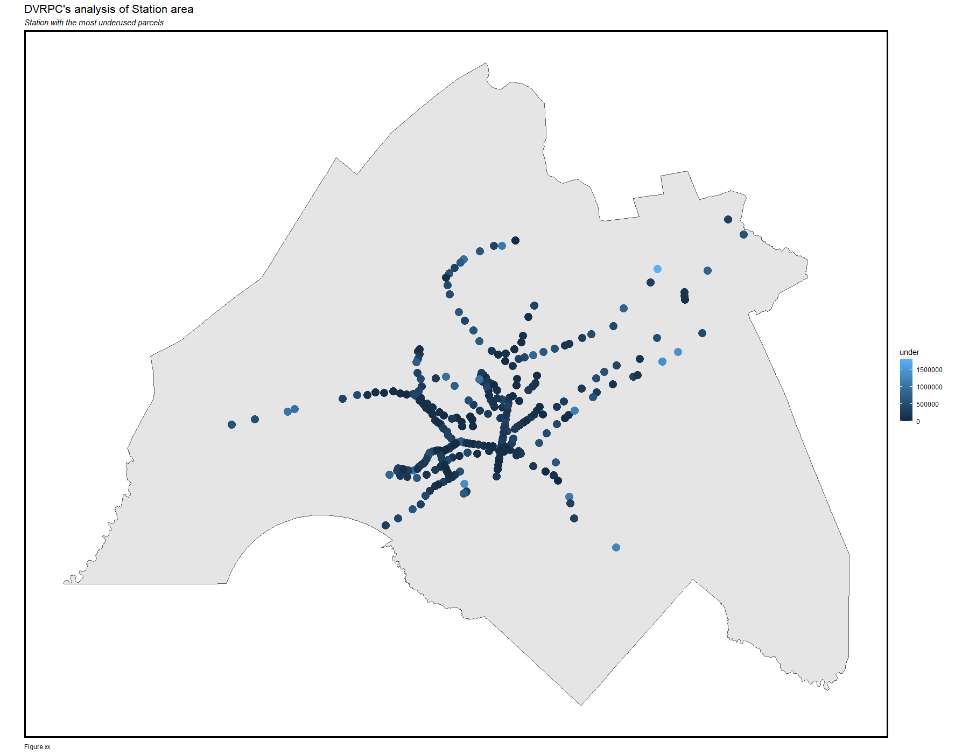

*Stations with the most underused land. There is no clear clustering patterns but by doing such quantitative and spatial analysis we would be able to filter them out.*

* + Attractive Land Score: People want to live next to place there are more attractive amenities. Thus, I aggregate the parcels zoned as Commercial, Institutional, Recreational and cut them into 10.
  + Unattractive Land Score: People generally don’t like living next to unattractive places. Thus, I aggregate the parcels zoned as Industrial, Military, Utility and negatively cut them into 10 – the higher the score is, the less unattractive land there are.

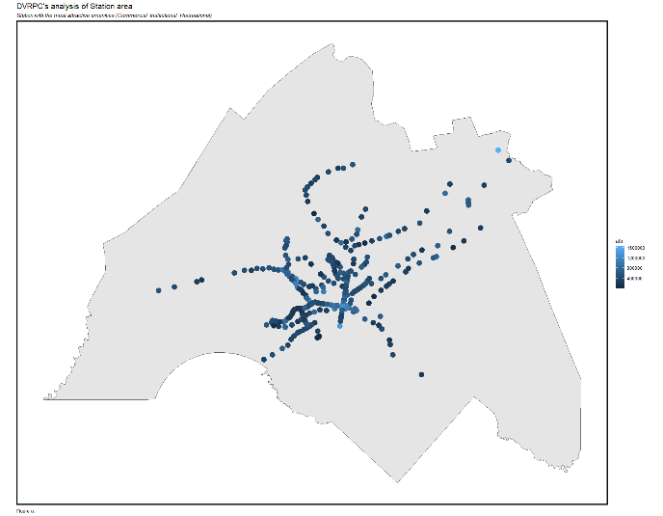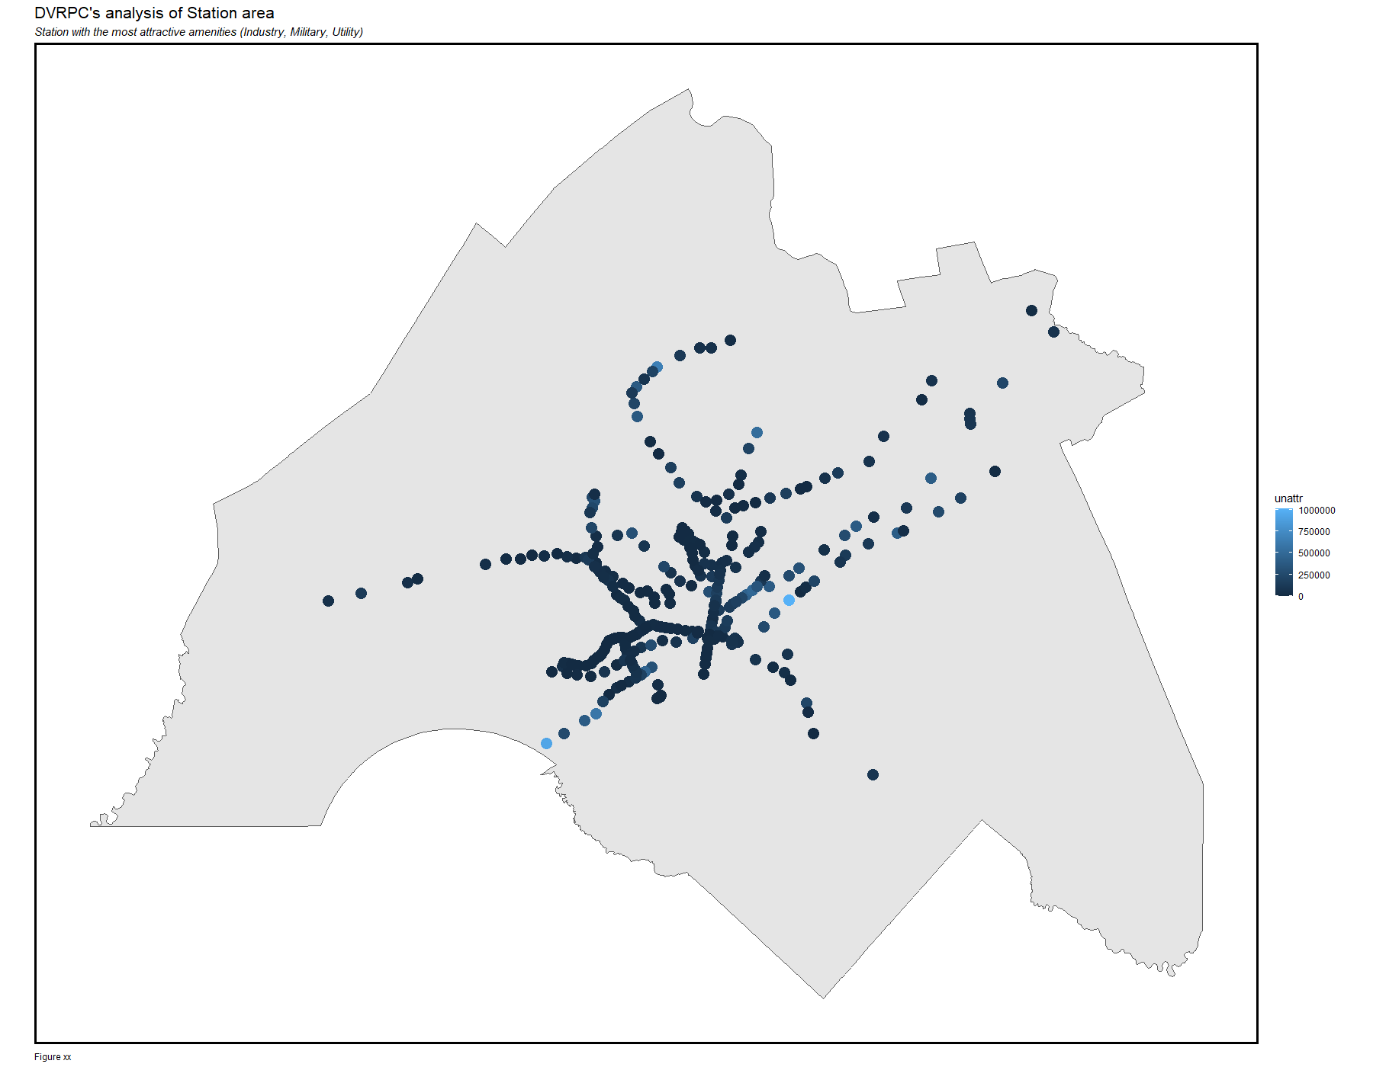

*Maps for Attractive and Unattractive land. Original files are in the folder cleaned_data. We can see that stations in Center City and Northwestern Suburban have the most attractive land, while stations alongside the Delaware River have the most unattractive lands.*

* 1. Model Building

With all the preliminary analysis completed, we can start build our model. The Multi-Criteria Decision Analysis (MCDA) is a common model used in social science; it helps researchers to generate decisions by quantitatively taking account of factors with different assigned weights. However, one of the biggest tradeoffs of such model is the process of weighting: it sometimes based on the subjective assumptions from the researchers rather in order to intentionally generate the “preferred” results. Thus, it is important to have a more scientific weighting methods in MCDA analysis.

Németh et al introduced a few weighting methods that could be used in this project. He lists a few weighting methods, like Direct Weighting, Swing Weighting, Scoring Functions, SMART etc. Among them, the method of Analytic Hierarchy Process (AHP) is the most appropriate one for this project: In this method, weights are calculated based on its relationship of importance with other factors, known as Pairwise Comparison in a Preference Matrix. Compared to other weighting methods, it has strengths in both resource requirement, low chance of bias, and overall complexity. By conducting such process, the weights are calculated for all indicators as the following table shows (the detailed weighting process are in the tab 2 of the Metadata):

|  |  |  |  |
| --- | --- | --- | --- |
| **Factors** | **Weights** | **Factors** | **Weights** |
| Accessibility | 0.1 | Not Gentrified | 0.09 |
| Job Score | 0.1 | Municipality | 0.08 |
| Employment Gap | 0.13 | Slope | 0.04 |
| Poverty Rate | 0.07 | Underused | 0.1 |
| Median Income | 0.04 | Attractive Land | 0.14 |
|  |  | Unattractive Land | 0.1 |

1. **Results**

The following is the final TOD score assigned to all of the rail-transit stations in the Greater Philadelphia Region. We can see a lot of them are clustered in Center City Philadelphia, Downtown Camden, plus some other stations in the suburban communities where there are a lot of underutilized parcels. Meanwhile, among stations served by rapid transit, stations located in Northeast Philadelphia and North Philly are assigned lower scores, probably for its high likelihood to gentrify.

By comparing with the prediction made by DVRPC, although most of stations have relatively similar scores for TOD potentials, my prediction successfully filter some suburban stations that should be suitable for TOD development and stations that are likely to gentrify – which were the goals I planned to achieve.

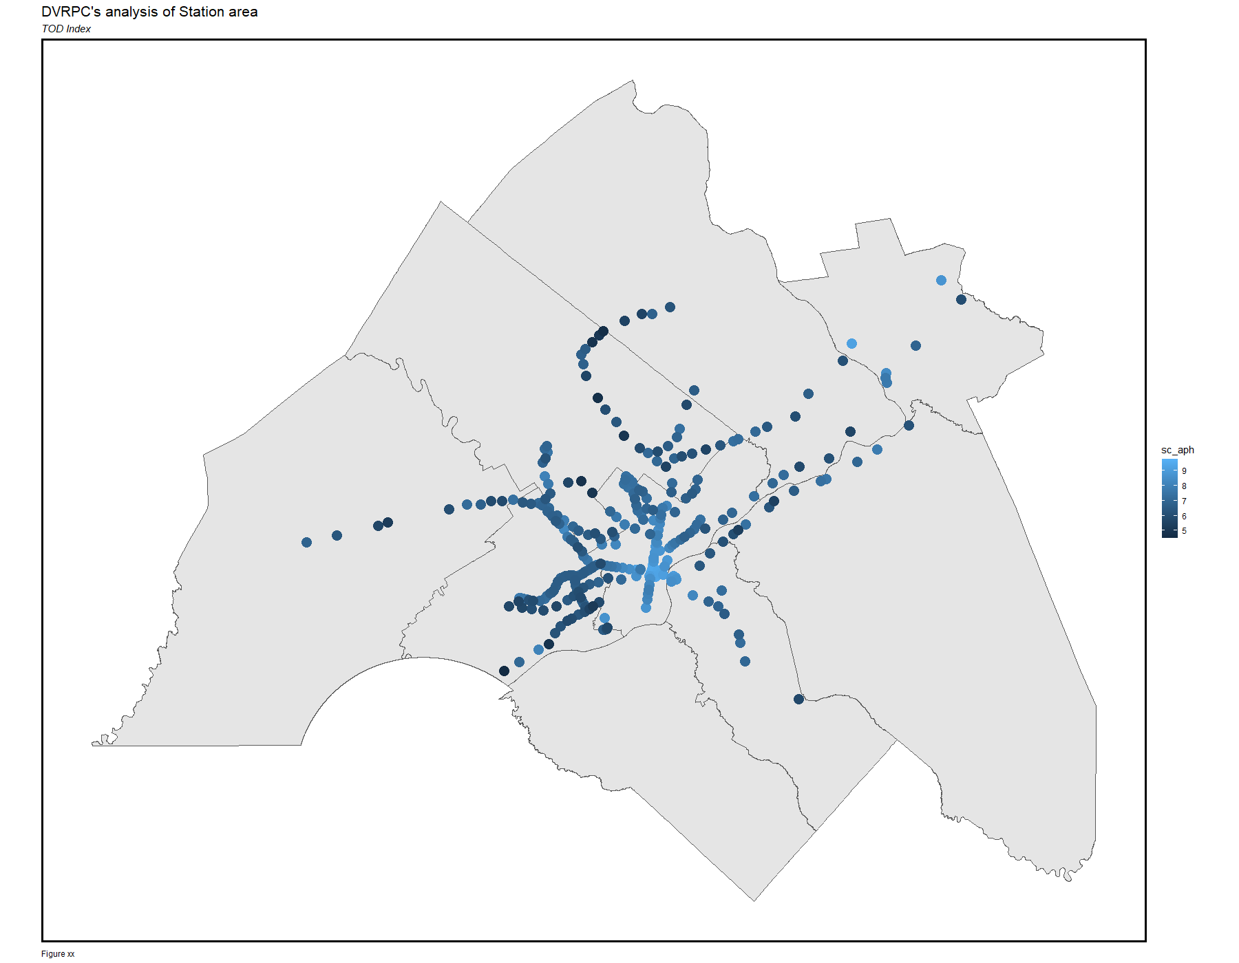

1. **Implementation**

This index provides panner good indications on all transit stations’ potential to have TOD development. For stations with low TOD scores, the local government could work on improving the land-use around the station, such as promoting mixed-use or adding commercial spaces – in which will have the most immediate change of the score.

However, TOD takes places on parcels larger than 1 acre. Thus, I build a dashboard to help planners to identify which stations are more suitable to have large-scale TOD development. The dashboard includes:

* Stations layers with TOD scores: by clicking the station, a breakdown of the score will be popped up on the bar on the left side. Planners could see how good the existing condition around the station is.
* Filters at the top to select stations by its TOD score range, municipality level, and service mode it has.
* Layer of parcels around the station that are larger than 1 acre and could be re-developed: currently undeveloped, parking lots, agriculture, and industrial. It’s worth mention that industrial parcels were not part of the “underused” factors, we include here for giving planners more information.

In the real life, planners are recommended to 1) filter the station based on his/her need, then 2) select a suitable parcel around the station. In the most case, we recommend planners to choose the “Between 5 and 7” for the score range, for starting looking for stations that are suitable to have its neighbor redeveloped.

1. **Reflection**

By conducting the land-use analysis, I gradually realized that the current standard for TOD buffers – half mile or 800 meters – are too large. The distance between a lot of rapid transit stations is smaller than 800 meters; also, by plotting parcels into the map, we can see a lot of stations alongside the Schuylkill or Delaware River have respective parcels located across the river. Also, stations served by low-ridership modes could also have smaller TOD buffer zone.

Secondly, the equity factors we include have limited effects on results: stations served by rail transit but have higher likelihood being gentrified are still have higher scores than a lot of regional rail stations in the suburbs, this is because the most significant factors in this model are still related to transit accessibility and existing land-use even if we adopt the APH weighting method. Thus, that’s the reason we decide to have the filter in our dashboard: when looking at stations of different service mode and different jurisdiction, the criteria on the “goodness” should also be flexible – and the breakdown of the score is more important than the weighted index itself.

1. **Reference**

DVRPC’s TOD Index: <https://www.dvrpc.org/webmaps/TOD/#map>

Németh, B., Molnár, A., Bozóki, S., Wijaya, K., Inotai, A., Campbell, J. D., & Kaló, Z. (2019). Comparison of weighting methods used in multicriteria decision analysis frameworks in healthcare with focus on low-and middle-income countries. Journal of comparative effectiveness research, 8(4), 195-204. <https://www.futuremedicine.com/doi/10.2217/cer-2018-0102>

Calthorpe Associates, Mintier & Associates. “Transit-Oriented Development Design Guidelines”. Sacramento County Planning & Community Development Department. September 1990. <https://planning.saccounty.net/PlansandProjectsIn-Progress/Documents/General%20Plan%202030/GP%20Elements/TOD%20Guidelines.pdf>.