MCDA

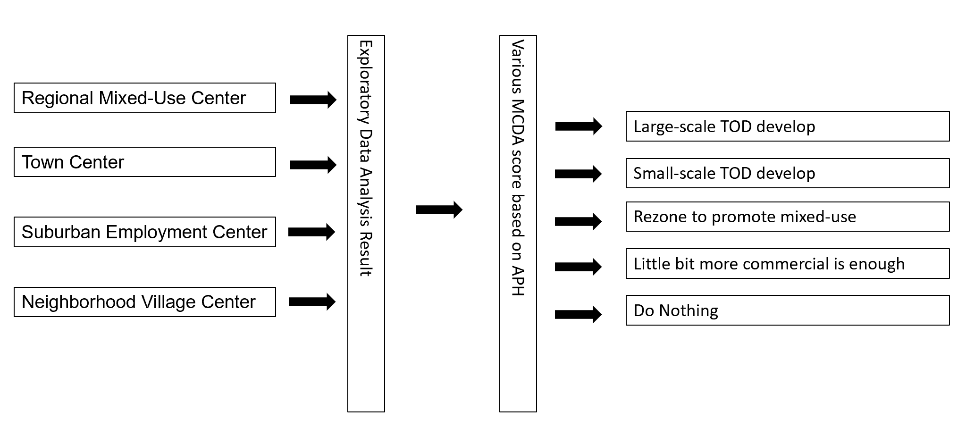

|  |  |  |
| --- | --- | --- |
| **Vision** | **Case** | **Detailed** |
| **Large-scale TOD** | > 5 acres, tower mansion, with garage | Very extra-large parcels (per size)  OK Transit Time |
| **Small-scale TOD develop** | 1 – 5 acres, multi-storey, mixed-use, with garage | Large underused land (per size)  OK Transit Time  Proximity to attraction  Relative denser |
| **Little bit more commercial is enough** | Town Center | Outside Center City  Some Mixed-used  Densely developed  Some Multifamily |
| **Little bit more apt is enough** | Regional Mixed-use Center  Suburban Employment Center | Outside Center City  Some Mixed-Use  Lots of Single-Family House |
| **Do nothing** | Very good TOD | 0 Transit Time  Lots of Job Access  Little underused land  Lots of Attraction |
| Very bad (too remote) | Long Transit Time  Low Job Access |

Transit Time to Center City

Job Access

Underused land (Parking)

Attraction Proximity

Parcel type weighted by shape-area: another parcel type weighted by shape-aera

Principles:

* Stations in “marginalized” neighborhoods should not have large-scale TOD projects. Promoting Commercial, Civil facitlieis might good enough (Gentrification)
* Stations in Single-family house Residential area should not have large-scale TOD projects. Promoting commercial might good enough (NIMBY)
* Stations next to schools should promote mixed-use TOD projects
* Stations with great access to jobs and large underused areas should promote TOD projects.
* Service Type: Transit Rail > Regional Rail > Trolley = Light Rail
* Interchange station (by line number)